Fig. S1 Estimation of corrected concentration index and horizontal inequity in healthcare utilization by age group
- Individuals aged 20-64 years
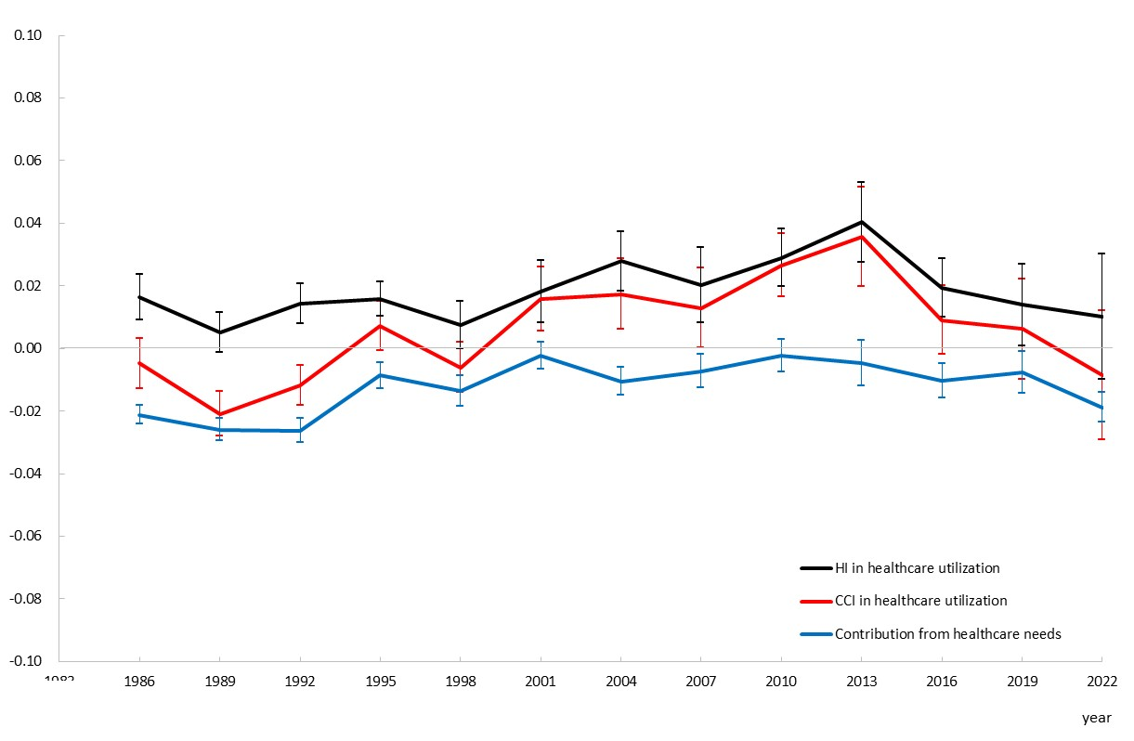
(B) Individuals aged ≥ 65 years
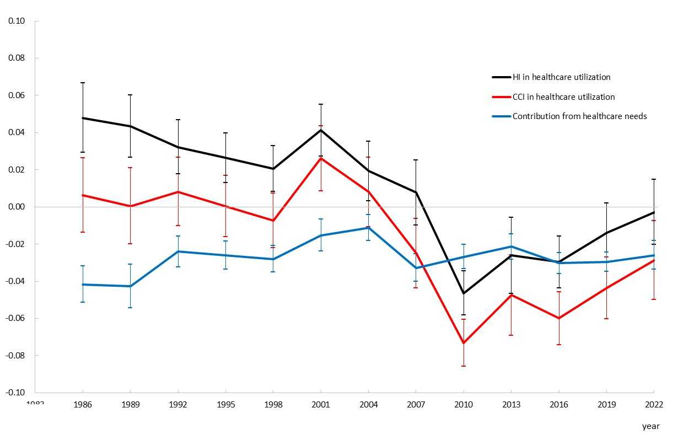
Note. CCI, corrected concentration index; HI, horizontal inequity. Error bars represent 95% confidence intervals.

