(A)
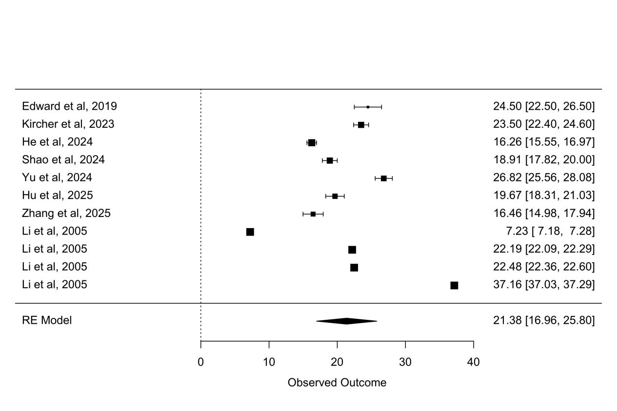
(B)
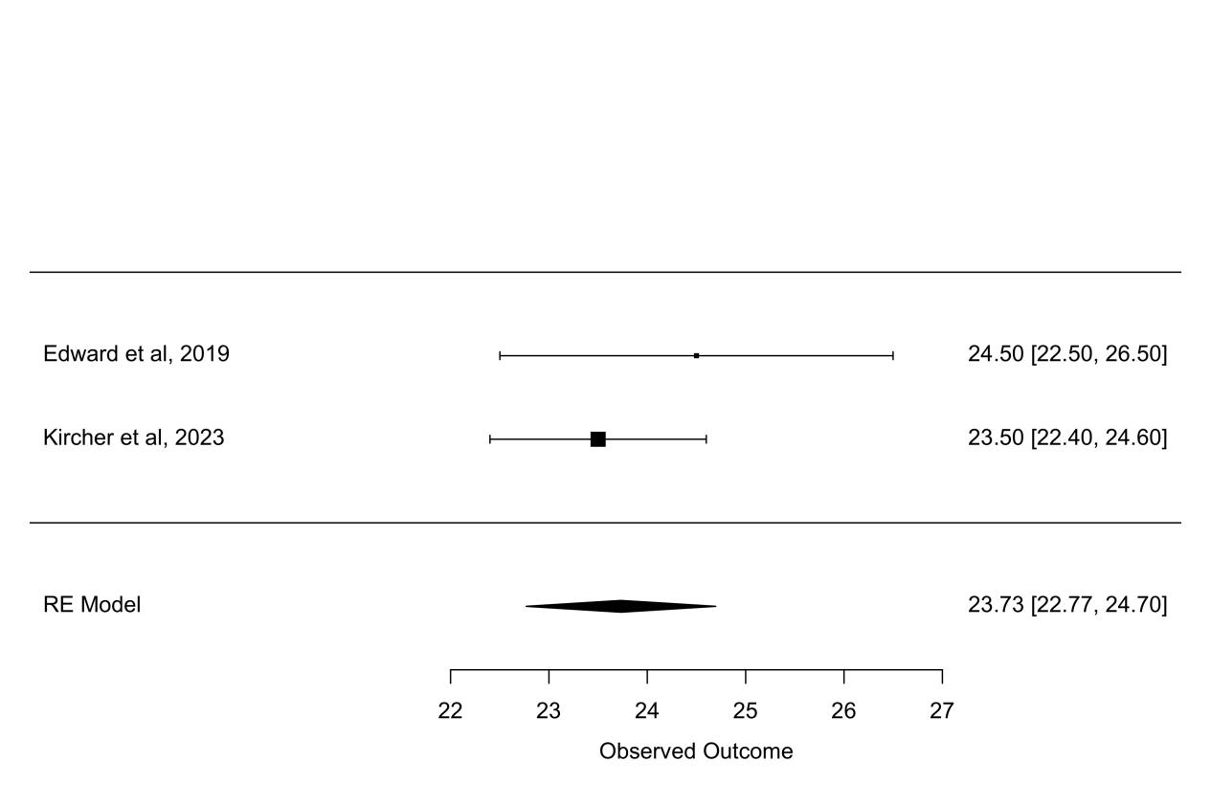

(C)
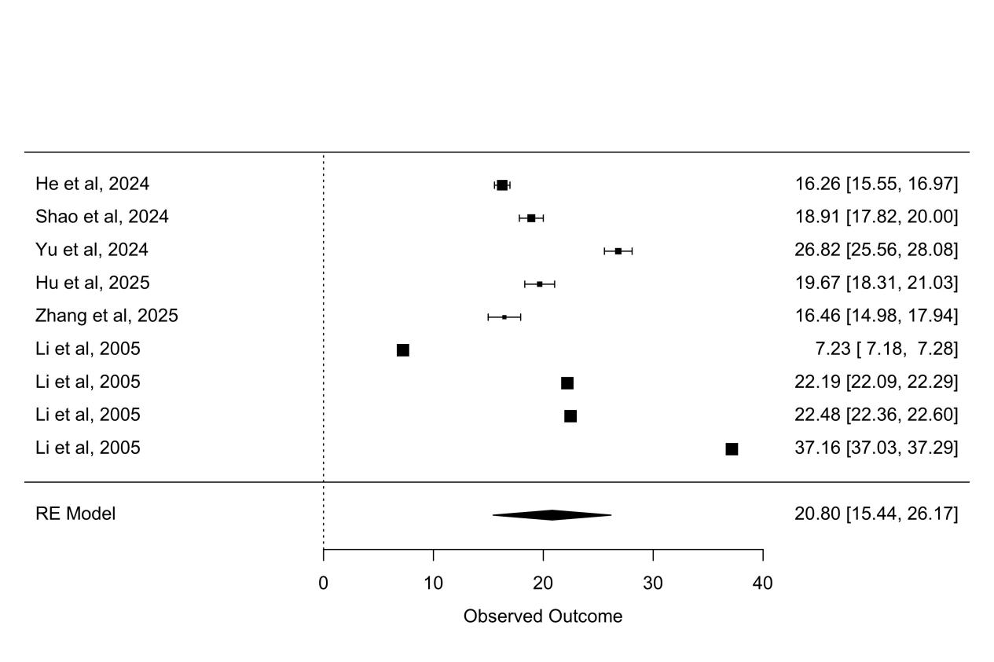
Appendix 3. Mean scores of financial toxicity (FT) assessed by the Comprehensive Score for Financial Toxicity–Patient-Reported Outcome Measure (COST-PROM) among colorectal cancer patients. (A) All included studies; (B) studies conducted in the United States; (C) studies conducted in China.

