Supplementary Materials

Figure S1. Overweight rural-urban prevalence difference at earliest data point.
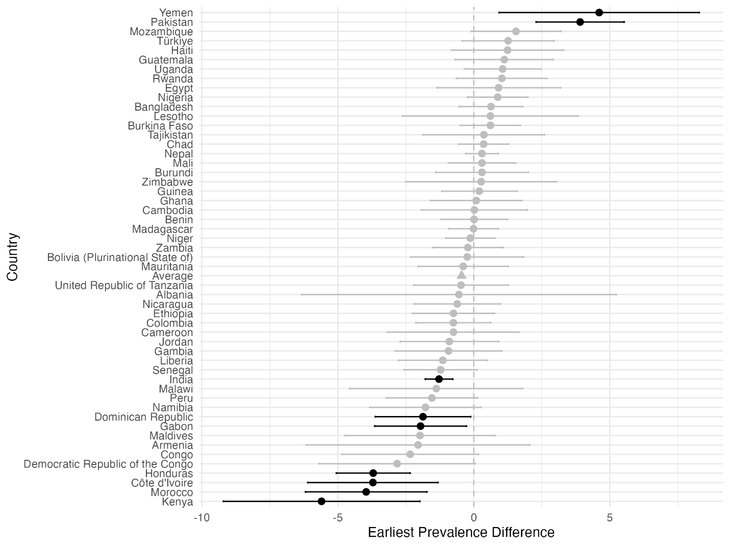

Figure S2. Overweight rural-urban prevalence difference at most recent data point.
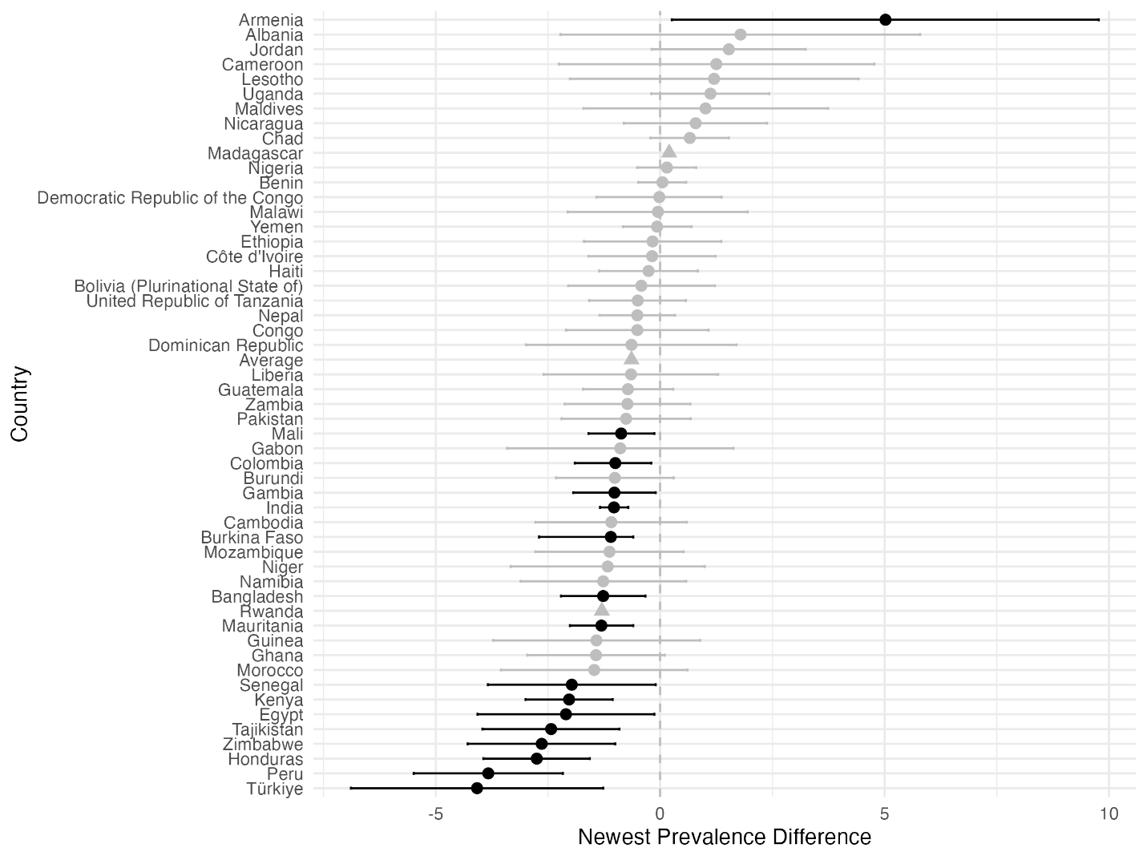

Figure S3. Underweight rural-urban prevalence difference at earliest data point.
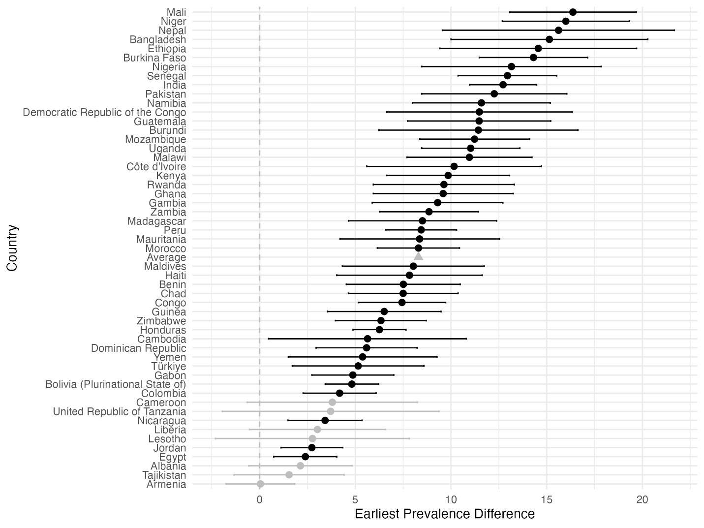

Figure S4. Underweight rural-urban prevalence difference at most recent data point.
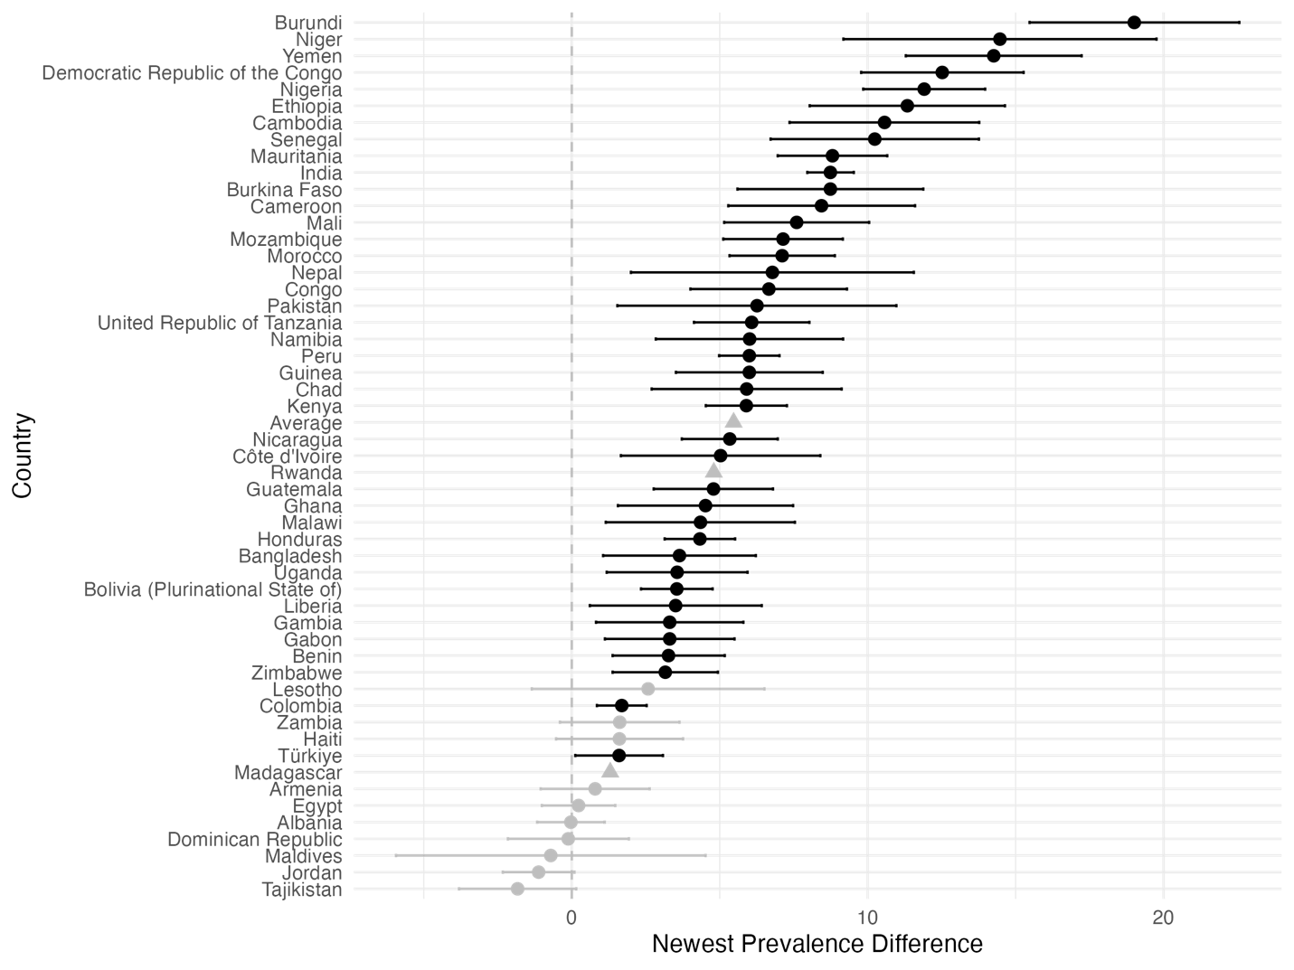

Figure S5. Stunting rural-urban prevalence difference at earliest data point.
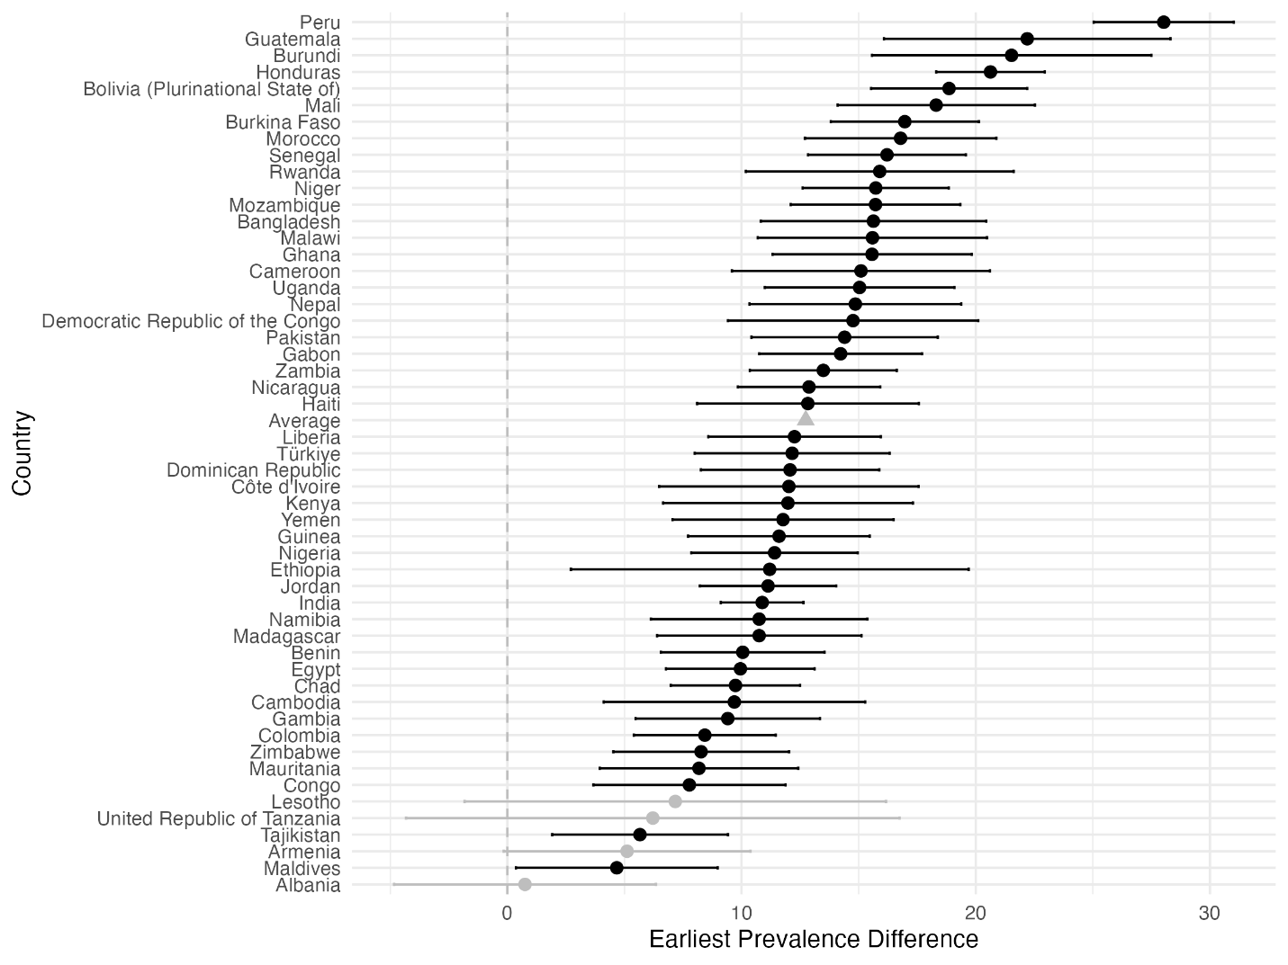

Figure S6. Stunting rural-urban prevalence difference at most recent data point.
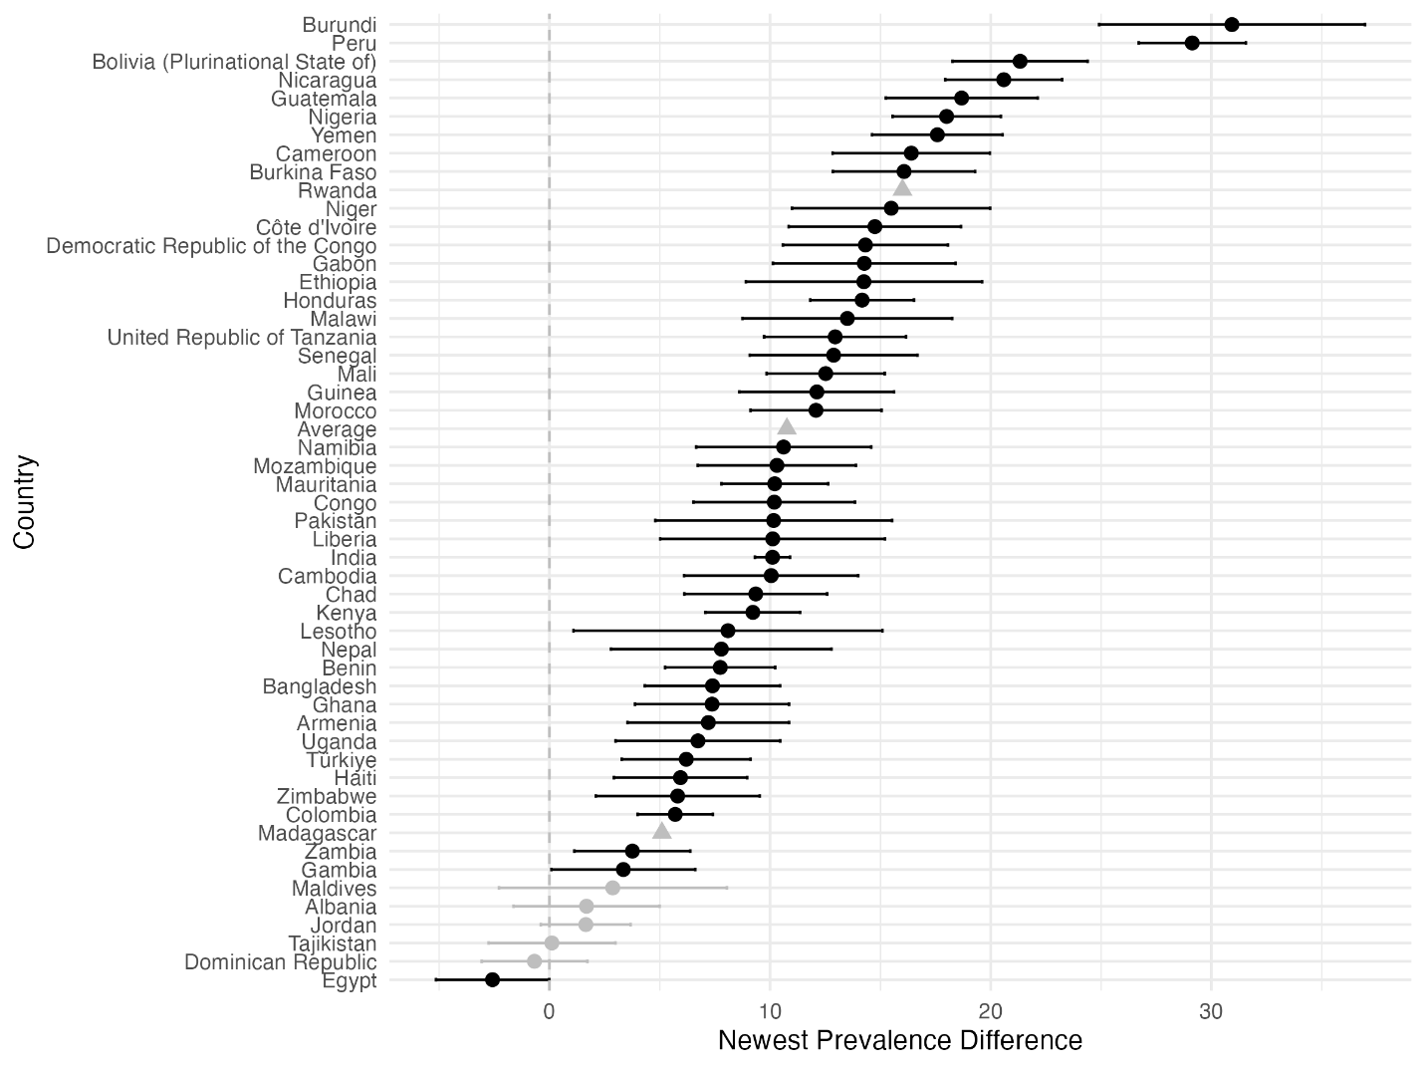

Figure S7. Wasting rural-urban prevalence difference at earliest data point.
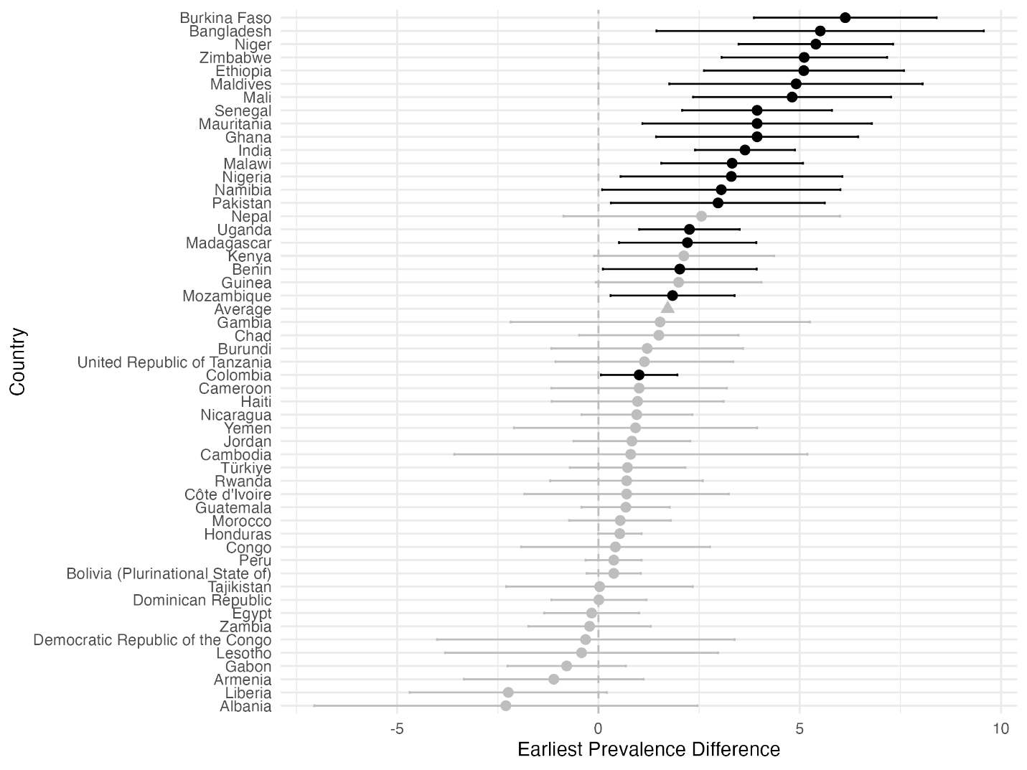

Figure S8. Wasting rural-urban prevalence difference at most recent data point.
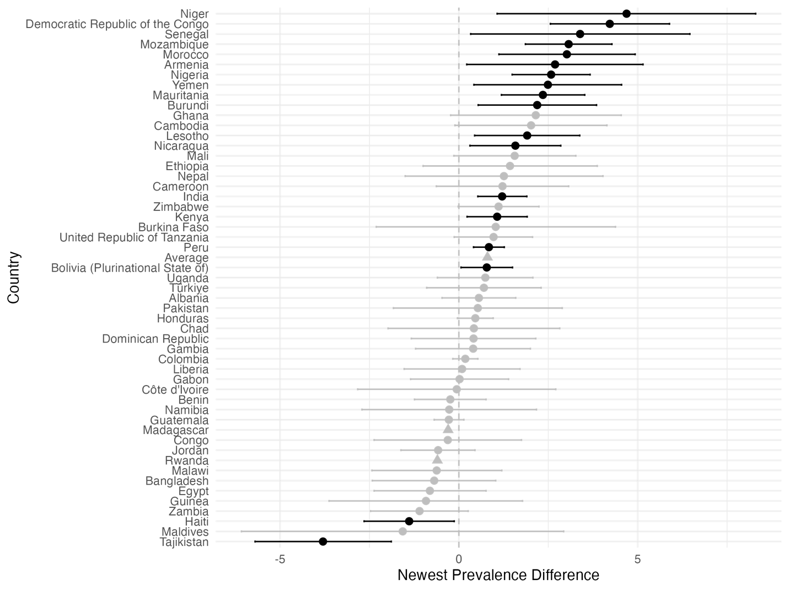

Figure S9. Severe wasting rural-urban prevalence difference at earliest data point.
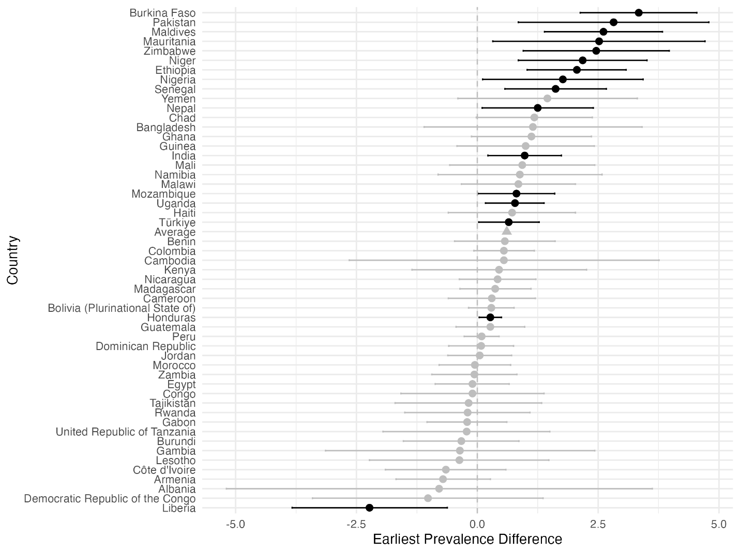

Figure S10. Severe wasting estimated rural-urban difference at most recent data point.
