Supplementary File 1: Literature Search Strategy and Flow Diagram
Toward Equitable Digital Health: An Integrated Framework Addressing Exclusion, Ethics, and Implementation Across Healthcare Systems

S1.1 Search Databases and Date Range
Searches were conducted across four electronic databases: PubMed/MEDLINE, Scopus, Web of Science (Core Collection), and the WHO Global Health Library. All searches were restricted to materials published between 1 January 2015 and 31 December 2025. Database searches were supplemented by targeted grey literature retrieval and reference list screening of highly cited publications.

S1.2 Search Terms by Domain
Search terms were organized into three conceptual domains, combined with Boolean operators (OR within domains; AND across domains):
Domain | Key Terms (OR within domain) | Notes
Domain 1: Digital Health Technologies | "digital health" OR "eHealth" OR "mHealth" OR "telemedicine" OR "telehealth" OR "health information system*" OR "electronic health record*" OR "EHR" OR "artificial intelligence" AND "health*" OR "machine learning" AND "health*" OR "mobile health" OR "patient portal" OR "remote patient monitoring" | Broad scope to capture full range of digital health modalities
Domain 2: Equity and Access | "health equit*" OR "digital divide" OR "digital exclusion" OR "health disparit*" OR "health inequit*" OR "marginalised population*" OR "underserved population*" OR "health access" OR "rural health" OR "vulnerable population*" OR "social determinants" | Includes both supply-side (access) and demand-side (exclusion) terminology
Domain 3: Ethics, Governance, and Implementation | "informed consent" AND "digital*" OR "data privac*" OR "data protection" OR "algorithmic bias" OR "AI ethics" OR "cybersecurity" AND "health*" OR "implementation scienc*" OR "LMIC" OR "low- and middle-income countr*" OR "India" OR "ABDM" OR "Ayushman Bharat" OR "Co-WIN" OR "governance" AND "digital health" | Targeted to capture India-specific and LMIC literature; ethical and governance dimensions
Table S1. Search Terms by Conceptual Domain.

S1.3 Grey Literature Sources
Grey literature was retrieved through targeted searches of the following institutional sources:
- World Health Organization (who.int) including the WHO Global Strategy on Digital Health 2020–2025
- Ministry of Health and Family Welfare, Government of India (mohfw.gov.in)
- National Health Authority, Government of India (abdm.gov.in) including ABDM Annual Reports
- World Bank digital development publications
- Reference lists of included peer-reviewed publications

S1.4 Inclusion and Exclusion Criteria
Criterion | Included | Excluded
Study types | Empirical quantitative and qualitative studies, systematic reviews, scoping reviews, policy analyses, national program evaluations, conceptual or analytical frameworks | Opinion/editorial pieces without substantive analytical content; conference abstracts without full paper; before 2015; non-English language
Phenomena of interest | Digital health equity and exclusion mechanisms; ethical, legal, or governance challenges in digital health; real-world implementation experiences; policy or conceptual frameworks | Technical performance evaluations without equity relevance; hospital IT infrastructure studies unrelated to patient-facing outcomes
Context | Any healthcare setting or country; emphasis on LMICs and India | Digital divide studies in non-health sectors (banking, education) without linkage to health outcomes
Quality | No formal quality scoring (narrative design); greater interpretive weight given to recent systematic reviews, large-scale implementation studies, authoritative policy sources | Sources without identifiable institutional affiliation; full text not retrievable after two retrieval attempts
Table S2. Inclusion and Exclusion Criteria Applied During Screening.

S1.5 Literature Flow Diagram
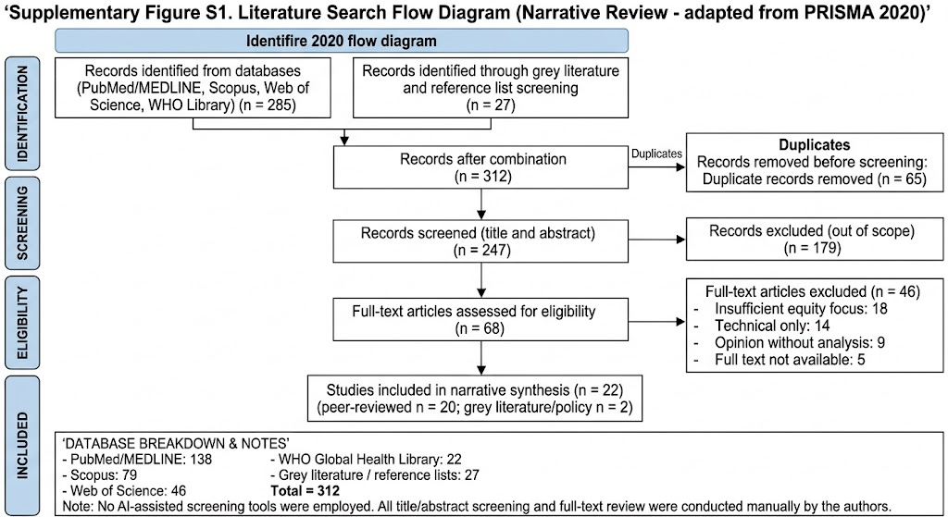
Supplementary Figure S1. Literature Search Flow Diagram (narrative review; adapted from PRISMA 2020 reporting standards). Note: No AI-assisted screening tools were employed at any stage of the review process. All title/abstract and full-text screening was conducted manually by the authors.

S1.6 Full-Text Exclusion Reasons
Reason | Description | n
Insufficient equity focus | Studies addressing digital health technologies but with no substantive equity analysis or consideration of differential outcomes across population subgroups | 18
Technical performance only | Studies evaluating algorithm accuracy, system performance, or technical specifications without addressing equity dimensions, population subgroup performance, or implementation experience | 14
Opinion without analysis | Editorial, commentary, or opinion pieces without substantive analytical framework, empirical data, or systematic evidence review | 9
Full text not retrievable | Studies meeting eligibility criteria on title/abstract screening but for which full text was unavailable after two retrieval attempts | 6
TOTAL |  | 47
Table S3. Reasons for Full-Text Exclusion (n = 47).

The 22 included sources comprise 20 peer-reviewed publications and 2 grey literature/policy documents (WHO Global Strategy on Digital Health 2020–2025 [ref 22]; NHA Annual Report 2022–23 [ref 23]). All included sources are listed in full in the manuscript reference list.

