Supplemental Figure 1: Funnel plots for cancer site specific analyses
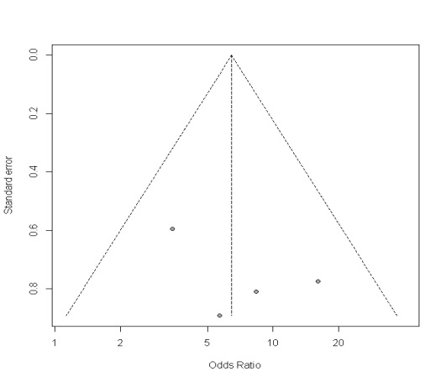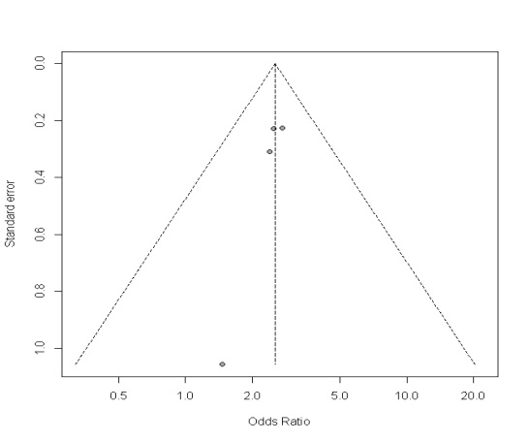
Laryngeal Cancer Fig 3d
Pharyngeal Cancer Fig 3c
Oral Cancer Fig 3b
Cervical Cancer Fig 3a
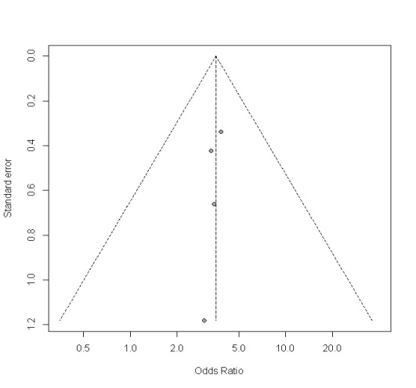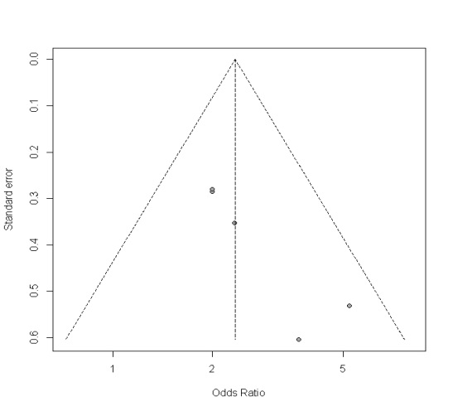
Nasopharyngeal cancer Fig 3f
Esophageal Cancer Fig 3e
