REPEATING CARDIOPULMONARY HEALTH EFFECTS IN RURAL NORTH CAROLINA POPULATION DURING A SECOND LARGE PEAT WILDFIRE

Running title: REPLICATING HEALTH EFFECTS OF PEAT WILDFIRE SMOKE

Authors:
Melissa A. Tinling, MSPH, Department of Horticulture, North Carolina State University (mtinlin@ncsu.edu)
J. Jason West, PhD, Environmental Sciences and Engineering, Gillings School of Global Public Health, University of North Carolina, Chapel Hill, NC (jjwest@email.unc.edu)
Wayne E. Cascio, MD, United States Environmental Protection Agency / National Health and Environmental Effects Research Laboratory / Environmental Public Health Division, NC (Cascio.Wayne@epa.gov)
Vasu Kilaru, MS, United States Environmental Protection Agency / National Exposure Research Laboratory / Environmental Sciences Division / Research Triangle Park, NC (vasu.kilaru@epa.gov)
Ana G. Rappold, PhD, United States Environmental Protection Agency / National Health and Environmental Effects Research Laboratory / Environmental Public Health Division, NC (Rappold.Ana@epa.gov)
Corresponding author:
Ana G. Rappold
109 T.W. Alexander Drive
US EPA
Research Triangle Park, NC 27707
919 843 9504
rappold.ana@epa.gov
The authors declare they have no actual or potential competing financial interests to disclose. This work was conducted as part of the masters’s thesis by Melissa Tinling at the Department of Environmental Science and Engineering at the Gillings School of Global Public Health, University of North Carolina at Chapel Hill. During this time Melissa was employed part-time Program Assistant at the Department of Epidemiology at the North Carolina Division of Public Health in Raleigh, North Carolina.

Data Attribution and Disclaimers:
NC DETECT is a statewide public health syndromic surveillance system, funded by the NC Division of Public Health (NC DPH) Federal Public Health Emergency Preparedness Grant and managed through collaboration between NC DPH and UNC-CH Department of Emergency Medicine’s Carolina Center for Health Informatics. The NC DETECT Data Oversight Committee does not take responsibility for the scientific validity or accuracy of methodology, results, statistical analyses, or conclusions presented.

Disclaimer: The research described in this article has been reviewed by the National Health and Environmental Effects Research Laboratory, U.S. Environmental Protection Agency, and approved for publication. Approval does not signify that the contents necessarily reflect the views and policies of the Agency, nor does the mention of trade names of commercial products constitute endorsement or recommendation for use.

Figure S1: Percent of population in poverty by county (US Census Bureau 2012).
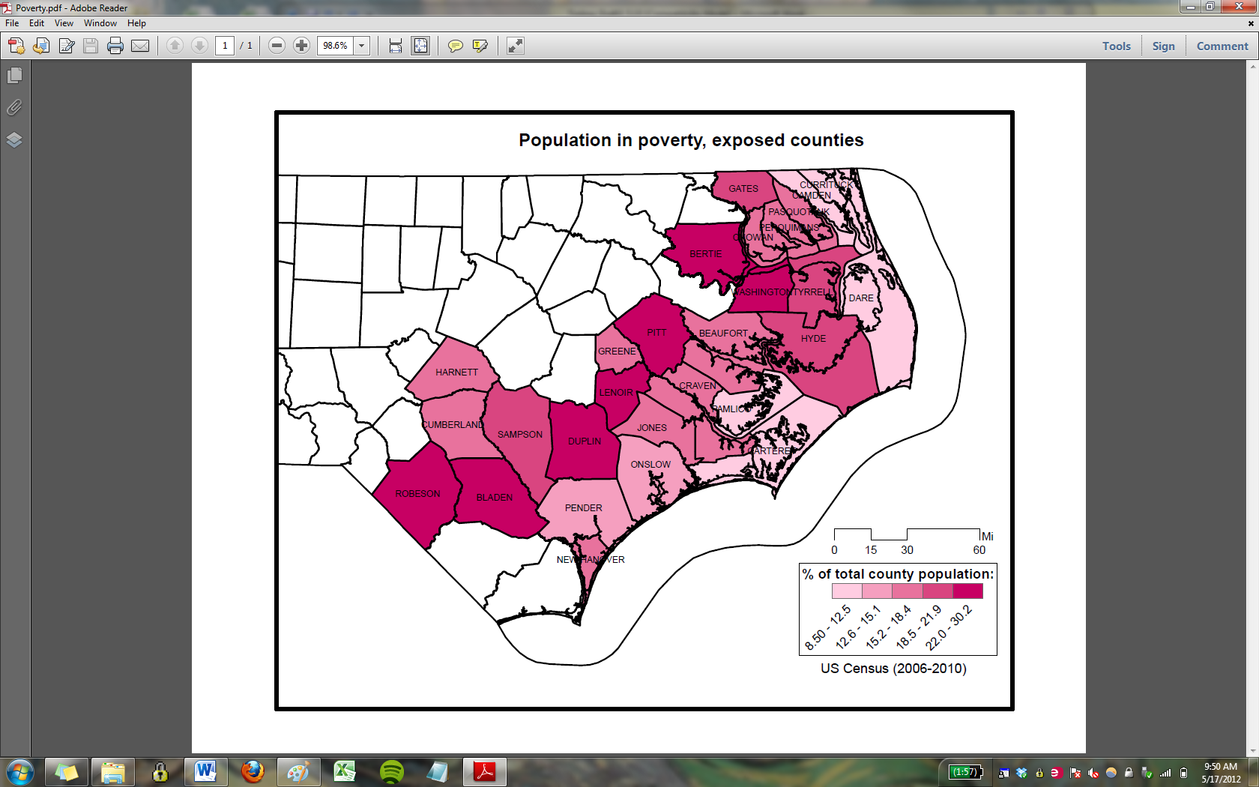
Figure S2: Comparison of SFS PM_{2.5}, satellite imagery and FRM monitor PM_{2.5}: May 11, 2011.
SFS HYSPLIT model PM_{2.5} prediction: | 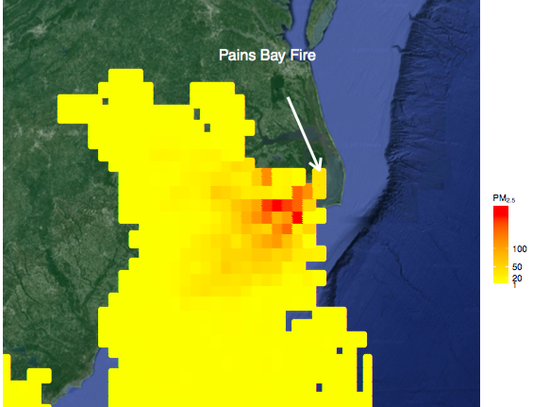
Federal Reference Monitor 24-hr PM_{2.5}: | 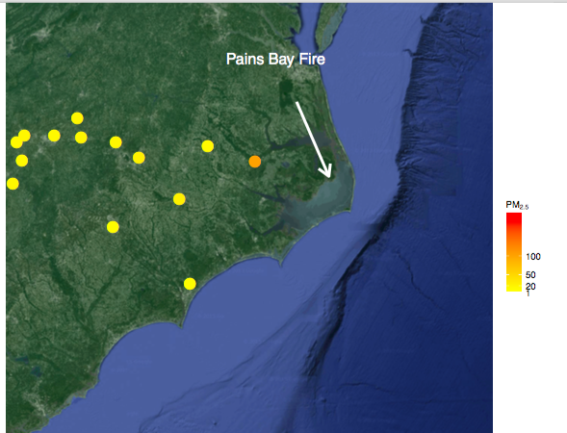
Modis Rapid Response Satellite Imagery: | 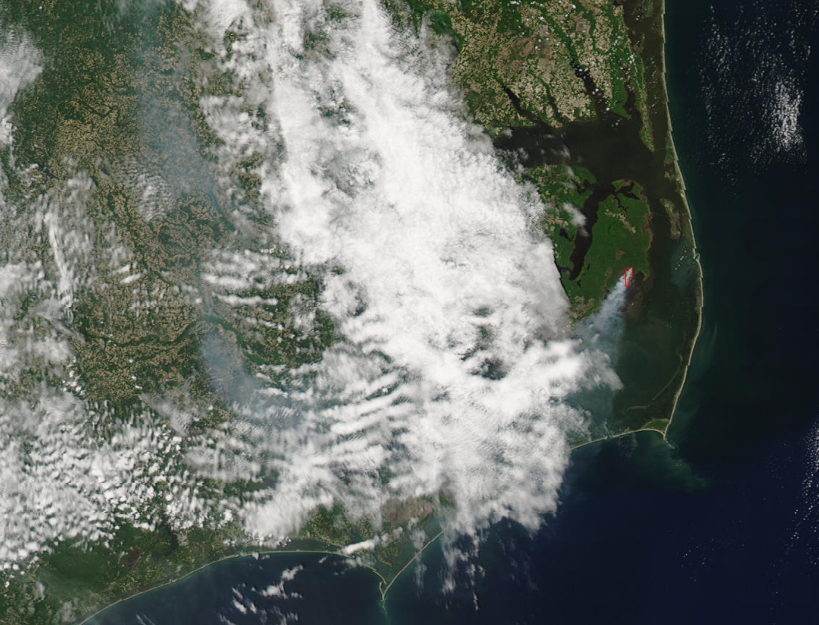
Figure S3. Comparison of cRR between statistical model adjusted for county-level poverty (used in this study) and an un-adjusted (crude) statistical model.
Figure S4. Percent change in ED visits and 95% confidence intervals per 10 µg/m³ rise in wildfire PM_{2.5} for adults, stratified by gender.
