Additional file

Newborn Sex-specific Transcriptome Signatures and Gestational Exposure to Fine Particles: Findings from the ENVIRONAGE Birth Cohort
Ellen Winckelmans, Karen Vrijens, Maria Tsamou, Bram G. Janssen, Nelly D. Saenen, Harry A. Roels, Jos Kleinjans, Wouter Lefebvre, Charlotte Vanpoucke, Theo M. de Kok, Tim S. Nawrot

Table of contents

Tables

Table S1. Descriptive characteristics of the ENVIRONAGE birth cohort participants compared to all births in Flanders (Northern part of Belgium) from 2002-2011.

Table S2. Significant differentially expressed genes by long-term PM_{2.5} exposure in cord blood of girls and boys.
Table S3. Top ten significant genes in cord blood of newborn boys and girls associated with long-term PM_{2.5} exposure.

Table S4. Significant differentially expressed genes by short-term PM_{2.5} exposure in cord blood of girls and boys.
Table S5. Top ten significant genes in cord blood of newborn boys and girls associated with short-term PM_{2.5} exposure.

Figures

Figure S1. Histogram representing the percentage of genes with p-value <0.05 for each variable included in the model.

Figure S2. Principal component analysis plot showing the transcriptomic response to long- and short-term PM_{2.5} exposure in (A, C) girls and (B, D) boys.

Figure S3. Pathways modulated by long-term PM_{2.5} exposure for girls (A) and boys (B) resulting from GSEA.

Figure S4. Pathways modulated by short-term PM_{2.5} exposure for girls (A) and boys (B) resulting from GSEA.

References

Tables

Table S1. Descriptive characteristics of the ENVIRONAGE birth cohort participants compared to all births in Flanders (Northern part of Belgium) from 2002-2011.
Characteristic | ENVIRONAGE subpopulation (n=142) | ENVIRONAGE birth cohort  (n=673)* | Flanders§ (n=606,877)
Maternal
Age, yrs | 29.4 (24.0-34.0) | 29.1 (23.0-35.0) | 29.5 (23.5-35.8)
Education
Low | 10.6 | 11.7 | 13.1
Medium | 35.2 | 36.0 | 40.8
High | 54.2 | 52.3 | 46.1
Parity
1 | 50.0 | 55.9 | 46.9
2 | 40.9 | 34.0 | 34.7
≥3 | 9.2 | 10.1 | 18.4
Newborn
Sex
Boys | 45.8 | 49.8 | 51.4
Ethnicity
European-Caucasian | 87.3 | 88.2 | 87.7
Birth weight, g | 3457 (2910, 4045) | 3419 (2850, 4004) | 3360 (2740, 3965)
Values are percentages or means (10th, 90th percentiles). *from 2010-2014. §(Cox et al. 2013)

Table S2. Significant differentially expressed genes by long-term PM_{2.5} exposure in cord blood of girls and boys.
Gene symbol | Gene name
Up-regulated genes for both sexes
AP3D1 | adaptor-related protein complex 3, delta 1 subunit
C1GALT1 | c core 1 synthase, glycoprotein-N-acetylgalactosamine 3-beta-galactosyltransferase 1
CEP131 | centrosomal protein 131kDa
FBXW8 | F-box and WD repeat domain containing 8
GTF2I | general transcription factor IIi
HECA | hdc homolog, cell cycle regulator
ITGB1 | integrin, beta 1 (fibronectin receptor, beta polypeptide, antigen CD29)
MAST3 | microtubule associated serine/threonine kinase 3
NEAT1 | nuclear paraspeckle assembly transcript 1 (non-protein coding)
NOL10 | nucleolar protein 10
RBM6 | RNA binding motif protein 6
TBC1D31 | TBC1 domain family, member 31
TBL1XR1 | transducin (beta)-like 1 X-linked receptor 1
TPCN1 | two pore segment channel 1
UBXN2A | UBX domain protein 2A
UHMK1 | U2AF homology motif (UHM) kinase 1
UPF2 | UPF2 regulator of nonsense transcripts homolog (yeast)
UTRN | utrophin
ZFC3H1 | zinc finger, C3H1-type containing
Down-regulated genes for both sexes
ART1 | ADP-ribosyltransferase 1
ATG4B | autophagy related 4B, cysteine peptidase
BHLHE23 | basic helix-loop-helix family, member e23
CACNA2D1 | calcium channel, voltage-dependent, alpha 2/delta subunit 1
CACTIN | cactin, spliceosome C complex subunit
CDC42EP5 | CDC42 effector protein (Rho GTPase binding) 5
CHRM1 | cholinergic receptor, muscarinic 1
CYGB | cytoglobin
ESR1 | estrogen receptor 1
HMG20B | high mobility group 20B
IP6K1 | inositol hexakisphosphate kinase 1
KCTD19 | potassium channel tetramerization domain containing 19
KRTAP2-4 | keratin associated protein 2-4
LINC00320 | long intergenic non-protein coding RNA 320
LINC00544 | long intergenic non-protein coding RNA 544
MAP1S | microtubule-associated protein 1S
PRR25 | proline rich 25
PRR36 | proline rich 36
SCGB2B2 | secretoglobin, family 2B, member 2
SNORD25 | small nucleolar RNA, C/D box 25
SORBS3 | sorbin and SH3 domain containing 3
TMEM151B | transmembrane protein 151B
Up-regulated genes for boys, down-regulated for girls
CEACAM7 | carcinoembryonic antigen-related cell adhesion molecule 7
DNAH10 | dynein, axonemal, heavy chain 10
Down-regulated genes for boys, up-regulated for girls
ALKBH2 | alkB homolog 2, alpha-ketoglutarate-dependent dioxygenase
APBA3 | amyloid beta (A4) precursor protein-binding, family A, member 3
BCL11B | B-cell CLL/lymphoma 11B (zinc finger protein)
BEX2 | brain expressed X-linked 2
CD248 | CD248 molecule, endosialin
CD6 | CD6 molecule
CECR5-AS1 | CECR5 antisense RNA 1
CHCHD6 | coiled-coil-helix-coiled-coil-helix domain containing 6
CIAO1 | cytosolic iron-sulfur assembly component 1
DBH-AS1 | DBH antisense RNA 1
EVL | Enah/Vasp-like
FARS2 | phenylalanyl-tRNA synthetase 2, mitochondrial
FBXO32 | F-box protein 32
IL32 | interleukin 32
MCF2L-AS1 | MCF2L antisense RNA 1
PCED1B | PC-esterase domain containing 1B
PLAG1 | pleiomorphic adenoma gene 1
PRPF39 | pre-mRNA processing factor 39
RAB11FIP3 | RAB11 family interacting protein 3 (class II)
RASA4 | RAS p21 protein activator 4
RPUSD3 | RNA pseudouridylate synthase domain containing 3
SEMA4C | sema domain, immunoglobulin domain (Ig), transmembrane domain (TM) and short cytoplasmic domain, (semaphorin) 4C
TESPA1 | thymocyte expressed, positive selection associated 1
THEMIS | thymocyte selection associated
TLDC1 | TBC/LysM-associated domain containing 1
UBQLNL | ubiquilin-like
URB2 | URB2 ribosome biogenesis 2 homolog (S. cerevisiae)
WFS1 | Wolfram syndrome 1 (wolframin)
ZNF32 | zinc finger protein 32
ZNF500 | zinc finger protein 500

Table S3. Top ten significant genes in cord blood of newborn boys and girls associated with long-term PM_{2.5} exposure.
Sex | Gene symbol | Gene name | FC
Girls (p-value <0.0025)
 | CDC42EP5 | CDC42 effector protein (Rho GTPase binding) 5 | 0.85
 | ZNF404 | zinc finger protein 404 | 1.60
 | SLC25A19 | solute carrier family 25 (mitochondrial thiamine pyrophosphate carrier), member 19 | 0.64
 | SMYD3 | SET and MYND domain containing 3 | 1.64
 | THEM4 | thioesterase superfamily member 4 | 1.52
 | ZBTB1 | zinc finger and BTB domain containing 1 | 1.73
 | PRR36 | proline rich 36 | 0.64
 | SNORD108 | small nucleolar RNA, C/D box 108 | 1.65
 | EXOG | endo/exonuclease (5'-3'), endonuclease G-like | 1.28
 | TSPYL2 | TSPY-like 2 | 1.53
Boys (p-value < 0.0001)
 | ZBTB45 | zinc finger and BTB domain containing 45 | 0.80
 | SBDS | Shwachman-Bodian-Diamond syndrome | 1.70
 | C22orf29 | chromosome 22 open reading frame 29 | 0.76
 | HSP90AA2P | heat shock protein 90kDa alpha (cytosolic), class A member 2, pseudogene | 1.51
 | RBM20 | RNA binding motif protein 20 | 0.46
 | HSP90AB1 | heat shock protein 90kDa alpha (cytosolic), class B member 1 | 1.36
 | KLHL34 | kelch-like family member 34 | 0.61
 | ST13 | suppression of tumorigenicity 13 (colon carcinoma) (Hsp70 interacting protein) | 1.44
 | SNORA5B | small nucleolar RNA, H/ACA box 5B | 0.53
 | ROBO2 | roundabout guidance receptor 2 | 0.50
FC: fold change calculated for an increase in PM_{2.5} of 5 µg/m³.

Table S4. Significant differentially expressed genes by short-term PM_{2.5} exposure in cord blood of girls and boys.
Gene symbol | Gene name
Up-regulated genes for both sexes
ANKRD44 | ankyrin repeat domain 44
ARMC8 | armadillo repeat containing 8
ATF4 | activating transcription factor 4
ATP6AP2 | ATPase, H+ transporting, lysosomal accessory protein 2
C1GALT1 | core 1 synthase, glycoprotein-N-acetylgalactosamine 3-beta-galactosyltransferase 1
CHD9 | chromodomain helicase DNA binding protein 9
E4F1 | E4F transcription factor 1
EDRF1 | erythroid differentiation regulatory factor 1
EIF1 | eukaryotic translation initiation factor 1
IL6ST | interleukin 6 signal transducer
LARP1 | La ribonucleoprotein domain family, member 1
MBD1 | methyl-CpG binding domain protein 1
NBPF9 | neuroblastoma breakpoint family, member 9
PBRM1 | polybromo 1
RPS25 | ribosomal protein S25
SRSF1 | serine/arginine-rich splicing factor 1
SRSF11 | serine/arginine-rich splicing factor 11
UBE2K | ubiquitin-conjugating enzyme E2K
UTRN | Utrophin
VPS13C | vacuolar protein sorting 13 homolog C (S. cerevisiae)
Down-regulated genes for both sexes
APBB2 | amyloid beta (A4) precursor protein-binding, family B, member 2
CACTIN | cactin, spliceosome C complex subunit
CNTNAP1 | contactin associated protein 1
CYP4F62P | cytochrome P450, family 4, subfamily F, polypeptide 62, pseudogene
DOCK3 | dedicator of cytokinesis 3
DRAP1 | DR1-associated protein 1 (negative cofactor 2 alpha)
GUF1 | GUF1 homolog, GTPase
HAMP | hepcidin antimicrobial peptide
HIC1 | hypermethylated in cancer 1
HMG20B | high mobility group 20B
IL2RG | interleukin 2 receptor, gamma
KCTD19 | potassium channel tetramerization domain containing 19
KRT7 | keratin 7, type II
KRTAP1-3 | keratin associated protein 1-3
KRTAP2-4 | keratin associated protein 2-4
LINC00320 | long intergenic non-protein coding RNA 320
MAP1S | microtubule-associated protein 1S
MTRNR2L10 | MT-RNR2-like 10
NACAP1 | nascent-polypeptide-associated complex alpha polypeptide pseudogene 1
NUTM2D | NUT family member 2D
PCSK1N | proprotein convertase subtilisin/kexin type 1 inhibitor
PFKL | phosphofructokinase, liver
PIK3CD-AS1 | PIK3CD antisense RNA 1
PRR25 | proline rich 25
PRR36 | proline rich 36
SFTPA2 | surfactant protein A2
TGFA | transforming growth factor alpha
TMEM151B | transmembrane protein 151B
TOMM20L | translocase of outer mitochondrial membrane 20 homolog (yeast)-like
TSHB | thyroid stimulating hormone, beta
TSPAN11 | tetraspanin 11
ZNF205 | zinc finger protein 205
ZNF771 | zinc finger protein 771
Down-regulated genes for boys, up-regulated for girls
CECR5-AS1 | CECR5 antisense RNA 1
KDM5D | lysine (K)-specific demethylase 5D

Table S5. Top ten significant genes in cord blood of newborn boys and girls associated with short-term PM_{2.5} exposure.
Sex | Gene symbol | Gene name | FC
Girls (p-value < 0.0026)
 | ASTN2 | astrotactin 2 | 0.84
 | THOP1 | thimet oligopeptidase 1 | 1.11
 | CDC16 | cell division cycle 16 | 1.22
 | MRPS2 | mitochondrial ribosomal protein S2 | 1.12
 | ZNF404 | zinc finger protein 404 | 1.30
 | TRIM61 | tripartite motif containing 61 | 1.21
 | PRP36 | proline Rich Protein 36 | 0.75
 | MRPS25 | mitochondrial ribosomal protein S25 | 1.15
 | NACAP1 | nascent-polypeptide-associated complex alpha polypeptide pseudogene 1 | 0.72
 | SRSF6 | serine/arginine-rich splicing factor 6 | 1.19
Boys (p-value < 0.0014)
 | MTRNR2L3 | MT-RNR2-like 3 | 0.75
 | AVL9 | AVL9 homolog (S. cerevisiase) | 1.30
 | TNP2 | transition protein 2 (during histone to protamine replacement) | 0.82
 | MTRNR2L7 | MT-RNR2-like 7 | 0.78
 | ADAM11 | ADAM metallopeptidase domain 11 | 0.73
 | POTEF | POTE ankyrin domain family, member F | 1.17
 | ITGB1 | integrin, beta 1 (fibronectin receptor, beta polypeptide, antigen CD29 includes MDF2, MSK12) | 1.14
 | NRG4 | neuregulin 4 | 0.69
 | MTRNR2L10 | MT-RNR2-like 10 | 0.76
 | HYALP1 | hyaluronoglucosaminidase pseudogene 1 | 0.63
FC: fold change calculated for an increase in PM_{2.5} of 10 µg/m³.

Figures

Figure S1. Histogram representing the percentage of genes with p-value <0.05 for each variable included in the model.

Figure S2. Principal component analysis plot showing the transcriptomic response to long- and short-term PM_{2.5} exposure in (A, C) girls and (B, D) boys.
The plot is based on the PM_{2.5} modulated genes (p-value<0.05). A color gradient (dark-light) represent the level of PM_{2.5} exposure (low-high). PC: principal component.

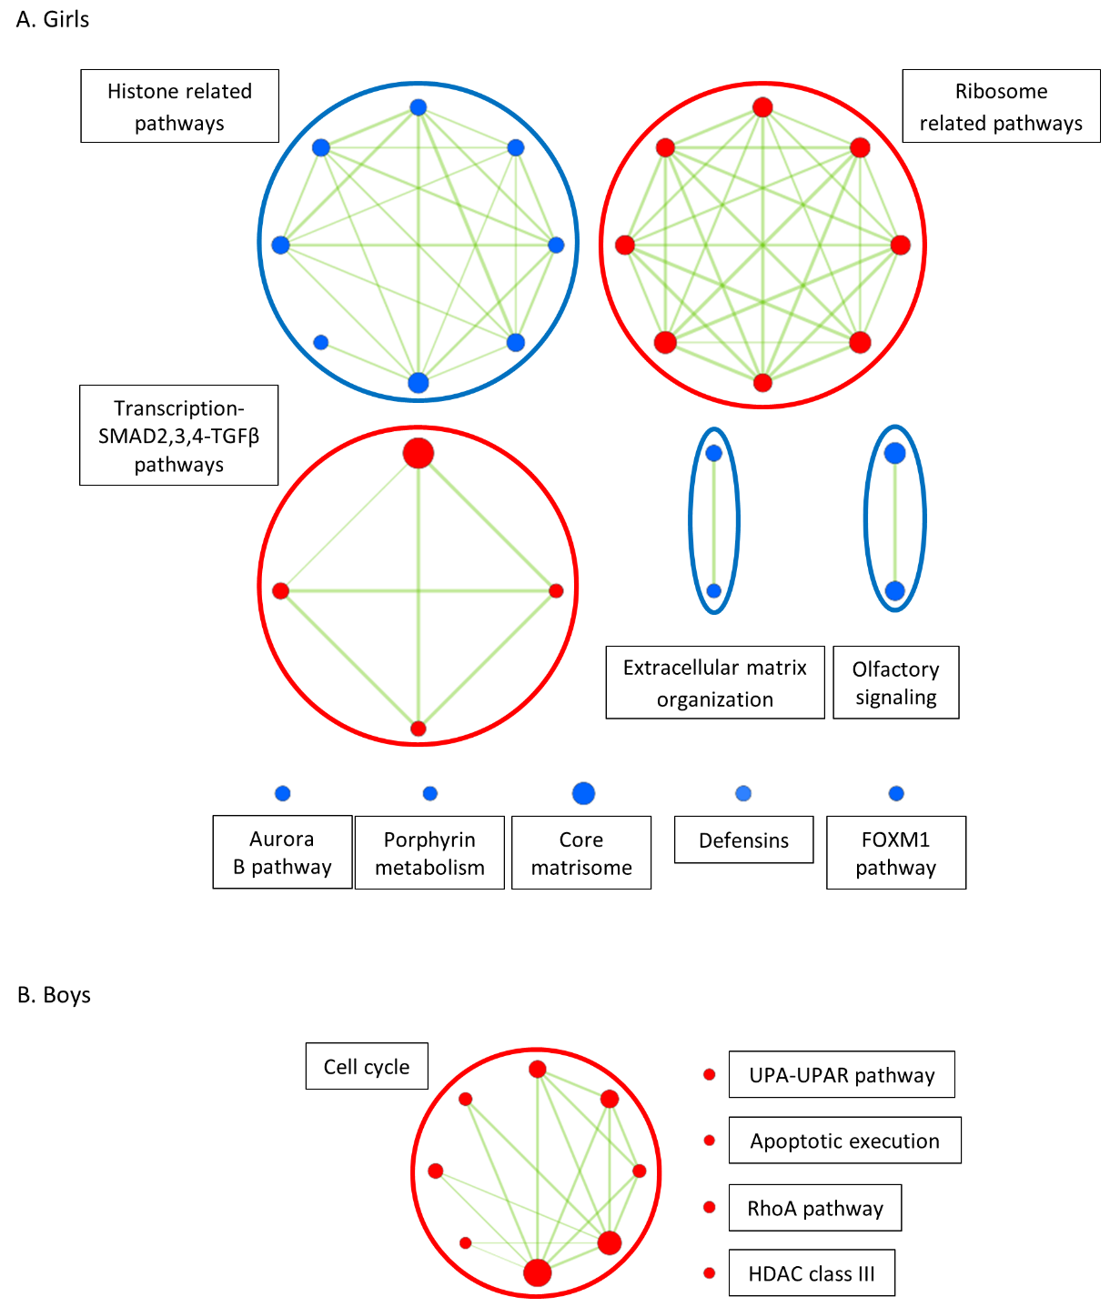
Figure S3. Pathways modulated by long-term PM_{2.5} exposure for girls (A) and boys (B) resulting from GSEA.
The size of the nods represents the size of the pathway. Related pathways are encircled, assigned a label, and connected by green lines, representing common genes between pathways. Up-regulated and down-regulated pathways are given in red and blue, respectively. uPAR: Urokinase-type plasminogen activator (uPA) receptor, HDAC: histone deacetylase, FOXM1: forkhead box M1, RhoA: Ras homolog gene family member A.
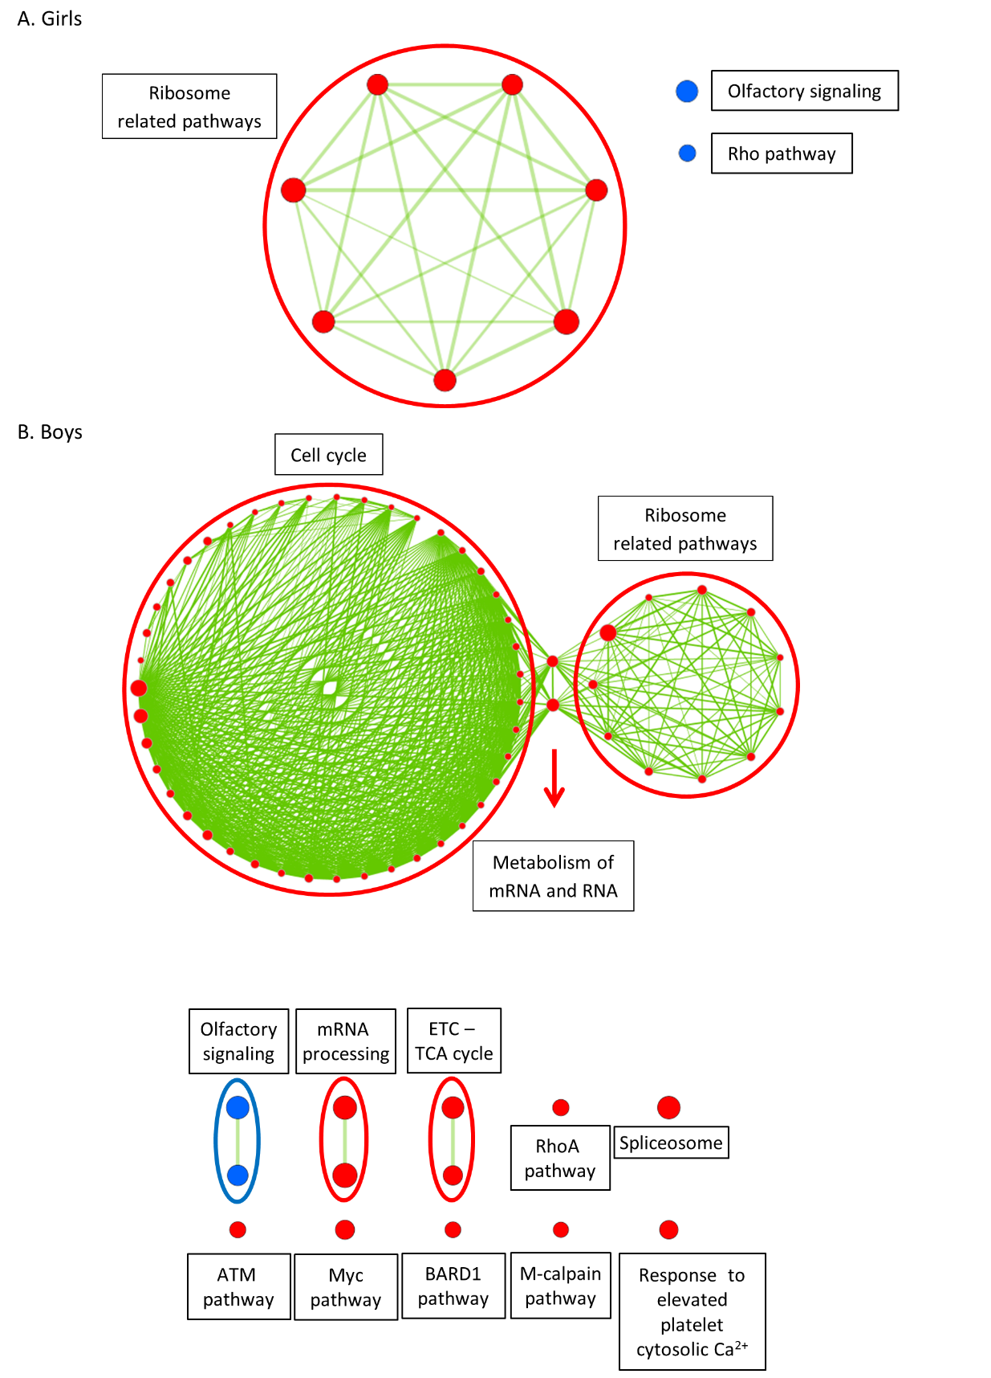
Figure S4. Pathways modulated by short-term PM_{2.5} exposure for girls (A) and boys (B) resulting from GSEA.
The size of the nods represents the size of the pathway. Related pathways are encircled, assigned a label, and connected by green lines, representing common genes between pathways. Up-regulated and down-regulated pathways are given in red and blue, respectively. Rho: Ras Homolog gene family, TCA: tricarboxylic acid, ETC: electron transport chain, ATM: Ataxia Telangiectasia Mutated, BARD1: BRCA1 associated RING domain 1. Myc: v-myc avian myelocytomatosis viral oncogene homolog.
References
Cox B, Martens E, Nemery B, Vangronsveld J, Nawrot TS. 2013. Impact of a stepwise introduction of smoke-free legislation on the rate of preterm births: Analysis of routinely collected birth data. Bmj 346:f441.

