Additional file 1

Prenatal and postnatal bisphenol A exposure and social impairment in 4-year-old children
Youn-Hee Lim^{1,2}, Sanghyuk Bae³, Bung-Nyun Kim⁴, Choong Ho Shin⁵, Young Ah Lee⁵, Johanna Inhyang Kim⁴, Yun-Chul Hong^{1,2,6,}*

¹Institute of Environmental Medicine, Seoul National University Medical Research Center, Seoul, Republic of Korea
²Environmental Health Center, Seoul National University College of Medicine, Seoul, Republic of Korea
³Department of Preventive Medicine, Dankook University, Cheonan, Republic of Korea
⁴Division of children and Adolescent Psychiatry, Department of Psychiatry, Seoul National University Hospital, Seoul, Republic of Korea
⁵Department of Pediatrics, Seoul National University Children’s Hospital, Seoul, Republic of Korea
⁶Department of Preventive Medicine, Seoul National University College of Medicine, Seoul, Republic of Korea

*Address correspondence to Yun-Chul Hong, Institute of Environmental Medicine, Seoul National University Medical Research Center, 103 Daehakro, Jongno-Gu, Seoul 110-799, Republic of Korea
Telephone: +82-2-740-8394; Fax: +82-2-747-4830; E-mail: ychong1@snu.ac.kr

Table of Contents

Tables & Figures
Figure S1. Selection of study participants 3
Table S1. Characteristics of mothers included and excluded in the follow-up of the Birth cohort (N=10,752) 4
Table S2. Characteristics of participants included and excluded in the study 5
Table S3. Percentage change in scores on the K-SCQ associated with 2-fold increase in creatinine-unadjusted prenatal and postnatal BPA levels 7
Table S4. Percentage change in scores on the K-SCQ associated with 2-fold increase in creatinine-adjusted prenatal and postnatal BPA levels after controlling for covariates 8
Figure S2. Percentage change in scores on the K-SCQ associated with 2-fold increase at or above level of creatinine-adjusted prenatal Bisphenol A (3.0 μg/g creatinine) by sex 9

Figure S1. Selection of study participants
- Flow chart of selection
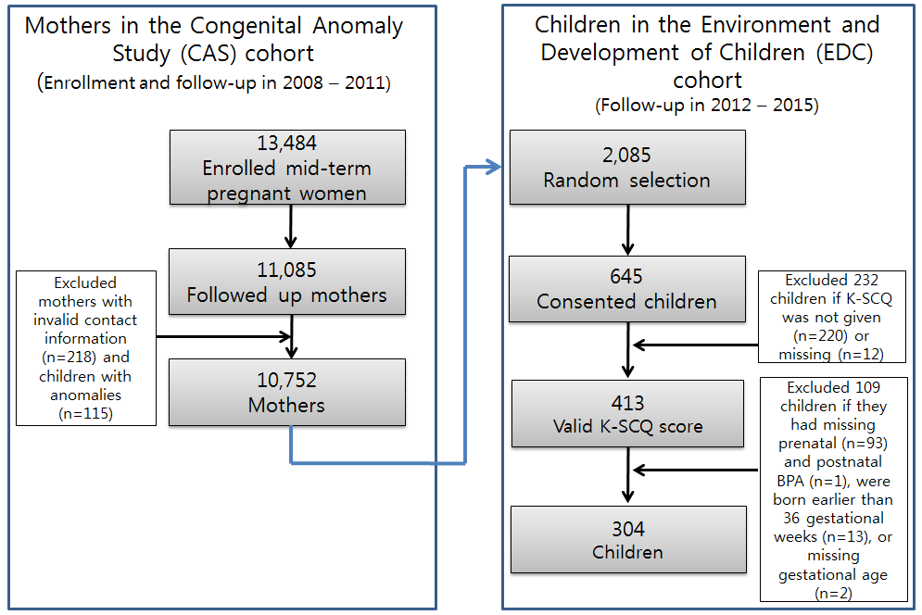
(b) Number of followed-up children in the EDC cohort by birth year
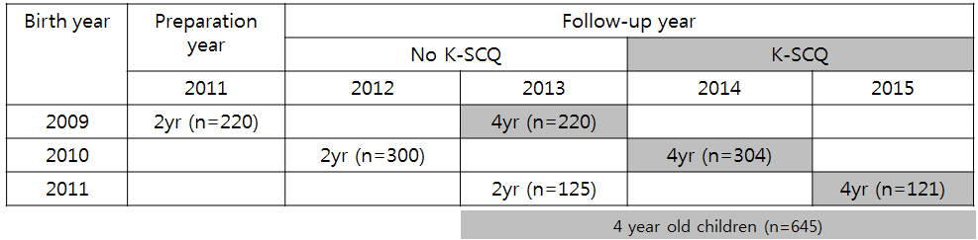

Table S1. Characteristics of mothers included and excluded in the follow-up of the Birth cohort (N=10,752)
Variables | Mean ± SD, n(%) |  |  | P-value
Variables | Overall (n=10,752) | Inclusion (n=615) | Exclusion (n=10,137) | P-value
Mother age (Years) | 30.6 ± 3.5 | 31.2 ± 3.6 | 30.6 ± 3.5 | <.0001
Gestational age (Weeks) | 39.3 ± 3.2 | 39.2 ± 1.4 | 39.3 ± 3.3 | 0.0227
Twin+ | 191 (1.8) | 24 (3.9) | 167 (1.7) | <.0001
Smoking during pregnancy | 589 (5.6) | 7 (1.2) | 284 (2.8) | 0.0175
Drinking alcohol during pregnancy | 2283 (21.9) | 28 (1.2) | 262 (3.2) | <.0001

Table S2. Characteristics of participants included and excluded in the study
Variables | Mean ± SD,  n (%) |  |  | P-value
Variables | Overall (n=645) | Inclusion (n=304) | Exclusion (n=341) | P-value
Maternal information
Mother age (Years) | 31.2 ± 3.6 | 31.2 ± 3.6 | 31.3 ± 3.6 | 0.8359
Gestational age (Weeks) | 39.0 ± 1.6 | 39.23 ± 1.19 | 38.85 ± 1.80 | 0.0019
Smoking at pregnancy | 590 (5.6) | 7 (2.4) | 583 (5.6) | 0.0132
Alcohol drink at pregnancy | 2285 (21.9) | 28 (9.7) | 2257 (22.2) | <.0001
Mother's education |  |  |  | 0.5404
> high school | 528 (81.9) | 252 (82.9) | 276 (80.9)
≤ high school | 117 (18.1) | 52 (17.1) | 65 (19.1)
Prenatal BPA (μg/L) | 1.7 ± 2.6 | 1.7 ± 2.4 | 1.8 ± 2.9 | 0.7268
Maternal creatinine (μg/L) | 86.9 ± 50.6 | 87.9 ± 50.3 | 85.6 ± 50.9 | 0.6090
Creatinine-adjusted prenatal BPA  (μg/g creatinine) | 2.0 ± 2.6 | 2.0 ± 2.1 | 2.1 ± 3.1 | 0.6993
Children’s information
Child age (Months) | 47.9 ± 1.8 | 47.7 ± 2.1 | 48.0 ± 1.4 | 0.0270
Sex
Boy | 338 (52.4) | 160 (52.6)
Girl | 307 (47.6) |  | 163 (47.8)
Body mass index (kg/m²) | 15.6 ± 1.3 | 15.7 ± 1.3 | 15.5 ± 1.3 | 0.0230
Parity |  |  |  | 0.9371
First child | 366 (56.8) | 177 (58.2) | 189 (55.6)
Second + | 278 (43.2) | 127 (41.8) | 151 (44.4)
Secondhand smoking |  |  |  | 0.5243
No | 484 (75.0) | 221 (72.7) | 263 (77.1)
Yes | 161 (25.0) | 83 (27.3) | 78 (22.9)
BPA at age 4 years (μg/L) | 3.8 ± 5.7 | 3.2 ± 5.0 | 4.3 ± 6.2 | 0.0183
Creatinine (μg/L) | 73.0 ± 35.1 | 72.1 ± 34.9 | 73.8 ± 35.3 | 0.5383
Creatinine-adjusted BPA at age 4 years (μg/g creatinine) | 5.0 ± 5.1 | 4.9 ± 10.8 | 5.7 ± 5.5 | 0.0006
K-SCQ- Total | 4.4 ± 3.1 | 4.3 ± 3.1 | 4.4 ± 3.2 | 0.9607
K-SCQ- Social interaction | 1.1 ± 1.2 | 1.1 ± 1.2 | 1.2 ± 1.3 | 0.2859
K-SCQ- Communication | 1.7 ± 1.4 | 1.7 ± 1.4 | 1.8 ± 1.5 | 0.6769
K-SCQ- Social interaction | 1.4 ± 1.6 | 1.38 ± 1.68 | 1.48 ± 1.42 | 0.5686
Abbreviations: SD, standard deviation; BPA, Bisphenol A; K-SCQ, Korean version of the Social Communication Questionnaire
Table S3. Percentage change in scores on the K-SCQ associated with 2-fold increase in creatinine-unadjusted prenatal and postnatal BPA levels
 | Subcategory of SCQ score | Prenatal BPA |  |  | Postnatal PBA
 | Subcategory of SCQ score | % change (95% CI) | P-value | P-value for sexual difference | % change (95% CI) | P-value | P-value for sexual difference
Total | Overall | 3.7 (-0.5, 8.1)# | 0.0814 | 0.1397 | -1.1 (-5.2, 3.3) | 0.6222 | 0.0911
 | Male | 4.6 (-0.7, 10.1)# | 0.0915 |  | -6.0 (-11.1, -0.7)* | 0.0283
 | Female | 2.4 (-4.4, 9.7) | 0.4914 |  | 4.6 (-2.2, 11.9) | 0.1910
Social interaction | Overall | -0.2 (-8.0, 8.4) | 0.9701 | 0.3776 | -5.6 (-13.1, 2.5) | 0.1693 | 0.7291
 | Male | -2.0 (-11.2, 8.1) | 0.6864 |  | -7.5 (-17.0, 3.0) | 0.1570
 | Female | 6.0 (-8.0, 22.2) | 0.4209 |  | -7.0 (-18.8, 6.6) | 0.2966
Social communication | Overall | 3.4 (-3.3, 10.6) | 0.3234 | 0.3899 | 2.0 (-4.9, 9.4) | 0.5760 | 0.2657
 | Male | 6.4 (-2.5, 16.0) | 0.1654 |  | -5.3 (-13.7, 3.8) | 0.2440
 | Female | -0.3 (-10.3, 10.9) | 0.9620 |  | 11.8 (0.5, 24.4)* | 0.0396
Behavior | Overall | 6.7 (-0.8, 14.8)# | 0.0819 | 0.3620 | -0.8 (-8.1, 7.0) | 0.8289 | 0.0504
 | Male | 7.8 (-1.5, 18.1) | 0.1034 |  | -6.7 (-15.2, 2.6) | 0.1507
 | Female | 3.1 (-8.9, 16.7) | 0.6286 |  | 6.0 (-6.1, 19.6) | 0.3455
Abbreviations: K-SCQ, Korean version of the Social Communication Questionnaire; BPA, Bisphenol A; CI, confidence interval
Models were adjusted for gender (boy or girl), parity (1st vs. other), mother’s education (high school or lower vs. more than high school), birth weight (kg), use of plastic dishes in the microwave oven (yes or no), and maternal and postnatal creatinine. In addition, creatinine-unadjusted prenatal and postnatal BPA levels were mutually controlled for in the model.
* P-value < 0.05; # P-value <0.1

Table S4. Percentage change in scores on the K-SCQ associated with 2-fold increase in creatinine-adjusted prenatal and postnatal BPA levels after controlling for covariates
Covariates | Sample size (n) | % change (95% CI)
Covariates | Sample size (n) | Prenatal BPA |  | Postnatal BPA
Covariates | Sample size (n) | Model 1 | Model 2 | Model 1 | Model 2
Maternal age | 304 | 3.4 (-0.8, 7.7) | 3.4 (-0.8, 7.7) | -1.0 (-5.1, 3.3) | -0.8 (-5.0, 3.5)
Gestational age | 304 | 3.4 (-0.8, 7.7) | 3.4 (-0.7, 7.8) | -1.0 (-5.1, 3.3) | -1.2 (-5.4, 3.1)
Smoking during pregnancy | 279 | 2.9 (-1.3, 7.3) | 2.1 (-2.2, 6.7) | -2.4 (-6.8, 2.2) | -3.4 (-7.8, 1.3)
Drinking alcohol during pregnancy | 290 | 2.9 (-1.3, 7.3) | 2.8 (-1.5, 7.2) | -2.4 (-6.8, 2.2) | -2.7 (-7.0, 1.9)
Mother's depression | 242 | 6.8 (2.0, 11.9) | 6.9 (2.0, 12.0) | -2.5 (-6.9, 2.2) | -2.7 (-7.2, 2.0)
Child's age | 304 | 3.4 (-0.8, 7.7) | 3.4 (-0.8, 7.8) | -1.0 (-5.1, 3.3) | -1.2 (-5.4, 3.1)
Infant feeding type | 223 | 8.6 (3.5, 13.9) | 8.8 (3.7, 14.3) | -2.7 (-7.0, 1.8) | -2.9 (-7.3, 1.6)
Body mass index | 304 | 3.4 (-0.8, 7.7) | 3.4 (-0.8, 7.7) | -1.0 (-5.1, 3.3) | -1.0 (-5.1, 3.3)
Secondhand Smoke | 304 | 3.4 (-0.8, 7.7) | 3.3 (-0.9, 7.6) | -1.0 (-5.1, 3.3) | -1.0 (-5.2, 3.3)
Place of childcare | 269 | 4.0 (-0.5, 8.6) | 4.0 (-0.5, 8.6) | -0.6 (-4.9, 3.9) | -0.6 (-5.0, 3.9)
Canned food or drinks | 304 | 3.4 (-0.8, 7.7) | 3.3 (-0.8, 7.7) | -1.0 (-5.1, 3.3) | -1.0 (-5.1, 3.3)
Instant rice | 304 | 3.4 (-0.8, 7.7) | 3.1 (-1.1, 7.4) | -1.0 (-5.1, 3.3) | -1.0 (-5.2, 3.3)
Abbreviations: K-SCQ, Korean version of the Social Communication Questionnaire; BPA, Bisphenol A; CI, confidence interval
Model 1 was adjusted for gender (boy or girl), parity (1st vs. other), mother’s education (high school or lower vs. more than high school), birth weight (kg), and use of plastic dishes in the microwave oven (yes or no). In addition, creatinine-adjusted maternal and postnatal BPAs were mutually controlled for in the model.
Model 2 was additionally adjusted for one of the potential covariates (maternal age, gestational age, smoking and drinking alcohol during pregnancy, mother’s depression, child age, infant feeding type, body mass index, secondhand smoke, place of childcare, canned food or drinks, and instant rice).

Figure S2. Percentage change in scores on the K-SCQ associated with 2-fold increase at or above level of creatinine-adjusted prenatal Bisphenol A (3.0 μg/g creatinine) by sex
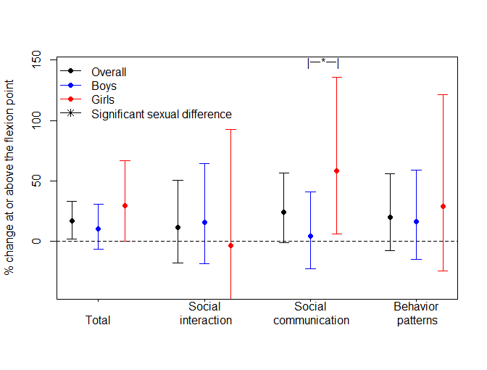
Abbreviations: K-SCQ, Korean version of the Social Communication Questionnaire; BPA, Bisphenol A
* Statistically significant at α=0.1; vertical lines represent confidence intervals.
Models were adjusted for gender (boy or girl), parity (1st vs. other), mother’s education (high school or lower vs. more than high school), birth weight (kg), use of plastic dishes in the microwave oven (yes or no), and postnatal BPA levels.

