Figure S1. AGD index and AGD (Mean per litter) box plot (A) and dot plot (B)
AGD INDEX FEMALE BOX PLOT  A | AGD INDEX MALE BOX PLOT
AGD FEMALE BOX PLOT | AGD MALE BOX PLOT
Group I: Control; II: Glyphosate; III: Roundup
AGD INDEX FEMALE DOT PLOT  B  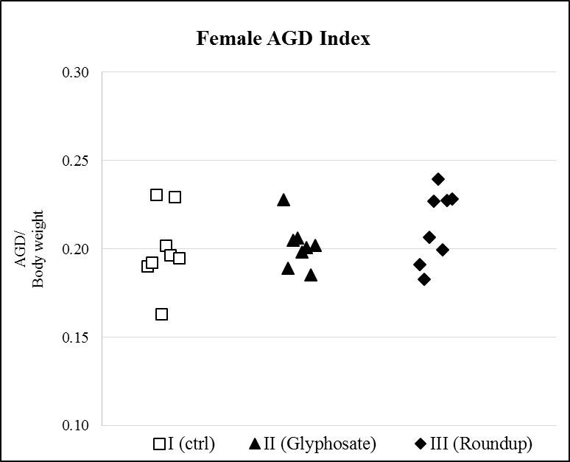 | AGD INDEX MALE DOT PLOT  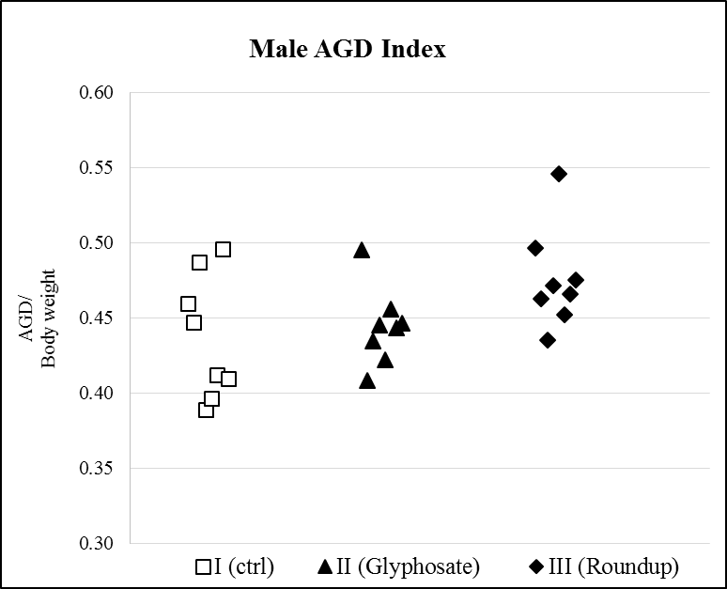
AGD FEMALE DOT PLOT  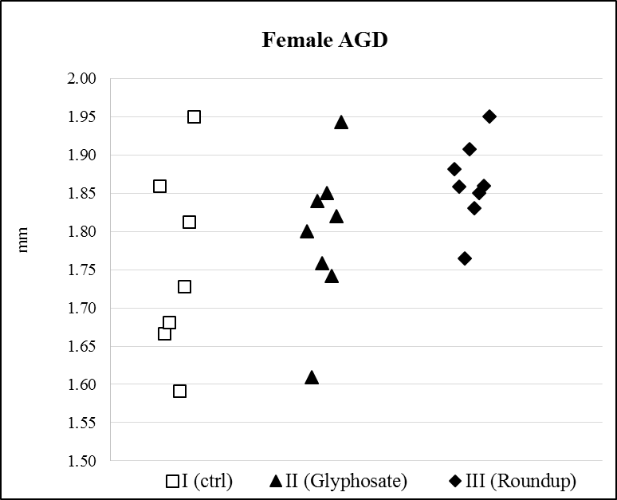 | AGD MALE DOT PLOT  