Figure S10: Single chemical curves
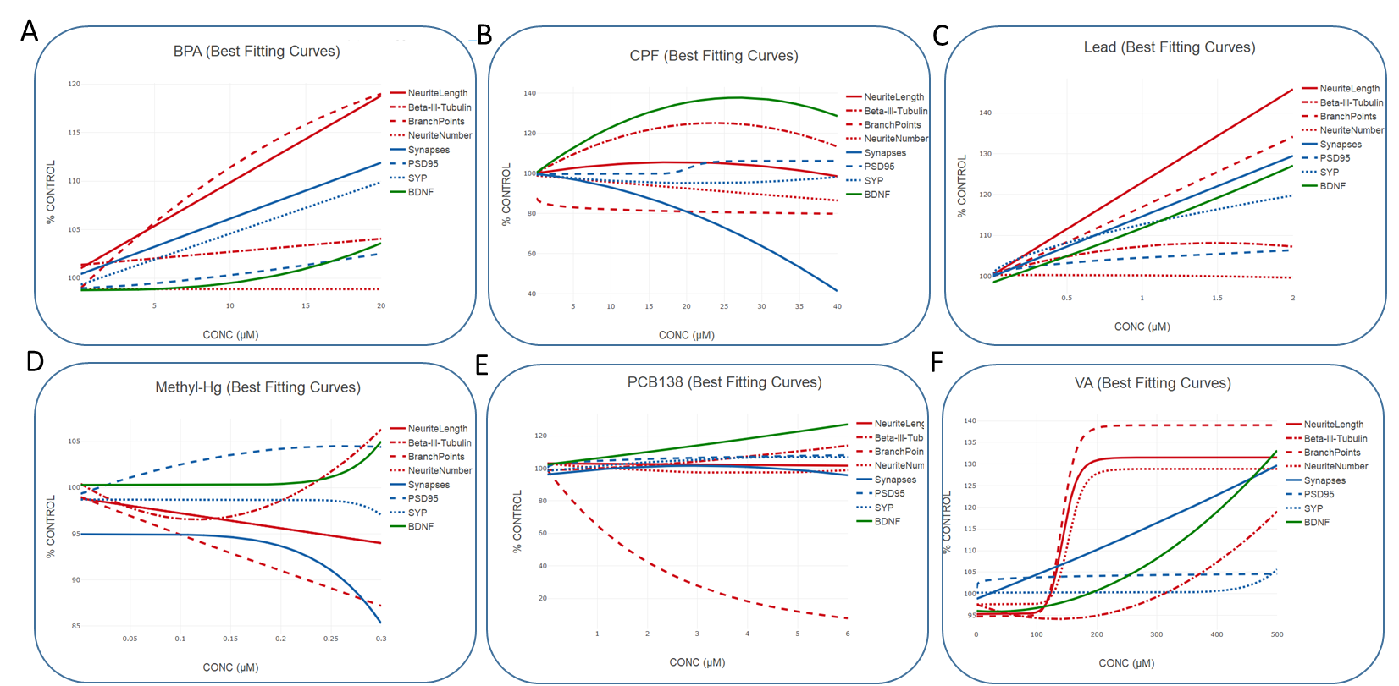

Table S3: BMDs for synaptogenesis
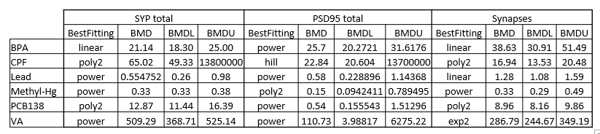
Table S4: BMDs for β-III-tubulin⁺ cell percentage and neurite outgrowth
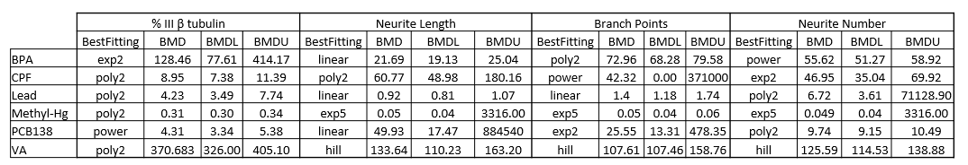
Table S5: BMDs for BDNF levels
