Supplementary Table 1. Search strategy
No | Search term | Pubmed | Embase | Web of Science
#1 | (air pollutant*) or (air pollution*) or (air qualit*) | 132,727 | 143,025 | 177,045
#2 | (particulate matter*) or (fine particulate*) or (fine particle*) or (coarse particulate*) or (coarse particle*) | 31,087 | 119,971 | 72,841
#3 | (nitrogen dioxide) or (nitrogen oxide*) | 24,533 | 83,213 | 56,671
#4 | (ozone) | 23,087 | 62,409 | 36,238
#5 | (sulfur dioxide) or (sulphur dioxide) or (sulfurous anhydride) or (sulphurous anhydride) | 9,312 | 18,382 | 19,818
#6 | (carbon monoxide) | 35,866 | 59,041 | 51,891
#7 | #1 or #2 or #3 or #4 or #5 or #6 | 204,544 | 410,633 | 329,593
#8 | (pneumonia*) | 204,857 | 149,098 | 395,526
#9 | (lower respiratory infection*) or (lower respiratory tract infection*) | 7,605 | 23,018 | 42,743
#10 | #8 or #9 | 209,608 | 165,457 | 424,570
#11 | (hospitalization*) or (hospitalisation*) or (admission*) or (hospital visit*) or (emergency visit*) | 403,428 | 307,679 | 997,149
#12 | #10 and #11 | 19,578 | 18,105 | 58,417
#13 | #7 and #12 | 222 | 379 | 733

Supplementary Table 2. Meta-analyses of association between air pollutants and hospital admission or emergency room visit for pneumonia in the same lag day.
Components | Lag day | Number of studies | Odds ratio | Lower 95% CI | Higher 95% CI | I²
PM_{2.5} | Lag 0 | 14 | 1.0045 | 1.0020 | 1.0070 | 12.9%
 | Lag 1 | 13 | 1.0044 | 1.0002 | 1.0087 | 53.0%
 | Lag 2 | 13 | 1.0043 | 1.0015 | 1.0072 | 19.6%
 | Lag 3 | 11 | 1.0100 | 1.0042 | 1.0159 | 43.9%
 | Lag 4 | 8 | 1.0070 | 1.0011 | 1.0129 | 56.7%
 | Lag 5 | 7 | 1.0073 | 1.0018 | 1.0129 | 46.3%
PM₁₀ | Lag 0 | 9 | 1.0026 | 1.0014 | 1.0039 | 20.9%
 | Lag 1 | 9 | 1.0021 | 1.0007 | 1.0035 | 24.8%
 | Lag 2 | 8 | 1.0021 | 1.0012 | 1.003 | 0.0%
 | Lag 3 | 6 | 1.0040 | 1.0014 | 1.0067 | 0.0%
 | Lag 4 | 5 | 1.0029 | 1.0002 | 1.0056 | 0.0%
 | Lag 5 | 5 | 1.0043 | 1.0024 | 1.0063 | 0.0%
SO₂ | Lag 0 | 6 | 0.9970 | 0.9612 | 1.0341 | 34.0%
 | Lag 1 | 6 | 1.0175 | 0.9877 | 1.0483 | 35.2%
 | Lag 2 | 7 | 1.0191 | 0.9926 | 1.0464 | 43.0%
 | Lag 3 | 6 | 1.0135 | 0.9859 | 1.0418 | 35.1%
 | Lag 4 | 5 | 1.0050 | 0.9916 | 1.0184 | 0.0%
 | Lag 5 | 4 | 1.0013 | 0.9754 | 1.0279 | 22.4%
NO₂ | Lag 0 | 7 | 1.0150 | 1.0031 | 1.0271 | 5.0%
 | Lag 1 | 7 | 1.0091 | 0.9951 | 1.0232 | 16.0%
 | Lag 2 | 8 | 1.0209 | 1.0006 | 1.0416 | 52.7%
 | Lag 3 | 7 | 1.0111 | 0.9973 | 1.0251 | 18.1%
 | Lag 4 | 6 | 1.0132 | 0.9917 | 1.0352 | 52.3%
 | Lag 5 | 5 | 1.0213 | 0.9997 | 1.0434 | 48.9%
CO | Lag 0 | 6 | 1.3106 | 0.9315 | 1.8441 | 82.0%
 | Lag 1 | 6 | 1.2037 | 1.0197 | 1.4209 | 30.5%
 | Lag 2 | 6 | 1.1309 | 0.9266 | 1.3802 | 47.9%
 | Lag 3 | 6 | 1.1848 | 0.9536 | 1.472 | 55.3%
 | Lag 4 | 5 | 1.1668 | 0.8445 | 1.6119 | 70.5%
 | Lag 5 | 4 | 1.2977 | 1.0075 | 1.6715 | 9.2%
O₃ | Lag 0 | 8 | 1.0072 | 0.9977 | 1.0168 | 90.1%
 | Lag 1 | 8 | 1.0019 | 0.9979 | 1.0059 | 48.1%
 | Lag 2 | 6 | 0.9992 | 0.9818 | 1.0169 | 9.6%
 | Lag 3 | 6 | 0.9982 | 0.9827 | 1.0140 | 0.0%
 | Lag 4 | 4 | 0.9898 | 0.9693 | 1.0108 | 21.2%
 | Lag 5 | 4 | 0.9939 | 0.9640 | 1.0248 | 51.0%
Values in bold are statistically significant.

Supplementary Figure 1. Funnel plot of association between air pollutants and hospital admission or emergency room visit for pneumonia.
Supplementary Figure 1a. Funnel plot of association between PM_{2.5} and hospital admission or emergency room visit for pneumonia.
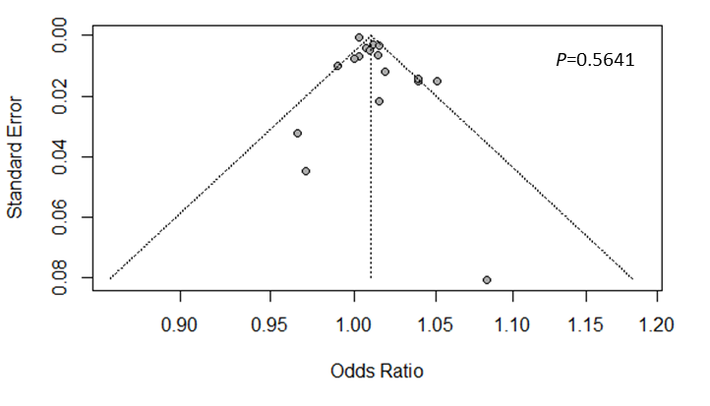

Supplementary Figure 1b. Funnel plot of association between PM₁₀ and hospital admission or emergency room visit for pneumonia.
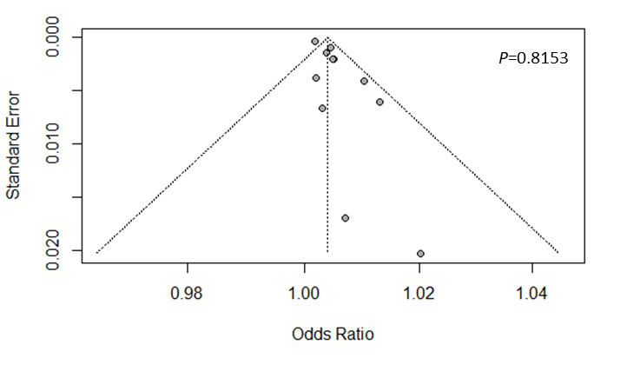

Supplementary Figure 1c. Funnel plot of association between SO₂ and hospital admission or emergency room visit for pneumonia.
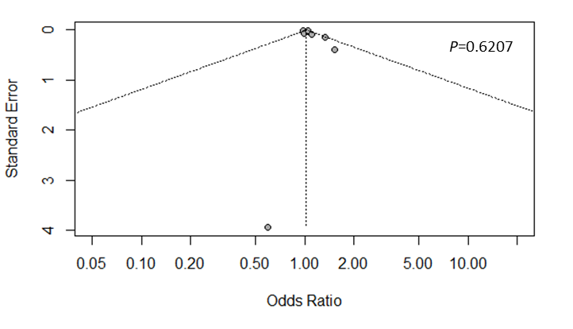

Supplementary Figure 1d. Funnel plot of association between NO₂ and hospital admission or emergency room visit for pneumonia.
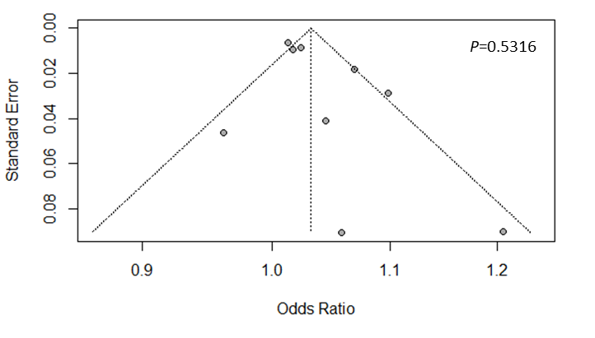

Supplementary Figure 1e. Funnel plot of association between CO and hospital admission or emergency room visit for pneumonia.
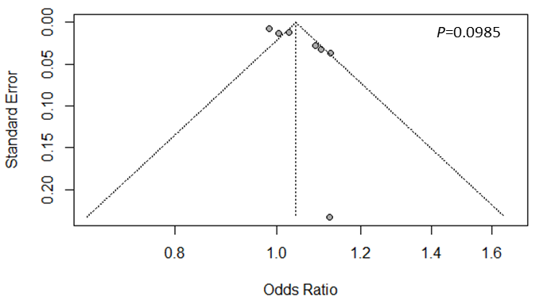

Supplementary Figure 1f. Funnel plot of association between O₃ and hospital admission or emergency room visit for pneumonia.
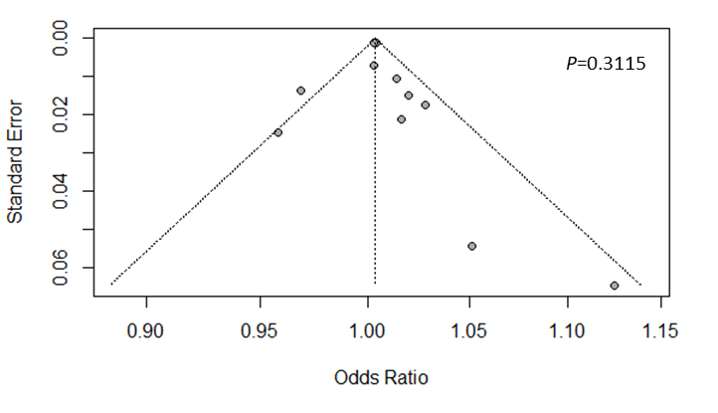

Supplementary Figure 2. Subgroup analysis by region for the association between air pollutants and hospital admission or emergency room visit for pneumonia.
Supplementary Figure 2a. Subgroup analysis by region for the association between PM_{2.5} and hospital admission or emergency room visit for pneumonia.
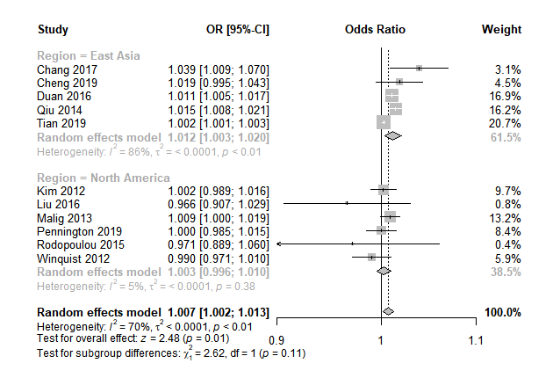

Supplementary Figure 2b. Subgroup analysis by region for the association between PM₁₀ and hospital admission or emergency room visit for pneumonia.
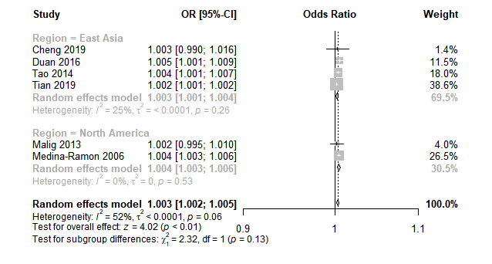
Supplementary Figure 2c. Subgroup analysis by region for the association between O₃ and hospital admission or emergency room visit for pneumonia.
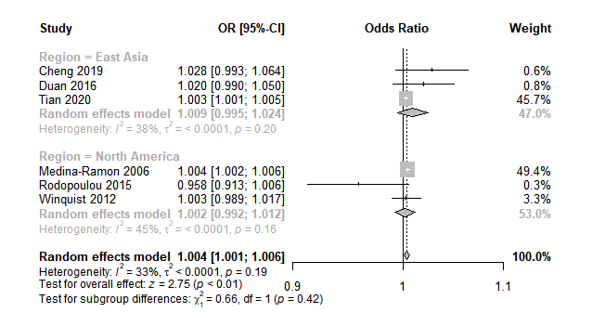

Supplementary Figure 3. Subgroup analysis by study design for the association between air pollutants and hospital admission or emergency room visit for pneumonia.
Supplementary Figure 3a. Subgroup analysis by study design for the association between PM_{2.5} and hospital admission or emergency room visit for pneumonia.
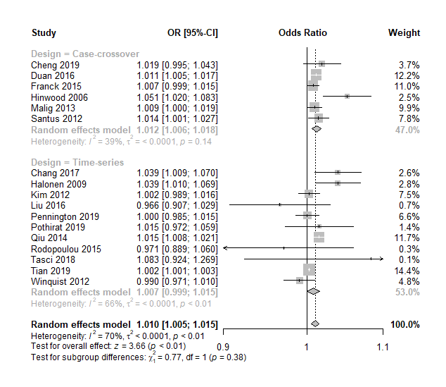

Supplementary Figure 3b. Subgroup analysis by study design for the association between PM₁₀ and hospital admission or emergency room visit for pneumonia.
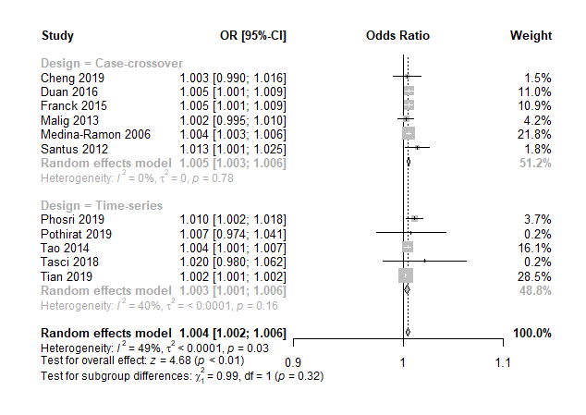
Supplementary Figure 3c. Subgroup analysis by study design for the association between SO₂ and hospital admission or emergency room visit for pneumonia.
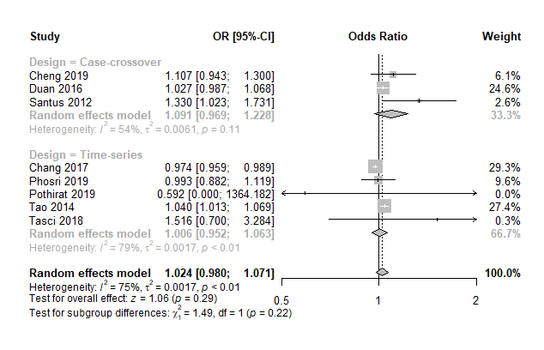
Supplementary Figure 3d. Subgroup analysis by study design for the association between NO₂ and hospital admission or emergency room visit for pneumonia.
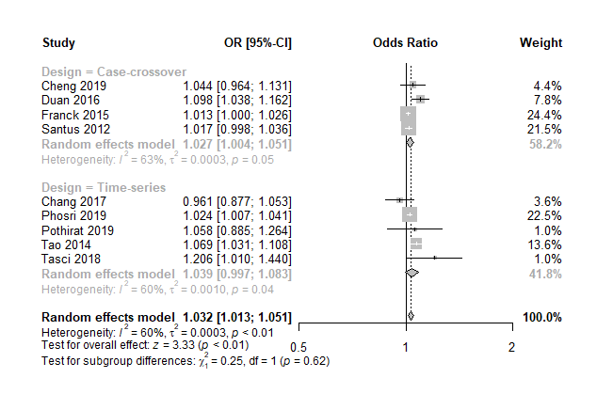
Supplementary Figure 3e. Subgroup analysis by study design for the association between CO and hospital admission or emergency room visit for pneumonia.
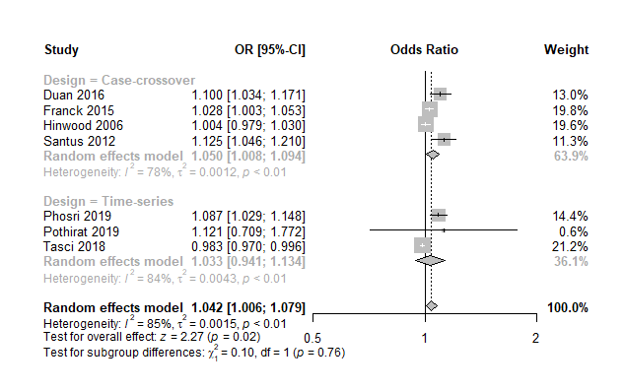

Supplementary Figure 3f. Subgroup analysis by study design for the association between O₃ and hospital admission or emergency room visit for pneumonia.
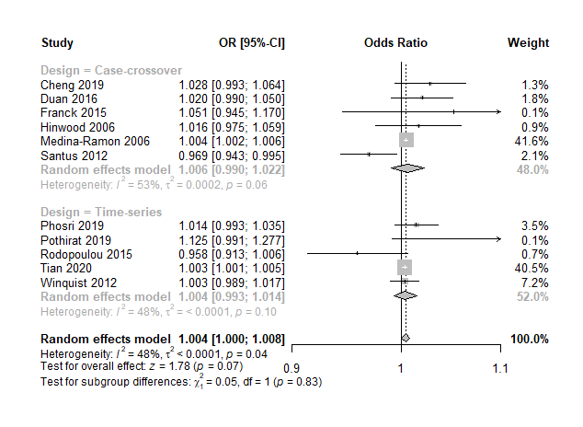

Supplementary Figure 4. Subgroup analysis by study quality for the association between air pollutants and hospital admission or emergency room visit for pneumonia.
Supplementary Figure 4a. Subgroup analysis by study quality for the association between PM_{2.5} and hospital admission or emergency room visit for pneumonia.
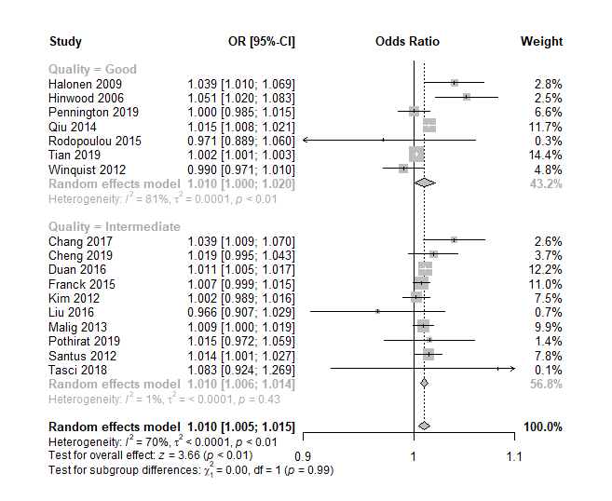

Supplementary Figure 4b. Subgroup analysis by study quality for the association between PM₁₀ and hospital admission or emergency room visit for pneumonia.
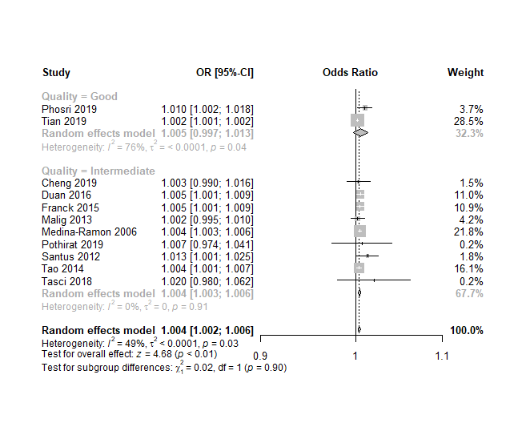

Supplementary Figure 4c. Subgroup analysis by study quality for the association between SO₂ and hospital admission or emergency room visit for pneumonia.
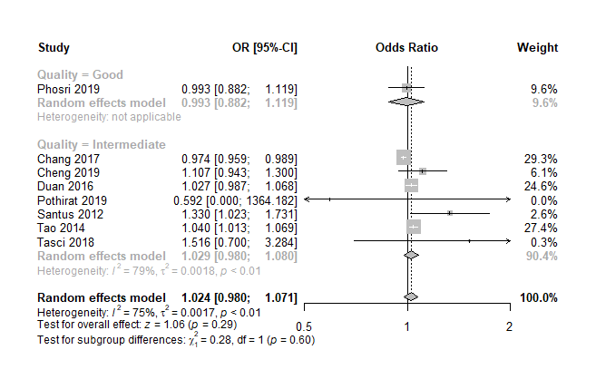

Supplementary Figure 4d. Subgroup analysis by study quality for the association between NO₂ and hospital admission or emergency room visit for pneumonia.
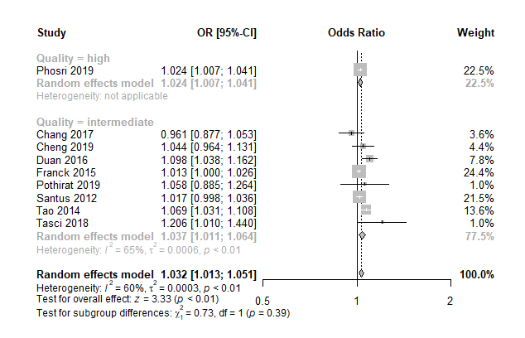
Supplementary Figure 4e. Subgroup analysis by study quality for the association between CO and hospital admission or emergency room visit for pneumonia.
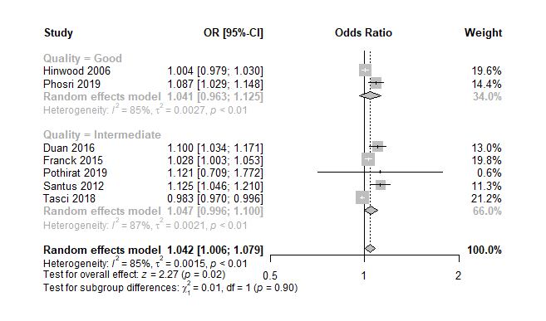

Supplementary Figure 4f. Subgroup analysis by study quality for the association between O₃ and hospital admission or emergency room visit for pneumonia.
