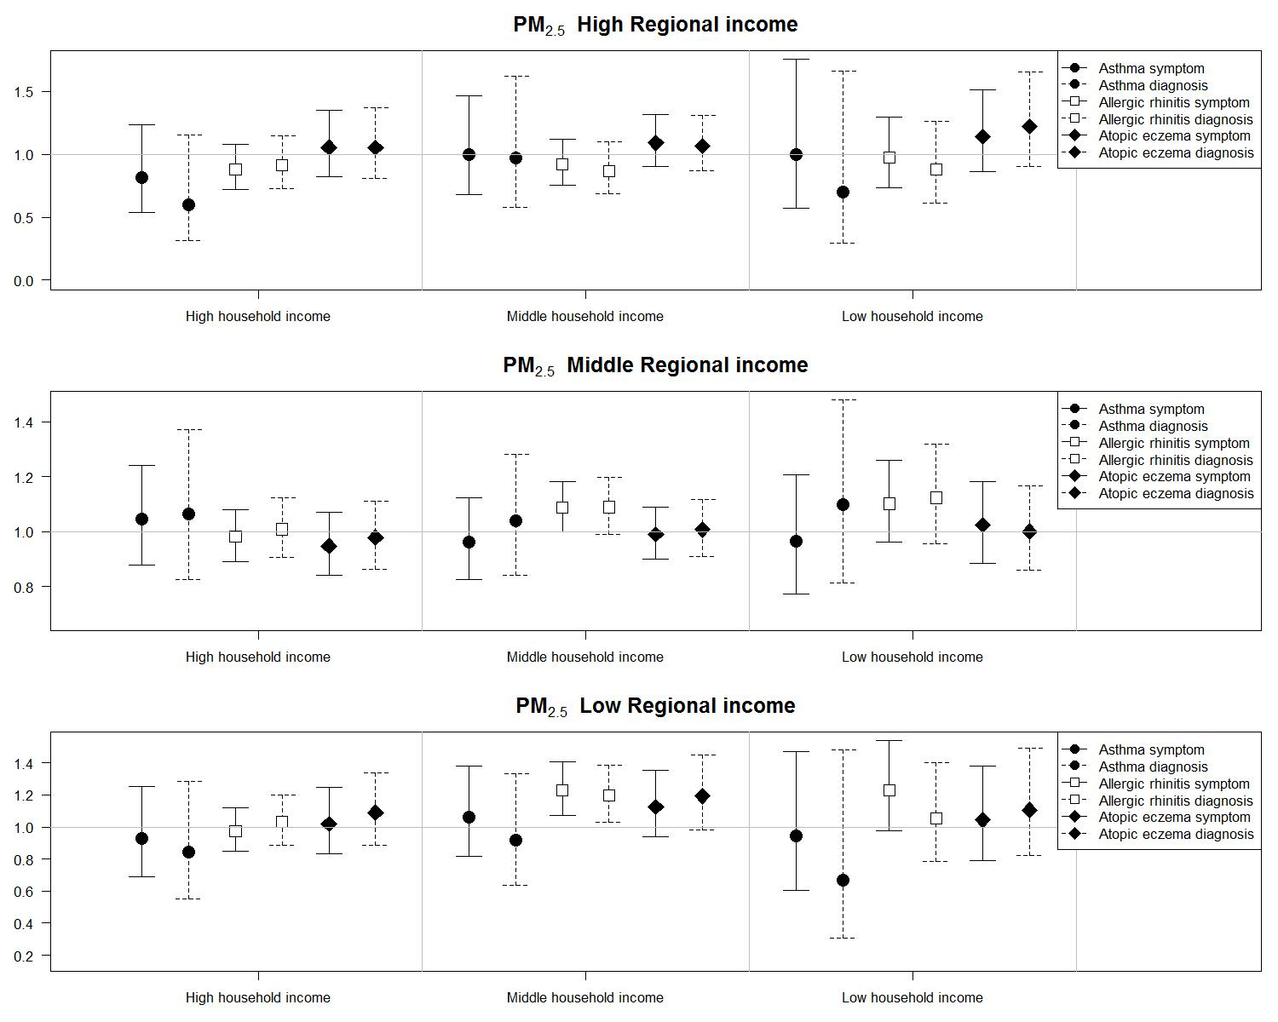
Figure S7. Odds ratios and 95% confidence intervals of symptoms and doctor-diagnoses of three allergic diseases for interquartile increases in individual-level annual average concentrations of PM2.5 (3.63 ug/m3) in 14,614 children at homes stratified by regional and household socioeconomic status from the Seoul Atopy Friendly School Project Survey in Seoul, Korea, for 2010

