Supplementary Material
Effect of short-term exposure to particulate air pollution on heart rate variability in normal-weight and obese adults
Luyi Li, Dayu Hu, Wenlou Zhang, Liyan Cui, Xu Jia, Di Yang, Shan Liu, Furong Deng*, Junxiu Liu*, Xinbiao Guo
Summary of Contents
Table S1. General characteristics of the study cohort 3
Table S2. Estimated percent changes in HRV and HR per interquartile range increase in personal PM_{2.5} and BC at different moving averages in the normal-weight (obese) group throughout the day 4
Table S3. Estimated percent changes in HRV indices and HR per interquartile range increase in personal PM_{2.5} and BC at different moving averages in the normal-weight (obese) group during the waking and sleeping hours 5
Table S4. Estimated percent changes (95% confidence intervals) in HRV and HR and p-values for interaction term in PM_{2.5}-obesity per interquartile range increase in personal PM_{2.5} at 15-min moving average in the normal-weight and the obese groups during the waking and sleeping hours 6
Table S5. Estimated percent changes (95% confidence intervals) in HRV and HR and p-values for interaction term in BC-obesity per interquartile range increase in personal BC at 15-min moving average in the normal-weight and the obese groups during the waking and sleeping hours 7
Table S6. Estimated percent changes (95% confidence intervals) in HRV and HR and p-values for interaction term in PM_{2.5}-obesity per interquartile range increase in personal PM_{2.5} at 30-min moving average in the normal-weight and the obese groups during the waking and sleeping hours 8
Table S7. Estimated percent changes (95% confidence intervals) in HRV and HR and p-values for interaction term in BC-obesity per interquartile range increase in personal BC at 30-min moving average in the normal-weight and the obese groups during the waking and sleeping hours 9
Table S8. Estimated percent changes (95% confidence intervals) in HRV and HR and p-values for interaction term in PM_{2.5}-obesity per interquartile range increase in personal PM_{2.5} at 1-h moving average in the normal-weight and the obese groups during the waking and sleeping hours 10
Table S9. Estimated percent changes (95% confidence intervals) in HRV and HR and p-values for interaction term in BC-obesity per interquartile range increase in personal BC at 1-h moving average in the normal-weight and the obese groups during the waking and sleeping hours 11
Table S10. Estimated percent changes (95% confidence intervals) in HRV and HR and p-values for interaction term in PM_{2.5}-obesity per interquartile range increase in personal PM_{2.5} at 3-h moving average in the normal-weight and the obese groups during the waking and sleeping hours 12
Table S11. Estimated percent changes (95% confidence intervals) in HRV and HR and p-values for interaction term in BC-obesity per interquartile range increase in personal BC at 3-h moving average in the normal-weight and the obese groups during the waking and sleeping hours 13
Table S12. Estimated percent changes in HRV and HR per interquartile range increase in ambient PM_{2.5} and BC at different moving averages in the normal-weight (obese) group throughout the day.. 14
Table S13. Estimated percent changes in HRV and HR per interquartile range increase in ambient PM_{2.5} and BC at different moving averages in the normal-weight (obese) group during the waking and sleeping hours 15
Figure S1. Exposure–response relationship between 30-min personal PM_{2.5} and 30-min personal BC moving average and total power with 95% confidence intervals under generalized additive models in all subjects, normal-weight and obese individuals. The degree of freedom was estimated by generalized cross validation. A and C, waking hours; B and D, sleeping hours 16
Figure S2. Exposure–response relationship between 30-min personal PM_{2.5} and 30-min personal BC moving average and SDNN with 95% confidence intervals under generalized additive models in all subjects, normal-weight and obese individuals. The degree of freedom was estimated by generalized cross validation. A and C, waking hours; B and D, sleeping hours 17
Figure S3. Exposure–response relationship between 30-min personal PM_{2.5} and 30-min personal BC moving average and LF with 95% confidence intervals under generalized additive models in all subjects, normal-weight and obese individuals. The degree of freedom was estimated by generalized cross validation. A and C, waking hours; B and D, sleeping hours 18
Figure S4. Exposure–response relationship between 30-min personal PM_{2.5} and 30-min personal BC moving average and LF/HF with 95% confidence intervals under generalized additive models in all subjects, normal-weight and obese individuals. The degree of freedom was estimated by generalized cross validation. A and C, waking hours; B and D, sleeping hours 19
Figure S5. Exposure–response relationship between 30-min personal PM_{2.5} and 30-min personal BC moving average and HR with 95% confidence intervals under generalized additive models in all subjects, normal-weight and obese individuals. The degree of freedom was estimated by generalized cross validation. A and C, waking hours; B and D, sleeping hours 20
Table S1. General characteristics of the study cohort

Variable | Normal-weight  (n=53) | Obese  (n=44)
Age, years
Mean ± SD | 23.3±1.9 | 23.3±2.0
Median | 24.0 | 23.0
Gender
Male | 35 | 30
Female | 18 | 14
Height, cm
Mean ± SD | 168.8±0.8 | 168.3±0.7
Median | 168.0 | 167.5
Weight, kg
Mean ± SD | 60.6±8.9 | 81.8±7.3
Median | 62.5 | 82.8
BMI, kg/m²
Mean ± SD | 21.2±2.0 | 28.8±1.3
Median | 21.1 | 28.4

Abbreviations: SD, standard deviation; BMI: body Mass index

Table S2. Estimated percent changes in HRV and HR per interquartile range increase in personal PM_{2.5} and BC at different moving averages in the normal-weight (obese) group throughout the day
Pollutant | Averaging period | HRV |  |  |  |  | HR
Pollutant | Averaging period | Total power | LF | HF | LF/HF | SDNN | HR
PM_{2.5} | 15min | 3.01(2.50) | 0.16(0.21) | 0.80(-11.50***) | 2.76(9.71***) | 0.12(1.63) | -2.05***(-1.75***)
PM_{2.5} | 30min | 3.33(0.47) | -1.17(0.68) | 0.59(-12.36***) | 2.09(15.54***) | -0.04(0.71) | -2.27***(-2.20***)
PM_{2.5} | 1h | 4.13(-1.82) | -1.41(1.31) | 2.60(-13.75***) | 1.08(11.91***) | -0.02(-0.36) | -2.72***(-3.03***)
PM_{2.5} | 2h | 1.71(-3.12) | -4.67(5.00) | 1.40(-14.87***) | -1.39(16.21***) | -2.24(-0.69) | -2.87***(-4.33***)
PM_{2.5} | 3h | -1.27(-0.45) | -9.37*(10.53***) | -0.04(-13.84***) | -3.11(20.93***) | -3.37(0.35) | -3.44***(-5.05***)
BC | 15min | 4.08(2.64) | -0.62(0.53) | 3.85(-6.59***) | 4.87(2.73) | 1.84(0.60) | -2.43***(-0.99)
BC | 30min | 4.26(1.79) | -1.33(1.48) | 6.27*(-7.09***) | 3.08(4.77) | 2.45(0.98) | -3.55***(-1.42*)
BC | 1h | 5.51(3.38) | -3.70(2.85) | 8.05*(-10.32***) | 3.98(8.45*) | 2.74(1.85) | -4.23***(-1.86***)
BC | 2h | 8.08(1.57) | -10.22*(9.45***) | 4.13(-14.43***) | -2.26(7.72*) | 3.80(0.49) | -4.76***(-2.59***)
BC | 3h | 2.35(1.23) | -18.00***(12.36***) | 1.63(-17.01***) | -9.60(21.64***) | 0.28(0.38) | -5.92***(-2.97***)
Abbreviations: HRV, heart rate variability; HR, heart rate; PM_{2.5}, fine particulate matter; BC, black carbon; LF, low frequency power; HF, high frequency power; LF/HF, ratio of low–high frequency power; SDNN, standard deviation of all normal-to-normal (NN) intervals.
* FDR-corrected p < 0.05; *** FDR-corrected p < 0.01.

Table S3. Estimated percent changes in HRV indices and HR per interquartile range increase in personal PM_{2.5} and BC at different moving averages in the normal-weight (obese) group during the waking and sleeping hours
 | Pollutant | Averaging period | HRV |  |  |  |  | HR
 | Pollutant | Averaging period | Total power | LF | HF | LF/HF | SDNN | HR
Waking hours | PM_{2.5} | 15min | 1.13(2.33) | -0.08(-1.32) | 5.04(-13.80***) | 4.72(10.88***) | 0.27(0.49) | -2.65***(4.66***)
Waking hours | PM_{2.5} | 30min | 0.60(0.92) | -1.32(1.93) | 3.70(-14.34***) | 4.69(12.06***) | 0.14(-0.13) | -1.84*(4.64***)
Waking hours | PM_{2.5} | 1h | 1.32(0.29) | -1.54(-3.23) | 4.36(-16.28***) | 4.51(15.48***) | 0.67(-0.33) | -1.51(4.51***)
Waking hours | PM_{2.5} | 2h | 6.03(0.03) | 2.33(0.10) | 2.55(-18.11***) | 8.94(20.67***) | 4.28(0.30) | -1.10(2.81*)
Waking hours | PM_{2.5} | 3h | 7.97(5.84) | 5.44(7.80) | 6.55(-15.67***) | 10.99(24.96***) | 2.30(2.74) | -2.80(2.11)
Waking hours | BC | 15min | 3.77(4.32) | -1.57(-0.21) | 4.69(-11.33***) | 4.01(8.79*) | 2.90(0.79) | -1.94(3.77***)
Waking hours | BC | 30min | 6.00(4.44) | -0.82(2.56) | 9.28(-12.33***) | 2.75(12.04***) | 4.08(3.14) | -2.62*(4.08***)
Waking hours | BC | 1h | 10.31*(6.66) | 3.23(5.54) | 14.83*(-14.63***) | 2.29(17.19***) | 6.49***(2.34) | -3.42*** (3.03***)
Waking hours | BC | 2h | 17.45*(9.76) | 5.61(2.24) | 12.55(-14.79***) | 6.43(37.64***) | 8.31***(0.96) | -3.14*(3.82***)
Waking hours | BC | 3h | 13.21(-2.81) | -2.19(14.74) | 18.55*(-25.25***) | -1.58(38.43***) | 6.99*(3.21) | -3.42 (5.40***)
Sleeping hours | PM_{2.5} | 15min | 24.30(0.65) | -3.76(7.77) | 28.83(10.16) | 3.14(14.53) | 12.66(-1.73) | 3.17(-1.41)
Sleeping hours | PM_{2.5} | 30min | 24.34(4.31) | 23.8(11.96) | 29.47(6.75) | 2.17(19.01) | 8.82(-2.11) | 3.70(-2.50)
Sleeping hours | PM_{2.5} | 1h | 22.20(-22.47) | 25.10(6.27) | 29.55(25.83) | 5.81(12.17) | 11.02(-3.75) | 8.56***(-3.11)
Sleeping hours | PM_{2.5} | 2h | 17.30(-28.79***) | 12.72(11.78) | 28.98(78.32***) | -3.79(-9.90) | 5.24(-1.12) | 14.03***(-7.89***)
Sleeping hours | PM_{2.5} | 3h | 12.57(-6.60) | -10.60(16.17) | 20.97(60.52*) | -7.08(8.03) | 1.36(-11.94) | 15.04***(-6.08)
Sleeping hours | BC | 15min | 20.81(-24.30) | 1.64(-15.01) | 21.29(-13.78) | -0.49(4.80) | 13.56(-13.29) | -0.95(-4.97)
Sleeping hours | BC | 30min | 25.54(-24.67) | 18.39(-11.99) | 31.01*(-9.10) | 8.42(-0.37) | 13.02(-13.07) | -0.34(-6.51*)
Sleeping hours | BC | 1h | 32.08(-26.96*) | 39.80 (-18.91) | 36.19*(-11.49) | 15.24(-8.92) | 12.76(-11.98) | 0.21(-4.65)
Sleeping hours | BC | 2h | 44.05(-6.90) | 7.29(10.24) | 20.10(-7.91) | 7.01(4.62) | 9.64(-6.28) | 6.13*(-1.57)
Sleeping hours | BC | 3h | 20.58(-12.53) | -13.99(15.95) | 10.18(-27.78*) | -8.18(18.70) | 2.35(-7.94) | 4.43(0.86)
Abbreviations: HRV, heart rate variability; HR, heart rate; PM_{2.5}, fine particulate matter; BC, black carbon; LF, low frequency power; HF, high frequency power; LF/HF, ratio of low–high frequency power; SDNN, standard deviation of all normal-to-normal (NN) intervals.
* FDR-corrected p < 0.05; *** FDR-corrected p < 0.01.

Table S4. Estimated percent changes (95% confidence intervals) in HRV and HR and p-values for interaction term in PM_{2.5}-obesity per interquartile range increase in personal PM_{2.5} at 15-min moving average in the normal-weight and the obese groups during the waking and sleeping hours
HRV indices | Normal-weight | Obese | p-value for the interaction term  (FDR corrected)
Waking hours
SDNN | 0.26(-2.47, 3.07) | 0.47(-2.12, 3.12) | 0.378
Total power | 0.87(-4.84, 6.93) | 3.41(-3.51, 10.82) | 0.328
HF | 4.05(-3.01, 11.62) | -13.31(-17.31, -9.12) | 0.017*
LF | 0.65(-4.74, 6.34) | 2.19(-3.89, 8.66) | 0.189
LF/HF | 4.66(-1.66, 11.39) | 13.50(7.49, 19.85) | 0.126
HR | -2.54(-3.52, -1.54) | 2.70(1.44, 3.97) | < 0.001*
Sleeping hours
SDNN | 12.14(-1.81, 28.06) | -1.67(-16.02, 15.15) | 0.114
Total power | 23.76(-5.37, 61.85) | -26.77(-39.68, -11.10) | 0.133
HF | 30.19(6.09, 59.76) | 7.72(-16.24, 38.53) | 0.040*
LF | 24.14(-10.77, 72.71) | 6.58(-17.58, 37.81) | 0.186
LF/HF | -0.78(-20.83, 24.33) | 13.01(-18.81, 57.30) | 0.237
HR | 2.01(-2.13, 6.31) | -0.11(-3.79, 3.71) | 0.363
Abbreviations: HRV, heart rate variability; HR, heart rate; PM_{2.5}, fine particulate matter; SDNN, standard deviation of all normal-to-normal (NN) intervals;
HF, high frequency power; LF, low frequency power; LF/HF, ratio of low–high frequency power.
* FDR-corrected p < 0.05.

Table S5. Estimated percent changes (95% confidence intervals) in HRV and HR and p-values for interaction term in BC-obesity per interquartile range increase in personal BC at 15-min moving average in the normal-weight and the obese groups during the waking and sleeping hours
HRV indices | Normal-weight | Obese | p-value for the interaction term  (FDR corrected)
Waking hours
SDNN | 2.90(-0.60, 6.53) | 0.79(-1.93, 3.60) | 0.215
Total power | 1.95(-5.44, 9.92) | 1.03(-5.00, 7.43) | 0.347
HF | 7.78(-1.17, 17.53) | -13.06(-17.43, -8.47) | 0.004*
LF | -2.12(-9.70, 6.08) | -5.77(-10.73, -0.53) | 0.194
LF/HF | 1.83(-6.06, 10.38) | 11.88(5.51, 18.65) | 0.086
HR | -1.64(-3.22, -0.04) | 3.24(1.93, 4.56) | < 0.001*
Sleeping hours
SDNN | 10.66(-3.14, 26.43) | -11.27(-22.27, 1.29) | 0.015*
Total power | 28.47(-3.07, 70.27) | -30.54(-43.33, -14.86) | 0.014*
HF | 14.26(-5.21, 37.72) | -22.48(-38.76, -1.87) | < 0.001*
LF | 3.44(-20.93, 35.33) | -20.04(-35.23, -1.30) | 0.074
LF/HF | 9.03(-12.85, 36.42) | 5.15(-21.68, 41.17) | 0.238
HR | -0.01(-3.36, 3.46) | -7.09(-10.83, -3.19) | 0.267
Abbreviations: HRV, heart rate variability; HR, heart rate; BC, black carbon; SDNN, standard deviation of all normal-to-normal (NN) intervals;
HF, high frequency power; LF, low frequency power; LF/HF, ratio of low–high frequency power.
* FDR-corrected p < 0.05.

Table S6. Estimated percent changes (95% confidence intervals) in HRV and HR and p-values for interaction term in PM_{2.5}-obesity per interquartile range increase in personal PM_{2.5} at 30-min moving average in the normal-weight and the obese groups during the waking and sleeping hours
HRV indices | Normal-weight | Obese | p-value for the interaction term  (FDR corrected)
Waking hours
SDNN | 0.13(-2.71, 3.06) | -0.13(-2.79, 2.61) | 0.326
Total power | -0.01(-5.91, 6.26) | -1.27(-6.92, 4.73) | 0.282
HF | 3.62(-3.73, 11.54) | -13.74(-17.83, -9.44) | 0.024*
LF | -0.84(-6.36, 5.01) | -2.53(-7.44, 2.63) | 0.343
LF/HF | 3.82(-2.69, 10.78) | 14.01(7.81, 20.57) | 0.111
HR | -1.94(-3.18, -0.68) | 2.57(1.25, 3.90) | < 0.001*
Sleeping hours
SDNN | 8.46(-4.79, 23.55) | -2.03(-16.70, 15.22) | 0.128
Total power | 22.09(-7.83, 61.71) | -2.95(-29.03, 32.72) | 0.144
HF | 32.04(7.97, 61.48) | 11.74(-14.34, 45.77) | 0.054
LF | 24.97(-10.51, 74.52) | 15.21(-16.12, 58.22) | 0.191
LF/HF | -1.76(-21.85, 23.50) | 17.00(-12.25, 56.00) | 0.268
HR | 3.03(-1.30, 7.54) | -1.37(-5.16, 2.57) | 0.130
Abbreviations: HRV, heart rate variability; HR, heart rate; PM_{2.5}, fine particulate matter; SDNN, standard deviation of all normal-to-normal (NN) intervals;
HF, high frequency power; LF, low frequency power; LF/HF, ratio of low–high frequency power.
* FDR-corrected p < 0.05.

Table S7. Estimated percent changes (95% confidence intervals) in HRV and HR and p-values for interaction term in BC-obesity per interquartile range increase in personal BC at 30-min moving average in the normal-weight and the obese groups during the waking and sleeping hours
HRV indices | Normal-weight | Obese | p-value for the interaction term  (FDR corrected)
Waking hours
SDNN | 4.08(0.43, 7.87) | 3.14(-0.26, 6.66) | 0.183
Total power | 4.18(-3.62, 12.60) | 1.10(-5.34, 7.98) | 0.279
HF | 16.69(7.99, 26.08) | -5.71(-11.64, 0.61) | < 0.001*
LF | -0.81(-7.82, 6.75) | -3.58(-8.99, 2.16) | 0.292
LF/HF | 0.24(-7.75, 8.92) | 15.02(8.03, 22.46) | 0.022*
HR | -2.11(-3.78, -0.41) | 3.45(2.01, 4.90) | < 0.001*
Sleeping hours
SDNN | 13.02(-1.83, 30.11) | -13.07(-23.85, -0.75) | 0.011*
Total power | 27.34(-4.81, 70.34) | -31.19(-44.05, -15.37) | 0.007*
HF | 34.37(10.49, 63.41) | -8.05(-27.68, 16.92) | 0.004*
LF | 11.07(-8.91, 35.44) | -8.59(-26.21, 13.23) | 0.025 *
LF/HF | 3.31(-16.32, 27.55) | -0.66(-25.41, 32.31) | 0.386
HR | -0.80(-4.33, 2.87) | -5.03(-8.69, -1.24) | 0.111
Abbreviations: HRV, heart rate variability; HR, heart rate; BC, black carbon; SDNN, standard deviation of all normal-to-normal (NN) intervals;
HF, high frequency power; LF, low frequency power; LF/HF, ratio of low–high frequency power.
* FDR-corrected p < 0.05.

Table S8. Estimated percent changes (95% confidence intervals) in HRV and HR and p-values for interaction term in PM_{2.5}-obesity per interquartile range increase in personal PM_{2.5} at 1-h moving average in the normal-weight and the obese groups during the waking and sleeping hours
HRV indices | Normal-weight | Obese | p-value for the interaction term  (FDR corrected)
Waking hours
SDNN | 0.64(-2.48, 3.86) | -0.31(-3.15, 2.60) | 0.259
Total power | 0.24(-6.20, 7.12) | -1.89(-7.83, 4.43) | 0.247
HF | -4.43(-10.59, 2.16) | -15.59(-19.83, -11.13) | 0.012*
LF | -1.47(-7.64, 5.10) | 2.07(-4.64, 9.25) | 0.233
LF/HF | 2.67(-4.32, 10.17) | 16.53(9.82, 23.65) | 0.039*
HR | -1.39(-2.81, 0.06) | 3.00(1.54, 4.47) | < 0.001*
Sleeping hours
SDNN | 10.57(-4.33, 27.78) | -3.61(-18.76, 14.37) | 0.137
Total power | 22.11(-8.87, 63.64) | -7.24(-34.00, 30.36) | 0.116
HF | 26.48(5.42, 51.75) | 25.84(-5.48, 67.53) | 0.115
LF | 0.90(-21.78, 30.15) | 8.31(-21.66, 49.73) | 0.153
LF/HF | 0.76(-19.72, 26.47) | 9.21(-25.38, 59.84) | 0.367
HR | 7.31(2.52, 12.32) | -2.88(-6.98, 1.41) | 0.004*
Abbreviations: HRV, heart rate variability; HR, heart rate; PM_{2.5}, fine particulate matter; SDNN, standard deviation of all normal-to-normal (NN) intervals;
HF, high frequency power; LF, low frequency power; LF/HF, ratio of low–high frequency power.
* FDR-corrected p < 0.05.

Table S9. Estimated percent changes (95% confidence intervals) in HRV and HR and p-values for interaction term in BC-obesity per interquartile range increase in personal BC at 1-h moving average in the normal-weight and the obese groups during the waking and sleeping hours
HRV indices | Normal-weight | Obese | p-value for the interaction term  (FDR corrected)
Waking hours
SDNN | 6.49(2.63, 10.50) | 2.34(-0.85, 5.64) | 0.102
Total power | 8.53(0.13, 17.63) | 4.38(-2.62, 11.88) | 0.258
HF | 23.13(13.7, 33.34) | -14.91(-19.74, -9.78) | < 0.001*
LF | 2.21(-5.45, 10.49) | -0.43(-6.33, 5.83) | 0.308
LF/HF | 0.08(-8.16, 9.06) | 20.84(11.91, 30.47) | 0.007*
HR | -1.95(-3.81, -0.06) | 2.90(1.33, 4.50) | < 0.001*
Sleeping hours
SDNN | 12.76(-3.71, 32.05) | -11.98(-23.06, 0.7) | 0.018*
Total power | 32.49(-1.01, 77.32) | -26.39(-43.35, -4.36) | 0.007*
HF | 40.88(14.82, 72.87) | -9.19(-28.57, 15.45) | < 0.001*
LF | 34.06(-2.77, 84.83) | -6.04(-26.45, 20.02) | 0.007*
LF/HF | 14.56(-14.59, 53.65) | -3.92(-26.62, 25.79) | 0.197
HR | -0.72(-4.52, 3.24) | -3.16(-7.09, 0.94) | 0.103
Abbreviations: HRV, heart rate variability; HR, heart rate; BC, black carbon; SDNN, standard deviation of all normal-to-normal (NN) intervals;
HF, high frequency power; LF, low frequency power; LF/HF, ratio of low–high frequency power.
* FDR-corrected p < 0.05.

Table S10. Estimated percent changes (95% confidence intervals) in HRV and HR and p-values for interaction term in PM_{2.5}-obesity per interquartile range increase in personal PM_{2.5} at 3-h moving average in the normal-weight and the obese groups during the waking and sleeping hours
HRV indices | Normal-weight | Obese | p-value for the interaction term  (FDR corrected)
Waking hours
SDNN | 2.21(-2.25, 6.88) | 2.63(-2.42, 7.94) | 0.364
Total power | 7.45(-2.16, 18.02) | 2.6(-6.18, 12.20) | 0.154
HF | -1.67(-10.55, 8.09) | -5.92(-14.48, 3.50) | 0.037*
LF | 5.18(-3.88, 15.09) | 8.31(-1.62, 19.25) | 0.310
LF/HF | 8.54(-2.06, 20.28) | 24.79(14.70, 35.75) | 0.110
HR | -1.65(-4.32, 1.09) | 1.88(-0.32, 4.13) | 0.175
Sleeping hours
SDNN | 1.30(-12.05, 16.69) | -11.50(-22.63, 1.24) | 0.335
Total power | 4.66(-17.11, 32.14) | -24.53(-38.18, -7.88) | 0.215
HF | 20.26(4.68, 38.16) | 58.09(15.90, 115.63) | 0.248
LF | -2.85(-30.63, 36.07) | 18.84(-12.95, 62.22) | 0.190
LF/HF | -10.61(-27.12, 9.65) | 10.78(-24.23, 61.96) | 0.251
HR | 7.52(3.23, 12.00) | -5.75(-9.69, -1.64) | < 0.001*
Abbreviations: HRV, heart rate variability; HR, heart rate; PM_{2.5}, fine particulate matter; SDNN, standard deviation of all normal-to-normal (NN) intervals;
HF, high frequency power; LF, low frequency power; LF/HF, ratio of low–high frequency power.
* FDR-corrected p < 0.05.

Table S11. Estimated percent changes (95% confidence intervals) in HRV and HR and p-values for interaction term in BC-obesity per interquartile range increase in personal BC at 3-h moving average in the normal-weight and the obese groups during the waking and sleeping hours
HRV indices | Normal-weight | Obese | p-value for the interaction term  (FDR corrected)
Waking hours
SDNN | 6.99(1.50, 12.78) | 3.21(-3.09, 9.91) | 0.038*
Total power | 18.65(5.32, 33.67) | -5.00(-14.43, 5.47) | 0.017*
HF | 30.25(15.76, 46.55) | -19.37(-27.88, -9.85) | < 0.001*
LF | 2.31(-8.76, 14.72) | 18.97(5.99, 33.54) | 0.127
LF/HF | -7.10(-19.12, 6.71) | 47.08(30.04, 66.35) | < 0.001
HR | -5.38(-8.08, -2.60) | 5.32(2.51, 8.21) | < 0.001*
Sleeping hours
SDNN | 2.35(-15.45, 23.89) | -7.94(-19.29, 5.02) | 0.155
Total power | 17.82(-15.28, 63.87) | -8.85(-30.25, 19.11) | 0.062
HF | 13.32(-8.94, 41.03) | -29.73(-43.82, -12.12) | 0.015*
LF | -8.72(-38.14, 34.69) | 19.78(-12.95, 64.80) | 0.250
LF/HF | -9.82(-27.82, 12.66) | 16.49(-15.84, 61.25) | 0.230
HR | 2.40(-1.88, 6.86) | 0.49(-3.65, 4.82) | 0.388
Abbreviations: HRV, heart rate variability; HR, heart rate; BC, black carbon; SDNN, standard deviation of all normal-to-normal (NN) intervals;
HF, high frequency power; LF, low frequency power; LF/HF, ratio of low–high frequency power.
* FDR-corrected p < 0.05.

Table S12. Estimated percent changes in HRV and HR per interquartile range increase in ambient PM_{2.5} and BC at different moving averages in the normal-weight (obese) group throughout the day
Pollutant | Averaging period | HRV |  |  |  |  | HR
Pollutant | Averaging period | Total power | LF | HF | LF/HF | SDNN | HR
PM_{2.5} | 1h | 4.26(-13.00) | -0.79(-10.80) | 6.66(-9.68) | 10.05(7.63) | -3.96(-4.55) | -2.94(0.89)
PM_{2.5} | 2h | 0.41(-12.87) | 6.63(-10.93) | 14.62(12.08) | 13.28(7.77) | -0.07(-3.50) | -1.94(-1.47)
PM_{2.5} | 3h | 2.41(-10.00) | 27.98(-8.28) | 10.36(12.81) | 13.39(6.43) | -1.54(-2.34) | -1.26(-2.63)
BC | 1h | -4.74(-5.75) | 4.94(-3.64) | -1.85(15.25) | 17.26(-10.08) | -4.98(-0.85) | 0.69(-3.42*)
BC | 2h | -4.50(-3.86) | 14.01(-4.05) | -13.23(12.50) | 10.76(-11.13) | -5.10(-0.95) | 0.95(-4.50***)
BC | 3h | -4.71(-1.39) | 4.15(-0.89) | -2.38(18.50) | 15.44(-10.87) | -5.28(-0.29) | -0.10(-4.28***)

Abbreviations: HRV, heart rate variability; HR, heart rate; PM_{2.5}, fine particulate matter; BC, black carbon; LF, low frequency power; HF, high frequency power;
LF/HF, ratio of low–high frequency power; SDNN, standard deviation of all normal-to-normal (NN) intervals.
* FDR-corrected p < 0.05; *** FDR-corrected p < 0.01.

Table S13. Estimated percent changes in HRV and HR per interquartile range increase in ambient PM_{2.5} and BC at different moving averages in the normal-weight (obese) group during the waking and sleeping hours
 | Pollutant | Averaging period | HRV |  |  |  |  | HR
 | Pollutant | Averaging period | Total power | LF | HF | LF/HF | SDNN | HR
Waking hours | PM_{2.5} | 1h | 0.63(-5.18) | -1.86(-6.31) | -6.70(5.84) | -2.36(-0.90) | 0.54(1.24) | -5.25* (-3.40*)
Waking hours | PM_{2.5} | 2h | 10.06(-4.88) | 7.17(-6.31) | 11.75(7.84) | -3.58(-3.16) | 2.11(2.47) | -5.73* (-3.73*)
Waking hours | PM_{2.5} | 3h | 8.87(-0.92) | 10.54(-2.15) | 23.18(8.17) | -4.99(3.29) | -1.92(3.67) | -6.09* (-1.99*)
Waking hours | BC | 1h | -0.20(3.67) | 4.94(6.49) | 18.00(7.25) | 8.29(4.58) | -2.83(0.76) | -1.52(-1.97*)
Waking hours | BC | 2h | 6.10(6.31) | 13.46(8.15) | -4.38(7.51) | 5.71(4.20) | -0.86(1.24) | -3.07* (-2.14*)
Waking hours | BC | 3h | 7.63(9.25) | 15.70(13.18) | 1.13(7.91) | 7.39(7.25) | -0.17(1.72) | -4.55* (-1.50*)
Sleeping hours | PM_{2.5} | 1h | 5.38(5.00) | -0.50(-2.22) | 12.83(6.80) | -3.61(9.82) | -3.66(-5.36) | -3.43(-1.17)
Sleeping hours | PM_{2.5} | 2h | 8.51(3.89) | 6.59(-0.67) | 6.40(-2.35) | 6.72(12.49) | -5.62(-1.89) | -0.91(-0.24)
Sleeping hours | PM_{2.5} | 3h | 11.51(1.73) | 13.44(-2.26) | 5.42(-5.24) | 12.24(8.72) | -0.60(-0.65) | 1.06(1.58)
Sleeping hours | BC | 1h | 12.72(-21.52) | 34.40(-19.75) | -7.98(-14.33) | 29.55(-14.09) | -3.13(-8.74) | 6.69(-0.12)
Sleeping hours | BC | 2h | 7.69(-19.56) | 20.21(-22.59) | -5.05(-10.41) | 15.01(-17.28) | -5.46(-9.15) | 6.49(-0.96)
Sleeping hours | BC | 3h | 9.08(-17.83) | 11.79(-22.13) | -9.71(-8.74) | 17.49(-15.12) | -7.35(-9.94) | 7.89(-1.46)
Abbreviations: HRV, heart rate variability; HR, heart rate; PM_{2.5}, fine particulate matter; BC, black carbon; LF, low frequency power; HF, high frequency power; LF/HF, ratio of low–high frequency power; SDNN, standard deviation of all normal-to-normal (NN) intervals.
* FDR-corrected p < 0.05

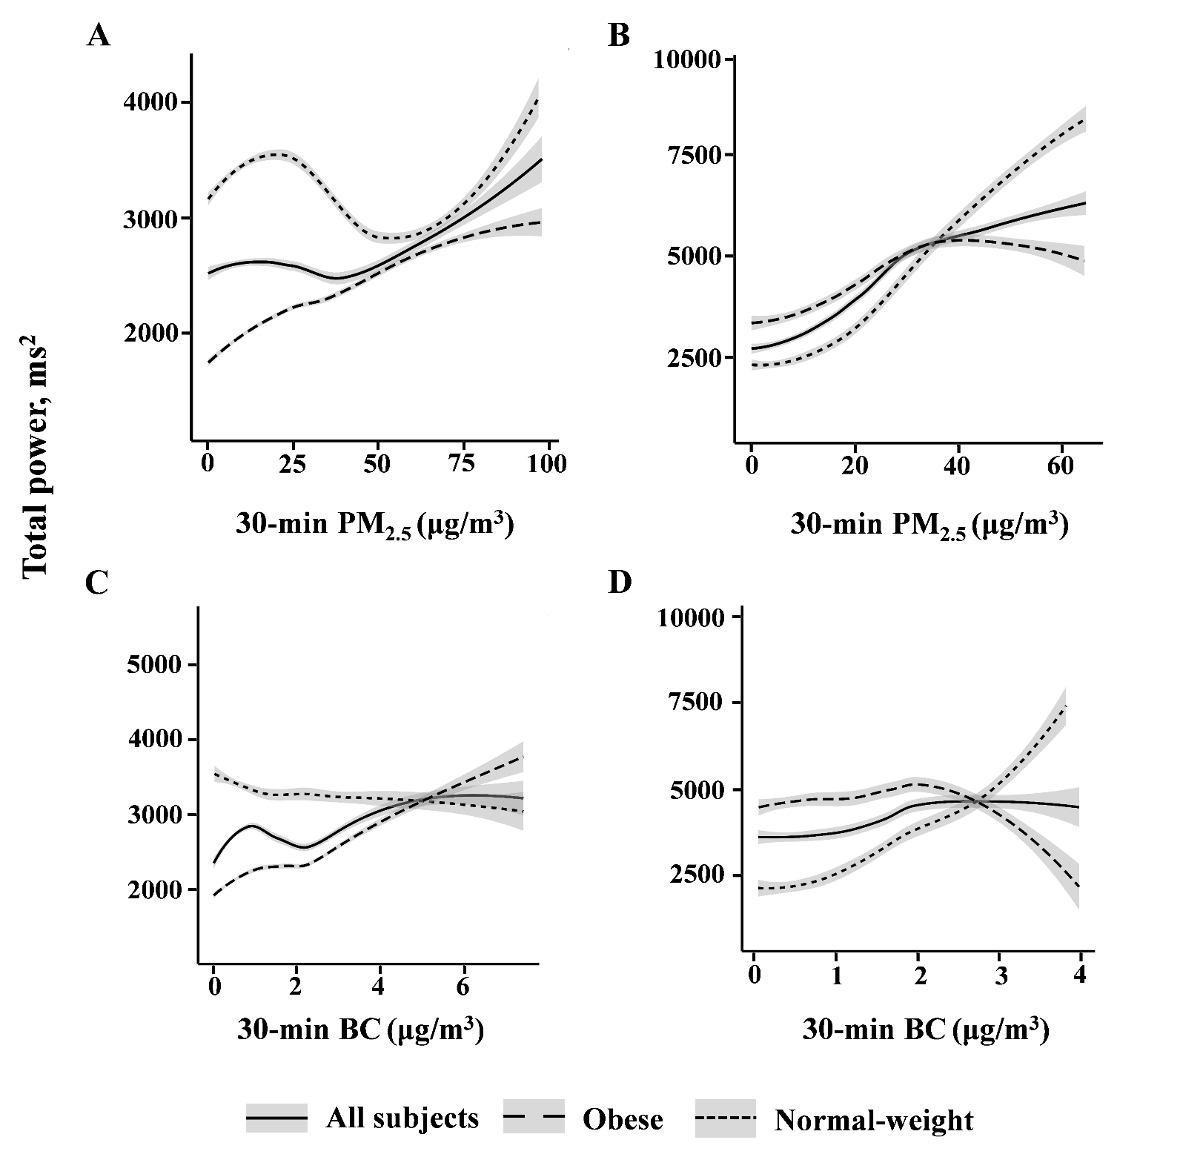

Figure S1. Exposure–response relationship between 30-min personal PM_{2.5} and 30-min personal BC moving average and total power with 95% confidence intervals under generalized additive models in all subjects, normal-weight and obese individuals. The degree of freedom was estimated by generalized cross validation. A and C, waking hours; B and D, sleeping hours.
Abbreviations: PM_{2.5}, fine particulate matter; BC, black carbon.

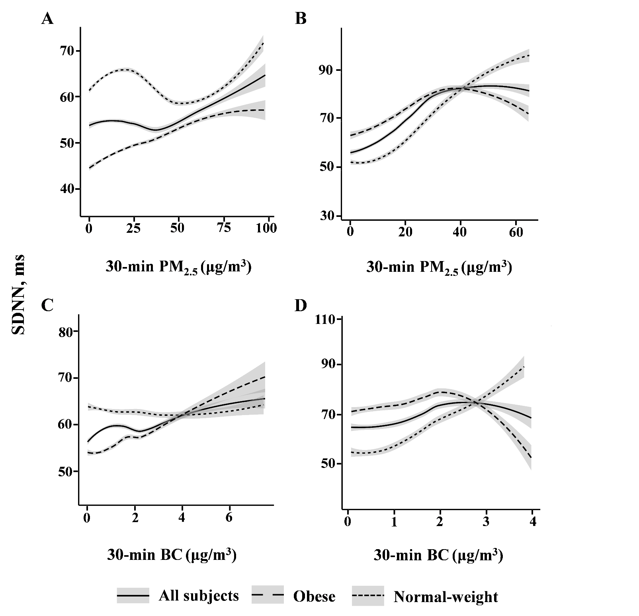Figure S2. Exposure–response relationship between 30-min personal PM_{2.5} and 30-min personal BC moving average and SDNN with 95% confidence intervals under generalized additive models in all subjects, normal-weight and obese individuals. The degree of freedom was estimated by generalized cross validation. A and C, waking hours; B and D, sleeping hours.
Abbreviations: PM_{2.5}, fine particulate matter; BC, black carbon; SDNN, standard deviation of all normal-to-normal (NN) intervals.

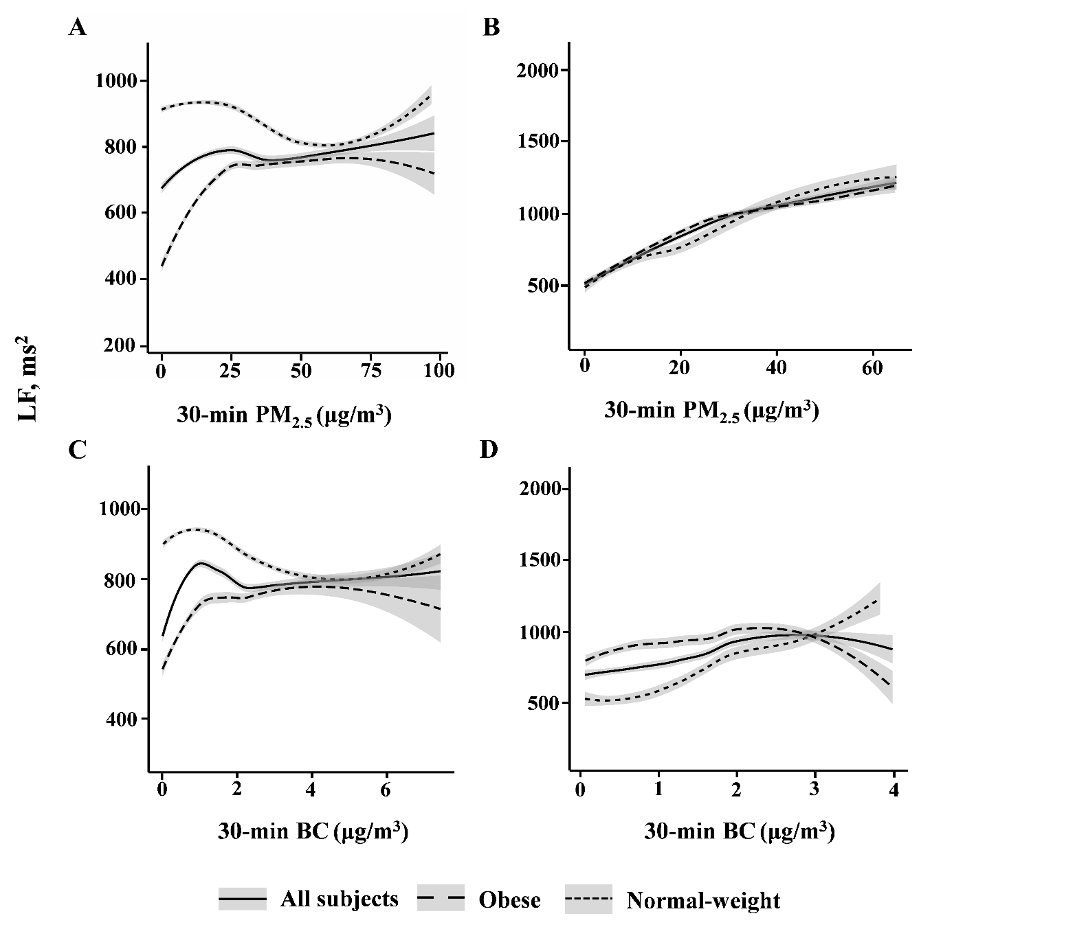Figure S3. Exposure–response relationship between 30-min personal PM_{2.5} and 30-min personal BC moving average and LF with 95% confidence intervals under generalized additive models in all subjects, normal-weight and obese individuals. The degree of freedom was estimated by generalized cross validation. A and C, waking hours; B and D, sleeping hours.
Abbreviations: PM_{2.5}, fine particulate matter; BC, black carbon; LF, low frequency power.

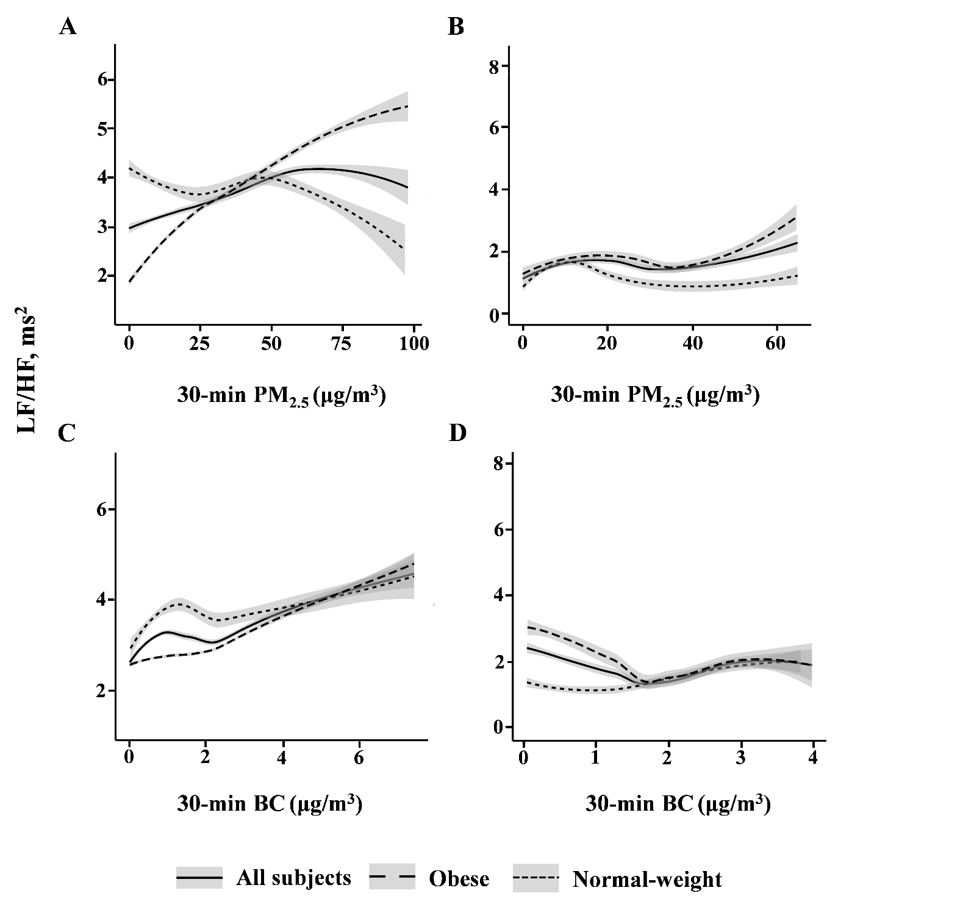Figure S4. Exposure–response relationship between 30-min personal PM_{2.5} and 30-min personal BC moving average and LF/HF with 95% confidence intervals under generalized additive models in all subjects, normal-weight and obese individuals. The degree of freedom was estimated by generalized cross validation. A and C, waking hours; B and D, sleeping hours.
Abbreviations: PM_{2.5}, fine particulate matter; BC, black carbon; LF/HF, ratio of low–high frequency power.

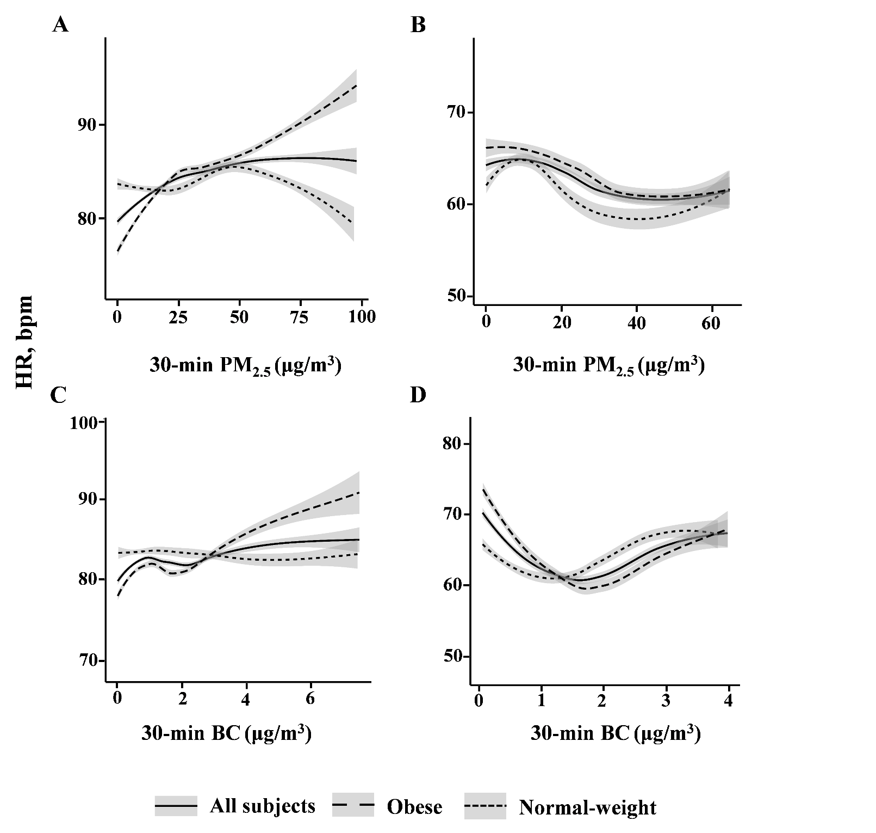Figure S5. Exposure–response relationship between 30-min personal PM_{2.5} and 30-min personal BC moving average and HR with 95% confidence intervals under generalized additive models in all subjects, normal-weight and obese individuals. The degree of freedom was estimated by generalized cross validation. A and C, waking hours; B and D, sleeping hours.
Abbreviations: PM_{2.5}, fine particulate matter; BC, black carbon; HR, heart rate; bpm, beat per minute.

