Additional file 6 – Identifying prioritised areas by combining categorical index scores

Figure 8: Example of priority areas with high heat exposure and very high sensitivity (~608 DAs)

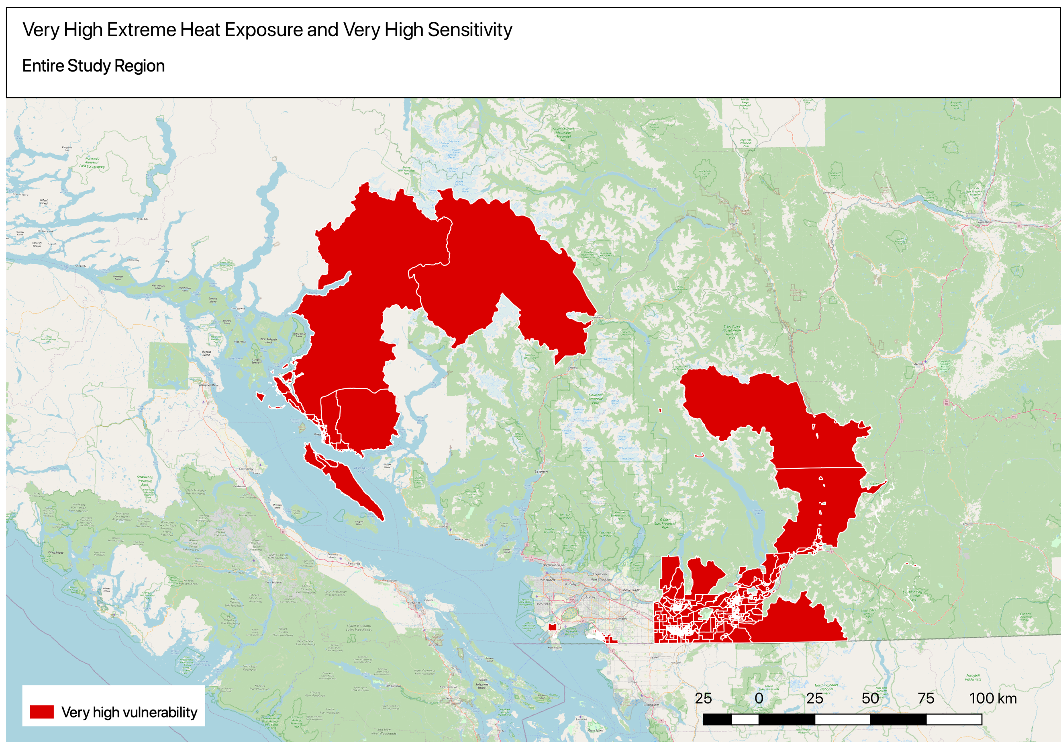
Figure 9: High flood exposure that are less vulnerable because of very high adaptive capacity (~203 DAs)
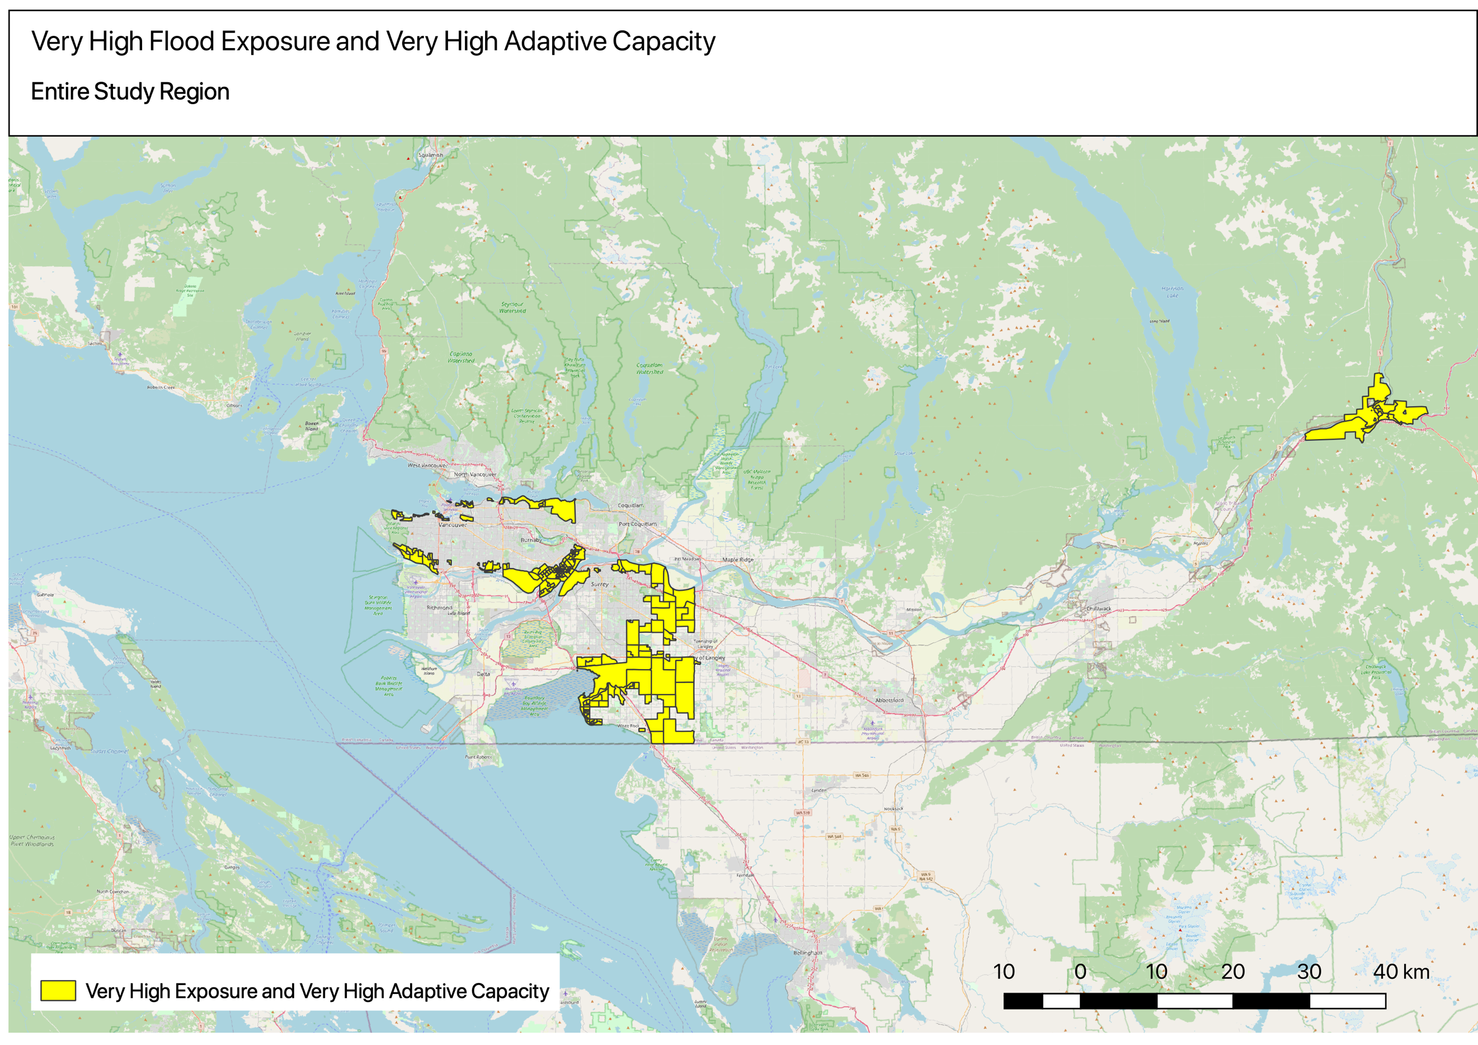

Figure 10: Highest vulnerability - very high smoke exposure and sensitivity and very low adaptive capacity (72 DAs)
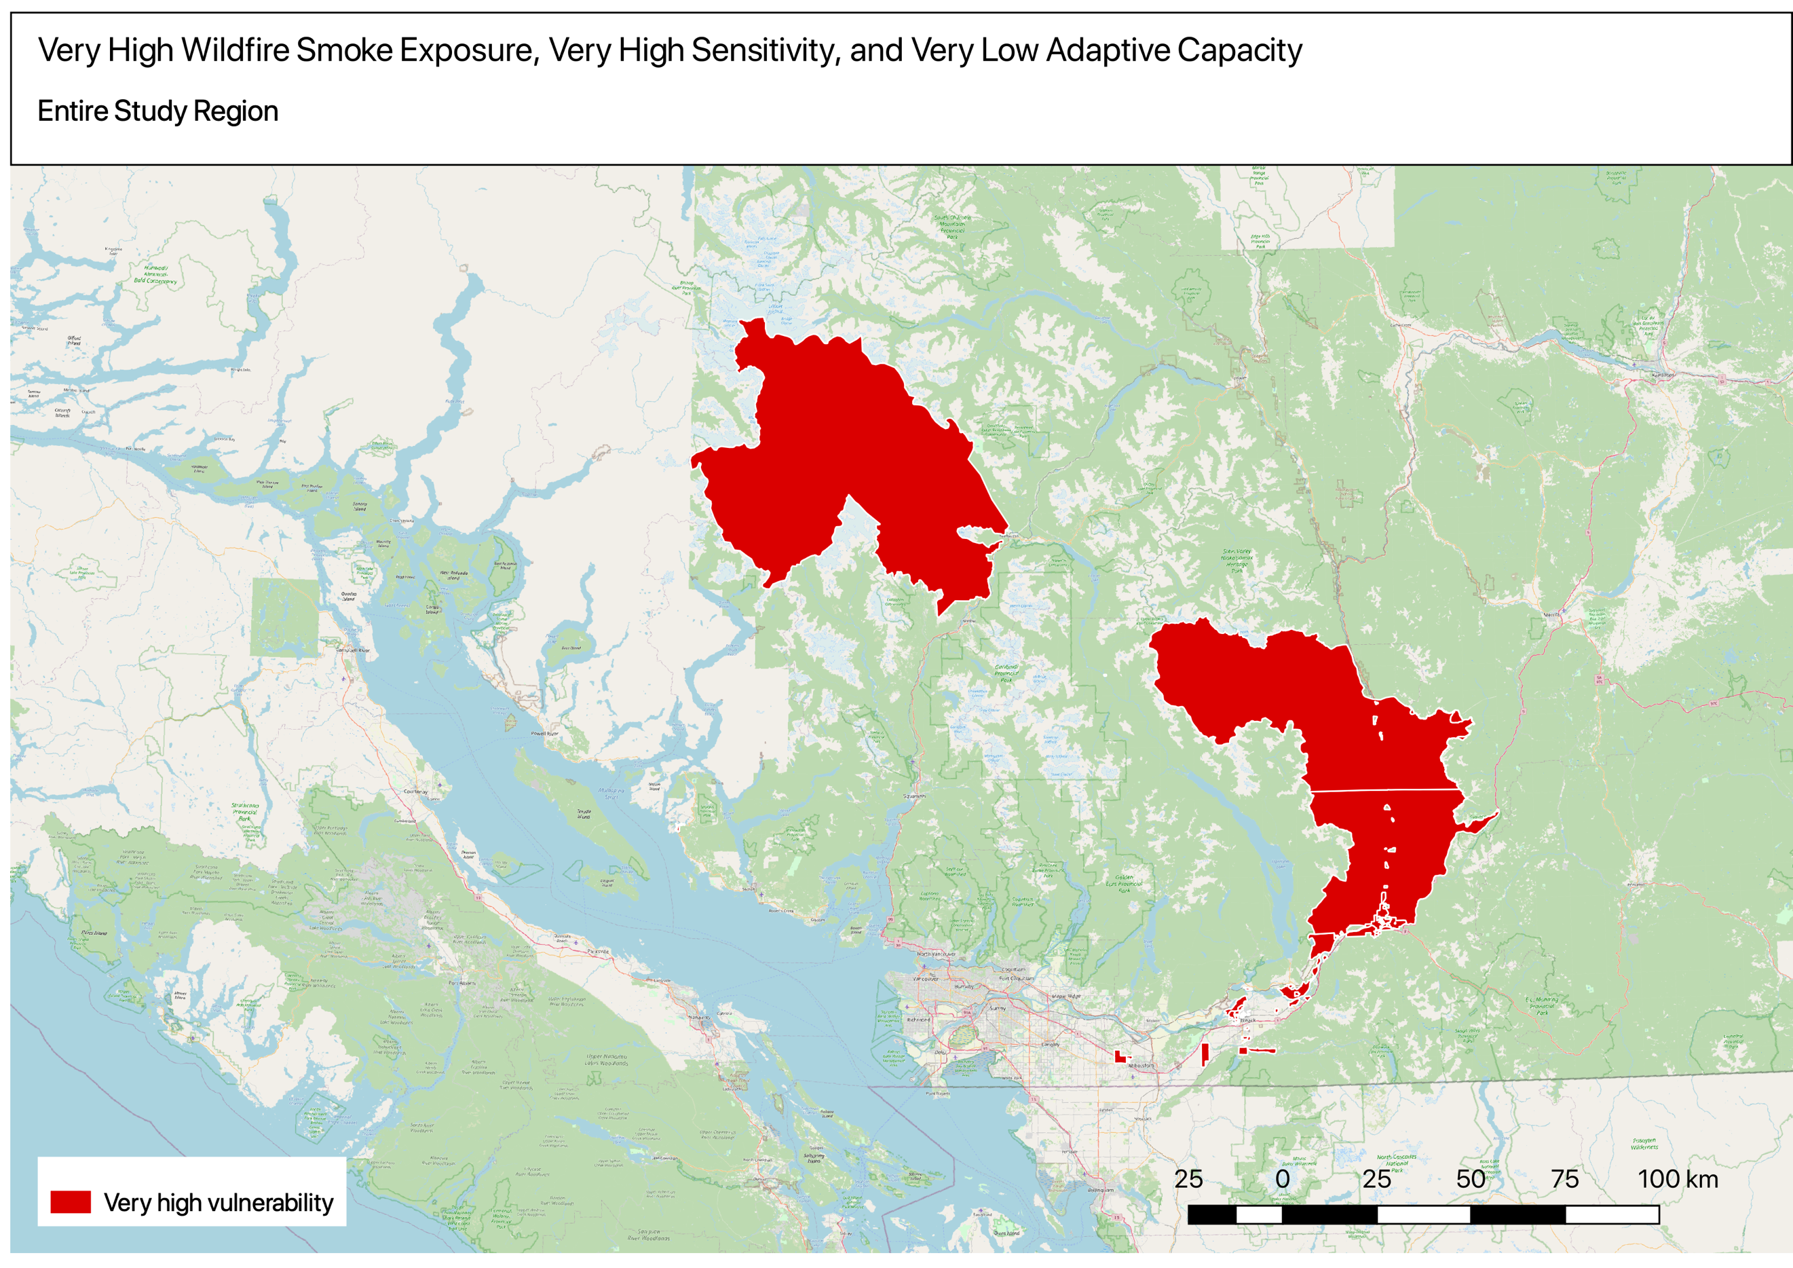
Figure 11: Lowest vulnerability - very low ozone exposure and sensitivity and very high adaptive capacity (~21 DAs)

