Exposure to arsenic at different life-stages and DNA methylation meta-analysis in buccal cells and leukocytes

Authors: Anne K. Bozack,¹ Philippe Boileau,² Linqing Wei,² Alan E. Hubbard,² Fenna C. M. Sillé,³ Catterina Ferreccio,⁴ Johanna Acevedo,^{5,6} Lifang Hou,⁷ Vesna Ilievski,⁸ Craig M. Steinmaus,¹ Martyn T. Smith,¹ Ana Navas-Acien,⁸ Mary V. Gamble,⁸ and Andres Cardenas¹

SUPPLEMENTAL MATERIALS
Figure S1: The leading principal components of the 5,000 most variable CpG sites across the Chile study’s buccal cell and PBMC samples suggest that within-participant similarity is not a significant source of variability.

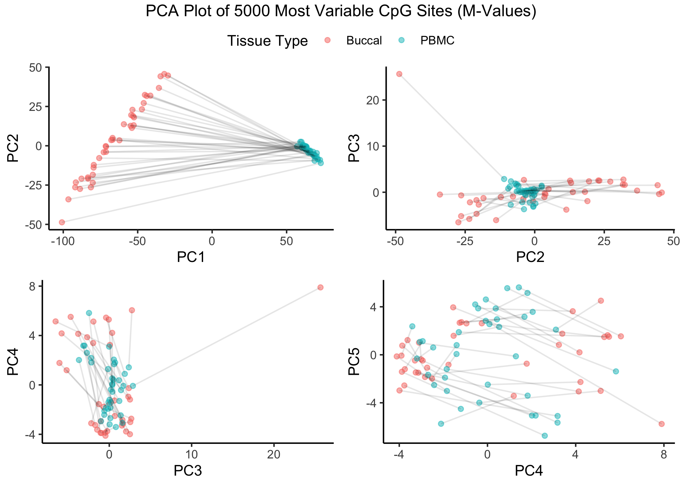

Figure S2: A permutation test of within-individual similarity scores identifies one nominally significant pair of samples (p < 0.05). After correcting for multiple testing (FDR < 0.05, FWER < 0.05), no samples are found to be significantly similar.

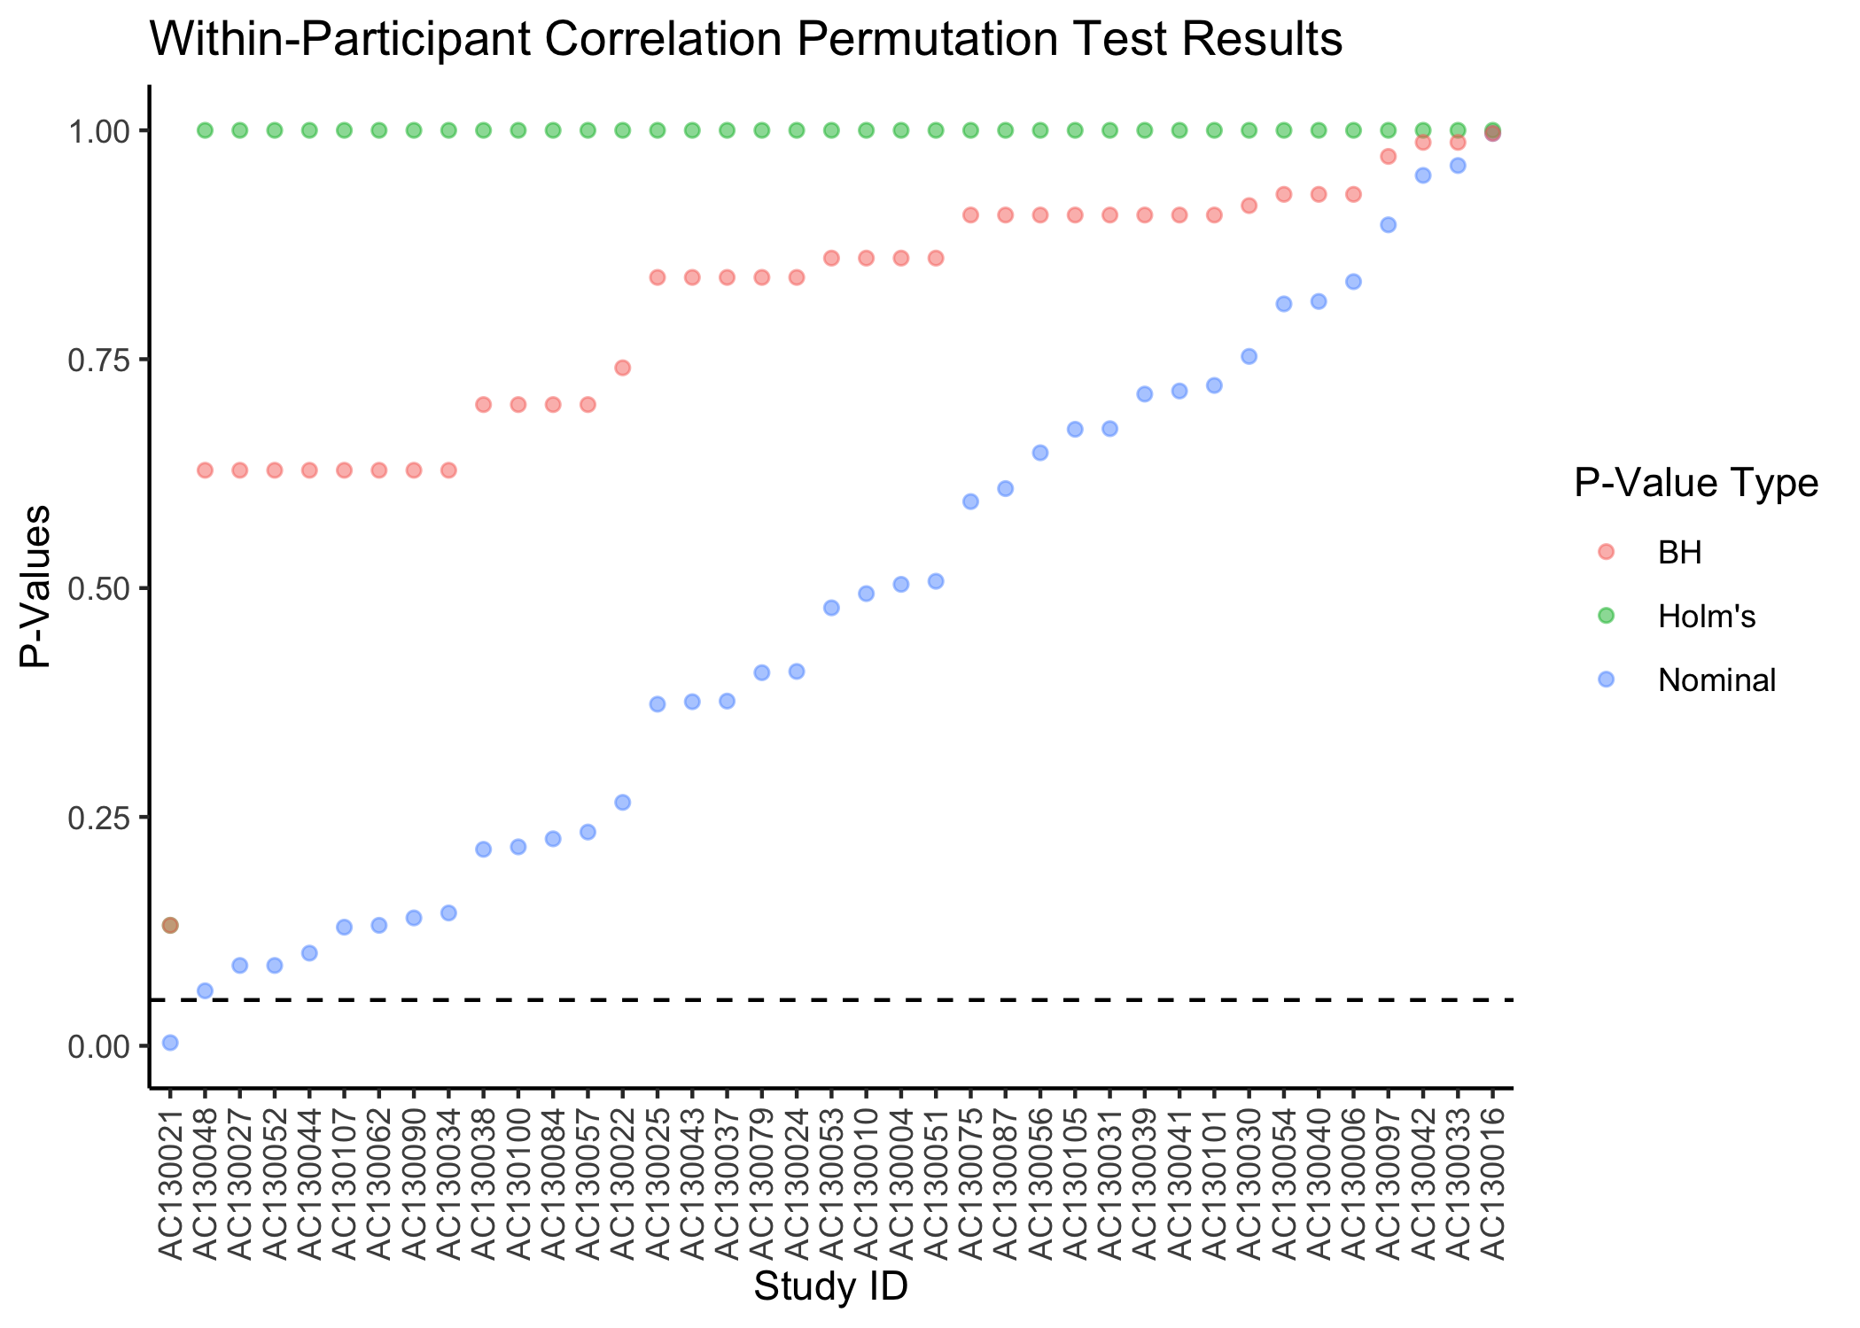

Figure S3: Q-Q plot of meta-analysis results of differentially methylated positions (DMPs) in PBMC EWAS (i.e., the Chile PBMC study, Bangladesh 450K study, and Bangladesh 850K study) adjusted for age, smoking status, cell type proportions, and sex in the Chile studies.

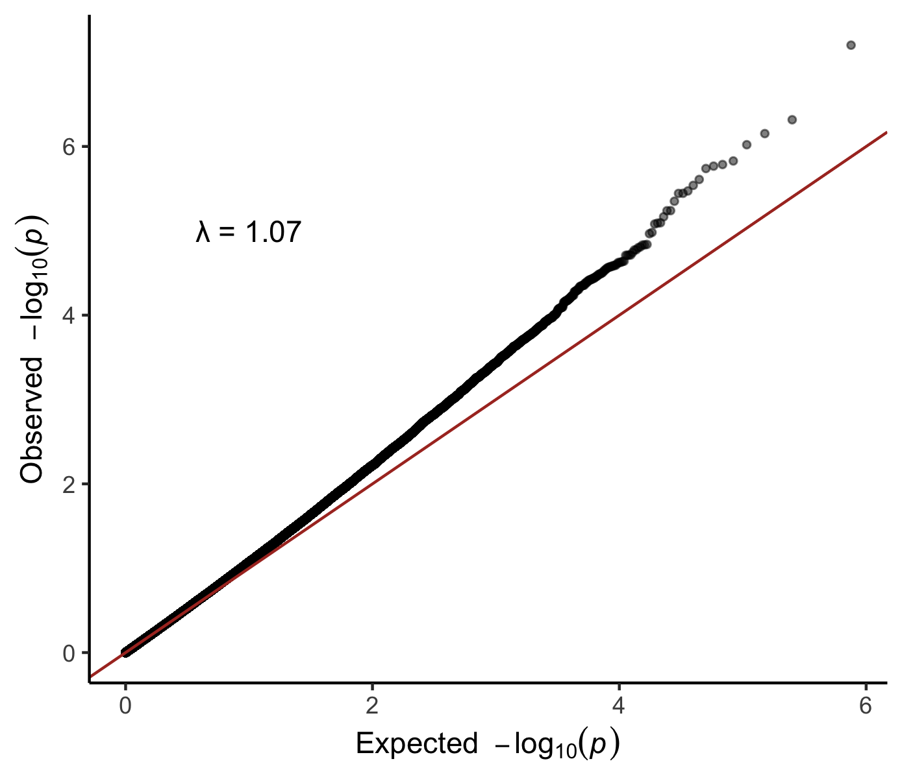
Figure S4: Q-Q plot of meta-analysis results of differentially variable positions (DVPs) in PBMC EWAS (i.e., the Chile PBMC study, Bangladesh 450K study, and Bangladesh 850K study) adjusted for age, smoking status, cell type proportions, and sex in the Chile studies.

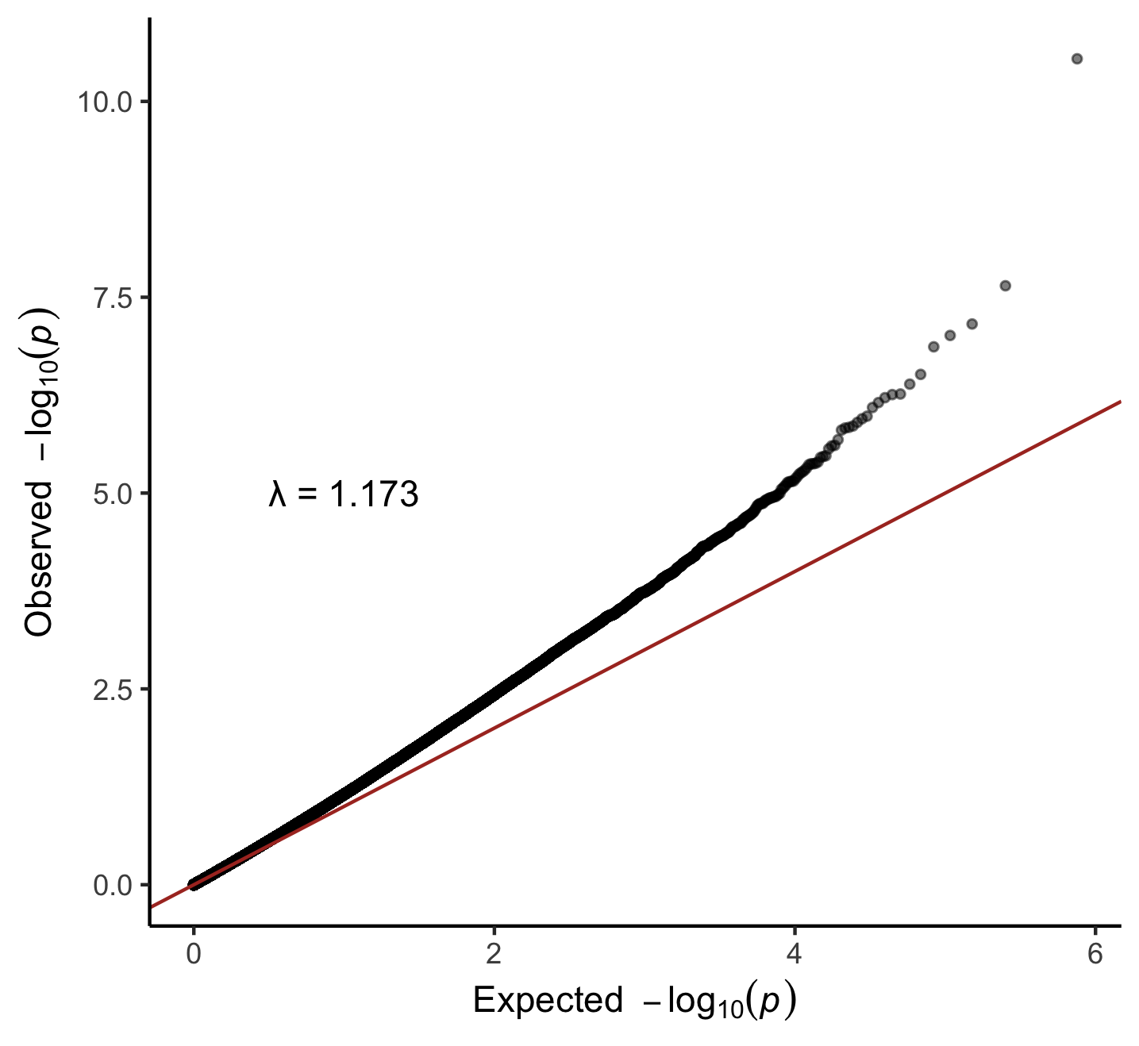

Supplemental Table S1: Heterogeneity of differentially methylated positions (DMPs) and differentially variable positions (DVPs) in meta-analyses. DMPs and DVPs (FDR < 0.05) in the PBMC meta-analysis (i.e., including the Chile PBMC study, Bangladesh 450K study, and Bangladesh 850K study) and PBMC + buccal cell meta-analysis (i.e., including the Chile buccal cell study) adjusted for age, smoking status, cell type proportions, and sex (in the Chile studies).
CpG | Effect | Direction ª | p | FDR | I² | p_{heterogeneity}^{b}
DMPs
PBMCs
cg13490635 | 0.31 | + + + | 6.30e-08 | 0.024 | 43.6 | 0.17
PBMCs + buccal cells
cg09275980 | 0.31 | + + + + | 2.52e-07 | 0.042 | 68.4 | 0.023
cg20784693 | -0.64 | - - - - | 3.08e-07 | 0.042 | 0.0 | 0.47
cg18263451 | -0.12 | - - + - | 3.31e-07 | 0.042 | 77.3 | 0.004
DVPs
PBMCs
cg23281729 | 0.97 | - + + | 2.86E-11 | 1.08E-05 | 84.7 | 0.001
cg27425262 | 0.82 | + + + | 2.26E-08 | 0.004 | 78.0 | 0.011
cg11361658 | 0.17 | + + + | 6.94E-08 | 0.009 | 2.2 | 0.36
cg03205258 | 0.69 | + + + | 9.72E-08 | 0.009 | 58.2 | 0.09
cg09692492 | -0.35 | - - - | 1.36E-07 | 0.010 | 42.3 | 0.18
cg11032634 | 0.77 | + + + | 3.06E-07 | 0.019 | 61.8 | 0.07
cg16511076 | 0.13 | + + + | 4.07E-07 | 0.022 | 0.0 | 0.79
cg22387890 | 0.55 | + + + | 5.44E-07 | 0.023 | 66.8 | 0.049
cg22749736 | 0.13 | + + + | 5.53E-07 | 0.023 | 6.2 | 0.34
cg04080724 | 0.14 | + + + | 6.06E-07 | 0.023 | 0.0 | 0.47
cg05169951 | 0.23 | + + + | 6.99E-07 | 0.024 | 4.9 | 0.35
cg00668103 | 0.14 | + + + | 8.08E-07 | 0.025 | 0.0 | 0.86
cg08207566 | 0.12 | + + + | 1.04E-06 | 0.030 | 61.9 | 0.07
cg01101647 | 0.13 | + + + | 1.13E-06 | 0.030 | 79.6 | 0.007
cg07611790 | 0.11 | + + + | 1.25E-06 | 0.031 | 0.0 | 0.86
cg11691429 | 0.21 | + + + | 1.39E-06 | 0.031 | 12.7 | 0.32
cg21185289 | 0.38 | + + + | 1.45E-06 | 0.031 | 0.0 | 0.93
cg08285768 | 0.11 | + + + | 1.48E-06 | 0.031 | 62 | 0.07
cg13972353 | 0.15 | + + + | 1.57E-06 | 0.031 | 0.0 | 0.69
cg06740986 | 0.11 | + + + | 2.08E-06 | 0.039 | 0.0 | 0.37
cg21857098 | 0.12 | + + + | 2.46E-06 | 0.043 | 68.6 | 0.041
cg03479942 | 0.13 | + + + | 2.50E-06 | 0.043 | 65.5 | 0.06
cg07984508 | 0.11 | + + + | 2.73E-06 | 0.045 | 80.6 | 0.006
PBMCs + buccal cells
cg23281729 | 0.99 | -+++ | 2.00E-14 | 7.51E-09 | 77.2 | 0.004
cg27425262 | 0.90 | + + + + | 4.52E-13 | 8.53E-08 | 69.7 | 0.020
cg03205258 | 0.64 | + + + + | 7.95E-09 | 0.001 | 42.4 | 0.16
cg11032634 | 0.70 | + + + + | 5.69E-08 | 0.006 | 50.9 | 0.11
cg04080724 | 0.14 | + + + + | 1.14E-07 | 0.009 | 0.0 | 0.68
cg26384602 | -0.12 | - - - - | 1.87E-07 | 0.010 | 71.8 | 0.014
cg11361658 | 0.16 | + + + + | 1.90E-07 | 0.010 | 29.8 | 0.23
cg09692492 | -0.30 | - - - - | 2.32E-07 | 0.011 | 49.7 | 0.11
cg22749736 | 0.12 | + + + + | 4.20E-07 | 0.018 | 11.6 | 0.34
cg21921619 | -0.15 | - + - - | 5.48E-07 | 0.021 | 82.0 | 0.001
cg07935287 | -0.13 | - - - - | 7.91E-07 | 0.026 | 54.4 | 0.09
cg05169951 | 0.22 | + + + + | 8.19E-07 | 0.026 | 0.0 | 0.40
cg21185289 | 0.37 | + + + + | 1.01E-06 | 0.030 | 0.0 | 0.95
cg22387890 | 0.48 | + + + + | 1.12E-06 | 0.030 | 63.4 | 0.042
cg13171197 | 0.12 | + - + + | 1.46E-06 | 0.037 | 48.9 | 0.12
cg24754507 | -0.10 | - - - - | 1.55E-06 | 0.037 | 23.7 | 0.27
cg00355447 | 0.14 | + + + + | 1.80E-06 | 0.039 | 3.8 | 0.37
cg16511076 | 0.12 | + + + - | 1.87E-06 | 0.039 | 58.7 | 0.06
cg04873963 | -0.10 | - - - - | 2.46E-06 | 0.049 | 41.3 | 0.16
DMP: differentially methylated position; DVP: differentially variable position. a. Direction of association between arsenic exposure and DNAm in each EWAS. For PBMCs, associations are listed in the following order: Bangladesh 850K, Bangladesh 450K, Chile PBMCs. For PBMCs + buccal cells, associations are listed in the following order Bangladesh 850K, Bangladesh 450K, Chile PBMCs, Chile buccal cells. b. Cochran’s Q test.

Supplemental Table S2: KEGG pathway analysis of differentially methylated regions (DMRs) and differentially variable regions (DVRs) in the PBMC meta-analysis (i.e., including the the Chile PBMC study, Bangladesh 450K study, and Bangladesh 850K study) and PBMC + buccal cell meta-analysis (i.e., including the Chile buccal cell study) adjusted for age, smoking status, cell type proportions, and sex (in the Chile studies). Pathways significant at p < 0.05 are shown.

Pathway | Description | N genes in pathway | N genes containing DMPs or DVPs | p
DMPs
PBMCs
hsa00062 | Fatty acid elongation | 25 | 1 | 0.012
hsa01212 | Fatty acid metabolism | 54 | 1 | 0.030
hsa04142 | Lysosome | 123 | 1 | 0.047
PBMCs + buccal cells
hsa00670 | One carbon pool by folate | 19 | 1 | 0.019
hsa04964 | Proximal tubule bicarbonate reclamation | 21 | 1 | 0.023
hsa04150 | mTOR signaling pathway | 150 | 2 | 0.028
hsa00062 | Fatty acid elongation | 25 | 1 | 0.035
hsa04136 | Autophagy - other | 29 | 1 | 0.042
DVPs
PBMCs
hsa00513 | Various types of N-glycan biosynthesis | 37 | 2 | 0.014
hsa05140 | Leishmaniasis | 65 | 2 | 0.036
hsa04144 | Endocytosis | 238 | 4 | 0.042
hsa04657 | IL-17 signaling pathway | 87 | 2 | 0.042
hsa04620 | Toll-like receptor signaling pathway | 83 | 2 | 0.050
PBMCs + buccal cells
hsa00051 | Fructose and mannose metabolism | 32 | 2 | 0.014
hsa00590 | Arachidonic acid metabolism | 61 | 2 | 0.017
hsa04144 | Endocytosis | 238 | 5 | 0.017
hsa04514 | Cell adhesion molecules | 133 | 3 | 0.049

Supplemental Table S3: Summary of genes containing differentially methylated positions (DMPs) of differentially variable positions (DVPs) identified in meta-analyses in and previous EWAS.

CpG | Gene | Associations in meta-analyses | Previously identified associations annotated to gene
cg13490635 | RBPMS | DMP in PBMC meta-analysis | 1 CpG (FDR < 0.05; Rojas et al. 2015)  1 CpG (p < 0.05; Bozack et al. 2020)
cg20784693 | HDAC4 | DMP in PBMC + buccal cell meta-analysis | 4 CpGs (FDR < 0.05; Rojas et al. 2015)  38 CpGs (p < 0.05; Bozack et al. 2020)
cg23281729 | PARD6G | DVP in PBMC and PBMC + buccal cell meta-analyses | 1 CpG (FDR < 0.05; Rojas et al. 2015)  2 CpGs (p < 0.05; Bozack et al. 2020)
cg03205258; cg11032634 | TXNRD2 | DVP in PBMC and PBMC + buccal cell meta-analyses | 3 CpGs (p < 0.05; Bozack et al. 2020)
 | COMT |  | 4 CpGs (p < 0.05; Bozack et al. 2020)
cg22387890 | USP42 | DVP in PBMC and PBMC + buccal cell meta-analyses | 5 CpGs (p < 0.05; Bozack et al. 2020)
cg22749736 | TOLLIP | DVP in PBMC and PBMC + buccal cell meta-analyses | 2 CpGs (FDR < 0.05; Rojas et al. 2015)  8 CpGs (p < 0.05; Bozack et al. 2020)
cg04080724 | C4orf49 | DVP in PBMC and PBMC + buccal cell meta-analyses | 1 CpG (p < 0.05; Bozack et al. 2020)
cg05169951 | KREMEN2 | DVP in PBMC and PBMC + buccal cell meta-analyses | 1 CpG (p < 0.05; Bozack et al. 2020)
 | PAQR4 |  | 2 CpGs (p < 0.05; Bozack et al. 2020)
cg00668103 | C7orf51 | DVP in PBMC meta-analysis | 1 CpG (p < 0.05; Bozack et al. 2020)
cg01101647 | EPHA5 | DVP in PBMC meta-analysis | 7 CpGs (p < 0.05; Bozack et al. 2020)
cg07611790 | RASIP1 | DVP in PBMC meta-analysis | 1 CpG (FDR < 0.05; Rojas et al. 2015)  1 CpG (p < 0.05; Bozack et al. 2020)
cg11691429 | SNTG2 | DVP in PBMC meta-analysis | 3 CpGs (FDR < 0.05; Rojas et al. 2015)  9 CpGs (p < 0.05; Bozack et al. 2020)
cg21185289 | TLX2 | DVP in PBMC and PBMC + buccal cell meta-analyses | 1 CpG (p < 0.05; Bozack et al. 2020)
cg08285768 | AKAP13 | DVP in PBMC meta-analysis | 11 CpGs (p < 0.05; Bozack et al. 2020)
cg13972353 | SEC16A | DVP in PBMC meta-analysis | 3 CpGs (p < 0.05; Bozack et al. 2020)
cg06740986 | FAM129A | DVP in PBMC meta-analysis | 1 CpG (p < 0.05; Bozack et al. 2020)
cg03479942 | SNTB2 | DVP in PBMC meta-analysis | 1 CpG (p < 0.05; Bozack et al. 2020)
cg26384602 | HNRNPUL1 | DVP in PBMC + buccal cell meta-analysis | 1 CpG (FDR < 0.05; Kaushal et al. 2017)  3 CpGs (p < 0.05; Bozack et al. 2020)
cg21921619 | ATRNL1 | DVP in PBMC + buccal cell meta-analysis | 1 CpG (p < 0.05; Bozack et al. 2020)
cg07935287 | WDR7 | DVP in PBMC + buccal cell meta-analysis | 1 CpG (p < 0.05; Bozack et al. 2020)
cg24754507 | GPX6 | DVP in PBMC + buccal cell meta-analysis | 1 CpG (p < 0.05; Bozack et al. 2020)
cg00355447 | HCG18 | DVP in PBMC + buccal cell meta-analysis | 6 CpGs (FDR < 0.05; Rojas et al. 2015)  4 CpGs (p < 0.05; Bozack et al. 2020)

