SUPPLEMENTARY MATERIALS

Table S1: Quality Assessment of studies included in the meta-analysis using the Newcastle-Ottawa Scaling

Studies | Selection |  |  |  | Comparability |  | Outcome/Exposure |  |  | Total Score | Score (%) | Risk
Studies | 1 | 2 | 3 | 4 | 1 | 2 | 1 | 2 | 3 | Total Score | Score (%) | Risk
Gent et al., 2002 | * | * | * | * | * | * | - | * | * | 8 | 89 | ꜜ
Rosenbaum et al., 2010 | - | * | * | * | * | * | * | * | * | 8 | 89 | ꜜ
Horick et al., 2006 | * | * | * | * | * | * | - | - | * | 7 | 78 | ꜛ
Park et al., 2001 | * | * | * | * | * | * | * | * | * | 9 | 100 | ꜜ
Harley et al., 2009 | * | * | * | * | * | * | * | * | * | 9 | 100 | ꜜ
Litongua et al., 2002 | - | * | * | * | * | * | - | * | * | 7 | 78 | ꜛ
Campo et al., 2006 | * | * | * | * | * | * | - | * | * | 8 | 89 | ꜜ
Gillespie et al. 2006 | * | * | * | * | * | * | - | * | * | 8 | 89 | ꜜ
Perzanowski et al. 2006 | - | * | * | * | * | * | - | * | * | 7 | 78 | ꜛ
Karvonen et al. 2012 | * | * | * | * | * | * | - | * | - | 7 | 78 | ꜛ
Stark et al., 2005 | * | * | * | * | * | * | * | * | * | 9 | 100 | ꜜ
Biagini et al., 2006 | - | * | * | * | * | * | - | * | * | 7 | 78 | ꜛ
Bolte et al., 2003 | * | * | * | - | * | * | - | * | * | 7 | 78 | ꜛ
Douwes et al., 2006 | * | * | * | - | * | * | * | - | * | 7 | 78 | ꜛ
Phipatanakul et al., 2005 | * | * | * | - | * | * | - | * | * | 7 | 78 | ꜛ
Note:
Low Risk of Bias = ≥80% = ꜜ
High Risk of Bias = <80% = ꜛ

Table S2: Leave-one-out sensitivity Analysis of pooled effect estimates of studies included in the meta-analysis
Study ID; Year/Country | N | I² (%) | Summary EE [95%CI] | P-value | Weight (%)
Wheeze
All Studies | 12 | 78 | 1.20 [1.05, 1.38] | 0.009 | 100.0
Gent et al., 2002/USA | 11 | 77 | 1.18 [1.02, 1.36] | 0.02 | 9.6
Rosenbaum et al., 2010/USA | 11 | 78 | 1.18 [1.03, 1.35] | 0.02 | 3.2
Horick et al., 2006/USA | 11 | 79 | 1.18 [1.03, 1.36] | 0.02 | 3.6
Park et al., 2001/USA | 11 | 79 | 1.20 [1.03, 1.40] | 0.02 | 10.1
Harley et al., 2009/USA | 11 | 78 | 1.18 [1.02, 1.35] | 0.02 | 7.2
Litongua et al., 2002/USA | 11 | 79 | 1.18 [ 1.03. 1.36] | 0.02 | 5.9
Campo et al., 2006/USA | 11 | 79 | 1.24 [ 1.08, 1.42] | 0.003 | 5.0
Gillespie et al. 2006/Europe | 11 | 79 | 1.20 [1.03, 1.40] | 0.02 | 10.2
Perzanowski et al. 2006/USA | 11 | 80 | 1.23 [1.05, 1.43] | 0.01 | 10.4
Karvonen et al. 2012/Europe | 11 | 61 | 1.24 [1.09, 1.41] | 0.001 | 11.8
Bolte et al., 2003/Europe | 11 | 79 | 1.19 [1.03, 1.38] | 0.02 | 9.9
Douwes et al., 2006/Europe | 11 | 79 | 1.24 [1.08, 1.42] | 0.003 | 5.3
Phipatanakul et al., 2005/USA | 11 | 78 | 1.18 [1.02, 1.36] | 0.02 | 7.9
Allergic rhinitis
All Studies | 3 | 70 | 1.18 [0.94, 1.48] | 0.16 | 100.0
Gillespie et al., 2006/Europe | 2 | 76 | 1.34 [0.91, 1.95] | 0.13 | 31.8
Perzanowski et al., 2006/USA | 2 | 78 | 1.32 [0.87, 2.01] | 0.19 | 35.8
Stark et al., 2005/USA | 2 | 13 | 1.03 [0.91, 1.17] | 0.66 | 23.1
Biagini et al., 2006/USA | 2 | 76 | 1.14 [0.90, 1.44] | 0.29 | 9.3
Asthma
All Studies | 1 | 58 | 0.78 [0.62, 0.99] | 0.04 | 100.0
Karvonen et al. 2012/Europe | 0 | # | 0.67 [0.51, 0.89] | 0.006 | 62.3
Douwes et al., 2006/Europe | 0 | # | 0.86 [0.75, 1.00] | 0.04 | 37.7

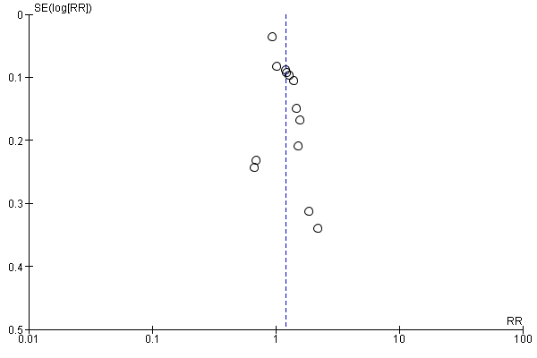 | 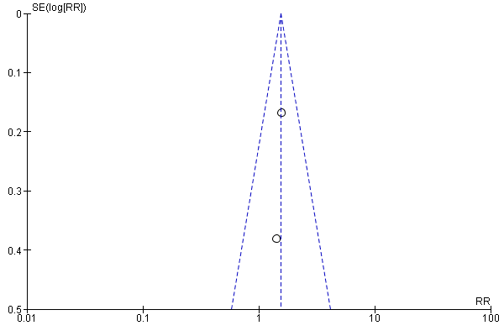 | 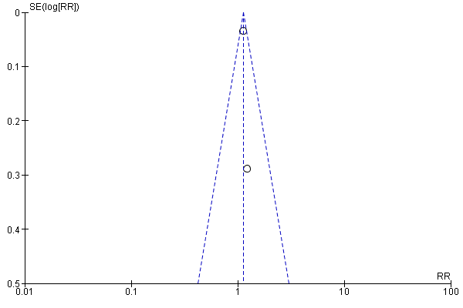
A. | B. | C.
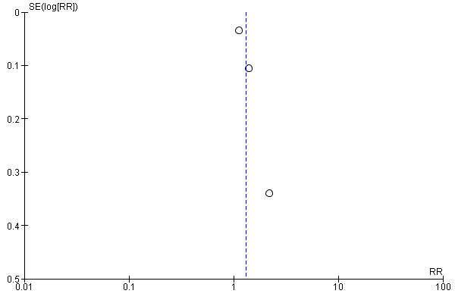 | 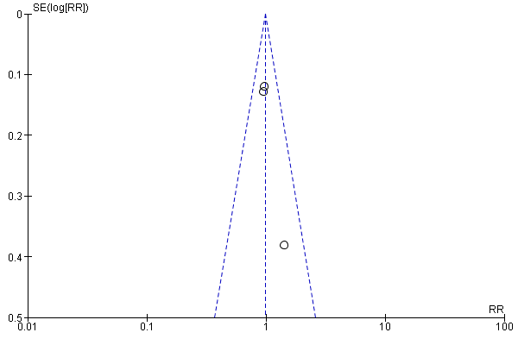 | 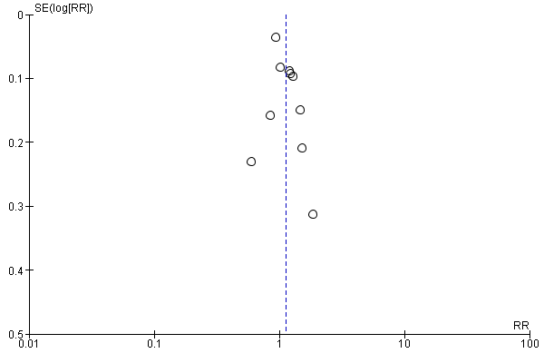
D. | E. | F.
Figure S1: Funnel plots with pseudo-95% confidence limit for any IM exposure and wheeze among U-5C (A); TFC and wheeze (B); Aspergillus spp. and wheeze (C); Penicillium spp. and wheeze (D); Cladosporium spp and wheeze (E); Endotoxin and wheeze (F)

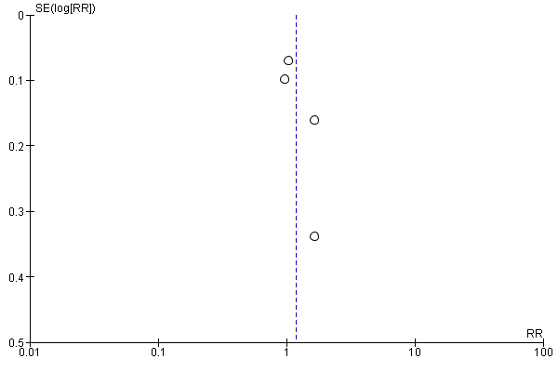 | 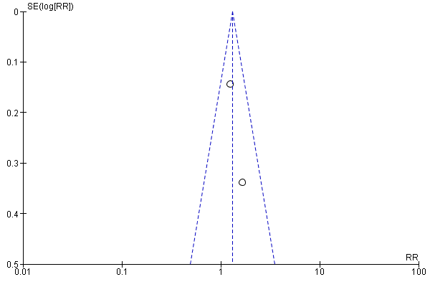 | 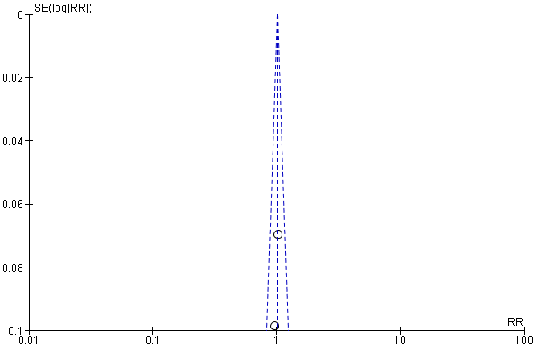
A. | B. | C.
Figure S2: Funnel plots with pseudo-95% confidence limit for any IM exposure and allergic rhinitis among U-5C (A); visible mold and allergic rhinitis (B); Endotoxin and allergic rhinitis (C).

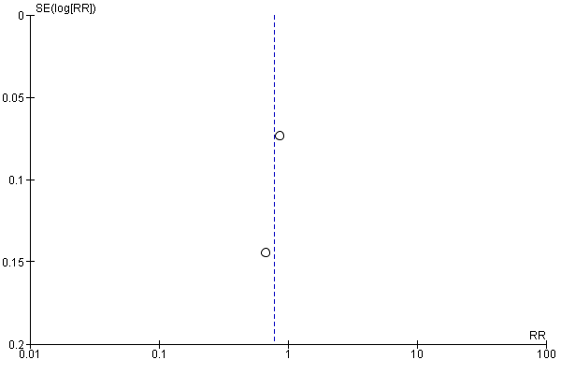

Figure Figure S3: Funnel plots with pseudo-95% confidence limit for any IM exposure/endotoxin and asthma among U-5C

