Supplemental Figure S1. Distribution of NDVI by site in the MESA cohort study participants
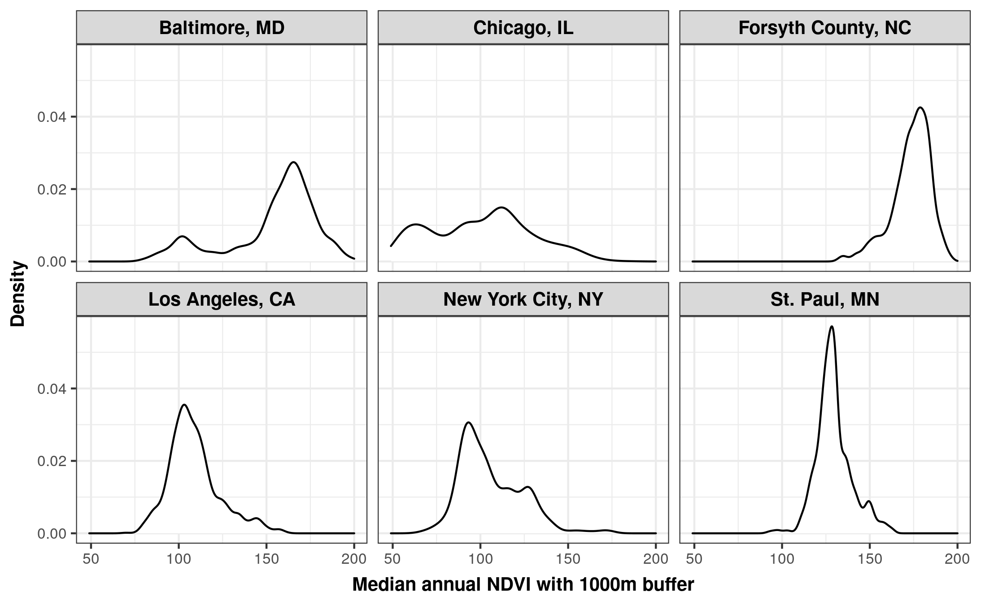

Supplemental Table S1. Distribution of NDVI by site and overall
Site | Min | 25th % | Median | 75th % | Max | IQR
Annual Median NDVI, 1000m buffer
All | 49 | 102 | 124 | 157 | 200 | 55
Forsyth County, NC | 132 | 168 | 176 | 181 | 196 | 13
New York, NY | 65 | 92 | 102 | 118 | 174 | 26
Baltimore, MD | 80 | 147 | 162 | 170 | 200 | 23
St. Paul, MN | 92 | 123.25 | 128 | 134 | 163 | 10.75
Chicago, IL | 49 | 75 | 102 | 119 | 185 | 44
Los Angeles, CA | 70 | 100 | 106 | 115 | 161 | 15
High Vegetation Season NDVI, 1000m buffer
All | 60 | 106 | 140 | 178 | 218 | 72
Forsyth County, NC | 144 | 186 | 196 | 202 | 216 | 16
New York, NY | 75 | 100 | 111 | 128 | 218 | 28
Baltimore, MD | 85 | 157 | 177 | 187 | 213 | 30
St. Paul, MN | 98 | 153 | 161 | 169 | 210 | 16
Chicago, IL | 60 | 82 | 116 | 134 | 204 | 52
Los Angeles, CA | 70 | 99 | 106 | 115 | 156 | 16
Note: NDVI is on a scale from 0 to 255 in the MESA study.

Supplemental Table S2. Hazard ratios (HRs) and 95% confidence intervals (CIs) for incident diabetes corresponding to a 0.1 increase in NDVI (on a -1 to 1 scale)
Category | HR (95% CI)
1km radius – annual median
Model 1¹ | 0.96 (0.91, 1.01)
Model 2² | 0.95 (0.90, 1.00)
Model 3³ | 0.97 (0.93, 1.02)
1km radius – high vegetation season median
Model 1¹ | 0.96 (0.92, 1.00)
Model 2² | 0.95 (0.91, 0.99)*
Model 3³ | 0.97 (0.93, 1.01)
500m radius - annual median
Model 1¹ | 0.96 (0.92, 1.01)
Model 2² | 0.96 (0.91. 1.01)
Model 3³ | 0.98 (0.93, 1.02)
2.5km radius - annual median
Model 1¹ | 0.97 (0.92, 1.03)
Model 2² | 0.96 (0.91, 1.02)
Model 3³ | 0.99 (0.94, 1.04)
¹ Model 1 adjustment set: age, sex, race/ethnicity, education category, income category, employment status, neighborhood deprivation index, neighborhood social cohesion, neighborhood walkability, neighborhood safety, urbanicity, and site
² Model 2 (primary model) adjustment set: Model 1 adjustment set plus family history of diabetes, BMI, physical activity score, chronic stress, smoking, drinking
³Model 3 adjustment set: site, age, sex, race/ethnicity, education category, income category, employment status, neighborhood deprivation index, family history of diabetes, chronic stress, smoking, drinking.
* p ≤ 0.05

