Supporting information for
The short-term effects and burden of particle air pollution on hospitalization for coronary heart disease: A time-stratified case-crossover study in Sichuan, China

Wanyanhan Jiang^{1¶}, Han Chen^{2¶}, Jiaqiang Liao³, Xi Yang¹, Biao Yang¹, Yuqin Zhang¹, Xiaoqi Pan¹, Lulu Lian⁴,Lian Yang^{1*}

¹ School of Public Health, Chengdu University of Traditional Chinese Medicine, Chengdu, 610075, Sichuan, China
² State Key Laboratory of Grassland and Agro-ecosystem, School of Life Sciences, Lanzhou University, Lanzhou, 730000, Gansu, China
³ West China School of Public Health, Sichuan University, No. 17 People's South Road, Wuhou District, Chengdu, 610041, Sichuan, China
⁴ Key Laboratory for Environmental Pollution Prediction and Control, Gansu Province, College of Earth and Environmental Sciences, Lanzhou University, Lanzhou, 730000, Gansu, China

* Corresponding author: Lian Yang
E-mail: yyanglian@163.com

¶ These authors contributed equally to this work.

S1 Assessment of exposure assessment
For each air pollution, the exposure levels of monitoring station on each date were predicted by the inverse distance weighting (IDW). Then the prediction accuracy was assessed by calculating coefficient of determination (R²), mean absolute error (MAE) and bias between predicted and measured concentrations as follows:
$MEA=\frac{1}{N}\sum_{i=1}^{N}{|P_{i}-M_{i}|}$ (S1)
$bias=\frac{1}{N}\sum_{i=1}^{N}{P_{i}-M_{i}}$ (S2)
where M is measure concentration (μg/m³); $\overline{M}$ is the mean of measured concentrations (μg/m³); P is the predicted concentrations (μg/m³).

Table S1. Performance of IDW method in exposure assessment for the daily air pollutant levels (μg/m³).
Air pollutants | MAE | Bias
PM₁₀ | 47.2 | 1.96
PM_{2.5} | 33.1 | 1.70
NO₂ | 12.3 | 0.976
O₃ | 50.4 | -1.20
SO₂ | 7.0 | 0.87

S2 Data description on city scale
Table S2. Summary statistics of daily CHD hospital admissions in 9 cities in Sichuan Province, 2017-2018.
City | Daily CHD hospital admissions (n)
City | Mean ± SD | Minimum | P₂₅ | P₅₀ | P₇₅ | Maximum
Chengdu | 45 ± 15 | 12 | 31 | 47 | 57 | 81
Guang’an | 11 ± 9 | 1 | 2 | 12 | 18 | 84
Liangshanzhou | 5 ± 3 | 1 | 3 | 4 | 7 | 29
Luzhou | 4 ± 2 | 1 | 2 | 3 | 5 | 14
Meishan | 13 ± 5 | 2 | 9 | 12 | 16 | 39
Mianyang | 21 ± 11 | 2 | 13 | 19 | 28 | 60
Nanchong | 4 ± 3 | 1 | 2 | 3 | 5 | 14
Yibin | 28 ± 11 | 7 | 20 | 26 | 33 | 83
Zigong | 15 ± 9 | 1 | 8 | 13 | 22 | 56
SD: standard deviation

Table S3. Mean ± SD (ug/m³) of daily air pollution concentration in 9 cities in Sichuan Province, 2017-2018.
City |  | Mean ± SD (ug/m³)
City | PM₁₀ |  | PM_{2.5} | NO₂ | O₃ | SO₂
Chengdu | 7.5 ± 5.1 |  | 4.7 ± 3.6 | 3.7 ± 1.7 | 8.6 ± 4.7 | 1.1 ± 0.5
Guang’an | 7.3 ± 4.1 |  | 4.4 ± 3.1 | 2.4 ± 1.1 | 7.4 ± 3.9 | 1.2 ± 0.6
Liangshanzhou | 3.9 ± 1.9 |  | 2.2 ± 1.3 | 1.6 ± 0.7 | 8.2 ± 2.7 | 1.4 ± 0.6
Luzhou | 7.2 ± 4.3 |  | 4.7 ± 3.2 | 2.9 ± 1.1 | 7.4 ± 4.1 | 1.7 ± 0.8
Meishan | 7.4 ± 4.5 |  | 4.7 ± 3.2 | 2.9 ± 1.2 | 9 ± 4.3 | 1 ± 0.5
Mianyang | 6.9 ± 4.3 |  | 4.3 ± 2.9 | 2.5 ± 1.1 | 7.9 ± 3.5 | 0.9 ± 0.5
Nanchong | 6.6 ± 3.8 |  | 4.1 ± 2.7 | 2.8 ± 1.2 | 7.6 ± 3.4 | 1.2 ± 0.5
Yibin | 6.8 ± 4.2 |  | 4.7 ± 3.3 | 2.9 ± 1.2 | 7.7 ± 3.8 | 1.8 ± 0.9
Zigong | 7.9 ± 4.9 |  | 5.4 ± 3.8 | 2.7 ± 1 | 8.3 ± 4.1 | 1.3 ± 0.5
SD: standard deviation

Table S4. Mean ± SD (ug/m³) of daily air pollution concentration in 9 cities in Sichuan Province, 2017-2018.
City | Mean ± SD
City | Temperature (℃) | Relative humidity (%)
Chengdu | 7.7 ± 1.2 | 1.7 ± 0.7
Guang’an | 7.8 ± 1.2 | 1.7 ± 0.8
Liangshanzhou | 6.3 ± 1.7 | 1.7 ± 0.6
Luzhou | 8 ± 1.1 | 1.8 ± 0.7
Meishan | 7.8 ± 1.1 | 1.8 ± 0.7
Mianyang | 7.4 ± 1.2 | 1.7 ± 0.8
Nanchong | 7.7 ± 1.2 | 1.7 ± 0.8
Yibin | 8 ± 1.1 | 1.8 ± 0.7
Zigong | 7.9 ± 1.1 | 1.8 ± 0.7
SD: standard deviation

S3 Correlation for air pollution and meteorological data
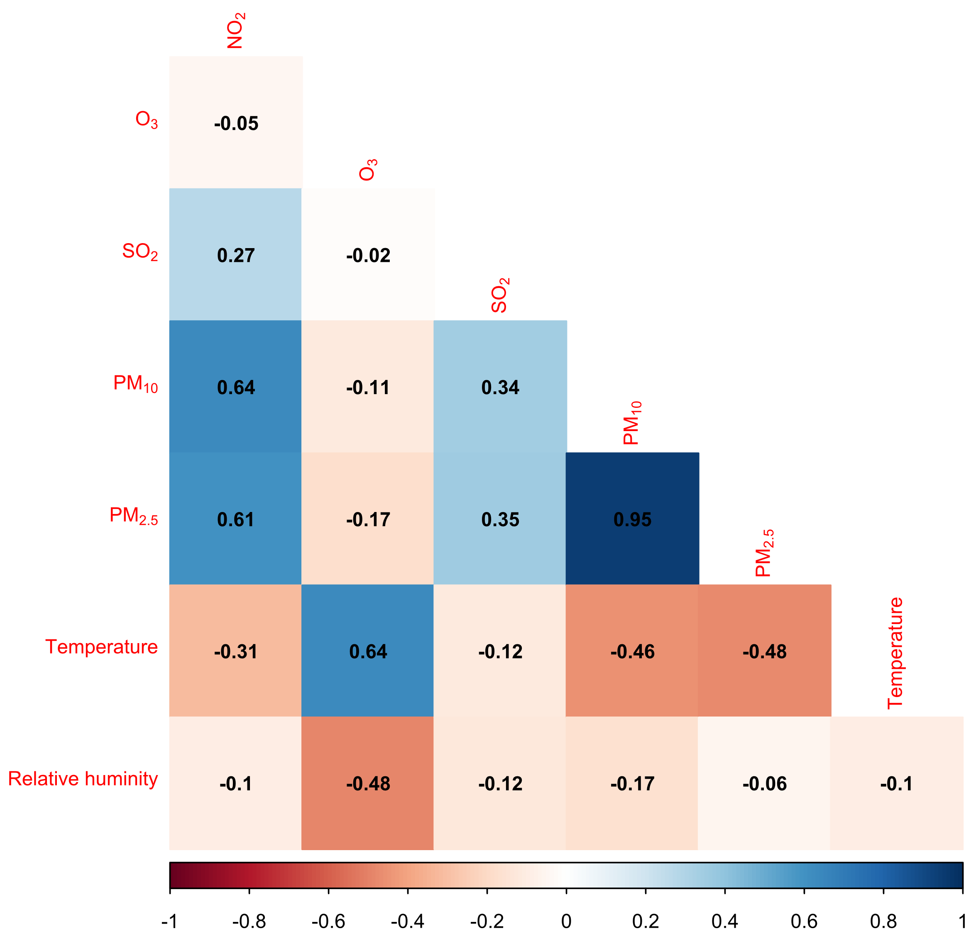
Figure S1. Pearson correlation coefficient between air pollutant levels and weather conditions in 9 cities in Sichuan Province, with the color bar on the bottom of the figure.
The Pearson correlation coefficients for the air pollution levels and meteorological conditions were displayed in Figure S1. As shown, PM_{2.5} was highly correlated with PM₁₀ (r = 0.95, p < 0.001). There was a certain degree of correlation for other gaseous pollutants except O₃ (for SO₂ and NO₂, r = 0.27-0.64, p < 0.001), and PM_{2.5} with meteorological factors.

S4 Sensitivity analysis
In the two-pollutant model, the effects of PM₁₀ and PM_{2.5} on HAs for CHD presented significant after adding NO₂, O₃, or SO₂. In accordance with results estimated from the single-pollutant models, the two-pollutant models at lag7 were fitted to assess the stability of the effects of PM, which was with the largest effects at lag 7.
Table S5. Percentage change (%) and its 95% CI of HAs for CHD associated with 10 μg/m³ increase of PM_{2.5} and PM₁₀ at lag7 after adjusting for NO₂, SO₂, PM_{2.5} and PM₁₀ levels at lag7 in two-pollutant models.
 | PM₁₀ | PM_{2.5}
none | 0.58 (0.33, 0.83) | 0.90 (0.56, 1.24)
+NO₂ | 1.06 (0.59, 1.55) | 1.63 (0.92, 2.35)
+O₃ | 0.48 (0.10, 0.86) | 0.62 (0.09, 1.15)
+SO₂ | 0.90 (0.44, 1.36) | 1.28 (0.62, 1.94)

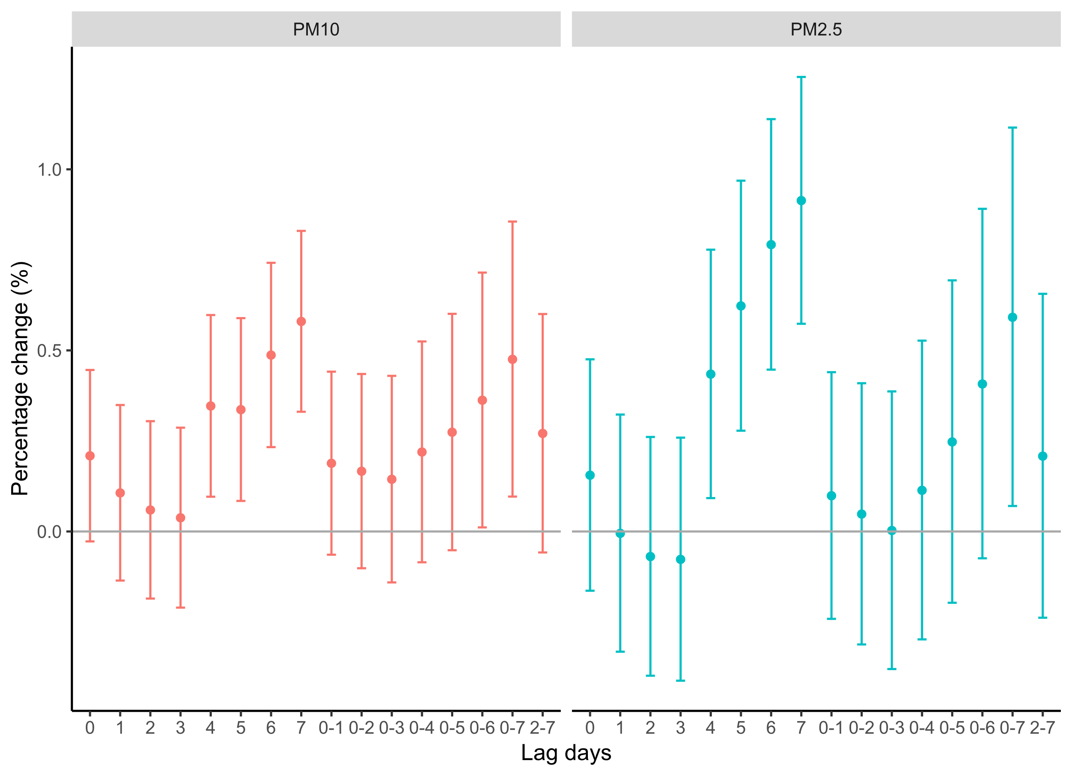
Figure S2. Percentage (95% CI) in HAs for CHD associated with an increase of 10 ug/m³ of PM₁₀, and PM_{2.5} at different lag days using single-pollutant models within the circular areas of 50km surrounding air monitoring stations in Sichuan, 2017-2018

