Supplementary Tables
Table 1. Logistic Regression Results between TCPy Quartiles and Hypertension
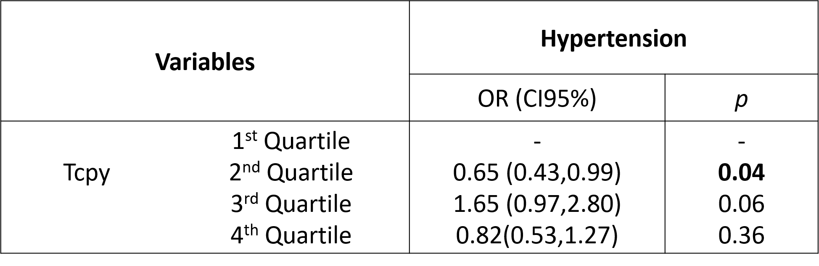
Table 2. Logistic Regression Results between Para-nitrophenol Quartiles and Hypertension
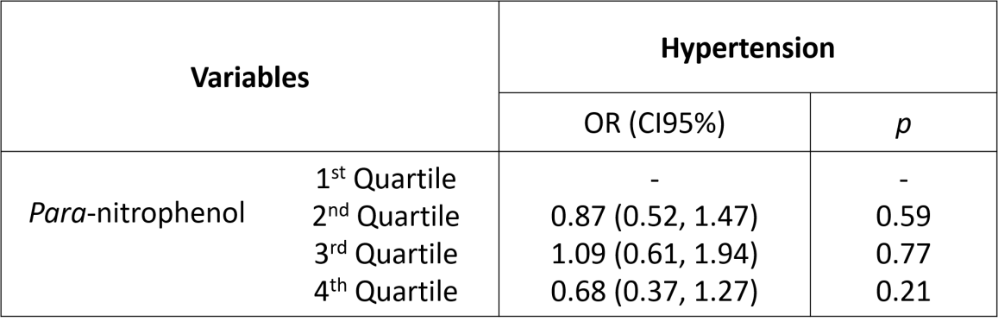
Table 3. Logistic Regression Results between Oxypyrimidine Percentiles and Hypertension 