Associations between long-term exposures to airborne PM_{2.5} components and mortality in Massachusetts: mixture analysis exploration
Additional File 1

Tingfan Jinª, Heresh Amini^{b}, Anna Koshelevaª, Mahdieh Danesh Yazdiª, Yaguang Weiª, Edgar Castroª, Qian Di^{c}, Liuhua Shi^{d}, Joel Schwartzª

ª Department of Environmental Health, Harvard T.H. Chan School of Public Health, Boston MA, US
^{b} Department of Public Health, University of Copenhagen, Copenhagen, Denmark
^{c} Vanke School of Public Health, Tsinghua University, Beijing, China
^{d} Gangarosa Department of Environmental Health, Rollins School of Public Health, Emory University, Atlanta, GA

Corresponding author:
Tingfan Jin
Department of Environmental Health
Harvard T.H. Chan School of Public Health
Boston, MA, United States
tingfanjin@hsph.harvard.edu

Figure S1a. Massachusetts Census Tract Level Mean Pollutants’ Concentrations Across 2000-2009
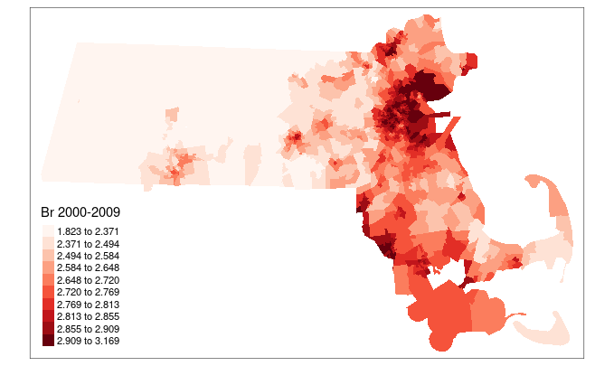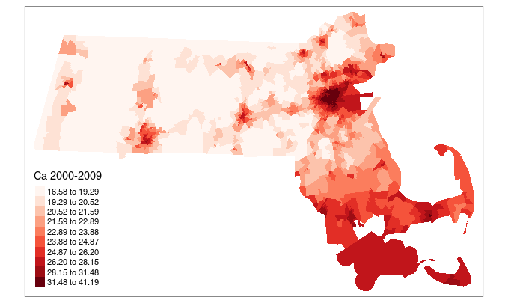
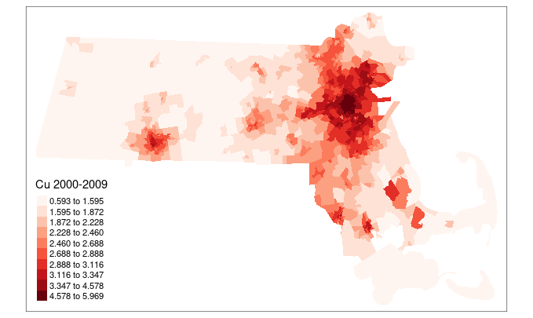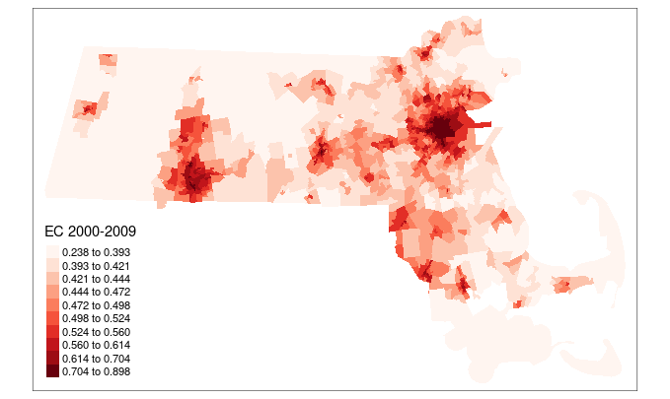
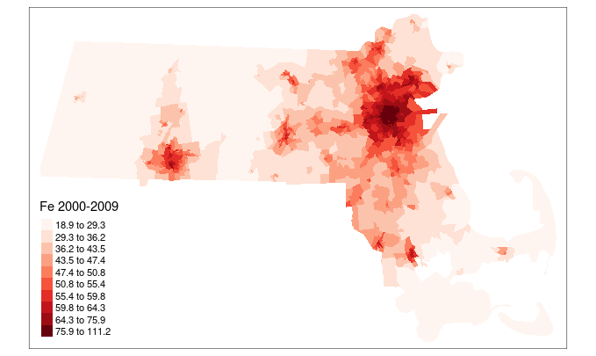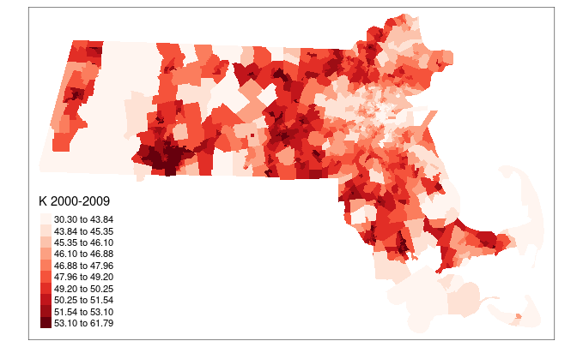
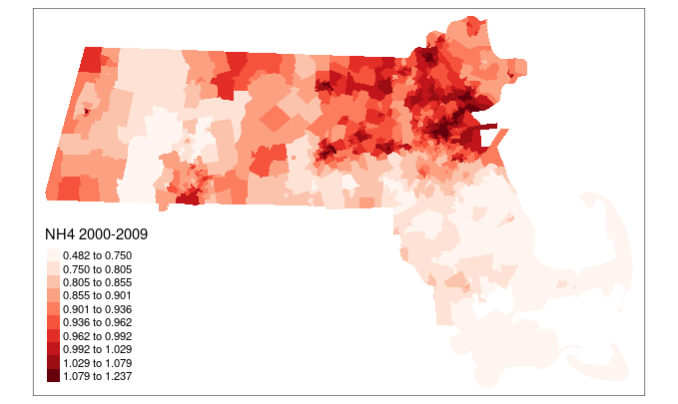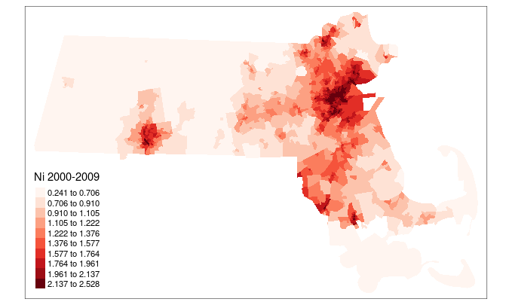
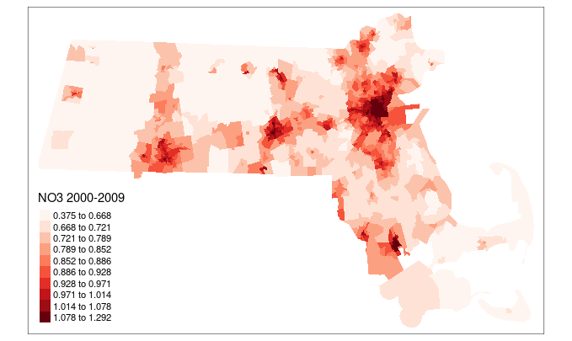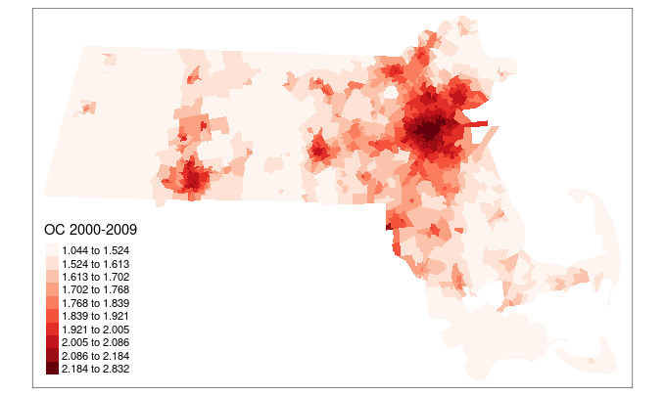
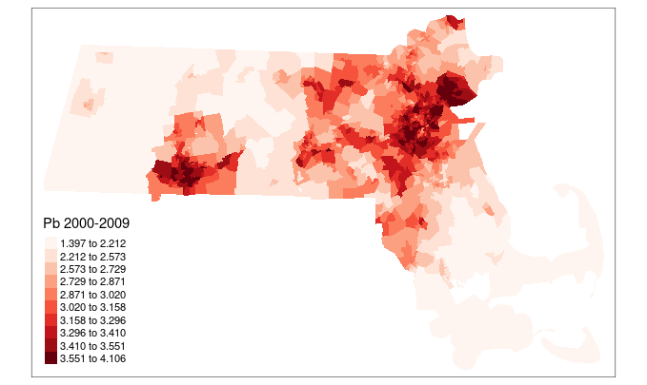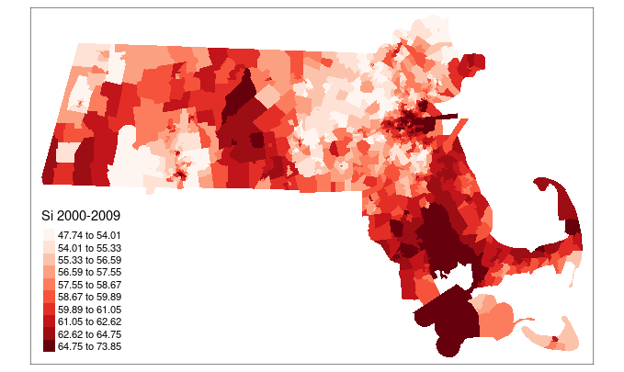
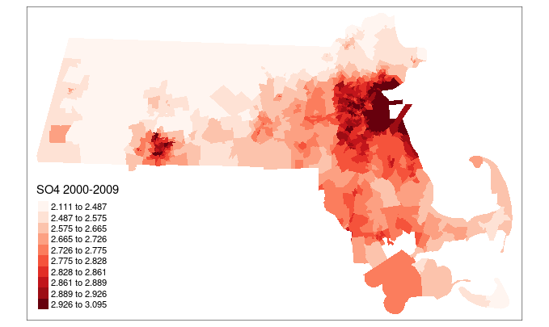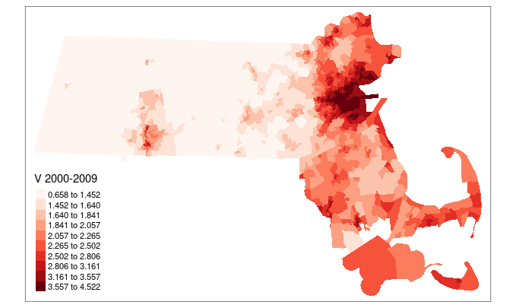
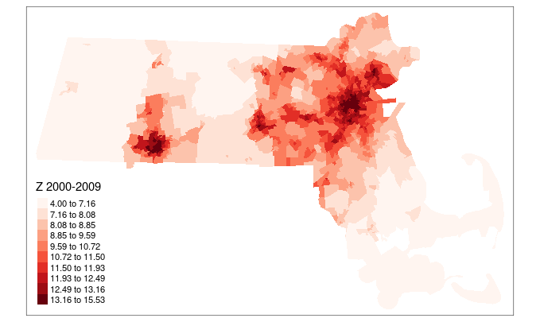

Figure S1b. Massachusetts Census Tract Level Mean Pollutants’ Concentrations Across 2010-2015
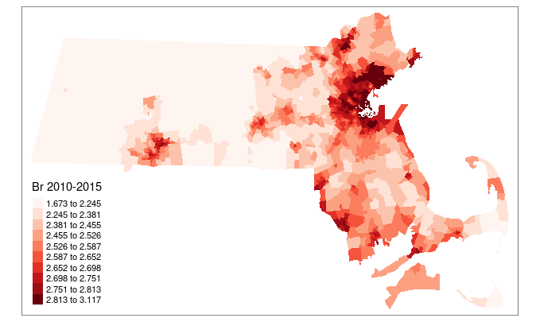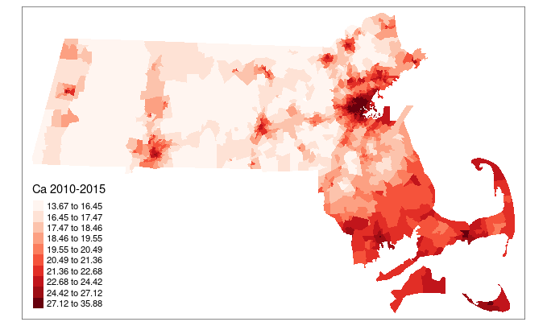
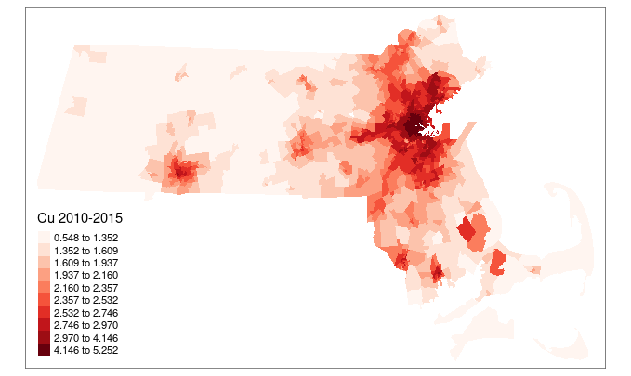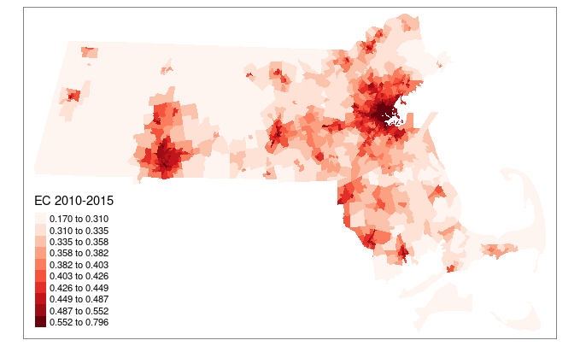
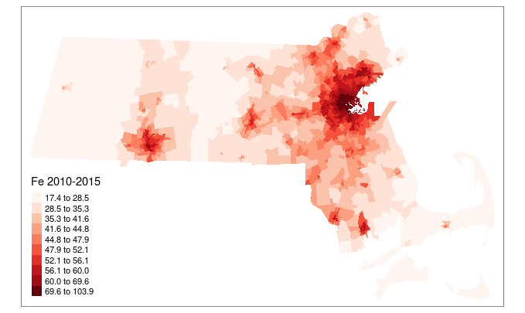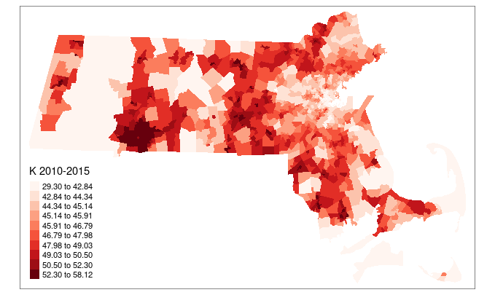
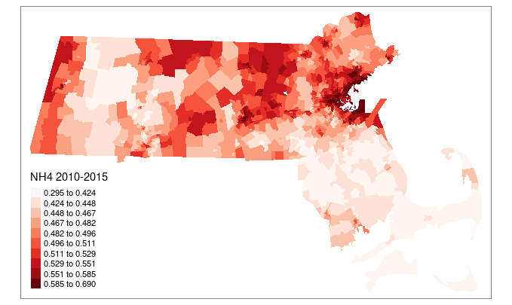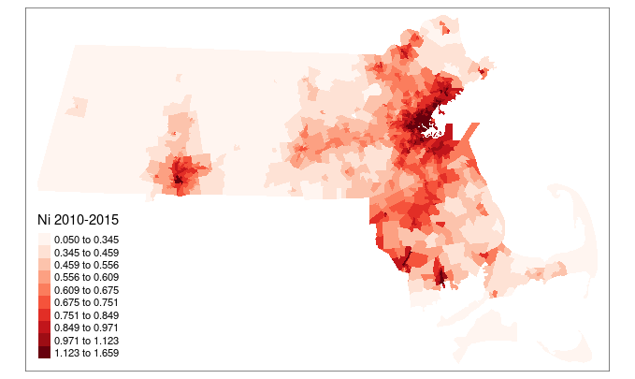

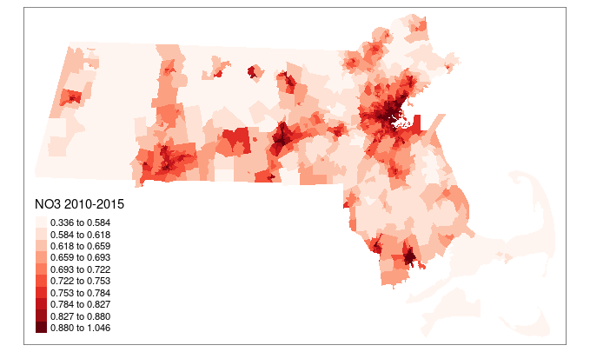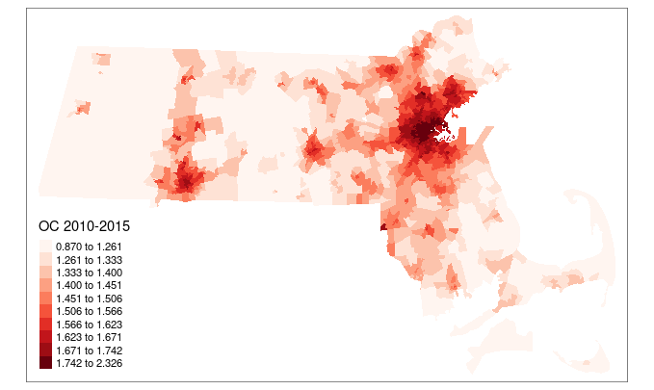
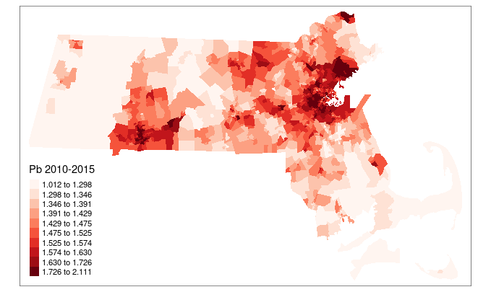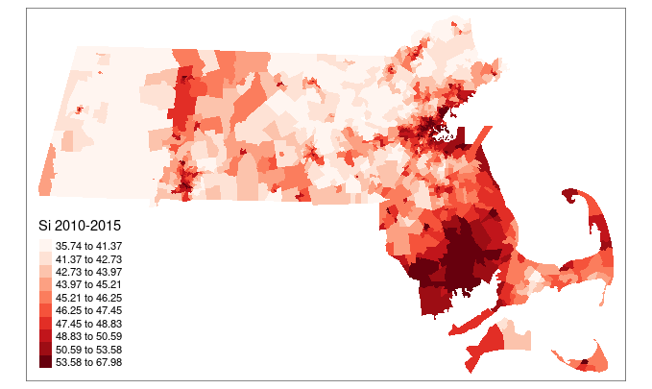
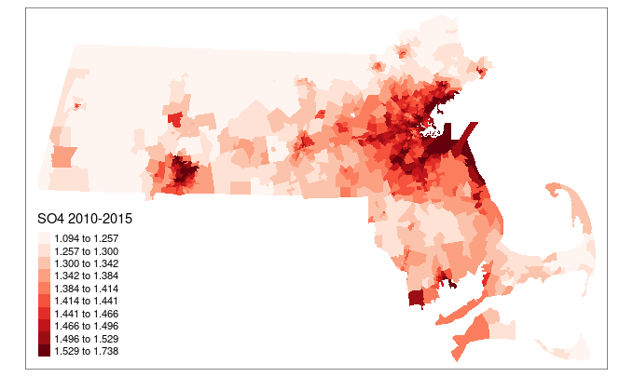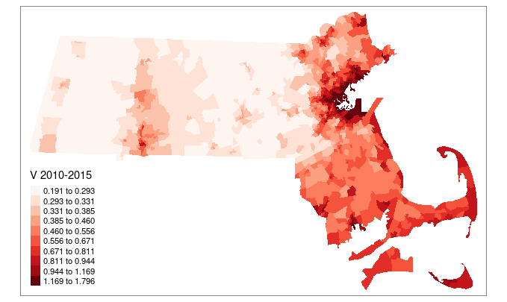
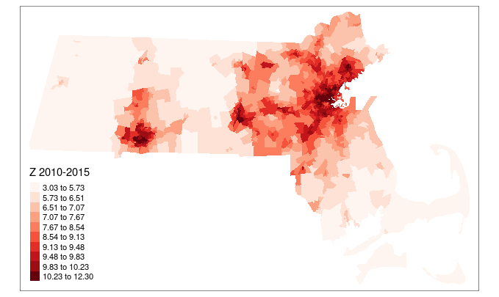

Figure S2a. Correlation Plot of PM_{2.5} Components
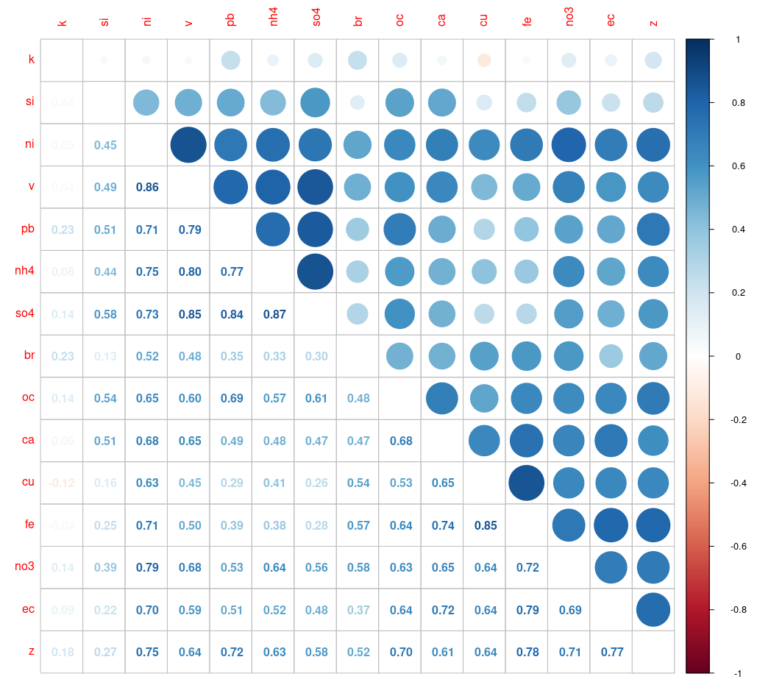

Figure S2b. Correlation Matrix of PM_{2.5} Components

Figure S3. The weights assigned to each PM_{2.5} component from additional WQS models excluding K. (a): all non-accidental mortality, (b): cardiovascular diseases related mortality, and (c): respiratory diseases related mortality (red dash line: reciprocal of the number of elements in the mixture)
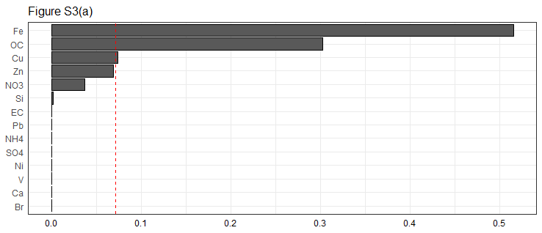
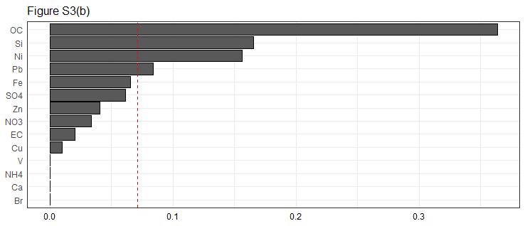
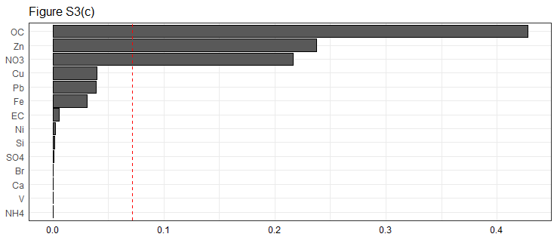

Table S1. Root-mean-square errors (RMSEs) comparing monitored and predicted annual average PM_{2.5} components concentrations in Massachusetts. RMSEs are calculated from regressing the monitored values against predicted values
PM_{2.5} Components | RMSE | Mean Concentration in Study
PM_{2.5} Major Components (μg/m³)
EC | 0.09 | 0.48
NH₄⁺ | 0.09 | 0.76
NO₃⁻ | 0.07 | 0.82
OC | 0.18 | 1.72
SO₄²⁻ | 0.28 | 2.21
PM_{2.5} Trace Elements (ng/m³)
Br | 0.18 | 2.63
Ca | 2.86 | 23.30
Cu | 1.35 | 2.66
Fe | 4.99 | 50.80
K | 4.77 | 47.81
Ni | 0.45 | 1.14
Pb | 0.34 | 2.39
Si | 10.15 | 54.34
V | 0.73 | 1.70
Zn | 1.82 | 9.49

Table S2. Mean annual average concentrations of 15 PM_{2.5} components across all census tracts in Massachusetts from 2000 to 2015
PM_{2.5} Components | 2000 | 2001 | 2002 | 2003 | 2004 | 2005 | 2006 | 2007 | 2008 | 2009 | 2010 | 2011 | 2012 | 2013 | 2014 | 2015
PM_{2.5} Major Components (μg/m³)
EC | 0.67 | 0.54 | 0.44 | 0.52 | 0.53 | 0.57 | 0.51 | 0.50 | 0.48 | 0.44 | 0.45 | 0.46 | 0.44 | 0.38 | 0.38 | 0.39
NH₄⁺ | 0.79 | 0.93 | 1.03 | 1.00 | 0.99 | 1.06 | 0.96 | 0.94 | 0.81 | 0.72 | 0.59 | 0.61 | 0.46 | 0.44 | 0.47 | 0.43
NO₃⁻ | 0.81 | 0.84 | 1.00 | 0.96 | 1.02 | 0.90 | 0.84 | 0.91 | 0.74 | 0.75 | 0.64 | 0.74 | 0.75 | 0.69 | 0.74 | 0.77
OC | 2.12 | 2.21 | 2.38 | 1.91 | 1.59 | 1.83 | 1.61 | 1.53 | 1.81 | 1.55 | 1.45 | 1.69 | 1.42 | 1.40 | 1.38 | 1.73
SO₄²⁻ | 2.68 | 3.22 | 3.04 | 2.99 | 2.93 | 3.04 | 2.66 | 2.51 | 2.41 | 1.88 | 1.56 | 1.70 | 1.42 | 1.36 | 1.23 | 1.14
PM_{2.5} Trace Elements (ng/m³)
Br | 2.57 | 2.54 | 2.83 | 2.81 | 2.57 | 2.95 | 2.85 | 2.68 | 2.57 | 2.34 | 2.22 | 2.42 | 2.52 | 2.47 | 2.70 | 3.01
Ca | 26.22 | 27.47 | 27.84 | 24.90 | 24.23 | 25.15 | 24.26 | 23.30 | 22.71 | 20.32 | 25.23 | 20.96 | 22.94 | 17.14 | 17.09 | 23.96
Cu | 2.14 | 2.31 | 3.21 | 2.86 | 2.43 | 2.96 | 3.42 | 3.41 | 2.89 | 2.28 | 2.72 | 2.47 | 2.58 | 2.13 | 2.10 | 2.76
Fe | 53.07 | 57.86 | 52.38 | 50.71 | 53.00 | 54.73 | 54.32 | 55.15 | 47.89 | 40.83 | 52.71 | 44.99 | 49.81 | 46.60 | 44.84 | 54.72
K | 51.07 | 48.59 | 48.21 | 48.84 | 46.04 | 52.12 | 48.81 | 48.49 | 47.13 | 42.66 | 48.23 | 45.52 | 47.20 | 43.18 | 46.06 | 53.14
Ni | 1.15 | 1.63 | 1.54 | 1.61 | 1.74 | 1.61 | 1.56 | 1.44 | 1.01 | 0.82 | 0.90 | 0.94 | 0.66 | 0.57 | 0.66 | 0.53
Pb | 3.24 | 4.17 | 3.54 | 3.05 | 2.92 | 3.49 | 3.64 | 2.16 | 1.68 | 1.72 | 1.66 | 1.79 | 1.63 | 1.27 | 1.16 | 1.45
Si | 54.12 | 79.55 | 83.87 | 64.65 | 65.26 | 40.95 | 51.13 | 50.65 | 55.31 | 45.19 | 58.16 | 38.04 | 46.71 | 48.03 | 44.07 | 47.09
V | 1.82 | 3.28 | 2.71 | 2.72 | 2.96 | 3.70 | 2.46 | 2.07 | 1.22 | 0.92 | 0.76 | 1.04 | 0.81 | 0.49 | 0.50 | 0.27
Zn | 11.75 | 10.77 | 10.20 | 10.99 | 11.04 | 11.57 | 11.03 | 10.24 | 8.94 | 6.84 | 8.69 | 7.97 | 9.02 | 7.60 | 7.30 | 8.53

Table S3. Cumulative associations between PM_{2.5} components and mortality estimated from additional WQS models on all 15 PM_{2.5} components (not on source groups) excluding Kª
Cause-specific Mortality | Mortality Rate Ratios
All Non-accidental Mortality | 1.0217 (1.0183, 1.0251)
Cardiovascular mortality | 1.0436 (1.0395, 1.0477)
Respiratory mortality | 1.0354 (1.0295, 1.0413)
ªThe mortality rate ratios are per 1 unit increase in the WQS index, which could be interpreted as approximately 1 decile increase in all PM_{2.5} components or the source groups identified for the PM_{2.5} components.

Table S4. Associations between PM_{2.5} components and mortality estimated from single pollutant quasi-Poisson models. Presented as the mortality rate ratio and 95% confidence intervals for interquartile range increase in concentrations
Components | All Non-accidental Mortality | Cardiovascular Mortality | Respiratory Mortality
PM_{2.5} Major Components
SO₄²⁻ | 1.0402 (1.0256, 1.0550) | 1.1593 (1.1380, 1.1810) | 1.0878 (1.0579, 1.1187)
NO₃⁻ | 1.0297 (1.0167, 1.0429) | 1.0785 (1.0605, 1.0968) | 1.0579 (1.0317, 1.0848)
NH₄⁺ | 1.0211 (1.0079, 1.0345) | 1.1019 (1.0831, 1.1211) | 1.0438 (1.0171, 1.0711)
OC | 1.0381 (1.0281, 1.0481) | 1.0899 (1.0762, 1.1037) | 1.0733 (1.0531, 1.0938)
EC | 1.0208 (1.0097, 1.0320) | 1.0580 (1.0429, 1.0734) | 1.0589 (1.0364, 1.0818)
PM_{2.5} Trace Elements
Zn | 1.0336 (1.0214, 1.0460) | 1.0811 (1.0643, 1.0982) | 1.0757 (1.0508, 1.1013)
V | 1.0158 (1.0041, 1.0277) | 1.0860 (1.0696, 1.1028) | 1.0403 (1.0166, 1.0645)
K | 1.0381 (1.0283, 1.0481) | 1.0398 (1.0266, 1.0532) | 1.0596 (1.0397, 1.0798)
Si | 1.0295 (1.0206, 1.0385) | 1.0814 (1.0692, 1.0938) | 1.0374 (1.0198, 1.0552)
Pb | 1.0348 (1.0224, 1.0474) | 1.1145 (1.0969, 1.1323) | 1.0835 (1.0582, 1.1093)
Ni | 1.0225 (1.0107, 1.0344) | 1.0903 (1.0737, 1.1070) | 1.0444 (1.0207, 1.0687)
Fe | 1.0209 (1.0046, 1.0375) | 1.0601 (1.0375, 1.0832) | 1.0337 (1.0010, 1.0675)
Cu | 1.0028 (0.9909, 1.0149) | 1.0294 (1.0129, 1.0461) | 1.0000 (0.9760, 1.0246)
Ca | 1.0251 (1.0130, 1.0373) | 1.0883 (1.0713, 1.1056) | 1.0409 (1.0164, 1.0660)
Br | 0.9938 (0.9845, 1.0033) | 1.0036 (0.9909, 1.0165) | 1.0056 (0.9868, 1.0247)
Abbreviations: Cardiovascular Mortality for cardiovascular diseases related mortality; Respiratory Mortality for respiratory diseases related mortality.

Paragraphs S1. Description of Weighted Quantile Sum Regression Models

The general idea of Weighted Quantile Sum (WQS) Regression is to: (1) first, summarize the mixture of pollutants into a composite index, where each component’s contribution to the index is weighted based on their relevance to the outcome; (2) second, we use this composite index as the exposure term to fit a regression model estimating the cumulative association between the pollutant mixture and the outcome. In our study, the pollutants’ mixture being studied is composed by the 15 PM_{2.5} components.
To fit the WQS models, the full dataset is first be divided into training set and validation set. The training set is used for the composite index and components’ weights estimation, and the validation set is used for the regression model estimating the cumulative association between mixture and outcome. The proportion of this division is determined by the researcher. In our study, we have used a 50:50 proportion for all WQS models, where 50% of the dataset was split into the training set, and the other 50% was split into the validation set.
1. WQS index and components’ weights estimation
The first part of WQS regression is to estimate the composite index, which is the weighted quantile sum (WQS) of the components’ concentration, and the weights of each component contributing to the WQS index.
First, the concentrations of all pollutants are scored into quantiles. By do so, the influence of outliers could be removed. The researchers determine which specific quantile (quartile, quintile, decile, etc.) to be used in the model. In our study, we used deciles, which means that the concentrations of PM_{2.5} components were scored into deciles. Besides the pollutant mixtures, we have also standardized all other covariates, which could be helpful in WQS models.
Second, to estimate the index and weights, several bootstrap samples of the training set is generated. In our study, we have set the number of bootstrap samples as 250 for all WQS models.
Next, the following model is estimated in each bootstrap sample:
$$g\left(Y\right)=β_{0}+β_{1}\left(\sum_{i=1}^{p}{w_{i}q_{i}}\right)+β_{2}^{'}ϕ$$
In this model, Y is the outcome of interest, g is the link function between outcome and regression formula. q_{i} are the quantiles scored for each component i (in our study, deciles), w_{i} are the weights for the component i, Φ are the other covariates, β_{i} are the coefficients for each variable. In this model, the parameters to be estimated are βs and the weights w_{i}. There are two constraints for the weights: first, each weight is constrained between 0 and 1 (0≤w_{i}≤1); second, the sum of all weights equals to 1 ($\sum_{1}^{p}{w_{i}}$=1). The optimization algorithm used for the parameter estimation has been presented by Carrico et al. This article has also been cited in the main text of the manuscript. Moreover, in our study, we have used a log link function and a quasi-Poisson family for the regression models.
In this estimation, the researcher also need to make an assumption of the direction of β₁: whether it is non-negative or non-positive. In our study, we assumed that the PM_{2.5} components are positively associated with the outcome (mortality), so we determined that the β₁ to be non-negative. There are two ways in the WQS estimation could be used to fit the constraint of β₁: (1) constraining the direction of β₁ in the optimization algorithm when fitting the models in every bootstrap samples; (2) estimate the β₁ without constraint in every bootstrap samples, and then only use estimated parameters that meet the assumption of β₁’s direction. In our study, we have used the second approach.
Then, we estimate the final WQS index as:
$$WQS=\sum_{i=1}^{p}{{\overline{w}}_{i}q_{i}}$$
In this index, q_{i} are the quantiles scored for each component (in our study, deciles), and ${\overline{w}}_{i}$ are the weights estimated for each pollutant in the WQS index. These weights are estimated through ${\overline{w}}_{i}=\frac{1}{B}\sum_{b=1}^{B}{w_{i(b)}}$, with B as the number of bootstrap samples where the fitted models fulfill the assumption of β₁, and w_{i(b)} are the weights for component i estimated in these B bootstrap samples. These weights could then be interpreted as the contribution of each pollutant to the cumulative association between the mixture and outcome in the assumed association direction.
2. WQS regression estimating the cumulative association between pollutants mixture and outcome
The second part for the WQS regression is using the composite WQS index as the exposure term to fit a regression model estimating the cumulative association between the pollutant mixture and the outcome. This regression model is fitted in the validation set as:
$$g\left(Y\right)=β_{0}+β_{1}WQS+β_{2}^{'}ϕ$$
In this model, Y is the outcome, g is the link function, WQS is the WQS index we have already estimated in the first part, Φ are the other covariates, and β₁ is the main coefficient of interest which demonstrates the cumulative association between pollutants mixture and the outcome. In our study, the link function is log and we have set a quasi-Poisson family.
All the WQS regression procedures, including the index and weights estimation and the final WQS regression could are implemented in the gWQS package in R. In our study, we have 3 outcomes of interest (all-cause mortality, cardiovascular mortality, and respiratory mortality), so 3 sets of WQS models have been fitted separately. Moreover, we have also used the sandwich package to estimate the robust confidence intervals for the β₁ coefficients in the final WQS regression models.
Carrico et al. have discussed the WQS algorithms before, and this paper is a good source for reference regarding the WQS models. This article has also been cited in the main text.

Carrico C, Gennings C, Wheeler DC, Factor-Litvak P. Characterization of Weighted Quantile Sum Regression for Highly Correlated Data in a Risk Analysis Setting. Journal of agricultural, biological, and environmental statistics. 2015;20(1):100-120. doi:10.1007/s13253-014-0180-3
Carrico C, Gennings C, Wheeler DC, Factor-Litvak P. Characterization of Weighted Quantile Sum Regression for Highly Correlated Data in a Risk Analysis Setting. Journal of agricultural, biological, and environmental statistics. 2015;20(1):100-120. doi:10.1007/s13253-014-0180-3

