Supplemental Figure 1. Average Prenatal PM₁₀ Exposure Demonstrated Non-Linear Associations with Composite, Fine, and Scaled Motor Scores at 2 Years
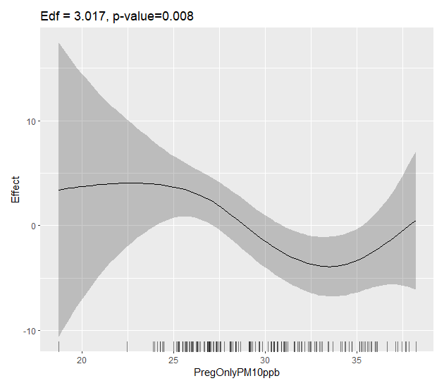
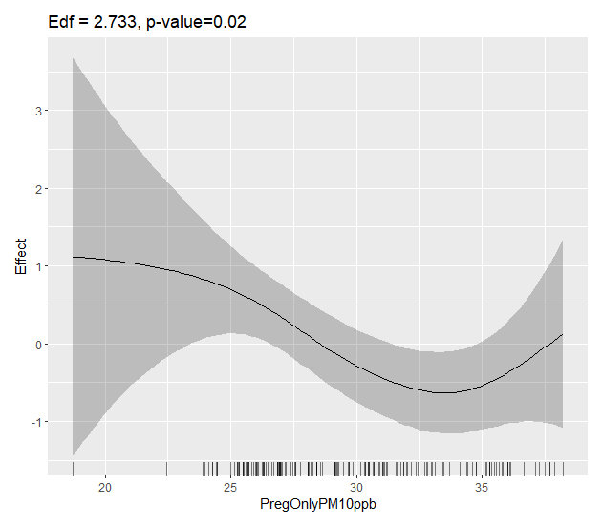
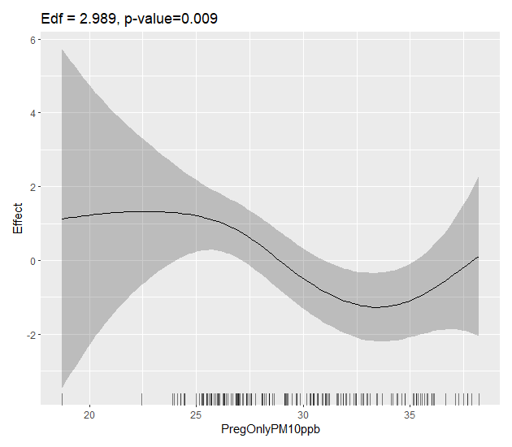
A
B
C
Prenatal PM₁₀
Composite Motor
Prenatal PM₁₀
Fine Motor
Prenatal PM₁₀
Scaled Motor
Effect
Effect
Effect
Edf = 3.017, p-value = 0.008
Edf = 2.733, p-value = 0.02
Edf = 2.989, p-value = 0.009

Supplemental Figure 1. Figures show effect sizes for non-linear associations between average prenatal PM₁₀ and composite, fine, and scaled motor score at 2 years. Results were obtained from generalized additive models (GAMs) that adjusted for socio-economic status (SES), breast feedings per day, gestational age, pre-pregnancy BMI, infant birthweight, and infant sex. Panels show relationship between average prenatal PM₁₀ and composite motor score (A), fine motor score (B), and scaled motor score (C). Effective degrees of freedom and exact p-values are reported on each panel, but each model was statistically significant p<0.05.

