Additional File 1.
Supplementary Table 1. Search strategy: the example of MEDLINE via PubMed.
 | Search timeline: Up to 13.Jun.2022 | Abstracts
#3 | Search: #1 AND #2 | 586
#2 | Search: ("activity days"[TIAB] OR "restricted activity days"[TIAB] OR "minor restricted activity days"[TIAB] OR "RAD"[TIAB] OR "RADs"[TIAB] OR "MRAD"[TIAB] OR "MRADs"[TIAB] OR "work loss"[TIAB] OR "work-loss"[TIAB] OR "lost work"[TIAB] OR "sick leaves"[TIAB] OR "absenteeism"[TIAB] OR "absenteeism"[MH] OR "nonattendance"[TIAB] OR "non-attendance"[TIAB] OR "attendance"[TIAB] OR "school loss"[TIAB] OR "school-loss"[TIAB] OR "bed days"[TIAB] OR "bed-days"[TIAB]) | 68,057
#1 | Search: ("particulate matter"[TIAB] OR "particulate air"[TIAB] OR "suspended particles"[TIAB] OR "coarse particles"[TIAB] OR "respirable particles"[TIAB] OR "fine particles"[TIAB] OR "inhalable particles"[TIAB] OR "SPM"[TIAB] OR "TSP"[TIAB] OR "PM10"[TIAB] OR "PM2.5"[TIAB] OR "particulate matter"[MH] OR "NO2"[TIAB] OR "nitrogen dioxide"[MH] OR "nitrogen oxides"[MH] OR "NOx"[TIAB] OR "ozone"[TIAB] OR "O3"[TIAB] OR "ozone"[MH] OR "air pollution"[TIAB] OR "air pollution"[MH] OR "air pollutants"[TIAB] OR "air pollutants"[MH]) | 335,423

Supplementary Table 2. Influential analysis for PM₁₀ and work-loss/school-loss days.
Study excluded | RR (95%CI) | I2
Gilliland, 2001 | 1.0173 (1.0036-1.0313) | 74%
Hansen, 2000 | 1.0149 (1.0017-1.0283) | 69%
Marcon, 2014 | 1.0157 (0.9995-1.0323) | 70%
Park, 2002 | 1.0201 (0.9982-1.0426) | 74%
Rondeau, 2005 | 1.0191 (1.0058-1.0326) | 71%
Yang, 2019 | 1.0235 (1.0092-1.0379) | 51%
Chen, 2021 | 1.0132 (0.9998-1.0268) | 66%
PM₁₀, particulate matter with aerodynamic diameters less or equal than 10 μm; RR, pooled relative risk, calculated for a 10 μg/m³ increase in the pollutant level; 95% CI, 95% confidence interval; I2, I-Squared values.

Supplementary Table 3. Influential analysis for PM_{2.5} and school-loss days.
Study excluded | RR (95%CI) | I2
Hales, 2016 (Alpine) | 1.0170 (1.0036-1.0306) | 98%
Hales, 2016 (Provo) | 1.0166 (1.0031-1.0304) | 99%
Hales, 2016 (Salt Lake) | 1.0190 (1.0127-1.0253) | 92%
Watanabe, 2021 | 1.0145 (1.0030-1.0262) | 99%
Wu, 2022 | 1.0196 (1.0053-1.0341) | 99%
Yang, 2019 | 1.0178 (1.0052-1.0307) | 99%
Zhang, 2018 | 1.0166 (1.0050-1.0283) | 99%
Chen, 2021 | 1.0168 (1.0041-1.0297) | 99%
PM_{2.5}, particulate matter with aerodynamic diameters less or equal than 10 μm; RR, pooled relative risk, calculated for a 10 μg/m³ increase in the pollutant level; 95% CI, 95% confidence interval; I2, I-Squared values.

Supplementary Figure 1. Forest plot of one cross-sectional study (6 effect sizes) evaluating the association between PM_{2.5} and restricted activity days. Relative risks for a 10 µg/m³ increase in PM_{2.5} level.
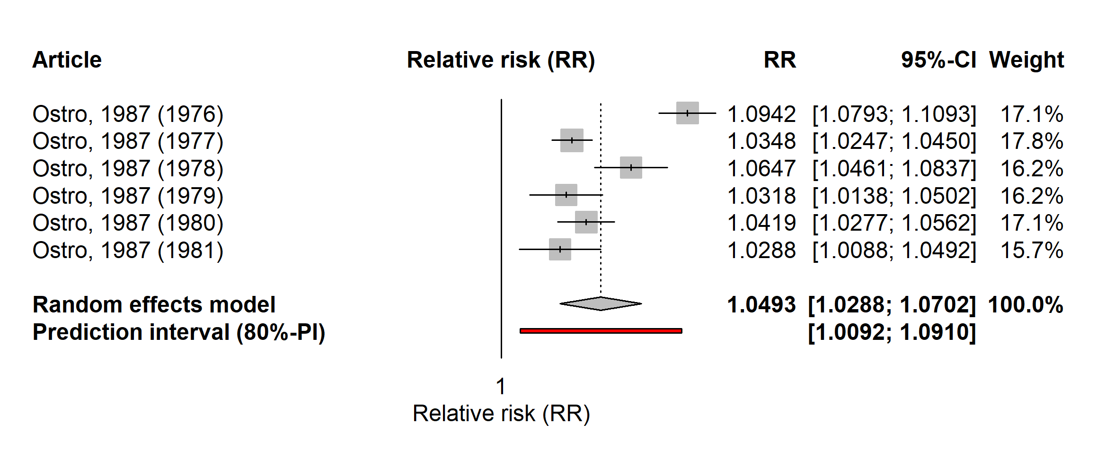
Supplementary Figure 2. Forest plot of one cross-sectional study (6 effect sizes) evaluating the association between PM_{2.5} and respiratory-related restricted activity days. Relative risks for a 10 µg/m³ increase in PM_{2.5} level.
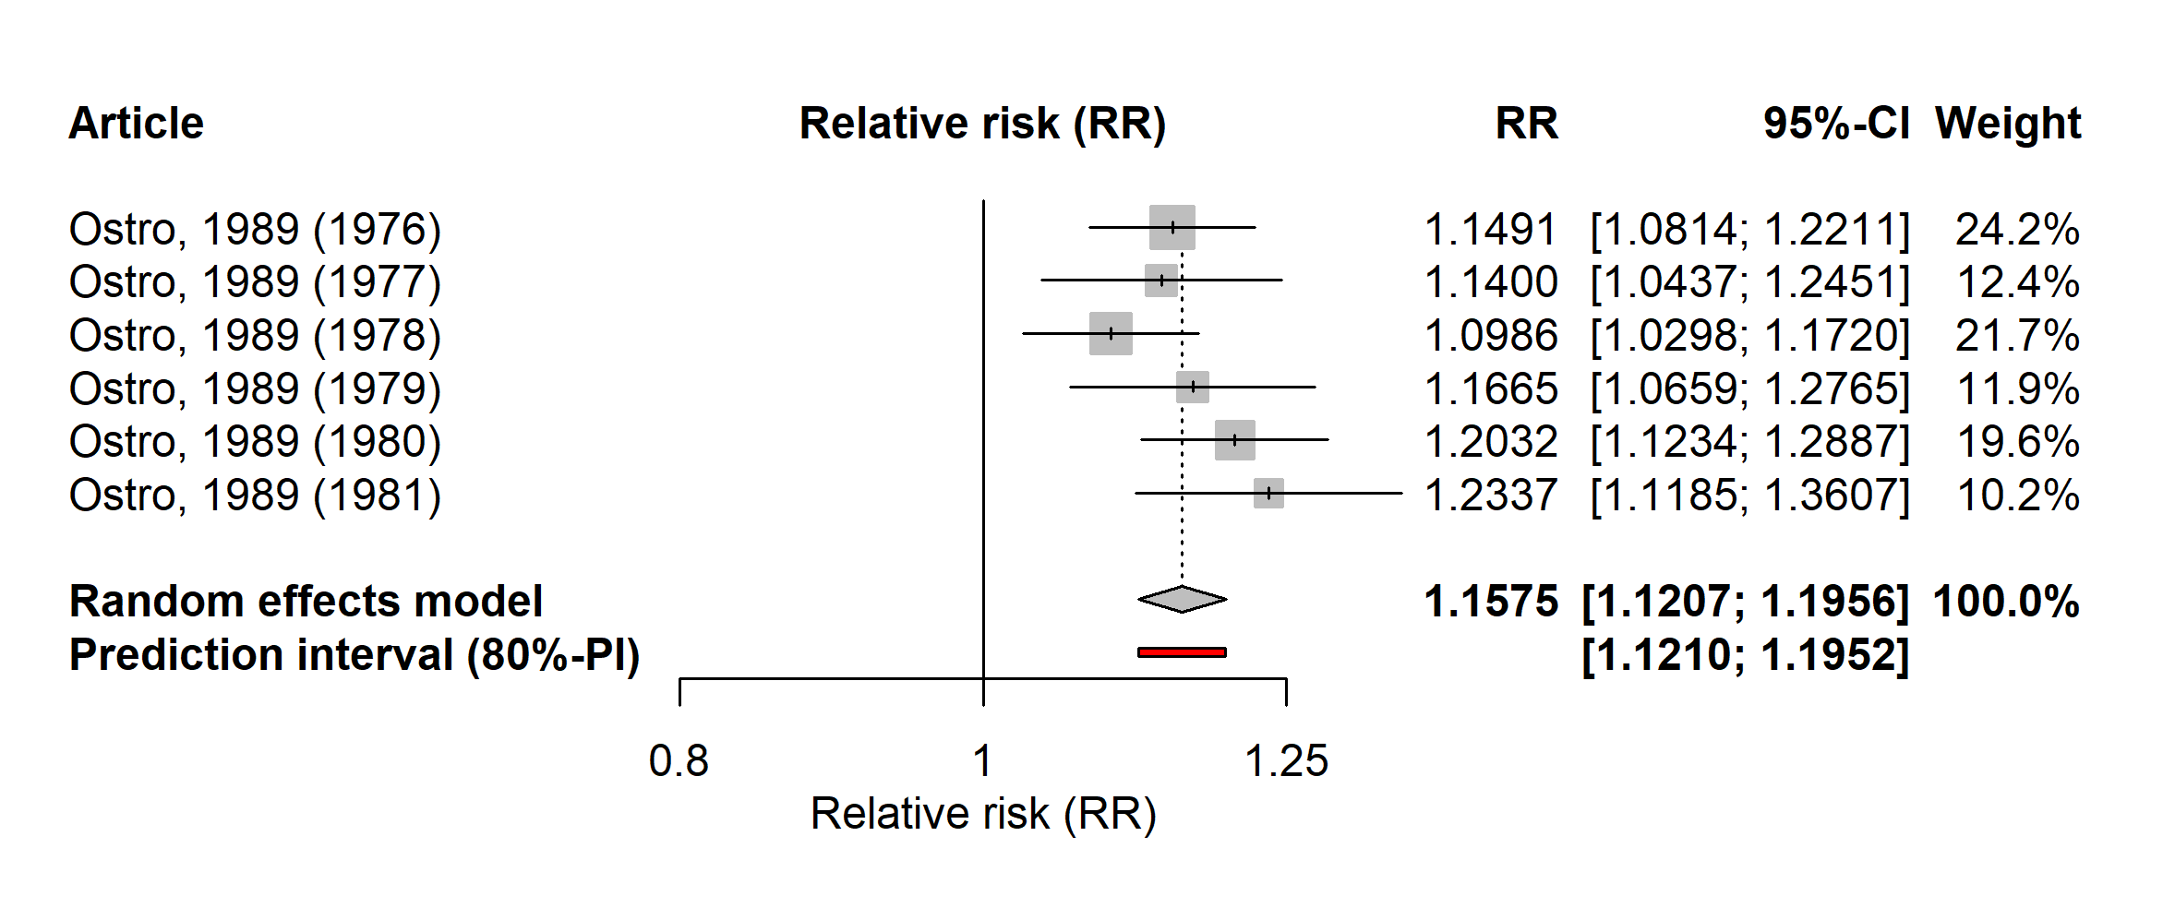

Supplementary Figure 3. Forest plot of one cross-sectional study (6 effect sizes) evaluating the association between PM_{2.5} and minor restricted activity days. Relative risks for a 10 µg/m³ increase in PM_{2.5} level.
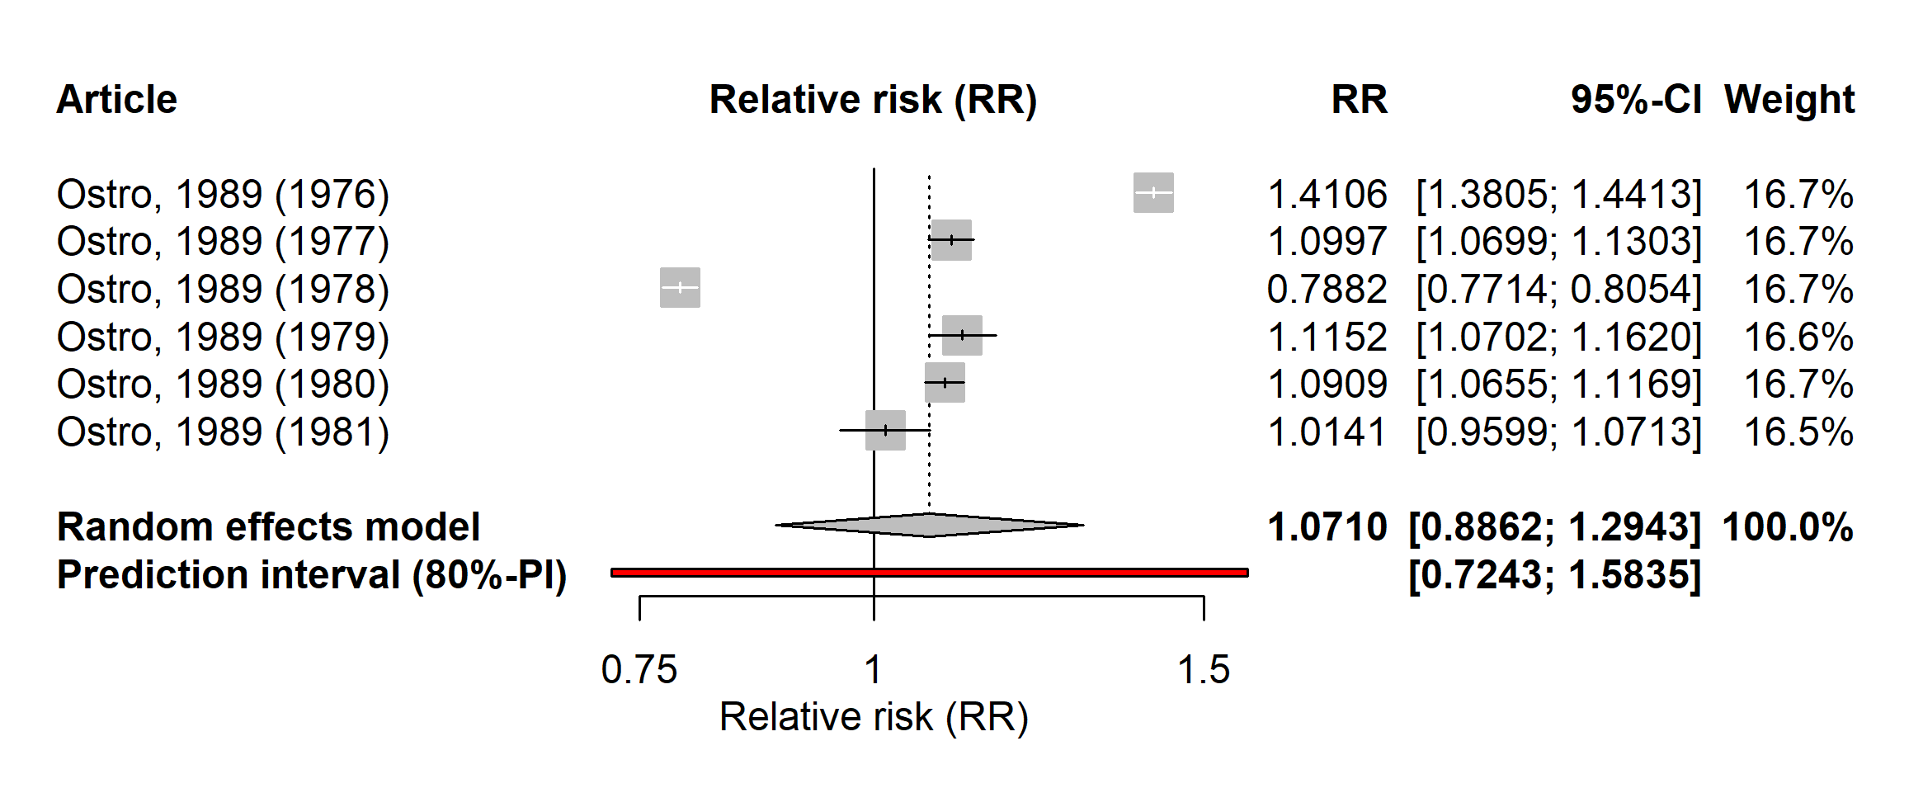
Supplementary Figure 4. Forest plot of one cross-sectional study (6 effect sizes) evaluating the association between PM_{2.5} and work-loss days. Relative risks for a 10 µg/m³ increase in PM_{2.5} level.
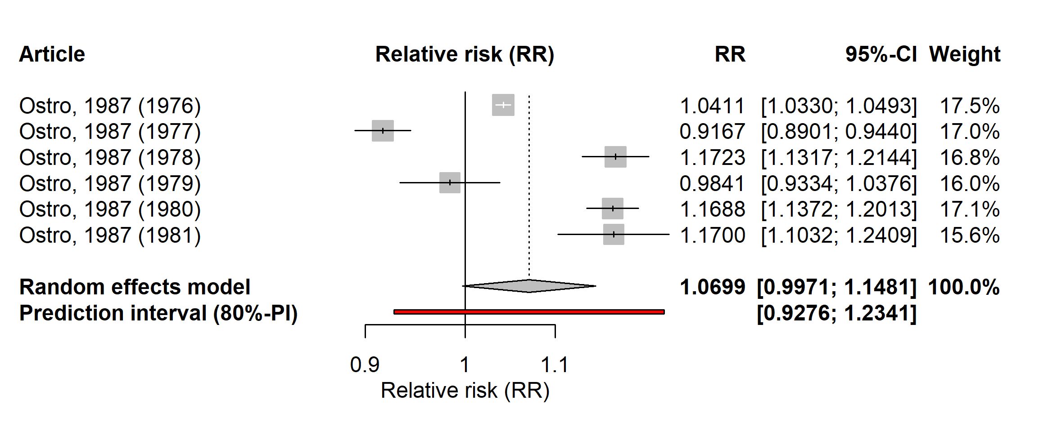
Supplementary Table 4. Influential analysis for NO₂ and work-loss/school-loss days.
Study excluded | RR (95%CI) | I2
Gilliland, 2001 | 1.0076 (0.9913-1.0242) | 80%
Hansen, 2000 | 1.0085 (0.9909-1.0264) | 80%
Park, 2002 | 1.0074 (0.9832-1.0321) | 80%
Rondeau, 2005 | 1.0147 (1.0012-1.0284) | 59%
Watanabe, 2021 | 1.0030 (0.9863-1.0199) | 77%
Yang, 2019 | 1.0091 (0.9903-1.0283) | 80%
Chen, 2021 | 1.0021 (0.9854-1.0191) | 68%
NO₂, nitrogen dioxide; RR, pooled relative risk, calculated for a 10 μg/m³ increase in the pollutant level; 95% CI, 95% confidence interval; I2, I-Square values.

Supplementary Table 5. Influential analysis for O₃ and school-loss days.
Study excluded | RR (95%CI) | I2
Gilliland, 2001 | 0.9944 (0.9543-1.0362) | 88%
Park, 2002 | 1.0095 (0.9147-1.1141) | 84%
Rondeau, 2005 | 1.0274 (0.9442-1.1180) | 80%
Samoli, 2017 | 1.0254 (0.9824-1.0703) | 90%
O₃, ozone; RR, pooled relative risk, calculated for a 10 μg/m³ increase in the pollutant level; 95% CI, 95% confidence interval; I2, I-Square values.

Supplementary Figure 5. Forest plot of one cross-sectional study (6 effect sizes) evaluating the association between O₃ and respiratory-related restricted activity days. Relative risks for a 10 µg/m³ increase in O₃ level.
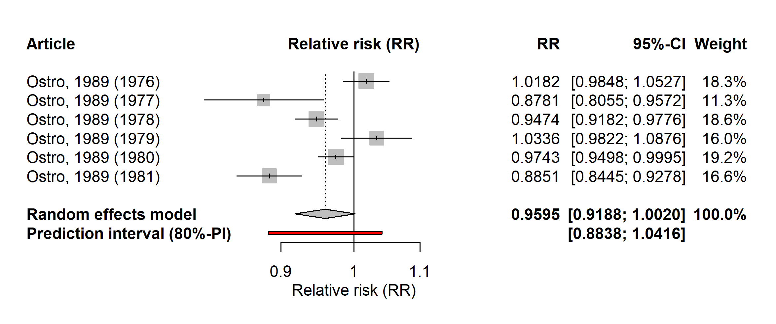
Supplementary Figure 6. Forest plot of one cross-sectional study (6 effect sizes) evaluating the association between O₃ and minor restricted activity days. Relative risks for a 10 µg/m³ increase in O₃ level.
