Supplemental Material

Early childhood exposure to phenols/parabens, phthalates, organophosphate pesticides, and trace elements in association with attention deficit hyperactivity disorder (ADHD) symptoms in the CHARGE study

Jiwon Oh, Kyoungmi Kim, Kurunthachalam Kannan, Patrick J. Parsons, Agnieszka Mlodnicka, Rebecca J. Schmidt, Julie B. Schweitzer, Irva Hertz-Picciotto, Deborah H. Bennett

Table of Contents

Table S1. List of items for Aberrant Behavior Checklist (ABC) ADHD/noncompliance and twos.
Table S2. Chemical names and abbreviations of 62 analytes.
Table S3. Limit of detection (LOD), percent detection above the LOD, and distribution of specific gravity (SG)-uncorrected concentrations (ng/mL) of phenols/parabens, phthalate metabolites, pesticide metabolites, and trace elements in urine samples of 549 CHARGE children.
Table S4. Covariate-adjusted associations between individual chemicals and ABC subscale/subdomain scores and p-values with and without FDR correction for multiple testing among 549 CHARGE children.
Table S5. Covariate-adjusted associations between mixtures and ADHD/noncompliance scores, stratified by child’s sex.
Figure S1. Flowchart depicting study design and study population.
Figure S2. Directed acyclic graph for associations of child urinary chemical concentrations with attention deficit hyperactivity disorder (ADHD) symptoms.
Figure S3. Heatmap of Spearman’s correlation coefficients among specific gravity (SG)-corrected concentrations of 43 compounds.
Figure S4. P-value matrix from the Wilcoxon rank-sum test or Kruskal-Wallis test comparing specific gravity (SG)-corrected chemical concentrations by characteristics of 549 CHARGE children.
Figure S5. Estimated weight distributions of urinary (A) phthalate metabolites and (B) pesticide metabolites from 100 repetitions of sex-stratified interaction weighted quantile sum (WQS) regression for ADHD/noncompliance.
Table S1. List of items for Aberrant Behavior Checklist (ABC) ADHD/noncompliance and twos subdomains.
ADHD/noncompliance | Hyperactivity/  impulsivity | Inattention
1. Excessively active at home, school, work, or elsewhere | O
7. Boisterous (inappropriately noisy and rough) | O
13. Impulsive (acts without thinking) | O
15. Restless, unable to sit still | O
18. Disobedient; difficult to control
21. Disturbs others | O
24. Uncooperative
31. Disrupts group activities | O
38. Does not stay in seat (e.g., during lesson or training periods, meals, etc.) | O
39. Will not sit still for any length of time | O
48. Constantly jumps or runs around the room | O
54. Tends to be excessively active | O
28. Does not pay attention to instructions |  | O
44. Easily distractible |  | O
51. Pays no attention when spoken to |  | O
56. Deliberately ignores directions
Abbreviations: ADHD, attention-deficit/hyperactivity disorder.
Note: Item no. 18, 24, and 56 were not used in the generation of the two subdomains.
Table S2. Chemical names and abbreviations of 62 analytes.
Abbreviation | Chemical name
Phenols/Parabens
BP1 | 2,4-dihydroxybenzophenone
BP2 | 2,2′,4,4′-tetrahydroxybenzophenone
BP3 | 2-hydroxy-4-methoxybenzophenone
BP8 | 2,2′-dihydroxy-4-methoxybenzophenone
BPA | Bisphenol A; 2,2-bis(4-hydroxyphenyl)propane
BPAF | 4,4′-(hexafluoroisopropylidene)-diphenol
BPAP | 4,4′-(1-phenylethylidene)bisphenol
BPB | 2,2-bis(4-hydroxyphenyl)butane
BPF | Bisphenol F; 4,4′-dihydroxydiphenylmethane
BPP | 4,4′-(1,4-phenylenediisopropylidene)bisphenol
BPS | Bisphenol S; 4,4′-sulfonyldiphenol
BPZ | 4,4′-cyclo-hexylidenebisphenol
BUPB | Butyl paraben
BZPB | Benzyl paraben
DCP24 | 2,4-dichlorophenol
DCP25 | 2,5-dichlorophenol
DHB34 | 3,4-dihydroxy benzoic acid
ETPB | Ethyl paraben
HB4 | 4-hydroxybenzoic acid
HEPB | Heptyl paraben
MEPB | Methyl Paraben
OH4BP | 4-hydroxybenzophenone
OHETP | Ethyl-protocatechuic acid
OHMEP | Methyl-protocatechuic acid
PCP | Pentachlorophenol
PRPB | Propyl paraben
TCC | Triclocarban
TCP245 | 2,4,5-trichlorophenol
TCP246 | 2,4,6-trichlorophenol
Triclosan | Triclosan
Phthalate metabolites
MBZP | Mono-benzyl phthalate
MCHP | Monocyclohexyl phthalate
MCHPP | Mono(7-carboxyheptyl)phthalate
MCINP | Mono-carboxy isononyl phthalate
MCIOP | Mono-carboxy isooctyl phthalate
MCMHP | Mono-2-(carboxymethyl) hexyl phthalate
MCPP | Mono (3-carboxypropyl) phthalate
MECPP | Mono-(2-ethyl-5-carboxypentyl) phthalate
MEHHP | Mono (2-ethyl-5-hydroxyhexyl) phthalate
MEOHP | Mono (2-ethyl-5-oxohexyl) phthalate
MEP | Monoethyl phthalate
MHPP | Mono-2-heptyl phthalate
MHXP | Mono-hexyl phthalate
MIBP | Mono-isobutyl phthalate
MINP | Mono-isononyl phthalate
MIPP | Mono-isopropyl phthalate
MMP | Mono-methyl phthalate
MNBP | Mono-n-butyl phthalate
MOP | Mono-n-octyl phthalate
MPEP | Mono-pentyl phthalate
Pesticide metabolites
DEDP | Diethyldithiophosphate
DEP | Diethylphosphate
DETP | Diethylthiophosphate
DMDP | Dimethyldithiophosphate
DMP | Dimethylphosphate
DMTP | Dimethylthiophosphate
Trace elements
As | Arsenic
Be | Beryllium
Cd | Cadmium
Mo | Molybdenum
Tl | Thallium
U | Uranium

Table S3. Limit of detection (LOD), percent detection above the LOD, analysis results of 15 blinded duplicate samples, and distribution of specific gravity (SG)-uncorrected concentrations (ng/mL) of phenols/parabens, phthalate metabolites, pesticide metabolites, and trace elements in urine samples of 549 CHARGE children.
Chemical | LOD | % above LOD | # of valid pairs ª | RPD ^{b} median (%) | 5th Percentile | 25th Percentile | Median | 75th Percentile | 95th Percentile
Phenols/parabens
BP1 | 0.05 | 100 | 15 | 11 | 1.3 | 4.5 | 13.8 | 56.7 | 6838.0
BP2 | 0.2 | 11.8 | 1 | 35 | <LOD | <LOD | <LOD | <LOD | 0.5
BP3 | 0.5 | 100 | 15 | 14 | 4.7 | 15.3 | 49.5 | 198.0 | 1582.0
BP8 | 0.02 | 82.0 | 11 | 21 | <LOD | 0.1 | 0.2 | 0.8 | 11.1
BPA | 0.05 | 98.5 | 13 | 17 | 0.2 | 1.1 | 2.2 | 4.3 | 12.6
BPAF | 0.05 | 0.7 | 0 | - | <LOD | <LOD | <LOD | <LOD | <LOD
BPAP | 0.1 | 89.4 | 14 | 46 | <LOD | 0.2 | 0.3 | 0.5 | 1.1
BPB | 0.05 | 50.3 | 5 | 43 | <LOD | <LOD | 0.1 | 0.1 | 0.3
BPF | 0.5 | 89.3 | 13 | 12 | <LOD | 1.2 | 3.0 | 7.2 | 21.1
BPP | 0.01 | 76.1 | 14 | 44 | <LOD | 0.01 | 0.1 | 0.2 | 0.7
BPS | 0.05 | 94.2 | 15 | 13 | <LOD | 0.2 | 0.4 | 0.9 | 3.8
BPZ | 0.05 | 1.3 | 0 | - | <LOD | <LOD | <LOD | <LOD | <LOD
BUPB | 0.05 | 92.3 | 15 | 26 | <LOD | 0.1 | 0.4 | 1.0 | 12.6
BZPB | 0.1 | 14.9 | 4 | 32 | <LOD | <LOD | <LOD | <LOD | 0.3
DCP24 | 0.02 | 95.3 | 15 | 17 | 0.1 | 1.2 | 2.6 | 5.8 | 13.9
DCP25 | 0.02 | 88.2 | 10 | 17 | <LOD | 1.5 | 3.4 | 6.5 | 78.2
DHB34 | 0.2 | 100 | 15 | 8 | 32.1 | 83.8 | 149.0 | 266.0 | 513.6
ETPB | 0.02 | 99.1 | 15 | 15 | 0.2 | 0.6 | 1.2 | 3.1 | 58.0
HB4 | 1 | 100 | 15 | 5 | 393.2 | 976.0 | 1470.0 | 2390.0 | 6408.0
HEPB | 0.1 | 0.4 | 0 | - | <LOD | <LOD | <LOD | <LOD | <LOD
MEPB | 0.05 | 99.8 | 15 | 8 | 3.4 | 12.5 | 40.4 | 206.0 | 2678.0
OH4BP | 0.2 | 98.9 | 15 | 13 | 0.5 | 1.1 | 1.8 | 2.9 | 12.1
OHETP | 0.1 | 64.7 | 10 | 9 | <LOD | <LOD | 0.3 | 1.0 | 4.5
OHMEP | 0.1 | 95.8 | 12 | 11 | 0.2 | 1.5 | 4.4 | 15.1 | 113.8
PCP | 0.05 | 96.0 | 12 | 21 | 0.1 | 0.5 | 1.0 | 1.9 | 4.9
PRPB | 0.1 | 98.5 | 15 | 18 | 0.4 | 1.8 | 5.7 | 25.5 | 383.6
TCC | 0.1 | 7.5 | 2 | 8 | <LOD | <LOD | <LOD | <LOD | 0.3
TCP245 | 0.1 | 49.9 | 6 | 35 | <LOD | <LOD | <LOD | 0.2 | 0.6
TCP246 | 0.02 | 99.8 | 15 | 6 | 0.4 | 0.9 | 1.5 | 2.5 | 7.0
Triclosan | 0.1 | 96.9 | 14 | 8 | 0.3 | 2.6 | 7.4 | 26.1 | 214.2
Phthalate metabolites
MBZP | 0.02 | 99.5 | 14 | 5 | 3.9 | 13.4 | 30.4 | 70.2 | 283.6
MCHP | 0.5 | 8.0 | 0 | - | <LOD | <LOD | <LOD | <LOD | 0.8
MCHPP | 0.1 | 26.6 | 4 | 5 | <LOD | <LOD | <LOD | 0.1 | 13.6
MCINP | 0.01 | 98.4 | 15 | 11 | 0.9 | 3.2 | 5.4 | 10.3 | 29.8
MCIOP | 0.01 | 99.8 | 15 | 6 | 3.2 | 9.8 | 20.0 | 40.2 | 111.8
MCMHP | 0.02 | 98.5 | 15 | 25 | 1.8 | 8.0 | 16.1 | 33.8 | 94.5
MCPP | 0.05 | 99.8 | 15 | 7 | 0.9 | 2.8 | 5.5 | 10.3 | 24.9
MECPP | 0.02 | 99.6 | 15 | 8 | 5.7 | 17.3 | 33.4 | 68.2 | 211.8
MEHHP | 0.2 | 100 | 15 | 7 | 7.0 | 21.9 | 44.3 | 97.1 | 270.2
MEOHP | 0.01 | 100 | 15 | 9 | 2.6 | 9.0 | 18.9 | 40.3 | 118.6
MEP | 0.1 | 100 | 15 | 5 | 9.3 | 20.9 | 41.3 | 76.1 | 317.0
MHPP | 0.5 | 73.6 | 8 | 38 | <LOD | <LOD | 1.3 | 3.0 | 15.2
MHXP | 0.5 | 55.9 | 6 | 14 | <LOD | <LOD | 0.7 | 8.9 | 160.0
MIBP | 0.01 | 100 | 15 | 9 | 3.3 | 10.6 | 19.2 | 33.5 | 82.3
MINP | 0.01 | 0.0 | 0 | - | <LOD | <LOD | <LOD | <LOD | <LOD
MIPP | 0.5 | 2.4 | 0 | - | <LOD | <LOD | <LOD | <LOD | <LOD
MMP | 5 | 40.8 | 5 | 36 | <LOD | <LOD | <LOD | 7.9 | 28.1
MNBP | 0.2 | 99.8 | 15 | 7 | 7.2 | 21.0 | 39.7 | 72.4 | 184.4
MOP | 0.5 | 1.3 | 0 | - | <LOD | <LOD | <LOD | <LOD | <LOD
MPEP | 1 | 2.2 | 0 | - | <LOD | <LOD | <LOD | <LOD | <LOD
Pesticide metabolites
DEDP | 0.05 | 3.8 | 0 | - | <LOD | <LOD | <LOD | <LOD | <LOD
DEP | 0.1 | 99.1 | 15 | 8 | 0.5 | 1.6 | 3.6 | 8.6 | 28.1
DETP | 0.02 | 98.5 | 15 | 13 | 0.0 | 0.2 | 0.5 | 1.3 | 5.0
DMDP | 0.02 | 91.4 | 13 | 8 | <LOD | 0.1 | 0.3 | 0.9 | 7.3
DMP | 0.05 | 99.5 | 15 | 8 | 0.9 | 3.3 | 8.1 | 20.3 | 70.2
DMTP | 0.05 | 95.3 | 15 | 8 | 0.1 | 1.0 | 3.3 | 11.2 | 49.6
Trace elements
As | 0.059 | 100 | 15 | 1 | 2.7 | 6.4 | 10.8 | 17.1 | 44.5
Be | 0.022 | 6.9 | 1 | 27 | <LOD | <LOD | <LOD | <LOD | 0.024
Cd | 0.006 | 73.2 | 11 | 21 | <LOD | <LOD | 0.02 | 0.05 | 0.1
Mo | 0.45 | 100 | 15 | 1 | 23.9 | 57.9 | 95.1 | 148.0 | 293.6
Tl | 0.005 | 100 | 15 | 3 | 0.1 | 0.1 | 0.2 | 0.3 | 0.5
U | 0.0007 | 99.6 | 15 | 3 | 0.002 | 0.006 | 0.01 | 0.02 | 0.05
Abbreviations: Full chemical names are listed in Table S2. ADHD, attention-deficit/hyperactivity disorder; ASD, autism spectrum disorder; CHARGE, Childhood Autism Risks from Genetics and Environment.
ª Number of blinded duplicate pairs where both were ≥LOD.
^{b} Relative percent differences (RPD) = |sample result – repeat result|/(sample result + repeat result)*100.
Table S4. Covariate-adjusted associations between individual chemicals and ABC subscale/subdomain scores and p-values with and without FDR correction for multiple testing among 549 CHARGE children.
Chemical | ADHD/noncompliance |  |  | Hyperactivity/impulsivity |  |  | Inattention
Chemical | CR (95% CI) ª | Unadj.  p-value | FDR-corrected p-value | CR (95% CI) ª | Unadj.  p-value | FDR-corrected p-value | CR (95% CI) ª | Unadj.  p-value | FDR-corrected p-value
Phenols/parabens
∑BP | 0.99 (0.90, 1.09) | 0.818 | 0.968 | 0.99 (0.89, 1.09) | 0.776 | 0.917 | 1.03 (0.95, 1.10) | 0.488 | 0.993
BPA | 1.01 (0.93, 1.10) | 0.780 | 0.968 | 1.00 (0.91, 1.10) | 0.980 | 0.980 | 1.00 (0.94, 1.07) | 0.993 | 0.993
BPAP | 0.98 (0.89, 1.07) | 0.633 | 0.942 | 0.95 (0.86, 1.05) | 0.329 | 0.854 | 1.00 (0.93, 1.07) | 0.964 | 0.993
BPF | 0.98 (0.88, 1.08) | 0.680 | 0.942 | 0.96 (0.86, 1.07) | 0.481 | 0.854 | 1.01 (0.93, 1.09) | 0.862 | 0.993
BPP | 0.97 (0.88, 1.07) | 0.491 | 0.942 | 0.96 (0.87, 1.07) | 0.473 | 0.854 | 1.04 (0.97, 1.13) | 0.271 | 0.993
BPS | 1.00 (0.91, 1.11) | 0.968 | 0.968 | 0.99 (0.89, 1.10) | 0.893 | 0.946 | 0.98 (0.90, 1.06) | 0.593 | 0.993
BUPB | 0.91 (0.84, 1.00) | 0.058 | 0.345 | 0.93 (0.84, 1.02) | 0.118 | 0.854 | 0.97 (0.90, 1.05) | 0.439 | 0.993
DCP24 | 1.02 (0.93, 1.12) | 0.642 | 0.942 | 1.04 (0.94, 1.14) | 0.473 | 0.854 | 1.00 (0.92, 1.08) | 0.926 | 0.993
DCP25 | 1.03 (0.93, 1.15) | 0.542 | 0.942 | 1.02 (0.91, 1.14) | 0.734 | 0.917 | 0.99 (0.91, 1.07) | 0.793 | 0.993
DHB34 | 0.90 (0.82, 0.99) | 0.023 | 0.211 | 0.90 (0.81, 0.99) | 0.029 | 0.527 | 1.00 (0.92, 1.08) | 0.935 | 0.993
ETPB | 0.94 (0.87, 1.03) | 0.220 | 0.659 | 0.97 (0.89, 1.07) | 0.585 | 0.877 | 0.98 (0.91, 1.05) | 0.586 | 0.993
HB4 | 0.94 (0.86, 1.02) | 0.158 | 0.659 | 0.94 (0.85, 1.03) | 0.185 | 0.854 | 0.96 (0.89, 1.03) | 0.278 | 0.993
MEPB | 0.94 (0.86, 1.03) | 0.202 | 0.659 | 0.95 (0.87, 1.05) | 0.335 | 0.854 | 0.99 (0.92, 1.07) | 0.880 | 0.993
OHMEP | 1.00 (0.90, 1.10) | 0.948 | 0.968 | 0.99 (0.89, 1.09) | 0.815 | 0.917 | 1.03 (0.95, 1.11) | 0.528 | 0.993
PCP | 1.01 (0.92, 1.10) | 0.902 | 0.968 | 1.02 (0.93, 1.12) | 0.705 | 0.917 | 0.96 (0.90, 1.04) | 0.308 | 0.993
PRPB | 0.95 (0.87, 1.04) | 0.329 | 0.846 | 0.96 (0.87, 1.05) | 0.410 | 0.854 | 1.03 (0.96, 1.11) | 0.417 | 0.993
TCP246 | 1.03 (0.93, 1.14) | 0.518 | 0.942 | 1.03 (0.93, 1.14) | 0.522 | 0.854 | 0.99 (0.92, 1.08) | 0.898 | 0.993
Triclosan | 0.90 (0.82, 0.99) | 0.022 | 0.211 | 0.94 (0.85, 1.04) | 0.209 | 0.854 | 0.89 (0.83, 0.96) | 0.002 | 0.030
Phthalate metabolites
∑DEHP | 1.09 (1.00, 1.20) | 0.064 | 0.405 | 1.11 (1.01, 1.22) | 0.038 | 0.268 | 1.06 (0.99, 1.13) | 0.099 | 0.446
MBZP | 0.97 (0.89, 1.05) | 0.510 | 0.765 | 1.00 (0.91, 1.09) | 0.951 | 0.951 | 0.99 (0.92, 1.07) | 0.806 | 0.910
MCINP | 1.07 (0.97, 1.17) | 0.130 | 0.405 | 1.08 (0.98, 1.19) | 0.108 | 0.317 | 1.07 (0.99, 1.15) | 0.073 | 0.446
MCIOP | 1.01 (0.92, 1.10) | 0.867 | 0.930 | 1.03 (0.94, 1.13) | 0.512 | 0.718 | 1.00 (0.94, 1.07) | 0.910 | 0.910
MCPP | 1.00 (0.92, 1.10) | 0.930 | 0.930 | 1.02 (0.93, 1.13) | 0.638 | 0.718 | 0.99 (0.93, 1.06) | 0.811 | 0.910
MEP | 0.99 (0.90, 1.10) | 0.875 | 0.930 | 1.03 (0.93, 1.14) | 0.604 | 0.718 | 1.01 (0.94, 1.09) | 0.734 | 0.910
MHPP | 1.08 (0.98, 1.18) | 0.135 | 0.405 | 1.08 (0.98, 1.19) | 0.141 | 0.317 | 1.04 (0.97, 1.12) | 0.260 | 0.468
MIBP | 1.03 (0.94, 1.13) | 0.466 | 0.765 | 1.05 (0.96, 1.15) | 0.304 | 0.547 | 1.05 (0.98, 1.12) | 0.195 | 0.468
MNBP | 1.05 (0.96, 1.14) | 0.264 | 0.593 | 1.10 (1.00, 1.22) | 0.059 | 0.268 | 1.04 (0.98, 1.12) | 0.232 | 0.468
Pesticide metabolites
DEP | 1.01 (0.92, 1.09) | 0.869 | 0.909 | 1.02 (0.93, 1.12) | 0.689 | 0.813 | 1.01 (0.94, 1.08) | 0.777 | 0.950
DETP | 1.05 (0.96, 1.15) | 0.336 | 0.789 | 1.05 (0.95, 1.15) | 0.371 | 0.759 | 1.05 (0.97, 1.13) | 0.217 | 0.950
DMDP | 0.99 (0.90, 1.09) | 0.909 | 0.909 | 1.01 (0.91, 1.12) | 0.813 | 0.813 | 0.98 (0.91, 1.05) | 0.519 | 0.950
DMP | 1.03 (0.95, 1.12) | 0.473 | 0.789 | 1.04 (0.95, 1.13) | 0.448 | 0.759 | 1.00 (0.93, 1.07) | 0.914 | 0.950
DMTP | 1.05 (0.95, 1.15) | 0.327 | 0.789 | 1.04 (0.94, 1.14) | 0.455 | 0.759 | 1.00 (0.93, 1.08) | 0.950 | 0.950
Trace elements
As | 1.00 (0.92, 1.10) | 0.919 | 0.919 | 1.00 (0.91, 1.10) | 0.980 | 0.980 | 1.04 (0.97, 1.12) | 0.265 | 0.758
Cd | 0.99 (0.91, 1.09) | 0.880 | 0.919 | 1.01 (0.92, 1.11) | 0.866 | 0.980 | 1.01 (0.94, 1.08) | 0.819 | 0.819
Mo | 1.01 (0.93, 1.11) | 0.747 | 0.919 | 1.02 (0.93, 1.12) | 0.655 | 0.980 | 1.04 (0.97, 1.11) | 0.303 | 0.758
Tl | 0.99 (0.89, 1.09) | 0.822 | 0.919 | 0.98 (0.89, 1.09) | 0.748 | 0.980 | 1.02 (0.95, 1.09) | 0.625 | 0.819
U | 1.03 (0.93, 1.14) | 0.596 | 0.919 | 1.03 (0.93, 1.15) | 0.535 | 0.980 | 0.99 (0.92, 1.07) | 0.795 | 0.819
Abbreviations: Full chemical names are listed in Table S2. ABC, Aberrant Behavior Checklist; ADHD, attention-deficit/hyperactivity disorder; CHARGE, Childhood Autism Risks from Genetics and Environment; CR, count ratio; FDR, false discovery rate.
ª Negative binomial regression models were adjusted for CHARGE case-control study frequency matching factors (child’s sex, age at assessment, and recruitment regional center), child’s birth year and race/ethnicity, parity, parental education, maternal metabolic conditions, and diagnosis.
Table S5. Covariate-adjusted associations between mixtures and ADHD/noncompliance scores, stratified by child’s sex.
Outcome | Mixture | Male (n = 440) |  |  | Female (n = 109) |  |  | Interaction (WQS*Sex)
Outcome | Mixture | Median CR ª | 2.5  PCT | 97.5 PCT | Median CR ª | 2.5  PCT | 97.5 PCT | Median β ª | 2.5  PCT | 97.5 PCT
ADHD/  noncompliance | Phenols/Parabens | 0.93 | 0.55 | 2.01 | 0.83 | 0.51 | 1.50 | 0.01 | -0.67 | 0.95
ADHD/  noncompliance | Phthalate metabolites | 1.32 | 1.01 | 2.70 | 1.06 | 0.74 | 1.91 | 0.22 | -0.51 | 1.08
ADHD/  noncompliance | Pesticide metabolites | 1.06 | 0.76 | 1.90 | 1.28 | 1.03 | 2.69 | -0.24 | -1.00 | 0.47
ADHD/  noncompliance | Trace elements | 0.90 | 0.63 | 2.33 | 1.06 | 0.64 | 1.48 | -0.18 | -0.68 | 0.95
ADHD/  noncompliance | Total mixture | 1.13 | 0.79 | 2.47 | 1.19 | 0.70 | 4.04 | -0.03 | -1.34 | 0.83
Abbreviations: ADHD, attention-deficit/hyperactivity disorder; CHARGE, Childhood Autism Risks from Genetics and Environment; CR, count ratio; FDR, false discovery rate, WQS, weighted quantile sum.
ª Sex-stratified interaction WQS regression models were adjusted for CHARGE case-control study frequency matching factors (child’s sex, age at assessment, and recruitment regional center), child’s birth year and race/ethnicity, parity, parental education, maternal metabolic conditions, diagnosis, and interaction term between sex and WQS index.
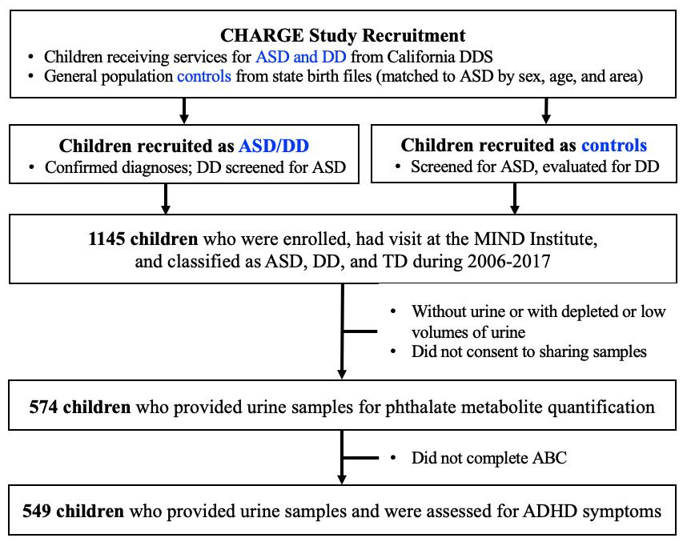
Figure S1. Flowchart depicting study design and study population. ABC, Aberrant Behavior Checklist; ADHD, attention-deficit/hyperactivity disorder; ASD, autism spectrum disorder; CHARGE, Childhood Autism Risks from Genetics and Environment; DD, developmental delay; DDS, department of developmental services; MIND, Medical Investigation of Neurodevelopmental Disorders; TD, typical development.

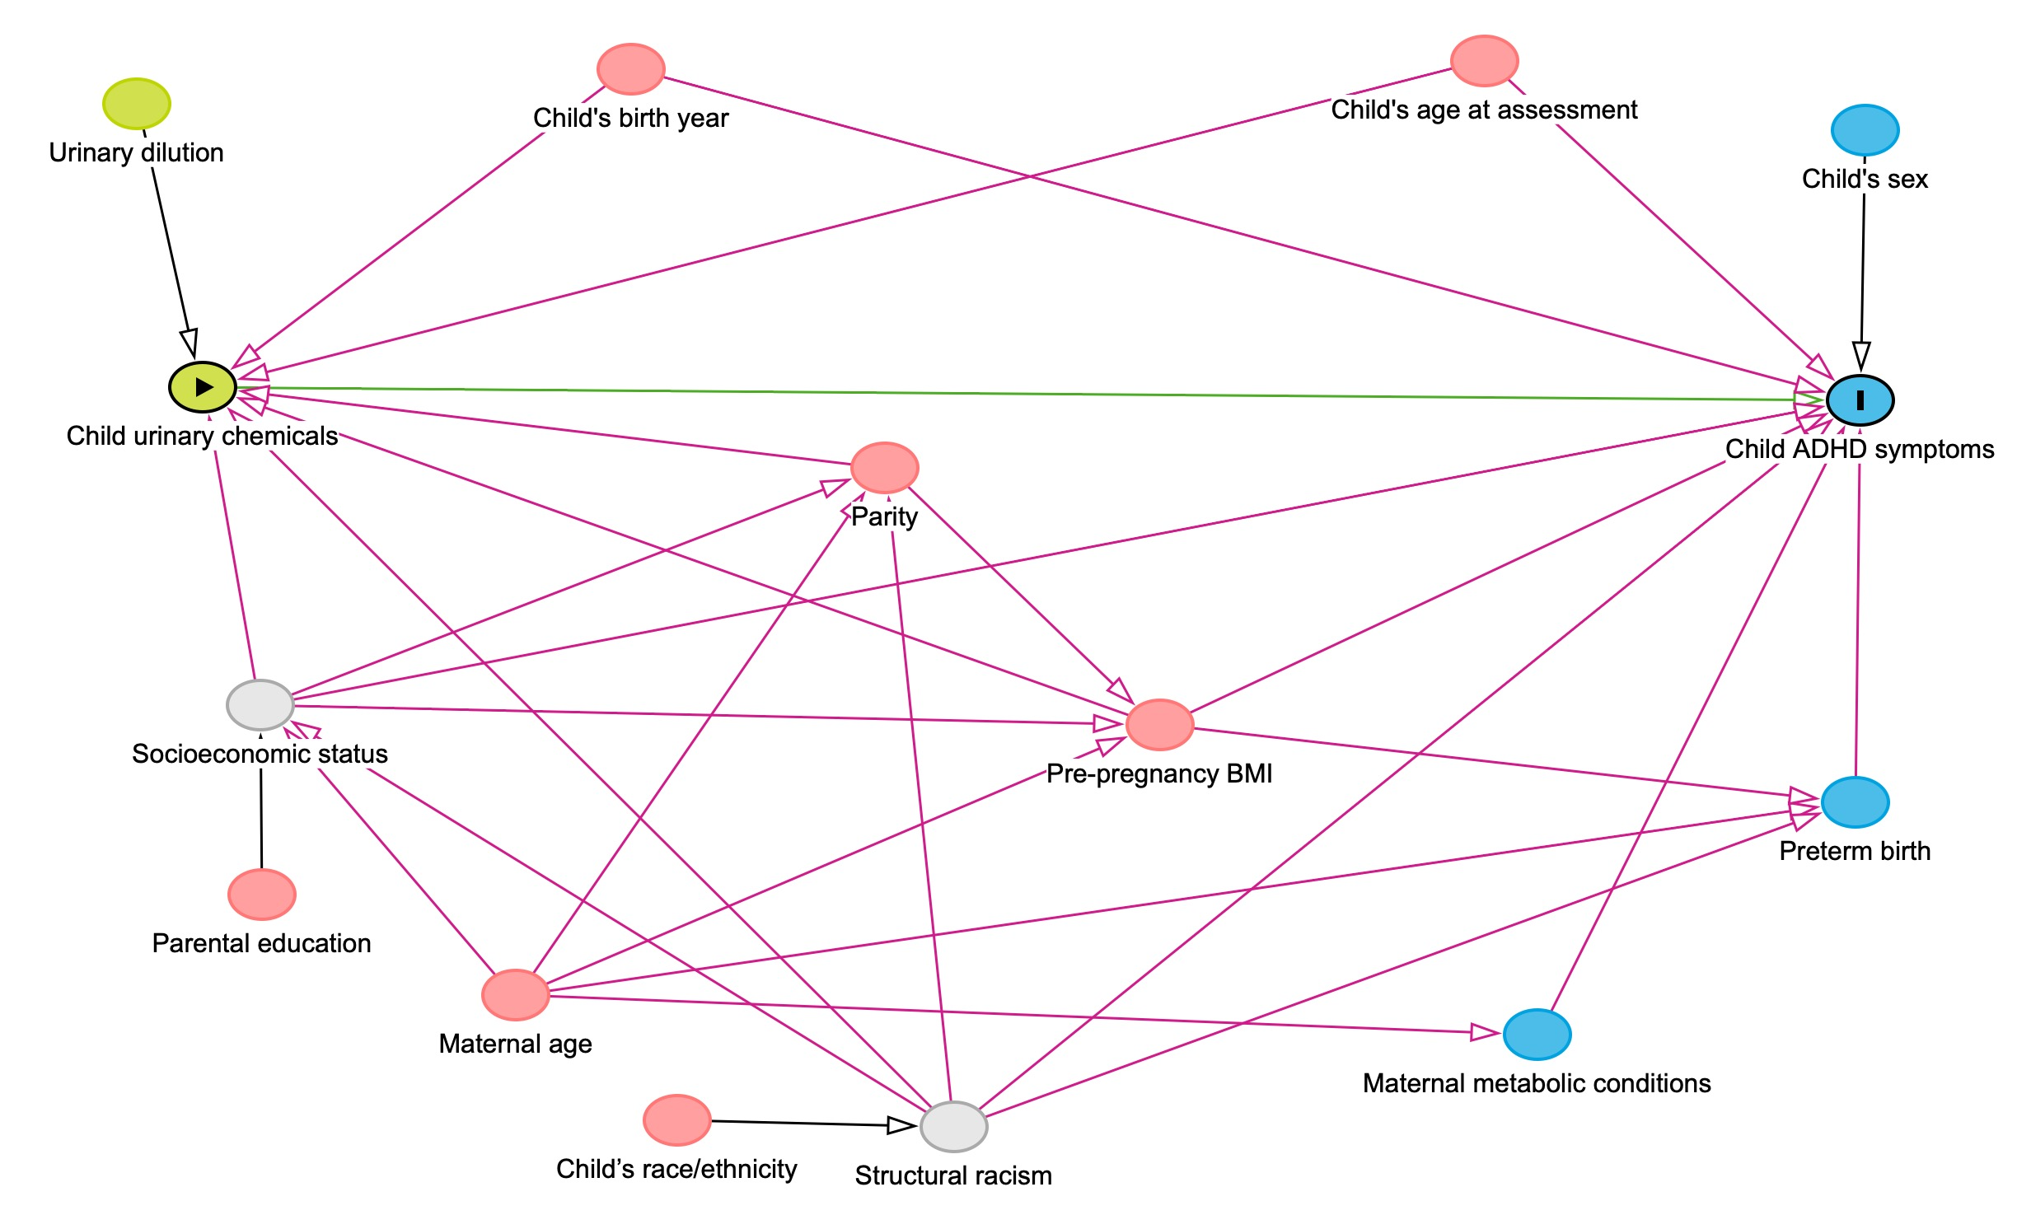Figure S2. Directed acyclic graph for associations of child urinary chemical concentrations with attention deficit hyperactivity disorder (ADHD) symptoms. Green circles indicate ancestors of the exposure, blue circles indicate ancestors of the outcome, pink circles indicate ancestors of both exposure and outcome, and grey circles indicate unobserved variables. BMI, body mass index.
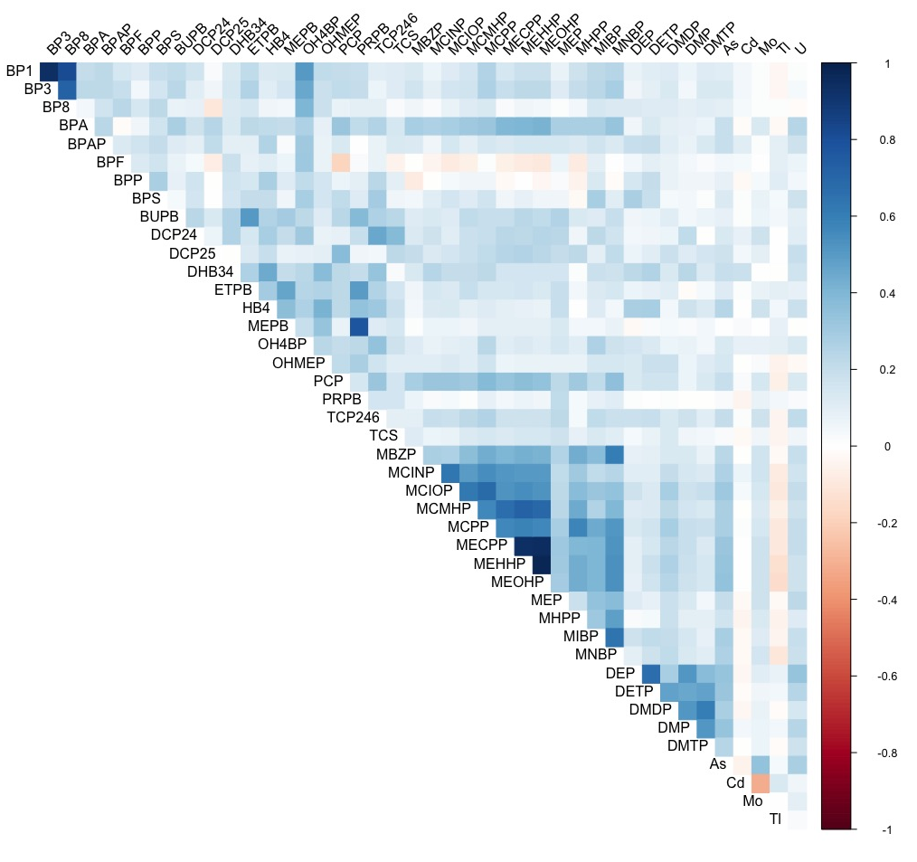
Figure S3. Heatmap of Spearman’s correlation coefficients among specific gravity (SG)-corrected concentrations of 43 compounds. Full chemical names are listed in Table S2.
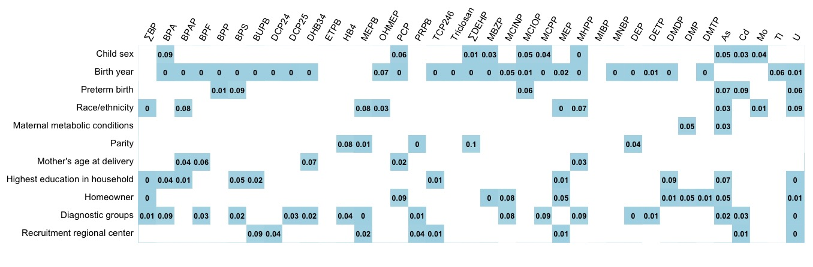
Figure S4. P-value matrix from the Wilcoxon rank-sum test or Kruskal-Wallis test comparing specific gravity (SG)-corrected chemical concentrations by characteristics of 549 CHARGE children. P-values less than 0.02 are presented. Full chemical names are listed in Table S2.
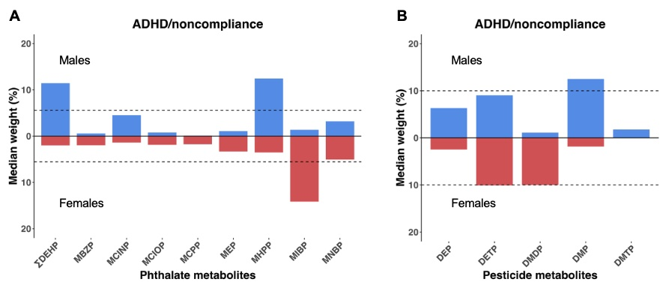
Figure S5. Estimated weight distributions of urinary (A) phthalate metabolites and (B) pesticide metabolites from 100 repetitions of sex-stratified interaction weighted quantile sum (WQS) regression for ADHD/noncompliance. Boxes indicate 50th percentiles of weights. Dashed line indicates a threshold for sex [1/(# of chemicals in the mixture*2)]. Full chemical names are listed in Table S2. ADHD, attention-deficit/hyperactivity disorder.

