Supplementary information

Table S1. ICD-9 and ICD-10 codes used for the identification of physician diagnosed CKD and comorbidities
Disease | ICD-Code
Chronic kidney disease | ICD9- 585.3, 585.4, 585.5, 585.6  ICD10- N18.3, N18.4, N18.5, N18.6
Hypertension | ICD9- 401.9  ICD10- I10
Diabetes | ICD9- 250.0, 250.00, 250.02, 250.1, 250.10, 250.12, 250.2, 250.20, 250.22, 250.3, 250.30, 250.32, 250.4, 250.40, 250.42, 250.5, 250.50, 250.52, 250.6, 250.60, 250.62, 250.7, 250.70, 250.72, 250.8, 250.80, 250.82, 250.9, 250.90, 250.92  ICD10- E11.0 – E11.9

Table S2. Summary of balance for matched cases, diagnosed by ICD code or e-phenotype, and controls
 | Means case | Means control | Std mean difference | Var ratio | eCDF mean | eCDF max | Pair distance
Distance | 0.03 | 0.03 | 0.01 | 0.99 | 0.01 | 0.02 | 0.02
Age | 65.32 | 65.63 | -0.02 | 1.06 | 0.01 | 0.03 | 0.69
Date | 14,493.34 | 14,429.13 | 0.048 | 1.14 | 0.03 | 0.05 | 1.06
Female | 0.54 | 0.56 | -0.03 | . | 0.02 | 0.02 | 0.96
Male | 0.46 | 0.44 | 0.03 | . | 0.02 | 0.02 | 0.96
Black | 0.41 | 0.36 | 0.11 | . | 0.05 | 0.05 | 0.82
Other | 0.04 | 0.06 | -0.11 | . | 0.02 | 0.02 | 0.48
White | 0.55 | 0.58 | -0.06 | . | 0.03 | 0.03 | 0.89
 | All | Matched | Unmatched | Discarded
Control | 99,754 | 4,084 | 95,670 | 0 | . | . | .
Case | 1,021 | 1,021 | 0 | 0 | . | . | .
*Standardized mean differences < 0.1 indicate adequate balance

Table S3. Results of fully adjusted single pollutant (1) linear mixed and (2) logistic regression models for eGFRcr and diagnosis of CKD
Results of single pollutant linear mixed model
 | IQR 1-year PM_{2.5} (µg/m³) | IQR 1-year O₃  (ppb) | IQR 1-year NO₂  (ppb)
Beta (95% CI) | -1.47  (-1.75, -1.18)
Results of single pollutant logistic regression
 | IQR 1-year PM_{2.5} (µg/m³) | IQR 1-year O₃  (ppb) | IQR 1-year NO₂  (ppb)
aOR (95% CI) | 0.89  (0.78, 1.01) | 0.88  (0.79, 0.98) | 0.78  (0.68, 0.90)

Table S4. Results of logistic regression models comparing patients with CKD to the entire random sample cohort using 1-year average concentrations for both first visit and median visit as exposures
 | IQR year PM_{2.5} (µg/m³) | IQR 1-year O₃  (ppb) | IQR 1-year NO₂  (ppb)
First visit in the UNC hospital system
Model 1 | 1.05  (0.91, 1.22)
Model 2 | 1.05  (0.89, 1.23)
Median visit in the UNC hospital system
Model 1 | 1.00  (0.86, 1.17) | 2.04  (1.88, 2.22) | 1.03  (0.93, 1.13)
Model 2 | 1.03  (0.87, 1.22) | 2.20  (2.00, 2.42) | 1.20  (1.05, 1.36)
Median visit in the UNC hospital system from fully adjusted conditional regression model
Model 2 | 2.56  (1.97, 3.39) | 0.84  (0.73, 0.97) | 0.83  (0.71, 0.98)
*Model 1 presents unadjusted estimates and Model 2 presents the results of the fully adjusted logistic regression models

Table S5. Results of fully adjusted models for stratified and sensitivity analysis examining associations between air pollutants and eGFR_{cr}
 | IQR year PM_{2.5} (µg/m³) | IQR 1-year O₃  (ppb) | IQR 1-year NO₂  (ppb)
Stratified analyses
Female | -1.31  (-1.76, -0.87)
Male | -1.85  (-2.32, -1.39)
≥ 12 PM_{2.5} µg/m³ | -2.58  (-3.83, -1.33)
< 12 PM_{2.5} µg/m³ | -078  (-1.13, -0.43) | 0.78  (0.49, 1.08) | 0.61  (0.09, 1.12)
≥ 60 eGFR_{cr} mL/min/1.73 m² | -1.06  (-1.34, -0.77) | 0.08  (-0.17, 0.33) | 0.37  (-0.03, 0.77)
< 60 eGFR_{cr} mL/min/1.73 m² | -0.51  (-0.90, -0.13) | 0.36  (0.03, 0.69) | 0.23  (-0.28, 0.74)
Never diagnosed with CKD | -0.92  (-1.28, -0.56) | -0.27  (-0.58, 0.04) | 0.82  (0.33, 1.30)
Smoking status
Caucasian
African American
Other race
BMI known | -0.74  (-1.20, -0.28) | 0.18  (-0.18, 0.53) | 0.40  (-0.32, 1.13)
Sensitivity analysis
Geocoded Address | -1.57  (-1.91, -1.23) | 0.21  (-08, 0.50) | 0.45  (-0.03, 0.93)

Climate Zone | Control | CKD | Total
 | n (%) |  | n
Zone 1 | 10 (0.20) | 1 (0.02) | 11
Zone 2 | 0 (0.0) | 4 (0.08) | 4
Zone 3 | 1,624 (41.25) | 490 (48.28) | 2,114
Zone 4 | 1,315 (33.40) | 302 (29.75) | 1,617
Zone 5 | 79 (2.01) | 24 (2.63) | 103
Zone 6 | 593 (15.06) | 126 (12.41) | 719
Zone 7 | 159 (4.04) | 47 (4.63) | 206
Zone 8 | 157 (3.99) | 21 (2.07) | 178
Total | 3,937 | 1,015 | 4,952
Table S6. Geographic distribution of CKD cases and matched controls over the eight climatic divisions of North Carolina

Figure S1. Balance statistics of standardized mean differences pre- and post-matching for CKD cases and controls
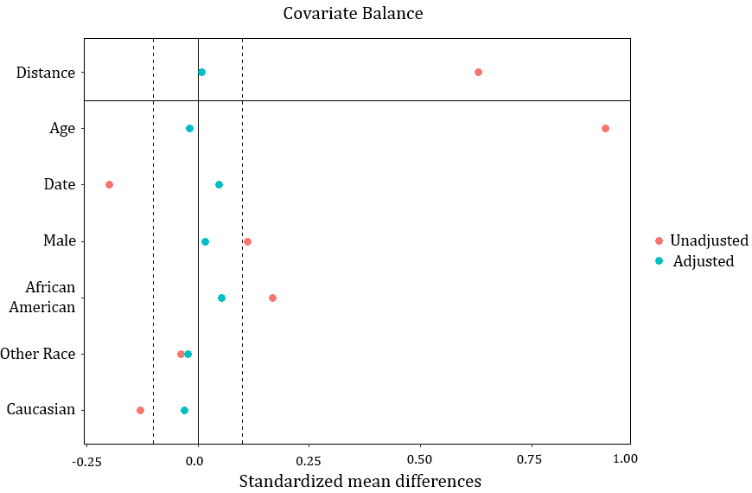

Figure S2. Q-Q Plots of pre- and post-matching
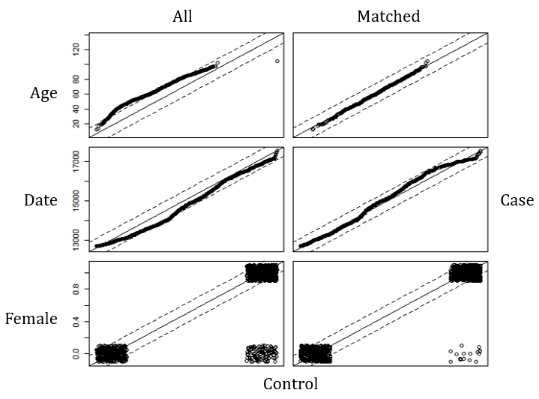
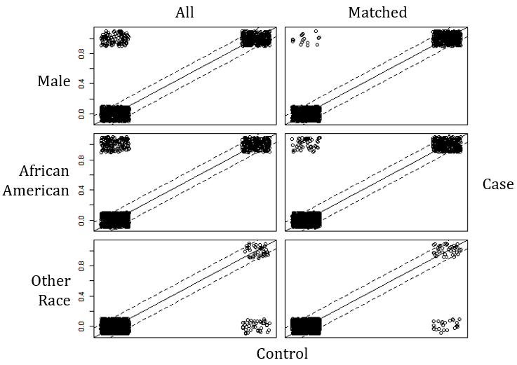
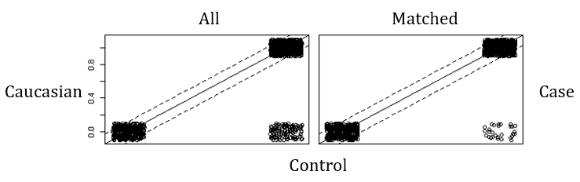

Figure S3. Map of the eight climate zones in North Carolina (this image was taken from http://www.climatechange.nc.gov/Climate_Maps_NC.pdf)
