Supplementary Materials
Table S1 Characteristics of the PARENTs cohort (N=199)
Characteristics | N | %
Maternal age (years)
≤24 | 4 | 2.0
25-29 | 29 | 14.6
30-34 | 92 | 46.2
≥35 | 74 | 37.2
Parity
0 | 94 | 47.2
≥1 | 105 | 52.8
Maternal race/ethnicity
Asian or Pacific islander | 52 | 26.1
Black | 14 | 7.0
Hispanic | 40 | 20.1
White, non-Hispanic | 92 | 46.2
American Indian or Alaskan Native | 1 | 0.5
Maternal education
Bachelor's degree or less | 84 | 45.2
Master's degree | 57 | 30.7
Doctoral degree or professional degree | 45 | 24.2
Missing | 13
Employment Status
Employed or student | 167 | 90.3
Not employed | 18 | 9.7
Missing | 14
Pre-pregnancy BMI
Underweight | 6 | 3.0
Normal | 120 | 60.3
Overweight | 49 | 24.6
Obese | 24 | 12.1
Gestational Diabetes
Yes | 22 | 11.1
No | 177 | 88.9
Gestational Hypertension
Yes | 22 | 11.1
No | 177 | 88.9
Pre-eclampsia
Yes | 18 | 9.1
No | 181 | 91.0
Season of Conception
Spring | 45 | 23.3
Summer | 47 | 24.4
Fall | 42 | 21.8
Winter | 59 | 30.6
Missing | 6

Table S2 Specific Gravity (SG) adjusted concentrations of urinary biomarkers in each sample collection
Biomarkers | N | Specific Gravity (SG) adjusted Value ª
Biomarkers | N | Minimum | Maximum | Geometric Mean | 25th Pct | 50th Pct | 75th Pct
1st sample collection (10-17 gestational weeks)
MDA (nmol/L) | 139 | 9.4 | 2370.0 | 184.5 | 119.0 | 190.0 | 281.0
8-OHdG (µg/L) | 136 | 0.4 | 34.0 | 2.7 | 1.9 | 2.6 | 3.8
Σ₇OHPAH (ng/L) | 138 | 862.7 | 38748.3 | 4136.1 | 2203.5 | 3460.2 | 6307.2
2- & 3-FLUO (ng/L) | 139 | 10.4 | 2340.0 | 107.7 | 62.0 | 95.7 | 175.4
2-NAP (ng/L) | 139 | 768.6 | 37100.0 | 3719.7 | 1964.2 | 2946.3 | 5892.6
1-PYR (ng/L) | 139 | 5.2 | 1430.0 | 42.3 | 24.7 | 37.8 | 68.3
Σ₄OHPHEN (ng/L) | 138 | 26.0 | 2265.5 | 140.1 | 88.4 | 130.9 | 206.9
1-PHEN (ng/L) | 139 | 5.5 | 1665.0 | 63.5 | 38.0 | 63.5 | 99.3
2-PHEN (ng/L) | 138 | 5.2 | 300.0 | 26.1 | 16.3 | 24.3 | 39.3
3-PHEN (ng/L) | 138 | 5.2 | 253.0 | 27.1 | 16.0 | 25.2 | 40.0
4-PHEN (ng/L) | 139 | 3.4 | 241.0 | 16.3 | 9.8 | 14.7 | 24.0
2nd sample collection (18-29 gestational weeks)
MDA (nmol/L) | 137 | 33.0 | 1205 | 185.0 | 119.4 | 167.9 | 274.4
8-OHdG (µg/L) | 134 | 0.2 | 18.1 | 2.4 | 1.6 | 2.2 | 3.0
Σ₇OHPAH (ng/L) | 137 | 895.6 | 114824.5 | 4463.2 | 2217.2 | 3894.4 | 8097.7
2- & 3-FLUO (ng/L) | 137 | 18.1 | 1146.0 | 117.0 | 71.3 | 112.1 | 174.4
2-NAP (ng/L) | 137 | 631.3 | 114545.5 | 4009.8 | 1964.2 | 3535.5 | 7473.7
1-PYR (ng/L) | 137 | 9.8 | 746.7 | 48.7 | 29.4 | 45.0 | 63.9
Σ₄OHPHEN (ng/L) | 137 | 40.4 | 841.0 | 149.2 | 103.8 | 140.2 | 209.6
1-PHEN (ng/L) | 137 | 5.2 | 450.0 | 72.5 | 49.1 | 69.6 | 113.0
2-PHEN (ng/L) | 137 | 4.7 | 156.7 | 27.7 | 19.1 | 26.4 | 34.9
3-PHEN (ng/L) | 137 | 4.9 | 133.0 | 25.6 | 17.5 | 24.0 | 37.4
4-PHEN (ng/L) | 137 | 3.3 | 135.4 | 16.3 | 10.8 | 17.0 | 22.1
3rd sample collection (≥30 gestational weeks)
MDA (nmol/L) | 115 | 12.7 | 5110.0 | 193.5 | 129.1 | 167.0 | 285.0
8-OHdG (µg/L) | 108 | 0.2 | 22.7 | 1.9 | 1.5 | 1.9 | 2.3
Σ₇OHPAH (ng/L) | 115 | 895.0 | 265794.4 | 5012.3 | 2728.6 | 4311.6 | 6571.9
2- & 3-FLUO (ng/L) | 115 | 17.7 | 2690.0 | 105.3 | 58.9 | 92.2 | 183.0
2-NAP (ng/L) | 115 | 679.9 | 262000.0 | 4531.6 | 2495.2 | 3828.6 | 6166.7
1-PYR (ng/L) | 115 | 8.0 | 2250.0 | 61.9 | 36.3 | 54.1 | 95.5
Σ₄OHPHEN (ng/L) | 115 | 18.6 | 2423.4 | 173.8 | 101.7 | 152.1 | 264.0
1-PHEN (ng/L) | 115 | 4.7 | 1860.0 | 85.1 | 46.6 | 81.4 | 159.2
2-PHEN (ng/L) | 115 | 4.7 | 496.7 | 33.1 | 20.7 | 28.3 | 51.9
3-PHEN (ng/L) | 115 | 4.7 | 376.7 | 25.6 | 14.7 | 23.2 | 38.5
4-PHEN (ng/L) | 115 | 2.9 | 225.7 | 16.0 | 8.8 | 14.7 | 29.5
a. Concentrations below the limit of detection (LOD) values were replaced with the LOD/√2

Table S3 Specific Gravity (SG) adjusted concentrations of urinary biomarkers by sample collection season
Biomarkers | N | Specific Gravity (SG) adjusted Value ª
Biomarkers | N | Minimum | Maximum | Geometric mean | 25th Pct | 50th Pct | 75th Pct
Spring
MDA (nmol/L) | 120 | 33.0 | 1500.0 | 185.1 | 117.3 | 185.7 | 275.6
8-OHdG (µg/L) | 116 | 0.3 | 24.5 | 2.5 | 1.7 | 2.2 | 3.5
Σ₇OHPAH (ng/L) | 120 | 1056.4 | 89760.4 | 4238.0 | 2384.3 | 3881.6 | 6098.8
2- & 3-FLUO (ng/L) | 120 | 18.1 | 880.0 | 101.3 | 61.4 | 88.6 | 157.7
2-NAP (ng/L) | 120 | 841.8 | 89523.8 | 3838.8 | 1964.2 | 3535.5 | 5890
1-PYR (ng/L) | 120 | 9.8 | 1430.0 | 48.6 | 29.4 | 44.3 | 76.1
Σ₄OHPHEN (ng/L) | 120 | 18.6 | 2265.5 | 145.3 | 94.5 | 135.2 | 217.4
1-PHEN (ng/L) | 120 | 4.7 | 1665.0 | 68.1 | 37.7 | 71.7 | 109.0
2-PHEN (ng/L) | 120 | 4.7 | 229.0 | 27.8 | 18.5 | 27.4 | 36.7
3-PHEN (ng/L) | 120 | 4.7 | 200.5 | 25.0 | 15.1 | 22.1 | 37.4
4-PHEN (ng/L) | 120 | 2.9 | 197.0 | 15.6 | 9.8 | 14.7 | 22.8
Summer
MDA (nmol/L) | 89 | 12.7 | 908.9 | 180.1 | 126.0 | 178.5 | 292.2
8-OHdG (µg/L) | 85 | 0.4 | 6.8 | 2.1 | 1.6 | 2.1 | 2.7
Σ₇OHPAH (ng/L) | 89 | 895.6 | 33779.7 | 4865.1 | 2168.9 | 4300.9 | 9471.1
2- & 3-FLUO (ng/L) | 89 | 10.4 | 2340.0 | 120.0 | 78.2 | 112.0 | 173.3
2-NAP (ng/L) | 89 | 631.3 | 33450.0 | 4360.2 | 1964.2 | 3863.2 | 8838.8
1-PYR (ng/L) | 89 | 9.2 | 746.7 | 50.0 | 29.0 | 50.4 | 79.0
Σ₄OHPHEN (ng/L) | 89 | 29.1 | 1362.2 | 161.1 | 98.9 | 148.6 | 216.1
1-PHEN (ng/L) | 89 | 5.5 | 868.0 | 75.7 | 43.5 | 67.2 | 118.3
2-PHEN (ng/L) | 89 | 5.5 | 288.1 | 29.3 | 18.5 | 25.4 | 41.4
3-PHEN (ng/L) | 89 | 5.2 | 193.6 | 27.5 | 17.7 | 25.4 | 41.7
4-PHEN (ng/L) | 89 | 3.3 | 135.4 | 15.9 | 9.8 | 14.7 | 25.5
Fall
MDA (nmol/L) | 88 | 59.6 | 5110.0 | 212.9 | 136.3 | 193 | 278.1
8-OHdG (µg/L) | 85 | 0.8 | 20.4 | 2.4 | 1.6 | 2.2 | 2.9
Σ₇OHPAH (ng/L) | 87 | 895.0 | 265794.4 | 4357.5 | 2350.0 | 3697.4 | 6340.4
2- & 3-FLUO (ng/L) | 88 | 17.7 | 837.0 | 112.1 | 64.5 | 106.4 | 188.6
2-NAP (ng/L) | 88 | 679.9 | 262000.0 | 3905.2 | 2199.3 | 3527.8 | 5755.8
1-PYR (ng/L) | 88 | 8.0 | 2250.0 | 50.7 | 30.9 | 46.0 | 73.8
Σ₄OHPHEN (ng/L) | 87 | 39.8 | 2423.4 | 156.5 | 102.7 | 142.9 | 213.4
1-PHEN (ng/L) | 88 | 14.5 | 1860.0 | 77.7 | 50.2 | 75.1 | 116.5
2-PHEN (ng/L) | 87 | 4.7 | 268.0 | 28.7 | 19.1 | 26.7 | 43.7
3-PHEN (ng/L) | 87 | 8.2 | 207.0 | 25.6 | 16.5 | 23.3 | 36.3
4-PHEN (ng/L) | 88 | 3.7 | 205.0 | 16.2 | 11.0 | 16.8 | 22.3
Winter
MDA (nmol/L) | 94 | 9.4 | 2370.0 | 175.0 | 103.2 | 164.4 | 274.4
8-OHdG (µg/L) | 92 | 0.2 | 34.0 | 2.3 | 1.6 | 2.2 | 3.2
Σ₇OHPAH (ng/L) | 94 | 862.7 | 114824.5 | 4630.7 | 2287.1 | 3590.1 | 7260.2
2- & 3-FLUO (ng/L) | 94 | 10.4 | 2690.0 | 111.1 | 61.1 | 110.8 | 183.0
2-NAP (ng/L) | 94 | 768.6 | 114545.5 | 4172.2 | 1987.5 | 3293.9 | 7027.3
1-PYR (ng/L) | 94 | 5.2 | 1130.0 | 49.9 | 29.5 | 43.5 | 78.6
Σ₄OHPHEN (ng/L) | 94 | 26.0 | 2382.3 | 150.8 | 89.7 | 131.3 | 224.5
1-PHEN (ng/L) | 94 | 5.9 | 1283.3 | 70.7 | 44.3 | 66.6 | 111.0
2-PHEN (ng/L) | 94 | 4.9 | 496.7 | 28.8 | 18.4 | 25.8 | 42.1
3-PHEN (ng/L) | 94 | 4.9 | 376.7 | 26.8 | 17.1 | 24.6 | 41.2
4-PHEN (ng/L) | 94 | 3.3 | 241.0 | 17.3 | 10.0 | 17.1 | 28.1
a. Concentrations below the limit of detection (LOD) values were replaced with the LOD/√2

Table S4 Linear regression for percentage changes and 95% confidence intervals (CI) in oxidative stress biomarker concentrations per doubling concentration of different PAH metabolites
Oxidative stress biomarkers | PAH metabolites | Percentage changes (95% CI) ª
Oxidative stress biomarkers | PAH metabolites | 1st Sampling | Interaction p-value | 2nd Sampling | Interaction p-value | 3rd Sampling | Interaction p-value
MDA (nmol/L) | Σ₇OHPAH (ng/L) | 14.5 (1.4, 29.3) | 0.36 | 8.7 (0.2, 18.0) | 0.06 | 23.6 (10.5, 38.3) | ref
MDA (nmol/L) | 2- & 3-FLUO (ng/L) | 41.1 (25.9, 58.2) | 0.89 | 13.7 (2.3, 26.3) | 0.03 | 33.8 (17.3, 52.6) | ref
MDA (nmol/L) | 2-NAP (ng/L) | 11.8 (-0.5, 25.7) | 0.27 | 7.5 (-0.5, 16.2) | 0.06 | 21.8 (9.2, 35.8) | ref
MDA (nmol/L) | 1-PYR (ng/L) | 39.9 (24.3, 57.5) | 0.58 | 17.7 (6.5, 30.1) | 0.14 | 31.6 (17.8, 47.1) | ref
MDA (nmol/L) | Σ₄OHPHEN (ng/L) | 46.0 (27.0, 67.8) | 0.85 | 14.5 (1.0, 29.8) | 0.02 | 38.8 (22.0, 57.8) | ref
MDA (nmol/L) | 1-PHEN (ng/L) | 35.8 (20.4, 53.1) | 0.84 | 9.6 (-0.8, 21.1) | 0.02 | 28.3 (16.1, 41.7) | ref
MDA (nmol/L) | 2-PHEN (ng/L) | 37.7 (20.2, 57.9) | 0.69 | 11.6 (-1.2, 25.9) | 0.02 | 38.3 (20.6, 58.7) | ref
MDA (nmol/L) | 3-PHEN (ng/L) | 39.9 (21.8, 60.6) | 0.55 | 13.8 (0.9, 28.3) | 0.15 | 29.3 (11.8, 49.4) | ref
MDA (nmol/L) | 4-PHEN (ng/L) | 25.1 (9.9, 42.4) | 0.43 | 5.8 (-6.0, 19.0) | 0.49 | 14.8 (2.1, 29.1) | ref
8-OHdG (µg/L) | Σ₇OHPAH (ng/L) | 22.2 (12.0, 33.4) | 0.11 | 15.5 (7.1, 24.6) | 0.02 | 34.5 (23.7, 46.1) | ref
8-OHdG (µg/L) | 2- & 3-FLUO (ng/L) | 35.9 (24.9, 47.8) | 0.25 | 25.1 (13.8, 37.6) | 0.04 | 42.0 (28.1, 57.3) | ref
8-OHdG (µg/L) | 2-NAP (ng/L) | 19.8 (10.0, 30.5) | 0.10 | 13.8 (6.0, 22.3) | 0.02 | 31.6 (21.3, 42.8) | ref
8-OHdG (µg/L) | 1-PYR (ng/L) | 44.6 (33.6, 56.4) | 0.38 | 23.8 (12.9, 35.8) | 0.15 | 33.7 (22.7, 45.7) | ref
8-OHdG (µg/L) | Σ₄OHPHEN (ng/L) | 58.6 (45.3, 73.1) | 0.80 | 33.9 (19.5, 50.0) | 0.11 | 48.1 (34.7, 62.8) | ref
8-OHdG (µg/L) | 1-PHEN (ng/L) | 46.0 (35.1, 57.8) | 0.41 | 24.7 (13.4, 37.1) | 0.31 | 31.3 (21.4, 42.0) | ref
8-OHdG (µg/L) | 2-PHEN (ng/L) | 47.3 (34.4, 61.5) | 0.38 | 28.4 (14.7, 43.7) | 0.04 | 49.7 (35.0, 65.9) | ref
8-OHdG (µg/L) | 3-PHEN (ng/L) | 46.6 (33.3, 61.2) | 0.84 | 28.6 (15.4, 43.3) | 0.09 | 40.2 (25.4, 56.6) | ref
8-OHdG (µg/L) | 4-PHEN (ng/L) | 35.8 (23.9, 48.7) | 0.17 | 17.2 (5.0, 30.8) | 0.48 | 19.2 (8.3, 31.3) | ref
a. Adjusted for maternal age, maternal race/ethnicity, maternal education, parity, pre-pregnancy BMI, season of sampling.

Table S5 Linear mixed regression models for percentage changes and 95% confidence intervals (CI) in oxidative stress biomarker concentrations per doubling concentration of different PAH metabolites
Oxidative stress biomarkers | PAH metabolites | Percentage changes (95% CI) ª
MDA (nmol/L) | Σ₇OHPAH (ng/L) | 15.5 (8.5, 22.9)
MDA (nmol/L) | 2- & 3-FLUO (ng/L) | 29.8 (21.1, 39.1)
MDA (nmol/L) | 2-NAP (ng/L) | 13.1 (6.6, 20.1)
MDA (nmol/L) | 1-PYR (ng/L) | 30.3 (22.4, 38.8)
MDA (nmol/L) | Σ₄OHPHEN (ng/L) | 35.3 (25.3, 46.1)
MDA (nmol/L) | 1-PHEN (ng/L) | 24.8 (17.1, 32.9)
MDA (nmol/L) | 2-PHEN (ng/L) | 31.7 (22.0, 42.2)
MDA (nmol/L) | 3-PHEN (ng/L) | 30.0 (20.3, 40.6)
MDA (nmol/L) | 4-PHEN (ng/L) | 17.5 (9.3, 26.4)
8-OHdG (µg/L) | Σ₇OHPAH (ng/L) | 22.1 (15.9, 28.5)
8-OHdG (µg/L) | 2- & 3-FLUO (ng/L) | 33.7 (26.5, 41.3)
8-OHdG (µg/L) | 2-NAP (ng/L) | 19.6 (13.8, 25.6)
8-OHdG (µg/L) | 1-PYR (ng/L) | 29.1 (22.5, 36.0)
8-OHdG (µg/L) | Σ₄OHPHEN (ng/L) | 42.7 (34.3, 51.7)
8-OHdG (µg/L) | 1-PHEN (ng/L) | 30.4 (23.8, 37.3)
8-OHdG (µg/L) | 2-PHEN (ng/L) | 36.6 (28.3, 45.4)
8-OHdG (µg/L) | 3-PHEN (ng/L) | 39.1 (30.9, 47.9)
8-OHdG (µg/L) | 4-PHEN (ng/L) | 25.3 (18.0, 33.0)
a. Adjusted for maternal age, maternal race/ethnicity, maternal education, parity, pre-pregnancy BMI, season of sampling.

Table S6 Linear regression for percentage changes and 95% confidence intervals (CI) in oxidative stress biomarker concentrations per doubling concentration of different PAH metabolites, with False Discovery Rate (FDR) adjusted p-values
Oxidative stress biomarkers | PAH metabolites | Percentage changes (95% CI) ª
Oxidative stress biomarkers | PAH metabolites | 1st Sampling | FDR adjusted p-values | 2nd Sampling | FDR adjusted p-values | 3rd Sampling | FDR adjusted p-values
MDA (nmol/L) | Σ₇OHPAH (ng/L) | 14.5 (1.4, 29.3) | 0.03 | 8.7 (0.2, 18.0) | 0.06 | 23.6 (10.5, 38.3) | 0.00
MDA (nmol/L) | 2- & 3-FLUO (ng/L) | 41.1 (25.9, 58.2) | <.0001 | 13.7 (2.3, 26.3) | 0.03 | 33.8 (17.3, 52.6) | <.0001
MDA (nmol/L) | 2-NAP (ng/L) | 11.8 (-0.5, 25.7) | 0.06 | 7.5 (-0.5, 16.2) | 0.08 | 21.8 (9.2, 35.8) | 0.00
MDA (nmol/L) | 1-PYR (ng/L) | 39.9 (24.3, 57.5) | <.0001 | 17.7 (6.5, 30.1) | 0.00 | 31.6 (17.8, 47.1) | <.0001
MDA (nmol/L) | Σ₄OHPHEN (ng/L) | 46.0 (27.0, 67.8) | <.0001 | 14.5 (1.0, 29.8) | 0.05 | 38.8 (22.0, 57.8) | <.0001
MDA (nmol/L) | 1-PHEN (ng/L) | 35.8 (20.4, 53.1) | <.0001 | 9.6 (-0.8, 21.1) | 0.08 | 28.3 (16.1, 41.7) | <.0001
MDA (nmol/L) | 2-PHEN (ng/L) | 37.7 (20.2, 57.9) | <.0001 | 11.6 (-1.2, 25.9) | 0.08 | 38.3 (20.6, 58.7) | <.0001
MDA (nmol/L) | 3-PHEN (ng/L) | 39.9 (21.8, 60.6) | <.0001 | 13.8 (0.9, 28.3) | 0.05 | 29.3 (11.8, 49.4) | 0.00
MDA (nmol/L) | 4-PHEN (ng/L) | 25.1 (9.9, 42.4) | 0.00 | 5.8 (-6.0, 19.0) | 0.35 | 14.8 (2.1, 29.1) | 0.02
8-OHdG (µg/L) | Σ₇OHPAH (ng/L) | 22.2 (12.0, 33.4) | <.0001 | 15.5 (7.1, 24.6) | 0.00 | 34.5 (23.7, 46.1) | <.0001
8-OHdG (µg/L) | 2- & 3-FLUO (ng/L) | 35.9 (24.9, 47.8) | <.0001 | 25.1 (13.8, 37.6) | <.0001 | 42.0 (28.1, 57.3) | <.0001
8-OHdG (µg/L) | 2-NAP (ng/L) | 19.8 (10.0, 30.5) | <.0001 | 13.8 (6.0, 22.3) | 0.00 | 31.6 (21.3, 42.8) | <.0001
8-OHdG (µg/L) | 1-PYR (ng/L) | 44.6 (33.6, 56.4) | <.0001 | 23.8 (12.9, 35.8) | <.0001 | 33.7 (22.7, 45.7) | <.0001
8-OHdG (µg/L) | Σ₄OHPHEN (ng/L) | 58.6 (45.3, 73.1) | <.0001 | 33.9 (19.5, 50.0) | <.0001 | 48.1 (34.7, 62.8) | <.0001
8-OHdG (µg/L) | 1-PHEN (ng/L) | 46.0 (35.1, 57.8) | <.0001 | 24.7 (13.4, 37.1) | <.0001 | 31.3 (21.4, 42.0) | <.0001
8-OHdG (µg/L) | 2-PHEN (ng/L) | 47.3 (34.4, 61.5) | <.0001 | 28.4 (14.7, 43.7) | <.0001 | 49.7 (35.0, 65.9) | <.0001
8-OHdG (µg/L) | 3-PHEN (ng/L) | 46.6 (33.3, 61.2) | <.0001 | 28.6 (15.4, 43.3) | <.0001 | 40.2 (25.4, 56.6) | <.0001
8-OHdG (µg/L) | 4-PHEN (ng/L) | 35.8 (23.9, 48.7) | <.0001 | 17.2 (5.0, 30.8) | 0.01 | 19.2 (8.3, 31.3) | 0.00
a. Adjusted for maternal age, maternal race/ethnicity, maternal education, parity, pre-pregnancy BMI, season of sampling.

Table S7 Linear regression for percentage changes and 95% confidence intervals (CI) in oxidative stress biomarker concentrations per doubling concentration of different PAH biomarkers among women without pregnancy complications ª
Oxidative stress biomarkers | PAH metabolites | 1st Sampling | 2nd Sampling | 3rd Sampling
MDA (nmol/L) | Σ₇OHPAH (ng/L) | 9.6 (-4.2, 25.2) | 14.5 (3.3, 26.8) | 27.3 (12.8, 43.7)
MDA (nmol/L) | 2- & 3-FLUO (ng/L) | 43.1 (26.4, 61.9) | 22.5 (8.3, 38.6) | 45.8 (25.3, 69.7)
MDA (nmol/L) | 2-NAP (ng/L) | 7.1 (-5.7, 21.7) | 12.6 (2.3, 24.0) | 25.3 (11.4, 41.0)
MDA (nmol/L) | 1-PYR (ng/L) | 51.5 (32.8, 72.7) | 14.9 (2.6, 28.7) | 39.2 (23.2, 57.2)
MDA (nmol/L) | Σ₄OHPHEN (ng/L) | 52.3 (30.4, 77.9) | 20.8 (4.8, 39.3) | 51.5 (32.2, 73.6)
MDA (nmol/L) | 1-PHEN (ng/L) | 36.6 (19.5, 56.1) | 13.8 (1.7, 27.2) | 33.9 (20.4, 48.8)
MDA (nmol/L) | 2-PHEN (ng/L) | 43.9 (23.5, 67.7) | 16.9 (1.9, 34.1) | 53.0 (32.6, 76.6)
MDA (nmol/L) | 3-PHEN (ng/L) | 50.8 (29.4, 75.6) | 18.3 (3.0, 35.8) | 42.9 (21.6, 68.1)
MDA (nmol/L) | 4-PHEN (ng/L) | 29.4 (11.8, 49.7) | 13.0 (-2.6, 31.0) | 26.6 (11.1, 44.2)
8-OHdG (µg/L) | Σ₇OHPAH (ng/L) | 23.5 (12.1, 36.0) | 23.0 (11.3, 35.9) | 36.9 (25.0, 49.9)
8-OHdG (µg/L) | 2- & 3-FLUO (ng/L) | 33.9 (21.5, 47.6) | 33.8 (18.9, 50.6) | 55.2 (38.9, 73.4)
8-OHdG (µg/L) | 2-NAP (ng/L) | 21.4 (10.6, 33.2) | 19.9 (9.1, 31.8) | 33.9 (22.5, 46.4)
8-OHdG (µg/L) | 1-PYR (ng/L) | 48.6 (35.3, 63.2) | 24.1 (10.9, 38.8) | 40.6 (28.5, 53.8)
8-OHdG (µg/L) | Σ₄OHPHEN (ng/L) | 60.6 (45.0, 77.9) | 43.4 (25.0, 64.5) | 57.3 (42.5, 73.6)
8-OHdG (µg/L) | 1-PHEN (ng/L) | 44.8 (32.3, 58.5) | 29.2 (14.9, 45.2) | 35.3 (24.0, 47.7)
8-OHdG (µg/L) | 2-PHEN (ng/L) | 50.4 (35.2, 67.3) | 39.0 (21.6, 58.8) | 60.1 (44.4, 77.6)
8-OHdG (µg/L) | 3-PHEN (ng/L) | 49.3 (33.7, 66.8) | 36.5 (19.7, 55.7) | 50.5 (33.6, 69.4)
8-OHdG (µg/L) | 4-PHEN (ng/L) | 40.3 (26.5, 55.7) | 36.6 (18.4, 57.7) | 29.5 (16.7, 43.6)
a. Adjusted for maternal age, maternal race/ethnicity, maternal education, parity, pre-pregnancy BMI, season of sampling. Excluded pregnancy complications including gestational diabetes, gestational hypertension, and pre-eclampsia.

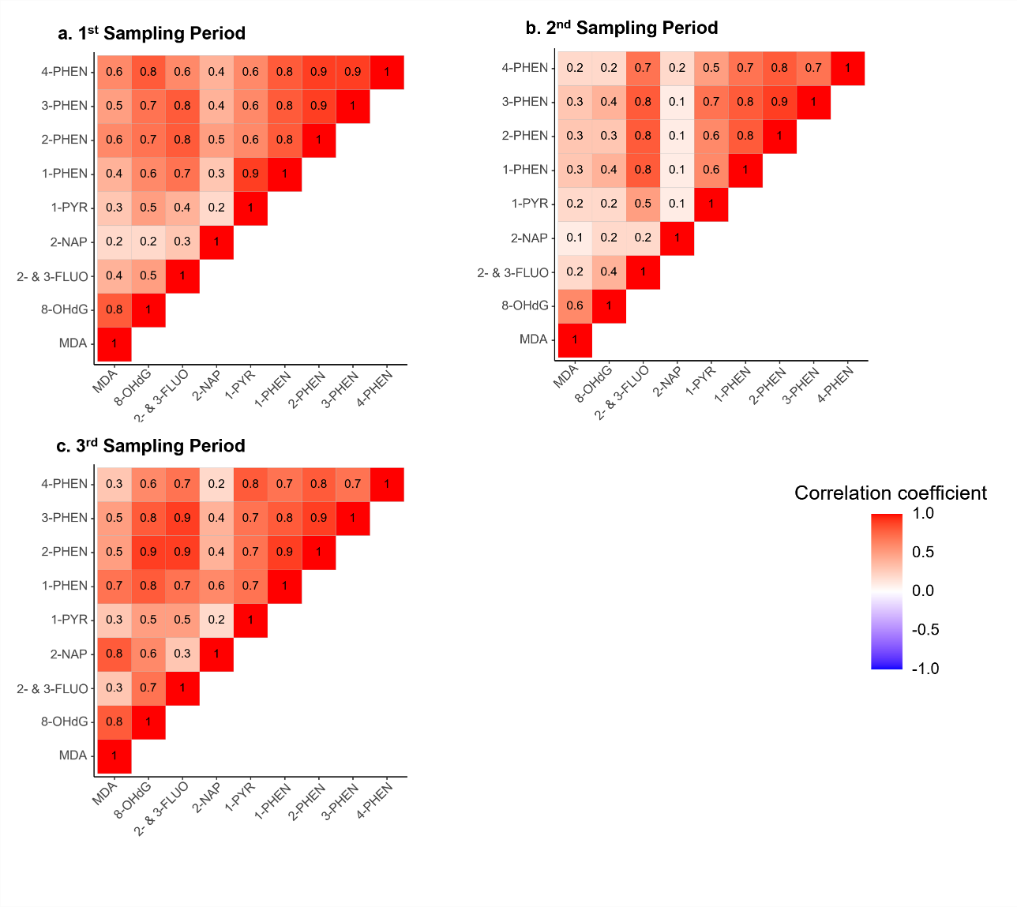
Figure S1 Pearson correlation coefficients of biomarker concentrations among study population
Figure S2 Linear regression for percentage changes of oxidative stress biomarker concentrations per doubling concentration of different PAH metabolites. Adjusted for maternal age, maternal race/ethnicity, maternal education, parity, pre-pregnancy BMI, and sampling season.
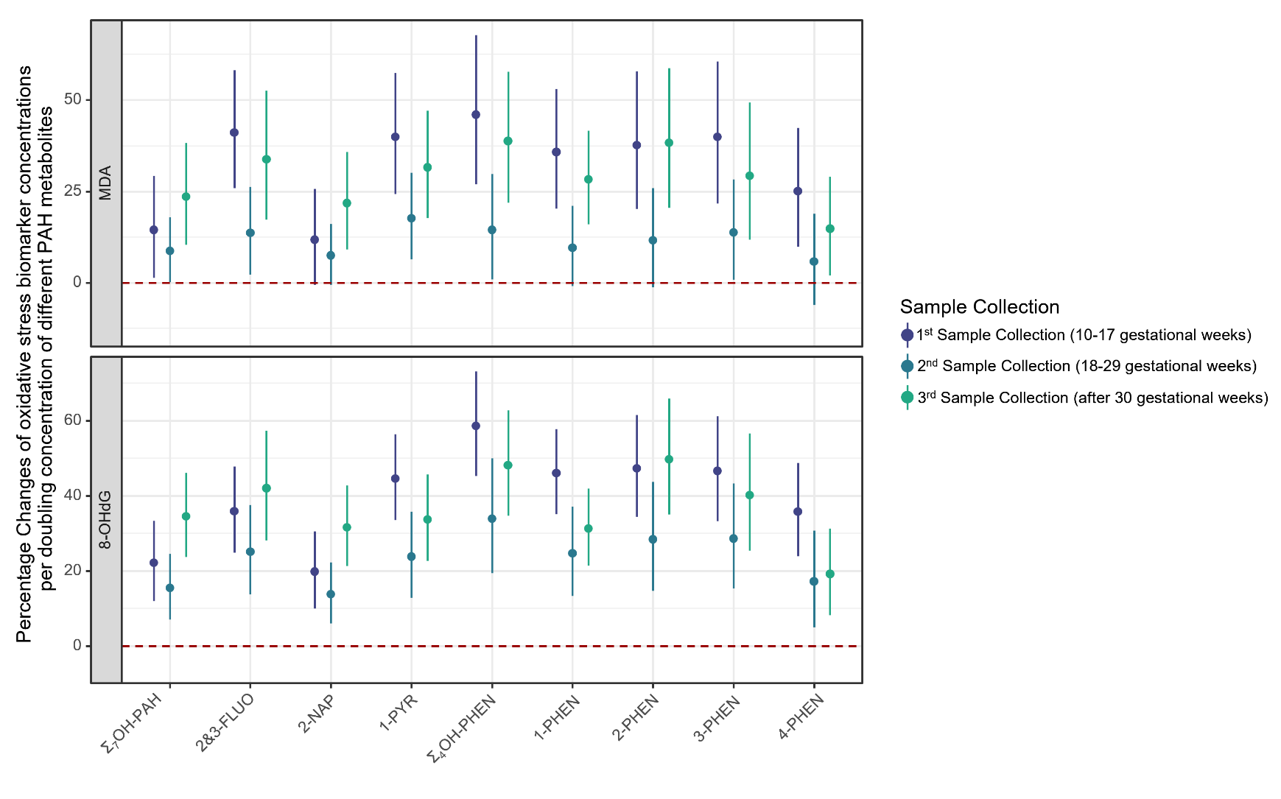

Figure S3 Linear mixed regression models for percentage changes in oxidative stress biomarker concentrations per doubling concentration of different PAH metabolites, stratified by sampling season. Adjusted for maternal age, maternal race/ethnicity, maternal education, parity, pre-pregnancy BMI.
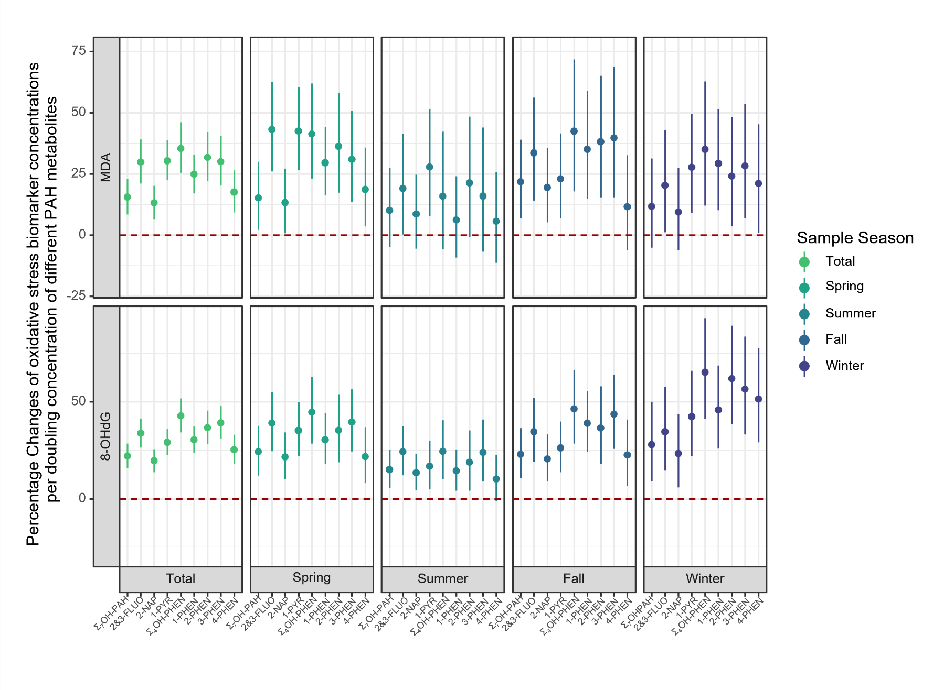
Figure S4 Linear mixed regression models for percentage changes of oxidative stress biomarker concentrations per doubling concentration of different PAH metabolites, stratified by fetal sex. Adjusted for maternal age, maternal race/ethnicity, maternal education, parity, pre-pregnancy BMI, and sampling season.
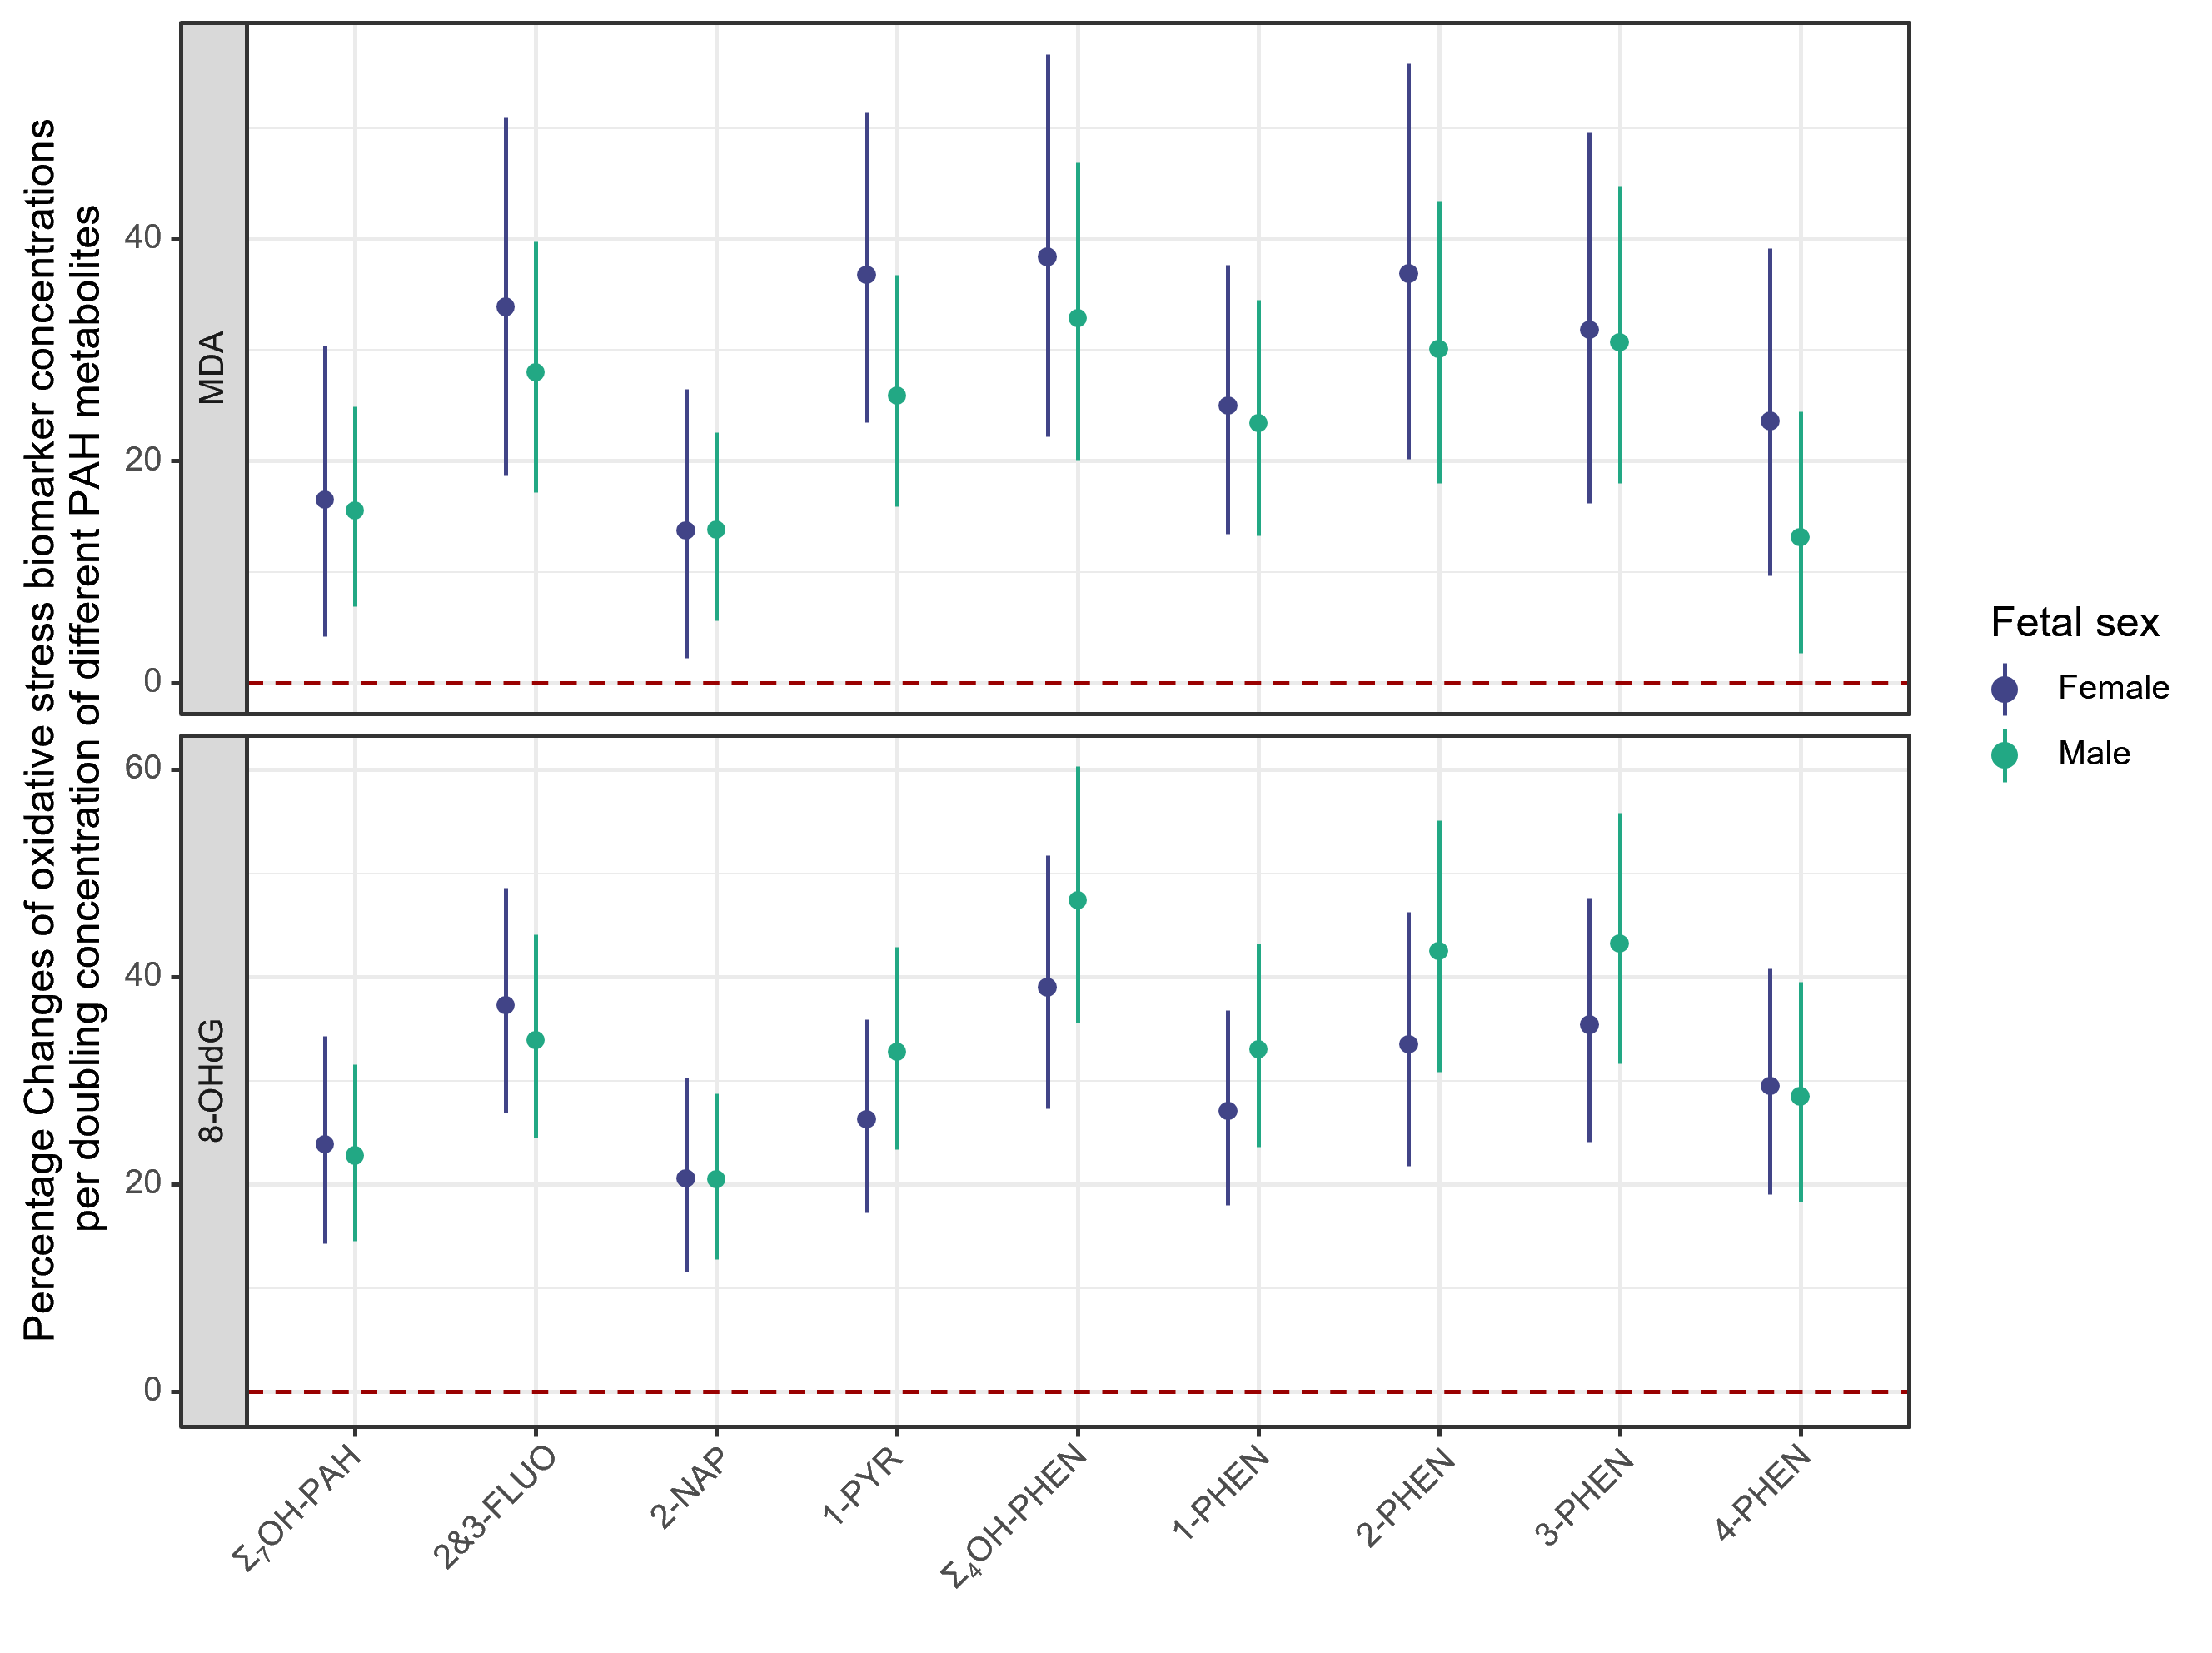
Figure S5 Linear mixed regression models for percentage changes of oxidative stress biomarker concentrations per doubling concentration of different PAH metabolites, stratified by maternal race/ethnicity. Adjusted for maternal age, maternal education, parity, pre-pregnancy BMI, and sampling season.
