To identify the total effect of education on multimorbidity we omit stratification by income, since it serves as a partial mediator of the effect of education, while age and gender are adjusted for. When estimating the total effect of income on multimorbidity we stratify by education since it influences multimorbidity through a backdoor path in addition to controlling for age, gender and region. When estimating the effect of O3, we stratify by NO2 since nitrogen dioxide infuences multimorbidity directly through a backdoor path. The other air pollutants are adjusted for since they are competing risk factors.

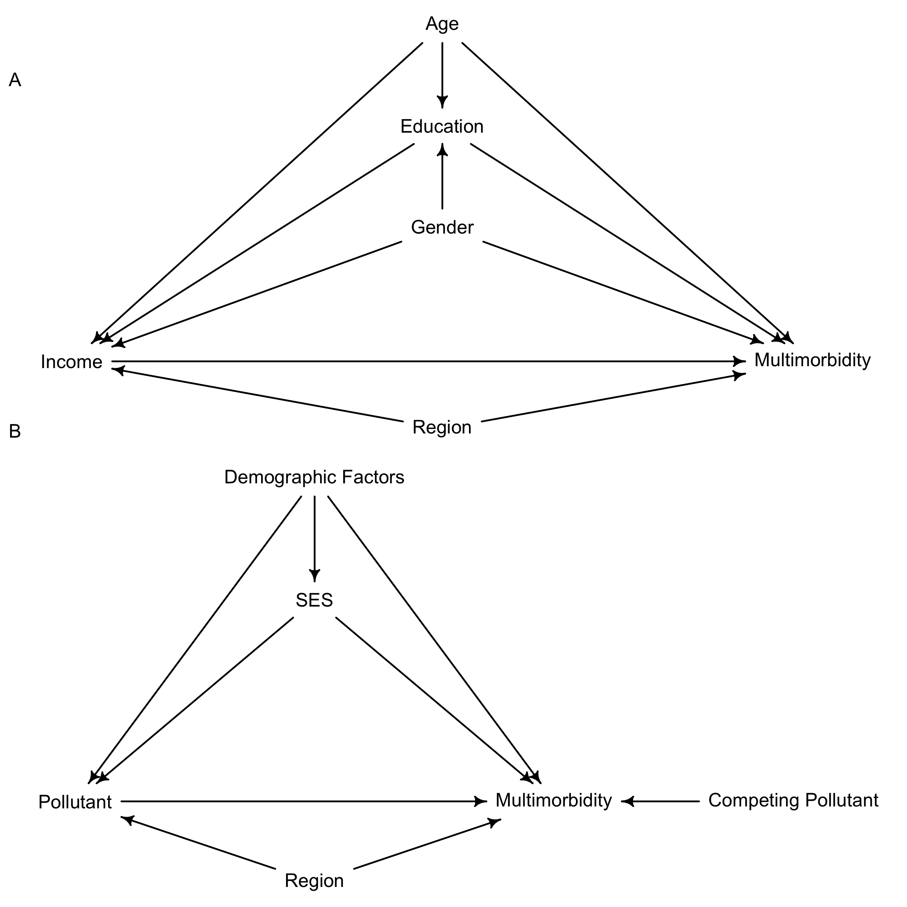
Fig Directed acyclic graphs (DAGs) of the assumed covariate relationship among predictors of multimorbidity. Plot A shows the derived DAG for estimating the effect of income and education on multimorbidity. Plot B shows the derived DAG for estimating the effect of a given pollutant given covariates and competing pollutants. Demographic factors (age and gender) and SES (income and education) are abbreviated for convenience. SES, socioeconomic status.

