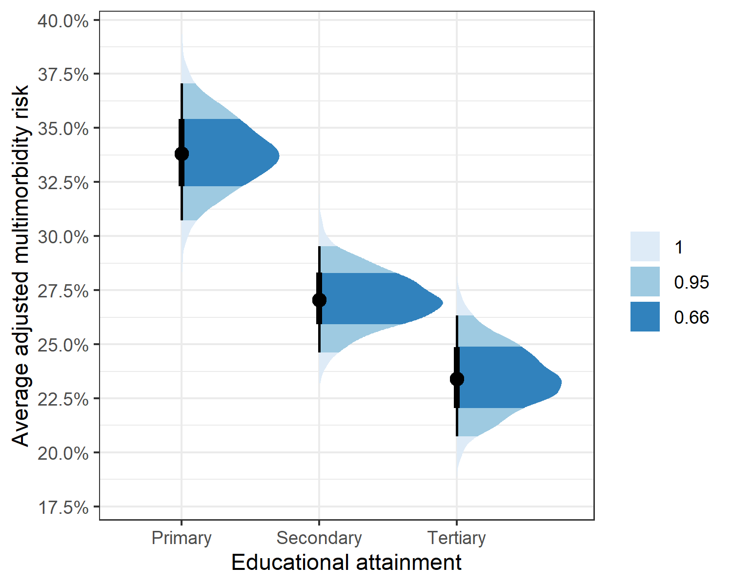
Fig Average adjusted posterior distributions of multimorbidity risk by educational attainment (shaded areas represent conventional credible intervals). Figure illustrates a notable decline in odds of having multimorbidity with higher levels of education. Individuals with a ‘primary’ education level served as the reference group.
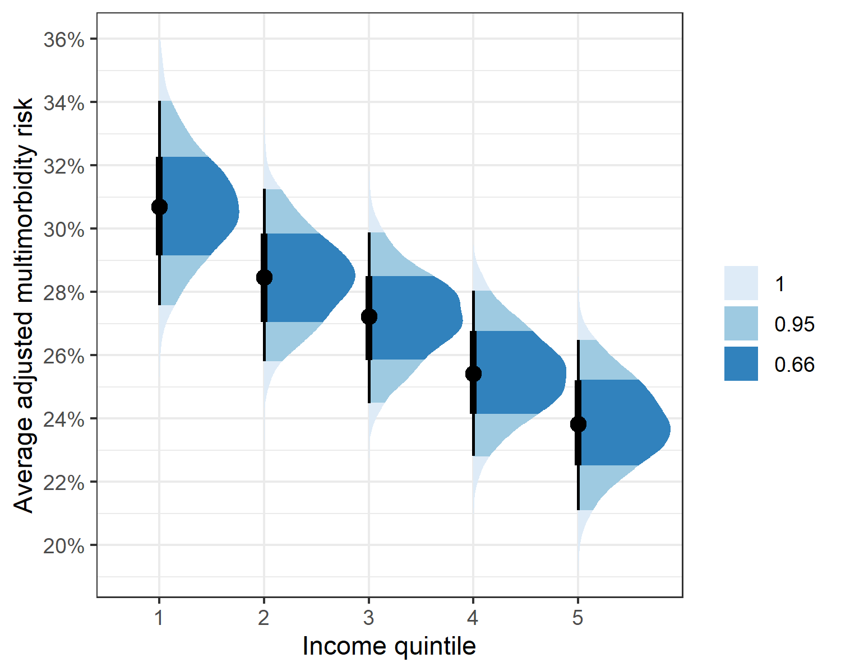
Fig Average adjusted posterior distributions of multimorbidity odds by income quintile (shaded areas represent conventional credible intervals). The Figure reveales a step-wise decrease in odds across income quintiles. Individuals in the lowest income quintile were used as the reference group.

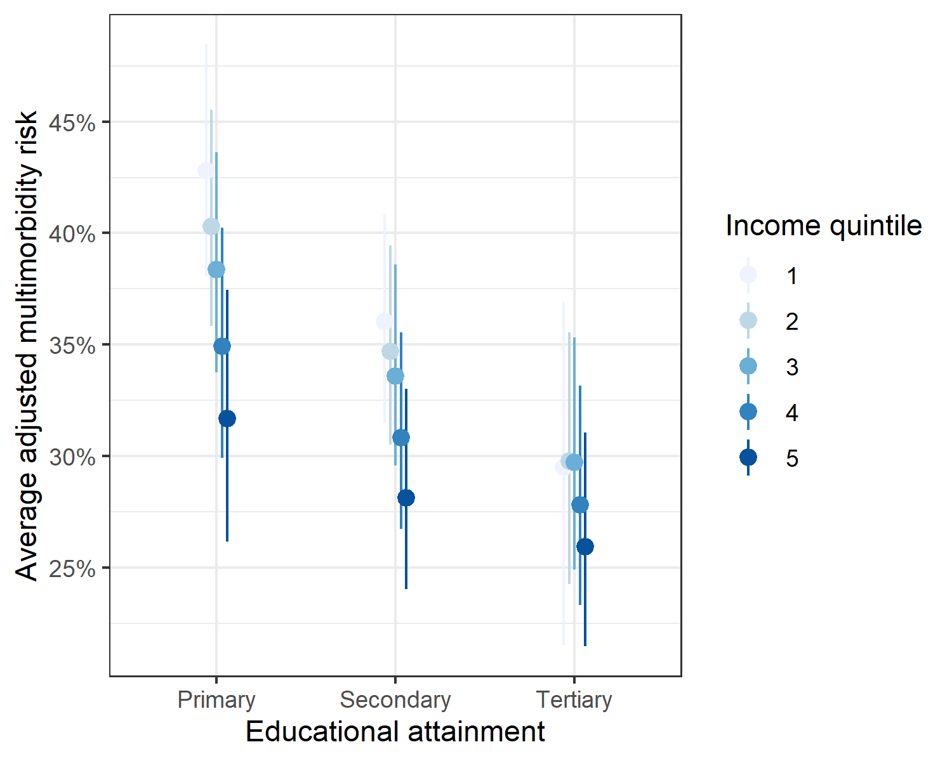

Fig Increases in income further lower multimorbidity odds for each level of attained education.

