Supplementary data

Supplementary table 1. Numeric range of cognitive function score change from 2011 to 2015.
 | Total cognitive function | Orienting attention | Visuoconstruction | Episodic memory
Average | 1.64 | 1.09 | 0.06 | 0.50
Median | 2.00 | 1.00 | 0.00 | 1.00
Standard deviation | 4.95 | 2.53 | 0.55 | 3.89
Numerical range | 40.00 | 18.00 | 2.00 | 32.00
Minimum value | -20.00 | -8.00 | -1.00 | -17.00
Maximum value | 20.00 | 10.00 | 1.00 | 15.00
5th | -7.00 | -3.00 | -1.00 | -6.00
25th | -1.00 | 0.00 | 0.00 | -2.00
75th | 5.00 | 3.00 | 0.00 | 3.00
95th | 10.00 | 5.00 | 1.00 | 7.00

Supplementary table 2. Numeric range of air pollutants in 2011.
Air pollutants (μg/m³) | PM_{2.5} | PM₁ | PM₁₀ | O₃ | NO₂
Average | 53.0196 | 40.1842 | 93.6430 | 95.1255 | 29.0342
Median | 53.2239 | 40.8511 | 91.6878 | 96.2074 | 26.6848
Standard deviation | 15.08422 | 13.24036 | 26.94723 | 6.60288 | 10.52836
Numerical range | 63.43 | 55.90 | 115.06 | 28.53 | 47.96
Minimum value | 17.54 | 12.94 | 34.52 | 78.50 | 9.30
Maximum value | 80.97 | 68.84 | 149.58 | 107.03 | 57.27
5th | 25.7619 | 16.8146 | 48.7240 | 85.0415 | 14.4824
25th | 42.3432 | 29.3667 | 74.3105 | 89.1870 | 20.6715
50th | 53.2239 | 40.8511 | 91.6878 | 96.2074 | 26.6848
75th | 65.5898 | 51.9670 | 111.6579 | 100.5972 | 37.6829

Supplementary table 3. Numeric range of delta air pollutants from 2011 to 2015.
ΔAir pollutants (μg/m³) | ΔPM_{2.5} | ΔPM₁ | ΔPM₁₀ | ΔO₃ | ΔNO₂
Average | -0.2928 | 1.5001 | 15.137 | 6.8796 | -1.0153
Median | -0.4868 | 1.1408 | 14.2245 | 7.0261 | -1.3439
Standard deviation | 5.27562 | 4.87103 | 10.0623 | 5.82774 | 3.84122
Numerical range | 30.69 | 25.16 | 56.75 | 39.48 | 18.33
Minimum value | -14.65 | -10.87 | -13.62 | -10.64 | -9.48
Maximum value  5th  25th  75th  95th | 16.04  -8.99  -3.27  3.18  8.84 | 14.29  -5.95  -1.71  5.64  9.35 | 43.13  0.24  8.04  23.38  31.69 | 28.84  -2.42  4.03  9.42  17.29 | 8.85  -6.91  -4.18  2.32  4.93

Supplementary table 4. Univariate linear regression analysis for correlation between air pollutants exposure in 2011 and changes in cognitive function scores from 2011 to 2015.

 | R² | Unstandardized B value | P value
NO₂ | 0.004 | -0.063 | <0.001
O₃ | 0.002 | -0.061 | 0.001
PM₁ | 0.009 | -0.072 | <0.001
PM₁₀ | 0.006 | -0.028 | <0.001
PM₂₅ | 0.009 | -0.064 | <0.001

Supplementary table 5. The interactions of hs-CRP with different air pollutants on cognitive decline.
 | OR (95%CI) | P-value
hs-CRP(continuous) | 1.007(0.999, 1.015) | 0.105
Hs-CRP(categorical ≥3mg/L) | 1.071(0.936, 1.225) | 0.318
ΔPM_{2.5} + ΔPM_{2.5} * hs-CRP + hs-CRP | 1.001(0.999, 1.002) | 0.331
ΔPM₁ + ΔPM₁ * hs-CRP + hs-CRP | 1.001(0.999, 1.002) | 0.568
ΔPM₁₀+ ΔPM₁₀ * hs-CRP + hs-CRP | 1.000(1.000, 1.001) | 0.304
ΔO₃ + ΔO₃ * hs-CRP + hs-CRP | 0.999(0.998, 1.001) | 0.304
ΔNO₂ + ΔNO₂ * hs-CRP + hs-CRP | 1.002(1.000, 1.004) | 0.036
Model 3
ΔPM_{2.5} + ΔPM_{2.5} * hs-CRP + hs-CRP | 1.001(0.999, 1.002) | 0.323
ΔPM₁ + ΔPM₁ * hs-CRP + hs-CRP | 1.000(0.999, 1.002) | 0.587
ΔPM₁₀+ ΔPM₁₀ * hs-CRP + hs-CRP | 1.000(1.000, 1.001) | 0.275
ΔO₃ + ΔO₃ * hs-CRP + hs-CRP | 0.999(0.998, 1.001) | 0.338
ΔNO₂ + ΔNO₂ * hs-CRP + hs-CRP | 1.002(1.000, 1.004) | 0.052
Model 4
ΔPM_{2.5} + ΔPM_{2.5} * hs-CRP + hs-CRP | 1.001(0.999, 1.002) | 0.328
ΔPM₁ + ΔPM₁ * hs-CRP + hs-CRP | 1.001(0.999, 1.002) | 0.569
ΔPM₁₀+ ΔPM₁₀ * hs-CRP + hs-CRP | 1.000(1.000, 1.001) | 0.267
ΔO₃ + ΔO₃ * hs-CRP + hs-CRP | 0.999(0.998, 1.001) | 0.325
ΔNO₂ + ΔNO₂ * hs-CRP + hs-CRP | 1.002(1.000, 1.004) | 0.055
Note: Model 3 adjusted for age, sex, birthplace and education level. Model 4 adjusted for age, sex, birthplace, education level, smoking, cooking fuel use and heating fuel use.

Supplementary table 6. The Spearman’s correlation analysis among hs-CRP and changes of ambient air pollutants exposure from 2011 to 2015.
 | ΔPM_{2.5} | ΔPM₁ | ΔPM₁₀ | ΔO₃ | ΔNO₂ | Δ2011-2015
hs-CRP | -0.008 | 0.005 | -0.013 | -0.001 | 0.023 | Correlation coefficient
 | 0.497 | 0.679 | 0.284 | 0.938 | 0.067 | P-value (two-tailed)

Supplementary table 7. The interactions of hs-CRP with different air pollutants on cognitive decline among different subpopulation.
 |  | OR (95%CI) | P-value
Non-smoking | hs-CRP(continuous) | 1.011(0.998, 1.023) | 0.106
 | hs-CRP(stratified ≥3mg/L) | 1.104(0.927, 1.316) | 0.266
 | ΔPM_{2.5} + ΔPM_{2.5} * hs-CRP + hs-CRP | 0.999(0.997, 1.002) | 0.595
 | ΔPM₁ + ΔPM₁ * hs-CRP + hs-CRP | 0.999(0.996, 1.002) | 0.568
 | ΔPM₁₀+ ΔPM₁₀ * hs-CRP + hs-CRP | 1.000(0.998, 1.001) | 0.527
 | ΔO₃ + ΔO₃ * hs-CRP + hs-CRP | 0.998(0.995, 1.001) | 0.203
 | ΔNO₂ + ΔNO₂ * hs-CRP + hs-CRP | 1.011(0.998, 1.025) | 0.087
Smoking | hs-CRP(continuous) | 1.003(0.993, 1.014) | 0.561
 | hs-CRP(stratified ≥3mg/L) | 1.002(0.812, 1.236) | 0.986
 | ΔPM_{2.5} + ΔPM_{2.5} * hs-CRP + hs-CRP | 1.002(1.000, 1.004) | 0.102
 | ΔPM₁ + ΔPM₁ * hs-CRP + hs-CRP | 1.001(0.999, 1.004) | 0.278
 | ΔPM₁₀+ ΔPM₁₀ * hs-CRP + hs-CRP | 1.001(1.000, 1.002) | 0.103
 | ΔO₃ + ΔO₃ * hs-CRP + hs-CRP | 1.000(0.998, 1.002) | 0.821
 | ΔNO₂ + ΔNO₂ * hs-CRP + hs-CRP | 1.003(1.000, 1.006) | 0.055
Cooking using clean fuels | hs-CRP(continuous) | 1.006(0.991, 1.021) | 0.440
Cooking using clean fuels | hs-CRP(stratified ≥3mg/L) | 1.012(0.822, 1.248) | 0.908
 | ΔPM_{2.5} + ΔPM_{2.5} * hs-CRP + hs-CRP | 1.002(0.999, 1.005) | 0.153
 | ΔPM₁ + ΔPM₁ * hs-CRP + hs-CRP | 1.000(0.996, 1.003) | 0.835
 | ΔPM₁₀+ ΔPM₁₀ * hs-CRP + hs-CRP | 1.000(0.999, 1.002) | 0.607
 | ΔO₃ + ΔO₃ * hs-CRP + hs-CRP | 0.999(0.997, 1.001) | 0.343
 | ΔNO₂ + ΔNO₂ * hs-CRP + hs-CRP | 1.001(0.997, 1.004) | 0.742
Cooking using solid fuels | hs-CRP(continuous) | 1.007(0.997, 1.017) | 0.165
Cooking using solid fuels | hs-CRP(stratified ≥3mg/L) | 1.116(0.936, 1.331) | 0.220
 | ΔPM_{2.5} + ΔPM_{2.5} * hs-CRP + hs-CRP | 1.000(0.998, 1.002) | 0.824
 | ΔPM₁ + ΔPM₁ * hs-CRP + hs-CRP | 1.001(0.999, 1.003) | 0.391
 | ΔPM₁₀+ ΔPM₁₀ * hs-CRP + hs-CRP | 1.000(1.000, 1.001) | 0.338
 | ΔO₃ + ΔO₃ * hs-CRP + hs-CRP | 0.999(0.997, 1.002) | 0.606
 | ΔNO₂ + ΔNO₂ * hs-CRP + hs-CRP | 1.003(1.000, 1.006) | 0.024
Heating using clean fuels | hs-CRP(continuous) | 1.003(0.988, 1.018) | 0.700
Heating using clean fuels | hs-CRP(stratified ≥3mg/L) | 1.003(0.816, 1.233) | 0.976
 | ΔPM_{2.5} + ΔPM_{2.5} * hs-CRP + hs-CRP | 1.000(0.996, 1.004) | 0.849
 | ΔPM₁ + ΔPM₁ * hs-CRP + hs-CRP | 1.001(0.998, 1.005) | 0.375
 | ΔPM₁₀+ ΔPM₁₀ * hs-CRP + hs-CRP | 1.000(0.998, 1.002) | 0.968
 | ΔO₃ + ΔO₃ * hs-CRP + hs-CRP | 1.000(0.997, 1.002) | 0.770
 | ΔNO₂ + ΔNO₂ * hs-CRP + hs-CRP | 1.001(0.997, 1.005) | 0.646
Heating using solid fuels | hs-CRP(continuous) | 1.008(0.998, 1.018) | 0.119
Heating using solid fuels | hs-CRP(stratified ≥3mg/L) | 1.126(0.943, 1.346) | 0.189
 | ΔPM_{2.5} + ΔPM_{2.5} * hs-CRP + hs-CRP | 1.001(0.999, 1.003) | 0.240
 | ΔPM₁ + ΔPM₁ * hs-CRP + hs-CRP | 1.000(0.998, 1.003) | 0.681
 | ΔPM₁₀+ ΔPM₁₀ * hs-CRP + hs-CRP | 1.001(1.000, 1.001) | 0.204
 | ΔO₃ + ΔO₃ * hs-CRP + hs-CRP | 0.999(0.996, 1.001) | 0.325
 | ΔNO₂ + ΔNO₂ * hs-CRP + hs-CRP | 1.003(1.000,1.005) | 0.030
Male | hs-CRP(continuous) | 1.003(0.993, 1.013) | 0.517
 | hs-CRP(stratified ≥3mg/L) | 1.058(0.872, 1.284) | 0.565
 | ΔPM_{2.5} + ΔPM_{2.5} * hs-CRP + hs-CRP | 1.001(0.999, 1.003) | 0.172
 | ΔPM₁ + ΔPM₁ * hs-CRP + hs-CRP | 1.002(0.992, 1.012) | 0.700
 | ΔPM₁₀+ ΔPM₁₀ * hs-CRP + hs-CRP | 1.000(1.000, 1.001) | 0.320
 | ΔO₃ + ΔO₃ * hs-CRP + hs-CRP | 0.999(0.998, 1.001) | 0.555
 | ΔNO₂ + ΔNO₂ * hs-CRP + hs-CRP | 1.003(1.000, 1.007) | 0.037
Female | hs-CRP(continuous) | 1.012(0.998, 1.026) | 0.091
 | hs-CRP(stratified ≥3mg/L) | 1.071(0.888, 1.291) | 0.474
 | ΔPM_{2.5} + ΔPM_{2.5} * hs-CRP + hs-CRP | 1.000(0.997, 1.002) | 0.751
 | ΔPM₁ + ΔPM₁ * hs-CRP + hs-CRP | 1.000(0.997, 1.003) | 0.947
 | ΔPM₁₀+ ΔPM₁₀ * hs-CRP + hs-CRP | 1.000(0.999, 1.001) | 0.948
 | ΔO₃ + ΔO₃ * hs-CRP + hs-CRP | 0.999(0.996, 1.002) | 0.523
 | ΔNO₂ + ΔNO₂ * hs-CRP + hs-CRP | 1.000(0.997, 1.003) | 0.853

Total cognitive function | Orienting attention
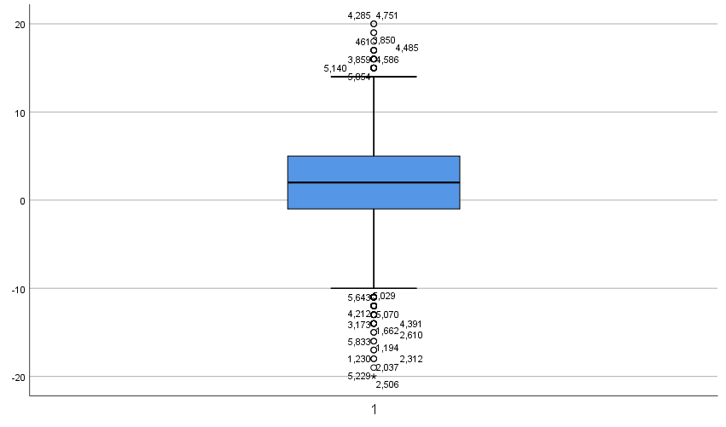 | 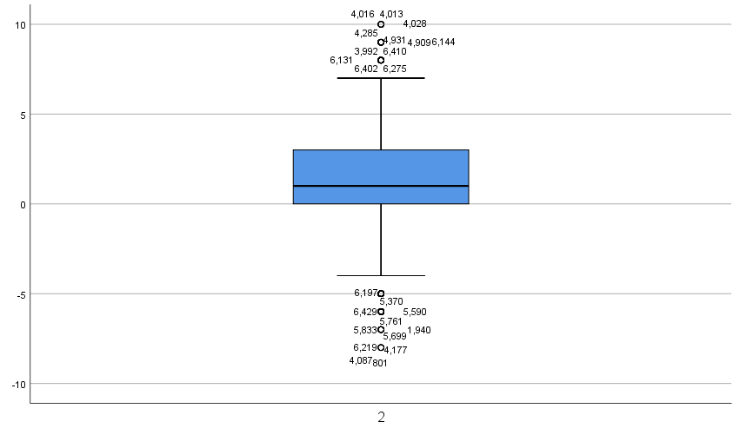
Visuoconstruction | Episodic memory
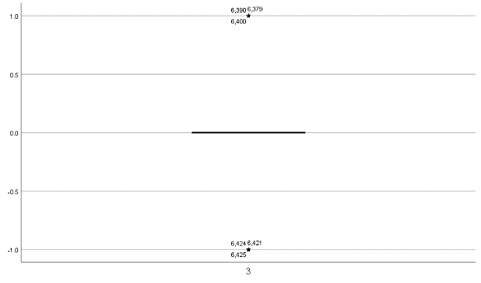 | 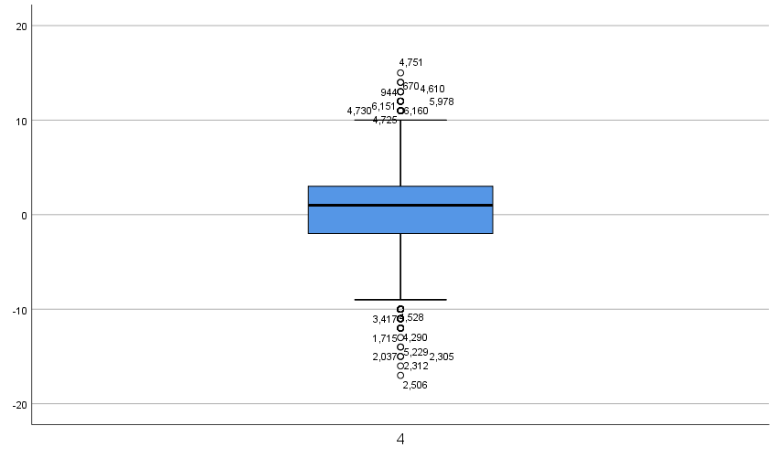

Supplementary figure 1. The distribution of cognitive function score change from 2011 to 2015.
A box plot showing the distribution of cognitive function scores. The boxes show the upper- and lower-quartile values, the horizontal lines indicate the median. The outliers, which fall outside the first and third quartiles by > 1.5 times the interquartile range, are marked by a circle symbol. The outliers, which are outside of > 3 times IRQ, are indicated by a star symbol. Numbers next to symbol correspond to line numbers.

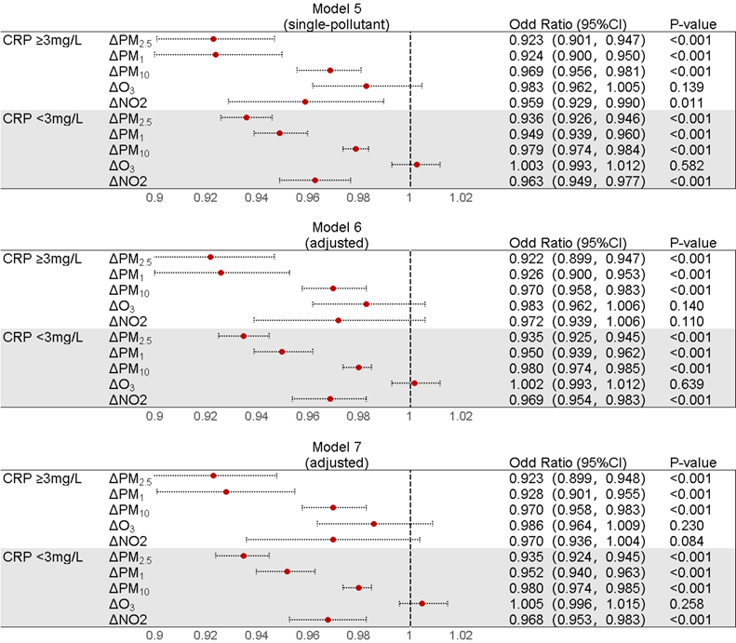
Supplementary figure 2. Stratified analyses according to hypersensitive CRP among the impact of air pollutants on cognitive decline.
Model 5 was unadjusted, model 6 was adjusted for age, sex, birthplace and education level, and model 7 were adjusted for age, sex, birthplace, education level, smoking, cooking fuel use and heating fuel use.

