Supplemental material
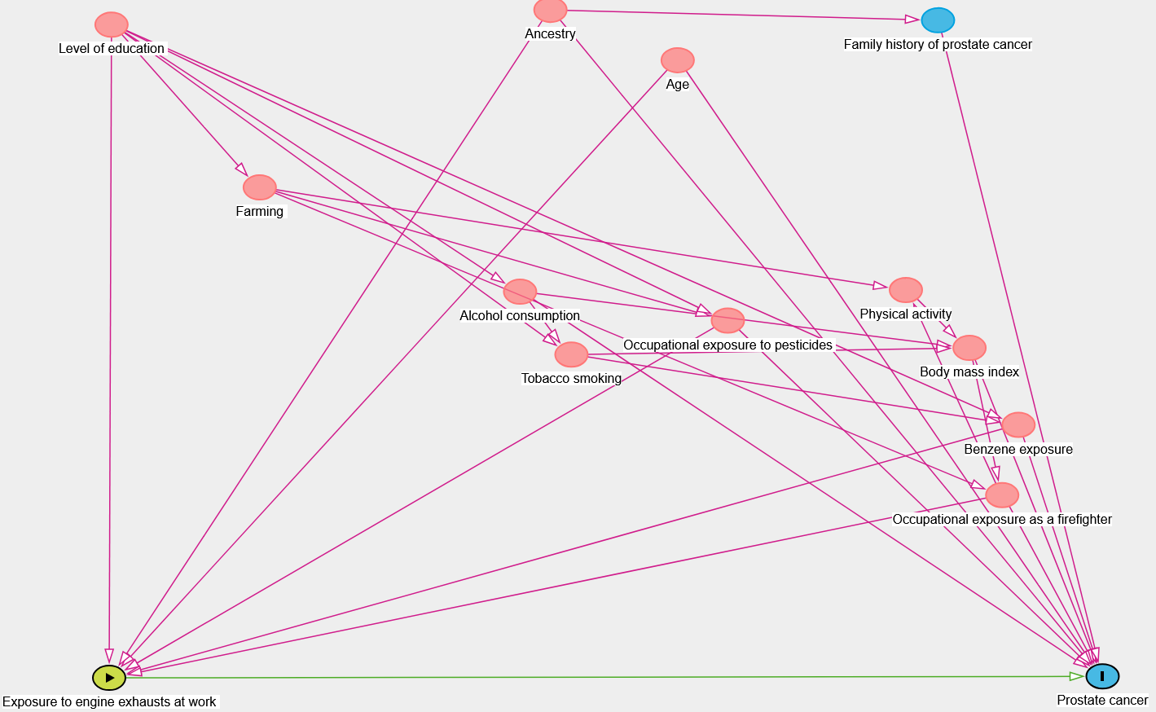
Figure S1. Directed Acyclic Graph for the association between Directed Acyclic Graph for the association between engine exhaust (EE) and prostate cancer risk, PROtEuS, Montreal, Canada, 2005-2012

Table S1. Most frequent* occupations classified as having probable or certain occupational exposure to engine exhausts (EE), PROtEuS, Montreal, Canada, 2005-2012
Leaded gasoline EE |  |  | Most frequent exposure coding
CCDO.Occupations | n jobs | % | Reliability¹ | Frequency² | Intensity³
9918.Occupations in labouring and other elemental work, n.e.c | 25 | 76 | 3 | 2 | 1
5145.Service stations attendants | 27 | 74 | 3 | 3 | 1
7513.Timber cutting and related occupations | 58 | 74 | 3 | 3 | 3
5193.Driver-Salesmen | 61 | 71 | 3 | 3 | 1
4172.Mail carriers | 32 | 63 | 3 | 2 | 1
4177.Messengers | 125 | 63 | 3 | 3 | 1
8730.Foremen: electrical power, lighting and wire communications equipment erecting, installing and repairing occupations | 26 | 62 | 3 | 2 | 1
6112.Police officers and detectives, government | 178 | 59 | 3 | 3 | 1
8581.Motor-vehicle mechanics and repairmen | 215 | 58 | 3 | 3 | 2
5171.Insurance salesmen and agents | 85 | 57 | 3 | 2 | 1
9175.Truck drivers | 398 | 55 | 3 | 4 | 1
8711.Excavating, grading and related occupations | 39 | 51 | 3 | 3 | 2
Unleaded gasoline EE
CCDO.Occupations | n jobs | % | Reliability | Frequency | Intensity
4172.Mail carriers | 32 | 84 | 3 | 2 | 1
5177.Business services salesmen | 28 | 75 | 3 | 3 | 1
9171.Bus drivers | 102 | 75 | 3 | 3 | 1
5172.Real estate salesmen | 86 | 74 | 3 | 2 | 1
5133.Commercial travellers | 243 | 60 | 3 | 3 | 1
2343.Lawyers and notaries | 91 | 54 | 2 | 1 | 1
9175.Truck drivers | 398 | 51 | 3 | 3 | 1
Diesel engine EE
CCDO.Occupations | n jobs | % | Reliability | Frequency | Intensity
8711.Excavating, grading and related occupations | 39 | 95 | 3 | 3 | 2
9171.Bus drivers | 102 | 86 | 3 | 2 | 1
7513.Timber cutting and related occupations | 58 | 79 | 2 | 2 | 1
1145.Management occupations, construction operations | 61 | 73 | 3 | 3 | 1
6111.Fire-fighting occupations | 65 | 72 | 3 | 2 | 2
8798.Occupations in labouring and other elemental work, other contruction trades | 74 | 70 | 2 | 2 | 1
8586.Inspecting and testing occupations, equipment repair, n.e.c | 21 | 67 | 3 | 2 | 2
9918.Occupations in labouring and other elemental work, n.e.c | 25 | 64 | 2 | 2 | 1
9175.Truck drivers | 398 | 64 | 3 | 3 | 1
9311.Hosting occupations, n.e.c | 37 | 62 | 3 | 3 | 1
2141.Architects | 30 | 60 | 2 | 1 | 1
2143.Civil engineers | 129 | 57 | 2 | 2 | 1
8582.Marine craft fabricating, assembling and repairing occupations | 23 | 57 | 3 | 3 | 2
8780.Foremen, other construction trades occupations | 123 | 54 | 3 | 2 | 1
8781.Carpenters and related occupations | 152 | 56 | 3 | 2 | 1
9113.Air transport operating support occupations | 21 | 52 | 2 | 3 | 1
9313.Longshore workers, stevedores and freight handlers | 37 | 51 | 2 | 3 | 1
Jet fuel EE
CCDO.Occupations | n jobs | % | Reliability | Frequency | Intensity
8582.Aircraft mechanics and repairmen | 29 | 59 | 3 | 2 | 2
9113.Air transport operating support occupations | 21 | 57 | 3 | 3 | 2
8586.Inspecting and testing occupations, equipment repair, n.e.c | 21 | 24 | 2 | 2 | 1
Propane EE
CCDO.Occupations | n jobs | % | Reliability | Frequency | Intensity
9315.Material handling equipment operators, N.E.C | 107 | 30 | 3 | 3 | 2
8529.Other fabricating and assembling occupations, metal products, n.e.c | 27 | 19 | 3 | 3 | 1
8315.Machine-tool operating occupations | 45 | 18 | 3 | 2 | 2
8593.Paper product fabricating and assembling occupations | 21 | 15 | 3 | 1 | 2
4150.Supervisors: materials recording, scheduling ans distributing occupations | 64 | 13 | 3 | 2 | 1
8161.Mixing and blending occupations, chemical and related materials | 24 | 13 | 2 | 2 | 1
8330.Foremen, metal shaping and forming occupations, except machining | 27 | 11 | 3 | 2 | 2
8334.Metalworking-machine operators | 38 | 11 | 3 | 2 | 2
9313.Longshore workers, stevedores and freight handlers | 37 | 11 | 3 | 3 | 1
9318.Occupations in labouring and other elemental work, material handling,N.E.C | 176 | 11 | 3 | 3 | 2
Heavy diesel EE
CCDO.Occupations | n jobs | % | Reliability | Frequency | Intensity
8580.Foremen: mechanics and repairmen, N.E.C | 76 | 14 | 2 | 3 | 1
8586.Inspecting and testing occupations, equipment repair, N.E.C | 21 | 14 | 2 | 2 | 1
1147.Management occupations, transport and communications | 56 | 9 | 2 | 1 | 2
8592.Marine craft fabricating, assemblinf and repairing occupations | 23 | 9 | 2 | 3 | 2
8533.Electrical and related equipment installing and repairing occupations, n.e.c | 84 | 8 | 3 | 3 | 3
4190.Supervisors, other clerical and related occupations, n.e.c | 22 | 5 | 2 | 2 | 2
8530.Foremen: fabricating, assembling, installing and repairing occupations, electrical, electronic and related equipement | 37 | 5 | 3 | 2 | 2
8393.Filing, grinding, buffing, cleaning and polishing occupations, n.e.c | 32 | 3 | 3 | 1 | 2
8595.Painting and decorating occupations, except construction | 55 | 2 | 3 | 3 | 2
1179.Occupations related to management and administration, N.E.C | 189 | 1 | 2 | 2 | 1
Light diesel EE
8711.Excavating, grading and related occuptations | 39 | 95 | 3 | 3 | 2
9171.Bus drivers | 102 | 86 | 3 | 2 | 1
7513.Timber cutting and related occupations | 58 | 79 | 2 | 2 | 1
1145.Management occupations, constructions operations | 61 | 74 | 3 | 3 | 1
6111.Fire-fighting occupations | 65 | 72 | 3 | 2 | 2
8798.Occupations in labouring and other elemental work, other construction trades | 74 | 70 | 2 | 2 | 1
9175.Truck drivers | 398 | 64 | 3 | 3 | 1
9311.Hoisting occupations, n.e.c | 37 | 62 | 3 | 3 | 2
8586.Inspecting and testing occupations, equipment repair, N.E.C | 21 | 62 | 2 | 3 | 1
2141.Architects | 30 | 60 | 3 | 2 | 1
2143.Civil engineers | 129 | 57 | 2 | 2 | 1
8592.Marine craft fabricating, assembling and repairing occupations | 23 | 57 | 2 | 3 | 2
8780.Foremen, other construction trades occupations | 123 | 54 | 3 | 1 | 1
8781.Carpenters and related occupations | 152 | 56 | 3 | 2 | 1
9113.Air transport operating support occupations | 21 | 52 | 2 | 3 | 1
9313.Longshore workers, stevedores and freight handlers | 37 | 51 | 3 | 3 | 1
*Number of jobs > 20 and percentage of jobs exposed to: leaded engine EE ≥ 50%, unleaded engine EE ≥ 50%, diesel EE ≥ 50%, jet fuel EE ≥ 20%, propane EE ≥ 10%, heavy diesel EE ≥ 0% (all jobs exposed), light diesel EE ≥ 50%.
¹Reliability (1=possible, 2=probable, 3= certain), ²Frequency, (<5%, 5%-30%, >30%-90%, >90% of usual workweek), ³Intensity (1=low, 2=medium, 3=high, with low representing a level above the background environmental level).
N jobs: total number of coded jobs, %, percentage of jobs exposed; CCDO, Canadian Classification and Dictionary of Occupations, n.e.c, not elsewhere classified; PROtEuS, Prostate Cancer & Environment study.

Leaded gasoline EE | Leaded gasoline EE
Unleaded gasoline EE | 0.53 | Unleaded gasoline EE
Diesel heavy EE | -0.03 | -0.04 | Heavy Diesel EE
Diesel light EE | 0.46 | 0.34 | 0.16 | Light Diesel EE
Jet fuel EE | 0.05 | 0.01 | 0.04 | 0.02 | Jet Fuel EE
Propane EE | 0.02 | 0.04 | -0.03 | 0.15 | 0.01 | Propane EE
-1.00; 0.09
[0.10; 0.30[
[0.30; 0.60[
Abbreviations: EE, Engine exhausts
Legend

Figure S2: Spearman correlation coefficients between cumulative exposures to engine exhaust among controls, PROtEuS, Montreal, Canada, 2005-2012

Table S2. Associations between occupational exposure to various engine exhaust (EE), in isolation or combined, and prostate cancer risk.
 |  |  | Prostate cancer |  |  | High grade prostate cancer
 |  |  | n=1924 |  |  | n=436
 |  |  | ORª | 95%CI |  | ORª | 95%CI
Exposure to EE | n Co | n Ca |  |  | n Ca
Never exposed to any EE | 724 | 665 | 1.00 | Ref | 137 | 1 | Ref
Leaded gasoline EE only | 68 | 70 | 1.17 | 0.81 to 1.69 | 14 | 1.04 | 0.56 to 1.95
Unleaded gasoline EE only | 129 | 116 | 0.83 | 0.32 to 1.10 | 26 | 0.99 | 0.61 to 1.58
Light diesel EE only | 68 | 68 | 1.07 | 0.74 to 1.54 | 17 | 1.28 | 0.71 to 2.29
Propane EE only | 18 | 21 | 1.18 | 0.61 to 2.30 | 2 | 0.63 | 0.14 to 2.79
Leaded gasoline EE and unleaded gasoline EE | 148 | 164 | 1.19 | 0.92 to 1.55 | 37 | 1.24 | 0.82 to 1.88
Leaded gasoline EE and diesel light EE | 73 | 79 | 1.25 | 0.87 to 1.80 | 18 | 1.27 | 0.72 to 2.26
Unleaded gasoline EE and diesel light EE | 52 | 68 | 1.20 | 0.81 to 1.78 | 16 | 1.32 | 0.72 to 2.42
Leaded gasoline EE, unleaded gasoline EE and light diesel EE | 186 | 187 | 1.04 | 0.81 to 1.33 | 48 | 1.15 | 0.77 to 1.71
Abbreviations: EE, engine exhaust; OR, odds ratio; CI, confidence intervals; Co, controls; Ca, cases
a Adjusted for age, ancestry, educational level, alcohol drinking, cigarette smoking, body mass index and (for analyses on gasoline, diesel and propane EE) cumulative occupational exposures to benzene and pesticides, ever farming and ever firefighting

