Supplement for: Prospective study of oil spill cleanup-related exposure to volatile organic compounds and glycemic dysregulation

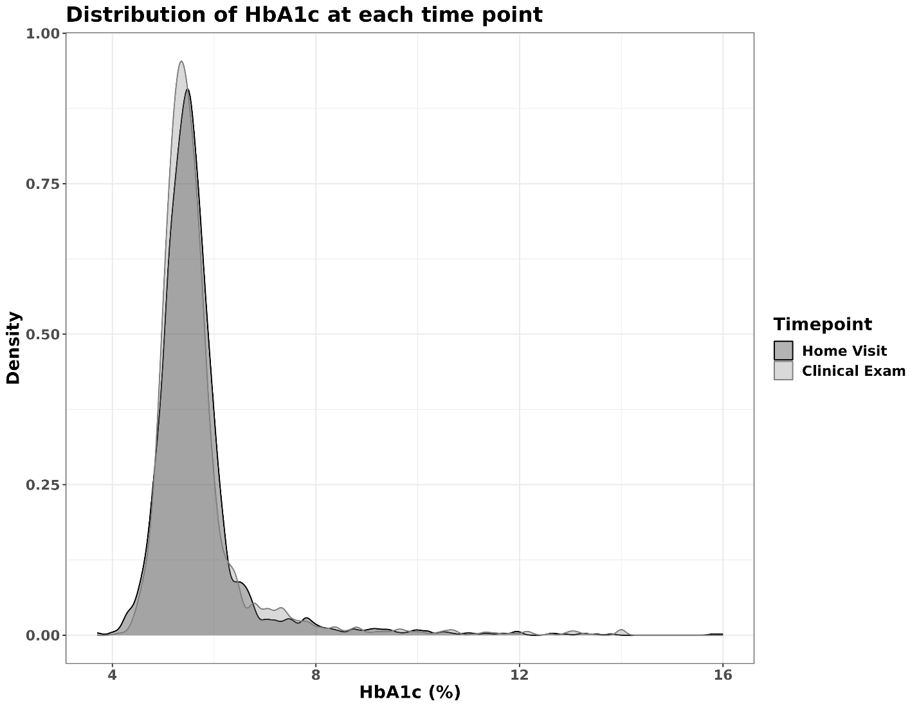
Supplementary Figure 1: Distribution of HbA1c (%) at the Home Visit and Clinical Exam
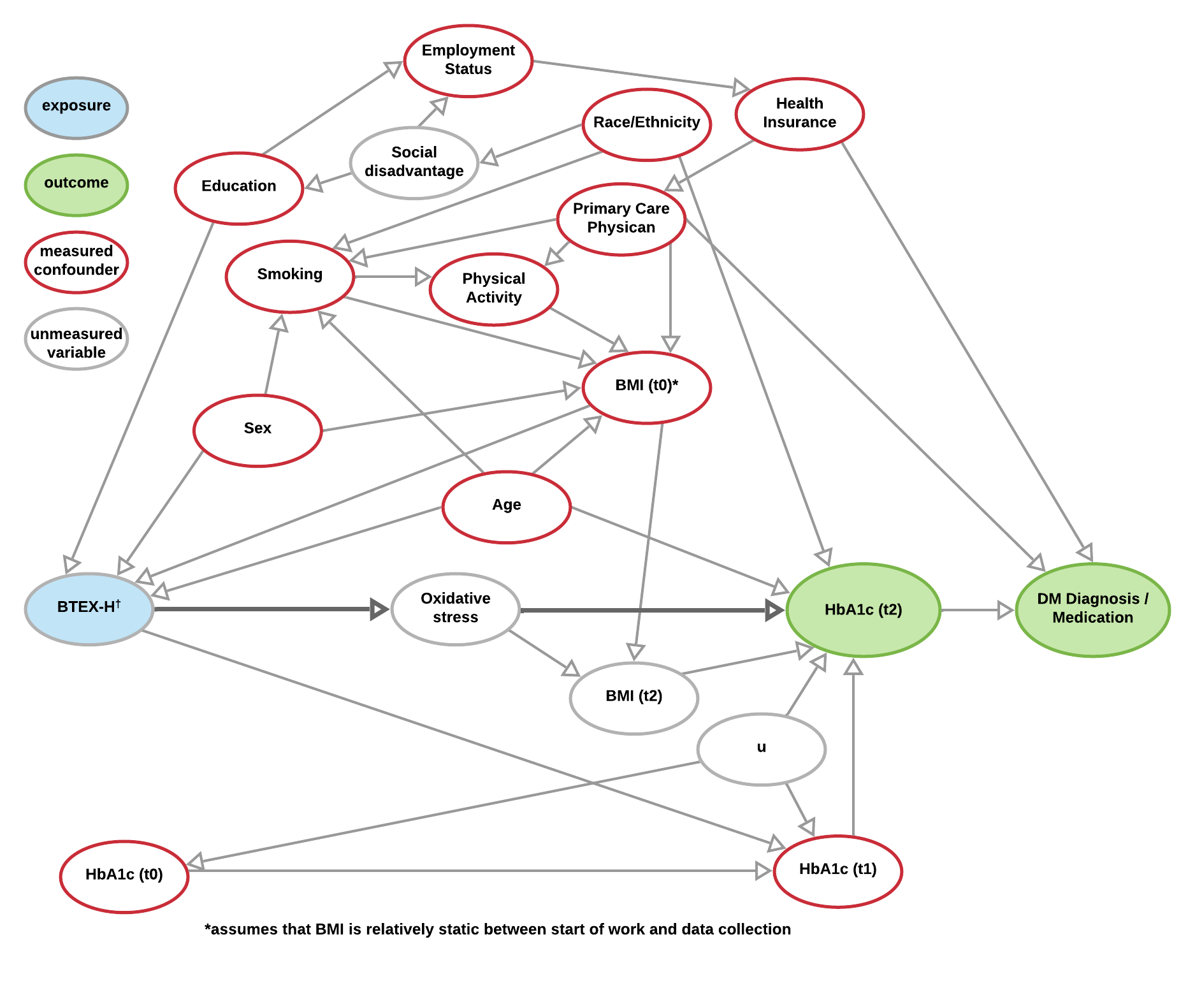
Supplementary Figure 2: Directed Acyclic Graph (DAG) for this analysis

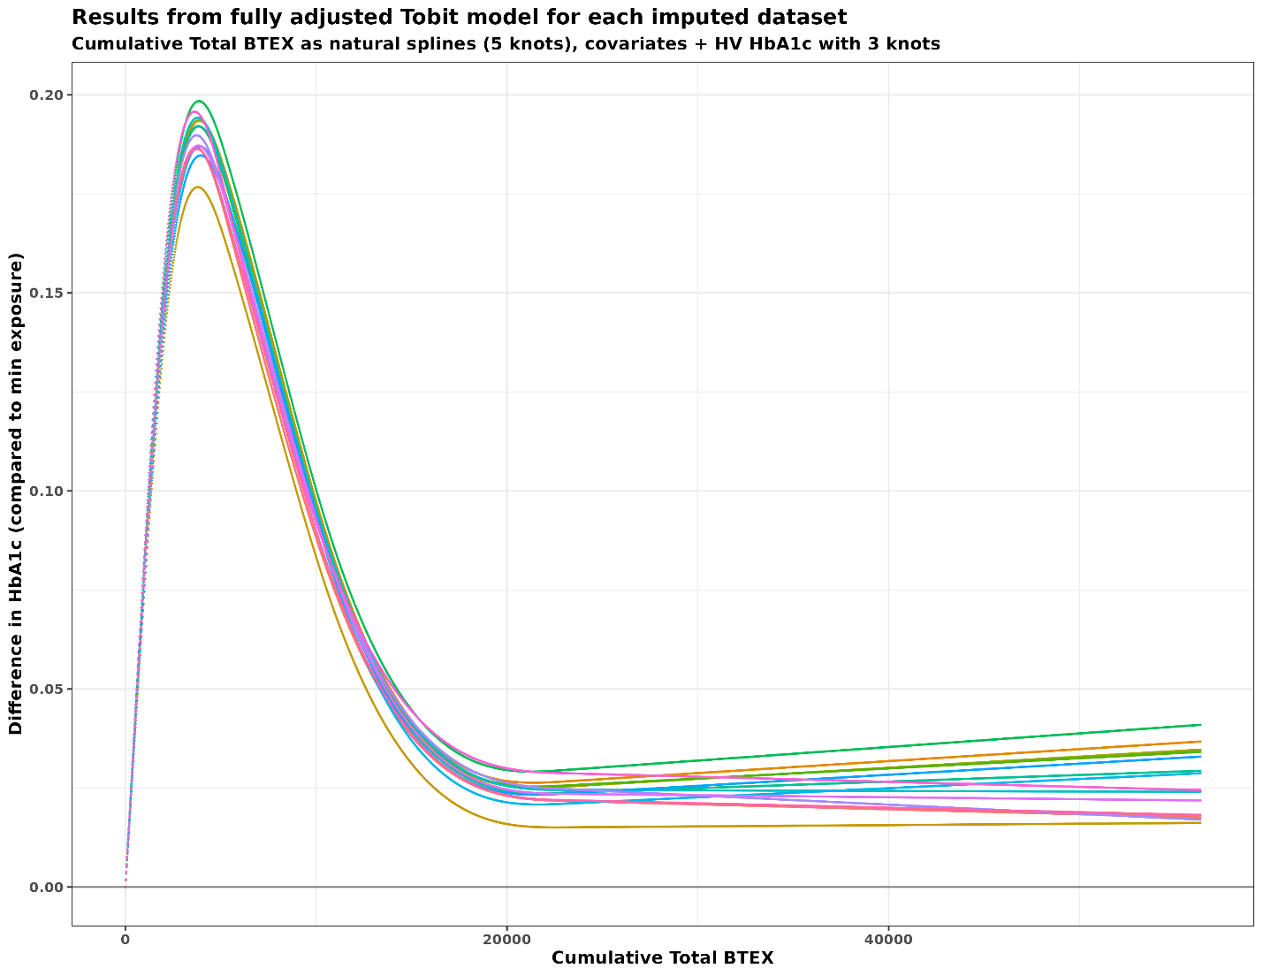
Supplementary Figure 3: Results from fully adjusted, weighted, Tobit regression comparing predicted HbA1c to predicted HbA1c at the minimum exposure. Total BTEX was modeled with natural splines (5 knots), Home Visit HbA1c with natural spline (3 knots), and all continuous covariates with natural splines (3 knots). Each line represents results from one imputed dataset
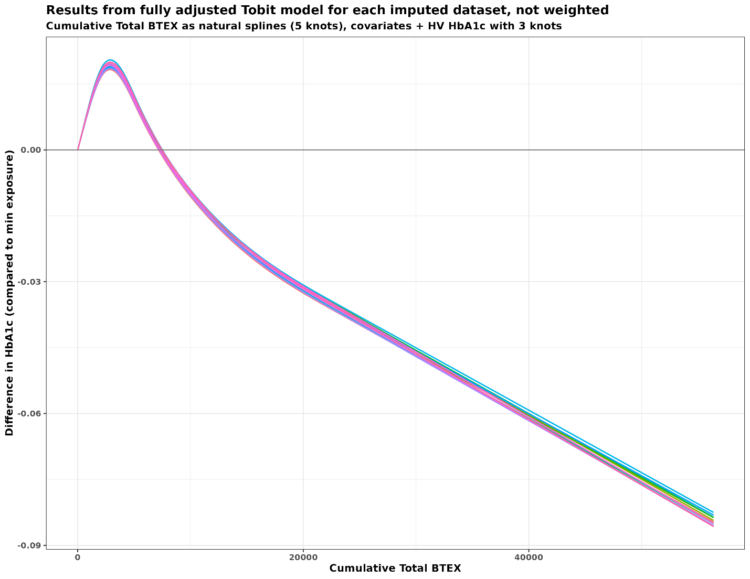
Supplementary Figure 4: Results from fully adjusted, unweighted, Tobit regression comparing predicted HbA1c to predicted HbA1c at the minimum exposure. Total BTEX was modeled with natural splines (5 knots), Home Visit HbA1c with natural spline (3 knots), and all continuous covariates with natural splines (3 knots). Each line represents results from one imputed dataset.

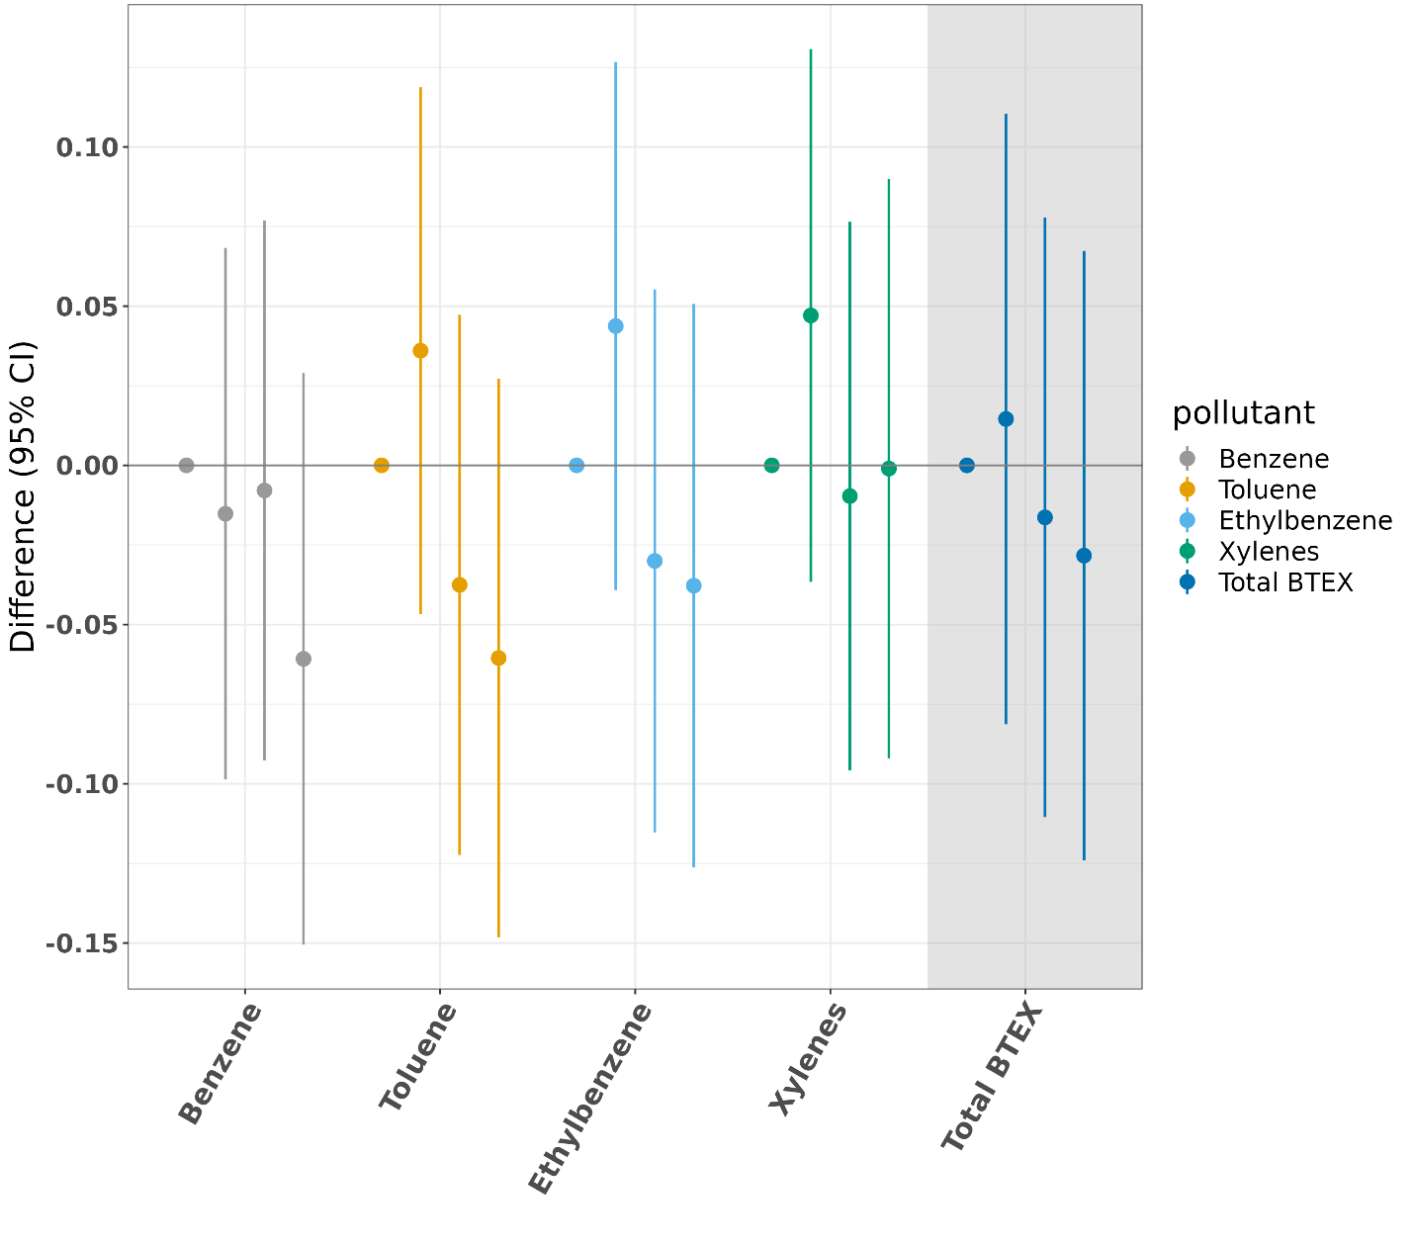
Supplementary Figure 5: Results from fully adjusted unweighted linear regression examining mean difference in HbA1c (%) at the Clinical Exam by quartile of cumulative exposure when compared to Q1, controlling for Home Visit HbA1c. For comparison to Tobit regression result

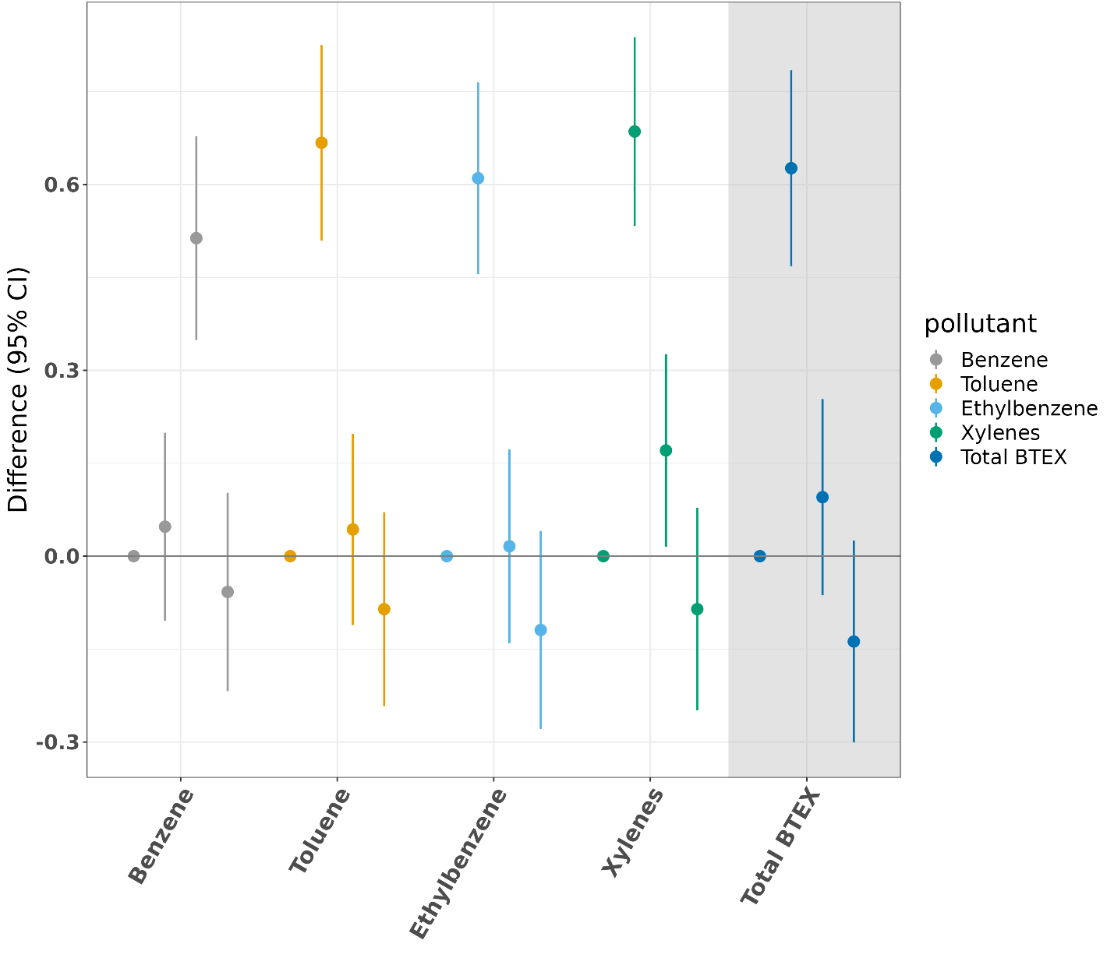
Supplementary Figure 6: Fully adjusted results (estimates and 95% confidence intervals) examining mean difference in Clinical Exam (final) HbA1c (%) by quartile of cumulative exposure when compared to Q1, not controlling for Home Visit (initial) HbA1c.

Supplementary Table 1: Variables used in calculation of inverse probability of censoring (treatment with HbA1c-lowering medication) weights
Home Visit weights | Numerator | Age at enrollment + BMI at Home Visit
Home Visit weights | Denominator | Age at enrollment + BMI at Home Visit + Health Insurance Status at Home Visit + Education at Enrollment + Race + Sex + Smoking status at Enrollment + Potential previous occupational exposure + Age at enrollment*Race + BMI at Home Visit*Race
Clinical Exam weights | Numerator | Age at enrollment + BMI at Home Visit + BMI at Clinical Exam
Clinical Exam weights | Denominator | Age at enrollment + HbA1c at Home Visit + BMI at Clinical Exam + BMI at Home Visit + Diabetes medication at Home Visit + Health Insurance Status at Home Visit + Education at Enrollment + Race + Sex + Smoking status at Enrollment + Potential previous occupational exposure + Age at enrollment*Race + BMI at Clinical Exam*Race + BMI at Home Visit*Race + HbA1c at Home Visit*Race

Supplementary Table 2: Results from fully adjusted analyses examining Home Visit Exam HbA1c (%)
Exposure | Quartile | Difference (95% CI) | CLD
Benzene | 1 | 1 (ref) | -
 | 2 | 0.07 (-0.05, 0.18) | 0.24
 | 3 | 0.05 (-0.05, 0.16) | 0.21
 | 4 | 0.03 (-0.08, 0.14) | 0.22
Toluene | 1 | 1 (ref) | -
 | 2 | 0.07 (-0.05, 0.18) | 0.23
 | 3 | 0.02 (-0.09, 0.13) | 0.22
 | 4 | 0.04 (-0.07, 0.14) | 0.21
Ethylbenzene | 1 | 1 (ref) | -
 | 2 | 0.03 (-0.08, 0.14) | 0.22
 | 3 | 0.06 (-0.05, 0.16) | 0.22
 | 4 | 0.03 (-0.08, 0.14) | 0.22
Xylenes | 1 | 1 (ref) | -
 | 2 | 0.03 (-0.08, 0.14) | 0.22
 | 3 | 0.11 (-0.01, 0.23) | 0.24
 | 4 | 0.01 (-0.10, 0.12) | 0.21
Total BTEX | 1 | 1 (ref) | -
 | 2 | 0.05 (-0.07, 0.16) | 0.23
 | 3 | 0.07 (-0.04, 0.19) | 0.23
 | 4 | 0.01 (-0.09, 0.12) | 0.21
Mixture* | 1 | 0.13 (-0.16, 0.43) | 0.59
*Mixture estimate is from Quantile G-Computation analysis and represents the estimate associated with a simultaneous 3-quartile increase in all constituent chemicals (BTEX)

Supplementary Table 3: Results from age adjusted analyses examining Clinical Exam HbA1c (%), controlling for Home Visit HbA1c
Exposure | Quartile | Difference (95% CI) | CLD
Benzene | 1 | 1 (ref) | -
 | 2 | 0.03 (-0.07, 0.13) | 0.19
 | 3 | 0.09 (-0.01, 0.19) | 0.21
 | 4 | -0.01 (-0.10, 0.08) | 0.19
Toluene | 1 | 1 (ref) | -
 | 2 | 0.25 (0.15, 0.34) | 0.20
 | 3 | 0.11 (0.01, 0.21) | 0.20
 | 4 | -0.03 (-0.12, 0.06) | 0.18
Ethylbenzene | 1 | 1 (ref) | -
 | 2 | 0.23 (0.13, 0.33) | 0.20
 | 3 | 0.11 (0.02, 0.21) | 0.19
 | 4 | 0.04 (-0.06, 0.13) | 0.19
Xylenes | 1 | 1 (ref) | -
 | 2 | 0.14 (0.05, 0.24) | 0.19
 | 3 | 0.14 (0.04, 0.24) | 0.19
 | 4 | -0.01 (-0.10, 0.09) | 0.19
Total BTEX | 1 | 1 (ref) | -
 | 2 | 0.25 (0.15, 0.35) | 0.20
 | 3 | 0.14 (0.04, 0.24) | 0.20
 | 4 | -0.02 (-0.12, 0.07) | 0.19
Mixture* | 1 | -0.06 (-0.14, 0.03) | 0.17
*Mixture estimate is from Quantile G-Computation analysis and represents the estimate associated with a simultaneous 3-quartile increase in all constituent chemicals (BTEX)

Supplementary Table 4: Results from fully adjusted (main) analyses examining Clinical Exam HbA1c (%), controlling for Home Visit HbA1c
Exposure | Quartile | Difference (95% CI) | CLD
Benzene | 1 | 1 (ref) | -
 | 2 | 0.06 (-0.03, 0.16) | 0.20
 | 3 | 0.11 (-0.00, 0.21) | 0.21
 | 4 | 0.01 (-0.09, 0.12) | 0.21
Toluene | 1 | 1 (ref) | -
 | 2 | 0.24 (0.14, 0.34) | 0.20
 | 3 | 0.12 (0.02, 0.22) | 0.20
 | 4 | -0.01 (-0.11, 0.09) | 0.20
Ethylbenzene | 1 | 1 (ref) | -
 | 2 | 0.22 (0.12, 0.32) | 0.20
 | 3 | 0.11 (0.01, 0.21) | 0.20
 | 4 | 0.05 (-0.05, 0.15) | 0.20
Xylenes | 1 | 1 (ref) | -
 | 2 | 0.14 (0.05, 0.24) | 0.19
 | 3 | 0.14 (0.04, 0.24) | 0.20
 | 4 | 0.01 (-0.09, 0.12) | 0.21
Total BTEX | 1 | 1 (ref) | -
 | 2 | 0.24 (0.14, 0.34) | 0.20
 | 3 | 0.13 (0.03, 0.24) | 0.20
 | 4 | -0.00 (-0.11, 0.10) | 0.21
Mixture* | 1 | -0.04 (-0.13, 0.05) | 0.18
*Mixture estimate is from Quantile G-Computation analysis and represents the estimate associated with a simultaneous 3-quartile increase in all constituent chemicals (BTEX)

Supplementary Table 5: Results from fully adjusted (main) analyses examining Clinical Exam HbA1c (%), controlling for Home Visit HbA1c, stratified by body mass index category
 |  | BMI < 25 |  |  | 25≤BMI<30 |  |  | BMI ≥30
Exposure | Quartile | Difference  (95% CI) | CLD |  | Difference  (95% CI) | CLD |  | Difference  (95% CI) | CLD
Benzene | 1 | 1 (ref) | - |  | 1 (ref) | - |  | 1 (ref) | -
 | 2 | 0.02 (-0.06, 0.10) | 0.15 |  | 0.01 (-0.08, 0.11) | 0.19 |  | 0.15 (-0.06, 0.37) | 0.43
 | 3 | -0.04 (-0.17, 0.09) | 0.26 |  | -0.06 (-0.21, 0.09) | 0.30 |  | 0.32 (0.09, 0.54) | 0.45
 | 4 | -0.06 (-0.14, 0.02) | 0.16 |  | -0.01 (-0.12, 0.09) | 0.21 |  | 0.10 (-0.14, 0.33) | 0.47
Toluene | 1 | 1 (ref) | - |  | 1 (ref) | - |  | 1 (ref) | -
 | 2 | 0.23 (0.14, 0.33) | 0.18 |  | 0.06 (-0.05, 0.18) | 0.23 |  | 0.39 (0.18, 0.60) | 0.42
 | 3 | 0.07 (-0.06, 0.21) | 0.27 |  | -0.10 (-0.23, 0.02) | 0.25 |  | 0.31 (0.09, 0.54) | 0.45
 | 4 | 0.05 (-0.03, 0.14) | 0.17 |  | -0.04 (-0.16, 0.07) | 0.22 |  | 0.03 (-0.20, 0.25) | 0.45
Ethylbenzene | 1 | 1 (ref) | - |  | 1 (ref) | - |  | 1 (ref) | -
 | 2 | 0.20 (0.11, 0.29) | 0.18 |  | 0.03 (-0.08, 0.14) | 0.23 |  | 0.34 (0.13, 0.55) | 0.42
 | 3 | 0.06 (-0.09, 0.20) | 0.29 |  | -0.01 (-0.13, 0.10) | 0.23 |  | 0.23 (0.02, 0.45) | 0.43
 | 4 | 0.07 (-0.01, 0.15) | 0.16 |  | -0.07 (-0.18, 0.05) | 0.24 |  | 0.12 (-0.10, 0.35) | 0.45
Xylenes | 1 | 1 (ref) | - |  | 1 (ref) | - |  | 1 (ref) | -
 | 2 | -0.02 (-0.10, 0.07) | 0.17 |  | 0.03 (-0.08, 0.14) | 0.22 |  | 0.33 (0.13, 0.53) | 0.40
 | 3 | -0.03 (-0.15, 0.08) | 0.23 |  | -0.01 (-0.12, 0.11) | 0.23 |  | 0.31 (0.10, 0.52) | 0.42
 | 4 | -0.03 (-0.11, 0.05) | 0.16 |  | -0.06 (-0.18, 0.07) | 0.25 |  | 0.12 (-0.10, 0.33) | 0.43
Total BTEX | 1 | 1 (ref) | - |  | 1 (ref) | - |  | 1 (ref) | -
 | 2 | 0.20 (0.11, 0.29) | 0.18 |  | 0.08 (-0.04, 0.19) | 0.23 |  | 0.33 (0.12, 0.54) | 0.42
 | 3 | 0.07 (-0.06, 0.20) | 0.27 |  | -0.07 (-0.19, 0.05) | 0.23 |  | 0.30 (0.08, 0.52) | 0.45
 | 4 | 0.06 (-0.02, 0.14) | 0.16 |  | -0.09 (-0.21, 0.04) | 0.25 |  | 0.04 (-0.19, 0.27) | 0.46
Mixture* | 1 | -0.02 (-0.09, 0.06) | 0.15 |  | -0.04 (-0.14, 0.07) | 0.21 |  | -0.07 (-0.26, 0.12) | 0.38
*Mixture estimate is from Quantile G-Computation analysis and represents the estimate associated with a simultaneous 3-quartile increase in all constituent chemicals (BTEX)

Supplementary Table 6: Results from fully adjusted (main) analyses examining Clinical Exam HbA1c (%), controlling for Home Visit HbA1c, stratified by Area Deprivation Index
 |  | ADI Q1/2 |  |  | ADI Q3 |  |  | ADI Q4
Exposure | Quartile | Difference  (95% CI) | CLD |  | Difference  (95% CI) | CLD |  | Difference  (95% CI) | CLD
Benzene | 1 | 1 (ref) | - |  | 1 (ref) | - |  | 1 (ref) | -
 | 2 | -0.01 (-0.19, 0.17) | 0.36 |  | 0.28 (0.06, 0.49) | 0.44 |  | -0.03 (-0.17, 0.10) | 0.27
 | 3 | 0.17 (-0.02, 0.37) | 0.39 |  | 0.00 (-0.23, 0.24) | 0.48 |  | 0.10 (-0.03, 0.24) | 0.27
 | 4 | 0.14 (-0.06, 0.35) | 0.40 |  | -0.05 (-0.29, 0.19) | 0.47 |  | 0.01 (-0.13, 0.15) | 0.29
Toluene | 1 | 1 (ref) | - |  | 1 (ref) | - |  | 1 (ref) | -
 | 2 | 0.03 (-0.13, 0.20) | 0.34 |  | 0.37 (0.14, 0.59) | 0.45 |  | 0.23 (0.10, 0.37) | 0.27
 | 3 | 0.22 (0.02, 0.42) | 0.40 |  | -0.10 (-0.32, 0.13) | 0.44 |  | 0.09 (-0.04, 0.22) | 0.26
 | 4 | -0.00 (-0.19, 0.18) | 0.37 |  | -0.10 (-0.34, 0.14) | 0.48 |  | 0.10 (-0.04, 0.24) | 0.28
Ethylbenzene | 1 | 1 (ref) | - |  | 1 (ref) | - |  | 1 (ref) | -
 | 2 | 0.01 (-0.15, 0.17) | 0.32 |  | 0.29 (0.06, 0.51) | 0.45 |  | 0.23 (0.10, 0.37) | 0.27
 | 3 | 0.22 (0.06, 0.38) | 0.31 |  | 0.02 (-0.21, 0.25) | 0.46 |  | 0.07 (-0.07, 0.20) | 0.26
 | 4 | 0.08 (-0.08, 0.24) | 0.32 |  | -0.06 (-0.31, 0.18) | 0.49 |  | 0.08 (-0.05, 0.20) | 0.26
Xylenes | 1 | 1 (ref) | - |  | 1 (ref) | - |  | 1 (ref) | -
 | 2 | -0.01 (-0.18, 0.16) | 0.34 |  | 0.30 (0.10, 0.50) | 0.40 |  | 0.11 (-0.04, 0.25) | 0.28
 | 3 | 0.22 (0.03, 0.40) | 0.37 |  | 0.04 (-0.17, 0.24) | 0.41 |  | 0.07 (-0.08, 0.21) | 0.29
 | 4 | 0.01 (-0.18, 0.21) | 0.39 |  | 0.02 (-0.20, 0.24) | 0.45 |  | 0.03 (-0.11, 0.16) | 0.27
Total BTEX | 1 | 1 (ref) | - |  | 1 (ref) | - |  | 1 (ref) | -
 | 2 | 0.03 (-0.14, 0.19) | 0.32 |  | 0.34 (0.12, 0.57) | 0.45 |  | 0.24 (0.10, 0.38) | 0.27
 | 3 | 0.23 (0.05, 0.41) | 0.36 |  | -0.07 (-0.29, 0.16) | 0.45 |  | 0.13 (-0.00, 0.27) | 0.27
 | 4 | 0.04 (-0.14, 0.23) | 0.37 |  | -0.08 (-0.33, 0.16) | 0.49 |  | 0.05 (-0.07, 0.18) | 0.25
Mixture* | 1 | 0.00 (-0.16, 0.16) | 0.32 |  | -0.18 (-0.37, 0.00) | 0.37 |  | 0.04 (-0.08, 0.16) | 0.23
*Mixture estimate is from Quantile G-Computation analysis and represents the estimate associated with a simultaneous 3-quartile increase in all constituent chemicals (BTEX)

Supplementary Table 7: Results from fully adjusted (main) analyses examining Clinical Exam HbA1c (%), controlling for Home Visit HbA1c, stratified by self-classified race
 |  | white |  |  | Black
Exposure | Quartile | Difference  (95% CI) | CLD |  | Difference  (95% CI) | CLD
Benzene | 1 | 1 (ref) | - |  | 1 (ref) | -
 | 2 | 0.09 (-0.05, 0.23) | 0.28 |  | -0.02 (-0.17, 0.12) | 0.29
 | 3 | -0.04 (-0.18, 0.10) | 0.28 |  | 0.26 (0.08, 0.44) | 0.36
 | 4 | 0.06 (-0.09, 0.21) | 0.31 |  | -0.08 (-0.23, 0.07) | 0.31
Toluene | 1 | 1 (ref) | - |  | 1 (ref) | -
 | 2 | 0.31 (0.17, 0.44) | 0.27 |  | 0.14 (-0.01, 0.29) | 0.30
 | 3 | 0.11 (-0.02, 0.24) | 0.26 |  | 0.10 (-0.08, 0.27) | 0.34
 | 4 | 0.01 (-0.14, 0.15) | 0.28 |  | -0.04 (-0.19, 0.11) | 0.30
Ethylbenzene | 1 | 1 (ref) | - |  | 1 (ref) | -
 | 2 | 0.25 (0.12, 0.38) | 0.27 |  | 0.13 (-0.03, 0.28) | 0.31
 | 3 | 0.05 (-0.07, 0.18) | 0.25 |  | 0.18 (0.02, 0.34) | 0.32
 | 4 | 0.09 (-0.04, 0.22) | 0.26 |  | -0.08 (-0.24, 0.07) | 0.31
Xylenes | 1 | 1 (ref) | - |  | 1 (ref) | -
 | 2 | 0.10 (-0.03, 0.23) | 0.26 |  | 0.10 (-0.05, 0.26) | 0.31
 | 3 | 0.08 (-0.05, 0.20) | 0.25 |  | 0.18 (0.02, 0.34) | 0.32
 | 4 | 0.03 (-0.11, 0.17) | 0.28 |  | -0.06 (-0.24, 0.12) | 0.36
Total BTEX | 1 | 1 (ref) | - |  | 1 (ref) | -
 | 2 | 0.30 (0.17, 0.43) | 0.27 |  | 0.12 (-0.03, 0.27) | 0.30
 | 3 | 0.11 (-0.02, 0.25) | 0.27 |  | 0.14 (-0.04, 0.31) | 0.35
 | 4 | 0.06 (-0.08, 0.20) | 0.28 |  | -0.09 (-0.23, 0.06) | 0.28
Mixture* | 1 | -0.04 (-0.15, 0.08) | 0.23 |  | -0.05 (-0.19, 0.09) | 0.28
*Mixture estimate is from Quantile G-Computation analysis and represents the estimate associated with a simultaneous 3-quartile increase in all constituent chemicals (BTEX)

Supplementary Table 8: Descriptive statistics of the analysis sample by cumulative total BTEX quartile
 |  | Cumulative total BTEX quartile
Characteristic | Overall, N = 2,541¹ | 1, N = 636¹ | 2, N = 635¹ | 3, N = 635¹ | 4, N = 635¹
Age (months) | 558 (423, 660) | 572 (431, 671) | 568 (431, 668) | 565 (419, 653) | 544 (413, 637)
missing | 0 | 0 | 0 | 0 | 0
Race
Black | 1,015 (40%) | 272 (43%) | 285 (45%) | 230 (36%) | 228 (36%)
Other | 199 (7.8%) | 51 (8.0%) | 37 (5.8%) | 52 (8.2%) | 59 (9.3%)
white | 1,327 (52%) | 313 (49%) | 313 (49%) | 353 (56%) | 348 (55%)
missing | 0 | 0 | 0 | 0 | 0
Sex
male | 1,979 (78%) | 404 (64%) | 469 (74%) | 535 (84%) | 571 (90%)
female | 562 (22%) | 232 (36%) | 166 (26%) | 100 (16%) | 64 (10%)
missing | 0 | 0 | 0 | 0 | 0
Educational attainment
less than HS | 554 (22%) | 117 (18%) | 121 (19%) | 154 (24%) | 162 (26%)
HS/GED | 862 (34%) | 198 (31%) | 217 (34%) | 231 (36%) | 216 (34%)
some college | 781 (31%) | 208 (33%) | 203 (32%) | 188 (30%) | 182 (29%)
4 yr college/more | 344 (14%) | 113 (18%) | 94 (15%) | 62 (9.8%) | 75 (12%)
missing | 0 | 0 | 0 | 0 | 0
Employment
other | 372 (15%) | 115 (18%) | 95 (15%) | 89 (14%) | 73 (12%)
unemployed | 749 (30%) | 168 (26%) | 208 (33%) | 185 (29%) | 188 (30%)
working/student/keeping house | 1,414 (56%) | 353 (56%) | 331 (52%) | 358 (57%) | 372 (59%)
missing | 6 | 0 | 1 | 3 | 2
Smoking status
former smoker | 562 (22%) | 145 (23%) | 138 (22%) | 142 (23%) | 137 (22%)
heavy current smoker | 277 (11%) | 53 (8.4%) | 71 (11%) | 79 (13%) | 74 (12%)
light current smoker | 570 (23%) | 122 (19%) | 148 (24%) | 136 (22%) | 164 (26%)
never smoked | 1,098 (44%) | 309 (49%) | 269 (43%) | 272 (43%) | 248 (40%)
missing | 34 | 7 | 9 | 6 | 12
Potential prior exposure to BTEX
0 | 963 (38%) | 293 (46%) | 264 (42%) | 214 (34%) | 192 (30%)
1 | 1,576 (62%) | 342 (54%) | 371 (58%) | 421 (66%) | 442 (70%)
missing | 2 | 1 | 0 | 0 | 1
Body Mass Index (kg/m^2) | 29 (25, 34) | 29 (25, 34) | 29 (25, 34) | 29 (26, 33) | 29 (25, 33)
missing | 19 | 6 | 6 | 2 | 5
ADI quartile
1/2 | 721 (28%) | 183 (29%) | 173 (27%) | 185 (29%) | 180 (28%)
3 | 888 (35%) | 197 (31%) | 221 (35%) | 245 (39%) | 225 (35%)
4 | 921 (36%) | 251 (40%) | 239 (38%) | 202 (32%) | 229 (36%)
missing | 11 | 5 | 2 | 3 | 1
Health insurance status
no | 1,260 (50%) | 269 (43%) | 307 (49%) | 332 (53%) | 352 (56%)
yes | 1,246 (50%) | 361 (57%) | 321 (51%) | 291 (47%) | 273 (44%)
missing | 35 | 6 | 7 | 12 | 10
Cumulative benzene (ppb) | 499 (151, 1,258) | 44 (11, 99) | 314 (208, 436) | 825 (569, 1,168) | 1,987 (1,351, 3,049)
missing | 0 | 0 | 0 | 0 | 0
Cumulative toluene(ppb) | 2,107 (575, 4,829) | 154 (60, 361) | 1,226 (853, 1,712) | 3,375 (2,668, 4,118) | 7,502 (5,623, 10,109)
missing | 0 | 0 | 0 | 0 | 0
Cumulative ethylbenzene(ppb) | 365 (123, 877) | 36 (8, 76) | 236 (170, 315) | 587 (424, 803) | 1,476 (994, 2,066)
missing | 0 | 0 | 0 | 0 | 0
Cumulative xylenes(ppb) | 2,466 (1,065, 4,970) | 519 (239, 822) | 1,706 (1,371, 2,123) | 3,622 (2,848, 4,418) | 7,202 (5,698, 9,363)
missing | 0 | 0 | 0 | 0 | 0
Cumulative total BTEX(ppb) | 5,362 (1,919, 11,300) | 832 (377, 1,314) | 3,429 (2,704, 4,348) | 8,005 (6,503, 9,616) | 16,343 (13,299, 21,551)
missing | 0 | 0 | 0 | 0 | 0
¹Median (IQR); n (%)

Supplementary Table 9: Descriptions of potential selection factors for all GuLF Study workers by quartile of cumulative total BTEX
 |  | Quartile of cumulative BTEX exposure
Characteristic | Overall, N = 24,375¹ | 1, N = 8,576¹ | 3, N = 4,856¹ | 2, N = 5,668¹ | 4, N = 5,076¹ | missing, N = 199¹
Completed Home Visit
no | 15,407 (63%) | 6,057 (71%) | 2,948 (61%) | 3,452 (61%) | 2,807 (55%) | 143 (72%)
yes | 8,968 (37%) | 2,519 (29%) | 1,908 (39%) | 2,216 (39%) | 2,269 (45%) | 56 (28%)
missing | 0 | 0 | 0 | 0 | 0 | 0
Completed Clinical Exam
no | 1,766 (38%) | 447 (39%) | 395 (37%) | 434 (38%) | 476 (37%) | 14 (40%)
yes | 2,873 (62%) | 685 (61%) | 667 (63%) | 696 (62%) | 804 (63%) | 21 (60%)
missing | 19,736 | 7,444 | 3,794 | 4,538 | 3,796 | 164
eligible for CE
no | 19,736 (81%) | 7,444 (87%) | 3,794 (78%) | 4,538 (80%) | 3,796 (75%) | 164 (82%)
yes | 4,639 (19%) | 1,132 (13%) | 1,062 (22%) | 1,130 (20%) | 1,280 (25%) | 35 (18%)
missing | 0 | 0 | 0 | 0 | 0 | 0
eligible for CE and CE done
CE done | 2,873 (12%) | 685 (8.0%) | 667 (14%) | 696 (12%) | 804 (16%) | 21 (11%)
CE not done | 1,766 (7.2%) | 447 (5.2%) | 395 (8.1%) | 434 (7.7%) | 476 (9.4%) | 14 (7.0%)
not eligible | 19,736 (81%) | 7,444 (87%) | 3,794 (78%) | 4,538 (80%) | 3,796 (75%) | 164 (82%)
missing | 0 | 0 | 0 | 0 | 0 | 0
Death (any cause)
0 | 22,700 (93%) | 8,066 (94%) | 4,503 (93%) | 5,272 (93%) | 4,677 (92%) | 182 (91%)
1 | 1,675 (6.9%) | 510 (5.9%) | 353 (7.3%) | 396 (7.0%) | 399 (7.9%) | 17 (8.5%)
missing | 0 | 0 | 0 | 0 | 0 | 0
Death (diabetes listed)
0 | 24,232 (99%) | 8,531 (99%) | 4,819 (99%) | 5,638 (99%) | 5,047 (99%) | 197 (99%)
1 | 143 (0.6%) | 45 (0.5%) | 37 (0.8%) | 30 (0.5%) | 29 (0.6%) | 2 (1.0%)
missing | 0 | 0 | 0 | 0 | 0 | 0
¹n (%)

