Revised version (9/5/2025)
Supplemental Material
Figure A. Geographic locations of all recorded occupational injuries during June, July, and August 2023, in contiguous United States.
Figure B. Geographic locations of all recorded occupational injuries during June, July, and August 2023, with average heat index values rounded to the nearest whole degree of latitude and longitude in contiguous United States.
Figure C. Comparison of states with and without occupational heat rules after excluding Colorado (which had a rule that applied only to the agricultural sector) and additionally excluding Washington (which had a rule that applied only to outdoor workplaces). Other states with heat rules were California and Oregon.
Figure D. Moving average of 3-, 5-, and 7-days compared to same day temperature (main model)
Figure E. DART and non-DART injuries compared to main model (DART = injuries that result in Days Away from work, job Restrictions, or Transfer)
Figure F. Dose-response relationship using year-round data (left panel) and all temperature ranges in summer-only (right panel)
Table S1. Distribution of occupational injuries recorded in OSHA’s Injury Tracking Application in summer 2023 (Jun-Aug)
Table S2. Average within-stratum standard deviation of exposures
Table S3. Estimated heat-attributable injuries and fractions were calculated using the 2023 BLS dataset
Table S4. Odds ratios of injuries by states with and without occupational heat rule in 2023

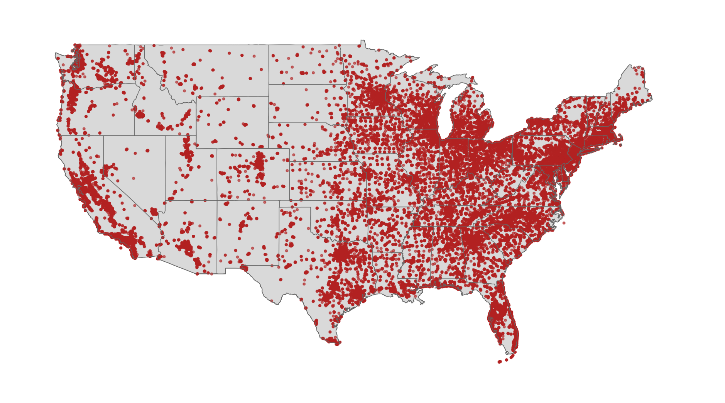
Figure A. Geographic locations of all recorded occupational injuries during June, July, and August 2023, in contiguous United States.

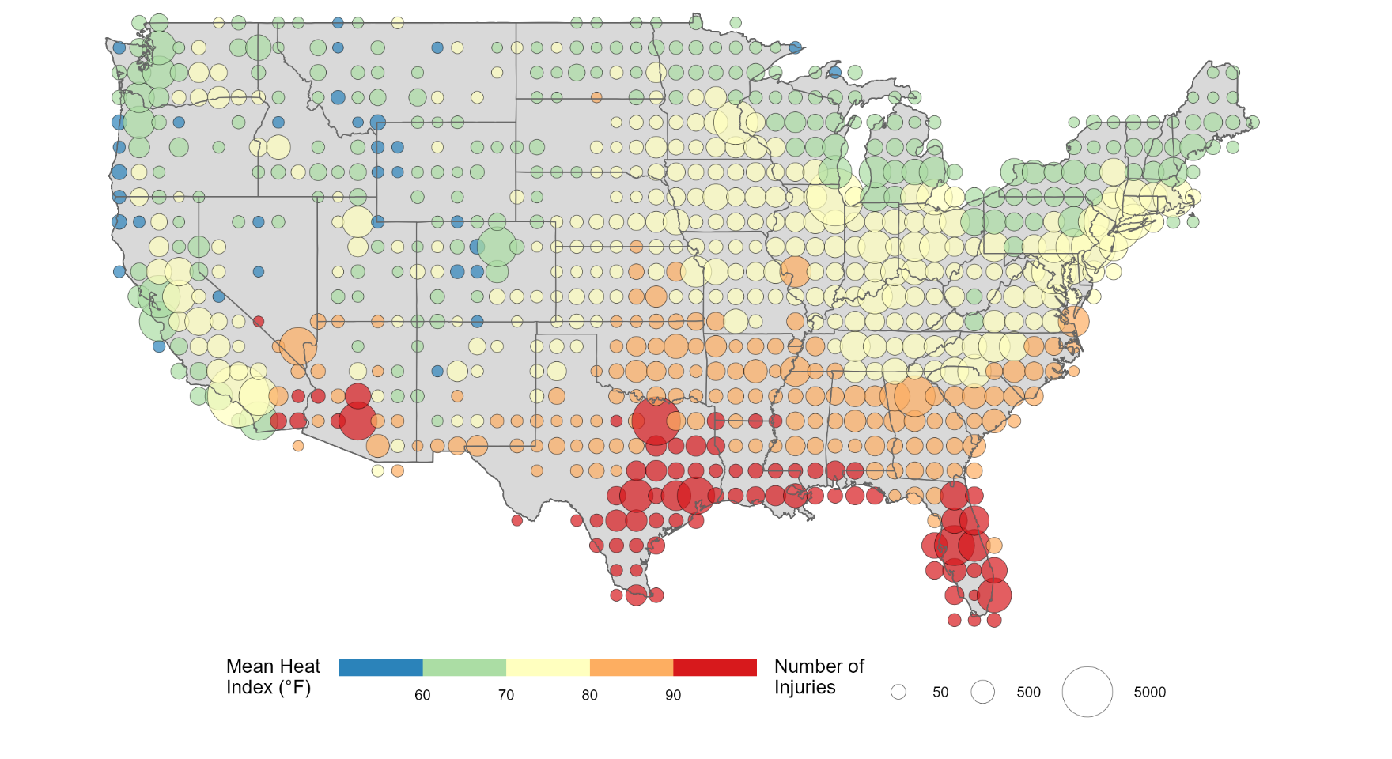
Figure B. Geographic locations of all recorded occupational injuries during June, July, and August 2023, with average heat index values rounded to the nearest whole degree of latitude and longitude in contiguous United States.

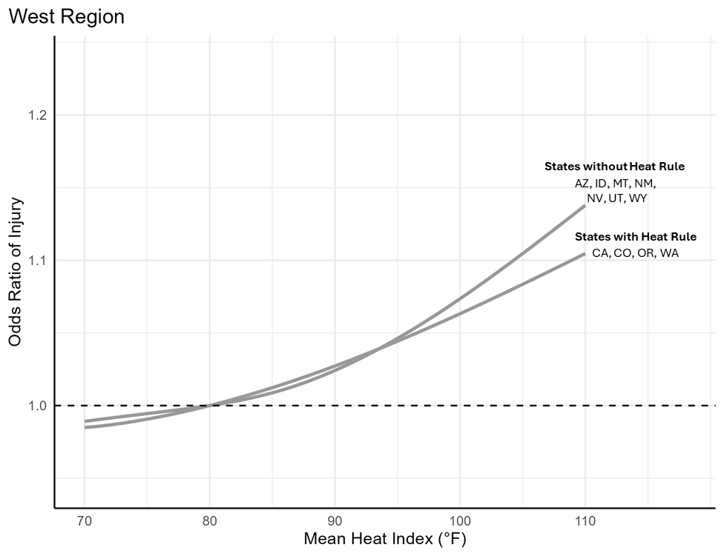
Figure C. Comparison of states with and without occupational heat rules within the West region stratified into two groups of states with heat rules (CA, CO, OR, WA) and states without heat rules (AZ, ID, MT, NM, NV, UT, WY). Odds ratios are scaled to 80°F (dashed line = 1.0).
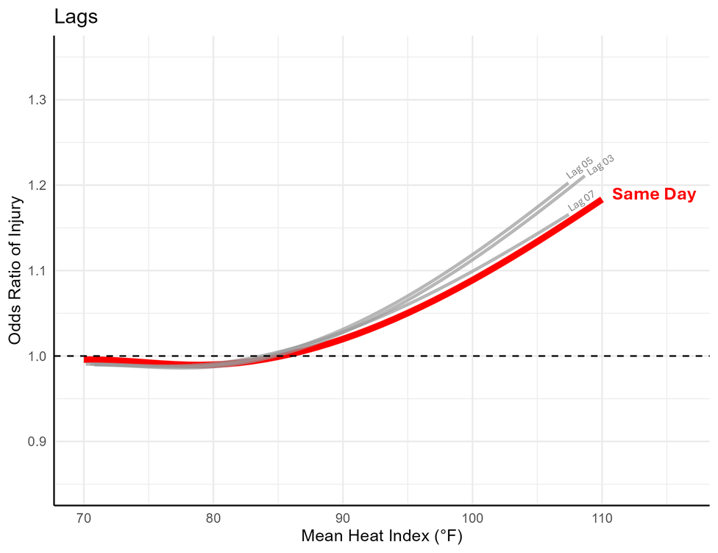
Figure D. Moving average of 3-, 5-, and 7-days compared to same day temperature (main model)

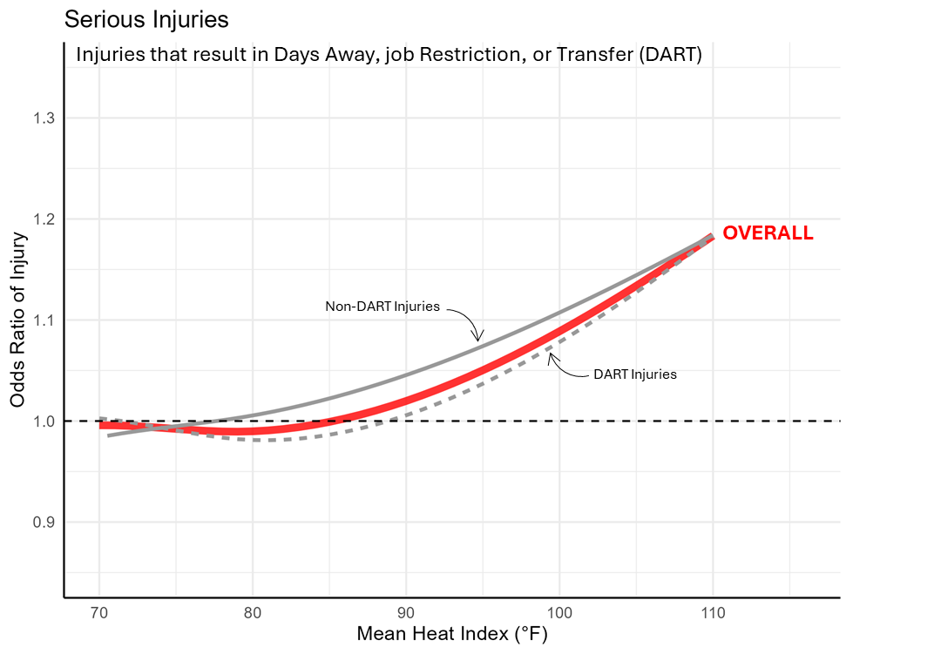
Figure E. DART and non-DART injuries compared to main model (DART = injuries that result in Days Away from work, job Restrictions, or Transfer)

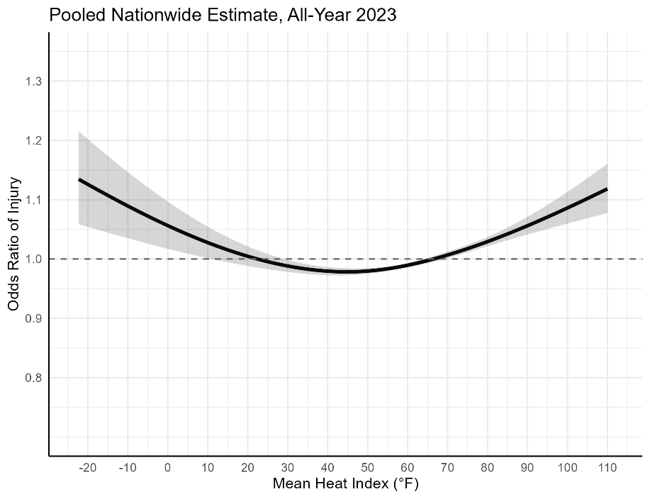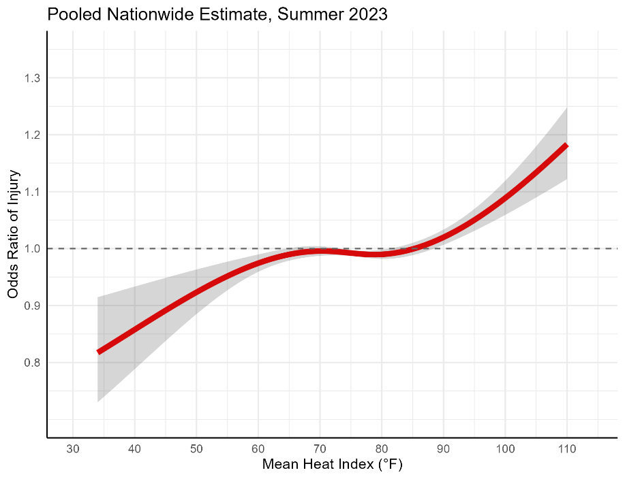
Figure F. Dose-response relationship using year-round data (left panel) and all temperature ranges in summer-only (right panel)

Table S1. Distribution of occupational injuries recorded in OSHA’s Injury Tracking Application in summer 2023 (Jun-Aug)
 | Region |  |  |  | Overall  (N=225,493)
NAICS 2-digit Sector | Midwest  (N=57,630) | Northeast  (N=37,614) | South  (N=75,181) | West  (N=55,068) | Overall  (N=225,493)
Health Care and Social Assistance | 13,681 (23.7%) | 12,595 (33.5%) | 18,532 (24.6%) | 10,620 (19.3%) | 55,428 (24.6%)
Transportation and Warehousing | 10,604 (18.4%) | 7,982 (21.2%) | 17,650 (23.5%) | 13,749 (25.0%) | 49,985 (22.2%)
Retail Trade | 8,932 (15.5%) | 7,174 (19.1%) | 15,247 (20.3%) | 11,324 (20.6%) | 42,677 (18.9%)
Manufacturing | 16,683 (28.9%) | 5,259 (14%) | 13,251 (17.6%) | 6,774 (12.3%) | 41,967 (18.6%)
Wholesale Trade | 2,547 (4.4%) | 1,951 (5.2%) | 3,286 (4.4%) | 2,254 (4.1%) | 10,038 (4.5%)
Accommodation and Food Services | 782 (1.4%) | 957 (2.5%) | 1,571 (2.1%) | 2,499 (4.5%) | 5,809 (2.6%)
Arts, Entertainment, and Recreation | 479 (0.8%) | 384 (1%) | 1,916 (2.5%) | 1,509 (2.7%) | 4,288 (1.9%)
Agriculture, Forestry, Fishing and Hunting | 452 (0.8%) | 215 (0.6%) | 484 (0.6%) | 2,506 (4.6%) | 3,657 (1.6%)
Public Administration | 1148 (2%) | 156 (0.4%) | 823 (1.1%) | 1,273 (2.3%) | 3,400 (1.5%)
Construction | 969 (1.7%) | 386 (1%) | 902 (1.2%) | 1,059 (1.9%) | 3,316 (1.5%)
Waste Management and Remediation Services | 557 (1%) | 316 (0.8%) | 689 (0.9%) | 673 (1.2%) | 2,235 (1.0%)
Educational Services | 251 (0.4%) | 78 (0.2%) | 207 (0.3%) | 131 (0.2%) | 667 (0.3%)
Utilities | 173 (0.3%) | 48 (0.1%) | 250 (0.3%) | 348 (0.6%) | 819 (0.4%)
Other | 372 (0.6%) | 113 (0.3%) | 373 (0.5%) | 349 (0.6%) | 1,207 (0.5%)

 | All Months | Summer Months (Jun-Aug)
 | Average within Stratum Standard Deviation*
Total Observations  (Cases + Control days) | (N = 3,711,104) | (N = 1,234,480)
Ambient Temperature | 6.2 °F | 4.0 °F
Relative Humidity | 11.2% | 8.1%
Heat Index | 6.6 °F | 5.0 °F
Table S2. Average within-stratum standard deviation of exposures.

*Calculated as the average of standard deviations for each matched stratum (case day plus its referent control days)

Table S3. Estimated heat-attributable injuries applied to the 2023 BLS national estimate
 | Estimated Population Attributable Fraction (PAF) † | Total Injuries Reported in BLS SOII | Estimated Attributable Injuries to Heat
 | PAF % [95% eCI] | N | N [95% eCI]
Heat Index Threshold
≥ 60 °F | 1.33% [1.04% - 1.64%] | 2,368,900 | 31,506 [24,637 – 38,850]
≥ 70 °F | 1.18% [0.92% - 1.45%] | 2,368,900 | 27,953 [21,794 – 34,349]
≥ 80 °F | 0.69% [0.52% - 0.85%] | 2,368,900 | 16,345 [12,318 – 20,136]
≥ 90 °F | 0.33% [0.24% - 0.41%] | 2,368,900 | 7,817 [5,685 – 9,712]
† PAFs were calculated using the analysis of ITA dataset

Table S4. Odds ratios of injuries by states with and without occupational heat rule in 2023
 | Total Reported Summer Injuries | Percent Injuries in days above 80°F | Odds Ratio at 90°F  (vs. 80°F) | Odds Ratio at 100°F  (vs. 80°F) | Odds Ratio at 110°F  (vs. 80°F)
 | N | % | OR (95% CI) | OR (95% CI) | OR (95% CI)
States without Heat Rule
Nationwide | 177,712 | 36.8% | 1.02 (1.01, 1.03) | 1.10 (1.07, 1.13) | 1.22 (1.15, 1.29)
States with Heat Rule
California | 28,616 | 15.1% | 1.03 (0.96, 1.11) | 1.09 (0.89, 1.33) | 1.14 (0.80, 1.62)
California + Oregon | 32,518 | 13.9% | 1.03 (0.95, 1.11) | 1.05 (0.87, 1.27) | 1.07 (0.77, 1.49)
California + Oregon + Washington | 39,059 | 12.1% | 1.03 (0.95, 1.11) | 1.07 (0.89, 1.27) | 1.11 (0.82, 1.51)
California + Oregon + Washington + Colorado | 42,818 | 11.3% | 1.03 (0.95, 1.11) | 1.06 (0.89, 1.27) | 1.10 (0.82, 1.49)
California + Oregon + Washington + Colorado + Minnesota | 49,377 | 11.0% | 1.03 (0.97, 1.10) | 1.06 (0.91, 1.23) | 1.09 (0.84, 1.41)

