Supplementary Material
Table S1. List of the municipalities of the SIN of Casale Monferrato*
List of municipalities in the SIN of Casale Monferrato
1. Alfiano Natta | 25. Occimiano
2. Altavilla Monferrato | 26. Odalengo Grande
3. Balzola | 27. Odalengo Piccolo
4. Borgo San Martino | 28. Olivola
5. Bozzole | 29. Ottiglio
6. Camagna Monferrato | 30. Ozzano Monferrato
7. Camino | 31. Palazzolo Vercellese
8. Casale Monferrato | 32. Pomaro Monferrato
9. Castelletto Merli | 33. Pontestura
10. Cella Monte | 34. Ponzano Monferrato
11. Cereseto | 35. Rosignano Monferrato
12. Cerrina Monferrato | 36. Sala Monferrato
13. Coniolo | 37. San Giorgio Monferrato
14. Conzano | 38. Serralunga Di Crea
15. Frassinello Monferrato | 39. Solonghello
16. Frassineto Po | 40. Terruggia
17. Gabiano | 41. Ticineto
18. Giarole | 42. Treville
19. Mirabello Monferrato | 43. Trino
20. Mombello Monferrato | 44. Valmacca
21. Moncalvo | 45. Vignale Monferrato
22. Moncestino | 46. Villadeati
23. Morano sul Po | 47. Villamiroglio
24. Murisengo | 48. Villanova Monferrato
*Note: The list of municipalities included in the Casale Monferrato National Priority Contaminated Site (SIN) is based on data from: C. Nazionale delle Ricerche et al., SENTIERI – Epidemiological Study of Residents in National Priority Contaminated Sites. Sixth Report, 2023. doi:10.19191/EP23.1-2-S1.003.

Table S2. Number of malignant mesothelioma cases for each period of diagnosis by age group and gender (RMM, 1990-2021)
 | Period of Diagnosis (Years)
Age of Diagnosis (Years) | Men (N) |  |  |  | Women (N)
Age of Diagnosis (Years) | 1990-99 | 2000-09 | 2010-19 | 2020-21 | 1990-99 | 2000-09 | 2010-19 | 2020-21
35-44 | 10 | 5 | 4 | 0 | 1 | 2 | 1 | 0
45-54 | 20 | 24 | 18 | 1 | 11 | 14 | 8 | 0
55-64 | 36 | 67 | 46 | 10 | 30 | 36 | 25 | 4
65-74 | 51 | 87 | 85 | 14 | 38 | 45 | 60 | 10
75-84 | 34 | 61 | 86 | 13 | 29 | 73 | 69 | 10
85-94 | 6 | 21 | 30 | 2 | 8 | 29 | 39 | 3
95-100 | 0 | 0 | 0 | 0 | 0 | 2 | 4 | 0
Total | 157 | 265 | 269 | 40 | 117 | 201 | 206 | 27

Table S3. Number of malignant mesothelioma cases for each birth cohort by age group and gender (RMM, 1990-2021)
Men cases by birth cohort (Years)
Age of Diagnosis  (Years) | 1900-09 | 1910-19 | 1920-29 | 1930-39 | 1940-49 | 1950-59 | 1960-69 | 1970-79
35-44 |  |  |  |  | 1 | 11 | 4 | 3
45-54 |  |  |  |  | 20 | 23 | 20
55-64 |  |  | 1 | 35 | 63 | 51 | 9
65-74 |  | 1 | 43 | 91 | 84 | 18
75-84 | 3 | 24 | 58 | 85 | 24
85-94 | 4 | 16 | 22 | 17
95-100
Total | 7 | 41 | 124 | 228 | 192 | 103 | 33 | 3
Women cases by birth cohort (Years)
Age of Diagnosis  (Years) | 1900-09 | 1910-19 | 1920-29 | 1930-39 | 1940-49 | 1950-59 | 1960-69 | 1970-79
35-44 |  |  |  |  |  | 1 | 2 | 1
45-54 |  |  |  |  | 10 | 15 | 8
55-64 |  |  | 4 | 21 | 40 | 20 | 10
65-74 |  | 4 | 33 | 43 | 60 | 13
75-84 |  | 25 | 75 | 61 | 20
85-94 | 2 | 25 | 41 | 11
95-100 |  | 3 | 3
Total | 2 | 57 | 156 | 136 | 130 | 49 | 20 | 1

Fig. S1 – Sensitivity to the number of knots (RMM, 1990-21, men)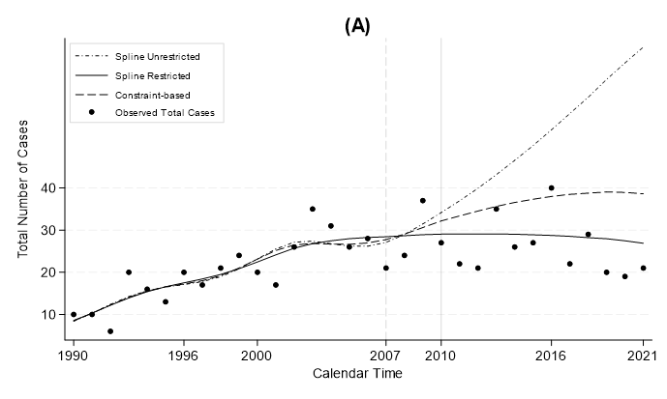
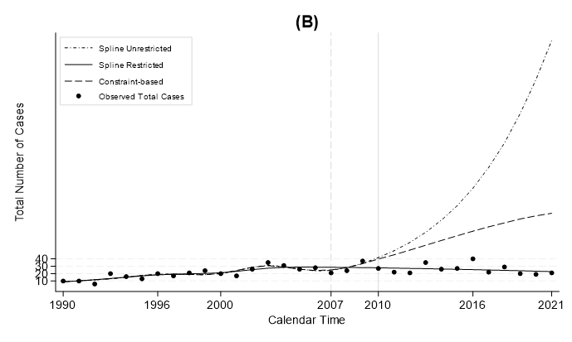
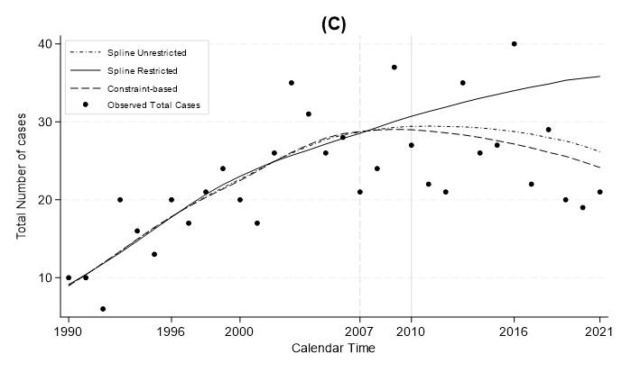
Fig. S1- A – Long-term projections (2010-2021) and observed number of MM cases among men (RMM, 1990–2021), using the three modeling approaches with different combinations of knots for age, period, and cohort effects. The configuration for panel A includes 4 knots for each variable (4,4,4). B – Configuration with 6, 5, and 3 knots for age, period, and cohort, respectively. C – Configuration with 6, 3, and 3 knots.

Fig. S2 – Sensitivity to the number of knots (RMM, 1990-21, women)
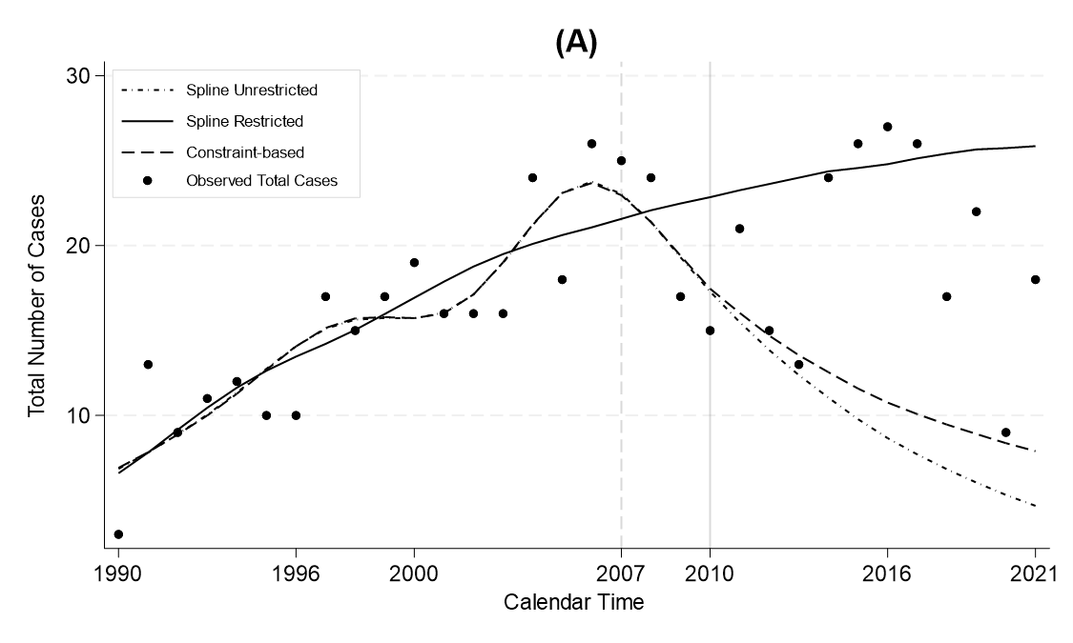
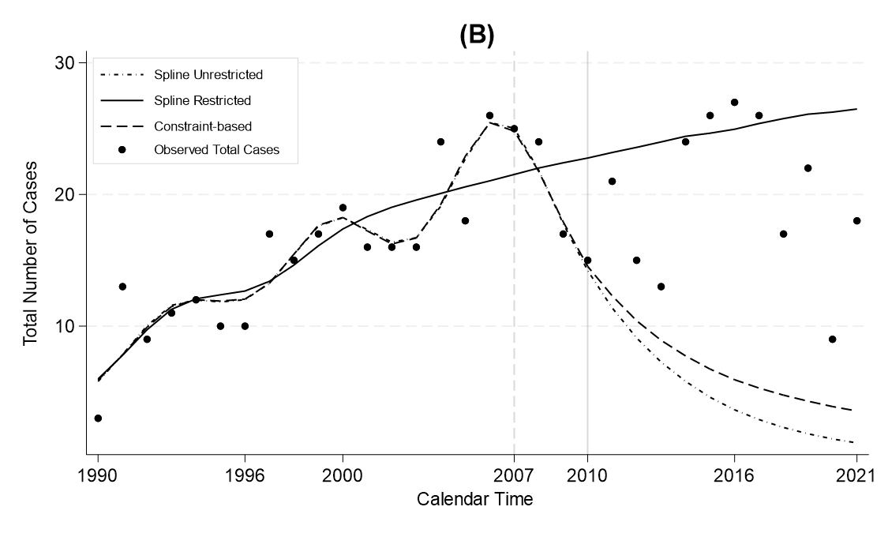
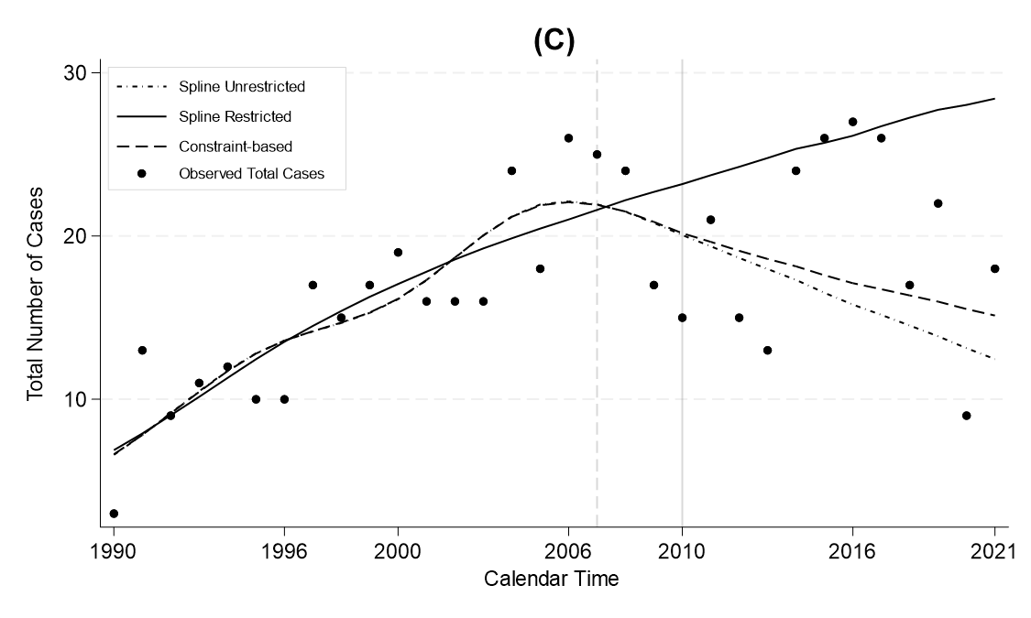
Fig. S2- A – Long-term projections (2010-2021) and observed number of MM cases among women (RMM, 1990–2021), using the three modeling approaches with different combinations of knots for age, period, and cohort effects. The configuration for panel A includes 4 knots for each variable (4,4,4). B – Configuration with 6, 5, and 3 knots for age, period, and cohort, respectively. C – Configuration with 6, 3, and 3 knots.

Fig. S3 – Sensitivity to the position of the boundary knot in the restricted approach (RMM, 1990-21, women).
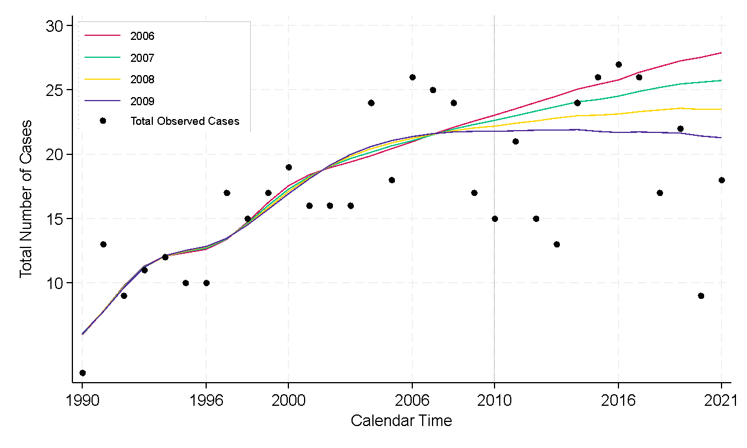
Fig. S3. Long-term projections (2010–2021) and observed number of malignant mesothelioma cases among women (RMM, 1990–2021), based on the restricted model with the best knot goodness-of-fit (6, 5, 3). The figure illustrates projections using different positions for the boundary knot to assess the sensitivity of the model to knot placement.

