Prenatal Fluoride Exposure and Autistic Behaviors in Preschool-Aged Children: The Maternal-Infant Research on Environmental Chemicals (MIREC) Cohort Study

Environmental Health

Adele Carty, Rivka Green, Carly V. Goodman, John R. McLaughlin, Howard Hu, Bruce Lanphear, E. Angeles Martinez-Mier, Amanda J. MacFarlane, Gina Muckle, Jeffrey R. Brook, Christine Till

Corresponding author:
Dr. Christine Till
York University
4700 Keele St.
Toronto ON
M3J 1P3 Canada
Email: ctill@yorku.ca
Additional Table 1. Adjustedª linear regression models for the effect of MUF_{SG} (mg/L) on SRS-2 total T-score after removing influential observations
 |  | Adjusted MUF_{SG}
 |  |  | 95% CI
Model | n | β | Lower | Upper | P Value
Total | 453 | -0.16 | -1.70 | 1.39 | 0.84
4 observations removed - high Cook's D & studentized residuals | 449 | -0.68 | -2.10 | 0.75 | 0.35
2 observations removed - high Cook's D, studentized residuals,  & leverage | 451 | -0.83 | -2.38 | 0.71 | 0.29
MUF_{SG} maternal urinary fluoride adjusted for specific gravity, SRS Social Responsiveness Scale.
a. Adjusted for: maternal - income, second-hand smoke, married, parity, HOME score; child - sex, city.

Additional Table 2. Adjustedª linear regression models (Model 1: unweighted; Model 2: inverse probability weighting (IPW)) for the effect of MUF_{SG} on SRS-2 scores (n = 453)
 | Model 1 (unweighted) |  |  |  |  | Model 2 (IPW)
 |  | 95% CI |  |  |  |  | 95% CI
Model | β | Lower | Upper | P Value |  | β | Lower | Upper | P Value
Total | -0.16 | -1.70 | 1.39 | 0.84 |  | -0.09 | -1.59 | 1.42 | 0.91
Boys^{b} | -0.06 | -2.16 | 2.04 | 0.96 |  | -0.05 | -2.11 | 2.00 | 0.96
Girls^{c} | 0.16 | -2.31 | 2.62 | 0.90 |  | 0.37 | -2.04 | 2.77 | 0.77
Subscales
Awareness | -0.88 | -2.92 | 1.17 | 0.40 |  | -0.71 | -2.71 | 1.29 | 0.48
Cognition | -0.18 | -1.81 | 1.46 | 0.83 |  | -0.14 | -1.72 | 1.45 | 0.86
Communication | -0.13 | -1.72 | 1.46 | 0.88 |  | -0.10 | -1.65 | 1.45 | 0.90
Motivation | 0.28 | -1.63 | 2.19 | 0.77 |  | 0.30 | -1.57 | 2.16 | 0.75
Restricted and repetitive | 0.12 | -1.61 | 1.86 | 0.89 |  | 0.30 | -1.39 | 1.99 | 0.73
DSM social | -0.08 | -1.63 | 1.47 | 0.92 |  | -0.02 | -1.53 | 1.49 | 0.98
DSM restricted | 0.12 | -1.62 | 1.86 | 0.89 |  | 0.29 | -1.40 | 1.98 | 0.73
MUF_{SG} maternal urinary fluoride adjusted for specific gravity, SRS Social Responsiveness Scale, DSM Diagnostic and Statistical Manual of Mental Disorders.
a. Adjusted for: maternal - income, second-hand smoke, married, parity, HOME score; child - sex, city.
b. n = 224.
c. n = 229.

Additional Table 3. Spearman rank correlation among prenatal fluoride measurements
Fluoride exposure (n = 369) | 1 | 2 | 3
(1) MUF_{SG} | -
(2) Fluoride intake | 0.57 | -
(3) Water fluoride | 0.47 | 0.76 | -
MUF_{SG}, by trimesterª (n = 453) | T1 | T2 | T3
T1 | -
T2 | 0.43 | -
T3 | 0.36 | 0.47 | -
MUF_{SG} maternal urinary fluoride adjusted for specific gravity, T trimester
a. Intraclass correlation coefficient (ICC) = 0.36 (95% CI: 0.30, 0.42).

Additional Table 4. Distribution of SRS-2 scores (n = 453)
 |  |  |  |  |  |  | Sex
 | All |  |  |  |  |  | Boys (n = 224) |  |  | Girls (n = 229)
SRS-2 Scale | Mean | SD | Min | Max |  |  | Mean | SD |  | Mean | SD | P Valueª
Total | 45.3 | 6.1 | 34 | 85 |  |  | 46.4 | 6.5 |  | 44.2 | 5.4 | <0.01
Subscales
Awareness | 44.9 | 7.8 | 29 | 80 |  |  | 46.1 | 8.1 |  | 43.7 | 7.4 | <0.01
Cognition | 44.2 | 6.3 | 35 | 84 |  |  | 45.0 | 6.7 |  | 43.4 | 5.8 | 0.01
Communication | 45.1 | 6.2 | 35 | 79 |  |  | 46.3 | 6.6 |  | 43.8 | 5.6 | <0.01
Motivation | 48.1 | 7.2 | 37 | 82 |  |  | 48.3 | 7.3 |  | 47.9 | 7.1 | 0.55
Restricted and repetitive | 47.7 | 6.6 | 40 | 84 |  |  | 49.0 | 7.1 |  | 46.5 | 5.9 | <0.01
DSM social | 45.0 | 6.1 | 34 | 84 |  |  | 46.0 | 6.5 |  | 44.0 | 5.4 | <0.01
DSM restricted | 47.7 | 6.6 | 40 | 84 |  |  | 49.0 | 7.1 |  | 46.5 | 5.9 | <0.01
SRS Social Responsiveness Scale, SD standard deviation, Min minimum, Max maximum.
a. Independent sample t-test, interpreted Welch-Satterthwaite for unequal variances.

Additional Table 5. Distribution of SRS-2 total T-score and MUF_{SG} by sociodemographic characteristics (n = 453)
 |  | SRS-2 total T-score |  |  |  | MUF_{SG} (mg/L)
Characteristic | n | Mean | SD | P Valueª |  | Mean | SD | P Valueª
Maternal
Age, y |  |  |  | <0.01 |  |  |  | 0.05
≤ 30 | 158 | 46.6 | 6.4 |  |  | 0.5 | 0.3
31-35 | 176 | 44.7 | 5.6 |  |  | 0.6 | 0.4
≥ 36 | 119 | 44.6 | 6.1 |  |  | 0.5 | 0.4
Race |  |  |  | 0.04 |  |  |  | 0.51
White | 413 | 45.2 | 6.0 |  |  | 0.5 | 0.4
Other | 40 | 47.2 | 5.9 |  |  | 0.5 | 0.4
Born in Canada |  |  |  | 0.14 |  |  |  | 0.81
Yes | 380 | 45.2 | 6.0 |  |  | 0.5 | 0.4
No | 73 | 46.3 | 6.1 |  |  | 0.5 | 0.4
Education level |  |  |  | 0.03 |  |  |  | 0.18
High school or less | 21 | 48.1 | 6.8 |  |  | 0.4 | 0.3
More than high school | 432 | 45.2 | 6.0 |  |  | 0.5 | 0.4
Annual household income |  |  |  | <0.01 |  |  |  | 0.94
≤ $70,000 CAD | 124 | 47.3 | 6.7 |  |  | 0.5 | 0.4
> $70,000 CAD | 329 | 44.6 | 5.6 |  |  | 0.5 | 0.4
Alcohol consumption, drink/mo |  |  |  | 0.30 |  |  |  | 0.45
None | 371 | 45.5 | 6.3 |  |  | 0.5 | 0.4
> 0 | 82 | 44.8 | 5.1 |  |  | 0.6 | 0.4
Smoked in trimester 1 |  |  |  | 0.50 |  |  |  | 0.91
Yes | 11 | 46.5 | 5.1 |  |  | 0.5 | 0.3
No | 442 | 45.3 | 6.1 |  |  | 0.5 | 0.4
Second-hand smoke in trimester 1 |  |  |  | 0.01 |  |  |  | 0.01
Yes | 17 | 49.1 | 6.5 |  |  | 0.4 | 0.2
No | 436 | 45.2 | 6.0 |  |  | 0.5 | 0.4
Marital status |  |  |  | <0.01 |  |  |  | <0.01
Married | 323 | 44.8 | 5.9 |  |  | 0.6 | 0.4
Other | 130 | 46.8 | 6.1 |  |  | 0.4 | 0.3
First birth |  |  |  | 0.05 |  |  |  | 0.68
Yes | 211 | 45.9 | 5.9 |  |  | 0.5 | 0.4
No | 242 | 44.8 | 6.2 |  |  | 0.5 | 0.4
HOME score |  |  |  | <0.01 |  |  |  | 0.76
Low (≤ 48) | 241 | 46.3 | 6.4 |  |  | 0.5 | 0.4
High (≥ 49) | 212 | 44.2 | 5.4 |  |  | 0.5 | 0.4
Folic acid supplementation, μg/day |  |  |  | 0.92 |  |  |  | 0.27
< 400 | 25 | 45.6 | 5.4 |  |  | 0.4 | 0.2
400-1000 | 325 | 45.4 | 6.3 |  |  | 0.5 | 0.4
> 1000 | 103 | 45.1 | 5.5 |  |  | 0.5 | 0.3
Plasma total folate, trimester 1 |  |  |  | 0.78 |  |  |  | 0.85
< 10th percentile (66.02 nmol/L) | 46 | 44.9 | 5.9 |  |  | 0.5 | 0.3
≥ 10th & < 80th percentiles | 316 | 45.5 | 6.4 |  |  | 0.5 | 0.4
≥ 80th percentile (126.26 nmol/L) | 91 | 45.10 | 4.8 |  |  | 0.5 | 0.4
Plasma total folate, trimester 3 |  |  |  | 0.28 |  |  |  | 0.23
< 10th percentile (49.14 nmol/L) | 45 | 46.2 | 7.1 |  |  | 0.5 | 0.4
≥ 10th & < 80th percentiles | 317 | 45.4 | 6.0 |  |  | 0.5 | 0.4
≥ 80th percentile (151.53 nmol/L) | 91 | 44.5 | 5.6 |  |  | 0.5 | 0.3
Child
Age at SRS-2 testing, mo |  |  |  | 0.70 |  |  |  | 0.36
30-41 | 288 | 45.4 | 5.8 |  |  | 0.5 | 0.4
42-54 | 165 | 45.2 | 6.5 |  |  | 0.5 | 0.4
Sex |  |  |  | <0.01 |  |  |  | 0.04
Male | 224 | 46.4 | 6.5 |  |  | 0.6 | 0.4
Female | 229 | 44.2 | 5.4 |  |  | 0.5 | 0.3
SRS Social Responsiveness Scale, MUF_{SG} maternal urinary fluoride adjusted for specific gravity, SD standard deviation, y year, mo month, HOME Home Observation for the Measurement of the Environment.
a. Independent sample t-test, interpreted Welch-Satterthwaite for unequal variances; or ANOVA, interpreted Welch's test for non-homogeneity.

Additional Table 6. Interaction termsª in adjusted^{b} regression model for the effect of MUF_{SG} (mg/L) on SRS-2 total T-score (n = 453)
 | Covariate |  |  |  |  | Interaction term^{b}
 |  | 95% CI
Model | β | Lower | Upper | P Value |  | P Value
Total + MUF_{SG}*child sex
MUF_{SG} | -0.07 | -2.58 | 2.44 | 0.96
Child sex
Male | 1.76 | -0.07 | 3.60 | 0.06 |  | 0.93
Female | Reference
Total + MUF_{SG}*daily folic acid supplementation
MUF_{SG} | -0.23 | -1.89 | 1.42 | 0.78
Daily folic acid supplementation, μg/day
< 400 | -1.13 | -6.59 | 4.32 | 0.68 |  | 0.68
400-1000 | Reference
> 1000 | -0.15 | -2.52 | 2.22 | 0.90 |  | 0.88
Total + MUF_{SG}*T1 plasma total folate
MUF_{SG} | 0.24 | -1.53 | 2.02 | 0.79
T1 Plasma total folate
< 10th percentile (66.02 nmol/L) | -0.58 | -3.85 | 2.68 | 0.73 |  | 0.61
≥ 10^{th &} < 80th percentiles | Reference
≥ 80th percentile (126.26 nmol/L) | 0.09 | -2.10 | 2.29 | 0.93 |  | 0.40
Total + MUFSG*T3 plasma total folate
MUF_{SG} | 0.46 | -1.27 | 2.19 | 0.60
T1 Plasma total folate
< 10th percentile (49.14 nmol/L) | 1.39 | -1.62 | 4.39 | 0.37 |  | 0.37
≥ 10^{th &} < 80th percentiles | Reference
≥ 80th percentile (151.53 nmol/L) | 0.56 | -1.75 | 2.87 | 0.63 |  | 0.14
MUF_{SG} maternal urinary fluoride adjusted for specific gravity, SRS Social Responsiveness Scale, T trimester.
a. Interaction term between MUF_{SG} and the following variables: child sex, daily folic acid supplementation, first trimester plasma total folate, and third trimester plasma total folate.
b. Adjusted for: maternal - income, second-hand smoke, married, parity, HOME score; child - sex, city.

Additional Table 7. Adjusted linear regression model for the effect of MUF_{SG} (mg/L) with linear splinesª on SRS-2 total T-score (n = 453)
 |  | 95% CI
Covariate | β | Lower | Upper | P Value
Intercept | 58.71 | 52.07 | 65.35 | <0.01
MUF_{SG}
Spline 1 | 0.53 | -3.24 | 4.29 | 0.78
Spline 2 | -0.49 | -2.75 | 1.77 | 0.67
Annual household income
≤$70,000 CAD | 1.19 | -0.08 | 2.45 | 0.07
>$70,000 CAD | Reference
Second-hand smoke in trimester 1
Yes | 1.57 | -1.36 | 4.51 | 0.29
No | Reference
Marital status
Married | Reference
Other | 0.77 | -0.59 | 2.13 | 0.26
First birth
Yes | 1.37 | 0.31 | 2.42 | 0.01
No | Reference
HOME total score | -0.35 | -0.48 | -0.22 | <0.01
City^{b}
A | 0.10 | -2.06 | 2.27 | 0.92
B | 2.85 | 0.30 | 5.40 | 0.03
C | 1.71 | -0.39 | 3.81 | 0.11
D | 1.39 | -0.67 | 3.45 | 0.19
E | -0.67 | -3.20 | 1.86 | 0.60
F | Reference
Sex
Male | 1.70 | 0.63 | 2.77 | <0.01
Female | Reference
MUF_{SG} maternal urinary fluoride adjusted for specific gravity, SRS Social Responsiveness Scale, HOME Home Observation for the Measurement of the Environment.
a. One knot placed at MUF_{SG} 0.7 mg/L.
b. City names suppressed for anonymity.

Additional Table 8. Inclusion of maternal prenatal metal exposures and maternal/child covariates in the adjustedª regression model for the effect of MUF_{SG} (mg/L) on SRS-2 total T-score
 |  | Adjusted MUF_{SG}
 |  |  | 95% CI
Model | n | β | Lower | Upper | P Value
Maternal
Total + T1 ln (blood lead ((µmol/L)) | 453 | -0.18 | -1.73 | 1.37 | 0.82
Total + T1 manganese (nmol/L) | 452 | -0.11 | -1.65 | 1.44 | 0.89
Total + T1 ln (mercury (nmol/L)) | 453 | -0.19 | -1.74 | 1.35 | 0.81
Total + T1 ln (urinary arsenic_{SG} (µmol/L)) | 453 | -0.13 | -1.69 | 1.44 | 0.87
Total + stress^{b} | 438 | -0.20 | -1.60 | 1.20 | 0.78
Total + depressive symptoms^{c} | 435 | -0.13 | -1.67 | 1.41 | 0.87
Total + pre-pregnancy BMI | 414 | -0.61 | -2.25 | 1.04 | 0.47
Child
Total + FSIQ^{d} | 450 | -0.37 | -1.89 | 1.15 | 0.63
MUF_{SG} maternal urinary fluoride adjusted for specific gravity, SRS Social Responsiveness Scale, T trimester, ln natural logarithm, SG specific gravity, BMI body mass index, FSIQ Full Scale IQ.
a. Adjusted for: maternal - income, second-hand smoke, married, parity, HOME score; child - sex, city.
b. Parenting Relationship Questionnaire.
c. Center for Epidemiological Studies–Depression Scale 10.
d. Wechsler Preschool and Primary Scale of Intelligence-Third Edition.

Additional Table 9. Adjustedª linear regression models for the effect of different fluoride exposures on SRS-2 scores
 | Fluoride Exposure
 | T1 MUF_{SG} (mg/L)  (n = 453) |  |  |  | T2 MUF_{SG} (mg/L)  (n = 453) |  |  |  | T3 MUF_{SG} (mg/L)  (n = 453) |  |  |  | MUF_{CRE} (mg/L)  (n = 360)
Model | β | 95% CI | P Value |  | β | 95% CI | P Value |  | β | 95% CI | P Value |  | β | 95% CI | P Value
Total | -0.47 | (-1.59, 0.65) | 0.41 |  | 0.32 | (-0.81, 1.46) | 0.57 |  | -0.09 | (-1.21, 1.02) | 0.87 |  | -0.13 | (-1.64, 1.38) | 0.86
Subscales
Awareness | -0.85 | (-2.33, 0.63) | 0.26 |  | -0.09 | (-1.59, 1.40) | 0.90 |  | -0.43 | (-1.91, 1.04) | 0.56 |  | -1.07 | (-3.09, 0.96) | 0.30
Cognition | -0.63 | (-1.82, 0.56) | 0.30 |  | 0.35 | (-0.85, 1.55) | 0.57 |  | 0.01 | (-1.17, 1.19) | 0.99 |  | 0.05 | (-1.59, 1.70) | 0.95
Communication | -0.35 | (-1.51, 0.80) | 0.55 |  | 0.28 | (-0.88, 1.45) | 0.63 |  | -0.12 | (-1.27, 1.02) | 0.83 |  | -0.30 | (-1.86, 1.26) | 0.70
Motivation | 0.42 | (-0.96, 1.80) | 0.55 |  | -0.34 | (-1.74, 1.06) | 0.63 |  | 0.35 | (-1.02, 1.72) | 0.62 |  | 0.07 | (-1.77, 1.92) | 0.94
Restricted and repetitive | -0.79 | (-2.05, 0.47) | 0.22 |  | 1.06 | (-0.21, 2.33) | 0.10 |  | -0.05 | (-1.30, 1.20) | 0.94 |  | 0.64 | (-1.02, 2.31) | 0.45
DSM social | -0.30 | (-1.42, 0.82) | 0.60 |  | 0.17 | (-0.96, 1.31) | 0.77 |  | 0.01 | (-1.11, 1.12) | 0.99 |  | -0.18 | (-1.71, 1.36) | 0.82
DSM restricted | -0.79 | (-2.05, 0.47) | 0.22 |  | 1.06 | (-0.21, 2.33) | 0.10 |  | -0.05 | (-1.31, 1.20) | 0.93 |  | 0.64 | (-1.03, 2.30) | 0.45
SRS Social Responsiveness Scale, T trimester, MUF_{SG} maternal urinary fluoride adjusted for specific gravity, MUF_{CRE} maternal urinary fluoride adjusted for creatinine, DSM Diagnostic and Statistical Manual of Mental Disorders.
a. Adjusted for: maternal - income, second-hand smoke, married, parity, HOME score; child - sex, city.

Additional Figure 1. Formula to calculate estimated daily maternal fluoride intake (mg/day), the mean calculated across trimesters 1 and 3

$$\frac{\left[\left(WaterFT1 x TotalCupsT1\right)+\left(BlackTeaFT1\right)+\left(GreenTeaFT1\right)\right]+\left[\left(WaterFT3 x TotalCupsT3\right)+\left(BlackTeaFT3\right)+\left(GreenTeaFT3\right)\right] }{2}$$
Where, WaterF is the amount of fluoride in a 200 mL cup based on each women’s individual drinking water fluoride concentration (mg/L), TotalCups is the total volume of water, coffee, and tea consumed (L), BlackTeaF is the fluoride intake from cups of black tea consumed times the amount of fluoride in a 200 mL cup of black tea (0.326 mg), and GreenTeaF is the fluoride intake from cups of green tea consumed times the amount of fluoride in a 200 mL cup of green tea (0.260 mg). T1 represents trimester 1 data and T3 represents trimester 3 data.

Additional Figure 2. Conceptual model of the association between autistic behaviors, prenatal fluoride exposure and potential confounding variables
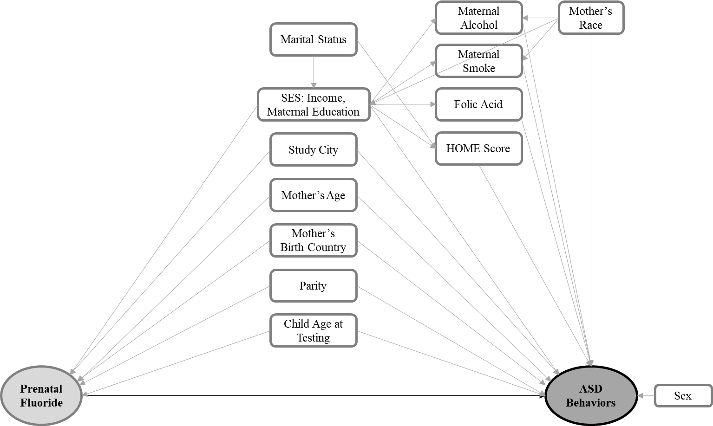

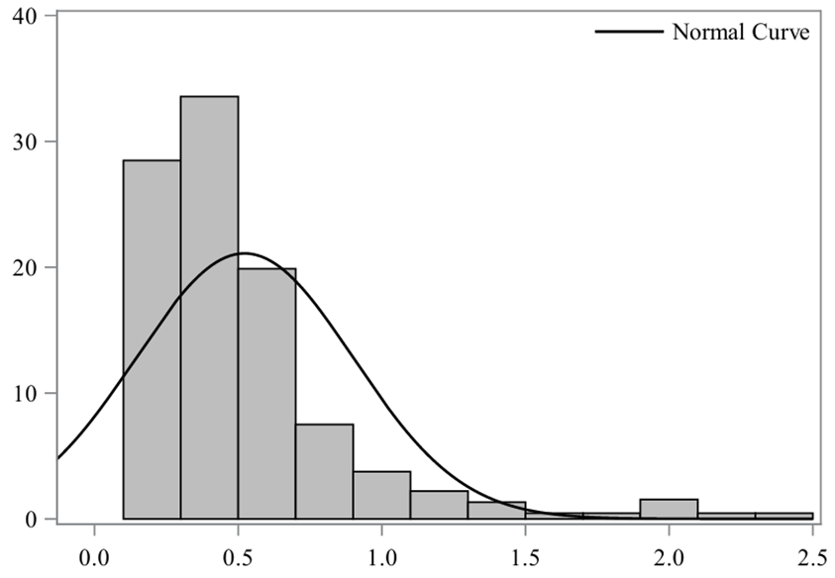
Additional Figure 3. Distribution of MUF_{SG} (n = 453)
MUF_{SG} mg/L
Percent
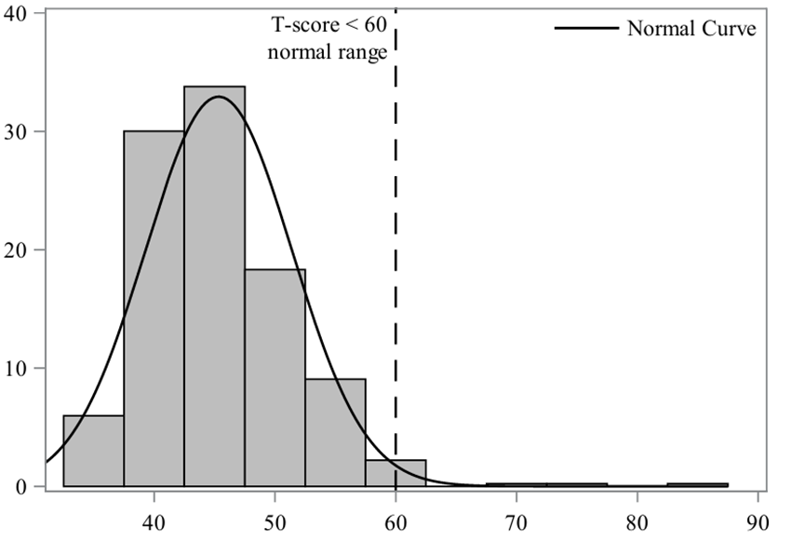
Additional Figure 4. Distribution of SRS-2 total T-score (n = 453)
SRS-2 total T-score
Percent

