Supplementals
Table 1S: Cancer cases count for the study duration (2001-2018) and cases per year in Massachusetts.

Cancer Type | Total Cases | Cases per Year (SD)
Breast | 106,968 | 5629.9 (539)
Lung | 97,582 | 5135.9 (257)
Prostate | 95,057 | 5003 (551)
Colorectal | 67,199 | 3536.8 (520)
Bladder | 36,158 | 1903.1 (74)
Melanoma | 31,289 | 1646.8 (239)
Uterine | 23,472 | 1235.4 (169)
Thyroid | 22,866 | 1203.5 (331)
Kidney | 22,590 | 1188.9 (190)
Leukemia | 18,927 | 996.2 (155)
Pancreas | 18,831 | 991.1 (180)
Oral | 17,319 | 911.5 (157)
Stomach | 10,334 | 543.9 (37)
Brain/Ns-Invasive | 10,077 | 530.4 (77)
Myeloma | 9,329 | 491 (113)
Esophageal | 8,816 | 464 (43)
Larynx | 5,240 | 275.8 (23)
Hl | 4,115 | 216.6 (19)
Cervix | 4,038 | 212.5 (21)
Testes | 3,874 | 203.9 (17)
Table 2S: Total and Annual Cancer Case Counts by Age Group and Sex (Massachusetts, 2000–2018).
sex | age group | total cases | mean yearly cases | sd yearly cases
Female | 0-1 | 83 | 4.4 | 2.7
Female | 1-4 | 474 | 24.9 | 5.2
Female | 5-14 | 2289 | 120.5 | 20.1
Female | 15-24 | 7639 | 402.1 | 50.5
Female | 25-34 | 21541 | 1133.7 | 55.5
Female | 35-44 | 48631 | 2559.5 | 173.6
Female | 45-54 | 954 | 50.2 | 10.1
Female | 55-64 | 66341 | 3491.6 | 521.2
Female | 65-74 | 71358 | 3755.7 | 628.6
Female | 75+ | 88310 | 4647.9 | 187
Male | 0-1 | 96 | 5.1 | 2.6
Male | 1-4 | 550 | 28.9 | 8.1
Male | 5-14 | 2034 | 107.1 | 15.3
Male | 15-24 | 4440 | 233.7 | 29.6
Male | 25-34 | 9543 | 502.3 | 47.1
Male | 35-44 | 34903 | 1837 | 132
Male | 45-54 | 859 | 45.2 | 8.3
Male | 55-64 | 78480 | 4130.5 | 400.3
Male | 65-74 | 91901 | 4836.9 | 541
Male | 75+ | 83609 | 4400.5 | 307.5

Table 3S. Annual covariates used in the statistical models (2000-2018).
Variable | Data source
Education below high school, % | United States Census American Community Survey
Median household income, $ | United States Census American Community Survey
Below federal poverty level, % | United States Census American Community Survey
White, % | United States Census American Community Survey
Population density, ppl/km² | NASA Socioeconomic Data and Applications Center
Average temperature, degrees ºC | National Oceanic and Atmospheric Administration
Average relative humidity, % | National Oceanic and Atmospheric Administration
Current smoke, (1-100) | BRFSS Area Health Resource Files
Nearest hospital, Km | ESRI’s hospital distribution files
Age over 65, % | United States Census American Community Survey
Renting, % | United States Census American Community Survey
Poverty, % | United States Census American Community Survey
Asian, % | United States Census American Community Survey
African American, % | United States Census American Community Survey
Average BMI | BRFSS Area Health Resource Files
PM2.5 | Atmospheric Composition Analysis Group – Washington University in St. Louis

Table 4S: All power plants within 120 km of a ZIP code population center in Massachusetts that were operational for at least one year in the period 2000 to 2018.
Plant Name | Reactor Type | Commercial Operation | Closed | State
Connecticut Yankee | PWR | 1/1/68 | 12/5/96 | Connecticut
Millstone | BWR, PWR | 12/28/70 | NA | Connecticut
Vermont Yankee | BWR | 11/30/72 | 12/29/14 | Vermont
Yankee Rowe | PWR | 7/1/61 | 10/1/91 | Massachusetts
Seabrook Station | PWR | 3/15/90 | NA | New Hampshire
Indian Point | PWR | 10/1/62 | 4/30/20 | New York
Pilgrim | BWR | 12/9/72 | 5/31/19 | Massachusetts

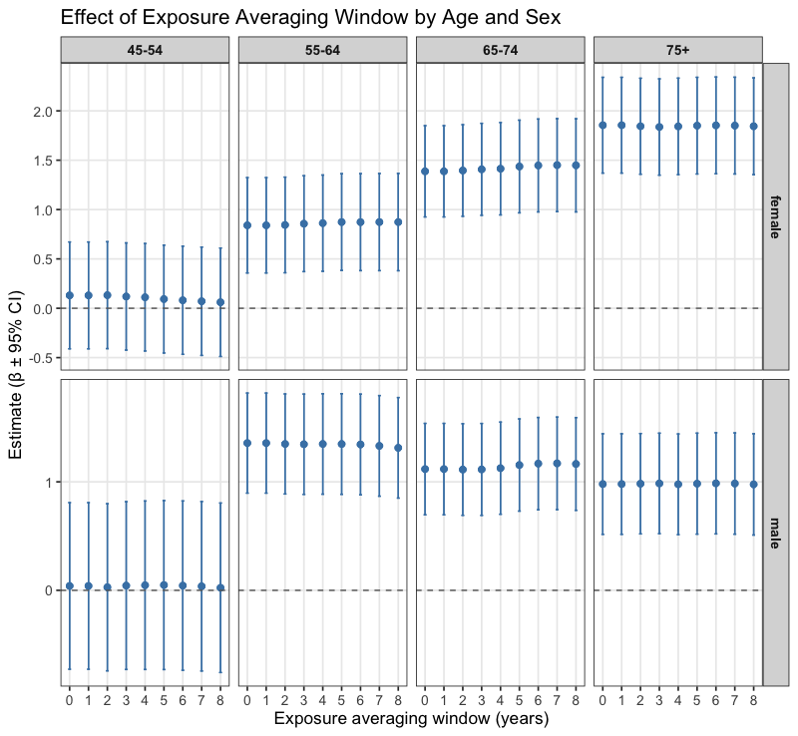
Figure 1S: Comparison of estimated associations across exposure averaging windows (0–8 years) by age group and sex.
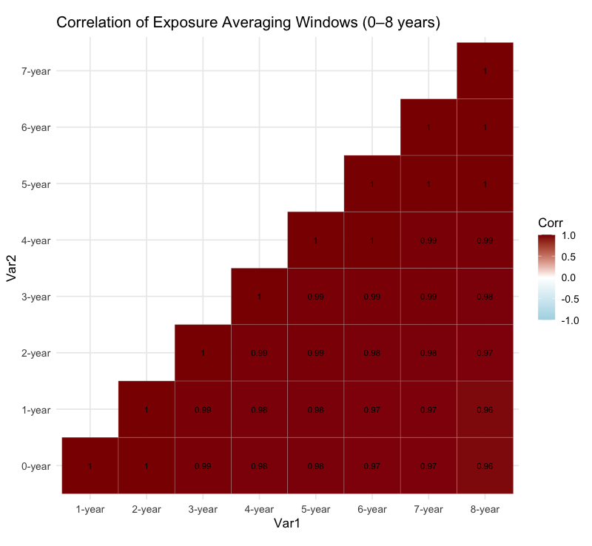
Figure 2S: Correlation matrix of exposure measures across averaging windows (0–8 years).
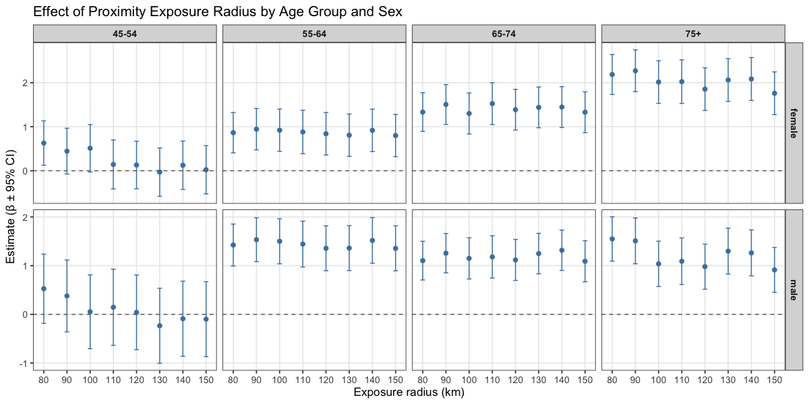
Figure 3S: Sensitivity analysis of exposure radius in relation to cancer incidence by age group and sex.

