Supplementary Material for “Exposure to active and abandoned oil and gas development and risk of childhood Ewing sarcoma in California”
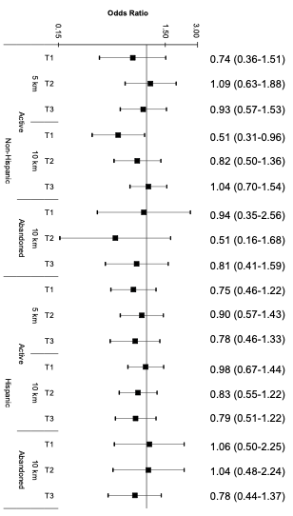
Supplementary Figure S1. Odds ratios and 95% confidence intervals for the association between OGD exposure to active or abandoned wells and Ewing sarcoma risk, stratified by Hispanic ethnicity.

Odds Ratios and 95% Confidence Intervals; adjusted for birth year, sex, age at diagnosis, race and ethnicity, birth weight, and community-level socio-economic status.
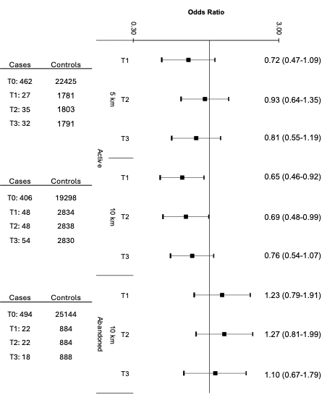
Supplementary Figure S2. Odds ratios and 95% confidence intervals for the association between OGD exposure to active or abandoned wells and Ewing sarcoma risk in the total population, adjusted for region of birth.

Odds Ratios and 95% Confidence Intervals; adjusted for birth year, sex, age at diagnosis, race and ethnicity, birth weight, region of birth, and community-level socio-economic status.

