Supplementary Material
Serum cotinine-assessed tobacco exposure, cadmium co-exposure, and childhood obesity: a cross-sectional study
Fanjia Guo^{1,2,†}, Changming Ding^{2,†}, Simeng Gu^{1,†}, Wanying Shi^{2,†}, Xinhan Zhang¹, Yingli Qu², Peiwei Xu^{1,2}, Zhe Mo¹, Xiaofeng Wang¹, Sujun Yan¹, Peijie Sun², Feng Zhao², Ying Zhu², Yuebin Lv², Zhijian Chen¹, Xiaoming Shi^{2,*}, Xiaoming Lou^{1,*}

¹ Department of Environmental Health, Zhejiang Provincial Center for Disease Control and Prevention, Hangzhou 310051, China
² China CDC Key Laboratory of Environment and Population Health, National Institute of Environmental Health, Chinese Center for Disease Control and Prevention, Beijing 100021, China.

† These authors contributed equally to this work.

*Correspondence:
Xiaoming Lou: Department of Environmental Health, Zhejiang Provincial Center for Disease Control and Prevention, Hangzhou 310051, China. Email: <xmlou@cdc.zj.cn>
Xiaoming Shi: China CDC Key Laboratory of Environment and Population Health, National Institute of Environmental Health, Chinese Center for Disease Control and Prevention, Beijing, China. Email: <shixm@chinacdc.cn>

Figure S1. Flowchart of participant enrolment.
Figure S2. Association of cotinine concentrations with BMI Z-score (A), WC (B), WHtR% (C), and BRI (D) in children and adolescents based on restricted cubic splines.
Figure S3. Subgroup analysis of odds ratios for general obesity and central obesity based on serum cotinine levels.
Table S1. Demographics comparison between included and excluded study participants.
Table S2. Demographic characteristics according to central obesity status of participants.
Table S3. Associations of individual serum cotinine levels (classified by SHS exposure) with BMI Z-score and prevalence of general obesity.
Table S4. Associations of individual serum cotinine (classified by SHS exposure) with central obesity
Table S5. Associations of individual Urinary Cadmium with general and central obesity.
Table S6. Odds ratios of general and central obesity by cotinine levels in sensitivity analyses.

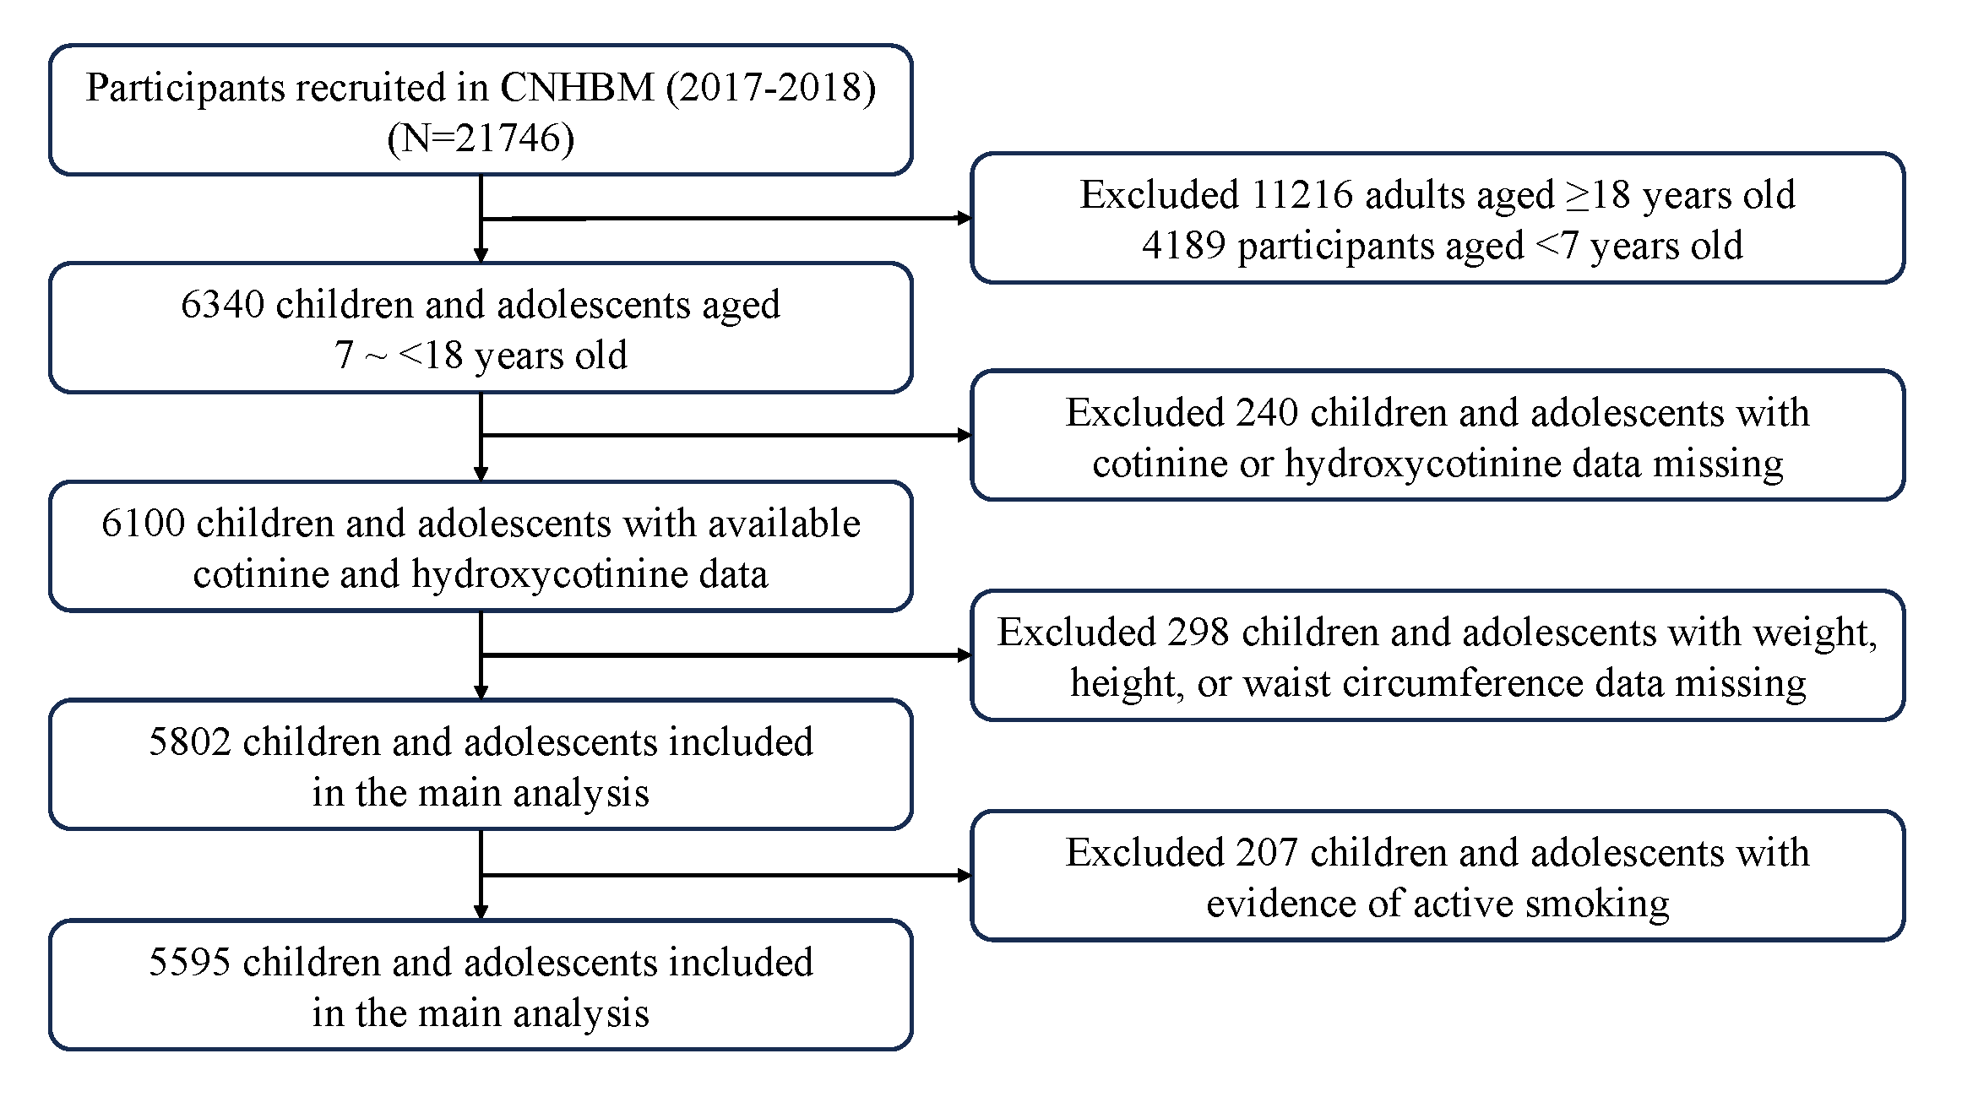
Figure S1. Flowchart of participants enrollment.

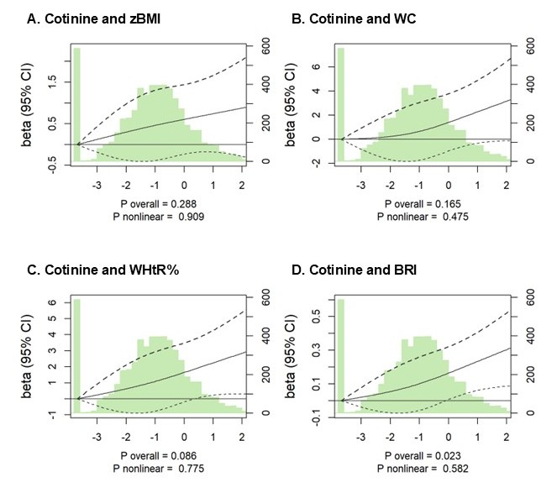
Figure S2. Association of nicotine metabolite concentrations with BMI Z-score (A), WC (B), WHtR% (C), and BRI (D) in children and adolescents based on restricted cubic splines.
Notes: Solid lines represent multivariable adjusted estimated betas, and the dashed lines represent their 95% confidence intervals. The histogram showed the distribution of serum cotinine and hydroxycotinine concentrations among the study participants. The dashed horizontal lines indicated reference lines for no association. Analyses were adjusted for age, sex, residence area, household income, physical activity, and consumption of rice, red meat, sea food, vegetables, fruits.

Figure S3. Subgroup analysis of odds ratios for general obesity and central obesity based on serum cotinine levels. Notes: Odds ratios (95% CIs) of general obesity and central obesity for each 1-unit increase in ln-transformed serum cotinine were estimated. Analyses were adjusted for age, sex, residence area, household income, physical activity, and consumption of rice, red meat, sea food, vegetables, fruits.

Table S1. Demographics comparison between included and excluded study participants.
Characteristic | Included  (N = 4984) | Excluded  (N = 611) | P value
Age (years) (N, %) |  |  | 0.106
≤11 | 2,847 (50.55%) | 449 (54.70%)
>11 | 2,748 (49.45%) | 296 (45.30%)
Sex (N, %) |  |  | 0.042
Girl | 2,902 (69.56%) | 299 (62.12%)
Boy | 2,693 (30.44%) | 446 (37.88%)
Residence area (N, %) |  |  | 0.491
Urban | 3,050 (56.45%) | 422 (60.19%)
Rural | 2,545 (43.55%) | 323 (39.81%)
Family income (yuan) (N, %) |  |  | 0.727
<30000 | 2,077 (36.52%) | 306 (38.88%)
30000-60000 | 1,654 (29.84%) | 221 (29.12%)
>60000 | 1,864 (33.65%) | 218 (31.99%)
Activity (N, %) |  |  | 0.944
<20 min per week | 1,927 (34.61%) | 249 (33.53%)
20-<60 min per week | 1,943 (35.56%) | 266 (35.87%)
≥60 min per week | 1,725 (29.83%) | 230 (30.60%)
Meat consumption (N, %) |  |  | 0.383
<7 times/week | 2,151 (40.38%) | 261 (35.74%)
7-<14 times/week | 1,804 (32.24%) | 252 (36.24%)
≥14 times/week | 1,640 (27.38%) | 232 (28.02%)
Seafood consumption (N, %) |  |  | 0.972
<1 times/week | 4,440 (78.61%) | 606 (78.75%)
≥1 times/week | 1,155 (21.39%) | 139 (21.25%)
Rice consumption (N, %) |  |  | 0.718
<7 times/week | 1,115 (21.65%) | 154 (24.63%)
7-<21 times/week | 3,199 (57.46%) | 432 (56.72%)
≥21 times/week | 1,281 (20.89%) | 159 (18.66%)
Vegetable consumption (N, %) |  |  | 0.520
<14 times/week | 2,198 (39.31%) | 296 (37.38%)
≥14 times/week | 3,397 (60.69%) | 449 (62.62%)
Fruit consumption (N, %) |  |  | 0.317
<7 times/week | 2,317 (40.04%) | 358 (43.58%)
≥7 times/week | 3,278 (59.96%) | 387 (56.42%)
Notes: Data were weighted to account for the complex sampling design.

Table S2. Demographic characteristics according to central obesity status of participants.
Characteristic | Without general obesity (N = 4356) | Central obesity  (N = 1239) | P value
Age (years) (N, %) |  |  | 0.026
≤11 | 2,153 (49.60%) | 694 (53.68%)
>11 | 2,203 (50.40%) | 545 (46.32%)
Sex (N, %) |  |  | 0.610
girl | 2,214 (69.28%) | 688 (70.46%)
boy | 2,142 (30.72%) | 551 (29.54%)
Residence area (N, %) |  |  | 0.029
urban | 2,290 (55.04%) | 760 (61.07%)
rural | 2,066 (44.96%) | 479 (38.93%)
Family income (yuan) (N, %) |  |  | 0.383
<30000 | 1,648 (36.91%) | 429 (35.22%)
30000-60000 | 1,270 (29.26%) | 384 (31.74%)
>60000 | 1,438 (33.83%) | 426 (33.04%)
Activity (N, %) |  |  | 0.298
<20 min per week | 1,523 (35.12%) | 404 (32.93%)
20-<60 min per week | 1,506 (35.70%) | 437 (35.08%)
≥60 min per week | 1,327 (29.18%) | 398 (31.99%)
Meat consumption (N, %) |  |  | 0.763
<7 times/week | 1,693 (40.76%) | 458 (39.13%)
7-<14 times/week | 1,392 (31.98%) | 412 (33.09%)
≥14 times/week | 1,271 (27.26%) | 369 (27.79%)
Seafood consumption (N, %) |  |  | <0.001
<1 times/week | 3,505 (80.28%) | 935 (73.12%)
≥1 times/week | 851 (19.72%) | 304 (26.88%)
Rice consumption (N, %) |  |  | 0.273
<7 times/week | 857 (21.04%) | 258 (23.66%)
7-<21 times/week | 2,488 (57.55%) | 711 (57.17%)
≥21 times/week | 1,011 (21.41%) | 270 (19.17%)
Vegetable consumption (N, %) |  |  | 0.620
<14 times/week | 1,720 (39.56%) | 478 (38.49%)
≥14 times/week | 2,636 (60.44%) | 761 (61.51%)
Fruit consumption (N, %) |  |  | 0.043
<7 times/week | 1,870 (41.08%) | 447 (36.64%)
≥7 times/week | 2,486 (58.92%) | 792 (63.36%)
Cotinine (ng/mL) | 0.34 (0.14, 0.68) | 0.37 (0.17, 0.81) | 0.030
UCd (μg/L) | 0.19 (0.09, 0.39) | 0.16 (0.08, 0.34) | 0.002
BMI (kg/m2, mean (SD)) | 17.51 (2.83) | 22.69 (4.31) | <0.001
WC (cm, mean (SD)) | 60.78 (10.32) | 82.52 (44.90) | <0.001
WHtR% (mean (SD)) | 41.66 (12.10) | 53.63 (29.79) | <0.001
BRI (mean (SD)) | 1.98 (1.55) | 3.74 (1.34) | <0.001
Notes: Data were weighted to account for the complex sampling design.
Abbreviations: UCd, urinary cadmium; BMI, body mass index; WC, waist circumference; WHtR%, waist-to-height ratio%; BRI, body roundness index.

Table S3. Associations of individual serum cotinine levels (classified by SHS exposure) with BMI Z-score and prevalence of general obesity.
Variables ª | General Obesity |  | BMI Z-score
Variables ª | OR (95% CI) |  | β (95% CI)
Model 1 ^{b}
No | Reference (1.000) |  | Reference (0.000)
Low | 1.440 (0.921,2.250) |  | 0.265 (-0.084,0.615)
High | 1.833 (1.157,2.904) |  | 0.509 (0.054,0.963)
Model 2 ^{c}
No | Reference (1.000) |  | Reference (0.000)
Low | 1.446 (0.928,2.252) |  | 0.246 (-0.097,0.590)
High | 1.912 (1.214,3.012) |  | 0.511 (0.089,0.933)
Model 3 ^{d}
No | Reference (1.000) |  | Reference (0.000)
Low | 1.416 (0.905,2.216) |  | 0.251 (-0.115,0.617)
High | 1.902 (1.205,3.004) |  | 0.512 (0.106,0.919)
ª Serum cotinine concentrations were distributed as follows: No < 0.05 ng/mL, Low = 0.05 – 0.42 ng/mL (median of exposed participants), High > 0.42 ng/mL.
^{b} Model 1 adjusted for age and sex.
^{c} Model 2 further adjusted for residence area, household income, physical activity.
^{d} Model 3 further adjusted for consumption of rice, red meat, sea food, vegetables, fruits.
Abbreviations: BMI, body mass index.

Table S4. Associations of individual serum cotinine (classified by SHS exposure) with central obesity.
Variables ª | Central Obesity |  | WC |  | WHtR% |  | BRI
Variables ª | OR (95% CI) |  | β (95% CI) |  | β (95% CI) |  | β (95% CI)
Model 1 ^{b}
No | Reference (1.000) |  | Reference (0.000) |  | Reference (0.000) |  | Reference (0.000)
Low | 1.224 (0.905,1.656) |  | -0.190 (-3.653,3.274) |  | 0.253 (-1.989,2.495) |  | 0.106 (-0.035,0.248)
High | 1.404 (1.035,1.905) |  | 0.723 (-1.834,3.279) |  | 1.258 (-0.444,2.959) |  | 0.264 (0.101,0.427)
Model 2 ^{c}
No | Reference (1.000) |  | Reference (0.000) |  | Reference (0.000) |  | Reference (0.000)
Low | 1.225 (0.908,1.654) |  | -0.192 (-3.631,3.246) |  | 0.257 (-1.969,2.483) |  | 0.104 (-0.038,0.245)
High | 1.426 (1.055,1.928) |  | 0.673 (-2.061,3.407) |  | 1.160 (-0.633,2.953) |  | 0.269 (0.108,0.429)
Model 3 ^{d}
No | Reference (1.000) |  | Reference (0.000) |  | Reference (0.000) |  | Reference (0.000)
Low | 1.198 (0.892,1.610) |  | -0.192 (-3.490,3.105) |  | 0.283 (-1.873,2.439) |  | 0.097 (-0.043,0.237)
High | 1.408 (1.050,1.887) |  | 0.750 (-1.864,3.363) |  | 1.214 (-0.511,2.939) |  | 0.267 (0.108,0.426)
ª Serum cotinine concentrations were distributed as follows: No < 0.05 ng/mL, Low = 0.05 – 0.42 ng/mL (median of exposed participants), High > 0.42 ng/mL.
^{b} Model 1 adjusted for age and sex.
^{c} Model 2 further adjusted for residence area, household income, physical activity.
^{d} Model 3 further adjusted for consumption of rice, red meat, sea food, vegetables, fruits.
Abbreviations: WC, waist circumference; WHtR%, waist-to-height ratio%; BRI, body roundness index.

Table S5. Associations of individual Urinary Cadmium with general and central obesity.
 | Exposure ª | T1 | T2 | T3 | P for trend ^{b} | 1-unit ln-transformed
General Obesity
 | General obesity (OR; 95% CI) | Reference (1.000) | 0.791 (0.597,1.048) | 0.560 (0.393,0.797) | 0.002 | 0.751 (0.656,0.861)
 | BMI Z-score (β; 95% CI) | Reference (0.000) | 0.054 (-0.541,0.649) | -0.563 (-0.929,-0.198) | 0.001 | -0.301 (-0.559,-0.044)
Central Obesity
 | Central obesity (OR; 95% CI) | Reference (1.000) | 0.894 (0.739,1.083) | 0.663 (0.526,0.837) | 0.001 | 0.818 (0.741,0.903)
 | WC (β; 95% CI) | Reference (0.000) | -2.144 (-4.688,0.399) | -3.777 (-6.846,-0.708) | 0.015 | -1.706 (-3.042,-0.371)
 | WHtR% (β; 95% CI) | Reference (0.000) | -1.416 (-3.212,0.381) | -2.514 (-4.528,-0.501) | 0.014 | -1.205 (-2.129,-0.281)
 | BRI (β; 95% CI) | Reference (0.000) | -0.106 (-0.232,0.021) | -0.247 (-0.380,-0.113) | 0.001 | -0.120 (-0.169,-0.071)
ª Serum cotinine concentrations were distributed according to tertiles: T1 < 0.22 ng/mL, T2 = 0.22 – 0.57 ng/mL, T3 > 0.57 ng/mL.
^{b} Models adjusted for age, sex, residence area, household income, physical activity, and consumption of rice, red meat, sea food, vegetables, fruits.
Abbreviations: UCd, urinary cadmium; BMI, body mass index; WC, waist circumference; WHtR%, waist-to-height ratio%; BRI, body roundness index.

Table S6. Odds ratios of general obesity by cotinine in sensitivity analyses.
Variables ª | No | Low | High | P for trend | 1-unit ln-transformed
General obesity
Complete data without multiple imputation
Model1 | Reference (1.000) | 1.389 (0.886,2.178) | 1.876 (1.181,2.979) | 0.002 | 1.179 (1.067,1.302)
Model2 | Reference (1.000) | 1.347 (0.835,2.171) | 1.928 (1.182,3.145) | 0.001 | 1.214 (1.089,1.354)
Model3 | Reference (1.000) | 1.361 (0.827,2.240) | 1.943 (1.163,3.247) | 0.001 | 1.231 (1.099,1.380)
General obesity defined by percentages
Model1 | Reference (1.000) | 1.157 (0.617,2.170) | 1.770 (0.990,3.166) | 0.003 | 1.279 (1.113,1.471)
Model2 | Reference (1.000) | 1.156 (0.620,2.158) | 1.820 (1.018,3.252) | 0.001 | 1.303 (1.126,1.509)
Model3 | Reference (1.000) | 1.148 (0.611,2.155) | 1.820 (1.014,3.269) | 0.001 | 1.306 (1.121,1.522)
Further adjustment for UCd
Model4 | Reference (1.000) | 1.417 (0.906,2.215) | 1.900 (1.216,2.967) | 0.003 | 1.209 (1.094,1.336)
Central obesity
Complete data without multiple imputation
Model1 | Reference (1.000) | 1.200 (0.884,1.631) | 1.414 (1.045,1.913) | 0.022 | 1.112 (1.032,1.198)
Model2 | Reference (1.000) | 1.245 (0.893,1.737) | 1.489 (1.081,2.049) | 0.022 | 1.127 (1.040,1.222)
Model3 | Reference (1.000) | 1.238 (0.888,1.724) | 1.470 (1.067,2.023) | 0.025 | 1.131 (1.039,1.231)
Obesity defined by percentages
Model1 | Reference (1.000) | 1.411 (0.948,2.101) | 1.846 (1.242,2.745) | 0.003 | 1.195 (1.092,1.307)
Model2 | Reference (1.000) | 1.407 (0.944,2.098) | 1.846 (1.239,2.748) | 0.004 | 1.199 (1.092,1.316)
Model3 | Reference (1.000) | 1.380 (0.929,2.050) | 1.822 (1.231,2.696) | 0.004 | 1.203 (1.095,1.322)
Further adjustment for UCd
Model4 | Reference (1.000) | 1.197 (0.891,1.608) | 1.393 (1.045,1.857) | 0.012 | 1.120 (1.039,1.207)
ª Serum cotinine concentrations were distributed as follows: No < 0.05 ng/mL, Low = 0.05 – 0.42 ng/mL (median of exposed participants), High > 0.42 ng/mL.
Model 1 adjusted for age and sex.
Model 2 further adjusted for residence area, household income, physical activity.
Model 3 further adjusted for consumption of rice, red meat, sea food, vegetables, fruits.
Model 4 further adjusted for urinary cadmium and blood lead.

