Supplemental materials

Figure S1………………………………………………………… Page 2
Figure S2………………………………………………………… Page 3
Figure S3………………………………………………………… Page 4
Figure S4………………………………………………………… Page 5

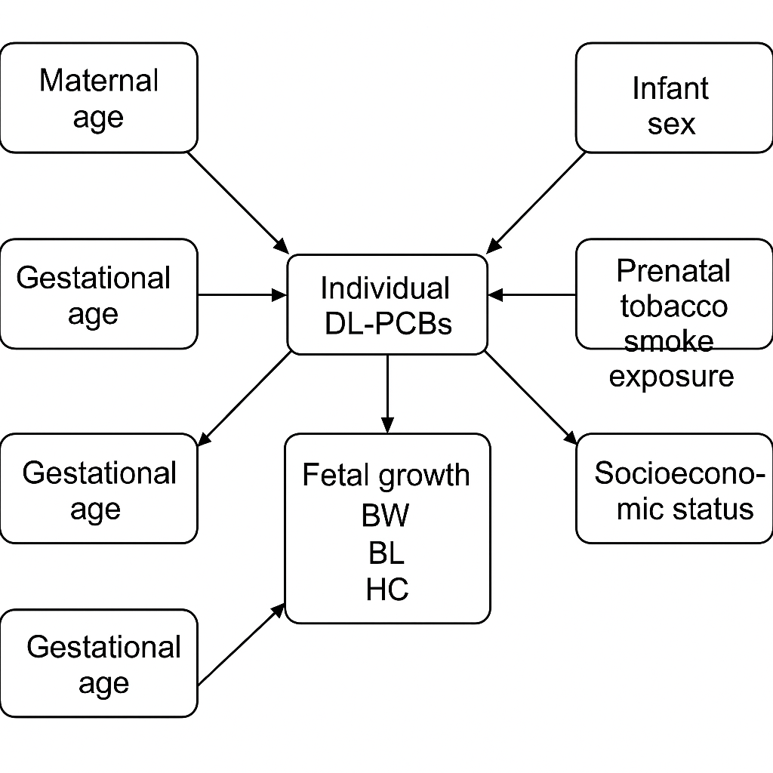
Fig S1. Directed Acyclic Graph (DAG) illustrating the hypothesized relationships between umbilical cord blood concentrations of dioxin-like polychlorinated biphenyls (DL-PCBs) and fetal growth indicators (birth weight, birth length, and head circumference). The DAG represents potential confounding variables adjusted in the multivariable linear regression models, including maternal age, pre-pregnancy BMI, parity, gestational age at delivery, infant sex, prenatal tobacco smoke exposure, and socioeconomic status (determined by maternal/paternal education and household income). Arrows indicate the assumed directional influences based on prior knowledge and biological plausibility.
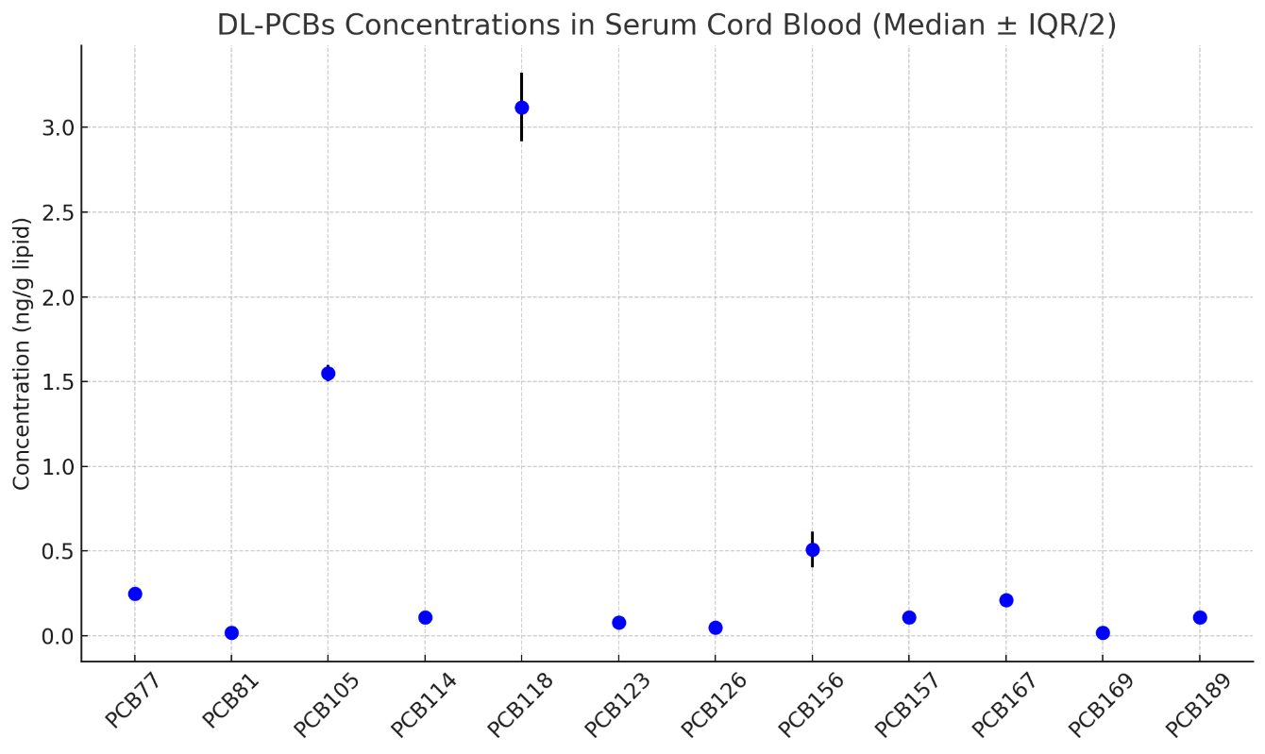
Figure S2. Descriptive statistics of umbilical cord blood concentrations of DL-PCB congeners.

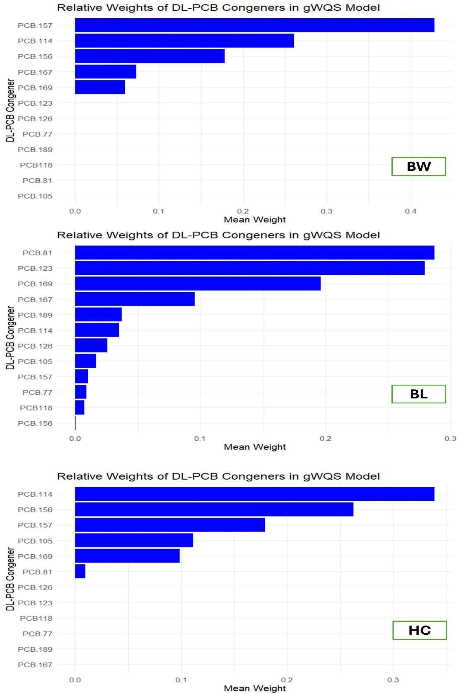
Figure S3. Relative weights of individual DL-PCB congeners in the gWQS regression model evaluating the association between umbilical cord blood DL-PCB mixture exposure and fetal growth indicators. The figure illustrates the contribution of each congener to the overall mixture effect on birth weight, birth length, and head circumference. Higher weights indicate a greater influence of the corresponding congener in the mixture model.

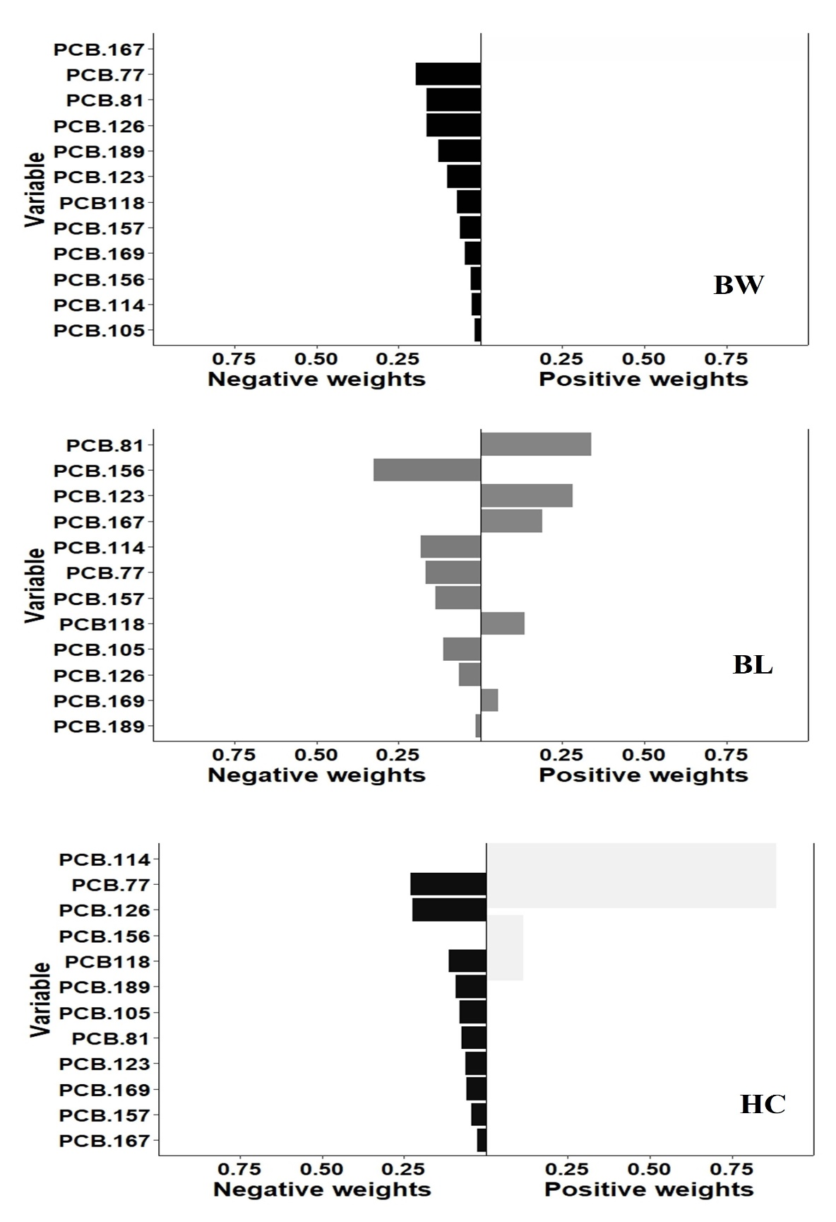
Figure S4. Component weights of individual DL-PCB congeners in the g-computation model for their association with fetal growth indicators. This figure displays the estimated weights reflecting the contribution of each congener to the cumulative mixture effect on birth weight, birth length, and head circumference. Positive and negative weights indicate the direction and magnitude of influence for each compound in the model.

