SUPPLEMENTAL MATERIALS

The assumption of a threshold is false in risk assessments for endocrine disrupting chemicals (EDCs) when endogenous hormones being disrupted are already above any possible threshold: A policy failure by the US FDA

Frederick S. vom Saal¹ and Wade V. Welshons²

¹Division of Biological Sciences
University of Missouri
Columbia MO 65211
vomsaalf@missouri.edu
+1 573-356-9621

²Department of Pathobiology and Integrative Biomedical Sciences
College of Veterinary Medicine
University of Missouri
Columbia MO 65211-5120
WelshonsW@missouri.edu
+1 573-673-0386

TABLE OF CONTENTS

Section 1: Derivation of Michaelis-Menten Equation with Modification for Background Dose
Section 2: Details of the Blair et al. [1] study and a summary figure showing the Blair et al. and Sheehan et al. [2] findings as well as the equations we used to calculate the dose-response curves presented in the figures.

SUPPLEMENTAL SECTION 1

Derivation of Michaelis-Menton (MM) Equations: Mathematical Basis for Rejection of the Threshold Assumption

MM Equation 1. The Michaelis-Menten equation as it applies to hormone-receptor binding, which also applies to EDCs that act via binding to hormone receptors.
Equation 1-A. Michaelis-Menten equation describing hormone (or EDC)-receptor interaction under equilibrium/steady state conditions.
[RH] = B_{max} * [H]
K_{d} + [H]

[RH] is the concentration of hormone bound to a specific receptor.
Bmax is the total number of a specific receptors present in the assay system, which determines the maximum binding of hormone to these receptors when all receptors are saturated (bound) with hormone.
[H] is the free (bioactive) hormone concentration that is not bound to a receptor or any other hormone-binding protein.
K_{d} is the dissociation constant of the binding reaction at steady state, which is also the hormone concentration at half-maximal binding, or the hormone concentration calculated using molarity, which is the amount of moles of a hormone per liter of solution that results in 50% of maximum receptor occupancy. The K_{d} is a physical-chemical constant that provides a measure of affinity of the hormone for the receptor. The dissociation constant K_{d} (units of M) is the reciprocal of the association (affinity; K_{a}) constant (units of 1/M); (K_{d} = 1/K_{a}). The K_{d} is typically used instead of the K_{a} to calculate hormone-receptor binding.

MM Equation 2. The mathematical basis for the use of the Michaelis-Menten equation to describe hormone-receptor interaction.
We start with the basic binding of a hormone to a receptor and progress to the Michaelis-Menten equation in logical steps. This involves derivation of the MM Equation 1-A equation used to describe hormone-receptor interaction based on the physical-chemical law of mass action. The mathematical solution is directed by the parts of the equation that can be measured experimentally, which was made possible of the creation of tritium-labeled hormones (allowing detection below picomolar concentrations) beginning in the middle of the last century. In endocrinology, the units used are molarity, describing molecular interactions.
Below we use the following terms:
[H] is the free (bioactive) hormone concentration that is not bound to a receptor.
[R] is the unbound concentration of receptor.
[RH] is the concentration of receptor that is bound by hormone.
When brackets are used, they denote concentrations.
B_{max} is the total number of a specific receptor present in the assay system, which determines the maximum binding of hormone to the receptors when all receptors are saturated (bound) with hormone.
K_{d} is the dissociation constant which is also the hormone concentration (calculated using molarity, which is the amount of moles of a hormone per liter of solution) that results in 50% of maximum receptor occupancy.

Equation 2-A. Reversible binding of a hormone (H) to its unoccupied receptor (R) is what allows receptor-mediated mechanisms to reflect both increases and decreases in circulating hormones in normal physiological processes. This is described by a specific physical chemical interaction, known as the law of mass action, and is a function of the kinetics of binding and dissociation. RH is the product of the interaction of H and R. The rate of dissociation of the RH complex to R + H is measurable as the off rate or k_{off}, a constant fraction of the RH per unit time, while the separate rate of association, R + H to the RH complex, the on rate or k_{on}, is determined by the concentration of the reactants and increases with R and H concentrations, or the reaction rate. The ratio of these rates, k_{off}/k_{on}, gives the steady state dissociation constant K_{d}. This constant applies to a system where the solutions are in a dynamic state of equilibrium, that is, concentrations of each such that the rate of association of R + H is equal to the rate of dissociation of the RH complex.
R + H ⇌ RH
k_{on}
k_{off}

Equation 2-B. Here we show the opposite (dissociation) of the equation shown in Equation 2-A. The math of the dissociation reaction is the reverse of the binding equation (Equation 2-A). The dissociation reaction is also exactly equally reversible. There is a reduction in bound or occupied receptors (and therefore a reduction in occupied receptor-mediated response) when the circulating hormone (or an EDC) concentration decreases.
RH ⇌ R + H

Equation 2-C. The physical-chemical constant for Equation 2-B relationship is called the K_{d} or “equilibrium dissociation constant”. The mathematical description of this relationship is also defined by “The Law of Mass Action”, and it describes what the concentrations of the reactants are when the system is at or near equilibrium. The K_{d} is equal to the concentration of unbound receptors [R] times the concentration of free (bioactive) hormone [H], divided by the concentration of the hormone bound to receptors [RH]. The square brackets are used to indicate concentration, which for hormones and receptors are molecule to molecule using molarity (M or Moles/Liter) rather than the masses of the different compounds.
K_{d} ₌ [R] * [H]
[RH]

The K_{d} is thus the most useful parameter that provides a valuable metric for comparing the affinity of different compounds for a specific receptor. Since for small molecules reaching the receptor, the on rate is largely determined by diffusion, which is similar for molecules of similar molecular weight that are able to be bound by the receptor. The K_{d} is more a function of the off rate, the k_{off} usually having the greater impact on the K_{d}. The longer and more tightly the hormone or EDC remains bound to the receptor, the higher the affinity and the lower the concentration of hormone or EDC required to produce an effect.
For example, for the endogenous estrogen, estradiol, binding to its first identified nuclear receptor (ERα), the off rate at the typical very low physiological hormone concentrations in women is much slower than the on rate; the off rate at body temperature (37ºC) may be, for example, around ~10-15 minutes in some systems, while the concentration-dependent on rate is faster (as one approaches equilibrium/steady state). The disassociation constant is the unit commonly used because it is easily understood and therefore more conveniently used in the mathematical equation that describes hormone-receptor binding kinetics.

Equation 2-D. The concentration of unoccupied receptor [R] is difficult to measure due to the absence of available radiolabeled forms (which are available for hormones). However, [R] can be taken out of the equation by substitution, because it is equal to the maximum amount of receptor [B_{max}] in the assay system minus the concentration of receptor that is actually occupied by a hormone that is radiolabeled and therefore measurable. Tritium has a sufficiently high specific activity for this purpose in practice. Tritium is a radioactive isotope of hydrogen that is substituted for some of the abundant hydrogen atoms (³H) in the hormone that is then able to be measured in a liquid scintillation counter when it is bound to a receptor [RH] by separation from the unbound radioactive hormone. This allows detection of the hormone-receptor complex. The ability to detect trace (below a picogram) an amount of tritium-labeled hormone is important because hormones work at very low concentrations that would otherwise be all but unmeasurable in a routine assay. The substitution that this permits is below:

[R] = [B_{max}] - [RH]
[RH] is measured by the binding of the radiolabeled hormone, and B_{max} can be estimated from the binding profile’s approach to its maximum.

Equation 2-E. Since K_{d} = [R] * [H] / [RH], based on Equation 2-C above, here [B_{max}] - [RH] is substituted for [R], which is removed because it is not easily measured experimentally.
K_{d} = (B_{max} - [RH]) * [H]
[RH]

Equation 2-F. This equation can be rearranged as below, and is the same as Equation 2-E, except that the [RH] in the denominator is moved by multiplication to the left side of the equation
K_{d} * [RH] = (B_{max} – [RH]) * [H]

Equation 2-G. On the right side of the equation, the [H] is distributed within the parentheses to yield B_{max} and [RH], each multiplied by [H].
K_{d} * [RH] = B_{max} * [H] – [RH] * [H]

Equation 2-H. Terms with the occupied receptor [RH] in Equation 2-G above are collected to the left side of the equation; [RH] * [H] is moved to the left side of the equation as + [RH] * [H].
K_{d} * [RH] + [RH] * [H] = B_{max} * [H]

Equation 2-I. The [RH] is rearranged in the left side of Equation 2-H to [RH] * (K_{d} + [H]).
[RH] * (K_{d} + [H]) = B_{max} * [H]

Equation 2-J. By dividing both sides of Equation 2-I by (K_{d} + [H]), the denominator on the right side of the equation yields an equation that solves for the concentration of receptor occupied by hormone [RH] (the biologically active initiator of response to the hormone), again assuming that the hormone is radiolabeled and thus able to be detected by measuring the radioactivity, and based on specific activity, converted to hormone concentration.
[RH] = B_{max} * [H]
K_{d} + [H]

Equation 2-J is the Michaelis-Menten equation when applied to a hormone binding to a receptor at equilibrium, and [RH] is the concentration of hormone bound to receptor (see MM Equation 1-A).

MM Equation 3. Methods to assess the biological response to the hormone, where the response is a function of (proportional to) the concentration of occupied receptors [HR] within a target cell.
This information contrasts with what is presented in MM Equation 2 that provides information regarding the interaction between a hormone and a receptor for that hormone but does not quantify the biological response that occurs. However, it is understood that the response that results from a hormone binding to a receptor is a function of the number of the receptors available in a target cell.

A difference between MM Equation 2, in which hormone concentration is shown as [H], is that here we use dose (D) for consistency with the figures from experiments that involved administration of a dose of a hormone or EDC. The same equation has been found to fit data showing effects of administration of EDCs that act additively with an endogenous hormone (Sheehan et al. 2006). The field of toxicokinetics/pharmacokinetics involves the complex set of events from administration, absorption, distribution, metabolism, clearance to elimination of an administered dose of a chemical, which will not be addressed here.

Equation 3-A. This equation identifies that the Biological Response (Resp) is a function of the dose (D) of an administered compound that is bound to receptors (R) within target cells.
Resp = f([RD])

Equation 3-B. Here we present the equation used to identify the response to a hormone or EDC as a result of exposure to a measured dose. We identify that the method used to calculate the biological response is essentially the same as the Michaelis-Menten equation in MM Equation 1, and the shape of the curves is typically parallel at low, physiologically relevant doses. ED_{max} requires administration of a dose (D) of a hormonally active compound that occupies all available receptors in generating the response.
Response = ED_{max} * D
ED₅₀ + D

D is the administered dose of a hormone or hormonally active compound.
ED_{max} is the maximum effective dose (ED) after administration of a dose of a hormonally active compound.
ED₅₀ is referred to as the effective dose that results in 50% of the maximum response.
* = multiplication.

Equation 3-C. The total dose (D_{T}) involves consideration of the endogenous (background) dose (D₀) of a hormone that exists in the negative control group (zero EDC dose), which is not taken into account in Equation 3-B. In contrast, Equation 3-C takes this into account in calculating the total exposure (D_{T}) of the experimental group being administered a dose of a hormone-mimicking chemical (i.e., EDC) that acts additively with the background endogenous dose of a hormone (D₀) that acts through the same receptor as the EDC being administered (here we are not including any non-hormonal interference with the system).
D_{T} = D₀ + D
D_{T} = Total combined dose of endogenous hormone and a mechanistically related EDC that binds to the same receptor as an endogenous hormone.
D₀ = Endogenous background dose of hormone that the EDC mimics or antagonizes.
D = Administered dose of a hormone or an EDC that mimics or antagonizes the activity of an endogenous hormone.

Equation 3-D. Here we modify Equation 3-B to consider the endogenous concentration of the hormone [D₀] being added to by administration of an exogenous EDC (D) that acts through the same receptor as the endogenous hormone. We thus add D₀ to the equation in order to calculate the total dose as opposed to just the exogenous administered dose.
Response = ED_{max} * [D + D₀]
ED₅₀ + [D + D₀]

Note that the addition of an endogenous background dose of EDC [D₀] will result in an increase in the calculation of both response and the ED₅₀.

Equation 3-E. The addition of the endogenous hormonal (D₀) dose to the dose on the X axis, and background non-hormonal factors (Bnh) to the response (R) on the Y axis created a fully modified Michaelis-Menten equation, which was required for the best statistically supported fit for each of the 26 data sets in the Blair et al. study (Blair et al. 2001), but not the data from Sheehan et al. (Sheehan et al. 1999) where endogenous estradiol explained all of the background activity impacting turtle sex determination.

Response = R_{max} * [D + D₀] + Bnh
ED₅₀ + [D + D₀]

SUPPLEMENTAL SECTION 2: BLAIR ET AL (2001) AND SHEEHAN ET AL (1999) STUDY DETAILS AND A SUMMARY FIGURE S1 AND EQUATIONS TABLE S1

Blair et al. [1] followed up on the experimental study by Sheehan et al. [2]. Blair et al. integrated data from 26 separate studies that examined 24 different endpoints from 9 different chemical/hormone treatments, all of which were EDCs. An inclusion criterion was that the study examined more than 3 doses of a chemical administered to animals (range was 4 – 10 doses) in order to have sufficient data to apply the Michaelis-Menten equation (Section 1; MM Equation 3). Since these data were from separate experiments with different units and scales, both X and Y variables were normalized. The X axis dose values were normalized to 0 to 10 arbitrary dose units, and the Y axis values were normalized to 0 to 1.5 arbitrary response units (Figure S1).
In order to plot the 178 data points from 26 different studies (Figure S1), Blair et al. identified the administered dose in each study that resulted in 50% of the maximum response (ED₅₀) as well as the dose that resulted in the maximum response in each experiment (ED_{max}). Because the dose had been established on a 0 – 10 scale, the Michaelis-Menten equation could be applied to the data sets after the equation was modified to take into account the total dose by addition of the background dose to the equation (Section 1; MM Equation 3).
The results from the study by Blair et al clearly demonstrated that the background hormonal activity had to be taken into account in applying the Michaelis-Menten equation to the data. Adding the background hormonal and any other nonhormonal factor to the administered EDC dose resulted in the data plotting to zero dose and zero response (Figure S1). The data in both Blair et al. and Sheehan et al. are thus consistent with Michaelis-Menten kinetics and are not consistent with the existence of a threshold for the chemicals examined in any of these studies. The endpoints in the 26 studies examined by Blair et al. included both physiological responses: uterine weight, liver weight, plasma prolactin levels and cell proliferation, and adverse responses, such as presence of vaginal threads, nephropathy lesions, and adenomas.
In these 26 experiments the data from each study were analyzed to determine whether the data fit the Michaelis-Menton equation using non-linear regression. For all data sets, the fitted model intersected the response (Y axis) above zero dose. The data fit the Michaelis-Menten equation with a range of r = 0.811 – 0. 999 in the Blair et al study (Figure S1). Thus, all 26 data sets closely followed the Michaelis-Menten model. However, in every case the zero response only occurred at a point on the X axis below zero dose, similar to findings reported in the Sheehan et al. study. These findings show that a response was already occurring in the absence of administration of the experimental chemical.
We show in Figure S1 graphical representations based on the approach used by Sheehan et al. and Blair et al. that fit their data to the Michaelis-Menten equation for hormone-receptor binding (Section 1: MM Equation 3). Importantly, a response occurred (Figure S1-A) in the controls in the absence of administration of the experimental chemical. The three steps shown in Figure S1 should serve as a guide for those conducting experiments with EDCs where the initial dose-response curve (Figure S1-A) shows that a positive response on the Y axis is occurring when the administered dose (X axis) is zero.

Figure S1
Panel A. This is a graphical representation of the data from the Sheehan et al. experiment where the dose-response curve intersected the response (Y) axis above zero administered dose (X axis) in the negative control animals. Panel B. The complete dose-response curve plotted to intersect the X axis below the zero administered dose (D) based on fitting the data to the Michaelis-Menten equation. Panel C. Adding background hormonal dose (D₀) to calculate the total dose (D_{T} = D + D₀) term in the Michaelis-Menten equation, resulted in the dose-response curve being shifted to the right, resulting in intersection of the X and Y axis at zero dose and zero response (See Section 1; MM Equation 3-D for further explanation).

Figure S1
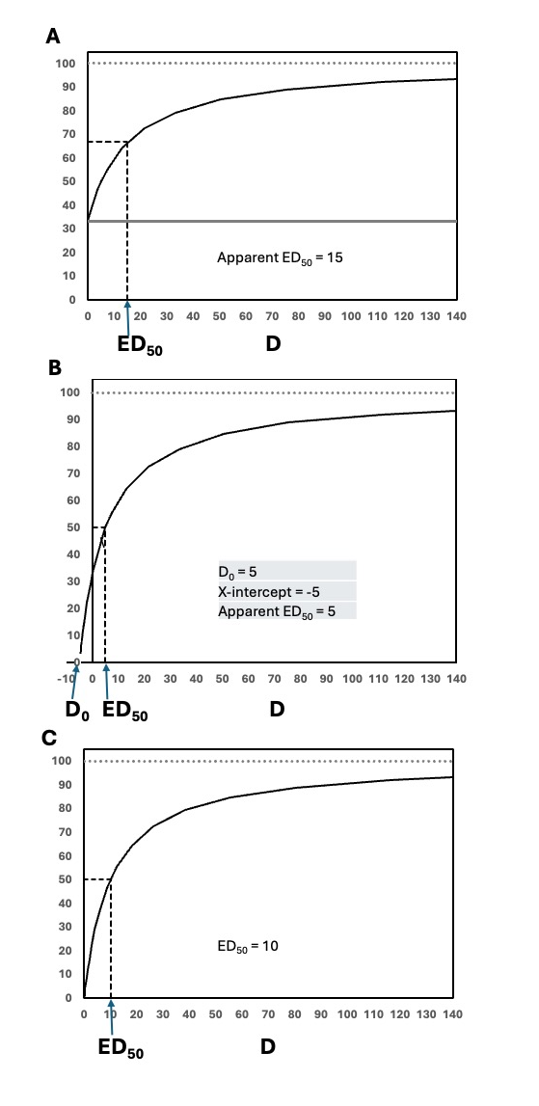

Table S1: Equations Used to Calculate the Plots in Figure S1 (these are in arbitrary units)
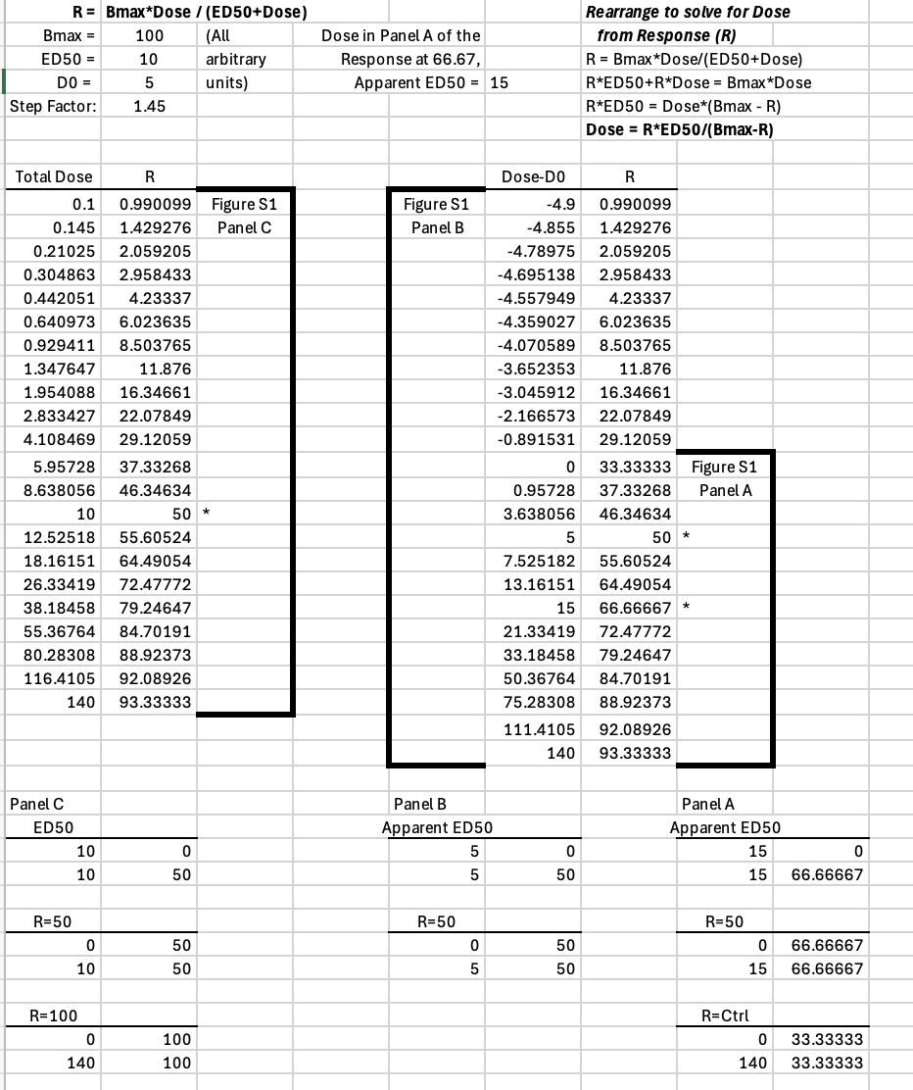

References

1. Blair RM, Fang H, Gaylor D, Sheehan DM: Threshold analysis of selected dose-response data for endocrine active chemicals. APMIS 2001, 109(3):198-208.
2. Sheehan DM, Willingham E, Gaylor D, Bergeron JM, Crews D: No threshold dose for estradiol-induced sex reversal of turtle embryos: how little is too much? Environ Health Perspect 1999, 107(2):155-159.

