Supplemental Material
Chemical mixtures and birth weight: comparison of multipollutant models in the Maternal-Infant Research on Environmental Chemicals (MIREC) Study

Table of contents:

Figure S1. Directed Acyclic Graph for first trimester chemicals and infant birth weight  Table S1. Distribution of first trimester EDC concentrations  Table S2. Distribution of first trimester EDC concentrations not included in our sample  Figure S2. Pearson correlation matrix for first trimester log-transformed maternal EDCs  Figure S3. The weights based on weighted quantile sum regression (WQSR) in the negative direction with birth weight z-score.  Figure S4. The weights based on weighted quantile sum regression (WQSR) in the positive direction with birth weight z-score.  Table S3: BKMR group and conditional Posterior Inclusion Probabilities (PIPs) and effect estimates (95% CIs) | p. 2  p. 2  p. 4  p. 6  p. 8  p. 10  p. 12

Figure S1. Directed Acyclic Graph for trimester 1 EDCs and infant birthweight 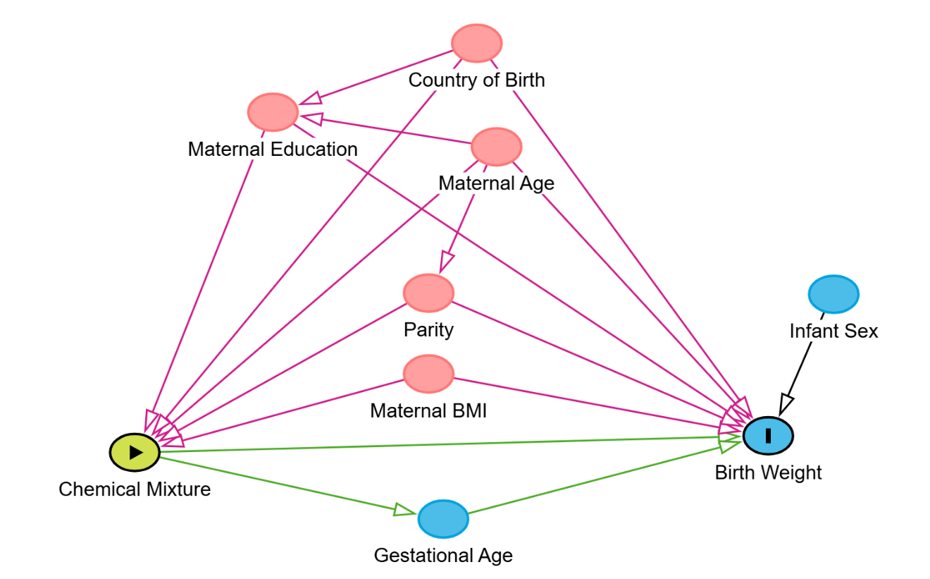

Table S1. Distribution of first trimester EDC concentrations (N = 1127)
Chemical Group | Chemical ¹ | Units | LOD | % > LOD | Min | 25th Percentile | 50th Percentile | 75th Percentile | Max | Geometric Mean (95% CI)
Arsenic³ | DMAA | μg/L | 0.75 | 86.87 | <LOD | 1.669 | 2.411 | 3.942 | 44.14 | 2.69 (2.59, 2.8)
Bisphenol analogues² | BP44 | μg/L | 0.01 | 99.47 | <LOD | 0.206 | 0.295 | 0.451 | 93.79 | 0.32 (0.3, 0.33)
Bisphenol analogues² | BPE | μg/L | 0.002 | 97.87 | <LOD | 0.015 | 0.023 | 0.037 | 4.70 | 0.02 (0.02, 0.03)
Bisphenol analogues² | BPF | μg/L | 0.03 | 72.94 | <LOD | 0.025 | 0.076 | 0.211 | 112.84 | 0.05 (0.04, 0.06)
Bisphenol analogues² | BPS | μg/L | 0.06 | 69.83 | <LOD | 0.059 | 0.117 | 0.266 | 18.61 | 0.11 (0.1, 0.12)
Bisphenol analogues² | DHDPE | μg/L | 0.04 | 99.29 | 0.056 | 0.298 | 0.489 | 0.912 | 49.77 | 0.56 (0.53, 0.59)
Herbicides² | AMPA | μg/L | 0.09 | 73.47 | <LOD | 0.112 | 0.210 | 0.385 | 6.14 | 0.16 (0.15, 0.18)
Herbicides² | GLYP | μg/L | 0.08 | 75.07 | <LOD | 0.120 | 0.250 | 0.474 | 3.91 | 0.11 (0.1, 0.13)
Metals³ | As | μg/L | 0.22 | 92.28 | <LOD | 0.509 | 0.749 | 1.124 | 34.46 | 0.75 (0.72, 0.78)
Metals³ | Cd | μg/L | 0.04 | 97.60 | <LOD | 0.135 | 0.202 | 0.315 | 4.50 | 0.22 (0.21, 0.23)
Metals³ | Hg | μg/L | 0.12 | 89.88 | <LOD | 0.341 | 0.722 | 1.404 | 9.43 | 0.63 (0.6, 0.67)
Metals³ | Mn | μg/L | 0.55 | 100.00 | 2.143 | 7.143 | 8.791 | 10.989 | 28.57 | 8.77 (8.61, 8.94)
Metals³ | Pb | μg/dL | 0.1 | 100.00 | 0.155 | 0.435 | 0.622 | 0.850 | 4.14 | 0.62 (0.61, 0.64)
OrganoChlorines³ | ΣOC Chlordane | μg/kg lipids | NA | NA | 2.578 | 5.829 | 7.483 | 9.857 | 48.00 | 7.72 (7.55, 7.91)
OrganoChlorines³ | ΣOC Insecticides | μg/kg lipids | NA | NA | 18.424 | 50.663 | 67.663 | 97.640 | 5919.01 | 78.44 (75.23, 81.78)
OPFRs² | BDCliPrP | µg/L | 0.05 | 89.26 | <LOD | 0.159 | 0.311 | 0.602 | 22.19 | 0.29 (0.27, 0.32)
OPFRs² | DBP | µg/L | 0.05 | 69.03 | <LOD | <LOD | 0.073 | 0.129 | 22.72 | 0.08 (0.07, 0.08)
OPFRs² | tb_DPhP | µg/L | 0.008 | 62.02 | <LOD | <LOD | 0.014 | 0.024 | 0.55 | 0.01 (0.01, 0.01)
OPFRs² | ΣTCiPP | nmol/L | NA | NA | 0.011 | 0.855 | 1.598 | 3.398 | 567.83 | 1.77 (1.64, 1.9)
OPFRs² | ΣTCrP | nmol/L | NA | NA | 0.000 | 0.001 | 0.013 | 0.041 | 1.26 | 0.01 (0.01, 0.01)
OPFRs² | ΣTECP | nmol/L | NA | NA | 0.001 | 0.654 | 1.170 | 2.475 | 166.74 | 1.31 (1.23, 1.4)
OPFRs² | ΣTPhP | nmol/L | NA | NA | 0.006 | 1.556 | 2.684 | 4.939 | 596.81 | 2.78 (2.6, 2.98)
OPs³ | ΣDEAP | nmol/L | NA | NA | 3.627 | 15.111 | 24.125 | 39.658 | 13666.76 | 25.08 (24.01, 26.21)
OPs³ | ΣDMAP | nmol/L | NA | NA | 5.168 | 32.300 | 63.674 | 123.316 | 1863.73 | 64 (60.37, 67.85)
PBDEs³ | ΣPBDE | μg/kg lipids | NA | NA | 12.602 | 31.460 | 38.082 | 50.519 | 1780.36 | 42.62 (41.43, 43.85)
PCBs³ | Aroclor 1260 | μg/kg lipids | 0.1 | 98.14 | 8.951 | 38.710 | 60.000 | 95.313 | 1183.33 | 63.71 (61.08, 66.46)
PCBs³ | PCB170 | μg/kg lipids | 0.01 | 55.72 | 0.442 | 1.219 | 1.725 | 3.016 | 71.67 | 2.08 (2, 2.17)
PCBs³ | PCB180 | μg/kg lipids | 0.01 | 93.70 | 0.842 | 3.036 | 4.918 | 8.148 | 183.33 | 5.21 (4.97, 5.47)
PCBs³ | ΣPCB | μg/kg lipids | NA | NA | 1.768 | 5.143 | 6.110 | 7.678 | 58.28 | 6.57 (6.42, 6.71)
PFAS³ | PFHxS | μg/L | 0.22 | 96.01 | <LOD | 0.660 | 1.000 | 1.600 | 25.00 | 1.05 (1, 1.1)
PFAS³ | PFOA | μg/L | 0.1 | 99.82 | <LOD | 1.200 | 1.700 | 2.500 | 16.00 | 1.7 (1.65, 1.76)
PFAS³ | PFOS | μg/L | 0.34 | 99.91 | <LOD | <LOD | 4.700 | 6.800 | 32.00 | 4.58 (4.43, 4.74)
Phenols³ | BPA | μg/L | 0.47 | 88.20 | <LOD | 0.494 | 0.884 | 1.473 | 79.13 | 0.95 (0.9, 1.01)
Phenols² | TCS | μg/L | 0.12 | 99.47 | <LOD | 2.586 | 9.670 | 114.800 | 1980.43 | 15.33 (13.48, 17.44)
Phthalates² | MBzP | µg/L | 0.1, 0.4 | 95.39 | <LOD | 1.579 | 3.110 | 6.860 | 476.97 | 3.24 (3.03, 3.46)
Phthalates² | MCPP | µg/L | 0.1 | 87.84 | <LOD | 0.413 | 0.714 | 1.280 | 159.99 | 0.72 (0.67, 0.78)
Phthalates² | MEP | µg/L | 0.8, 1.0 | 99.02 | <LOD | 11.562 | 25.079 | 65.864 | 8599.57 | 29.3 (26.76, 32.09)
Phthalates² | MMP | µg/L | 0.2 | 96.18 | <LOD | 1.193 | 1.780 | 2.765 | 424.88 | 1.73 (1.63, 1.83)
Phthalates² | ΣDEHP | nmol/L | NA | NA | 4.073 | 40.765 | 69.093 | 115.135 | 5861.48 | 72.74 (68.89, 76.8)
Phthalates² | ΣDiBP | nmol/L | NA | NA | 0.621 | 24.407 | 41.855 | 69.007 | 1043.50 | 40.8 (38.92, 42.78)
Phthalates² | ΣDiDP | nmol/L | NA | NA | 0.002 | 1.594 | 2.696 | 5.035 | 353.41 | 2.46 (2.26, 2.69)
Phthalates² | ΣDiNP | nmol/L | NA | NA | 0.019 | 4.252 | 8.409 | 21.553 | 3651.57 | 9.72 (8.92, 10.59)
Phthalates² | ΣDnBP | nmol/L | NA | NA | 0.021 | 23.464 | 45.215 | 78.118 | 146505.67 | 42.9 (40.21, 45.77)
Solvents² | ΣNEP | µmol/L | NA | NA | 0.005 | 1.177 | 13.005 | 288.946 | 12588.17 | 11.24 (8.97, 14.07)
Tobacco Metabolite³ | Cotinine | ng/ml | 0.37 | 53.06 | <LOD | <LOD | <LOD | 0.200 | 290.00 | 0.03 (0.02, 0.03)
Flouride² | FLD | µg/mL | 0.02 | NA | <LOD | 0.183 | 0.338 | 0.565 | 7.25 | 0.3 (0.28, 0.32)
¹ The full chemical names are in Table 1.
² Machine readings were available for results below the limit of detection.
³ Results below the limit of detection (LOD) were replaced by LOD/√2.
Urinary chemical concentrations were specific gravity standardized. PolyBrominated Diphenyl Ethers (PBDEs), PolyChlorinated Biphenyls (PCBs) and OrganoChlorine compounds (OCs) were lipid standardized.

Table S2. Distribution of first trimester EDC concentrations not included in our sample (N = 733)

Chemical Group | Chemical ¹ | Units | n | LOD | % > LOD | Min | 25th Percentile | 50th Percentile | 75th Percentile | Max | Geometric Mean (95% CI)
Arsenic³ | DMAA | μg/L | 684 | 0.75 | 83.48 | <LOD | 1.62 | 2.40 | 3.61 | 38.07 | 2.69 (2.59, 2.8)
Bisphenol analogues² | BP44 | μg/L | 603 | 0.01 | 100.00 | 0.05 | 0.19 | 0.29 | 0.47 | 26.57 | 0.32 (0.3, 0.33)
Bisphenol analogues² | BPE | μg/L | 609 | 0.002 | 96.55 | <LOD | 0.01 | 0.02 | 0.04 | 0.98 | 0.02 (0.02, 0.03)
Bisphenol analogues² | BPF | μg/L | 606 | 0.03 | 69.47 | <LOD | <LOD | 0.08 | 0.25 | 806.91 | 0.05 (0.04, 0.06)
Bisphenol analogues² | BPS | μg/L | 585 | 0.06 | 65.81 | <LOD | 0.06 | 0.11 | 0.24 | 9.71 | 0.11 (0.1, 0.12)
Bisphenol analogues² | DHDPE | μg/L | 593 | 0.04 | 97.13 | 0.04 | 0.28 | 0.51 | 1.00 | 261.44 | 0.56 (0.53, 0.59)
Herbicides² | AMPA | μg/L | 605 | 0.09 | 68.43 | <LOD | 0.11 | 0.21 | 0.38 | 2.58 | 0.16 (0.15, 0.18)
Herbicides² | GLYP | μg/L | 587 | 0.08 | 70.70 | <LOD | 0.11 | 0.24 | 0.44 | 3.41 | 0.11 (0.1, 0.13)
Metals³ | As | μg/L | 694 | 0.22 | 93.37 | <LOD | 0.52 | 0.82 | 1.20 | 14.23 | 0.75 (0.72, 0.78)
Metals³ | Cd | μg/L | 694 | 0.04 | 96.69 | <LOD | 0.13 | 0.20 | 0.31 | 5.06 | 0.22 (0.21, 0.23)
Metals³ | Hg | μg/L | 694 | 0.12 | 91.50 | <LOD | 0.30 | 0.66 | 1.26 | 10.03 | 0.63 (0.6, 0.67)
Metals³ | Mn | μg/L | 694 | 0.55 | 100.00 | 2.03 | 7.14 | 8.79 | 10.99 | 29.12 | 8.77 (8.61, 8.94)
Metals³ | Pb | μg/dL | 694 | 0.1 | 100.00 | 0.18 | 0.44 | 0.60 | 0.83 | 3.52 | 0.62 (0.61, 0.64)
OrganoChlorines³ | ΣOC Chlordane | μg/kg lipids | 689 | NA | NA | 2.25 | 5.47 | 7.12 | 9.23 | 27.93 | 7.21 (7.01, 7.42)
OrganoChlorines³ | ΣOC Insecticides | μg/kg lipids | 689 | NA | NA | 20.90 | 46.20 | 62.86 | 91.58 | 2751.48 | 73.91 (69.86, 78.19)
OPFRs² | BDCliPrP | µg/L | 579 | 0.05 | 88.08 | <LOD | 0.16 | 0.32 | 0.65 | 19.40 | 0.31 (0.28, 0.34)
OPFRs² | DBP | µg/L | 608 | 0.05 | 65.63 | <LOD | 0.05 | 0.07 | 0.12 | 2.40 | 0.08 (0.07, 0.08)
OPFRs² | tb_DPhP | µg/L | 526 | 0.008 | 51.14 | <LOD | <LOD | 0.01 | 0.02 | 0.48 | 0.01 (0, 0.01)
OPFRs² | ΣTCiPP | nmol/L | 621 | NA | NA | 0.05 | 0.78 | 1.58 | 3.72 | 240.57 | 1.75 (1.58, 1.94)
OPFRs² | ΣTCrP | nmol/L | 621 | NA | NA | 0.00 | 0.00 | 0.01 | 0.04 | 2.10 | 0.01 (0.01, 0.01)
OPFRs² | ΣTECP | nmol/L | 621 | NA | NA | 0.00 | 0.66 | 1.25 | 2.61 | 134.35 | 1.27 (1.14, 1.41)
OPFRs² | ΣTPhP | nmol/L | 621 | NA | NA | 0.00 | 1.47 | 2.60 | 4.99 | 116.71 | 2.61 (2.37, 2.86)
OPs³ | ΣDEAP | nmol/L | 684 | NA | NA | 4.32 | 15.11 | 23.19 | 36.33 | 292.05 | 24.24 (22.95, 25.6)
OPs³ | ΣDMAP | nmol/L | 684 | NA | NA | 4.04 | 27.98 | 59.02 | 128.14 | 1309.95 | 61.2 (56.53, 66.26)
PBDEs³ | ΣPBDE | μg/kg lipids | 682 | NA | NA | 17.69 | 31.39 | 37.70 | 49.28 | 571.78 | 42.05 (40.6, 43.56)
PCBs³ | Aroclor 1260 | μg/kg lipids | 689 | 0.1 | 96.08 | 8.62 | 34.62 | 53.97 | 85.07 | 655.17 | 55.11 (52.22, 58.15)
PCBs³ | PCB170 | μg/kg lipids | 689 | 0.01 | 50.07 | 0.59 | 1.14 | 1.57 | 2.68 | 40.30 | 1.88 (1.79, 1.97)
PCBs³ | PCB180 | μg/kg lipids | 689 | 0.01 | 90.28 | 0.59 | 2.68 | 4.38 | 7.19 | 114.93 | 4.46 (4.21, 4.73)
PCBs³ | ΣPCB | μg/kg lipids | 689 | NA | NA | 2.36 | 4.96 | 5.86 | 7.19 | 47.69 | 6.18 (6.02, 6.35)
PFAS³ | PFHxS | μg/L | 695 | 0.22 | 95.97 | <LOD | 0.64 | 1.00 | 1.50 | 40.00 | 1.01 (0.95, 1.07)
PFAS³ | PFOA | μg/L | 695 | 0.1 | 99.86 | <LOD | 1.10 | 1.60 | 2.30 | 11.00 | 1.57 (1.5, 1.64)
PFAS³ | PFOS | μg/L | 695 | 0.34 | 99.71 | <LOD | 3.20 | 4.60 | 6.80 | 36.00 | 4.53 (4.34, 4.74)
Phenols³ | BPA | μg/L | 684 | 0.47 | 86.40 | <LOD | 0.50 | 0.82 | 1.51 | 204.29 | 0.92 (0.86, 0.99)
Phenols² | TCS | μg/L | 618 | 0.12 | 99.19 | <LOD | 2.52 | 7.90 | 67.63 | 4199.80 | 12.47 (10.55, 14.74)
Phthalates² | MBzP | µg/L | 599 | 0.1, 0.4 | 95.33 | <LOD | 1.46 | 2.96 | 6.61 | 238.21 | 3.2 (2.92, 3.52)
Phthalates² | MCPP | µg/L | 536 | 0.1 | 84.89 | <LOD | 0.41 | 0.74 | 1.30 | 60.86 | 0.7 (0.62, 0.79)
Phthalates² | MEP | µg/L | 629 | 0.8, 1.0 | 98.89 | 0.47 | 10.28 | 22.82 | 62.88 | 3545.22 | 27.6 (24.79, 30.72)
Phthalates² | MMP | µg/L | 551 | 0.2 | 94.19 | <LOD | 1.21 | 1.85 | 2.93 | 46.84 | 1.65 (1.5, 1.81)
Phthalates² | ΣDEHP | nmol/L | 635 | NA | NA | 5.82 | 37.01 | 62.25 | 104.13 | 3920.09 | 67.13 (62.58, 72)
Phthalates² | ΣDiBP | nmol/L | 633 | NA | NA | 2.45 | 22.51 | 38.78 | 66.69 | 1117.90 | 39.13 (36.63, 41.8)
Phthalates² | ΣDiDP | nmol/L | 635 | NA | NA | 0.00 | 1.63 | 2.73 | 4.83 | 1173.63 | 2.33 (2.05, 2.63)
Phthalates² | ΣDiNP | nmol/L | 635 | NA | NA | 0.05 | 3.60 | 8.10 | 16.90 | 1826.32 | 8.61 (7.7, 9.62)
Phthalates² | ΣDnBP | nmol/L | 626 | NA | NA | 0.03 | 22.54 | 42.05 | 77.90 | 3775.64 | 39.84 (36.55, 43.42)
Solvents² | ΣNEP | µmol/L | 621 | NA | NA | 0.00 | 0.24 | 9.45 | 350.92 | 17243.17 | 7.71 (5.56, 10.68)
Tobacco Metabolite³ | Cotinine | ng/ml | 695 | 0.37 | 55.40 | <LOD | <LOD | <LOD | <LOD | 290.00 | 0.03 (0.03, 0.04)
Flouride² | FLD | µg/mL | 630 | 0.02 | 100.00 | <LOD | 0.17 | 0.32 | 0.57 | 4.64 | 0.31 (0.28, 0.33)
¹ The full chemical names are in Table 1.
² Machine readings were available for results below the limit of detection.
³ Results below the limit of detection (LOD) were replaced by LOD/√2.
Urinary chemical concentrations were specific gravity standardized. PolyBrominated Diphenyl Ethers (PBDEs), PolyChlorinated Biphenyls (PCBs) and OrganoChlorine compounds (OCs) were lipid standardized.

Figure S2. Pearson correlation matrix for first trimester log-transformed maternal EDCs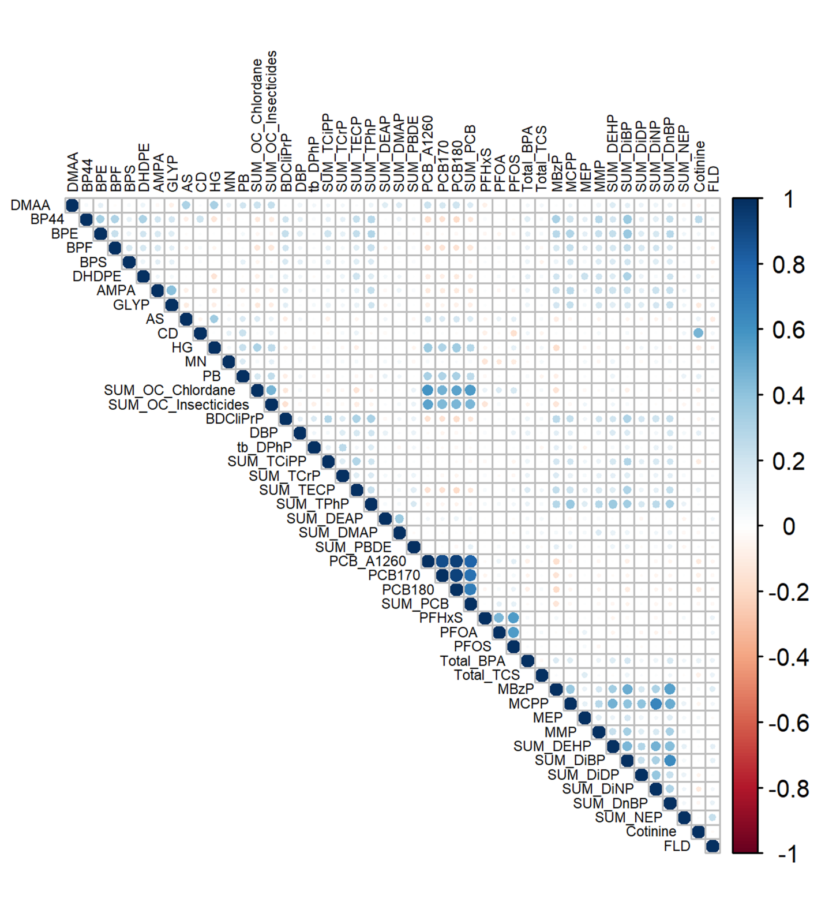

Figure S3. The weights based on weighted quantile sum regression (WQSR) in the negative direction with birth weight z-score. A: Overall sample; B: Male Infants; C: Female infants
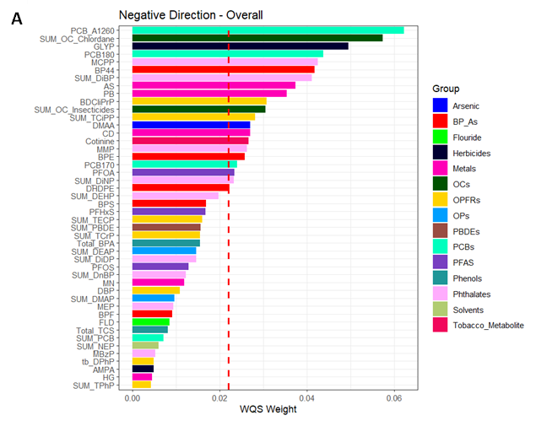
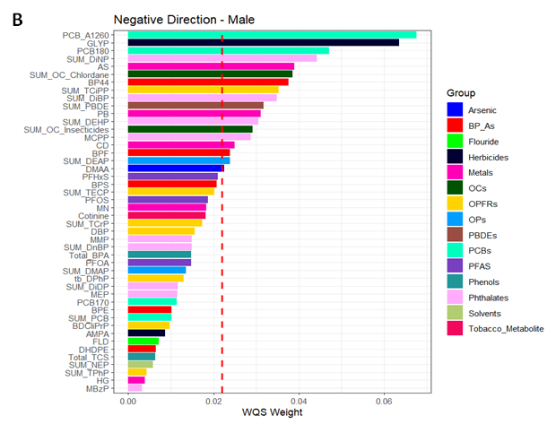
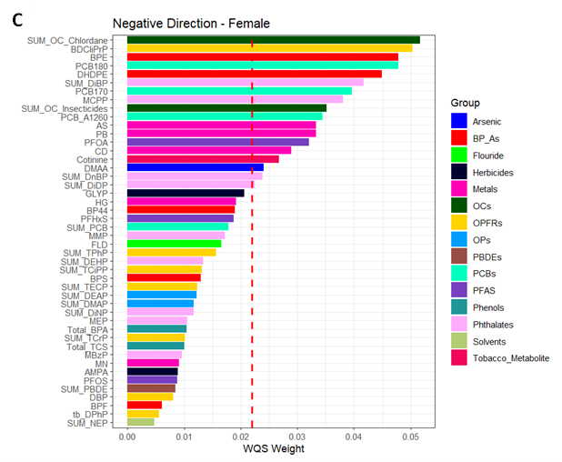

Figure S4. The weights based on weighted quantile sum regression (WQSR) in the positive direction with birth weight z-score. A: Overall sample; B: Male Infants; C: Female infants
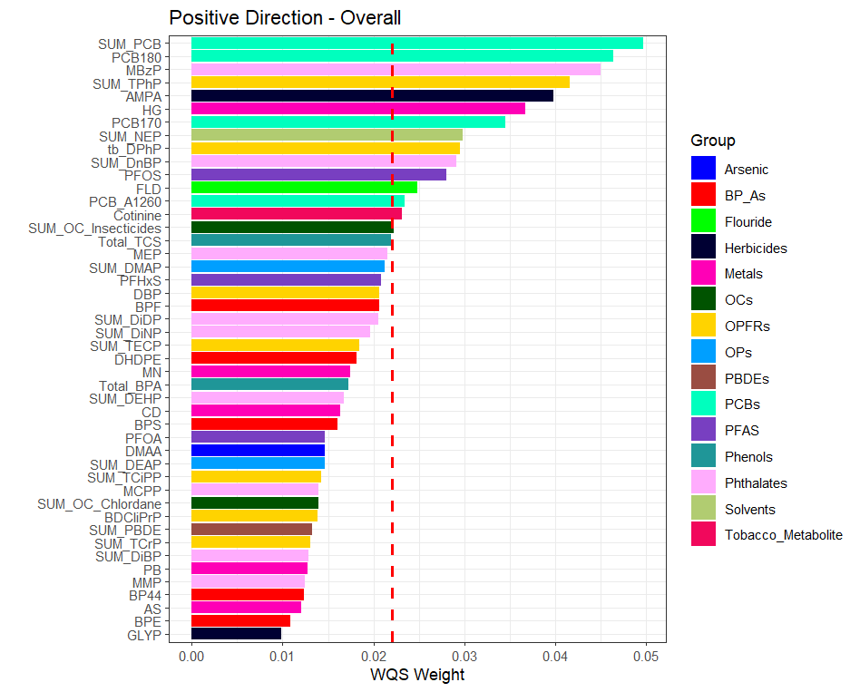
A

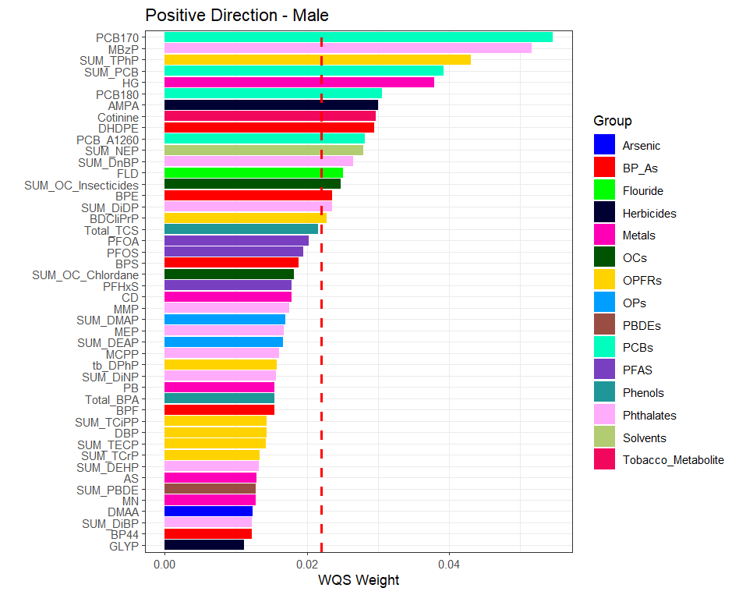
B

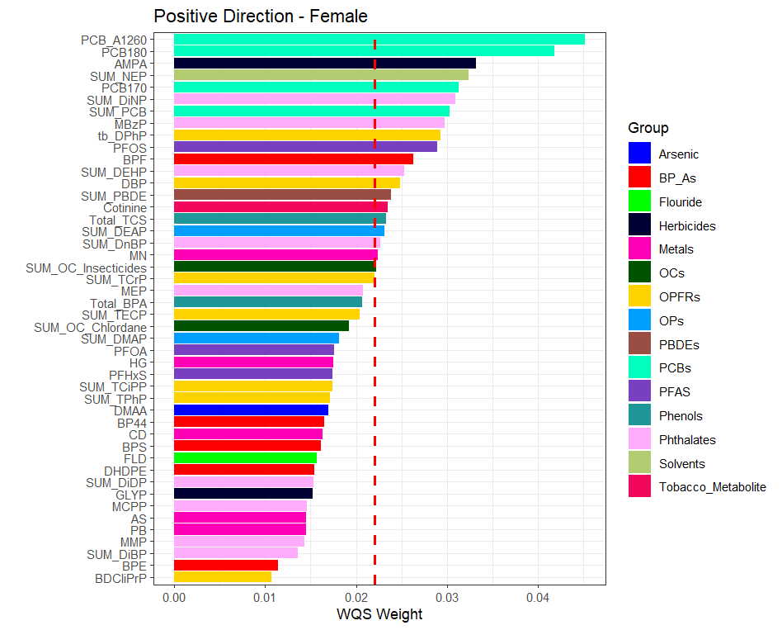
C

Table S3. BKMR group and conditional Posterior Inclusion Probabilities (PIPs) and effect estimates (95% CIs)
 |  | OVERALL (n=1127) |  |  | MALES (n =589) |  |  | FEMALES (n = 538)
Chemical Group | Chemical | Group PIP | Cond. PIP | Estimate¹ (95% CI) | Group PIP | Cond. PIP | Estimate¹ (95% CI) | Group PIP | Cond. PIP | Estimate¹ (95% CI)
Arsenic | DMAA | 0.206 | 1.000 | -0.038 (-0.128, 0.053) | 0.190 | 1.000 | -0.029 (-0.156, 0.099) | 0.321 | 1.000 | -0.064 (-0.224, 0.095)
Bisphenol analogues | BP44 | 0.141 | 0.323 | -0.046 (-0.115, 0.024) | 0.221 | 0.174 | -0.037 (-0.124, 0.05) | 0.447 | 0.117 | -0.02 (-0.117, 0.078)
Bisphenol analogues | BPE | 0.141 | 0.159 | -0.017 (-0.066, 0.031) | 0.221 | 0.127 | -0.005 (-0.071, 0.061) | 0.447 | 0.295 | -0.07 (-0.186, 0.046)
Bisphenol analogues | BPF | 0.141 | 0.106 | 0 (-0.036, 0.036) | 0.221 | 0.128 | -0.012 (-0.064, 0.04) | 0.447 | 0.108 | 0.021 (-0.056, 0.098)
Bisphenol analogues | BPS | 0.141 | 0.180 | -0.007 (-0.055, 0.041) | 0.221 | 0.358 | -0.032 (-0.112, 0.047) | 0.447 | 0.050 | 0 (-0.065, 0.066)
Bisphenol analogues | DHDPE | 0.141 | 0.232 | -0.017 (-0.083, 0.049) | 0.221 | 0.212 | 0.058 (-0.041, 0.157) | 0.447 | 0.430 | -0.148 (-0.314, 0.018)
Fluoride | FLD | 0.130 | 1.000 | 0.038 (-0.04, 0.116) | 0.357 | 1.000 | 0.124 (-0.014, 0.262) | 0.285 | 1.000 | -0.036 (-0.184, 0.111)
Herbicides | AMPA | 0.104 | 0.544 | 0.027 (-0.02, 0.073) | 0.284 | 0.301 | 0.036 (-0.033, 0.106) | 0.235 | 0.582 | 0.045 (-0.076, 0.165)
Herbicides | GLYP | 0.104 | 0.456 | -0.017 (-0.049, 0.014) | 0.284 | 0.699 | -0.057 (-0.126, 0.013) | 0.235 | 0.418 | -0.002 (-0.058, 0.054)
Metals | As | 0.173 | 0.110 | -0.024 (-0.08, 0.031) | 0.217 | 0.225 | -0.041 (-0.123, 0.041) | 0.271 | 0.141 | -0.016 (-0.11, 0.077)
Metals | Cd | 0.173 | 0.354 | -0.027 (-0.097, 0.043) | 0.217 | 0.245 | -0.038 (-0.155, 0.078) | 0.271 | 0.219 | -0.026 (-0.114, 0.063)
Metals | Hg | 0.173 | 0.068 | 0.027 (-0.036, 0.09) | 0.217 | 0.186 | 0.099 (-0.036, 0.235) | 0.271 | 0.160 | -0.001 (-0.116, 0.114)
Metals | Mn | 0.173 | 0.078 | 0.015 (-0.046, 0.075) | 0.217 | 0.135 | 0.006 (-0.082, 0.095) | 0.271 | 0.178 | 0.013 (-0.087, 0.113)
Metals | Pb | 0.173 | 0.390 | -0.053 (-0.144, 0.039) | 0.217 | 0.209 | -0.026 (-0.143, 0.09) | 0.271 | 0.302 | -0.066 (-0.199, 0.067)
OrganoChlorines | ΣOC Chlordane | 0.406 | 0.838 | -0.121 (-0.235, -0.007) | 0.254 | 0.552 | -0.082 (-0.243, 0.079) | 0.413 | 0.748 | -0.147 (-0.354, 0.06)
OrganoChlorines | ΣOC Insecticides | 0.406 | 0.162 | 0.005 (-0.06, 0.071) | 0.254 | 0.448 | -0.01 (-0.132, 0.111) | 0.413 | 0.252 | 0.013 (-0.105, 0.132)
OPFRs | BDCliPrP | 0.113 | 0.137 | -0.023 (-0.072, 0.027) | 0.272 | 0.058 | 0.008 (-0.055, 0.072) | 0.298 | 0.353 | -0.095 (-0.212, 0.021)
OPFRs | DBP | 0.113 | 0.135 | 0.003 (-0.048, 0.053) | 0.272 | 0.067 | -0.009 (-0.076, 0.058) | 0.298 | 0.109 | 0.03 (-0.052, 0.111)
OPFRs | tb_DPhP | 0.113 | 0.150 | 0.012 (-0.02, 0.043) | 0.272 | 0.120 | -0.012 (-0.072, 0.047) | 0.298 | 0.126 | 0.025 (-0.027, 0.077)
OPFRs | ΣTCiPP | 0.113 | 0.167 | -0.023 (-0.082, 0.035) | 0.272 | 0.128 | -0.024 (-0.105, 0.057) | 0.298 | 0.088 | -0.01 (-0.098, 0.079)
OPFRs | ΣTCrP | 0.113 | 0.099 | 0.022 (-0.058, 0.101) | 0.272 | 0.076 | -0.005 (-0.115, 0.104) | 0.298 | 0.158 | 0.084 (-0.072, 0.24)
OPFRs | ΣTECP | 0.113 | 0.043 | -0.002 (-0.044, 0.041) | 0.272 | 0.142 | -0.036 (-0.146, 0.074) | 0.298 | 0.077 | 0.013 (-0.053, 0.079)
OPFRs | ΣTPhP | 0.113 | 0.269 | 0.067 (0.006, 0.129) | 0.272 | 0.408 | 0.123 (0.016, 0.23) | 0.298 | 0.088 | 0.02 (-0.054, 0.094)
OPs | ΣDEAP | 0.097 | 0.486 | -0.02 (-0.098, 0.057) | 0.170 | 0.461 | -0.029 (-0.149, 0.09) | 0.222 | 0.451 | -0.025 (-0.159, 0.11)
OPs | ΣDMAP | 0.097 | 0.514 | 0.011 (-0.069, 0.092) | 0.170 | 0.539 | -0.011 (-0.125, 0.104) | 0.222 | 0.549 | 0.08 (-0.078, 0.238)
PBDEs | ΣPBDE | 0.085 | 1.000 | -0.007 (-0.066, 0.053) | 0.168 | 1.000 | -0.031 (-0.128, 0.066) | 0.221 | 1.000 | 0.048 (-0.061, 0.158)
PCBs | Aroclor 1260 | 0.170 | 0.245 | -0.023 (-0.145, 0.1) | 0.203 | 0.295 | -0.038 (-0.198, 0.121) | 0.303 | 0.214 | 0.002 (-0.295, 0.299)
PCBs | PCB170 | 0.170 | 0.233 | -0.013 (-0.13, 0.104) | 0.203 | 0.220 | 0.038 (-0.104, 0.179) | 0.303 | 0.254 | -0.031 (-0.192, 0.129)
PCBs | PCB180 | 0.170 | 0.245 | 0.006 (-0.11, 0.122) | 0.203 | 0.267 | -0.002 (-0.13, 0.126) | 0.303 | 0.224 | 0 (-0.172, 0.173)
PCBs | ΣPCB | 0.170 | 0.277 | 0.055 (-0.036, 0.145) | 0.203 | 0.217 | 0.044 (-0.048, 0.137) | 0.303 | 0.308 | 0.018 (-0.159, 0.194)
PFAS | PFHxS | 0.088 | 0.323 | 0.002 (-0.064, 0.067) | 0.175 | 0.406 | 0.012 (-0.098, 0.123) | 0.210 | 0.262 | 0 (-0.092, 0.093)
PFAS | PFOA | 0.088 | 0.341 | -0.012 (-0.087, 0.063) | 0.175 | 0.233 | -0.005 (-0.102, 0.093) | 0.210 | 0.427 | -0.014 (-0.147, 0.119)
PFAS | PFOS | 0.088 | 0.337 | 0.018 (-0.057, 0.092) | 0.175 | 0.362 | -0.002 (-0.114, 0.11) | 0.210 | 0.311 | 0.011 (-0.107, 0.129)
Phenols | BPA | 0.131 | 0.580 | -0.014 (-0.09, 0.062) | 0.170 | 0.476 | -0.007 (-0.111, 0.097) | 0.249 | 0.574 | -0.005 (-0.167, 0.157)
Phenols | TCS | 0.131 | 0.420 | 0.05 (-0.052, 0.153) | 0.170 | 0.524 | 0.049 (-0.095, 0.192) | 0.249 | 0.426 | 0.06 (-0.111, 0.231)
Phthalates | MBzP | 0.144 | 0.161 | 0.062 (-0.011, 0.135) | 0.276 | 0.316 | 0.137 (0.016, 0.259) | 0.264 | 0.072 | 0.007 (-0.073, 0.087)
Phthalates | MCPP | 0.144 | 0.159 | -0.025 (-0.082, 0.032) | 0.276 | 0.155 | -0.018 (-0.121, 0.085) | 0.264 | 0.120 | -0.022 (-0.094, 0.05)
Phthalates | MEP | 0.144 | 0.038 | 0.015 (-0.03, 0.059) | 0.276 | 0.039 | 0.009 (-0.045, 0.063) | 0.264 | 0.063 | 0.008 (-0.05, 0.066)
Phthalates | MMP | 0.144 | 0.093 | -0.009 (-0.05, 0.031) | 0.276 | 0.031 | 0.002 (-0.041, 0.044) | 0.264 | 0.214 | -0.014 (-0.1, 0.071)
Phthalates | ΣDEHP | 0.144 | 0.087 | -0.017 (-0.074, 0.04) | 0.276 | 0.195 | -0.076 (-0.187, 0.036) | 0.264 | 0.072 | 0.013 (-0.062, 0.087)
Phthalates | ΣDiBP | 0.144 | 0.151 | -0.042 (-0.118, 0.033) | 0.276 | 0.060 | -0.033 (-0.118, 0.052) | 0.264 | 0.188 | -0.025 (-0.159, 0.109)
Phthalates | ΣDiDP | 0.144 | 0.077 | 0 (-0.032, 0.033) | 0.276 | 0.051 | 0.001 (-0.048, 0.05) | 0.264 | 0.085 | 0.004 (-0.038, 0.047)
Phthalates | ΣDiNP | 0.144 | 0.176 | 0.007 (-0.075, 0.089) | 0.276 | 0.107 | -0.049 (-0.151, 0.053) | 0.264 | 0.112 | 0.045 (-0.051, 0.14)
Phthalates | ΣDnBP | 0.144 | 0.059 | -0.002 (-0.05, 0.045) | 0.276 | 0.044 | -0.002 (-0.057, 0.053) | 0.264 | 0.074 | -0.003 (-0.062, 0.057)
Solvents | ΣNEP | 0.278 | 1.000 | 0.084 (-0.011, 0.179) | 0.232 | 1.000 | 0.076 (-0.059, 0.212) | 0.317 | 1.000 | 0.108 (-0.08, 0.295)
Tobacco Met. | Cotinine | 0.112 | 1.000 | -0.006 (-0.122, 0.111) | 0.236 | 1.000 | 0.067 (-0.144, 0.277) | 0.252 | 1.000 | -0.036 (-0.228, 0.157)

