Supplementary Information

Table S1. Categorical distributions of antibody titers in mid-childhood blood among participants with prenatal PFAS measurements, at least one antibody titer outcome, and a complete MMR or DTaP vaccine series.
Antibody Titers | Samples Tested (n) | Above seroprotective threshold¹  n (%) | Borderline¹  n (%) | Below seroprotective threshold¹  n (%)
Measles | 416 | 214 (51.4) | 92 (22.1) | 110 (26.4)
Mumps | 416 | 399 (95.9) | 6 (1.4) | 11 (2.6)
Rubella | 402 | 350 (87.1) | 24 (6.0) | 28 (7.0)
Pertussis | 396 | 6 (1.5) | 26 (6.6) | 364 (92.0)
Diphtheria | 388 | 388 (100) | 0 (0) | 0 (0)
Tetanus | 333 | 369 (100) | 0 (0) | 0 (0)
Abbreviations: n, sample size; PFAS, per- and polyfluoroalkyl substances.
¹Based on assay recommendations and not on universal guidelines.

Table S2. Sex-stratified associations of prenatal blood PFOS (ng/mL) and pertussis among females (n=191) and males (n=214).
Females  Pertussis %Δ (95% confidence interval)ª | Males  Pertussis %Δ (95% confidence interval)ª
-0.9 (-2.0, 0.2) | 1.0 (-0.1, 2.1)
Abbreviations: %Δ, percent change; PFOS, perfluorooctane sulfonate.
ªWe log-transformed the pertussis antibody titer outcomes and estimates and confidence intervals were converted using the formulas (e^{β}-1)*100 and (e^{95% CI upper or lower bound}-1)*100 and interpreted as the relative change in median pertussis antibody titer [(%Δ (95% CI)] when adding one unit of PFOS concentration. Models adjusted for assigned child sex at birth, time since last vaccination, and parity.

2128 live births

2100 maternal-child pairs included in present analyses
[kept first live birth only, for participants with more than one live birth]

1627 participants with all maternal first trimester blood PFAS measurements

523 children with at least one antibody titer outcome measured at mid-childhood

486 children with medical record data

424 children with 2 Doses MMR vaccine
414 children with 5 Doses DTaP vaccine

412 children with 5 Doses DTaP vaccine at recommended time
423 children with 2 Doses MMR vaccine at recommended time

405 children with 5 Doses DTaP vaccine at recommended time and more than 14-day difference between antibody titer blood draw and 2nd vaccine dose
416 children with 2 Doses MMR vaccine at recommended time and more than 14-day difference between antibody titer blood draw and 2nd vaccine dose

Figure S1. Flow chart of participant inclusion.

Mid-childhood antibody titers
Prenatal PFAS (first trimester)
Vaccine status
Maternal education
Housing or work location (rural vs. urban) or healthcare access
Maternal age
Maternal race and ethnicity
Structural racism, redlining
Vaccine beliefs
Maternal religion or family values
Time since last vaccination

Parity

Child sex at birth
Breastfeeding & milk composition current pregnancy

Figure S2. Directed acyclic graphs (DAGs) for the exposure-response relationship between prenatal PFAS (first trimester) (green or without an outline) and mid-childhood antibody titers (orange or without an outline) to measles, mumps, rubella, pertussis, diphtheria, tetanus, in a fully vaccinated population. The blue or circled variables are those we adjusted for in final models (parity, time since last vaccination, child sex at birth). To account for the variable vaccine status (purple or without an outline), included in the DAG, we included only individuals fully vaccinated with the MMR and DTaP vaccine series in our analytical sample.

B
A
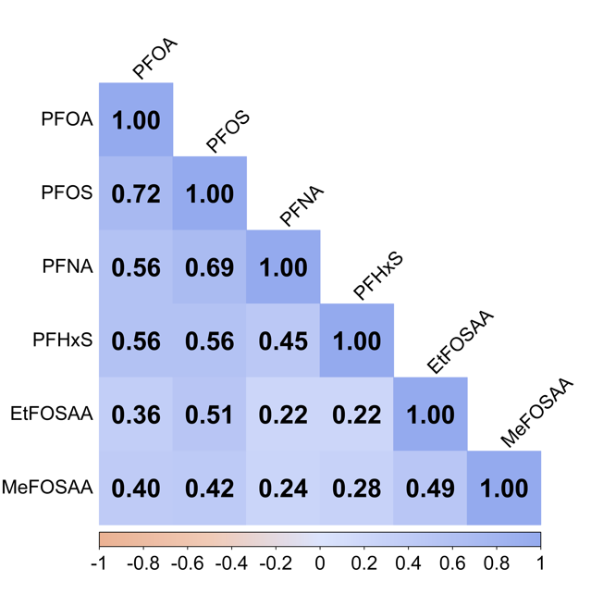
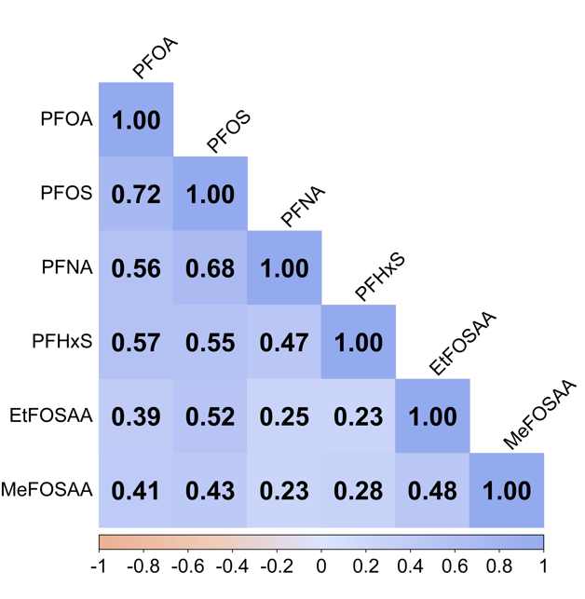

Figure S3. Spearman correlation coefficients among prenatal PFAS measurements in participants with at least one antibody titer outcome, and (A) a complete MMR vaccine series (n=416) or (B) a complete DTaP vaccine series (n=405).

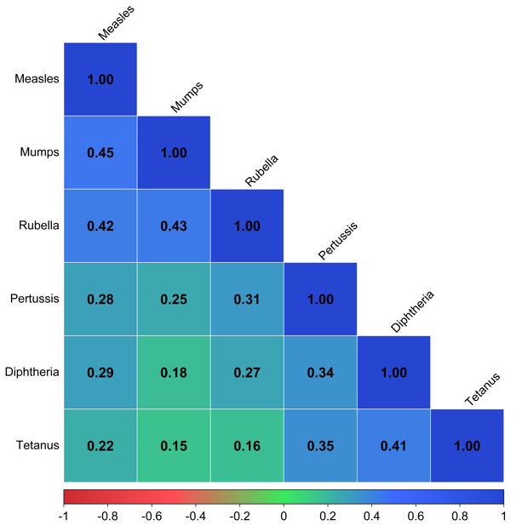

Figure S4. Spearman correlation coefficients among continuous antibody titer outcomes in participants with at least one antibody titer outcome and a complete MMR and DTaP vaccine series (n=383).

