Supplementary file 1
Association between ambient temperature and first recorded hospitalizations for acute kidney injury in Taiwan: A nationwide case-crossover study

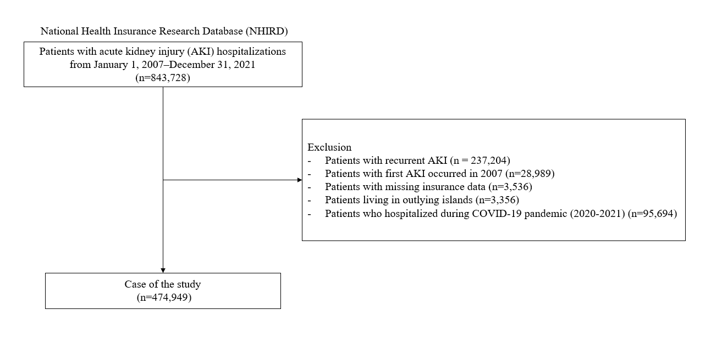
Figure S1. Study population selection process

Table S1. Demographic characteristics of hospitalized patients with acute kidney injury (AKI) in Taiwan (2008–2019)
Cases hospitalized for acute kidney injury
(n =474,949)
 | n | %
Age (year)
0-44 | 39,409 | 8.30
45-64 | 115,183 | 24.25
≥ 65 | 320,357 | 67.45
Gender
Male | 279,993 | 58.95
Female | 194,956 | 41.05
Hypertension
Yes | 288,645 | 60.77
No | 186,304 | 39.23
Diabetes
Yes | 188,538 | 39.70
No | 286,411 | 60.30
Chronic kidney disease
Yes | 78,915 | 16.62
No | 396,034 | 83.38
Farmer
Yes | 111,015 | 23.37
No | 363,934 | 76.63
Fisherman
Yes | 7,559 | 1.59
No | 467,390 | 98.41
Low income
Yes | 7,145 | 1.50
No | 467,804 | 98.50
Study areas
Yilan County | 12,131 | 2.55
Hualien County | 12,223 | 2.57
Nantou County | 8,835 | 1.86
Pingtung County | 15,288 | 3.22
Miaoli County | 6,291 | 1.32
Taoyuan City | 47,215 | 9.94
Kaohsiung City | 60,691 | 12.78
Keelung City | 9,769 | 2.06
Yunlin County | 14,999 | 3.16
New Taipei City | 36,414 | 7.67
Hsinchu City | 10,458 | 2.20
Hsinchu County | 4,668 | 0.98
Chiayi City | 12,428 | 2.62
Chiayi County | 13,954 | 2.94
Changhua County | 25,301 | 5.33
Taichung City | 52,054 | 10.96
Taipei City | 80,771 | 17.01
Taitung County | 5,467 | 1.15
Tainan City | 45,992 | 9.68
Years
2008 | 29,648 | 6.24
2009 | 31,185 | 6.57
2010 | 34,016 | 7.16
2011 | 36,066 | 7.59
2012 | 38,267 | 8.06
2013 | 38,023 | 8.01
2014 | 40,385 | 8.50
2015 | 42,830 | 9.02
2016 | 44,208 | 9.31
2017 | 45,114 | 9.50
2018 | 46,837 | 9.86
2019 | 48,370 | 10.18
Months
January | 40,583 | 8.54
February | 38,761 | 8.16
March | 39,444 | 8.30
April | 38,427 | 8.09
May | 40,289 | 8.48
June | 40,416 | 8.51
July | 41,763 | 8.79
August | 40,866 | 8.60
September | 38,451 | 8.10
October | 38,724 | 8.15
November | 36,785 | 7.75
December | 40,439 | 8.51
Day of week
Sunday | 50,806 | 10.70
Monday | 75,626 | 15.92
Tuesday | 71,506 | 15.06
Wednesday | 70,879 | 14.92
Thursday | 71,005 | 14.95
Friday | 72,681 | 15.30
Saturday | 62,446 | 13.15

Table S2. Model selection based on AIC across combinations of degrees of freedom for the temperature–response and lag–response functions
Model | Temperature df | Lag df | AIC | ΔAIC
1 | 3 | 3 | 1396395 | 38.44
2 | 3 | 4 | 1396361 | 4.22
3 | 3 | 5 | 1396363 | 5.85
4 | 3 | 6 | 1396367 | 10.12
5 | 4 | 3 | 1396393 | 36.36
6 | 4 | 4 | 1396359 | 1.83
7 | 4 | 5 | 1396362 | 4.96
8 | 4 | 6 | 1396368 | 10.85
9 | 5 | 3 | 1396391 | 34.17
10 | 5 | 4 | 1396357 | 0.00
11 | 5 | 5 | 1396358 | 1.39
12 | 5 | 6 | 1396366 | 9.71
13 | 6 | 3 | 1396394 | 36.98
14 | 6 | 4 | 1396360 | 3.48
15 | 6 | 5 | 1396365 | 7.99
16 | 6 | 6 | 1396375 | 17.93

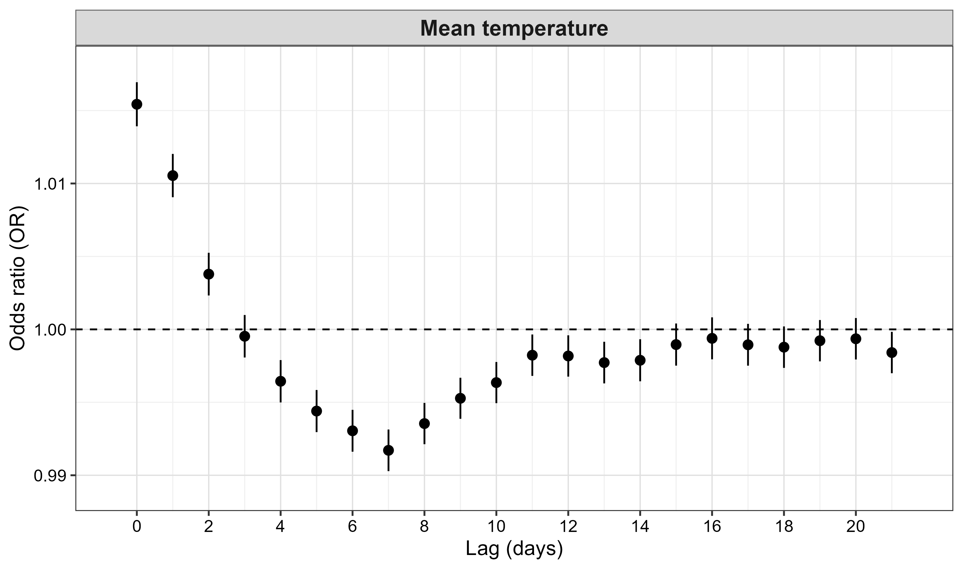

Figure S2. Sensitivity analysis of lag-specific associations between mean temperature and AKI hospitalization using an extended lag period of 0–21 days. Lag-specific odds ratios (ORs) and 95% confidence intervals were estimated using a time-stratified case-crossover design with a distributed lag non-linear model. The positive association was strongest on the day of exposure (lag 0) and remained evident through lag 2. Estimates attenuated thereafter, with later-lag estimates generally approaching or falling below the null, suggesting that the temperature-associated increase in AKI risk was predominantly acute rather than delayed.
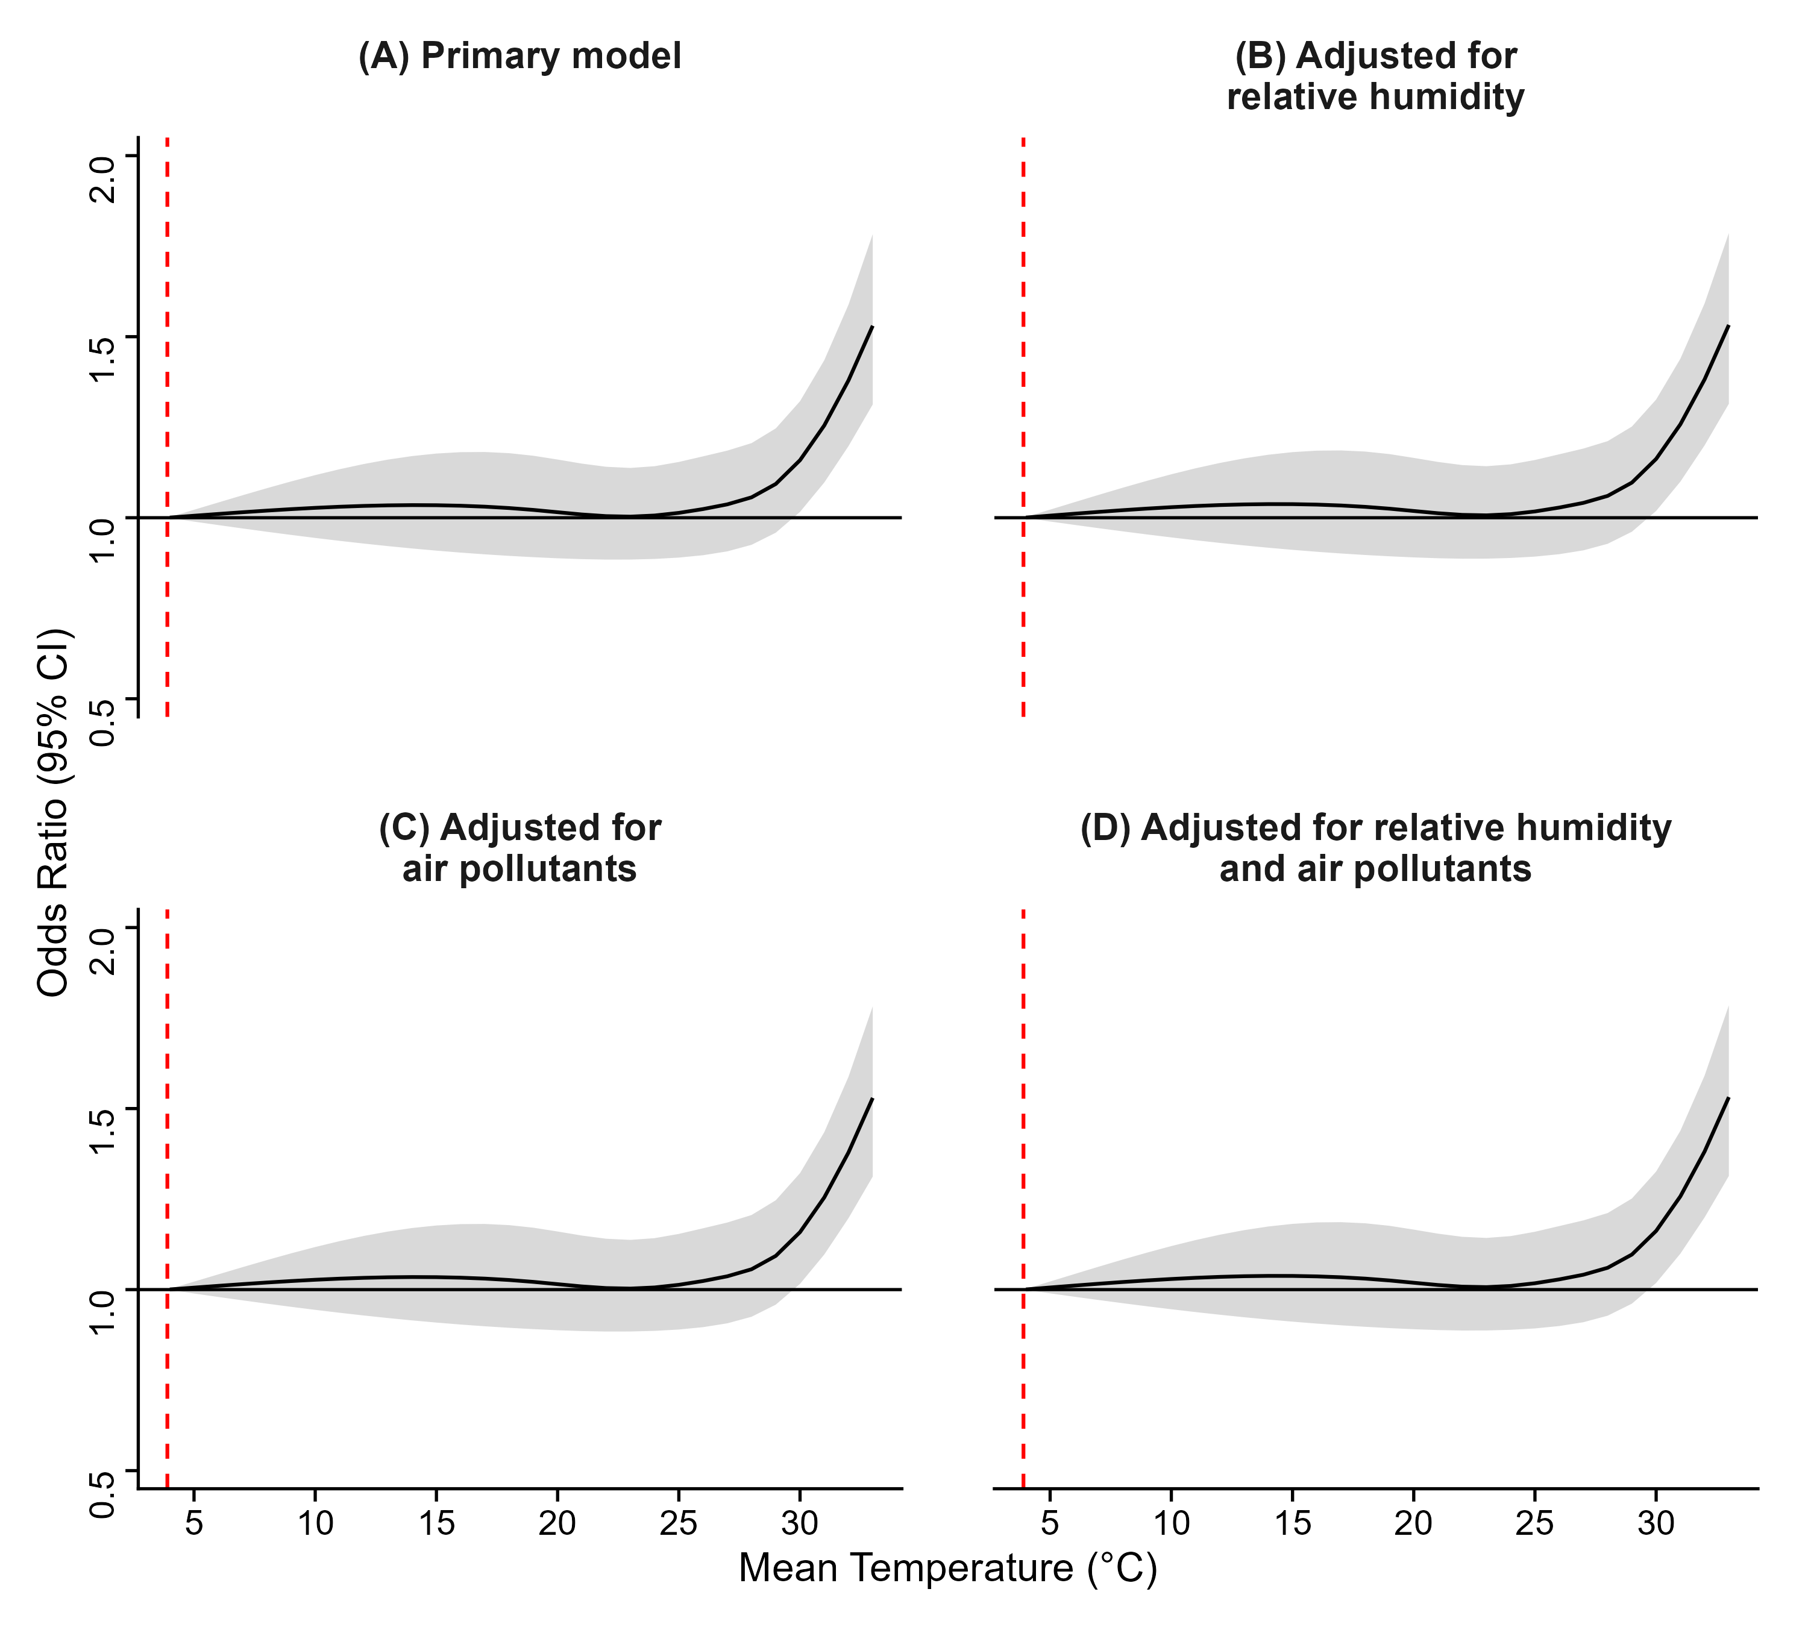
Figure S3. Exposure–response associations between mean temperature and first recorded AKI hospitalization in (A) the primary model, (B) the model adjusted for relative humidity, (C) the model adjusted for air pollutants, and (D) the model adjusted for both relative humidity and air pollutants. Solid lines represent cumulative odds ratios, shaded areas represent 95% confidence intervals, and red dashed lines indicate the minimum morbidity temperature.
Table S3. Overall cumulative associations of mean and maximum temperatures with AKI hospitalization, 2008–2019
 | Mean temperature |  |  |  | Maximum temperature
 | OR ª | Lower CI | Upper CI | OR ª |  | Lower CI | Upper CI
4°C | 1.000 | (reference) | – | – |  | – | –
5°C | 1.001 | 0.989 | 1.022 | 1.000 |  | (reference) | –
6°C | 1.010 | 0.980 | 1.042 | 1.003 |  | 0.994 | 1.012
7°C | 1.015 | 0.970 | 1.062 | 1.007 |  | 0.985 | 1.030
8°C | 1.020 | 0.961 | 1.081 | 1.011 |  | 0.977 | 1.047
9°C | 1.024 | 0.953 | 1.100 | 1.015 |  | 0.968 | 1.064
10°C | 1.027 | 0.944 | 1.118 | 1.019 |  | 0.960 | 1.081
11°C | 1.030 | 0.936 | 1.134 | 1.023 |  | 0.953 | 1.098
12°C | 1.033 | 0.929 | 1.148 | 1.026 |  | 0.946 | 1.114
13°C | 1.034 | 0.922 | 1.161 | 1.030 |  | 0.939 | 1.129
14°C | 1.035 | 0.915 | 1.170 | 1.032 |  | 0.933 | 1.142
15°C | 1.036 | 0.909 | 1.177 | 1.035 |  | 0.928 | 1.155
16°C | 1.033 | 0.904 | 1.181 | 1.037 |  | 0.923 | 1.165
17°C | 1.031 | 0.899 | 1.182 | 1.039 |  | 0.919 | 1.174
18°C | 1.027 | 0.895 | 1.178 | 1.040 |  | 0.916 | 1.181
19°C | 1.022 | 0.891 | 1.171 | 1.040 |  | 0.913 | 1.186
20°C | 1.015 | 0.888 | 1.161 | 1.040 |  | 0.912 | 1.188
21°C | 1.009 | 0.886 | 1.149 | 1.040 |  | 0.910 | 1.188
22°C | 1.004 | 0.884 | 1.141 | 1.039 |  | 0.910 | 1.185
23°C | 1.003 | 0.885 | 1.137 | 1.037 |  | 0.911 | 1.179
24°C | 1.006 | 0.886 | 1.142 | 1.034 |  | 0.913 | 1.173
25°C | 1.013 | 0.890 | 1.154 | 1.033 |  | 0.914 | 1.167
26°C | 1.024 | 0.896 | 1.170 | 1.033 |  | 0.917 | 1.164
27°C | 1.037 | 0.907 | 1.185 | 1.035 |  | 0.919 | 1.167
28°C | 1.056 | 0.925 | 1.206 | 1.041 |  | 0.921 | 1.176
29°C | 1.093 | 0.959 | 1.247 | 1.049 |  | 0.925 | 1.190
30°C | 1.159 | 1.016 | 1.322 | 1.060 |  | 0.932 | 1.205
31°C | 1.255 | 1.097 | 1.435 | 1.075 |  | 0.946 | 1.222
32°C | 1.379 | 1.198 | 1.589 | 1.101 |  | 0.970 | 1.248
33°C | 1.530 | 1.313 | 1.783 | 1.144 |  | 1.010 | 1.296
34°C | – | – | – | 1.210 |  | 1.068 | 1.371
35°C | – | – | – | 1.300 |  | 1.144 | 1.477
36°C | – | – | – | 1.413 |  | 1.235 | 1.617
37°C | – | – | – | 1.550 |  | 1.338 | 1.796
38°C | – | – | – | 1.711 |  | 1.451 | 2.018
39°C | – | – | – | 1.894 |  | 1.572 | 2.282
ª ORs were estimated from the cumulative association over lag days 0–6.

Table S4. Subgroup-specific cumulative ORs for AKI hospitalization per 1°C increase in mean and maximum temperature above the corresponding overall 90th-percentile temperature thresholds (2008–2019).
 | Mean temperature |  |  |  | Maximum temperature
 | OR ª | Lower CI | Upper CI | OR ª |  | Lower CI | Upper CI
Overall | 1.142 | 1.116 | 1.169 | 1.134 |  | 1.111 | 1.157
Age (year)
0-44 | 1.077 | 0.994 | 1.168 | 1.084 |  | 1.013 | 1.160
45-64 | 1.157 | 1.103 | 1.212 | 1.123 |  | 1.079 | 1.168
≥65 | 1.145 | 1.113 | 1.179 | 1.121 |  | 1.095 | 1.148
Sex
Male | 1.126 | 1.093 | 1.161 | 1.114 |  | 1.086 | 1.143
Female | 1.165 | 1.123 | 1.209 | 1.124 |  | 1.090 | 1.159
Hypertension
Yes | 1.131 | 1.097 | 1.165 | 1.139 |  | 1.075 | 1.207
No | 1.160 | 1.117 | 1.203 | 1.184 |  | 1.104 | 1.270
Diabetes
Yes | 1.129 | 1.087 | 1.173 | 1.109 |  | 1.075 | 1.145
No | 1.150 | 1.117 | 1.185 | 1.124 |  | 1.096 | 1.152
Chronic kidney disease
Yes | 1.077 | 1.013 | 1.145 | 1.081 |  | 1.029 | 1.136
No | 1.154 | 1.125 | 1.184 | 1.125 |  | 1.101 | 1.149
Farmer
Yes | 1.168 | 1.104 | 1.236 | 1.112 |  | 1.064 | 1.163
No | 1.137 | 1.108 | 1.166 | 1.120 |  | 1.096 | 1.144
Fisherman
Yes | 1.339 | 1.099 | 1.632 | 1.247 |  | 1.050 | 1.482
No | 1.140 | 1.113 | 1.167 | 1.117 |  | 1.095 | 1.139
Low income
Yes | 1.195 | 0.989 | 1.445 | 1.116 |  | 0.953 | 1.307
No | 1.141 | 1.115 | 1.169 | 1.118 |  | 1.096 | 1.141
ª ORs were estimated from the cumulative association over lag days 0–6.

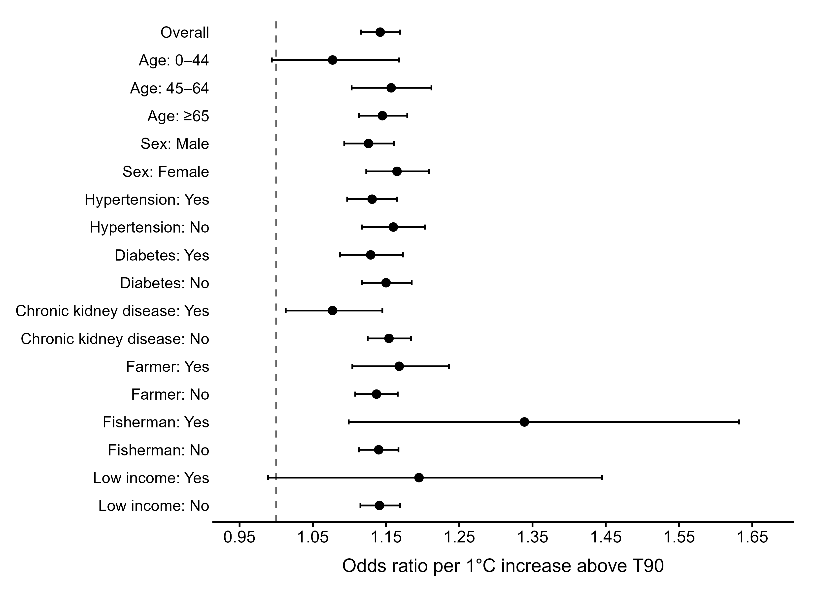
Figure S4. ORs of AKI hospitalization per 1°C increase in daily mean temperature above 29.98°C, stratified by age group, sex, hypertension, diabetes, chronic kidney disease, occupation (farmers, fishermen), and income status (low-income vs. non-low-income).

Table S5. ORs for AKI hospitalization at the 90th, 95th, and 99th percentiles of mean temperature compared with the minimum morbidity temperature (MMT), stratified by age, sex, comorbidity, occupation, and socioeconomic status (2008–2019).
 | Mean temperature
 | T90 | Lower CI | Upper CI | T95 | Lower CI | Upper CI | T99 | Lower CI | Upper CI
Overall | 1.157 | 1.015 | 1.320 | 1.205 | 1.056 | 1.376 | 1.300 | 1.135 | 1.490
Age (year)
0-44 | 1.653 | 1.053 | 2.592 | 1.689 | 1.074 | 2.659 | 1.768 | 1.107 | 2.822
45-64 | 1.295 | 0.990 | 1.693 | 1.349 | 1.030 | 1.767 | 1.461 | 1.107 | 1.929
≥ 65 | 1.079 | 0.919 | 1.267 | 1.127 | 0.959 | 1.325 | 1.223 | 1.036 | 1.444
Sex
Male | 1.056 | 0.890 | 1.252 | 1.094 | 0.922 | 1.299 | 1.168 | 0.979 | 1.394
Female | 1.328 | 1.080 | 1.633 | 1.392 | 1.130 | 1.714 | 1.524 | 1.230 | 1.889
Hypertension
Yes | 1.104 | 0.931 | 1.307 | 1.145 | 0.965 | 1.358 | 1.228 | 1.030 | 1.463
No | 1.246 | 1.011 | 1.534 | 1.304 | 1.057 | 1.609 | 1.423 | 1.146 | 1.766
Diabetes
Yes | 1.108 | 0.897 | 1.367 | 1.147 | 0.928 | 1.418 | 1.221 | 0.982 | 1.519
No | 1.185 | 1.002 | 1.402 | 1.239 | 1.046 | 1.468 | 1.348 | 1.132 | 1.604
Chronic kidney disease
Yes | 0.872 | 0.630 | 1.206 | 0.893 | 0.644 | 1.238 | 0.932 | 0.666 | 1.305
No | 1.224 | 1.060 | 1.413 | 1.277 | 1.105 | 1.477 | 1.387 | 1.195 | 1.610
Farmer
Yes | 1.050 | 0.791 | 1.394 | 1.095 | 0.823 | 1.456 | 1.179 | 0.880 | 1.580
No | 1.187 | 1.023 | 1.377 | 1.235 | 1.063 | 1.434 | 1.332 | 1.142 | 1.554
Fisherman
Yes | 4.234 | 1.293 | 13.870 | 4.660 | 1.412 | 15.376 | 5.547 | 1.639 | 18.779
No | 1.141 | 1.000 | 1.303 | 1.187 | 1.039 | 1.357 | 1.279 | 1.115 | 1.467
Low income
Yes | 1.606 | 0.519 | 4.973 | 1.695 | 0.543 | 5.289 | 1.902 | 0.590 | 6.134
No | 1.153 | 1.010 | 1.316 | 1.200 | 1.050 | 1.371 | 1.294 | 1.128 | 1.484
Table S6. ORs for AKI hospitalization at the 90th, 95th, and 99th percentiles of maximum temperature compared with the minimum morbidity temperature (MMT), stratified by age, sex, comorbidity, occupation, and socioeconomic status (2008–2019).
 | Maximum temperature
 | T90 | Lower CI | Upper CI | T95 | Lower CI | Upper CI | T99 | Lower CI | Upper CI
Overall | 1.184 | 1.045 | 1.341 | 1.232 | 1.087 | 1.397 | 1.355 | 1.189 | 1.545
Age (year)
0-44 | 1.204 | 0.785 | 1.846 | 1.233 | 0.802 | 1.894 | 1.314 | 0.839 | 2.058
45-64 | 1.379 | 1.068 | 1.780 | 1.438 | 1.112 | 1.859 | 1.587 | 1.214 | 2.074
≥65 | 1.129 | 0.970 | 1.314 | 1.179 | 1.012 | 1.373 | 1.302 | 1.111 | 1.527
Sex
Male | 1.096 | 0.932 | 1.288 | 1.140 | 0.969 | 1.341 | 1.249 | 1.054 | 1.480
Female | 1.328 | 1.091 | 1.616 | 1.384 | 1.136 | 1.686 | 1.529 | 1.245 | 1.878
Hypertension
Yes | 1.162 | 0.989 | 1.365 | 1.208 | 1.027 | 1.420 | 1.327 | 1.121 | 1.571
No | 1.217 | 0.998 | 1.483 | 1.268 | 1.039 | 1.547 | 1.400 | 1.138 | 1.723
Diabetes
Yes | 1.185 | 0.971 | 1.446 | 1.232 | 1.008 | 1.505 | 1.341 | 1.088 | 1.653
No | 1.180 | 1.006 | 1.385 | 1.230 | 1.047 | 1.444 | 1.362 | 1.152 | 1.611
Chronic kidney disease
Yes | 0.899 | 0.660 | 1.225 | 0.924 | 0.678 | 1.261 | 0.987 | 0.714 | 1.363
No | 1.247 | 1.088 | 1.430 | 1.302 | 1.135 | 1.494 | 1.439 | 1.247 | 1.660
Farmer
Yes | 1.174 | 0.896 | 1.539 | 1.208 | 0.921 | 1.585 | 1.305 | 0.985 | 1.728
No | 1.179 | 1.024 | 1.357 | 1.229 | 1.067 | 1.416 | 1.352 | 1.166 | 1.567
Fisherman
Yes | 3.258 | 1.038 | 10.226 | 3.497 | 1.110 | 11.012 | 4.077 | 1.257 | 13.227
No | 1.175 | 1.036 | 1.332 | 1.223 | 1.078 | 1.388 | 1.342 | 1.177 | 1.532
Low income
Yes | 1.533 | 0.524 | 4.485 | 1.588 | 0.540 | 4.667 | 1.785 | 0.582 | 5.473
No | 1.179 | 1.040 | 1.337 | 1.228 | 1.082 | 1.394 | 1.349 | 1.183 | 1.539

Table S7. Area-specific ORs for AKI hospitalization per 1°C increase in daily mean and maximum temperatures above the corresponding area-specific 90th-percentile thresholds, 2008–2019.
 | Mean temperature |  |  |  | Maximum temperature
 | OR ª | Lower CI | Upper CI | OR ª |  | Lower CI | Upper CI
Overall | 1.142 | 1.116 | 1.169 | 1.134 |  | 1.111 | 1.157
Study areas
Yilan County | 1.013 | 0.867 | 1.184 | 0.992 |  | 0.888 | 1.107
Hualien County | 1.264 | 1.084 | 1.475 | 1.246 |  | 1.097 | 1.415
Nantou County | 1.329 | 1.144 | 1.545 | 1.257 |  | 1.077 | 1.468
Pingtung County | 1.229 | 1.088 | 1.388 | 1.222 |  | 1.085 | 1.378
Miaoli County | 1.310 | 1.047 | 1.638 | 1.240 |  | 1.042 | 1.475
Taoyuan City | 1.213 | 1.117 | 1.317 | 1.133 |  | 1.063 | 1.209
Kaohsiung City | 1.193 | 1.114 | 1.277 | 1.100 |  | 1.004 | 1.205
Keelung City | 1.156 | 0.994 | 1.344 | 1.171 |  | 1.098 | 1.248
Yunlin County | 1.547 | 1.296 | 1.845 | 1.288 |  | 1.133 | 1.464
New Taipei City | 1.189 | 1.095 | 1.292 | 1.151 |  | 1.074 | 1.234
Hsinchu City | 1.301 | 1.084 | 1.561 | 1.171 |  | 1.038 | 1.321
Hsinchu County | 1.421 | 1.082 | 1.867 | 1.202 |  | 1.011 | 1.429
Chiayi City | 1.121 | 0.976 | 1.288 | 1.025 |  | 0.920 | 1.141
Chiayi County | 0.997 | 0.849 | 1.171 | 1.013 |  | 0.880 | 1.166
Changhua County | 1.221 | 1.085 | 1.374 | 1.149 |  | 1.045 | 1.263
Taichung City | 1.205 | 1.111 | 1.306 | 1.205 |  | 1.118 | 1.299
Taipei City | 1.096 | 1.040 | 1.156 | 1.101 |  | 1.055 | 1.150
Taitung County | 1.013 | 0.802 | 1.279 | 1.001 |  | 0.854 | 1.173
Tainan City | 1.120 | 1.023 | 1.226 | 1.102 |  | 1.016 | 1.195
ª ORs were estimated from the cumulative association over lag days 0–6.

