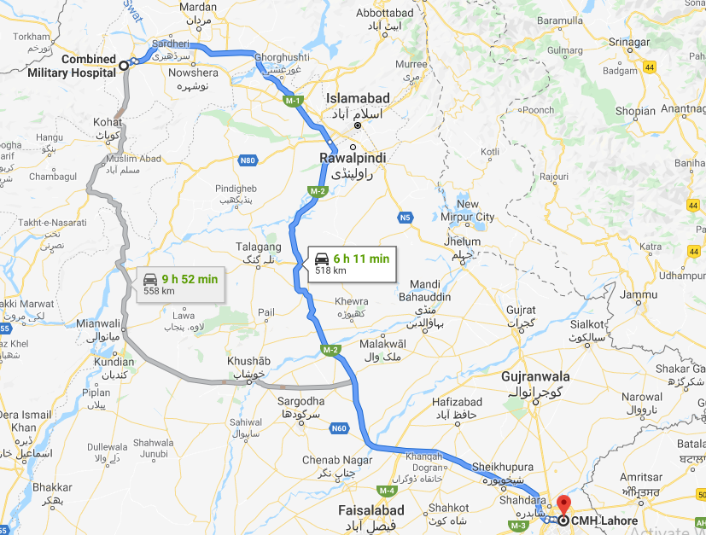
Figure S1. The geographic distance between the Combined Military Hospital in Lahore (CMH Lahore) and the Combined Military Hospital in Peshawar (CMH Peshawar) as drawn by Google Maps https://www.google.com/maps/dir/Combined+Military+Hospital,+Mall+Rd,+Peshawar+Cantonment,+Peshawar,+Khyber+Pakhtunkhwa,+Pakistan/CMH+Lahore,+Abdul+Rehman+Rd,+Saddar+Town,+Lahore,+Punjab,+Pakistan/@32.7700744,72.6522947,8z/data=!4m14!4m13!1m5!1m1!1s0x38d917bbe7a07855:0xf8ccf377d1a61673!2m2!1d71.5423502!2d34.0033769!1m5!1m1!1s0x39190517756f887b:0xc49fc1d23f55d0b0!2m2!1d74.3726762!2d31.5408931!3e0

