Additional file 1:

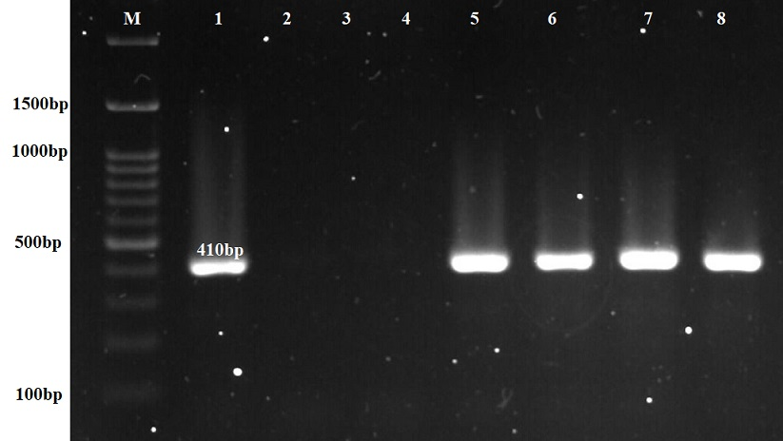

Figure S1 (A): Agarose gel electrophoresis of PCR products for sfa (1177bp) gene. M: 100 bp DNA size marker

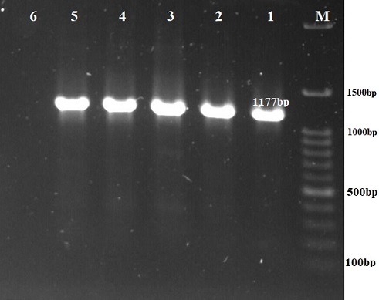

Figure S1 (B): Agarose gel electrophoresis of PCR products for hlyA (1177bp) gene. M: 100 bp DNA size marker

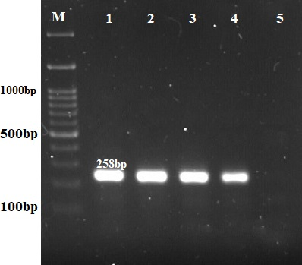

Figure S1 (C): Agarose gel electrophoresis of PCR products for papG III (258bp) gene. M: 100 bp DNA size marker

Figure S1 (D): Agarose gel electrophoresis of PCR products for iutA (300bp) gene. M: 100 bp DNA size marker

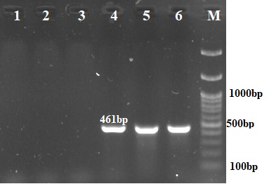
Figure S1 (E): Agarose gel electrophoresis of PCR products for papG1 (461bp) gene. M: 100 bp DNA size marker

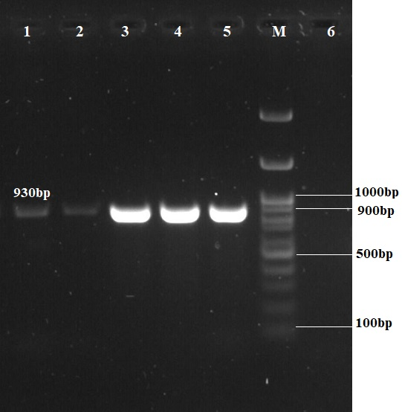

Figure S1 (F): Agarose gel electrophoresis of PCR products for pai (930bp) gene. M: 100 bp DNA size marker

Figure S1 (G): Agarose gel electrophoresis of PCR products for fimH (508bp) and (afa 750bp) genes. M: 100 bp DNA size marker

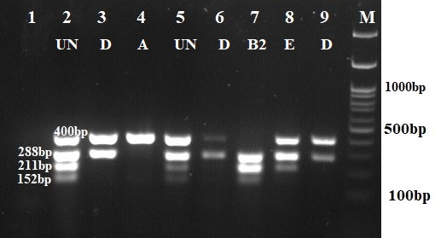

Figure S2: Agarose gel electrophoresis of Quadruplex PCR profiles of Clermont phylo-typing method. D: phylogenetic group D; A: phylogenetic group A; B₂: phylogenetic group B₂; Un: Unknown phylogenetic group M: 100 bp DNA size marker

