Additional material

List of Additional tables

Additional Table S1. Search strategies for systematic reviews 5
Additional Table S2. Disclosure of interests for panel members involved on recommendations 6
Additional Table S3. Should Tixagevimab + Cilgavimab treatment be recommended for pre-exposure prophylaxis in people at high risk of developing severe COVID-19? 7
Additional Table S4. Should monoclonal antibody (Tixagevimab + Cilgavimab) treatment be recommended for outpatients with mild COVID-19? ª 8
Additional Table S5. Should molnupiravir treatment be recommended for outpatients with mild COVID-19 without risk factors for severe disease? 9
Additional Table S6. Should molnupiravir treatment be recommended for outpatients with mild COVID-19 with risk factors for severe disease? 10
Additional Table S7. Should Nirmatrelvir/ ritonarir treatment be recommended for outpatients with mild COVID-19? 11
Additional Table S8. Should Remdesivir treatment be recommend for outpatients with mild COVID-19? 12
Additional Table S9. Should Hidroxychloroquine treatment be recommended for outpatients with mild COVID-19? 13
Additional Table S10. Should Ivermectin treatment be recommended for outpatients with mild COVID-19? 14
Additional Table S11. Should Remdesivir treatment be recommended for hospitalized patients with severe COVID-19? 15
Additional Table S12. Should Baracitinib treatment be recommended for hospitalized patients with severe COVID-19? 16
Additional Table S13.Should Baracitinib treatment vs. dexamethasone be recommended for hospitalized patients with severe COVID-19? 17
Additional Table S14. Should Tocilizumab treatment be recommended for hospitalized patients with severe COVID-19? 18
Additional Table S15. Evidence to decision framework for recommending Tixagevimab + Cilgavimab treatment of pre-exposure prophylaxis in people at high risk of developing COVID-19 19
Additional Table S16. Evidence to decision framework for recommending Tixagevimab + Cilgavimab treatment in outpatients with mild COVID-19 20
Additional Table S17. Evidence to decision framework for recommending Molnupiravir treatment in outpatients with mild COVID-19 21
Additional Table S18. Evidence to decision framework for recommending Nirmatrevir/Ritonavir treatment in outpatients with mild COVID-19 22
Additional Table S19. Evidence to decision framework for recommending Remdesivir treatment in outpatients with mild COVID-19 23
Additional Table S20. Evidence to decision framework for recommending Hidroxychloroquine or Chloroquine treatment in outpatients with mild COVID-19 24
Additional Table S21. Evidence to decision framework for recommending Ivermectin treatment in outpatients with mild COVID-19 25
Additional Table S22. Evidence to decision framework for recommending Remdesivir treatment in hospitalized patients with severe COVID-19 26
Additional Table S23. Evidence to decision framework for recommending Baricitinib treatment in hospitalized patients with severe COVID-19 27
Additional Table S24. Evidence to decision framework for recommending Tocilizumab treatment in hospitalized patients with severe COVID-19 28

List of Additional figures

Additional Figure S1. Flow chart of study selection of Tixagevimab and Cilgavimab in Covid-19 pre-exposure prophylaxis 29
Additional Figure S2. Flow chart of study selection of monoclonal antibody in outpatients with mild COVID-19 30
Additional Figure S3. Flow chart of study selection of Nirmatrelvir plus Ritonavir in outpatients with mild COVID-19 31
Additional Figure S4. Flow chart of study selection of Molnupiravir in outpatients with mild COVID-19 32
Additional Figure S5. Flow chart of study selection of Remdesivir in outpatients with mild COVID-19 33
Additional Figure S6. Flow chart of study selection of Hidroxychloroquine and Chloroquine in outpatients mild COVID-19 34
Additional Figure S7. Flow chart of study selection of Ivermectin in outpatients mild COVID-19 35
Additional Figure S8. Flow chart of study selection of Rendesivir in hospitalized patients with severe COVID-19 36
Additional Figure S9. Flow chart of study selection of Baracitinib in hospitalized patients with severe COVID-19 37
Additional Figure S10. Flow chart of study selection of Tocilizumab in hospitalized patients with severe COVID-19 38
Additional Figure S11. Effect of Molnupiravir compared to control on mortality of outpatients with mild COVID-19 39
Additional Figure S12. Effect of Molnupiravir compared to control on hospitalization of outpatients with mild COVID-19 39
Additional Figure S13. Effect of Molnupiravir compared to control on serious adverse events in outpatients with mild COVID-19 39
Additional Figure S14. Effect of Hidroxychloroquine and Chloroquine compared to control on mortality of outpatients with mild COVID-19 39
Additional Figure S15. Effect of Hidroxychloroquine and Chloroquine compared to control on hospitalization of outpatients with mild COVID-19 40
Additional Figure S16. Effect of Hidroxychloroquine and Chloroquine compared to control on serious adverse events in outpatients with mild COVID-19 40
Additional Figure S17. Effect of Ivermectin compared to control on hospitalization of outpatients with mild COVID-19 40
Additional Figure S18. Effect of Ivermectin compared to control on serious adverse events in outpatients with mild COVID-19 41
Additional Figure S19. Effect of Remdesivir compared to control on mortality of hospitalized patients with severe COVID-19 41
Additional Figure S20. Effect of Remdesivir compared to control on mechanical ventilation of hospitalized patients with severe COVID-19 41
Additional Figure S21. Effect of Remdesivir compared to control on serious adverse events in hospitalized patients with severe COVID-19 42
Additional Figure S22. Effect of Tocilizumab compared to control on mortality in hospitalized patients with severe COVID-19 42
Additional Figure S23. Effect of Tocilizumab compared to control on mechanical ventilation in hospitalized patients with severe COVID-19 42
Additional Figure S24. Effect of Tocilizumab compared to control on serious adverse events in hospitalized patients with severe COVID-19 43
Additional Figure S25. Risk of bias assessment for the study of Tixagevimab + Cilgavimab in COVID-19 pre-exposure prophylaxis 44
Additional Figure S26. Risk of bias assessment for the study of Tixagevimab + Cilgavimab in outpatients with mild COVID-19 44
Additional Figure S27. Risk of bias assessment for the studies of Molnupiravir in outpatients with mild COVID-19 44
Additional Figure S28. Risk of bias assessment for the study of Remdesivir in outpatients with mild COVID-19 45
Additional Figure S29. Risk of bias assessment for the study of Nirmatrelvir plus Ritonavir in outpatients with mild COVID-19 45
Additional Figure S30. Risk of bias assessment for the studies of Hidroxychloroquine and Chloroquine in outpatients with mild COVID-19 45
Additional Figure S31. Risk of bias assessment for the studies of Ivermectin in outpatients with mild COVID-19 46
Additional Figure S32. Risk of bias assessment for the study of Baricitinib in hospitalized patients with severe COVID-19 46
Additional Figure S33. Risk of bias assessment for the studies of Tocilizumab in hospitalized patients with severe COVID-19 46

Additional table S1. Search strategies for systematic reviews
Question | Search Strategy*
Question 1 | (AZD7442 OR Tixagevimab OR Cilgavimab) AND (COVID-19 OR COVID OR coronavirus OR SARS-CoV-2) AND Random*
Question 2 | (Casirivimab OR Imdevimab OR Bamlanivimab OR Etesivimab OR Sotrovimab OR Regdanvimab OR Tixagevimab OR Cilgavimab OR Bebtelovimab  OR Monoclonal Antibodies OR Monoclonal Antibody) AND (COVID OR COV OR CORONAVIRUS OR SARS) AND Random*
Question 3 | (Molnupiravir) AND (COVID OR COV OR CORONAVIRUS OR SARS) AND Random*
Question 4 | (Nirmatrelvir) AND (COVID OR COV OR CORONAVIRUS OR SARS) AND Random*
Question 5 | (Remdesivir) AND (COVID OR COV OR CORONAVIRUS OR SARS) AND Random*
Question 6 | (IVERMECTIN) AND (COVID OR COV OR CORONAVIRUS OR SARS) AND Random*
Question 7 | (Chloroquine OR Chlorochin OR Hydroxychloroquine OR Oxychloroquine OR Hydroxychlorochin) AND (COVID OR COV OR CORONAVIRUS OR SARS) AND Random*
Question 8 | (Remdesivir) AND (COVID OR COV OR CORONAVIRUS OR SARS) AND Random*
Question 9 | (sars cov 2 OR sars cov 2 OR covid OR covid 19 OR covid 19 OR COV OR coronavirus OR coronavirus OR coronaviruses OR SARS) AND (baricitinib) AND random*
Question 10 | (sars cov 2 OR sars cov 2 OR covid OR covid 19 OR covid 19 OR COV OR coronavirus OR coronavirus OR coronaviruses OR SARS) AND (tocilizumab) AND random*
*Search update: July 6th, 2022.

Additional table S2. Disclosure of financial interests for panel members involved on recommendations
Name | Disclosure of interests | Questions with potential financial conflict of interestª
Alberto Chebabo | - | 1, 2 (tixagebimab + cilgavimab);
Alexandre Naime Barbosa | - | 1, 2 (tixagebimab + cilgavimab); 3 (molnupiravir); 5, 8 (remdesivir)
Alfonso Javier Rodriguez-Morales | No direct financial interests | Not applicable
Carlos Starling | - | 1, 2 (tixagebimab + cilgavimab)
Clevy Pérez | No direct financial interests | Not applicable
Clóvis Arns Cunha | - | 1, 2 (tixagebimab + cilgavimab); 3 (molnupiravir); 5 (remdesivir)
David de Luna | No direct financial interests | Not applicable
Estevão Portela Nunes | - | 5, 8 (remdesivir)
Gabriela Zambrano | No direct financial interests | Not applicable
Juliana Carvalho Ferreira | No direct financial interests | Not applicable
Júlio Croda | - | 3 (molnupiravir); 4 (Nirmatrevir/ritonavir)
Monica Maria Gomes da Silva | - | 3 (molnupiravir);
Monica Thormann | No direct financial interests | Not applicable
Sérgio Cimerman | - | 1, 2 (tixagebimab + cilgavimab); 3 (molnupiravir); 5, 8 (remdesivir)
Suzana Tanni | No direct financial interests | Not applicable
ª Members with a direct financial conflict of interest related to a given intervention did not vote for the related questions

Additional table S3. Should Tixagevimab + Cilgavimab treatment be recommended for pre-exposure prophylaxis in people at high risk of developing severe COVID-19?
Certainty assessment |  |  |  |  |  |  | № of patients |  | Effect |  | Certainty | Importance
№ of studies | Study design | Risk of bias | Inconsistency | Indirectness | Imprecision | Other considerations | Tixagevimab + cilgavimab | Placebo | Relative  (95% CI) | Absolute  (95% CI) | Certainty | Importance
Symptomatic COVID-19 episode
1 | randomised trials | very seriousª | not serious | not serious | not serious | none | 20/3461 (0.6%) | 44/1736 (2.5%) | not estimable | - | ⨁⨁◯◯  Low | CRITICAL
Adverse event with death
1 | randomised trials | very seriousª | not serious | not serious | serious^{b} | none | 4/3461 (0.1%) | 4/1736 (0.2%) | not estimable | - | ⨁◯◯◯  Very low | CRTICAL
Serious adverse event
1 | randomised trials | very seriousª | not serious | not serious | serious^{b} | none | 50/3461 (1.4%) | 23/1736 (1.3%) | not estimable | - | ⨁◯◯◯  Very low | IMPORTANT
CI: Confidence interval

Explanations
a. Follow-up loss greater than 20%.
b. Optimal Information Size not met.

Additional table S4. Should monoclonal antibody (Tixagevimab + Cilgavimab) treatment be recommended for outpatients with mild COVID-19? ª
Certainty assessment |  |  |  |  |  |  | № de pacientes |  | Efeito |  | Certainty | Importance
№ of studies | Study design | Risk of bias | Inconsistency | Indirectness | Imprecision | Other considerations | Tixagevimab + cilgavimab | Placebo | Relative  (95% CI) | Absolut  (95% CI) | Certainty | Importance
Mortality
1 | randomised trials | not serious | not serious | not serious | serious^{b} | none | 6/456 (1.3%) | 6/454 (1.3%) | not estimable | 0 fewer per 100  (from 1 fewer to 1 more) | ⨁⨁⨁◯  Moderate | CRTICAL
Hospitalization
1 | randomised trials | not serious | not serious | not serious | not serious | none | 17/456 (3.7%) | 40/454 (8.8%) | not estimable | 5 fewer per 100  (from 8 fewer to 2 fewer) | ⨁⨁⨁⨁  High | IMPORTANT
Serious adverse event
1 | randomised trials | not serious | not serious | not serious | not serious | none | 22/456 (4.8%) | 30/454 (6.6%) | not estimable | 2 fewer per 100  (from 5 fewer to 1 more) | ⨁⨁⨁⨁  High | IMPORTANT
CI: Confidence interval

Explanations
a. Due to the lack of effectiveness for the omicron variant, the panel chose not to make recommendations for Bamlanivimab, Casirivimab, Etesivimab, Imdevimab, Regdanvimab and Sotrovimab. For Bebtelovimab, no recommendation was made due to lack of evidence.
b. Optimal Information Size not met.

Additional table S5. Should molnupiravir treatment be recommended for outpatients with mild COVID-19 without risk factors for severe disease?
Certainty assessment |  |  |  |  |  |  | № of patients |  | Effect |  | Certainty | Importance
№ of studies | Study design | Risk of bias | Inconsistency | Indirectness | Imprecision | Other considerations | Molnupiravir | Placebo | Relative  (95% CI) | Absolut  (95% CI) | Certainty | Importance
Mortality
2 | randomised trials | serious^{a, b, c} | not serious | not serious | not serious | none | 0/610 (0.0%) | 0/610 (0.0%) | not estimable | 10 more per 1.000  (from 10 fewer to 20 more) | ⨁⨁⨁◯  Moderate | CRITICAL
Hospitalization
2 | randomised trials | serious^{a, b, c} | not serious | not serious | not serious | none | 7/610 (1.2%) | 13/610 (2.1%) | not estimable | 10 more per 1.000  (from 0 fewer to 30 more) | ⨁⨁⨁◯  Moderate | CRITICAL
Serious Adverse Events
2 | randomised trials | serious^{a, b, c} | not serious | not serious | not serious | none | 78/610 (12.8%) | 81/610 (13.3%) | not estimable | 0 per 1.000  (from 40 fewer to 30 more) | ⨁⨁⨁◯  Moderate | IMPORTANT
CI: confidence interval

Explanations
a. No blinding.
b. Absence of blinding, analysis by ITT and sample calculation.
b. No sample size calculation.

Additional table S6. Should molnupiravir treatment be recommended for outpatients with mild COVID-19 with risk factors for severe disease?
Certainty assessment |  |  |  |  |  |  | № of patients |  | Effect |  | Certainty | Importance
№ of studies | Study design | Risk of bias | Inconsistency | Indirectness | Imprecision | Other considerations | Molnupiravir | Placebo | Relative  (95% CI) | Absolut  (95% CI) | Certainty | Importance
Mortality
1 | randomised trial | not serious | not serious | not serious | not serious | none | 1/716 (0.1%) | 9/717 (1.3%) | not estimable | 10 more per 1.000  (from 20 fewer to 0 fewer) | ⨁⨁⨁⨁  High | CRITICAL
Hospitalization
1 | randomised trial | not serious | not serious | not serious | not serious | none | 47/716 (6.6%) | 59/717 (8.2%) | not estimable | 20 more per 1.000  (from 40 fewer to 10 more) | ⨁⨁⨁⨁  High | CRITICAL
Serious Adverse Events
1 | randomised trial | not serious | not serious | not serious | not serious | none | 49/716 (6.8%) | 67/717 (9.3%) | not estimable | 30 more per 1.000  (from 50 fewer to 0 more) | ⨁⨁⨁⨁  High | IMPORTANT
CI: confidence interval

Explanations

Additional table S7. Should Nirmatrelvir/ ritonarir treatment be recommended for outpatients with mild COVID-19?
Certainty assessment |  |  |  |  |  |  | № of patients |  | Effect |  | Certainty | Importance
№ of studies | Study design | Risk of bias | Inconsistency | Indirectness | Imprecision | Other considerations | Nirmatrelvir + Ritonavir | Placebo | Relative (95% CI) | Absolut  (95% CI) | Certainty | Importance
Mortality
1 | randomised trials | not serious | not serious | not serious | seriousª | none | 0/1120 (0.0%) | 12/1126 (1.1%) | not estimable | - | ⨁⨁⨁◯  Moderate | CRITICAL
Hospitalization
1 | randomised trials | not serious | not serious | not serious | not serious | none | 8/1120 (0.7%) | 65/1126 (5.8%) | not estimable | - | ⨁⨁⨁⨁  High | CRITICAL
Adverse Events
1 | randomised trials | not serious | not serious | not serious | not serious | none | 18/1120 (1.6%) | 74/1126 (6.6%) | not estimable | - | ⨁⨁⨁⨁  High | IMPORTANT
CI: Confidence interval

Explanations
a. Optimal Information Size not met.

Additional table S8. Should Remdesivir treatment be recommend for outpatients with mild COVID-19?
Certainty assessment |  |  |  |  |  |  | № of patients |  | Effect |  | Certainty | Importance
№ of studies | Study design | Risk of bias | Inconsistency | Indirectness | Imprecision | Other considerations | Remdesivir | Placebo | Relative  (95% CI) | Absolut  (95% CI) | Certainty | Importance
Mortality
1 | randomised trials | seriousª | not serious | not serious | serious^{b} | none | 0/292 (0.0%) | 0/292 (0.0%) | not estimable | - | ⨁⨁◯◯  Low | CRITICAL
Hospitalization
1 | randomised trials | seriousª | not serious | not serious | not serious | none | 5/292 (1.7%) | 18/292 (6.2%) | not estimable | - | ⨁⨁⨁◯  Moderate | CRITICAL
Serious Adverse Events
1 | randomised trials | seriousª | not serious | not serious | not serious | none | 5/292 (1.7%) | 19/292 (6.5%) | not estimable | - | ⨁⨁⨁◯  Moderate | IMPORTANT
CI: Confidence interval

Explanations
a. Early discontinuation of the study.
b. Optimal Information Size not met.

Additional Table S9. Should Hidroxychloroquine treatment be recommended for outpatients with mild COVID-19?
Certainty assessment |  |  |  |  |  |  | № of patients |  | Effect |  | Certainty | Importance
№ of studies | Study design | Risk of bias | Inconsistency | Indirectness | Imprecision | Other considerations | HCQ | Placebo | Relative  (95% CI) | Absolut  (95% CI) | Certainty | Importance
Mortality
6 | randomised trials | serious^{c} | not serious | not serious | not serious | none | 6/1514 (0.4%) | 7/1467 (0.5%) | not estimable | 0 fewer per 1.000  (from 0 fewer to 10 more) | ⨁⨁⨁◯  Moderate | CRITICAL
Hospitalization
6 | randomised trials | seriousª | not serious | not serious | not serious | none | 71/1514 (4.7%) | 93/1467 (6.3%) | not estimable | 20 more per 1.000  (from 0 fewer to 30 more) | ⨁⨁⨁◯  Moderate | CRITICAL
Serious Adverse Events
5 | randomised trials | serious^{b} | not serious | not serious | not serious | none | 41/1302 (3.1%) | 45/1256 (3.6%) | not estimable | 0 fewer per 1.000  (from 10 fewer to 20 more) | ⨁⨁⨁◯  Moderate | IMPORTANT
CI: Confidence interval; HCQ: Hidroxychloroquine

Explanations
a. Follow-up loss greater than 20%.
b. Absence of analysis by ITT.
c. Absence of blinding.

Additional Table S10. Should Ivermectin treatment be recommended for outpatients with mild COVID-19?
Certainty assessment |  |  |  |  |  |  | № of patients |  | Effect |  | Certainty | Importance
№ of studies | Study design | Risk of bias | Inconsistency | Indirectness | Imprecision | Other considerations | Ivermectin | Placebo | Relative  (95% CI) | Absolut  (95% CI) | Certainty | Importance
Mortality
3 | randomised trials | seriousª | not serious | not serious | not serious | none | 22/1734 (1.3%) | 25/1691 (1.5%) | not estimable | 0 fewer per 1000  (from 10 fewer to 10 more) | ⨁⨁⨁◯  Moderate | CRITICAL
Hospitalization
3 | randomised trials | seriousª | not serious | not serious | not serious | none | 110/1734 (6.3%) | 124/1691 (7.3%) | not estimable | 10 fewer per 1000  (from 10 fewer to 20 more) | ⨁⨁⨁◯  Moderate | CRITICAL
Serious Adverse Event
3 | randomised trials | seriousª | not serious | not serious | not serious | none | 50/1734 (2.9%) | 53/1691 (3.1%) | not estimable | 0 fewer per 1000  (from 10 fewer to 10 more) | ⨁⨁⨁◯  Moderate | IMPORTANT
CI: Confidence interval

Explanations
a. Limitation on sample size calculation, ITT analysis and unclear risk of bias.

Additional Table S11. Should Remdesivir treatment be recommended for hospitalized patients with severe COVID-19?
Certainty assessment |  |  |  |  |  |  | № of patients |  | Effect |  | Certainty | Importance
№ of studies | Study design | Risk of bias | Inconsistency | Indirectness | Imprecision | Other considerations | Remdesivir | Placebo | Relative  (95% CI) | Absolut  (95% CI) | Certainty | Importance
Mortality
8 | randomised trials | seriousª | not serious | not serious | not serious | none | 863/6451 (13.4%) | 934/6157 (15.2%) | not estimable | 10 more per 1.000  (from 0 fewer to 30 more) | ⨁⨁⨁◯  Moderate | CRITICAL
Mechanical Ventilation or ECMO
8 | randomised trials | seriousª | serious^{b} | not serious | not serious | none | 677/6069 (11.2%) | 822/5788 (14.2%) | not estimable | 30 more per 1.000  (from 10 more to 50 more) | ⨁⨁◯◯  Low | CRITICAL
Serious Adverse Events
5 | randomised trials | seriousª | very serious^{c} | not serious | serious^{d} | none | 297/1399 (21.2%) | 331/1316 (25.2%) | not estimable | 30 more per 1.000  (from 20 fewer to 80 more) | ⨁◯◯◯  Very low | IMPORTANT
CI: confidence interval

Explanations
a. Absence of blinding.
b. Heterogeneity 50% - 75%.
c. Heterogeneity > 75%.
d. Large 95% CI.

Additional Table S12. Should Baracitinib treatment be recommended for hospitalized patients with severe COVID-19?
Certainty assessment |  |  |  |  |  |  | № of patients |  | Effect |  | Certainty | Importance
№ of studies | Study design | Risk of bias | Inconsistency | Indirectness | Imprecision | Other considerations | Baricitinib | Placebo | Relative  (95% CI) | Absolute  (95% CI) | Certainty | Importance
Mortality
1 | randomised trials | seriousª | not serious | not serious | not serious | none | 62/764 (8.1%) | 100/761 (13.1%) | not estimable | 5 fewer per 100  (from 8 fewer to 2 fewer) | ⨁⨁⨁◯  Moderate | CRITICAL
Serious Adverse Events
1 | randomised trials | seriousª | not serious | not serious | serious^{b} | none | 111/764 (14.5%) | 130/761 (17.1%) | not estimable | 3 fewer per 100  (from 6 fewer to 1 more) | ⨁⨁◯◯  Low | IMPORTANT
CI: confidence interval

Explanations
a. Follow-up loss greater than 20%.
b. Large 95% CI.

Additional Table S13.Should Baracitinib treatment vs. dexamethasone be recommended for hospitalized patients with severe COVID-19?
Certainty assessment |  |  |  |  |  |  | № of patients |  | Effect |  | Certainty | Importance
№ of studies | Study design | Risk of bias | Inconsistency | Indirectness | Imprecision | Other considerations | Baricitinib | Dexamethasone | Relative  (95% CI) | Absolute  (95% CI) | Certainty | Importance
Mortality
1 | randomised trials | seriousª | not serious | not serious | serious^{b} | none | 27/516 (5.2%) | 30/494 (6.1%) | not estimable | 1 fewer per 100  (from 4 fewer to 2 more) | ⨁⨁◯◯  Low | CRITICAL
Mechanical Ventilation or ECMO
1 | randomised trials | seriousª | not serious | not serious | serious^{b} | none | 57/516 (11.0%) | 50/494 (10.1%) | not estimable | 1 fewer per 100  (from 3 fewer to 5 more) | ⨁⨁◯◯  Low | CRITICAL
Serious Adverse Events
1 | randomised trials | seriousª | not serious | not serious | serious^{b} | none | 95/516 (18.4%) | 94/494 (19.0%) | not estimable | 1 fewer per 100  (from 5 fewer to 4 more) | ⨁⨁◯◯  Low | IMPORTANT
CI: confidence interval

Explanations
a. Follow-up loss greater than 20%.
b. Large 95% CI.

Additional Table S14. Should Tocilizumab treatment be recommended for hospitalized patients with severe COVID-19?
Certainty assessment |  |  |  |  |  |  | № of patients |  | Effect |  | Certainty | Importance
№ of studies | Study design | Risk of bias | Inconsistency | Indirectness | Imprecision | Other considerations | Tocilizumab | Placebo | Relative (95% CI) | Absolut  (95% CI) | Certainty | Importance
Mortality
14 | randomised trials | seriousª | not serious | not serious | not serious | none | 1089/4365 (24.9%) | 986/3501 (28.2%) | not estimable | 1 fewer per 1000  (from 10 fewer to 50 fewer) | ⨁⨁⨁◯  Moderate | CRITICAL
Mechanical Ventilation
7 | randomised trials | seriousª | not serious | not serious | not serious | none | 389/3849 (10.1%) | 282/3017 (9.3%) | not estimable | 20 fewer per 1000  (from 10 fewer to 40 fewer) | ⨁⨁⨁◯  Moderate | CRITICAL
Adverse Events
11 | randomised trials | seriousª | not serious | not serious | not serious | none | 301/1436 (21.0%) | 227/1053 (21.6%) | not estimable | 10 more per 1000  (from 20 fewer to 50 more) | ⨁⨁⨁◯  Moderate | IMPORTANT
CI: confidence interval

Explanations
a. Absence of blinding.
Additional Table 15. Evidence to decision framework for recommending Tixagevimab + Cilgavimab treatment of pre-exposure prophylaxis in people at high risk of developing COVID-19
1) Should Tixagevimab + Cilgavimab treatment be recommended for pre-exposure prophylaxis in people at high risk of developing severe COVID-19?
Domain | Question | Judgement
Problem | Is the problem a priority? | ☐ No  ☐ Probably no  ☐ Probably yes  ☐ Yes  - Varies  ☐ Don’t know
Desirable effects | How substantial are the desirable anticipated effects? | ☐ Trivial  ☐ Small  ☐ Moderate  - Large  ☐ Varies  ☐ Don’t know
Undesirable effects | How substantial are the undesirable anticipated effects? | - Trivial  ☐ Small  ☐ Moderate  ☐ Large  ☐ Varies  ☐ Don’t know
Certainty of evidence | What is the overall certainty of the evidence of effects? | - Very low  ☐ Low  ☐ Moderate  ☐ High  ☐ No included studies
Balance of effects | Does the balance between desirable and undesirable effects favor the intervention or the comparison? | ☐ Favors the comparison  ☐ Probably favors the comparison  ☐ Does not favor either the intervention or the comparison  - Probably favors the intervention  ☐ Favors the intervention  ☐ Varies  ☐ Don't know
Feasibility | Is the intervention feasible to implement? | ☐ No  ☐ Probably no  - Probably yes  ☐ Yes  ☐ Varies  ☐ Don’t know
Recommendation | We suggest using Tixagevimab + Cilgavimab for prophylaxis in people at high risk of developing severe COVID-19 (conditional recommendation, very low certainty in evidence).

Additional Table S16. Evidence to decision framework for recommending Tixagevimab + Cilgavimab treatment in outpatients with mild COVID-19
Should Tixagevimab + Cilgavimab treatment be recommended for outpatients with mild COVID-19?
Domain | Question | Judgement
Problem | Is the problem a priority? | ☐ No  ☐ Probably no  ☐ Probably yes  - Yes  ☐ Varies  ☐ Don’t know
Desirable effects | How substantial are the desirable anticipated effects? | ☐ Trivial  ☐ Pequena  - Moderada  ☐ Grande  ☐ Varia  ☐ Desconhecido
Undesirable effects | How substantial are the undesirable anticipated effects? | ☐ Trivial  - Small  ☐ Moderate  ☐ Large  ☐ Varies  ☐ Don’t know
Certainty of evidence | What is the overall certainty of the evidence of effects? | ☐ Very low  ☐ Low  - Moderate  ☐ High  ☐ No included studies
Balance of effects | Does the balance between desirable and undesirable effects favor the intervention or the comparison? | ☐ Favors the comparison  ☐ Probably favors the comparison  ☐ Does not favor either the intervention or the comparison  - Probably favors the intervention  ☐ Favors the intervention  ☐ Varies  ☐ Don't know
Feasibility | Is the intervention feasible to implement? | ☐ No  ☐ Probably no  - Probably yes  ☐ Yes  ☐ Varies  ☐ Don’t know
Recommendation | We suggest using tixagevimab + cilgavimab for prophylaxis in outpatients with mild COVID-19 (conditional recommendation, moderate certainty in evidence).

Additional Table S17. Evidence to decision framework for recommending Molnupiravir treatment in outpatients with mild COVID-19
Should Molnupiravir treatment be recommended for outpatients with mild COVID-19?
Domain | Question | Opções de resposta
Problem | Is the problem a priority? | ☐ No  ☐ Probably no  ☐ Probably yes  ☐ Yes  - Varies  ☐ Don’t know
Desirable effects | How substantial are the desirable anticipated effects? | ☐ Trivial  - Small  ☐ Moderate  ☐ Large  ☐ Varies  ☐ Don’t know
Undesirable effects | How substantial are the undesirable anticipated effects? | - Trivial  ☐ Small  ☐ Moderate  ☐ Large  ☐ Varies  ☐ Don’t know
Certainty of evidence | What is the overall certainty of the evidence of effects? | - Very low  ☐ Low  ☐ Moderate  ☐ High  ☐ No included studies
Balance of effects | Does the balance between desirable and undesirable effects favor the intervention or the comparison? | ☐ Favors the comparison  ☐ Probably favors the comparison  ☐ Does not favor either the intervention or the comparison  - Probably favors the intervention  ☐ Favors the intervention  ☐ Varies  ☐ Don't know
Feasibility | Is the intervention feasible to implement? | ☐ No  ☐ Probably no  - Probably yes  ☐ Yes  ☐ Varies  ☐ Don’t know
Recommendation | We suggest using Molnupiravir in outpatients with mild COVID-19 (conditional recommendation, very low certainty in evidence).

Additional Table S18. Evidence to decision framework for recommending Nirmatrevir/Ritonavir treatment in outpatients with mild COVID-19
Should Nirmatrelvir/ritonavir treatment be recommended for outpatients with mild COVID-19?
Domain | Question | Judgement
Problem | Is the problem a priority? | ☐ No  ☐ Probably no  - Probably yes  ☐ Yes  ☐ Varies  ☐ Don’t know
Desirable effects | How substantial are the desirable anticipated effects? | ☐ Trivial  ☐ Small  ☐ Moderate  - Large  ☐ Varies  ☐ Don’t know
Undesirable effects | How substantial are the undesirable anticipated effects? | ☐ Trivial  - Small  ☐ Moderate  ☐ Large  ☐ Varies  ☐ Don’t know
Certainty of evidence | What is the overall certainty of the evidence of effects? | ☐ Very low  ☐ Low  - Moderate  ☐ High
Balance of effects | Does the balance between desirable and undesirable effects favor the intervention or the comparison? | ☐ Favors the comparison  ☐ Probably favors the comparison  ☐ Does not favor either the intervention or the comparison  ☐ Probably favors the intervention  - Favors the intervention  ☐ Varies  ☐ Don't know
Feasibility | Is the intervention feasible to implement? | ☐ No  ☐ Probably no  - Probably yes  ☐ Yes  ☐ Varies  ☐ Don’t know
Recommendation | We recommend using Nirmatrelvir/Ritonavir in outpatients with mild COVID-19 (strong recommendation, moderate certainty in evidence).

Additional Table S19. Evidence to decision framework for recommending Remdesivir treatment in outpatients with mild COVID-19
Should Remdesivir treatment be recommend for outpatients with mild COVID-19?
Domain | Question | Judgement
Problem | Is the problem a priority? | ☐ No  ☐ Probably no  - Probably yes  ☐ Yes  ☐ Varies  ☐ Don’t know
Desirable effects | How substantial are the desirable anticipated effects? | ☐ Trivial  ☐ Small  - Moderate  ☐ Large  ☐ Varies  ☐ Don’t know
Undesirable effects | How substantial are the undesirable anticipated effects? | - Trivial  ☐ Small  ☐ Moderate  ☐ Large  ☐ Varies  ☐ Don’t know
Certainty of evidence | What is the overall certainty of the evidence of effects? | ☐ Very low  - Low  ☐ Moderate  ☐ High  ☐ No included studies
Balance of effects | Does the balance between desirable and undesirable effects favor the intervention or the comparison? | ☐ Favors the comparison  ☐ Probably favors the comparison  ☐ Does not favor either the intervention or the comparison  - Probably favors the intervention  ☐ Favors the intervention  ☐ Varies  ☐ Don't know
Feasibility | Is the intervention feasible to implement? | ☐ No  ☐ Probably no  ☐ Probably yes  ☐ Yes  - Varies  ☐ Don’t know
Recommendation | We suggest using Remdesivir in outpatients with mild COVID-19 (conditional recommendation, low certainty in evidence).

Additional Table S20. Evidence to decision framework for recommending Hidroxychloroquine or Chloroquine treatment in outpatients with mild COVID-19
Should Hidroxychloroquine or Chloroquine treatment be recommended for outpatients with mild COVID-19?
Domain | Question | Judgement
Problem | Is the problem a priority? | ☐ No  ☐ Probably no  - Probably yes  ☐ Yes  ☐ Varies  ☐ Don’t know
Desirable effects | How substantial are the desirable anticipated effects? | - Trivial  ☐ Small  ☐ Moderate  ☐ Large  ☐ Varies  ☐ Don’t know
Undesirable effects | How substantial are the undesirable anticipated effects? | ☐ Trivial  - Small  ☐ Moderate  ☐ Large  ☐ Varies  ☐ Don’t know
Certainty of evidence | What is the overall certainty of the evidence of effects? | ☐ Very low  ☐ Low  - Moderate  ☐ High  ☐ No included studies
Balance of effects | Does the balance between desirable and undesirable effects favor the intervention or the comparison? | ☐ Favors the comparison  - Probably favors the comparison  ☐ Does not favor either the intervention or the comparison  ☐ Probably favors the intervention  ☐ Favors the intervention  ☐ Varies  ☐ Don't know
Feasibility | Is the intervention feasible to implement? | ☐ No  ☐ Probably no  ☐ Probably yes  - Yes  ☐ Varies  ☐ Don’t know
Recommendation | We recommend against using Hidroxychloroquine or Chloroquine in outpatients with mild COVID-19 (strong recommendation, moderate certainty in evidence).

Additional Table 21. Evidence to decision framework for recommending Ivermectin treatment in outpatients with mild COVID-19
Should Ivermectin treatment be recommended for outpatients with mild COVID-19?
Domain | Question | Judgement
Problem | Is the problem a priority? | ☐ No  ☐ Probably no  - Probably yes  ☐ Yes  ☐ Varies  ☐ Don’t know
Desirable effects | How substantial are the desirable anticipated effects? | - Trivial  ☐ Small  ☐ Moderate  ☐ Large  ☐ Varies  ☐ Don’t know
Undesirable effects | How substantial are the undesirable anticipated effects? | ☐ Trivial  - Small  ☐ Moderate  ☐ Large  ☐ Varies  ☐ Don’t know
Certainty of evidence | What is the overall certainty of the evidence of effects? | ☐ Very low  ☐ Low  - Moderate  ☐ High  ☐ No included studies
Balance of effects | Does the balance between desirable and undesirable effects favor the intervention or the comparison? | ☐ Favors the comparison  - Probably favors the comparison  ☐ Does not favor either the intervention or the comparison  ☐ Probably favors the intervention  ☐ Favors the intervention  ☐ Varies  ☐ Don't know
Feasibility | Is the intervention feasible to implement? | ☐ No  ☐ Probably no  ☐ Probably yes  - Yes  ☐ Varies  ☐ Don’t know
Recommendation | We recommend against using Ivermectin in outpatients with mild COVID-19 (strong recommendation, moderate certainty in evidence)

Additional Table S22. Evidence to decision framework for recommending Remdesivir treatment in hospitalized patients with severe COVID-19
Should Remdesivir treatment be recommended for hospitalized patients with severe COVID-19?
Domain | Question | Judgement
Problem | Is the problem a priority? | ☐ No  ☐ Probably no  ☐ Probably yes  - Yes  ☐ Varies  ☐ Don’t know
Desirable effects | How substantial are the desirable anticipated effects? | ☐ Trivial  ☐ Small  - Moderate  ☐ Large  ☐ Varies  ☐ Don’t know
Undesirable effects | How substantial are the undesirable anticipated effects? | ☐ Trivial  - Small  ☐ Moderate  ☐ Large  ☐ Varies  ☐ Don’t know
Certainty of evidence | What is the overall certainty of the evidence of effects? | ☐ Very low  - Low  ☐ Moderate  ☐ High  ☐ No included studies
Balance of effects | Does the balance between desirable and undesirable effects favor the intervention or the comparison? | ☐ Favors the comparison  ☐ Probably favors the comparison  ☐ Does not favor either the intervention or the comparison  - Probably favors the intervention  ☐ Favors the intervention  ☐ Varies  ☐ Don't know
Feasibility | Is the intervention feasible to implement? | ☐ No  ☐ Probably no  - Probably yes  ☐ Yes  ☐ Varies  ☐ Don’t know
Recommendation | We suggest using Remdesivir in hospitalized patients with severe COVID-19 (conditional recommendation, low certainty in evidence).

Additional Table S23. Evidence to decision framework for recommending Baricitinib treatment in hospitalized patients with severe COVID-19
Should Baracitinib treatment be recommended for hospitalized patients with severe COVID-19?
Domain | Question | Judgement
Problem | Is the problem a priority? | ☐ No  ☐ Probably no  ☐ Probably yes  - Yes  ☐ Varies  ☐ Don’t know
Desirable effects | How substantial are the desirable anticipated effects? | ☐ Trivial  ☐ Small  - Moderate  ☐ Large  ☐ Varies  ☐ Don’t know
Undesirable effects | How substantial are the undesirable anticipated effects? | ☐ Trivial  - Small  ☐ Moderate  ☐ Large  ☐ Varies  ☐ Don’t know
Certainty of evidence | What is the overall certainty of the evidence of effects? | ☐ Trivial  ☐ Small  - Moderate  ☐ Large  ☐ Varies  ☐ Don’t know
Balance of effects | Does the balance between desirable and undesirable effects favor the intervention or the comparison? | ☐ Favors the comparison  ☐ Probably favors the comparison  ☐ Does not favor either the intervention or the comparison  - Probably favors the intervention  ☐ Favors the intervention  ☐ Varies  ☐ Don't know
Feasibility | Is the intervention feasible to implement? | ☐ No  ☐ Probably no  - Probably yes  ☐ Yes  ☐ Varies  ☐ Don’t know
Recommendation | We suggest using Baricitinib in hospitalized patients with severe COVID-19 (conditional recommendation, moderate certainty in evidence).

Additional Table S24. Evidence to decision framework for recommending Tocilizumab treatment in hospitalized patients with severe COVID-19
Should Tocilizumab treatment be recommended for hospitalized patients with severe COVID-19?
Domain | Question | Judgement
Problem | Is the problem a priority? | ☐ No  ☐ Probably no  ☐ Probably yes  - Yes  ☐ Varies  ☐ Don’t know
Desirable effects | How substantial are the desirable anticipated effects? | ☐ Trivial  ☐ Small  - Moderate  ☐ Large  ☐ Varies  ☐ Don’t know
Undesirable effects | How substantial are the undesirable anticipated effects? | ☐ Trivial  - Small  ☐ Moderate  ☐ Large  ☐ Varies  ☐ Don’t know
Certainty of evidence | What is the overall certainty of the evidence of effects? | ☐ Trivial  ☐ Small  - Moderate  ☐ Large  ☐ Varies  ☐ Don’t know
Balance of effects | Does the balance between desirable and undesirable effects favor the intervention or the comparison? | ☐ Favors the comparison  ☐ Probably favors the comparison  ☐ Does not favor either the intervention or the comparison  - Probably favors the intervention  ☐ Favors the intervention  ☐ Varies  ☐ Don't know
Feasibility | Is the intervention feasible to implement? | ☐ No  ☐ Probably no  - Probably yes  ☐ Yes  ☐ Varies  ☐ Don’t know
Recommendation | We suggest using Tocilizumab in hospitalized patients with severe COVID-19 (conditional recommendation, moderate certainty in evidence).

Records identified through databases searching (n = 13)
Medline: n = 2, Embase: n = 2, Clinical Trials: n = 2 and Scholar: n = 7
Manual search (n = 0)

Identification

Screening
Record after duplicates removed (n = 13)

Records excluded (n = 12)

Treatment (n = 2)
Duplicate (n = 4)
Interview (n = 1)
Unrelated (n = 1)
Comment (n = 1)
Letter to the editor (n = 1)
Case series (n = 1)
Cohort (n = 1)

Full-text article assessed for eligibility (n = 13)

Eligibility

Study included in qualitative synthesis (n = 1)

Study included in quantitative synthesis (n = 1)

Included

Additional figure 1. Flow chart of study selection of Tixagevimab and Cilgavimab in Covid-19 pre-exposure prophylaxis

Records identified through databases searching (n = 53)
Medline: n = 26, Embase: n = 15, Clinical Trials: n = 3 and Scholar: n = 9
Manual search (n = 0)

Identification

Record excluded bases on title and/or abstract
(n = 0)

Screening

Records after duplicates removed (n = 53)

Records excluded (n = 52)

Inpatients (n = 1)
Prevention (n = 11)
Opinionated evidence (n = 13)
Exploratory (n = 1)
Unrelated with doubt (n = 3)
Letter/editorial (n = 5)
In vitro/animal model (n = 4)
Review (n = 6)
Case series (n: 5)
No results (n = 3)

Full-text article assessed for eligibility (n = 53)

Eligibility

Study included in qualitative synthesis (n = 1)

Study included in quantitative synthesis (n = 1)

Included

Additional figure 2. Flow chart of study selection of monoclonal antibody in outpatients with mild COVID-19

Records identified through databases searching (n = 19)
Medline: n = 11, Embase: n = 3, Clinical Trials: n = 4 and Scholar: n = 1
Manual search (n = 0)

Identification

Screening

Record excluded bases on title and/or abstract
(n = 9)

Records screened after duplicates removed (n = 19)

Record excluded (n = 9)

RCT phase 1 (n = 3)
Review (n = 1)
Observational (n = 1)
Recruiting (n = 4)

Full-text article assessed for eligibility (n = 10)

Eligibility

Study included in qualitative synthesis (n = 1)

Study included in quantitative synthesis (n = 1)

Included

Additional figure 3. Flow chart of study selection of Nirmatrelvir plus Ritonavir in outpatients with mild COVID-19

Records identified through databases searching (n = 27)
Medline: n =16, Embase: n =3, Clinical Trials: n = 5 and Scholar: n = 2
Manual search (n = 1)

Identification

Screening

Record excluded bases on title and/or abstract
(n = 10)

Records screened after duplicates removed (n = 27)

Record excluded (n = 14)

RCT phase 1 (n = 3)
RCT phase 2 (n = 4)
Review (n = 2)
Preprint (n = 1) Pharmacokinetics outcome (n = 1)
Recruiting (n = 2)
Protocols (n = 2)

Full-text article assessed for eligibility (n = 17)

Eligibility

Study included in qualitative synthesis (n = 2)

Study included in quantitative synthesis (n = 2)

Included

Additional figure 4. Flow chart of study selection of Molnupiravir in outpatients with mild COVID-19

Records identified through databases searching (n = 430)
Medline: n = 329, Embase: n = 51, Clinical Trials: n = 12 and Scholar: n = 38
Manual search (n = 0)

Identification

Screening

Record excluded bases on title and/or abstract (n = 378)

Records screened after duplicates removed (n = 426)

Record excluded (n = 47)

Inpatient (n = 10)
Association (n = 6)
Cohort (n = 8)
Non-randomized (n = 1)
Comment (n = 4)
Another drug (n = 2)
Abstract (n = 9)
No results (n = 2)
Post hoc (n = 2)
Model (n = 2)
Review (n = 1)

Full-text article assessed for eligibility (n = 48)

Eligibility

Study included in qualitative synthesis (n = 1)

Study included in quantitative synthesis (n = 1)

Included

Additional figure 5. Flow chart of study selection of Remdesivir in outpatients with mild COVID-19

Records identified through databases searching (n = 783)
Manual search (n = 0)

Identification

Screening

Record excluded bases on title and/or abstract (n = 719)

Records screened after duplicates removed (n = 783)

Record excluded (n = 58)

Inpatient (n = 14)
Another outcome (n = 9)
Comment (n = 1)
Meta-analysis (n = 1)
RCT phase 1/2 (n = 3)
Observational (n = 8)
Prophylaxis (n = 6)
Improper control (n = 7)
Protocol (n = 3)
Duplicate (n = 6)

Full-text article assessed for eligibility (n = 64)

Eligibility

Study included in qualitative synthesis (n = 6)

Study included in quantitative synthesis (n = 6)

Included

Additional figure 6. Flow chart of study selection of Hidroxychloroquine and Chloroquine in outpatients mild COVID-19

Records identified through databases searching (n = 168)
Medline: n = 102, Embase: n = 18, Clinical Trials: n = 25 and Scholar: n = 23
Manual search (n = 0)

Identification

Record excluded bases on title and/or abstract (n = 114)

Screening

Records screened (n = 168)

Record excluded (n = 51)

Inpatient (n = 10)
Severe COVID-19 (n = 5)
Prophylaxis (n = 2)
Asymptomatic (n = 2)
Associations (n = 4)
Another outcome (n = 6)
Comment (n = 1)
Meta-analysis (n = 1)
Protocol (n = 2)
RCT phase 2 (n = 10)
Non-randomized (n = 1)
Observational (n = 1)
Improper control (n = 1)
Duplicate (n = 5)

Full-text article assessed for eligibility (n = 54)

Eligibility

Study included in qualitative synthesis (n = 3)

Study included in quantitative synthesis (n = 3)

Included

Additional figure 7. Flow chart of study selection of Ivermectin in outpatients mild COVID-19
Records identified through databases searching (n = 430)
Medline: n = 329, Embase: n = 51, Clinical Trials: n = 12 and Scholar: n = 38
Manual search (n = 0)

Identification

Record excluded bases on title and/or abstract (n = 378)

Screening

Records screened (n = 430)

Record excluded (n = 44)

Outpatient (n = 1)
Associations (n = 6)
Another drug (n = 2)
Comment (n = 4)
Interim analysis (n = 1)
Post-hoc (n = 2)
Model (n =2)
RCT phase 2 (n = 1)
Non-randomized (n = 1)
Cohort (n = 8)
Abstract (n = 9)
Review (n = 1)
Duplicate (n = 4)
No results (n = 2)

Full-text article assessed for eligibility (n = 52)

Eligibility

Study included in qualitative synthesis (n = 8)

Study included in quantitative synthesis (n = 8)

Included

Additional figure 8. Flow chart of study selection of Rendesivir in hospitalized patients with severe COVID-19
Records identified through databases searching (n = 74)
Medline: n = 55, Embase: n = 15, Clinical Trials: n = 2 and Scholar: n = 2
Manual search (n = 1)

Identification

Screening

Record excluded bases on title and/or abstract (n = 65)

Records screened (n = 75)

Record excluded (n = 8)

Associations (n = 3)
Exploratory clinical trial (n = 2)
Cohort (n = 1)
Abstract (n = 1)
Duplicate (n = 1)

Full-text article assessed for eligibility (n = 10)

Eligibility

Study included in qualitative synthesis (n = 2)

Study included in quantitative synthesis (n = 2)

Included

Additional figure 9. Flow chart of study selection of Baracitinib in hospitalized patients with severe COVID-19

Records identified through databases searching (n = 430)
Medline: n = 329, Embase: n = 51, Clinical Trials: n = 12 and Scholar: n = 38
Manual search (n = 0)

Identification

Record excluded bases on title and/or abstract (n = 378)

Screening

Records screened (n = 430)

Record excluded (n = 37)

Associations (n = 4)
Protocol (n = 3)
Interim analysis (n = 1)
Post-hoc (n = 3)
RCT phase 2 (n = 3)
Short follow-up (n = 1)
No control or improper (n = 4)
Cohort (n = 2)
Abstract (n = 6)
Review (n = 1)
Duplicate (n = 10)

Full-text article assessed for eligibility (n = 51)

Eligibility

Study included in qualitative synthesis (n = 14)

Study included in quantitative synthesis (n = 14)

Included

Additional figure 10. Flow chart of study selection of Tocilizumab in hospitalized patients with severe COVID-19

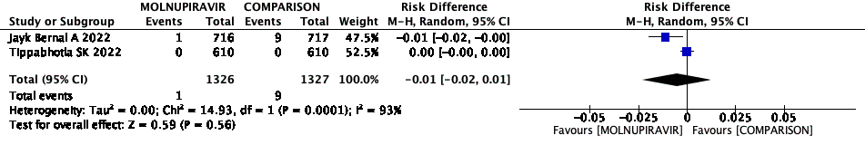
Additional figure 11. Effect of Molnupiravir compared to control on mortality of outpatients with mild COVID-19

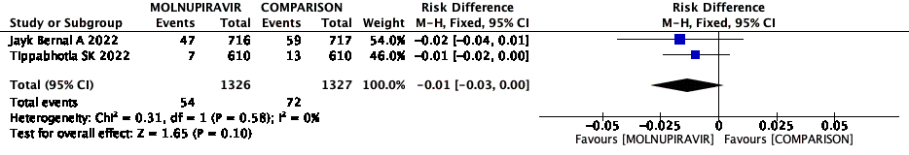
Additional figure 12. Effect of Molnupiravir compared to control on hospitalization of outpatients with mild COVID-19

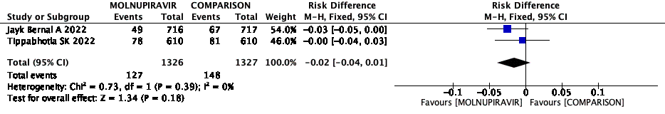
Additional figure 13. Effect of Molnupiravir compared to control on serious adverse events in outpatients with mild COVID-19

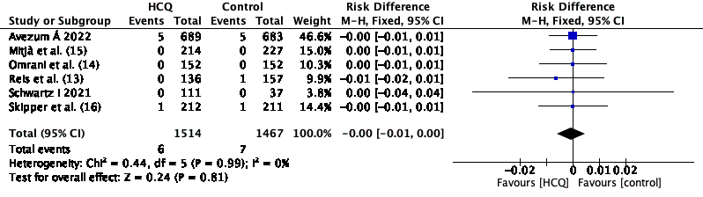
Additional figure 14. Effect of Hidroxychloroquine and Chloroquine compared to control on mortality of outpatients with mild COVID-19

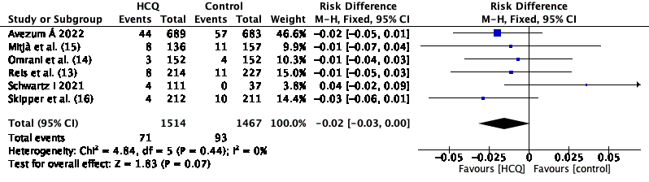
Additional figure 15. Effect of Hidroxychloroquine and Chloroquine compared to control on hospitalization of outpatients with mild COVID-19

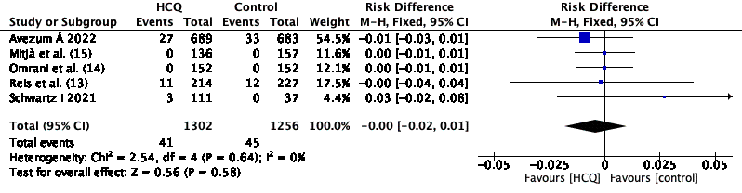
Additional figure 16. Effect of Hidroxychloroquine and Chloroquine compared to control on serious adverse events in outpatients with mild COVID-19

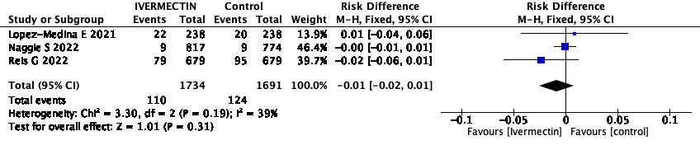
Additional figure 17. Effect of Ivermectin compared to control on hospitalization of outpatients with mild COVID-19

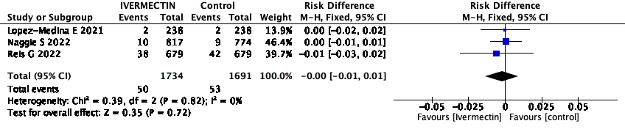
Additional figure 18. Effect of Ivermectin compared to control on serious adverse events in outpatients with mild COVID-19

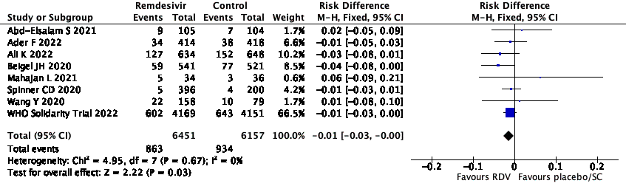
Additional figure 19. Effect of Remdesivir compared to control on mortality of hospitalized patients with severe COVID-19

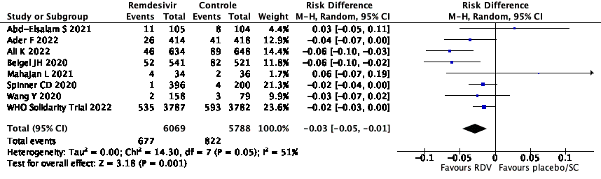
Additional figure 20. Effect of Remdesivir compared to control on mechanical ventilation of hospitalized patients with severe COVID-19

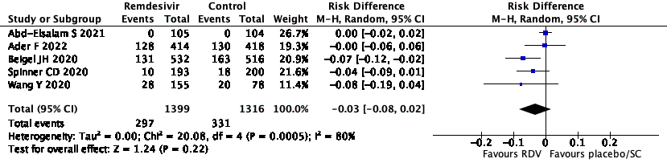
Additional figure 21. Effect of Remdesivir compared to control on serious adverse events in hospitalized patients with severe COVID-19

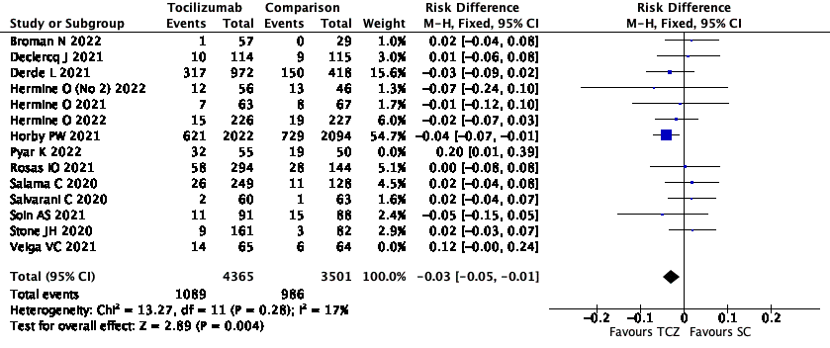
Additional figure 22. Effect of Tocilizumab compared to control on mortality in hospitalized patients with severe COVID-19

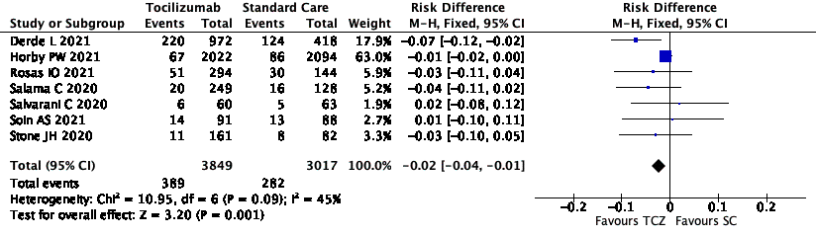
Additional figure 23. Effect of Tocilizumab compared to control on mechanical ventilation in hospitalized patients with severe COVID-19

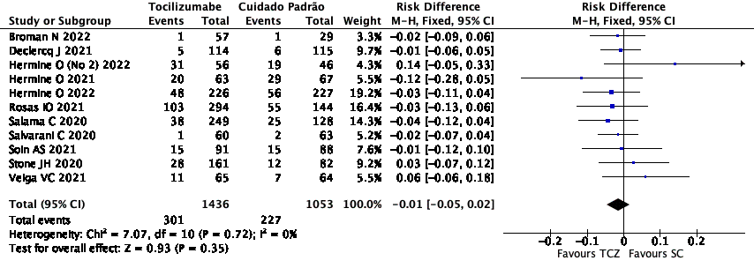
Additional figure 24. Effect of Tocilizumab compared to control on serious adverse events in hospitalized patients with severe COVID-19

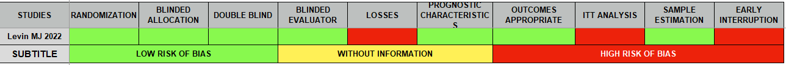
Additional figure 25. Risk of bias assessment for the study of Tixagevimab + Cilgavimab in COVID-19 pre-exposure prophylaxis

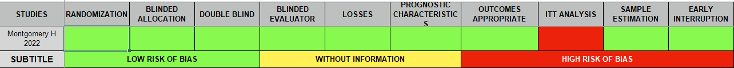
Additional figure 26. Risk of bias assessment for the study of Tixagevimab + Cilgavimab in outpatients with mild COVID-19

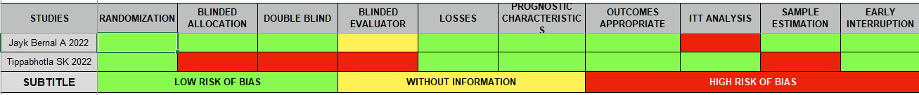
Additional figure 27. Risk of bias assessment for the studies of Molnupiravir in outpatients with mild COVID-19

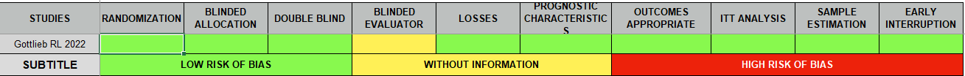
Additional figure 28. Risk of bias assessment for the study of Remdesivir in outpatients with mild COVID-19

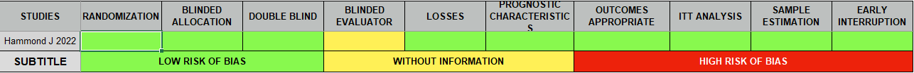
Additional figure 29. Risk of bias assessment for the study of Nirmatrelvir plus Ritonavir in outpatients with mild COVID-19

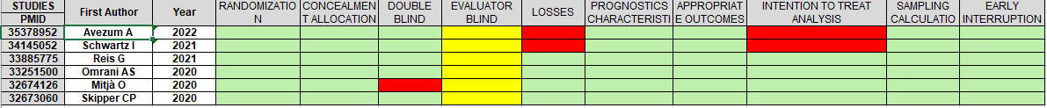
Additional figure 30. Risk of bias assessment for the studies of Hidroxychloroquine and Chloroquine in outpatients with mild COVID-19

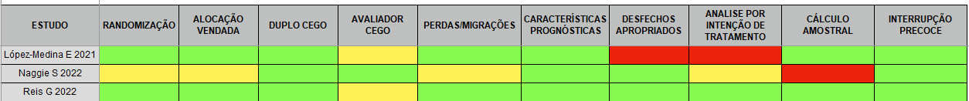
Additional figure 31. Risk of bias assessment for the studies of Ivermectin in outpatients with mild COVID-19

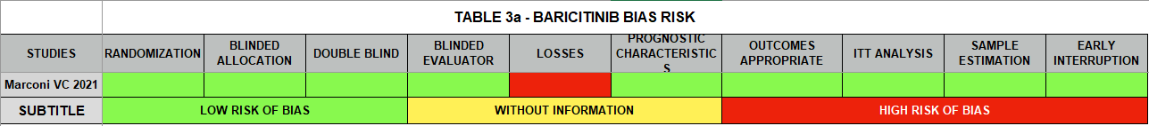
Additional figure 32. Risk of bias assessment for the study of Baricitinib in hospitalized patients with severe COVID-19

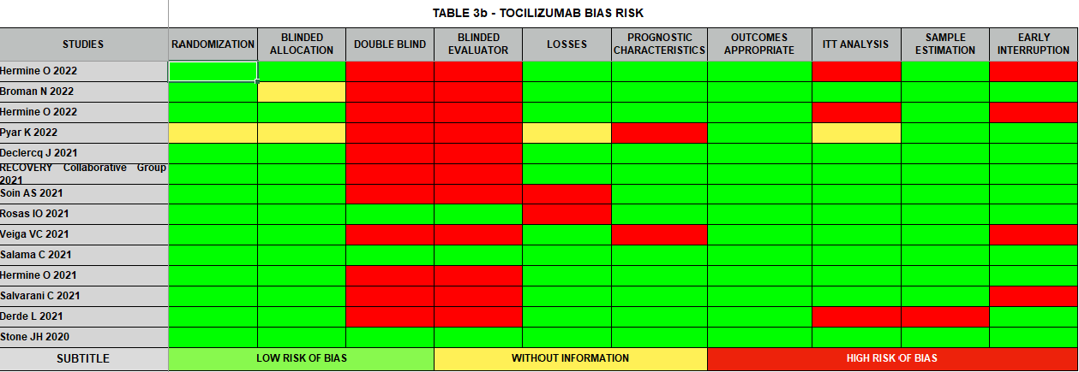
Additional figure 33. Risk of bias assessment for the studies of Tocilizumab in hospitalized patients with severe COVID-19

