Table S1. Normality tests for data from different groups of mice
Variables | Description | Kolmogorov-Smirnov |  |  | Shapiro-Wilk
Variables | Description | Statistic | df | Sig. | Statistic | df | Sig.
Log bacterial count | infected, treated by free-form | 0.203 | 9 | 0.200 | 0.904 | 9 | 0.278
Log bacterial count | infected, treated by a microencapsulated form | 0.196 | 9 | 0.200 | 0.925 | 9 | 0.436
Log bacterial count | infected, treated by vehicle | 0.152 | 9 | 0.200 | 0.960 | 9 | 0.793
Log bacterial count | infected, untreated | 0.194 | 9 | 0.200 | 0.894 | 9 | 0.222
Log bacterial count | uninfected, untreated | 0.000 | 3 | 0.000 | 0.000 | 3 | 0.000
Weight gain | infected, treated by free-form | 0.149 | 9 | 0.200 | 0.945 | 9 | 0.634
Weight gain | infected, treated by a microencapsulated form | 0.180 | 9 | 0.200 | 0.956 | 9 | 0.761
Weight gain | infected, treated by vehicle | 0.329 | 9 | 0.006 | 0.809 | 9 | 0.026
Weight gain | infected, untreated | 0.185 | 9 | 0.200 | 0.920 | 9 | 0.396
Weight gain | uninfected, untreated | 0.213 | 3 | 0.000 | 0.990 | 3 | 0.809

The normality of the data was assessed using the Kolmogorov-Smirnov and Shapiro-Wilk tests. Results, in Table S1, showed that the log bacterial count data followed a normal distribution for all groups (Figure S1). The weight gain data (Figure S2) were normally distributed for all groups except the infected, treated by vehicle group, which revealed a substantial deviation from normality (p < 0.05).

Table S2. Levene’s test for homogeneity of variances
 |  | Levine’s test | df1 | df2 | Sig.
Log bacterial count | Based on Mean | 1.805 | 4 | 34 | 0.151
Log bacterial count | Based on Median | 1.135 | 4 | 34 | 0.357
Log bacterial count | Based on Median and with adjusted df | 1.135 | 4 | 29.117 | 0.359
Log bacterial count | Based on trimmed mean | 1.766 | 4 | 34 | 0.158
The level of significance p-value was set at 0.05. The homogeneity of variances assumption was tested using Levene’s test. Results in Table S2 revealed that there were no significant differences in the variances of the log bacterial count among the five groups, regardless of the method employed for Levene's test (p > 0.05), Sig, significance..

Table S3. Analysis of variance (ANOVA)
 |  | Sum of Squares | df | Mean Square | F | Sig.
Log bacterial count | Between Groups | 40.102 | 4 | 10.025 | 145.946 | 0.000
Log bacterial count | Within Groups | 2.336 | 34 | 0.069 | 145.946 | 0.000
Log bacterial count | Total | 42.437 | 38
Weight gain | Between Groups | 37728.986 | 4 | 9432.246 | 99.993 | 0.000
Weight gain | Within Groups | 3207.198 | 34 | 94.329 | 99.993 | 0.000
Weight gain | Total | 40936.184 | 38
The level of significance p-value was set at 0.05. Analysis of variance. A one-way ANOVA was performed to investigate the effects of different interventions on log bacterial count and mice weight. The findings are presented in Table S3. The findings revealed a statistically significant disparity in the logarithmic bacterial count and mice weight among at least two treatment groups (p < 0.001). These findings indicate that the treatments had distinct impacts on both the bacterial infection and the mice weight. Sig, significance.

Table S4. Genomic annotation analysis and the resulting open reading frames (ORFs) of the phage vB_ST_E15. (https://www.ncbi.nlm.nih.gov/nuccore/OR757455)
ORF | Start | Stop | Strand | Putative Function
1 | 2 | 676 | + | Phage terminase, small subunit
2 | 822 | 2297 | + | Phage terminase, large subunit
3 | 2732 | 2340 | - | Hypothetical protein
4 | 3454 | 5124 | + | Phage tail protein
5 | 5480 | 6136 | + | Phage peptidase
6 | 6147 | 7154 | + | Major phage capsid protein [Enterobacteriaceae]
7 | 7167 | 7559 | + | Phage Hypothetical Protein
8 | 8236 | 8841 | + | Phage Hypothetical Protein
9 | 8841 | 11318 | + | Phage Hypothetical Protein
10 | 11318 | 11782 | + | Phage Hypothetical Protein
11 | 11782 | 12324 | + | Phage Hypothetical Protein
12 | 13409 | 14866 | + | Phage Hypothetical Protein
13 | 15200 | 16771 | + | Phage Hypothetical Protein
14 | 20230 | 23442 | + | Right-handed parallel beta-helix repeat-containing protein
15 | 24662 | 23484 | - | O-antigen ligase family protein
16 | 25037 | 25441 | + | Phage holin family protein
17 | 25811 | 26833 | + | Putative Phage glycoside hydrolase
18 | 27470 | 28402 | + | Phage tyrosine-type recombinase/integrase
19 | 29441 | 28863 | - | Putative Phage methyltransferase
20 | 29982 | 29608 | - | Putative transcriptional activator
21 | 31345 | 30323 | - | Phage recombination protein RecT
22 | 32251 | 31355 | - | Phage endonuclease/ recombinase protein
23 | 32574 | 32251 | - | Phage hypothetical protein
24 | 33522 | 32926 | - | Phage helix-turn-helix transcriptional regulator
25 | 34370 | 35365 | + | Phage protein
26 | 35414 | 36091 | + | DNA T-like ssDNA-binding domain-containing protein
27 | 36222 | 36686 | + | Crossover junction endodeoxyribonuclease RuvC
28 | 36743 | 37438 | + | Eae-like protein [Salmonella phage epsilon15]
29 | 37435 | 38268 | + | ead/Ea22-like family protein
30 | 38270 | 38488 | + | Unnamed protein product
31 | 38492 | 39247 | + | DUF551 domain-containing protein
32 | 39512 | 39850 | + | Hypothetical protein

Table S5. Genomic annotation analysis and the resulting open reading frames (ORFs) of the phage VB_ST_SPNIS2. ( https://www.ncbi.nlm.nih.gov/nuccore/OR757456)
ORF | Start | Stop | Strand | Function
1 | 1 | 594 | + | Terminase small subunit
2 | 591 | 2072 | + | Terminase [Salmonella enterica]
3 | 2611 | 2853 | + | Hypothetical protein
4 | 3308 | 4978 | + | Phage Tail Protein
5 | 5277 | 5987 | + | Peptidase [Citrobacter freundii]
6 | 5998 | 7005 | + | Phage capsid protein
7 | 7018 | 7410 | + | Hypothetical protein
8 | 8087 | 8692 | + | Hypothetical protein
9 | 8692 | 11169 | + | Hypothetical protein
10 | 11633 | 12175 | + | Hypothetical protein [Enterobacteriaceae]
11 | 12961 | 15018 | + | Phage Structural Protein
12 | 15015 | 16817 | + | Hypothetical protein
13 | 16822 | 19296 | + | Hypothetical protein
14 | 19541 | 19834 | + | Hypothetical protein
15 | 19957 | 20340 | + | Tail spike protein
16 | 20550 | 22280 | + | Tail spike protein
17 | 23140 | 22316 | - | Acyltransferase
18 | 23565 | 23188 | - | Acyltransferase [Salmonella enterica]
19 | 24182 | 23571 | - | Acyltransferase [Salmonella enterica]
20 | 24778 | 25182 | + | Putative Phage holin Protein
21 | 25552 | 26178 | + | Glycoside hydrolase family 19 protein [Salmonella enterica]
22 | 27211 | 28146 | + | Tyrosine-type recombinase/integrase
23 | 28955 | 28143 | - | Adenine methylase
24 | 30019 | 28952 | - | DGQHR domain-containing protein
25 | 30541 | 30167 | - | Putative transcriptional activator
26 | 31759 | 30878 | - | RecT family recombinase
27 | 32179 | 31769 | - | Endonuclease
28 | 32984 | 32160 | - | Exodeoxyribonuclease VIII
29 | 33304 | 32981 | - | HP
30 | 34252 | 33656 | - | Helix-turn-helix transcriptional regulator
31 | 35092 | 35847 | + | Pyocin large subunit
32 | 36731 | 37003 | + | Hypothetical protein
33 | 37015 | 37638 | + | Phage Protein
34 | 37889 | 38248 | + | eaf [Salmonella phage P22] Family of unknown function (DUF5448); pfam17526"
35 | 38390 | 38698 | + | Hypothetical protein

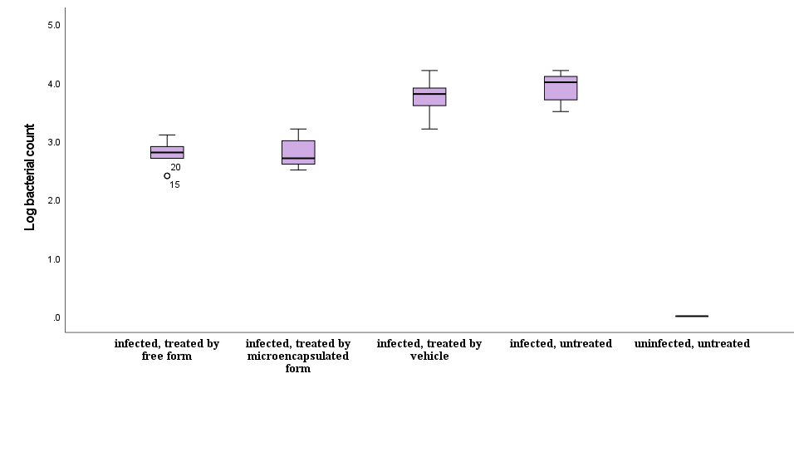
Figure S1. Log bacterial count of different groups of mice under various conditions. The y-axis represents the log bacterial count, and the x-axis represents the different groups: infected, treated by free form (FF); infected, treated by microencapsulated form (MF); infected, treated by vehicle (V); infected, untreated (I); uninfected, untreated (U). The pink boxes indicate the data distribution.

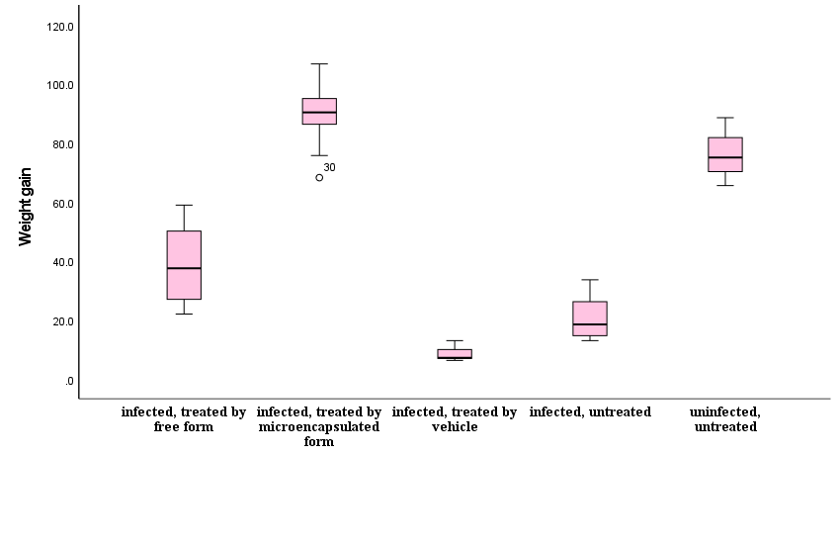
Figure S2. Weight gain of different groups of mice under various conditions. The y-axis represents the weight gain, and the x-axis represents the different groups: infected, treated by free form (FF); infected, treated by microencapsulated form (MF); infected, treated by vehicle (V); infected, untreated (I); uninfected, untreated (U). The pink boxes indicate the data distribution, and the circles indicate the outliers.

