List of Contents

The funnel plots and meta-regression of the Penicillins group
The funnel plot and meta-regression of the Monobactam
The funnel plot and meta-regression of the Fosfomycin
The funnel plots and meta-regression of the β-lactam combination agent
The funnel plots and meta-regression of the Carbapenems
The funnel plots and meta-regression of the Cephalosporins
The funnel plots and meta-regression of the Aminoglycosides
The funnel plots and meta-regression of the Tetracyclines
The funnel plots and meta-regression of the Fluoroquinolones
The funnel plots and meta-regression of the Sulfonamides
The funnel plot and meta-regression of the Colistin
The funnel plot meta-regression of the Chloramphenicol
The funnel plot and meta-regression of the Rifampin

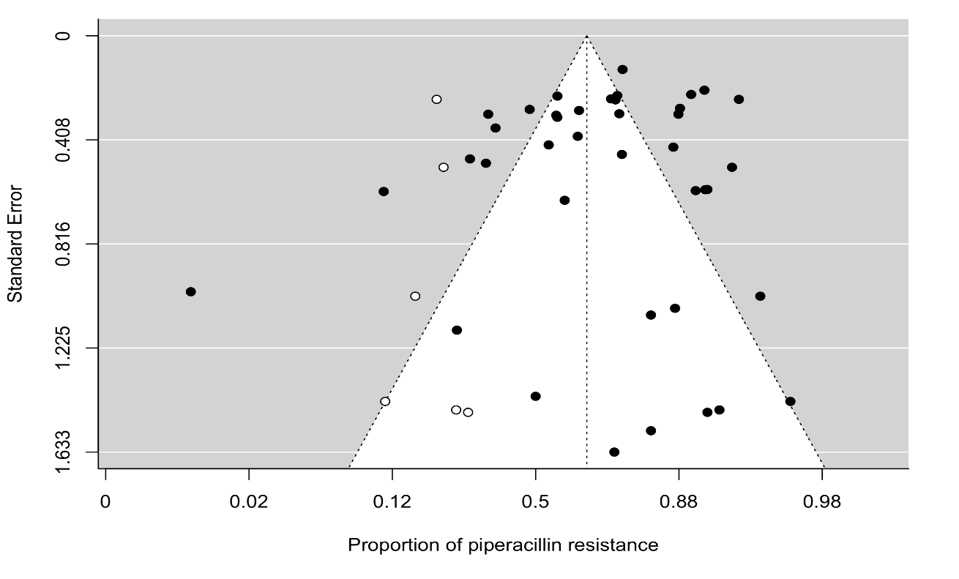
Figure 1. The funnel plot of meta-analysis of publication studies. Each black dot represents a study. The white dots represent missing studies. The black line in the middle represents the average effect size.
Penicillin group
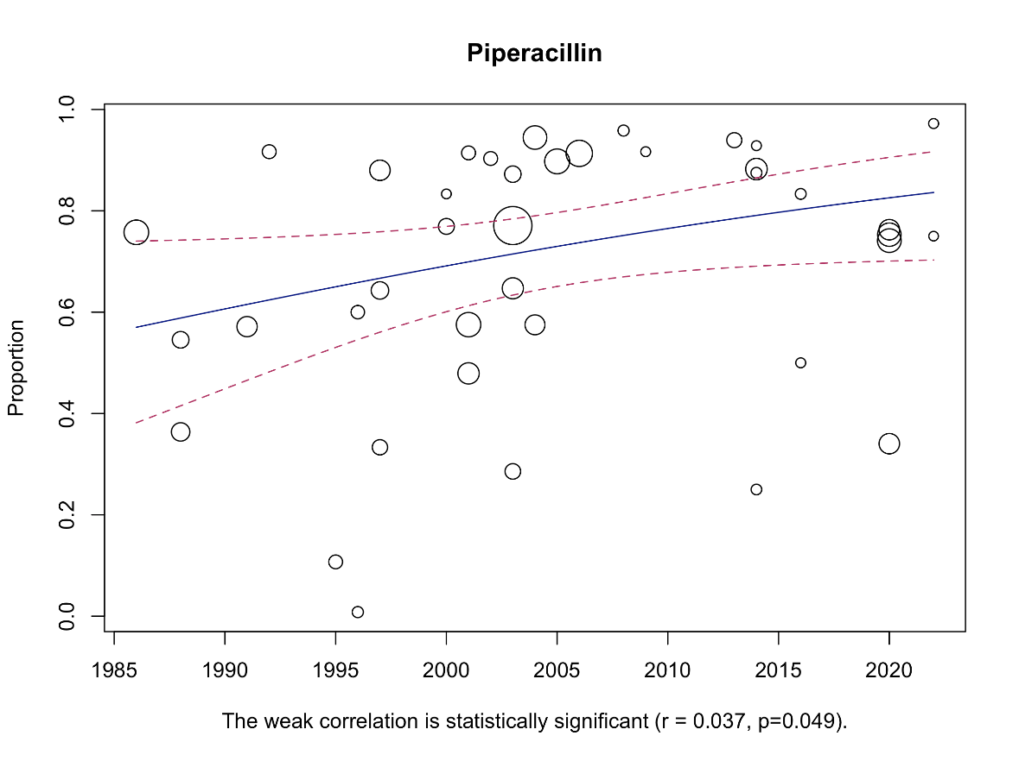

Figure 2. Bubble plot with fitted meta-regression for the year of publication.
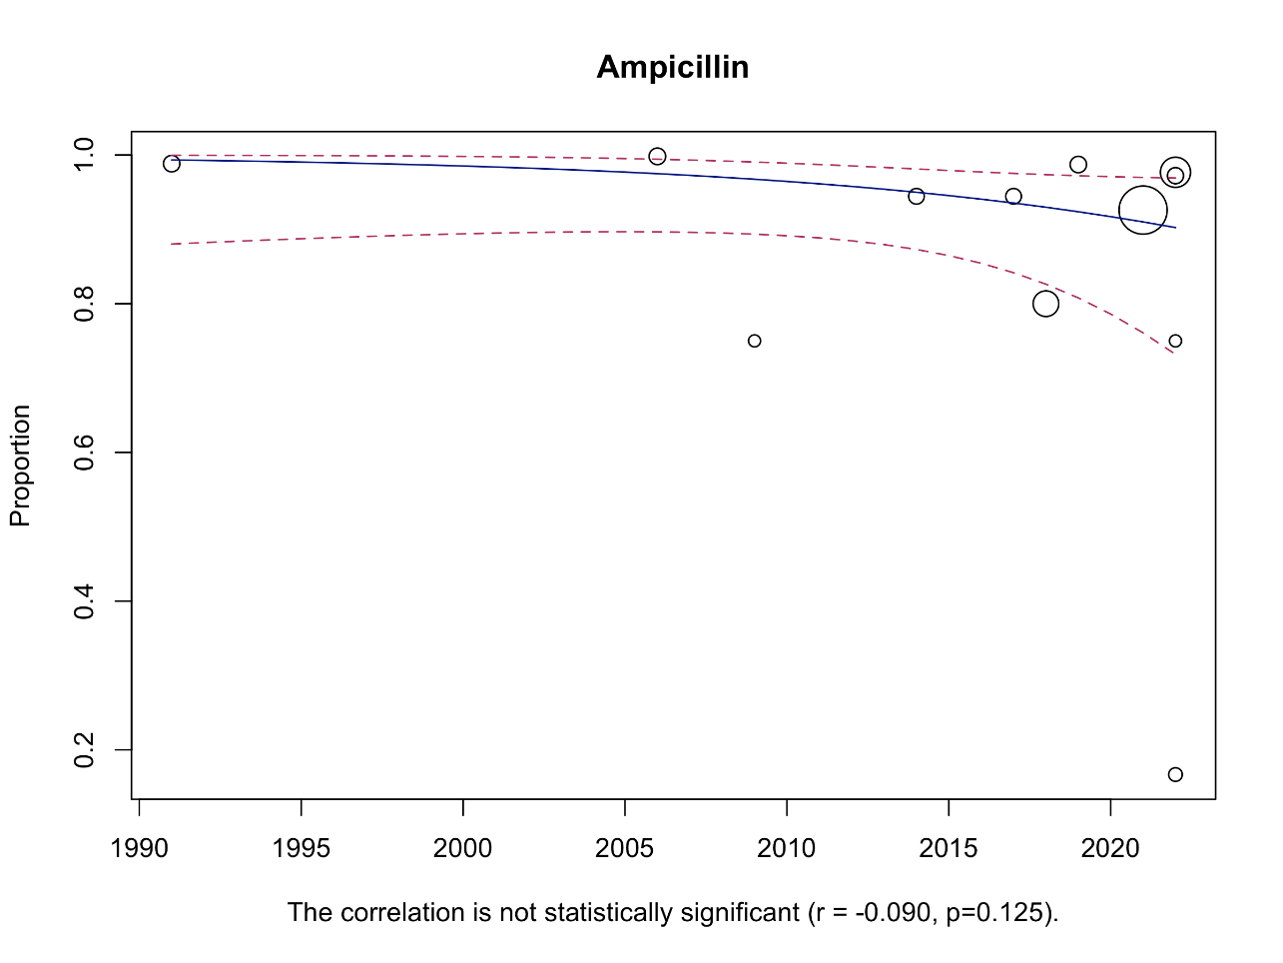
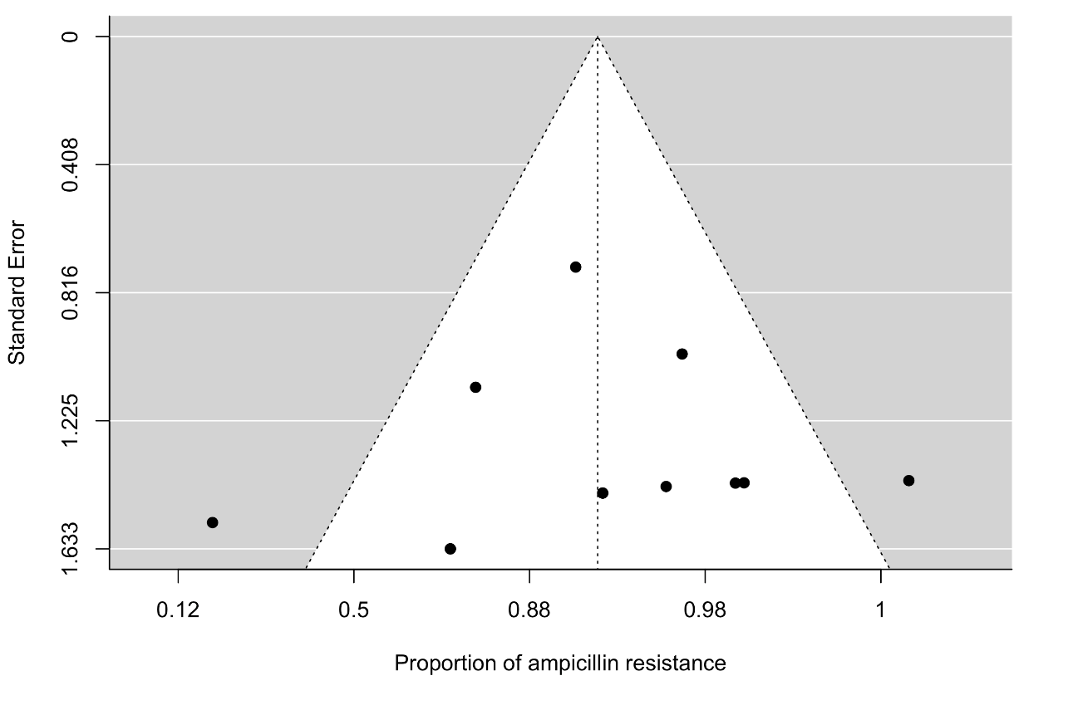
Figure 3. The funnel plot of meta-analysis of publication studies. Each black dot represents a study. The black line in the middle represents the average effect size.
Figure 4. Bubble plot with fitted meta-regression for the year of publication.
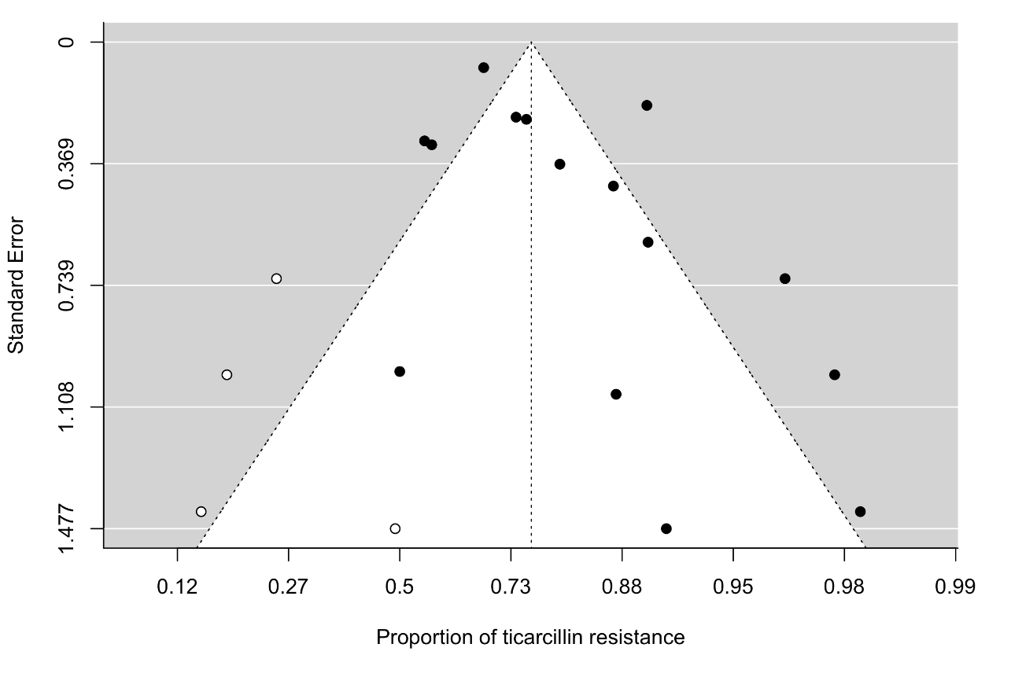

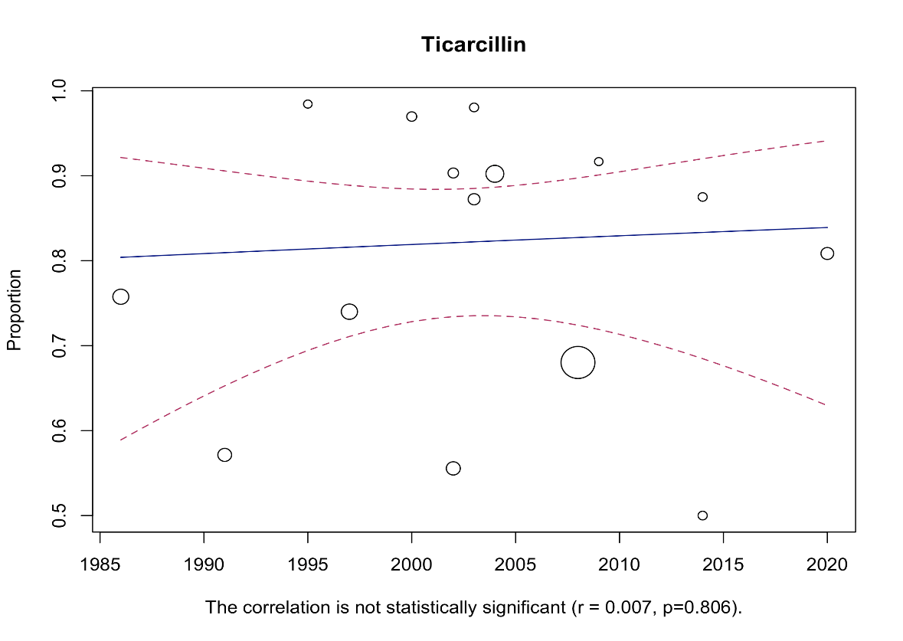
Figure 5. Bubble plot with fitted meta-regression for the year of publication.

Figure 6. The funnel plot of meta-analysis of publication studies. Each black dot represents a study. The white dots represent missing studies. The black line in the middle represents the average effect size.
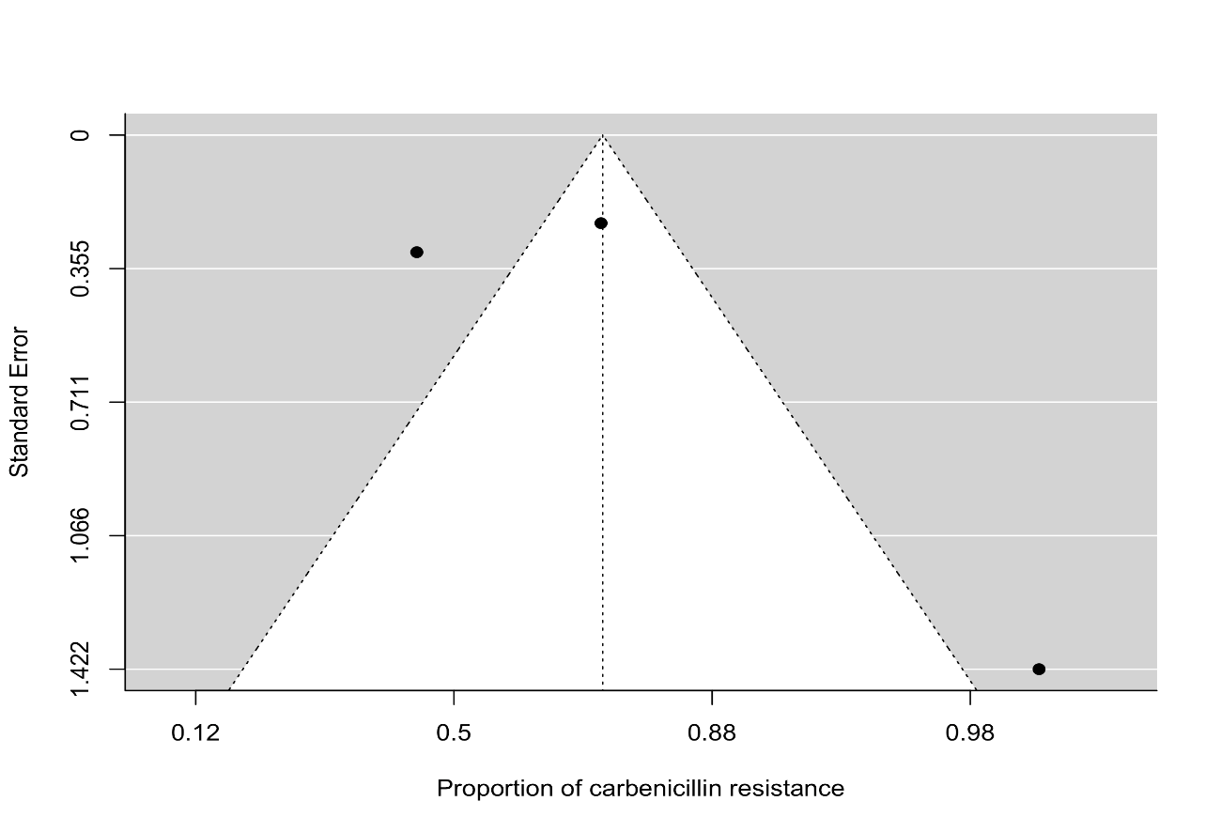
Figure 7. The funnel plot of meta-analysis of publication studies. Each black dot represents a study. The black line in the middle represents the average effect size
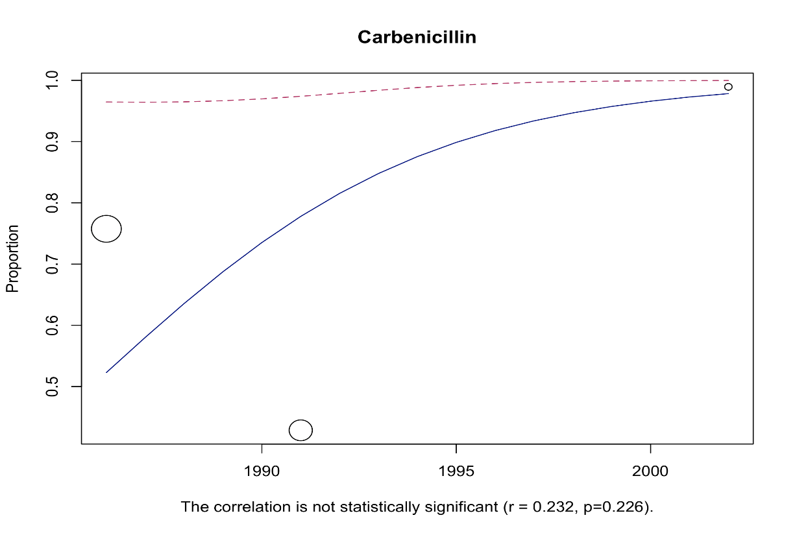
Figure 8. Bubble plot with fitted meta-regression for the year of publication.
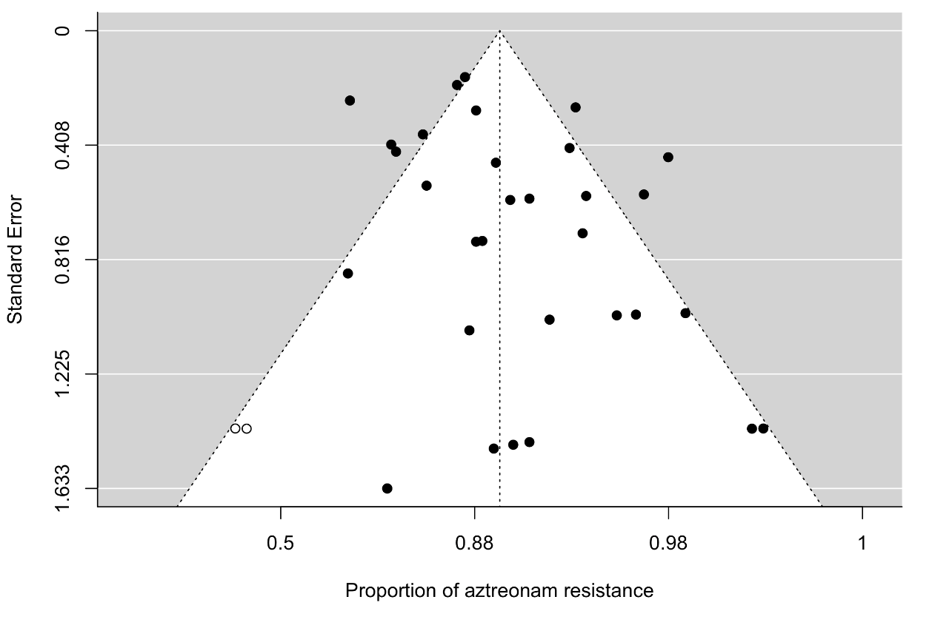
Monobactam
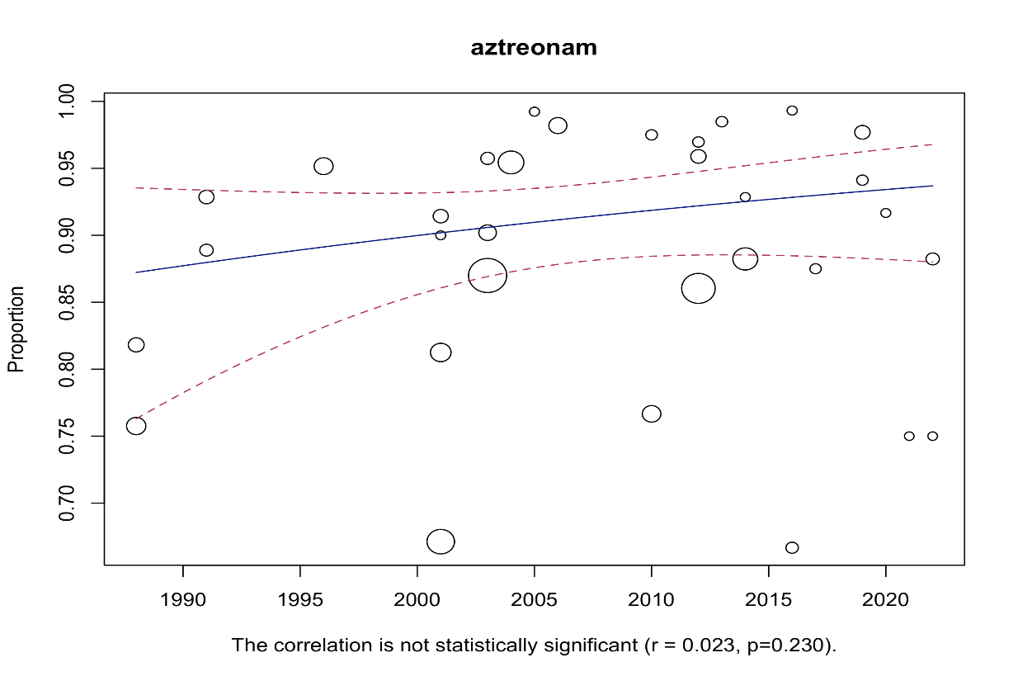
Figure 9. The funnel plot of meta-analysis of publication studies. Each black dot represents a study. The white dots represent missing studies. The black line in the middle represents the average effect size.

Figure 10. Bubble plot with fitted meta-regression for the year of publication.

Fosfomycin
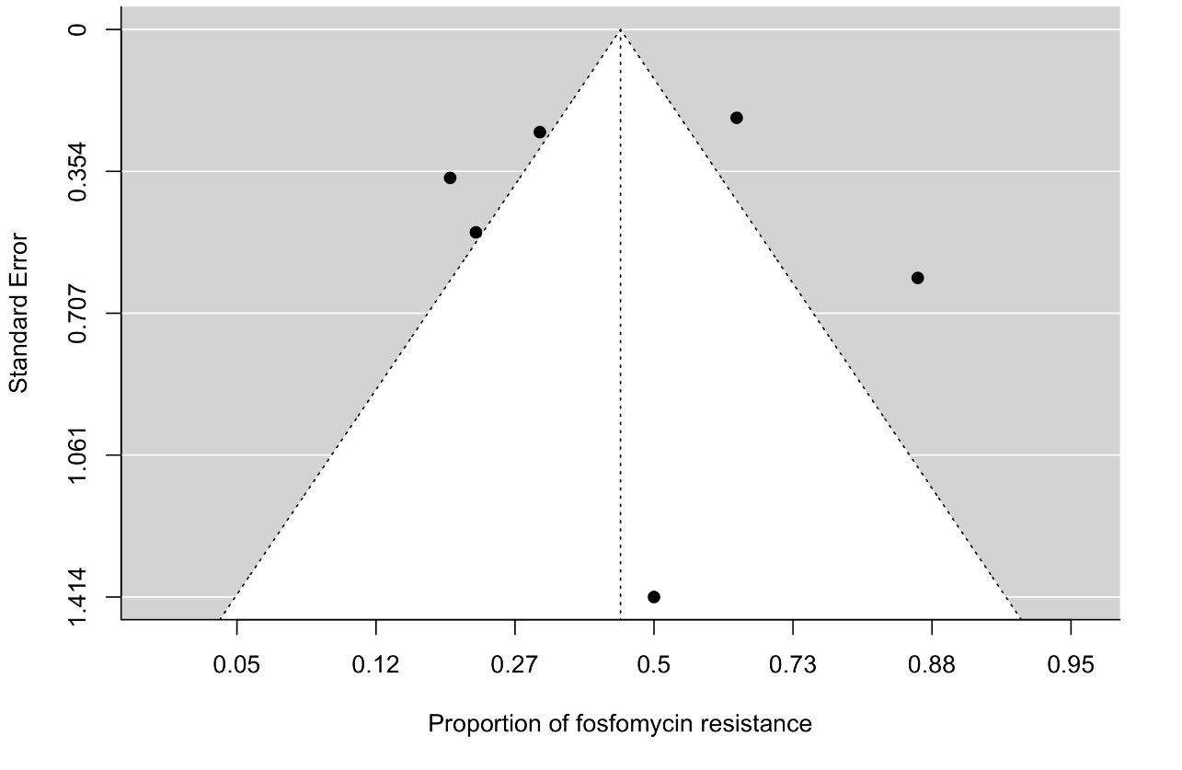

Figure 11. The funnel plot of meta-analysis of publication studies. Each black dot represents a study. The white dots represent missing studies. The black line in the middle represents the average effect size.
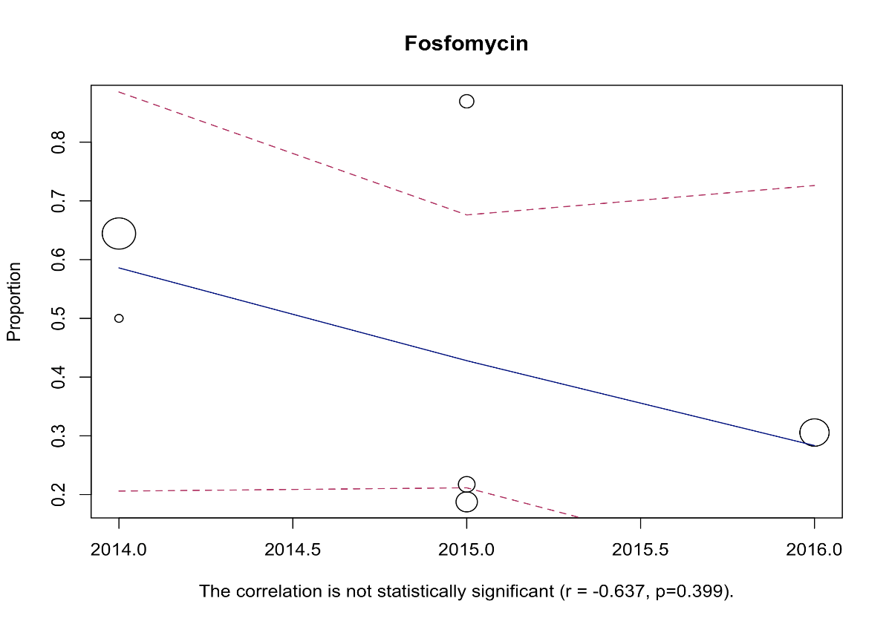

Figure 12. Bubble plot with fitted meta-regression for the year of publication.
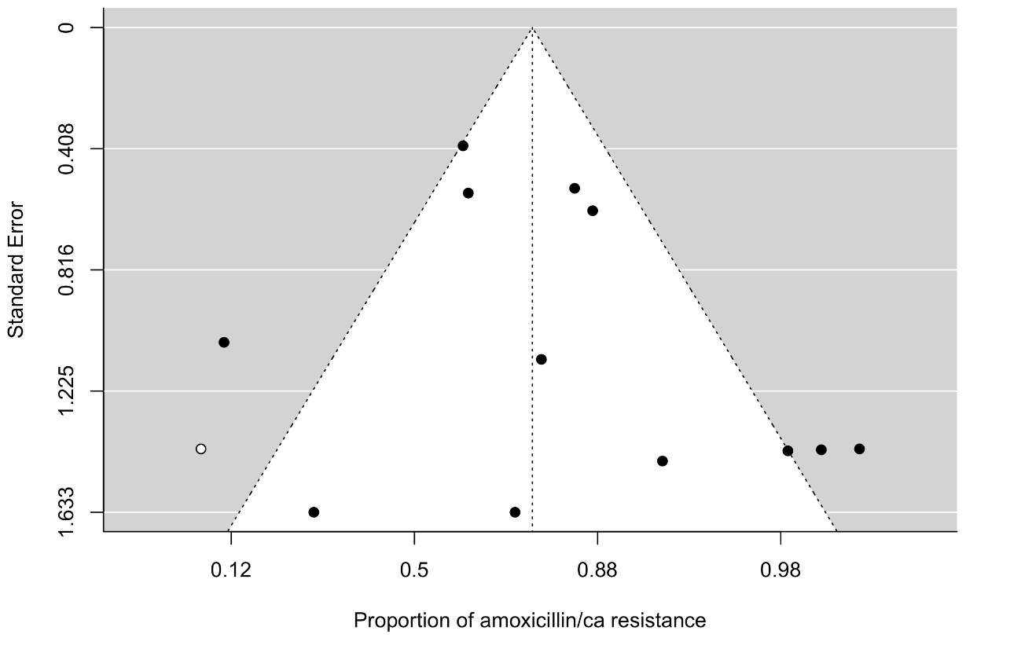
β-lactam combination agent
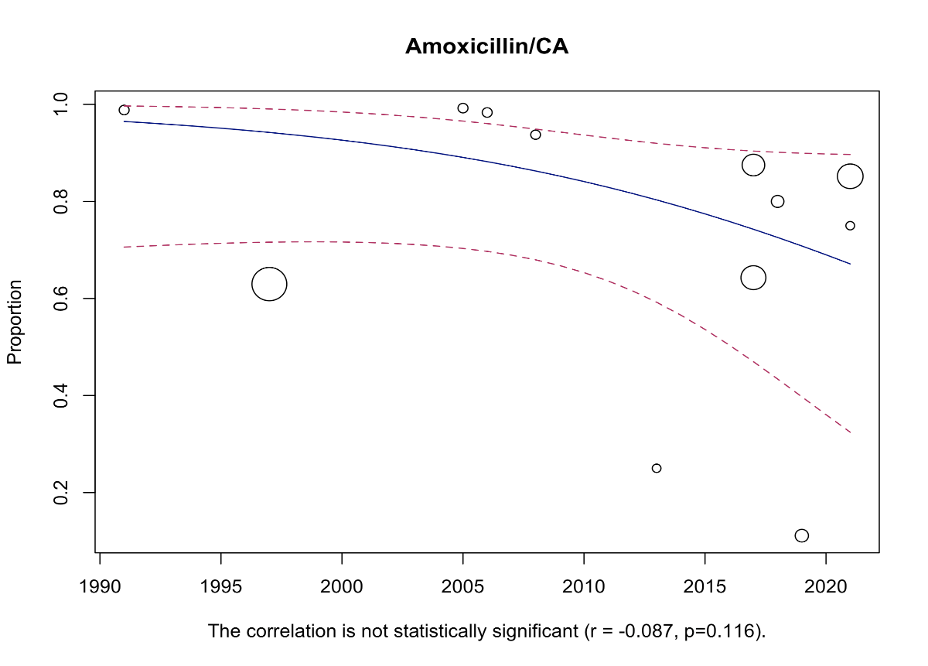
Figure 13. The funnel plot of meta-analysis of publication studies. Each black dot represents a study. The white dots represent missing studies. The black line in the middle represents the average effect size.

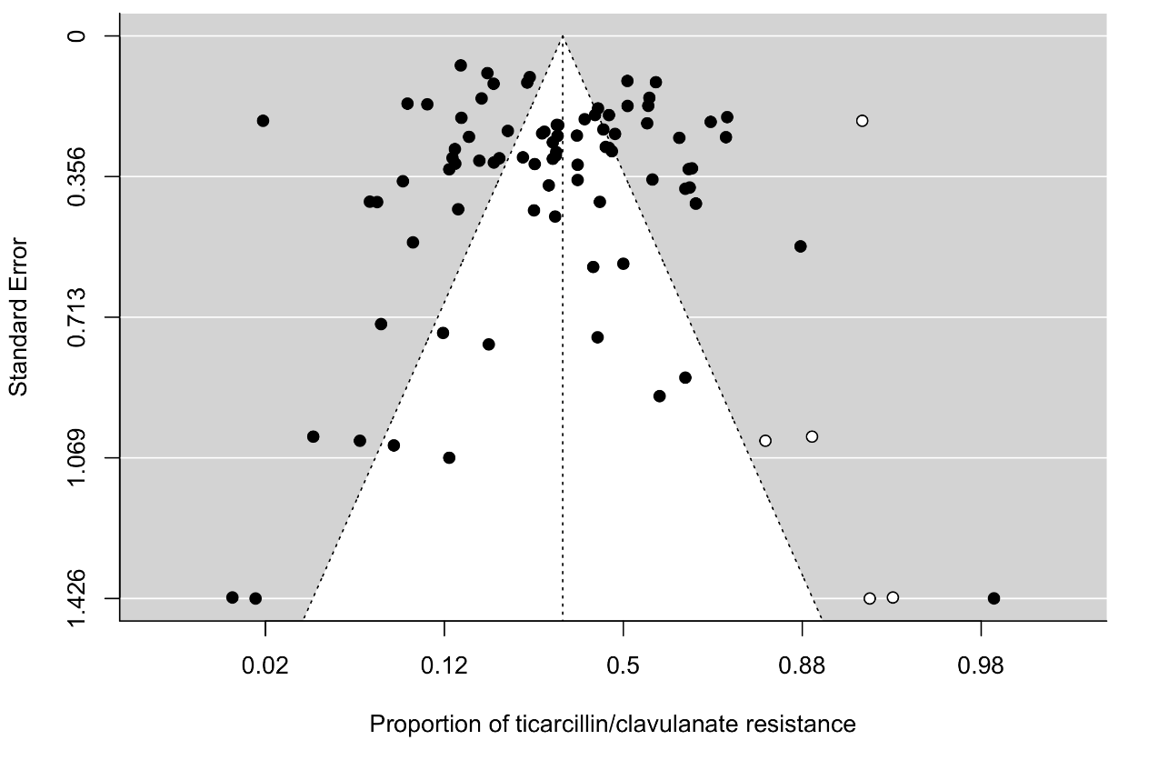
Figure 14. Bubble plot with fitted meta-regression for the year of publication.
Figure 15. The funnel plot of meta-analysis of publication studies. Each black dot represents a study. The white dots represent missing studies. The black line in the middle represents the average effect size.
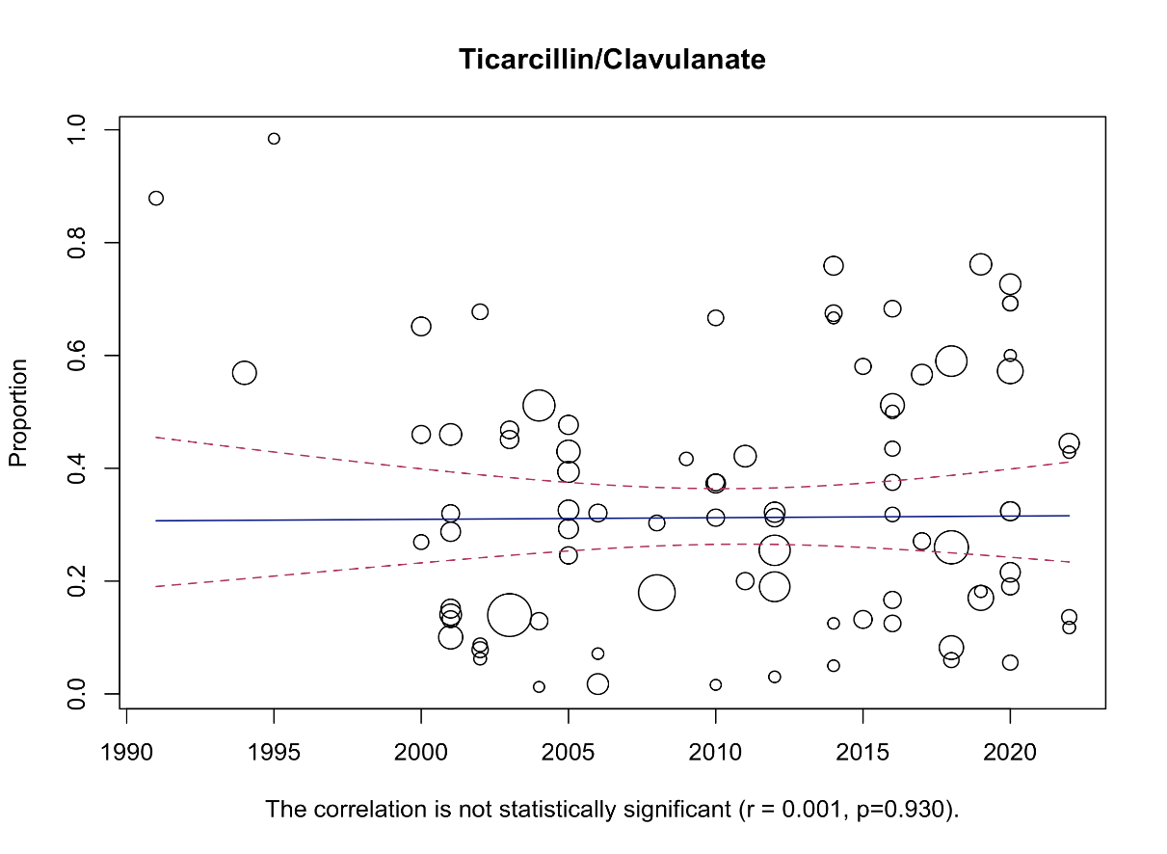

Figure 16. Bubble plot with fitted meta-regression for the year of publication.
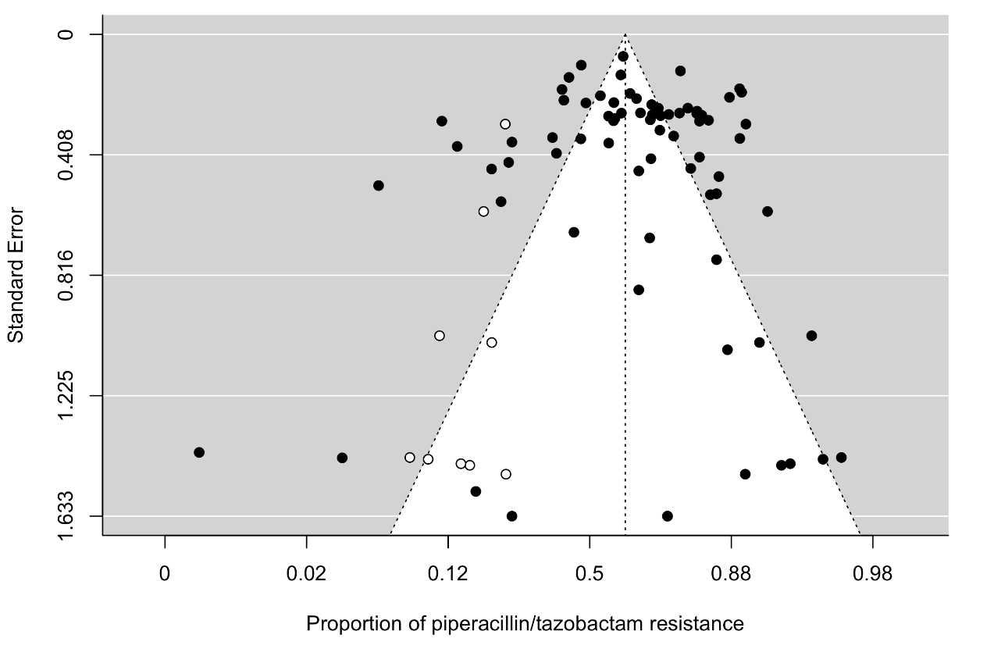

Figure 17. The funnel plot of meta-analysis of publication studies. Each black dot represents a study. The white dots represent missing studies. The black line in the middle represents the average effect size.
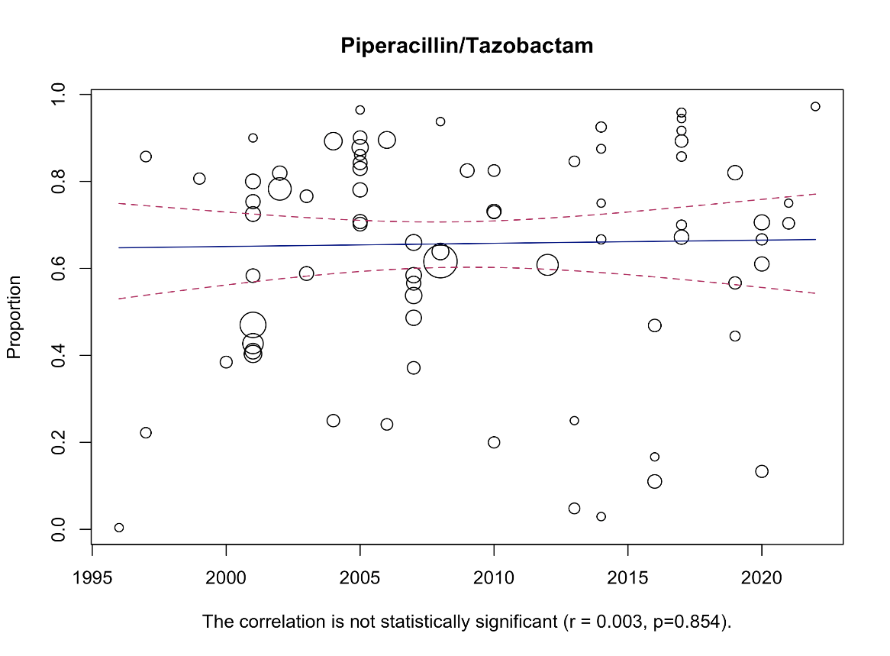

Figure 18. Bubble plot with fitted meta-regression for the year of publication.

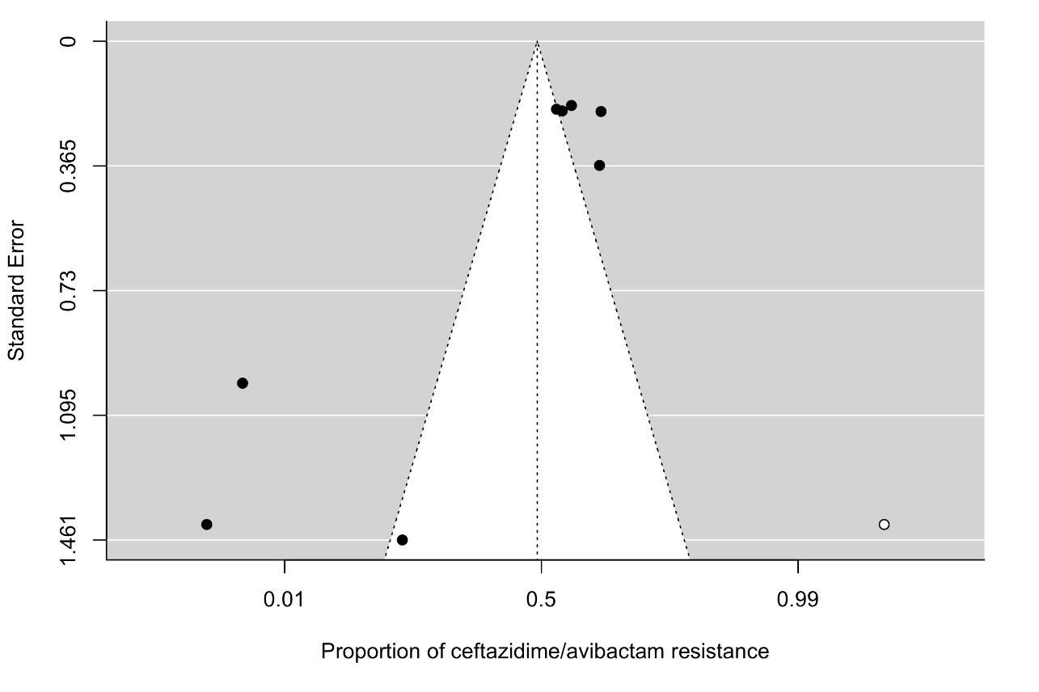
Figure 19. The funnel plot of meta-analysis of publication studies. Each black dot represents a study. The white dots represent missing studies. The black line in the middle represents the average effect size.
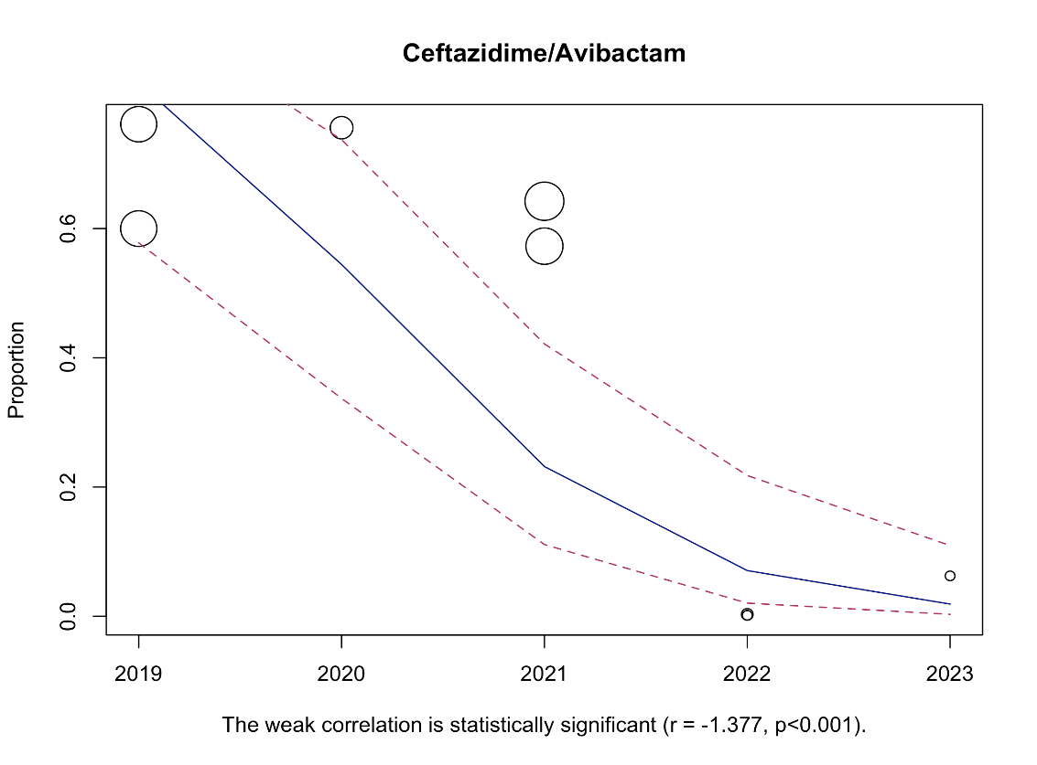

Figure 20. Bubble plot with fitted meta-regression for the year of publication.
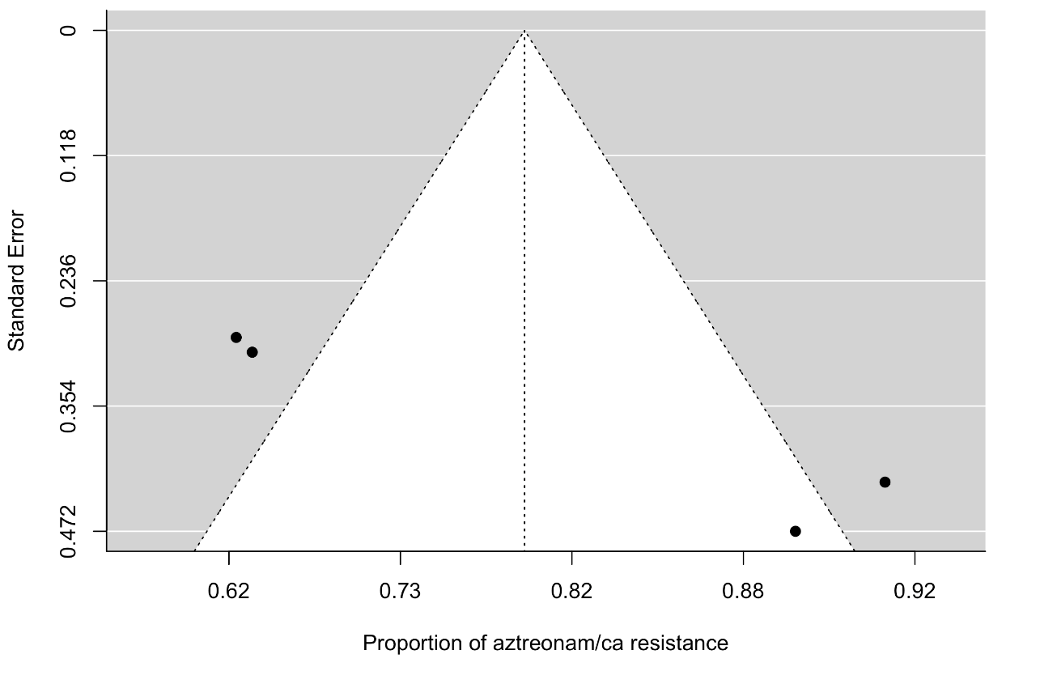
Figure 21. The funnel plot of meta-analysis of publication studies. Each black dot represents a study. The black line in the middle represents the average effect size.
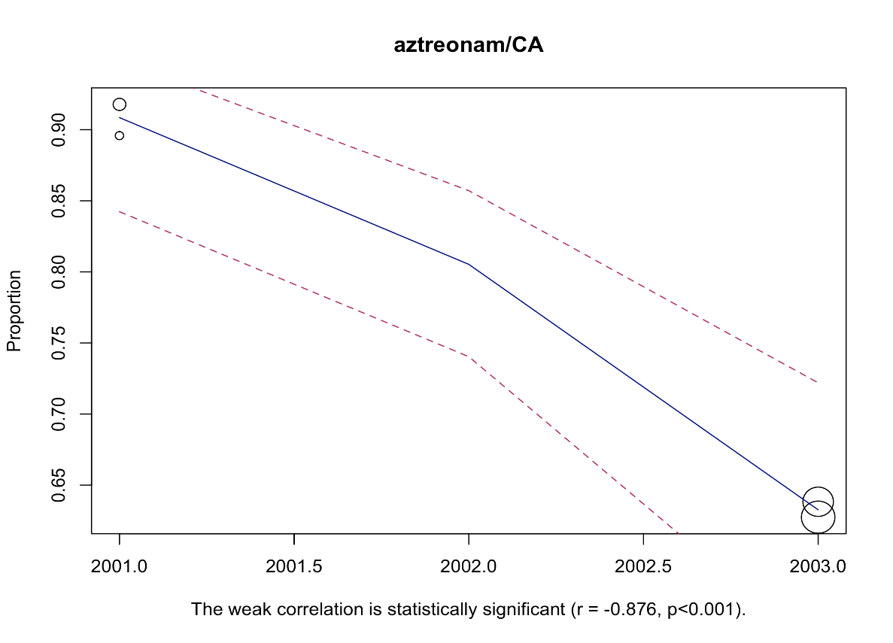

Figure 22. Bubble plot with fitted meta-regression for the year of publication.

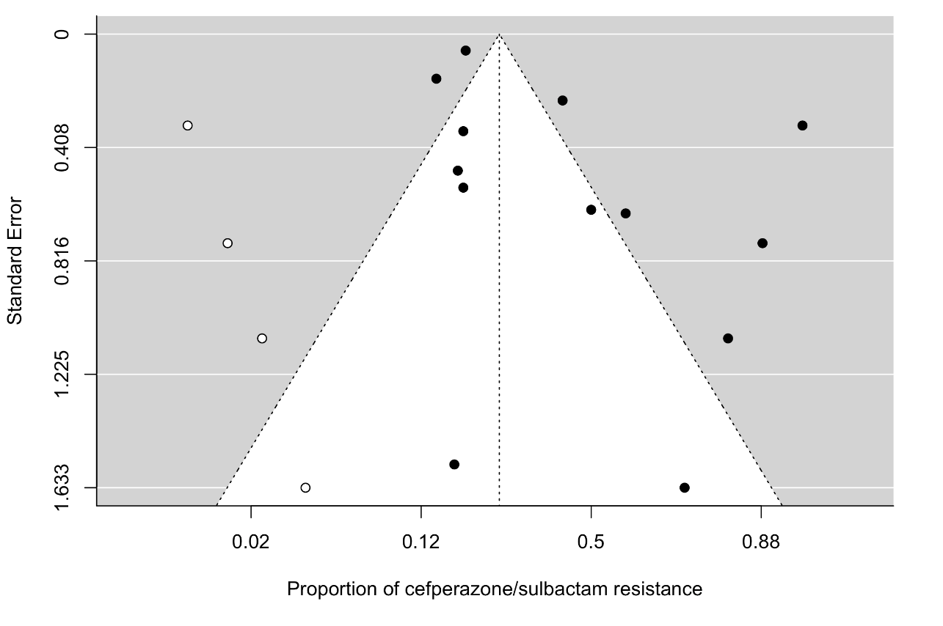
Figure 23. The funnel plot of meta-analysis of publication studies. Each black dot represents a study. The white dots represent missing studies. The black line in the middle represents the average effect size.
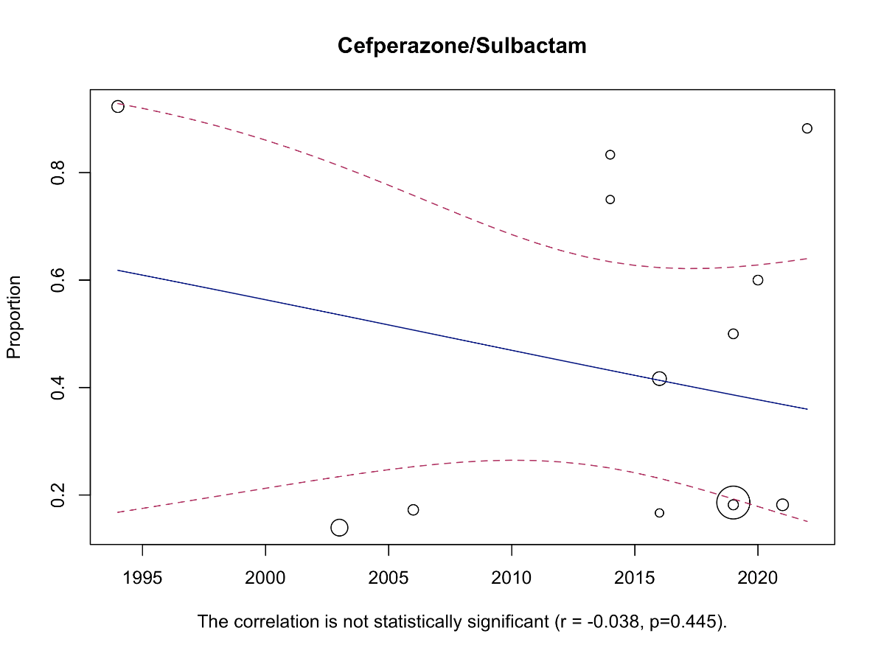

Figure 24. Bubble plot with fitted meta-regression for the year of publication.
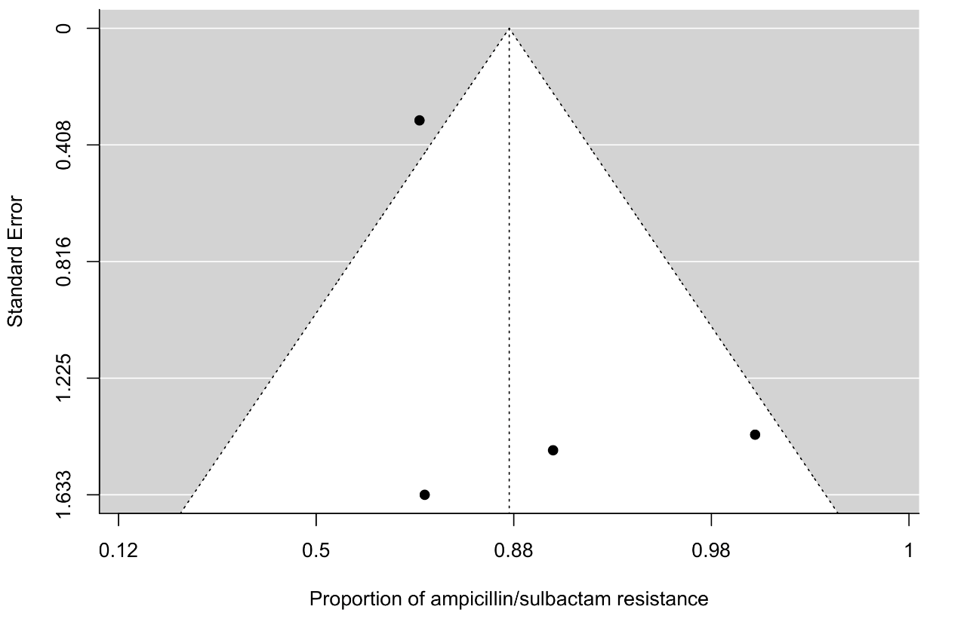
Figure 25. The funnel plot of meta-analysis of publication studies. Each black dot represents a study. The black line in the middle represents the average effect size.

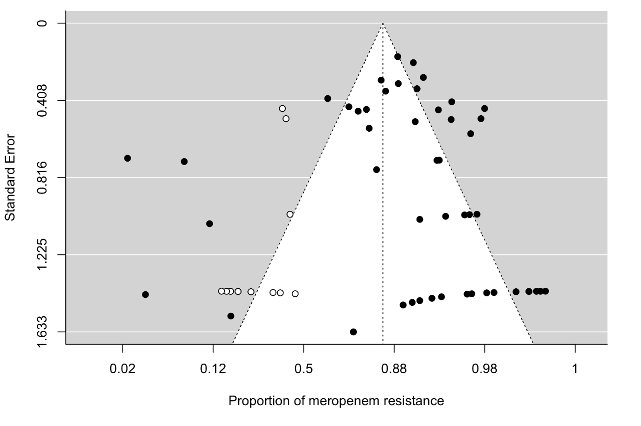
Carbapenems

Figure 26. The funnel plot of meta-analysis of publication studies. Each black dot represents a study. The white dots represent missing studies. The black line in the middle represents the average effect size.
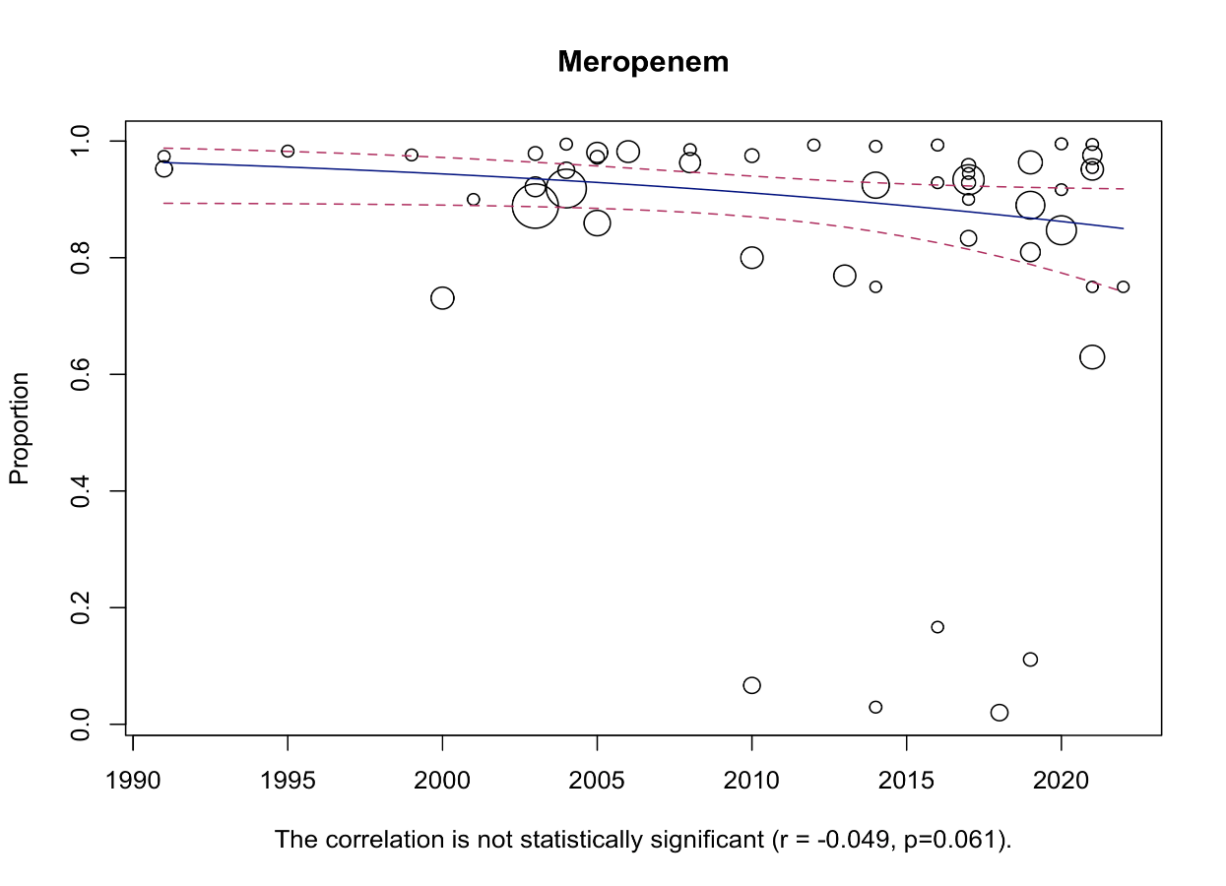

Figure 27. Bubble plot with fitted meta-regression for the year of publication
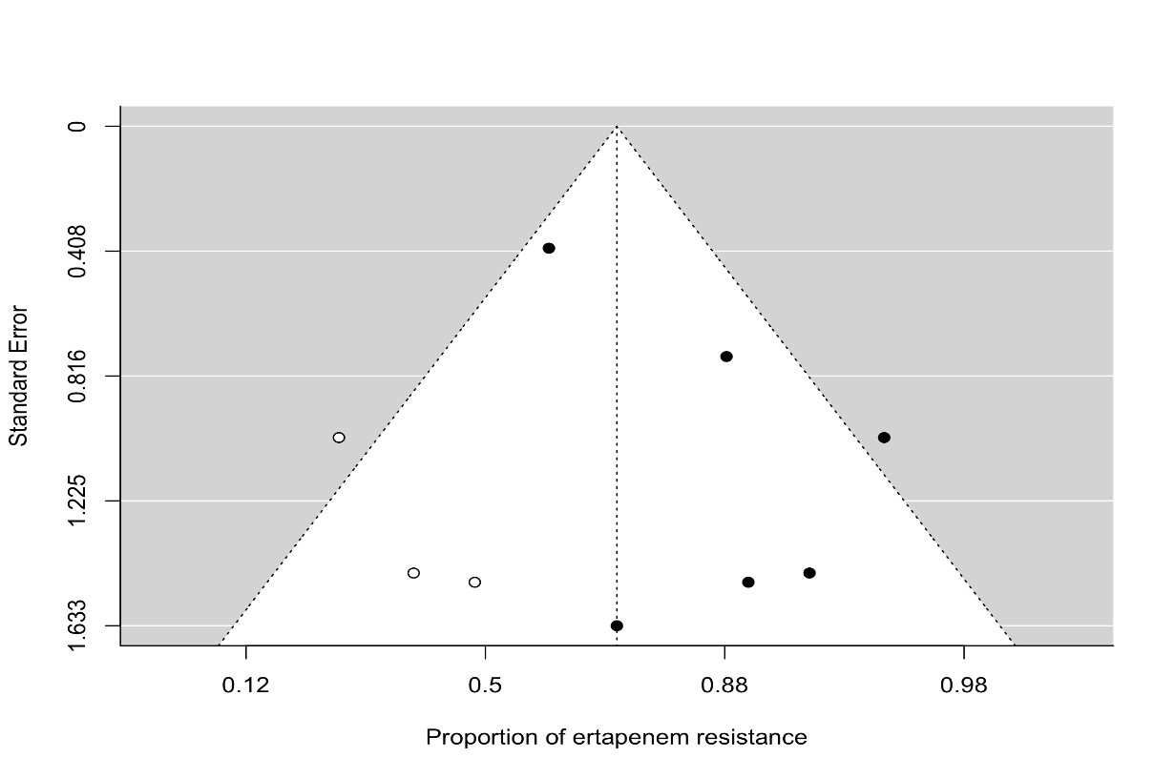
.
Figure 28. The funnel plot of meta-analysis of publication studies. Each black dot represents a study. The white dots represent missing studies. The black line in the middle represents the average effect size.

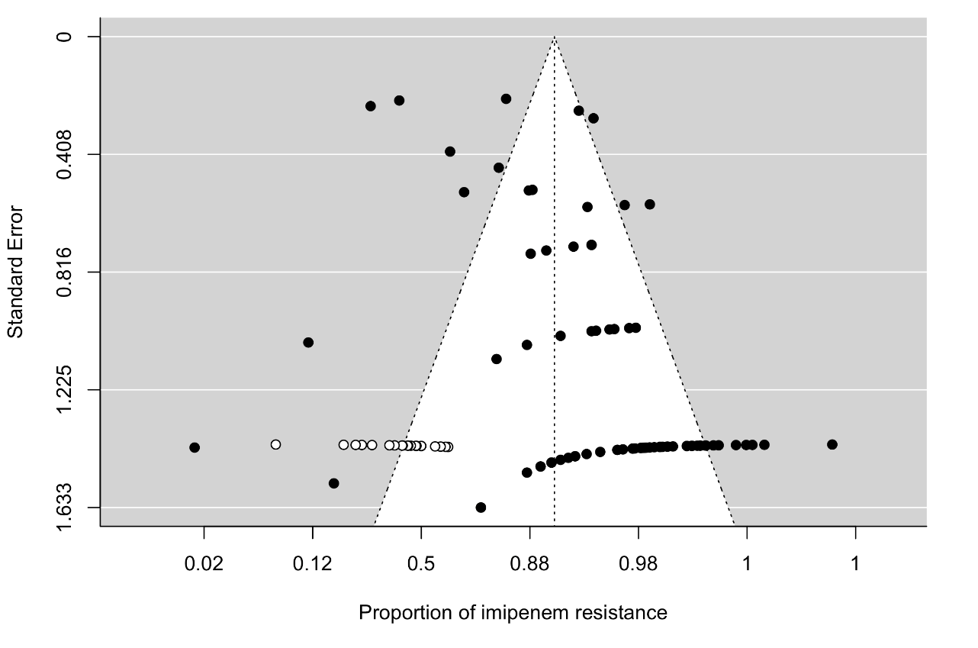
Figure 29. The funnel plot of meta-analysis of publication studies. Each black dot represents a study. The white dots represent missing studies. The black line in the middle represents the average effect size.
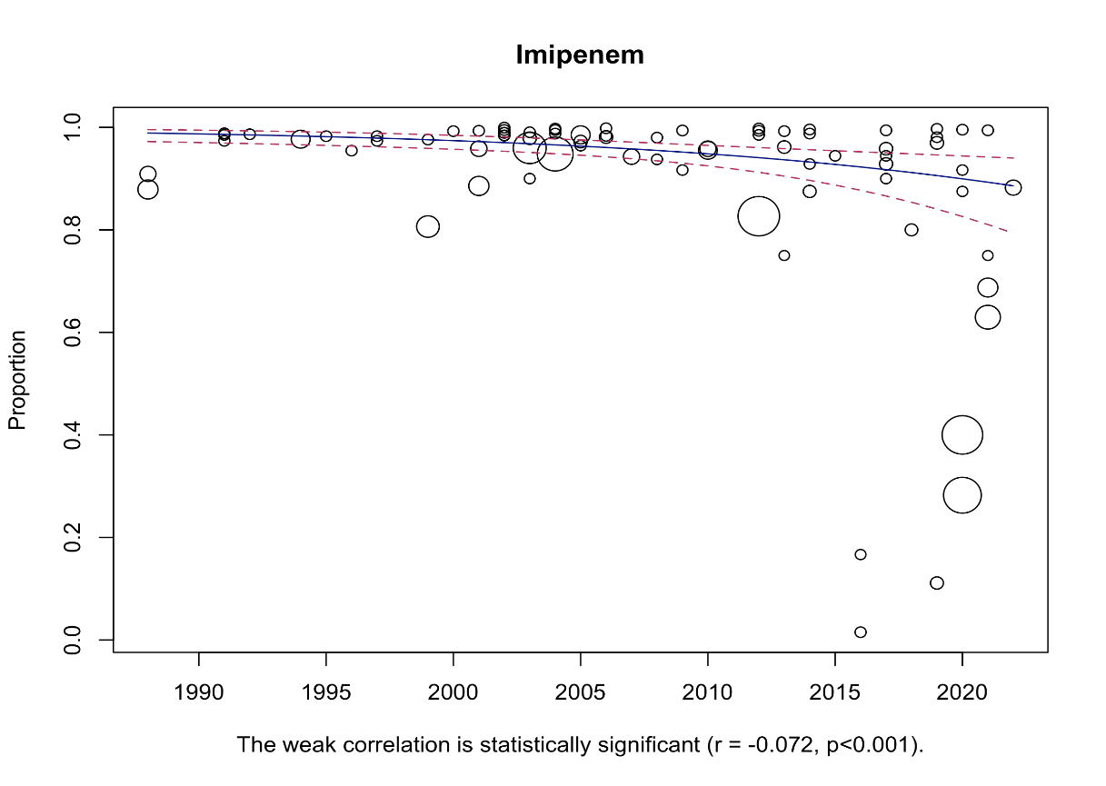
Figure 30. Bubble plot with fitted meta-regression for the year of publication.

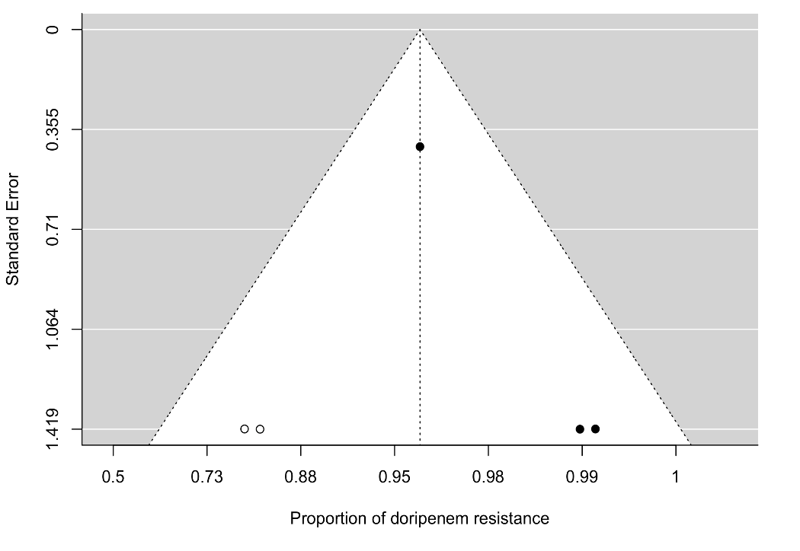

Figure 31. The funnel plot of meta-analysis of publication studies. Each black dot represents a study. The black line in the middle represents the average effect size

Cephalosporins

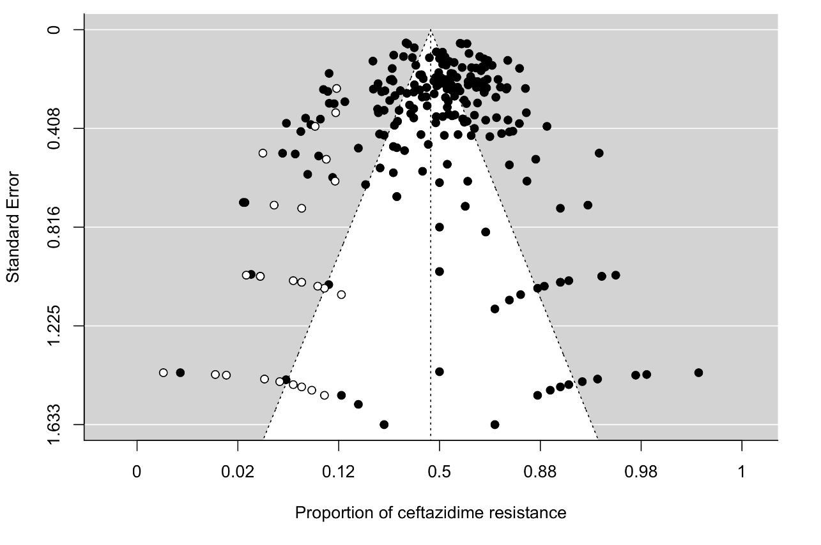
Figure 32. The funnel plot of meta-analysis of publication studies. Each black dot represents a study. The white dots represent missing studies. The black line in the middle represents the average effect size.
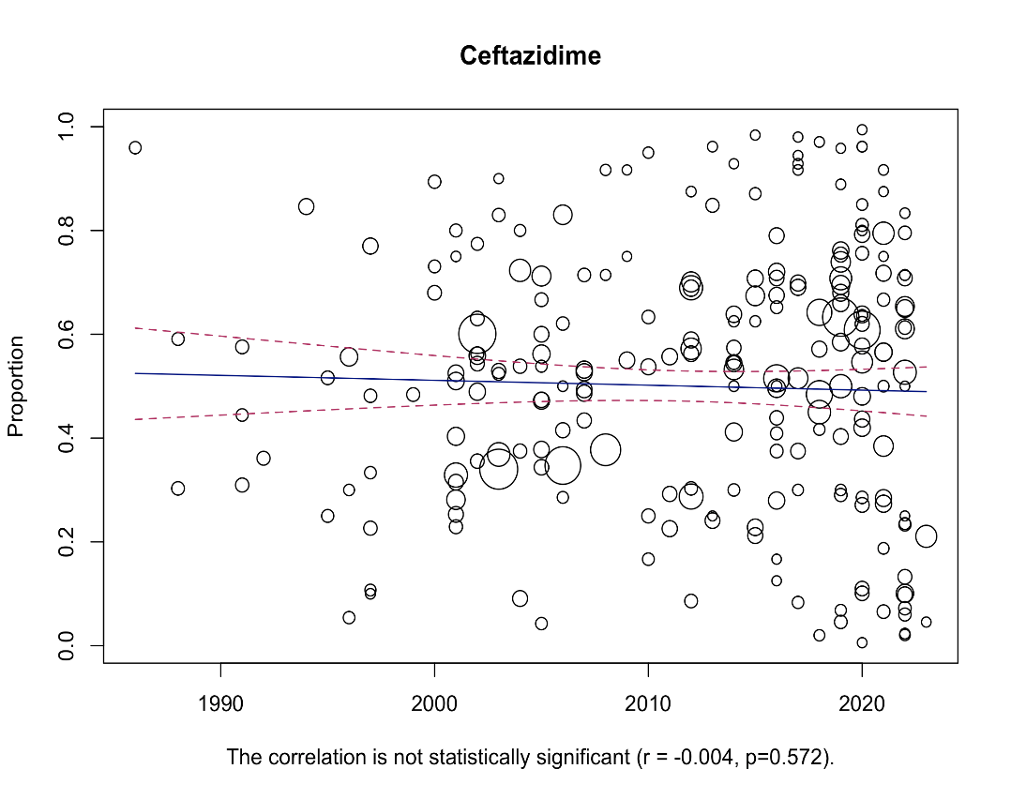

Figure 33. Bubble plot with fitted meta-regression for the year of publication.

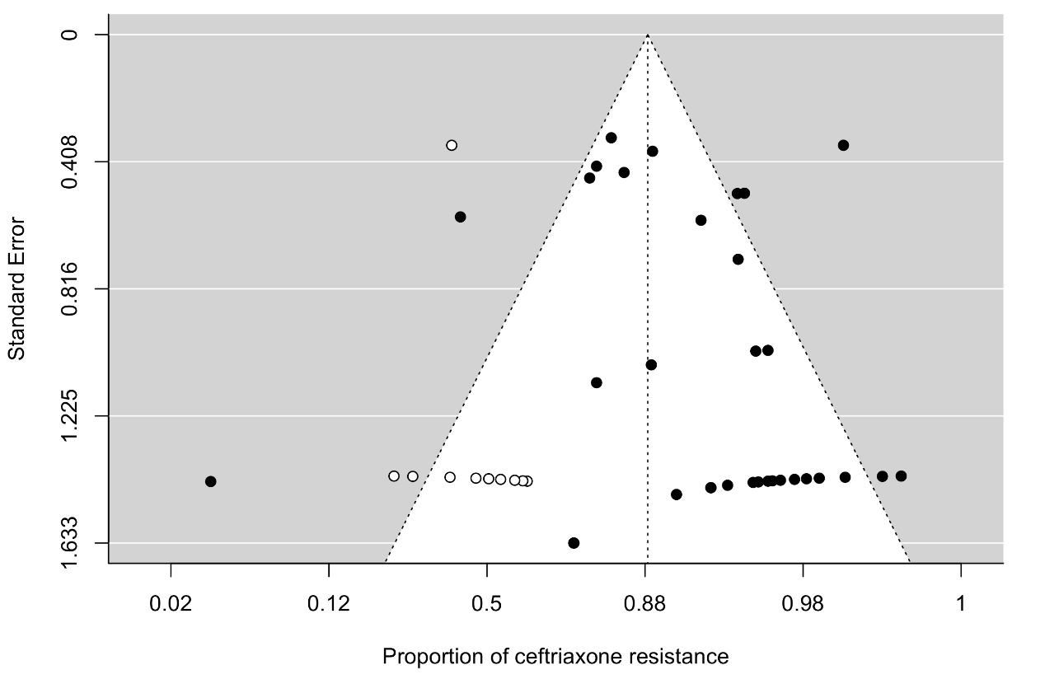
Figure 34. The funnel plot of meta-analysis of publication studies. Each black dot represents a study. The white dots represent missing studies. The black line in the middle represents the average effect size
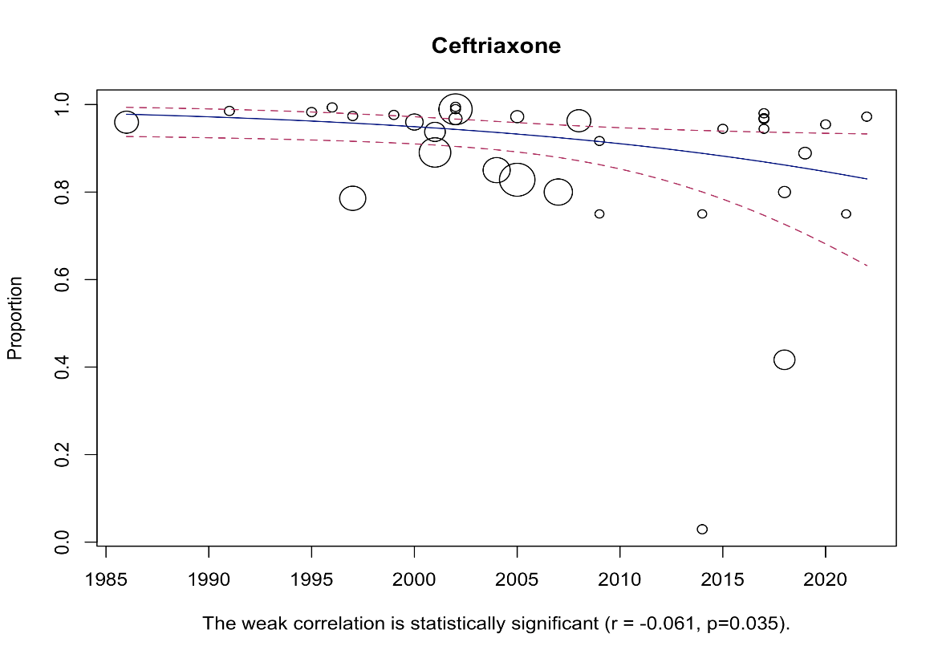

Figure 35. Bubble plot with fitted meta-regression for the year of publication.
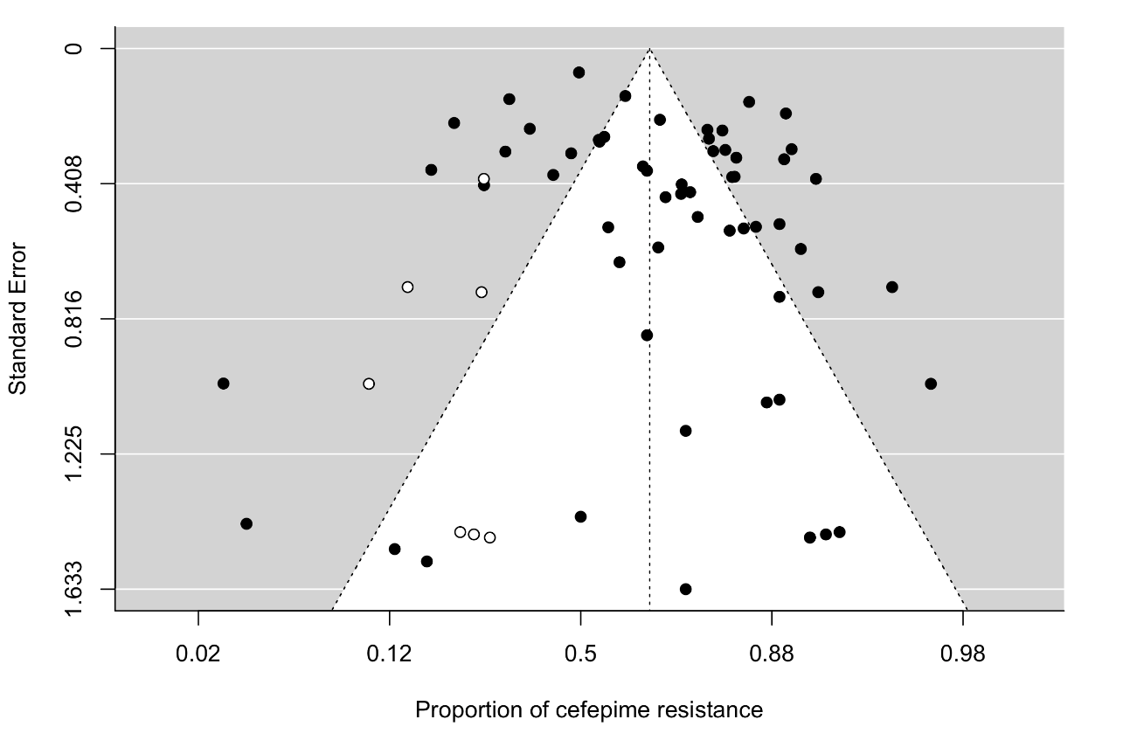
Figure 36. The funnel plot of meta-analysis of publication studies. Each black dot represents a study. The white dots represent missing studies. The black line in the middle represents the average effect size.
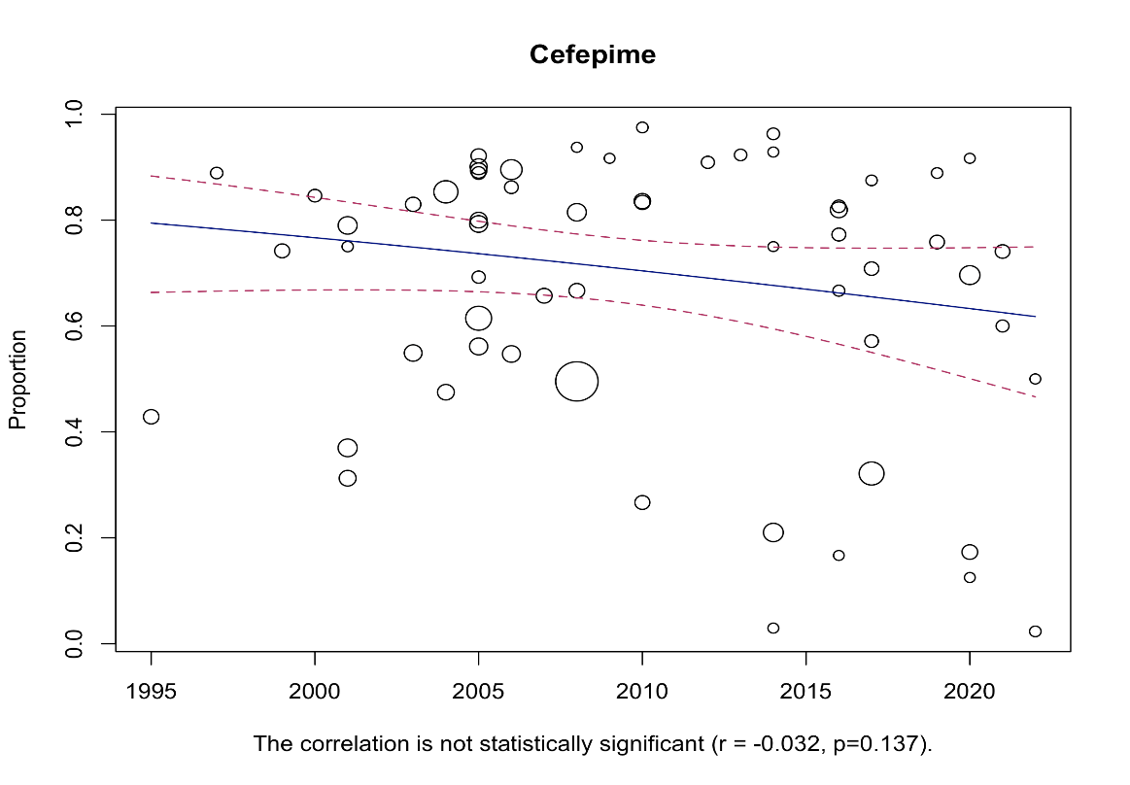

Figure 37. Bubble plot with fitted meta-regression for the year of publication.

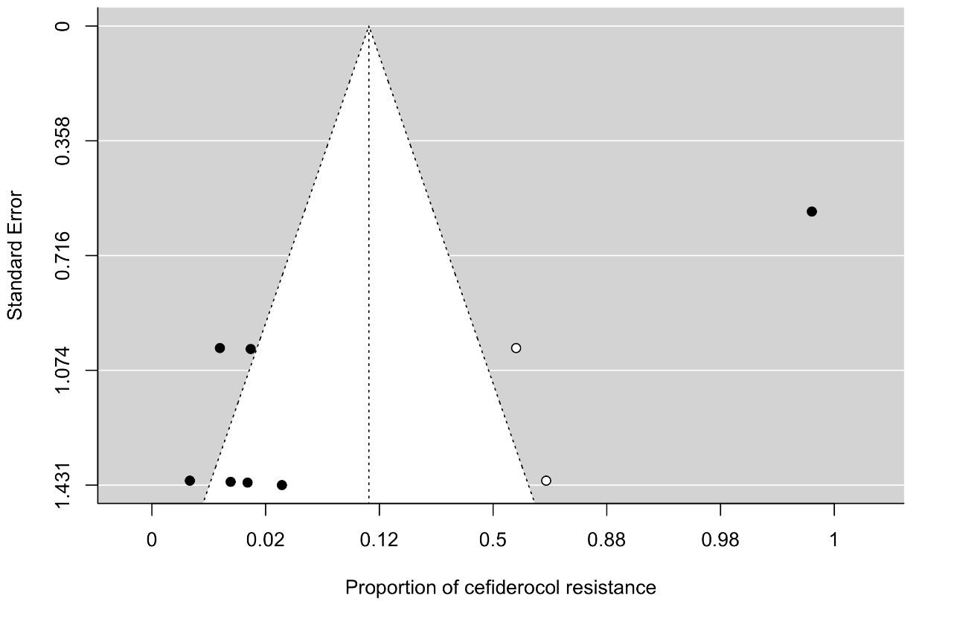
Figure 38. The funnel plot of meta-analysis of publication studies. Each black dot represents a study. The white dots represent missing studies. The black line in the middle represents the average effect size
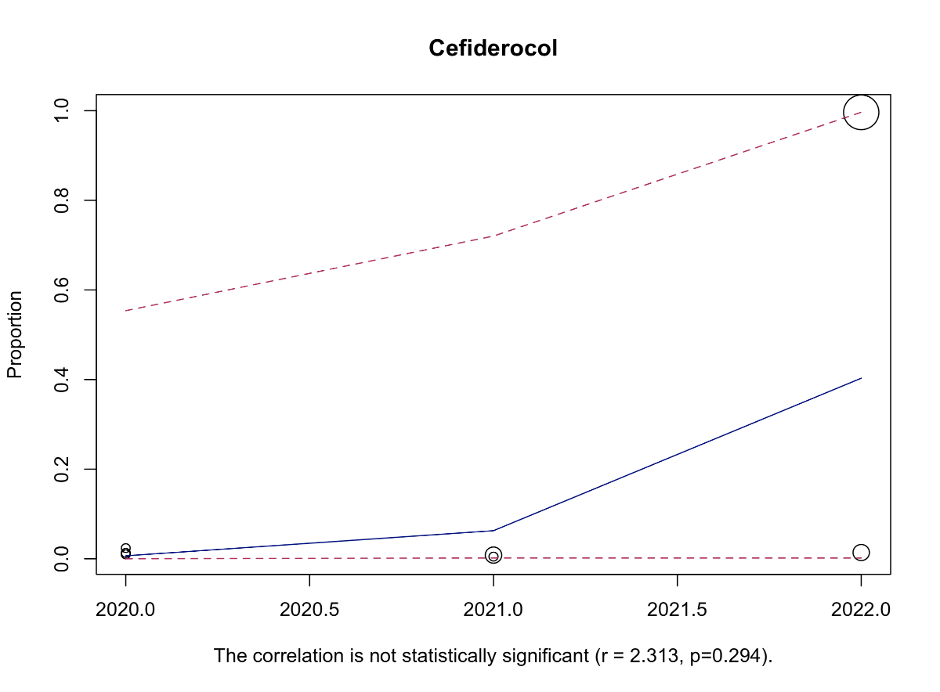

Figure 39. Bubble plot with fitted meta-regression for the year of publication.
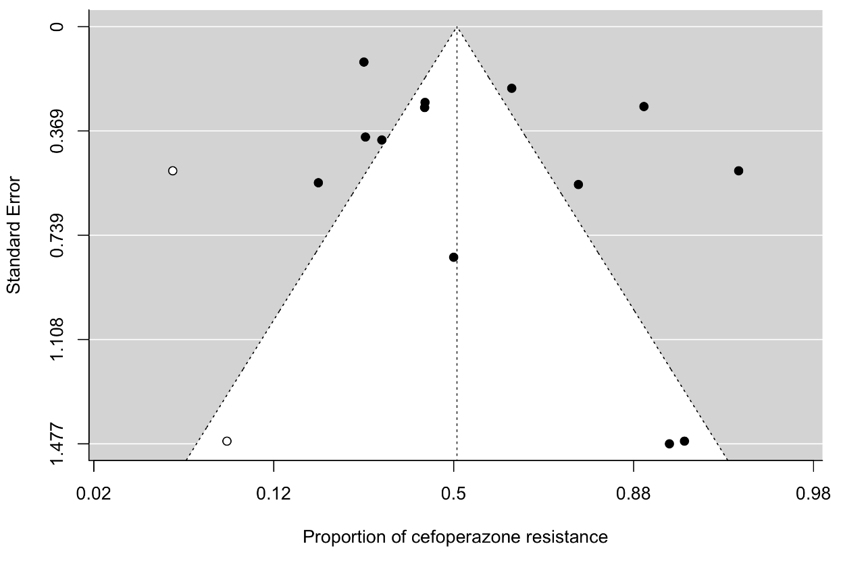

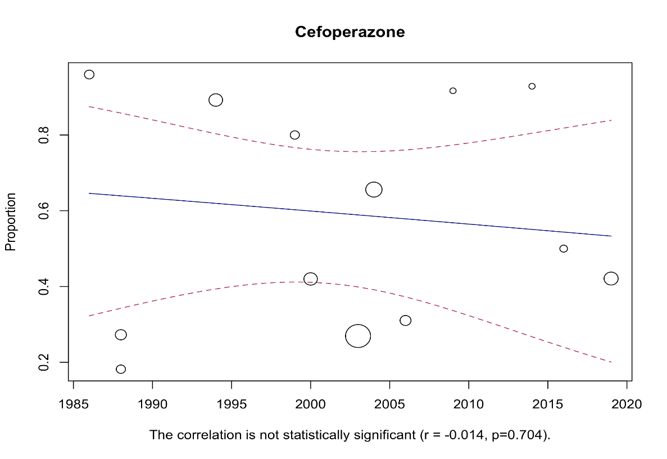
Figure 40. The funnel plot of meta-analysis of publication studies. Each black dot represents a study. The white dots represent missing studies. The black line in the middle represents the average effect size

Figure 41. Bubble plot with fitted meta-regression for the year of publication
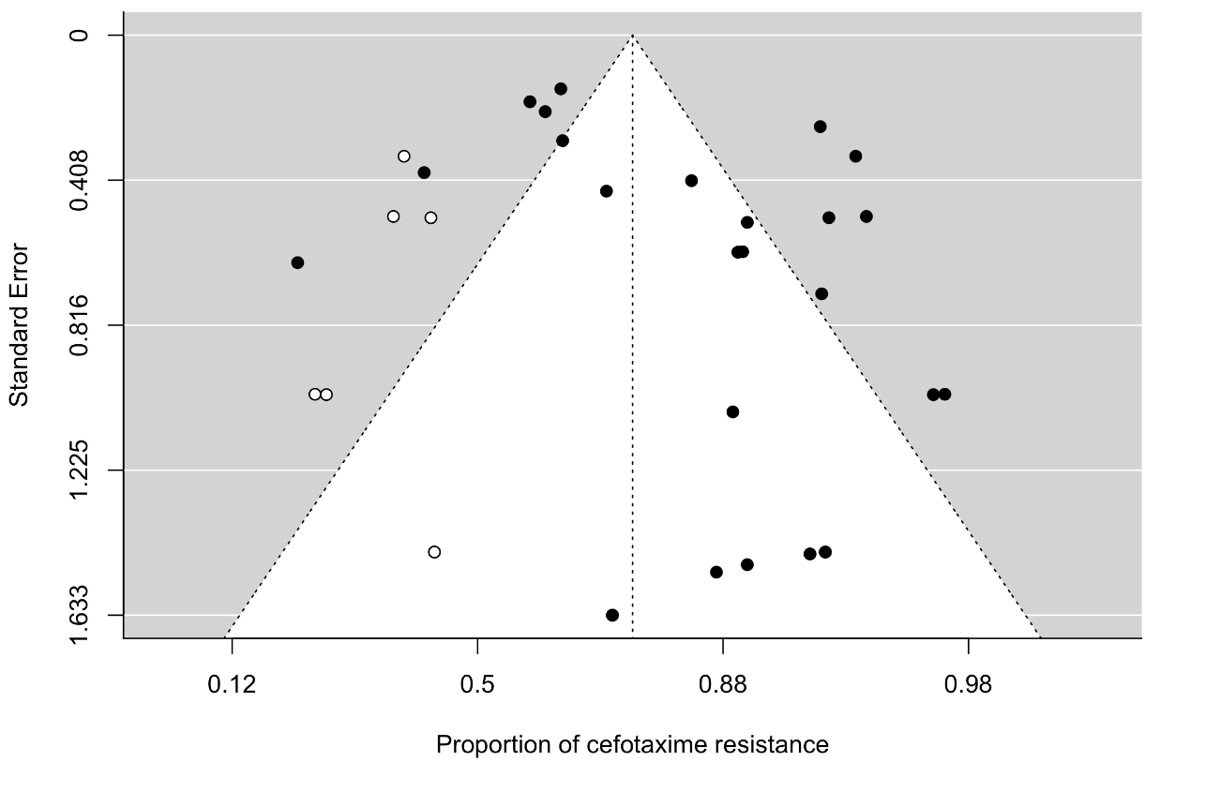
Figure 42. The funnel plot of meta-analysis of publication studies. Each black dot represents a study. The white dots represent missing studies. The black line in the middle represents the average effect size.

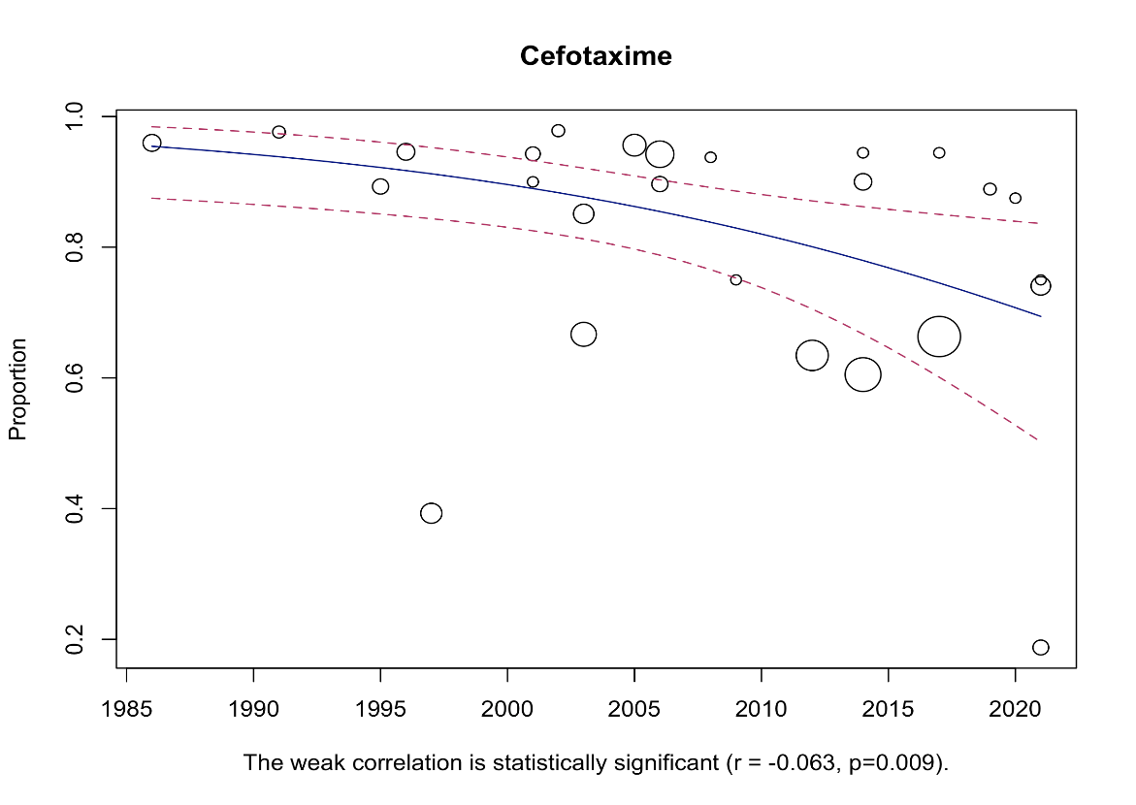

Figure 43. Bubble plot with fitted meta-regression for the year of publication.
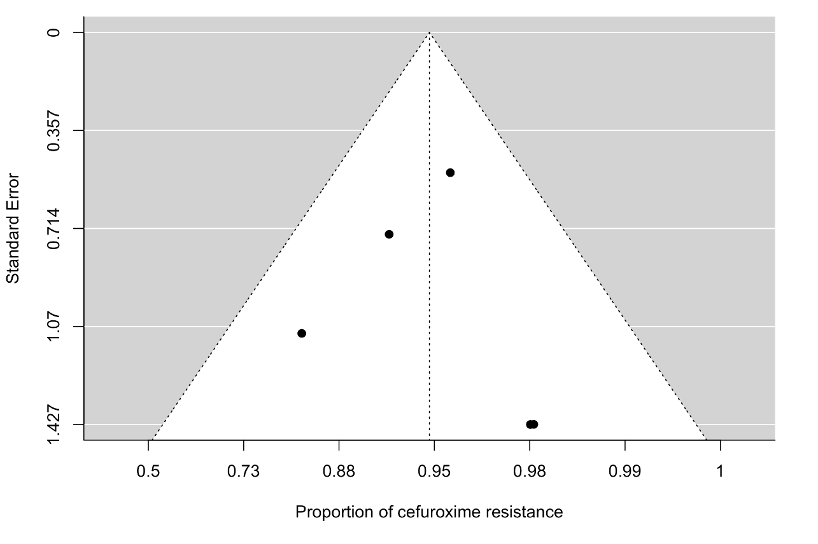

Figure 44. The funnel plot of meta-analysis of publication studies. Each black dot represents a study. The black line in the middle represents the average effect size.

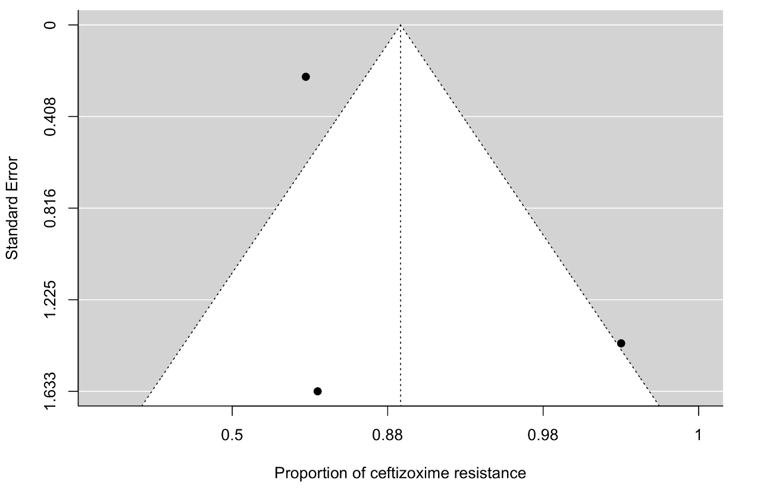

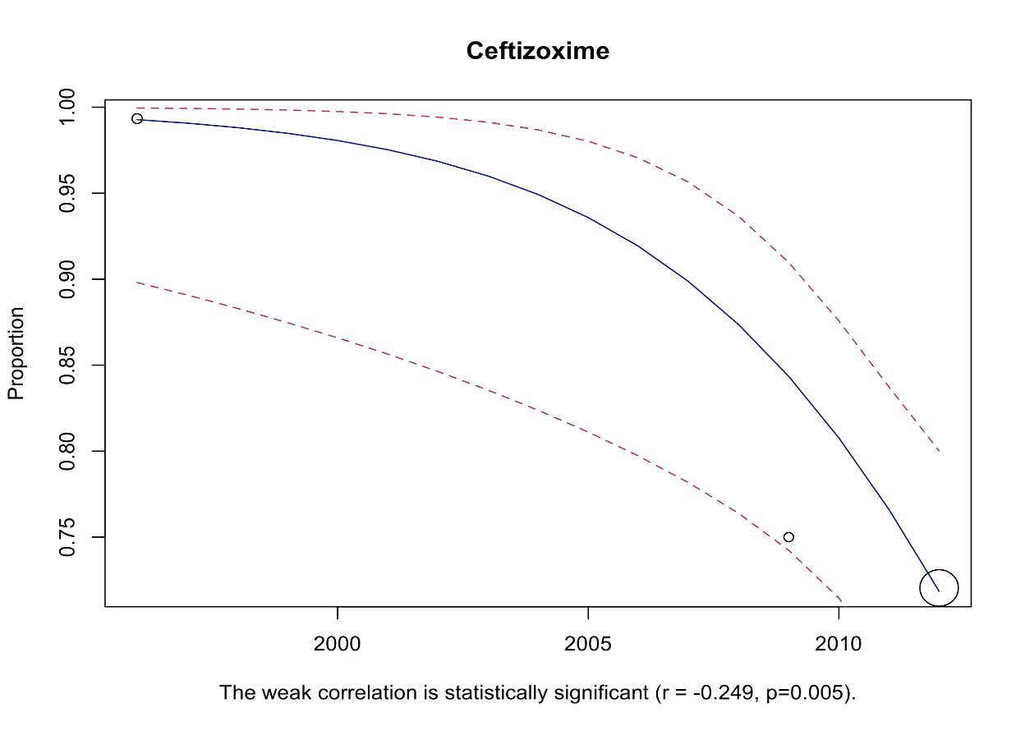
Figure 45. The funnel plot of meta-analysis of publication studies. Each black dot represents a study. The black line in the middle represents the average effect size

Figure 46. Bubble plot with fitted meta-regression for the year of publication.
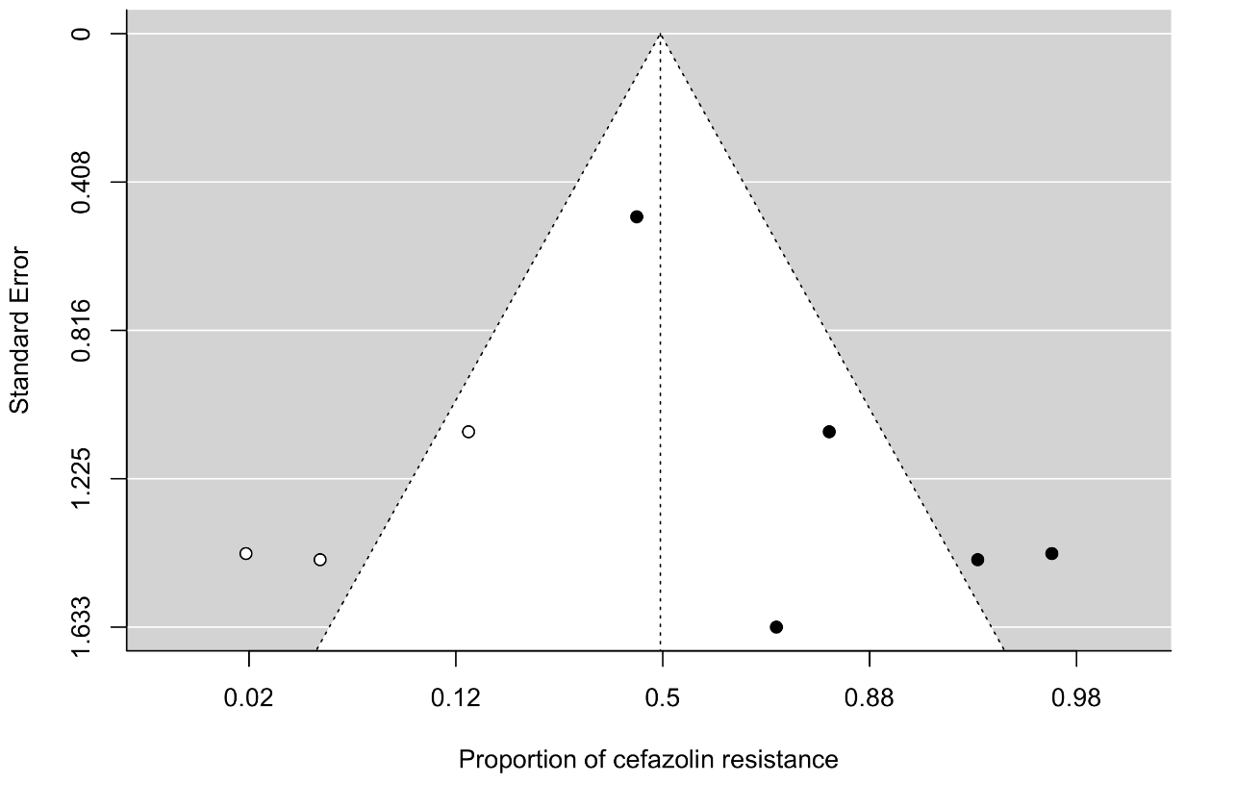

Figure 47. The funnel plot of meta-analysis of publication studies. Each black dot represents a study. The white dots represent missing studies. The black line in the middle represents the average effect size

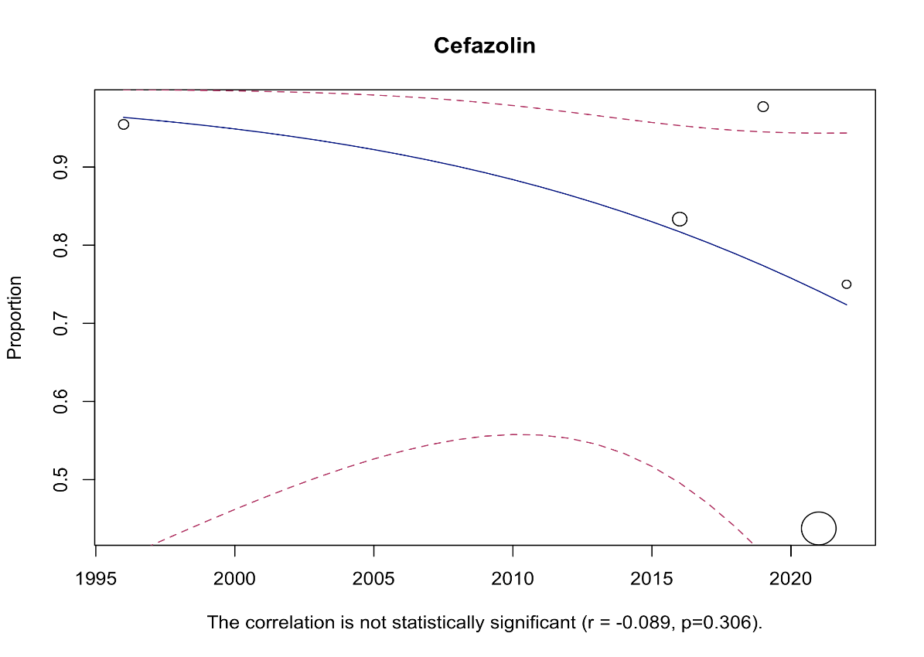

Figure 48. Bubble plot with fitted meta-regression for the year of publication.

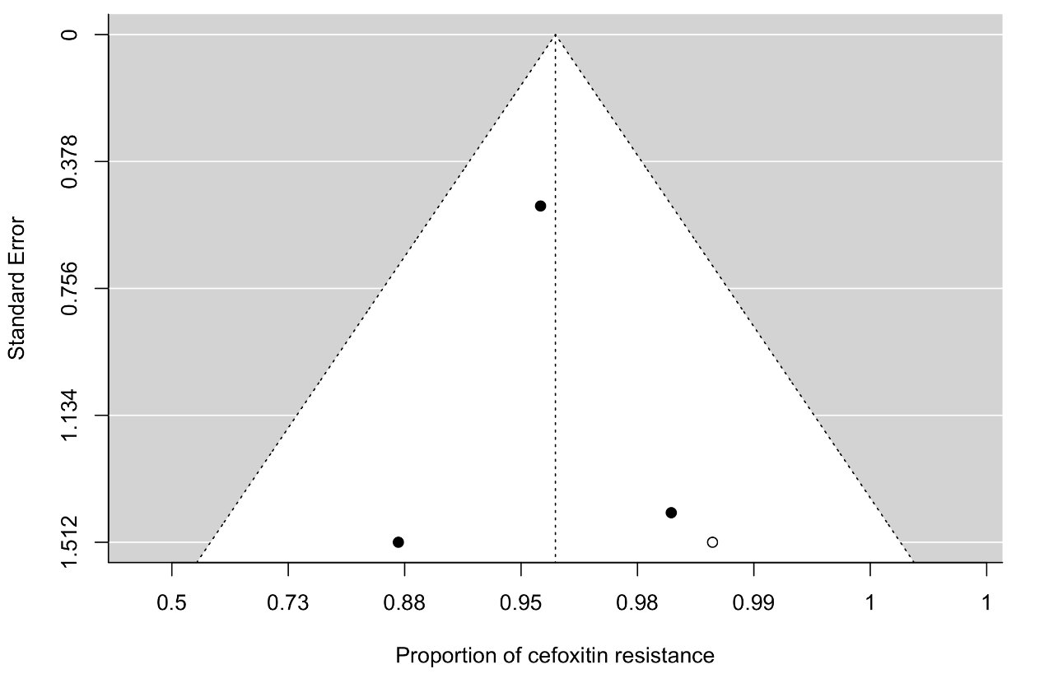
Figure 49. The funnel plot of meta-analysis of publication studies. Each black dot represents a study. The white dots represent missing studies. The black line in the middle represents the average effect size.

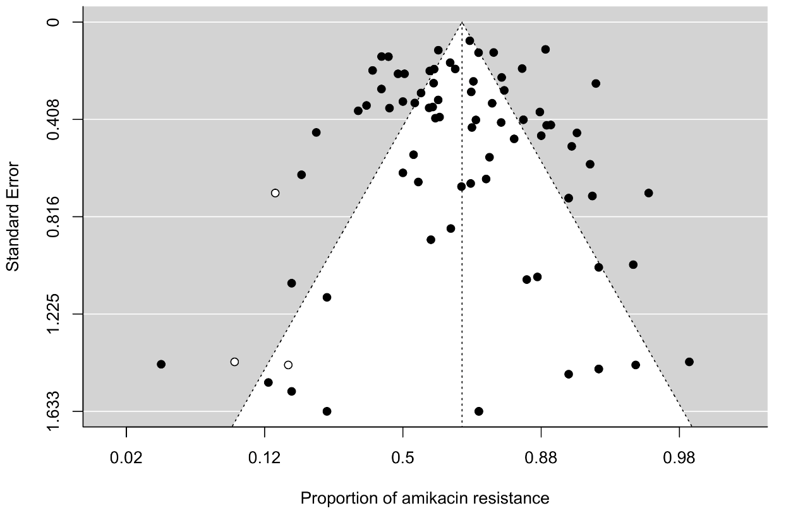
Figure 50. The funnel plot of meta-analysis of publication studies. Each black dot represents a study. The white dots represent missing studies. The black line in the middle represents the average effect size.
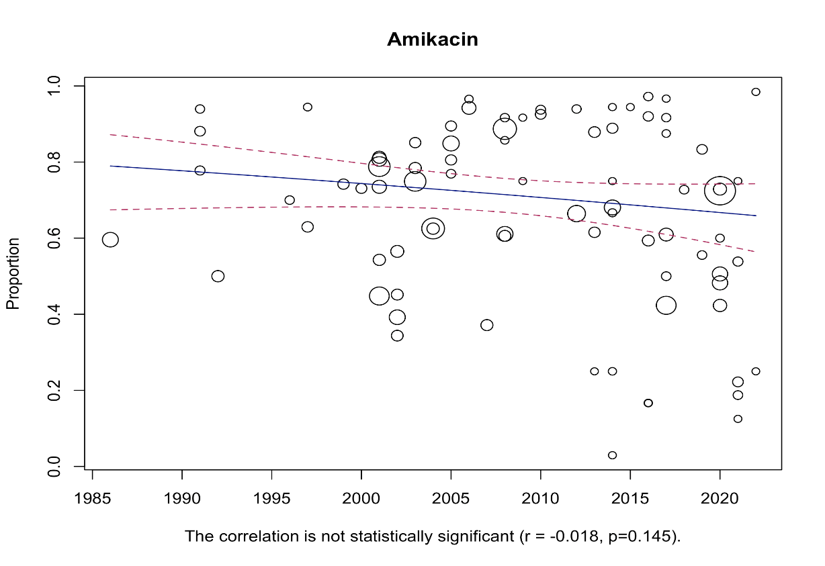

Figure 51. Bubble plot with fitted meta-regression for the year of publication.
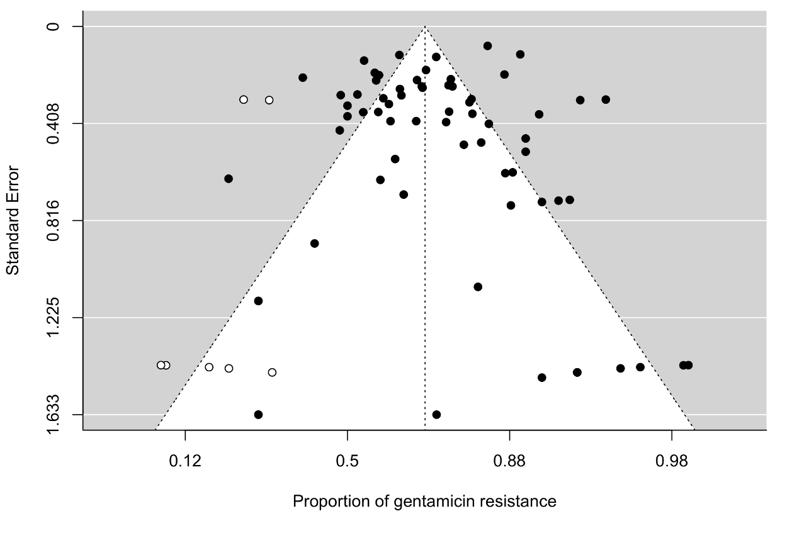
Figure 52. The funnel plot of meta-analysis of publication studies. Each black dot represents a study. The white dots represent missing studies. The black line in the middle represents the average effect size.
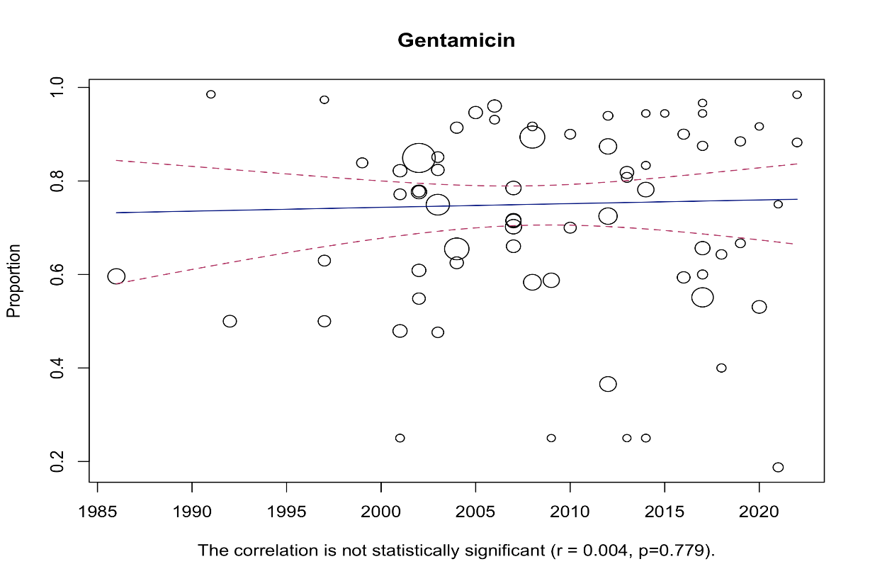

Figure 53. Bubble plot with fitted meta-regression for the year of publication.

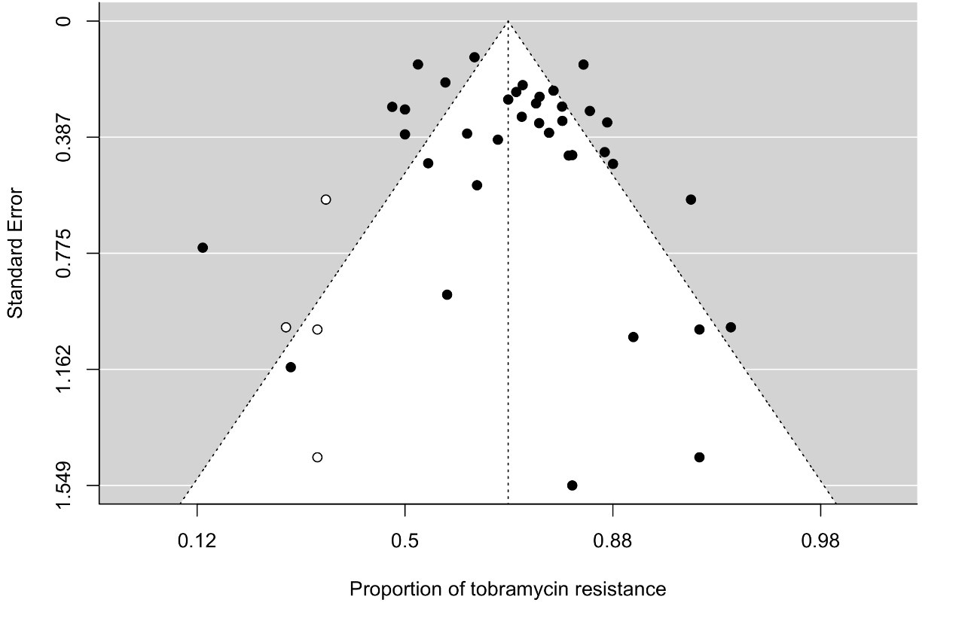
Figure 54. The funnel plot of meta-analysis of publication studies. Each black dot represents a study. The white dots represent missing studies. The black line in the middle represents the average effect size.
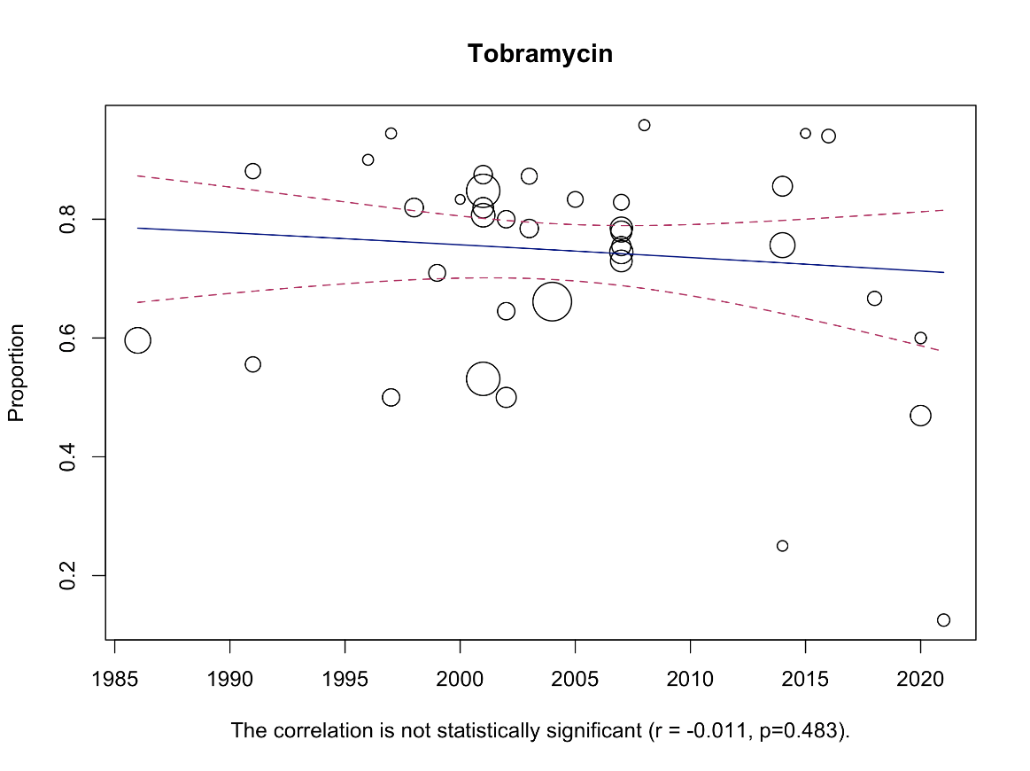

Figure 55. Bubble plot with fitted meta-regression for the year of publication.

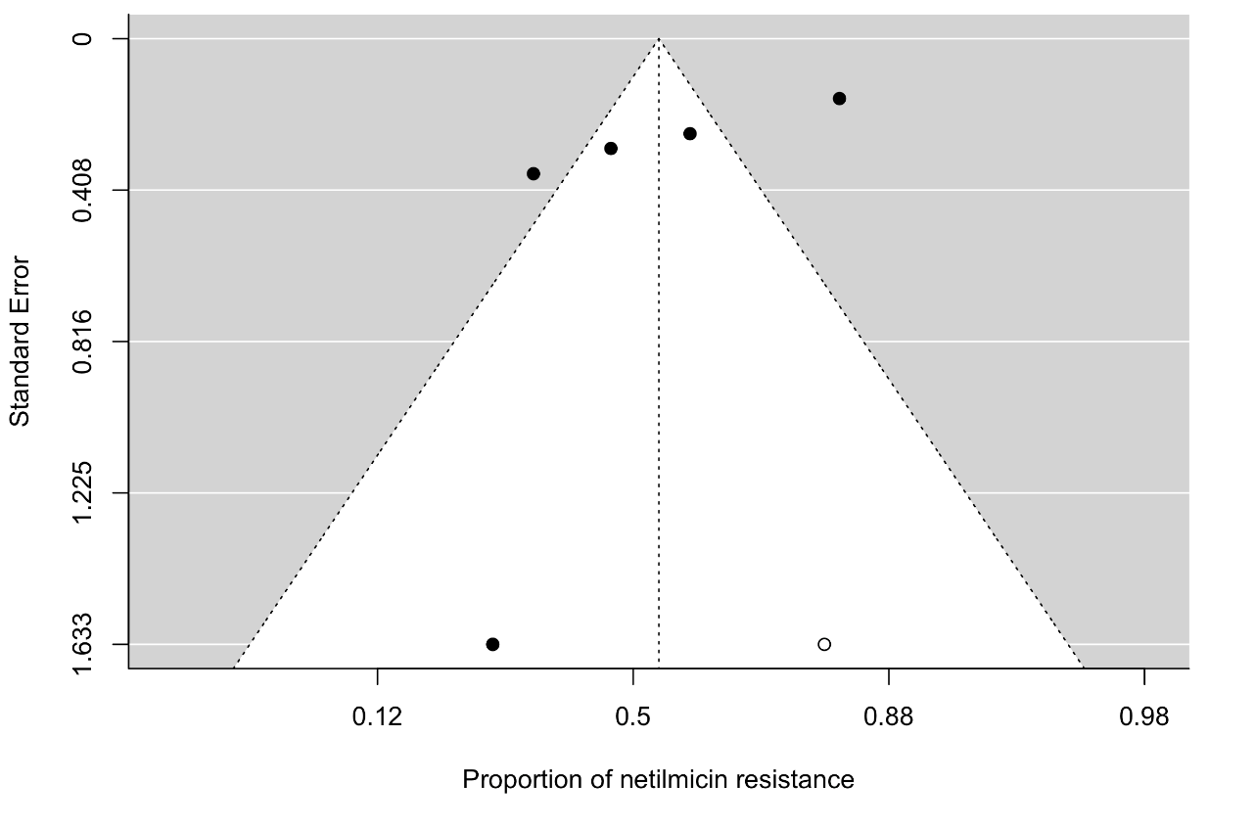
Figure 56. The funnel plot of meta-analysis of publication studies. Each black dot represents a study. The white dots represent missing studies. The black line in the middle represents the average effect size.
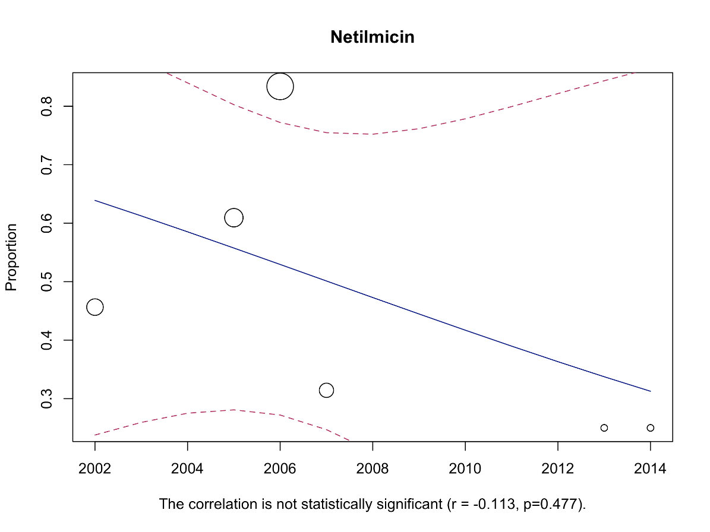

Figure 57. Bubble plot with fitted meta-regression for the year of publication.
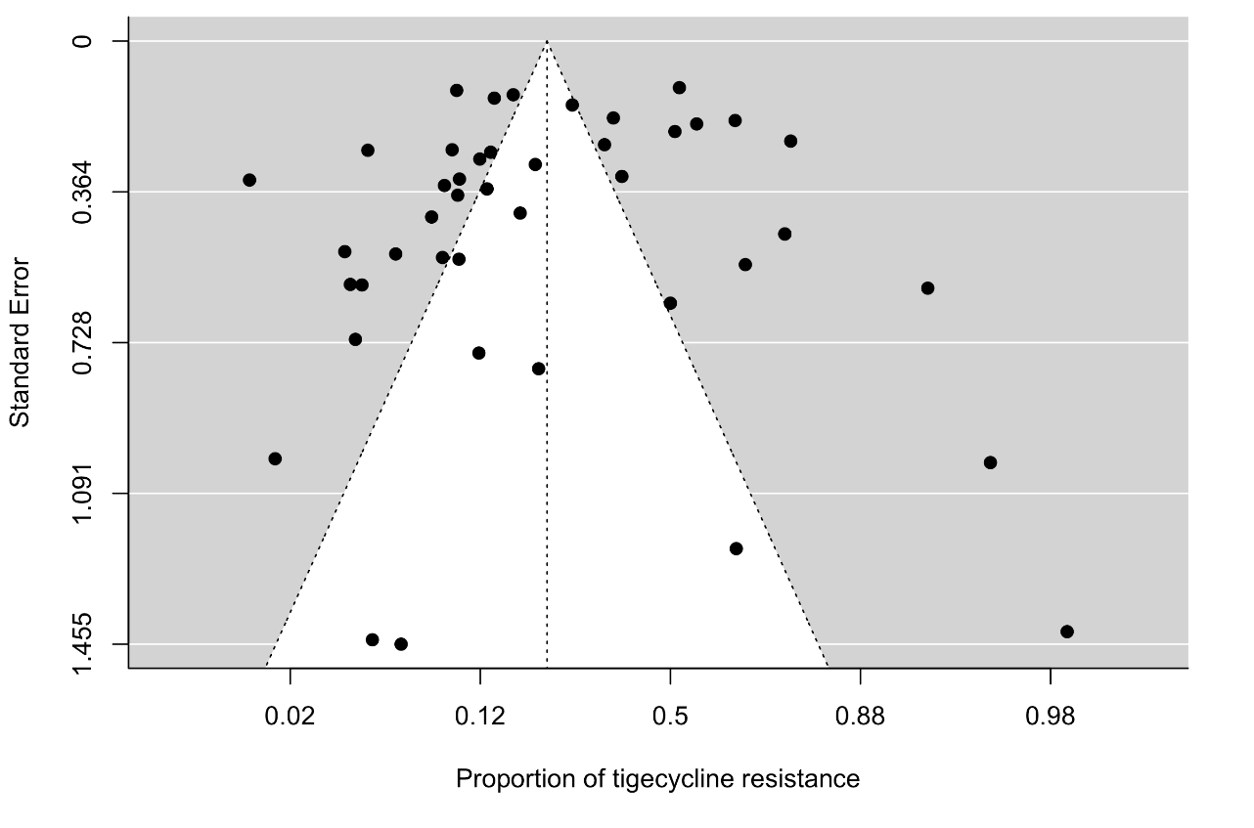
Figure 58. The funnel plot of meta-analysis of publication studies. Each black dot represents a study. The white dots represent missing studies. The black line in the middle represents the average effect size.
Tetracyclines
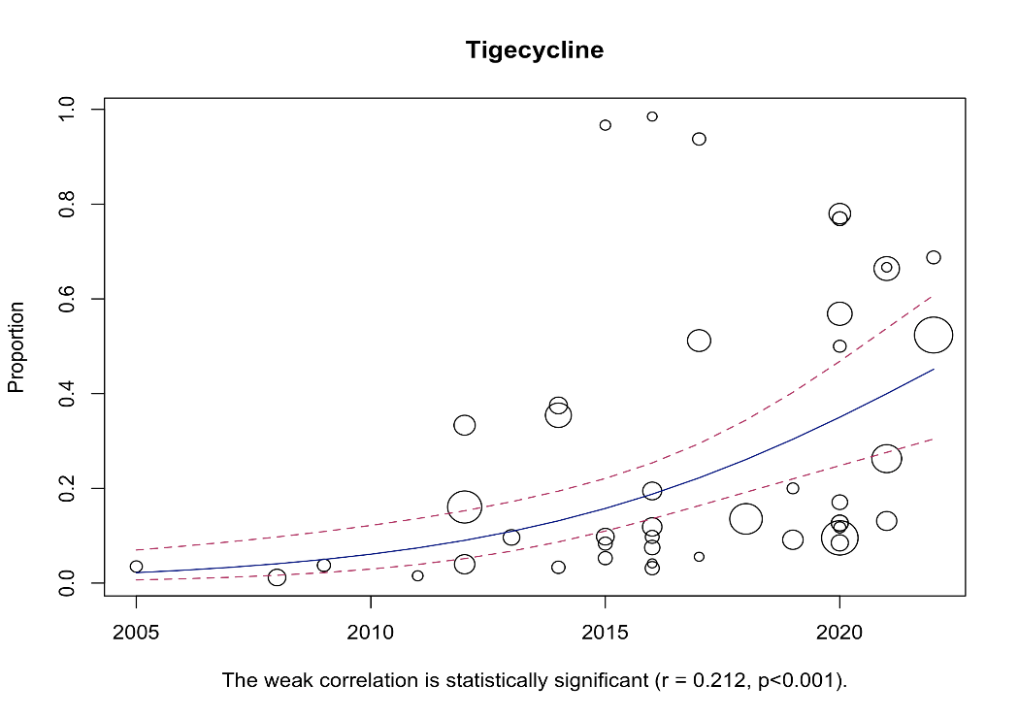

Figure 59. Bubble plot with fitted meta-regression for the year of publication.

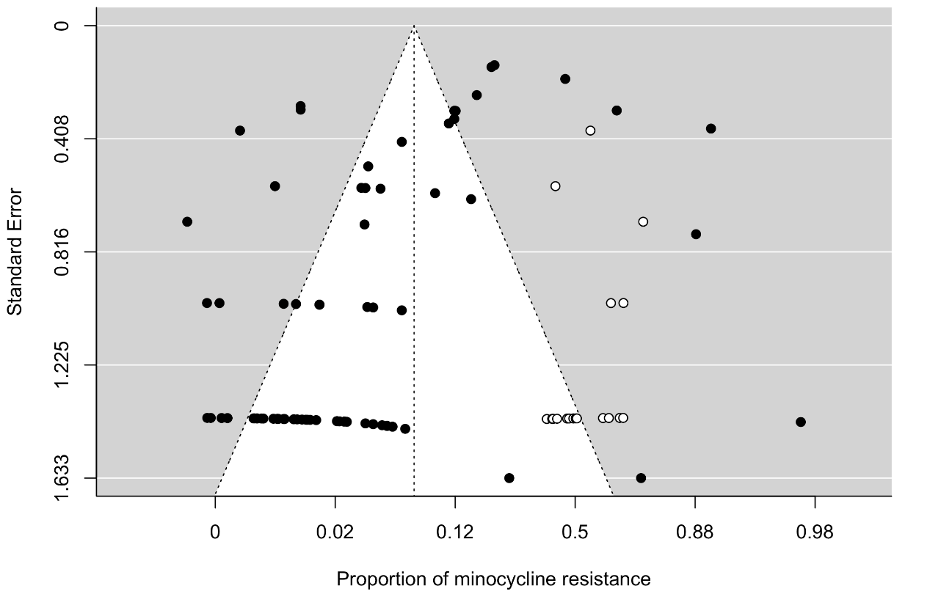
Figure 60. The funnel plot of meta-analysis of publication studies. Each black dot represents a study. The white dots represent missing studies. The black line in the middle represents the average effect size
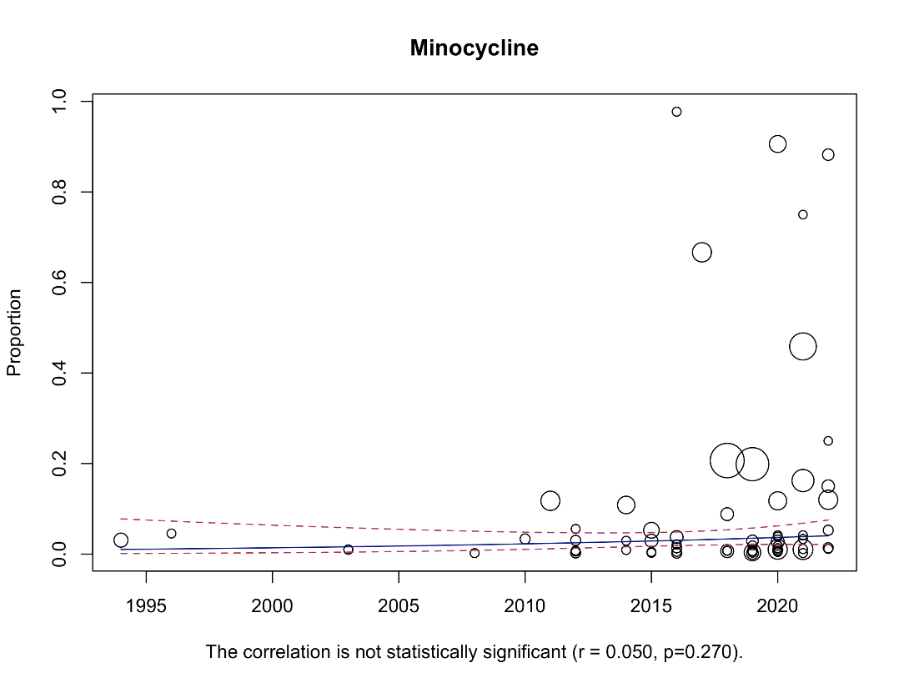

Figure 61. Bubble plot with fitted meta-regression for the year of publication

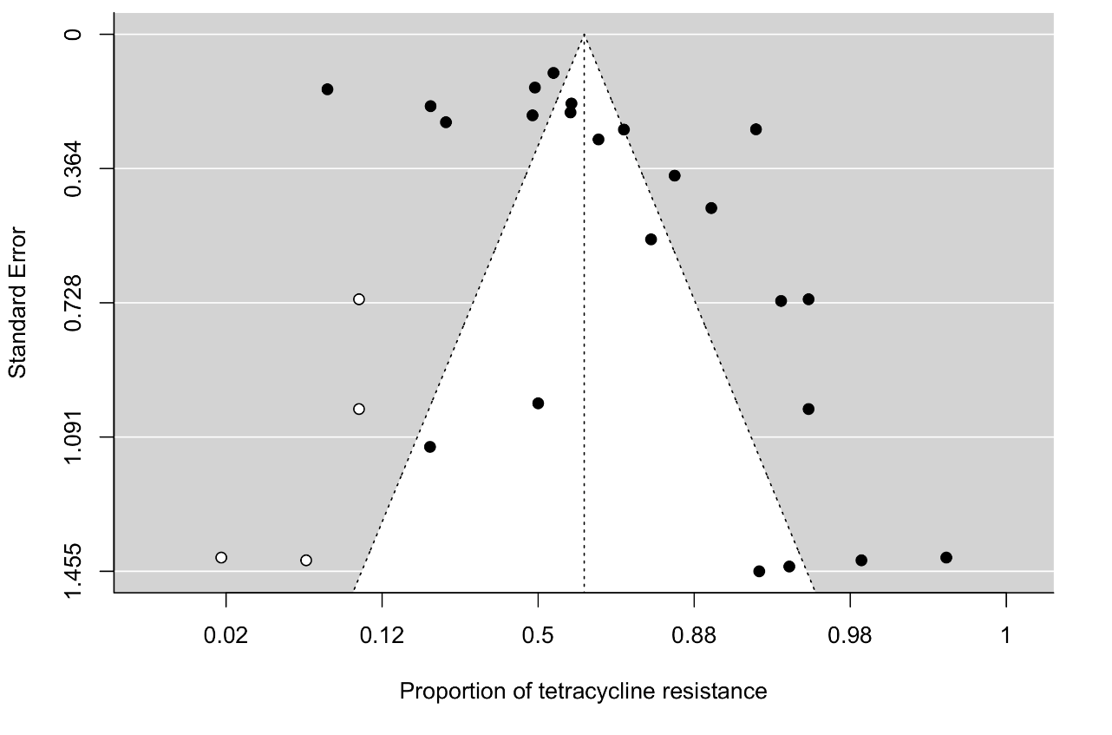
Figure 62. The funnel plot of meta-analysis of publication studies. Each black dot represents a study. The white dots represent missing studies. The black line in the middle represents the average effect size.
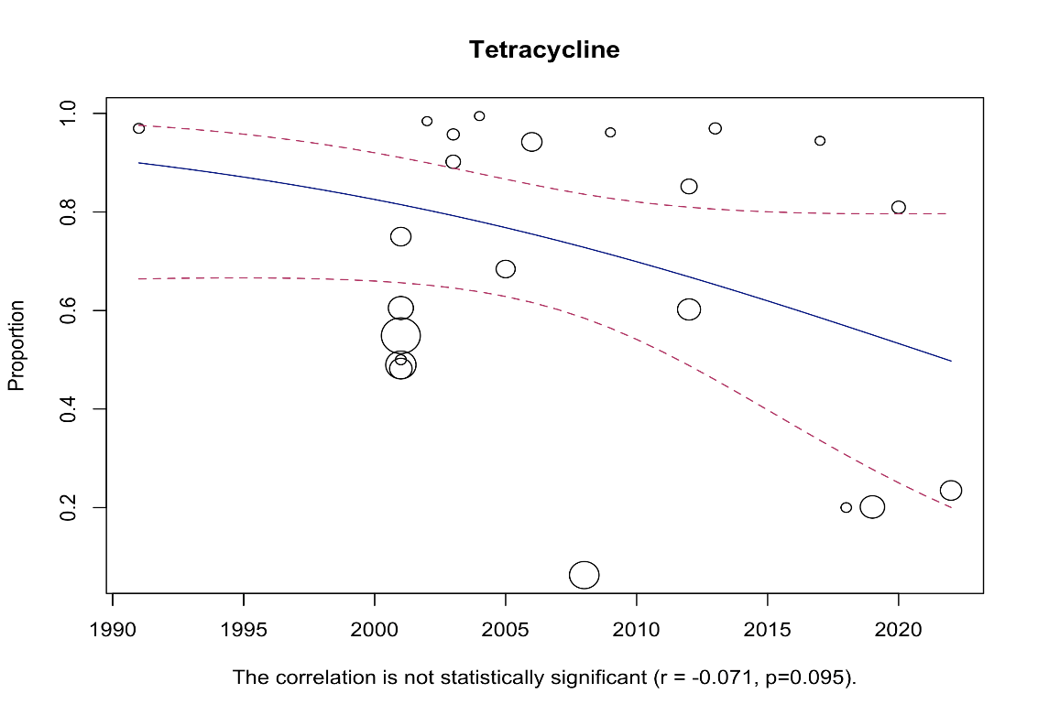

Figure 63. Bubble plot with fitted meta-regression for the year of publication
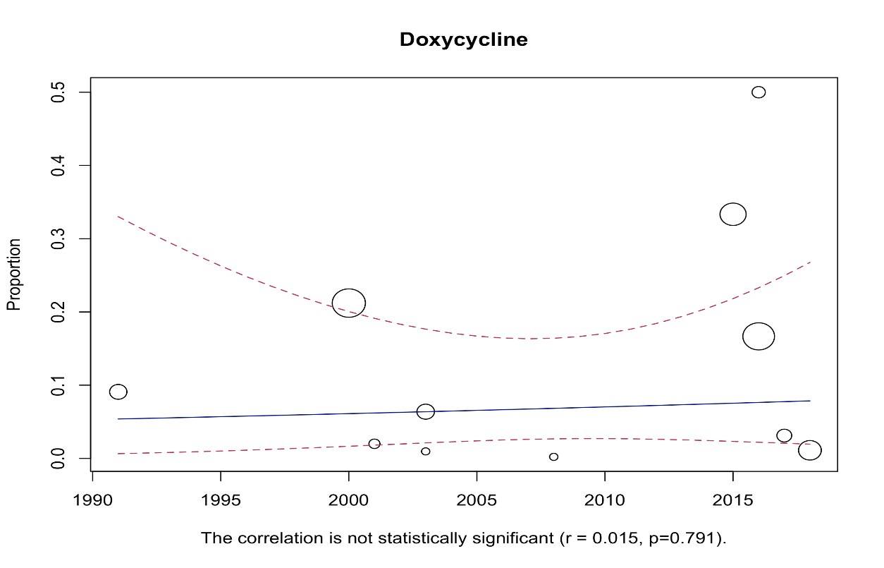
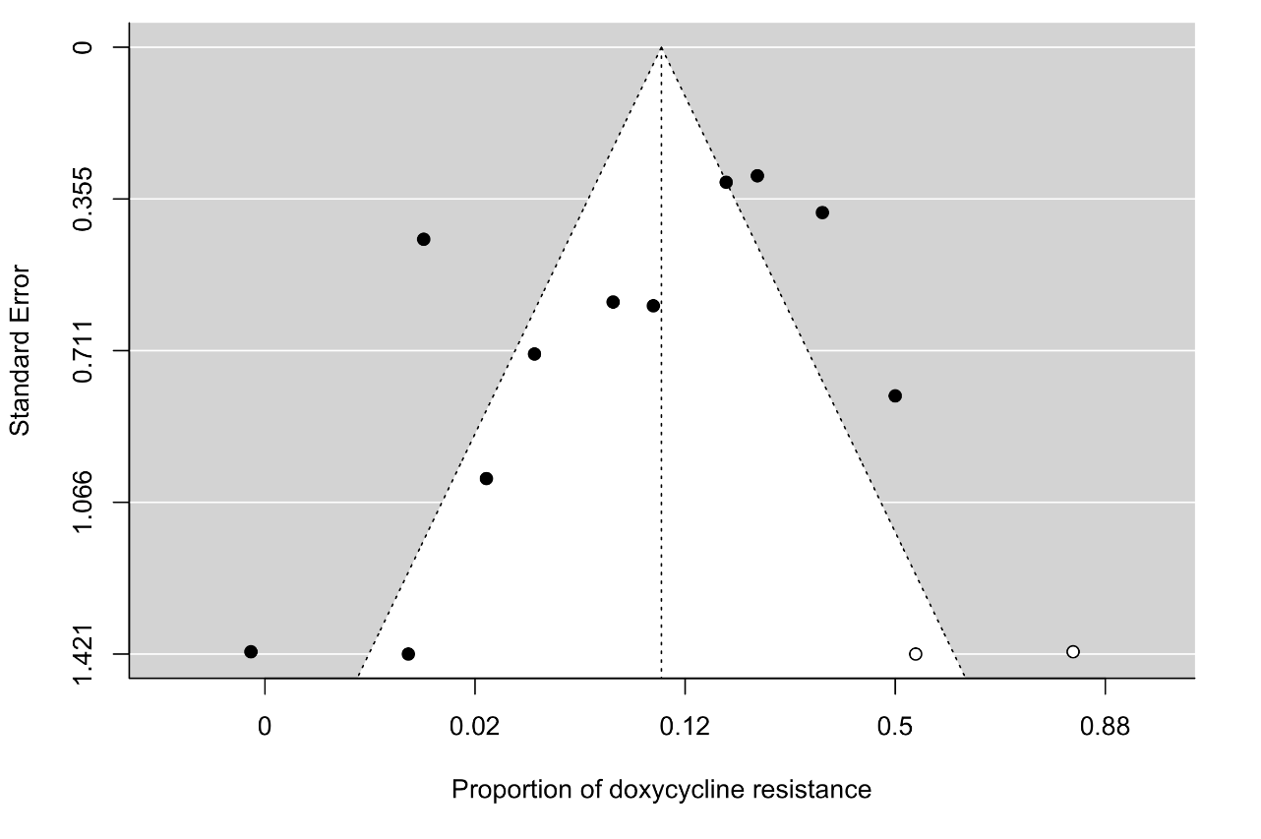
Figure 64. The funnel plot of meta-analysis of publication studies. Each black dot represents a study. The white dots represent missing studies. The black line in the middle represents the average effect size

Figure 65. Bubble plot with fitted meta-regression for the year of publication

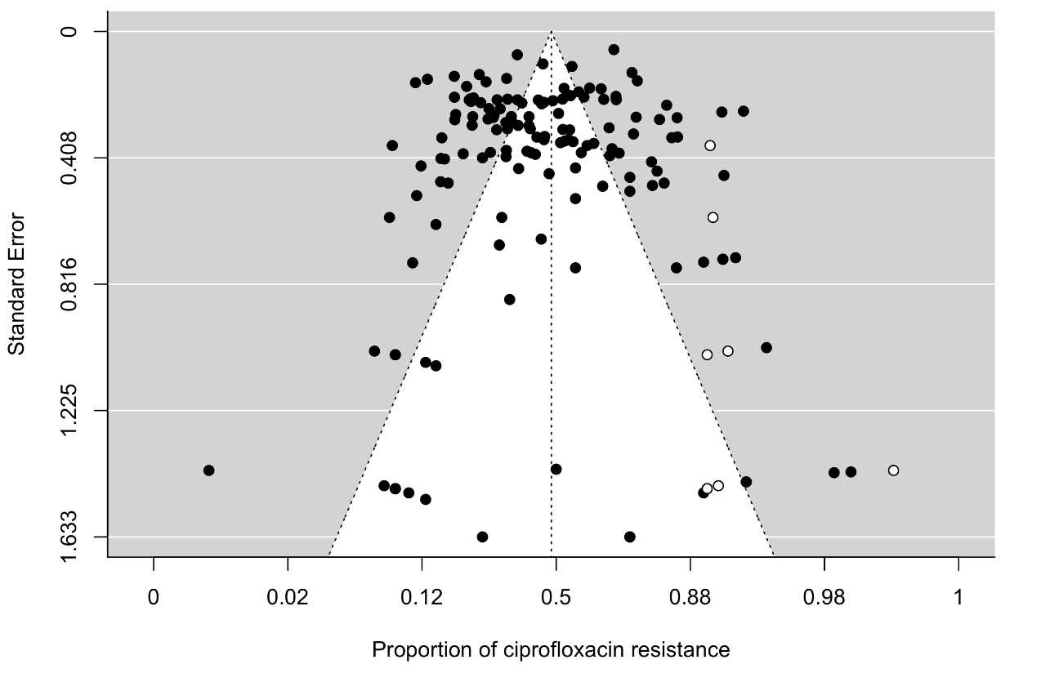
Fluoroquinolones

Figure 66. The funnel plot of meta-analysis of publication studies. Each black dot represents a study. The white dots represent missing studies. The black line in the middle represents the average effect size.
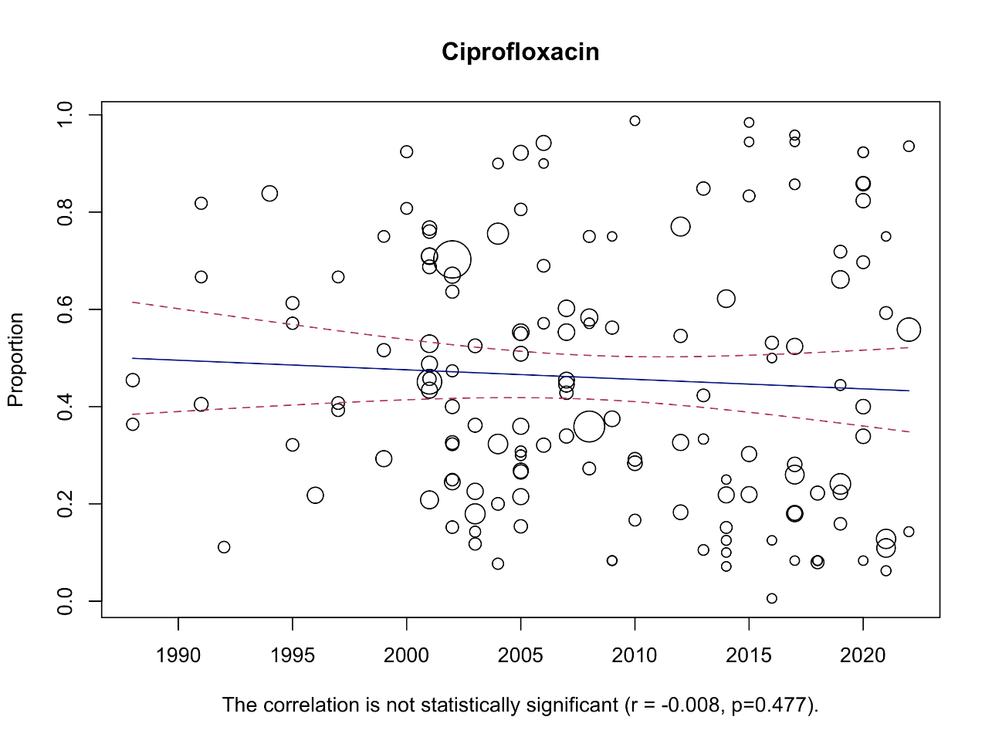

Figure 67. Bubble plot with fitted meta-regression for the year of publication

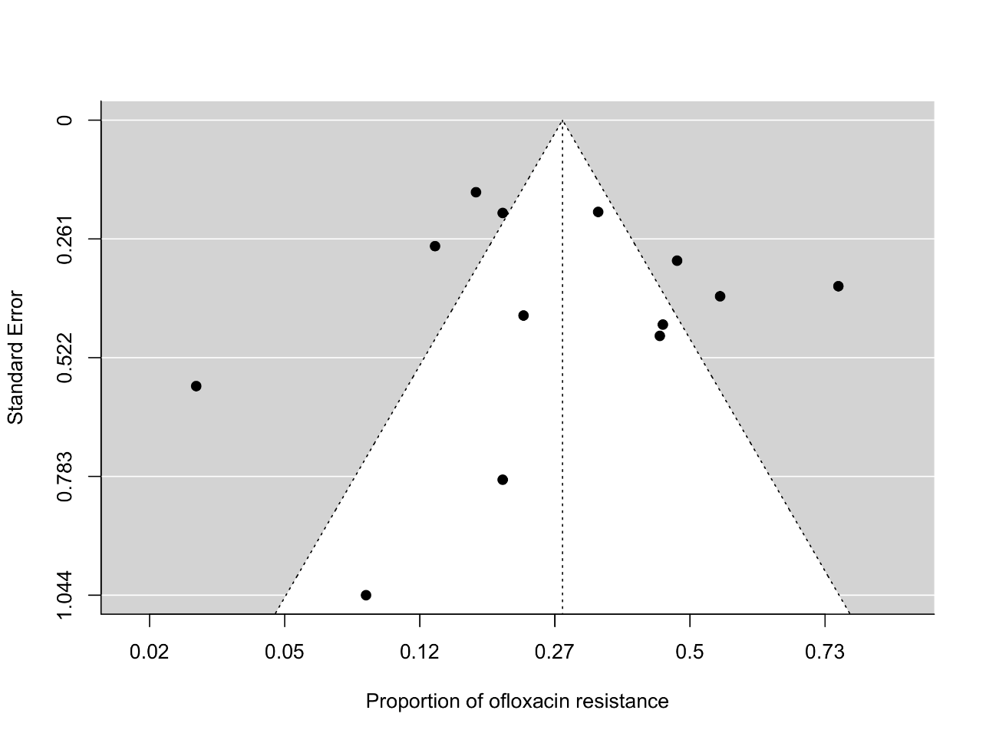
Figure 68. The funnel plot of meta-analysis of publication studies. Each black dot represents a study. The black line in the middle represents the average effect size
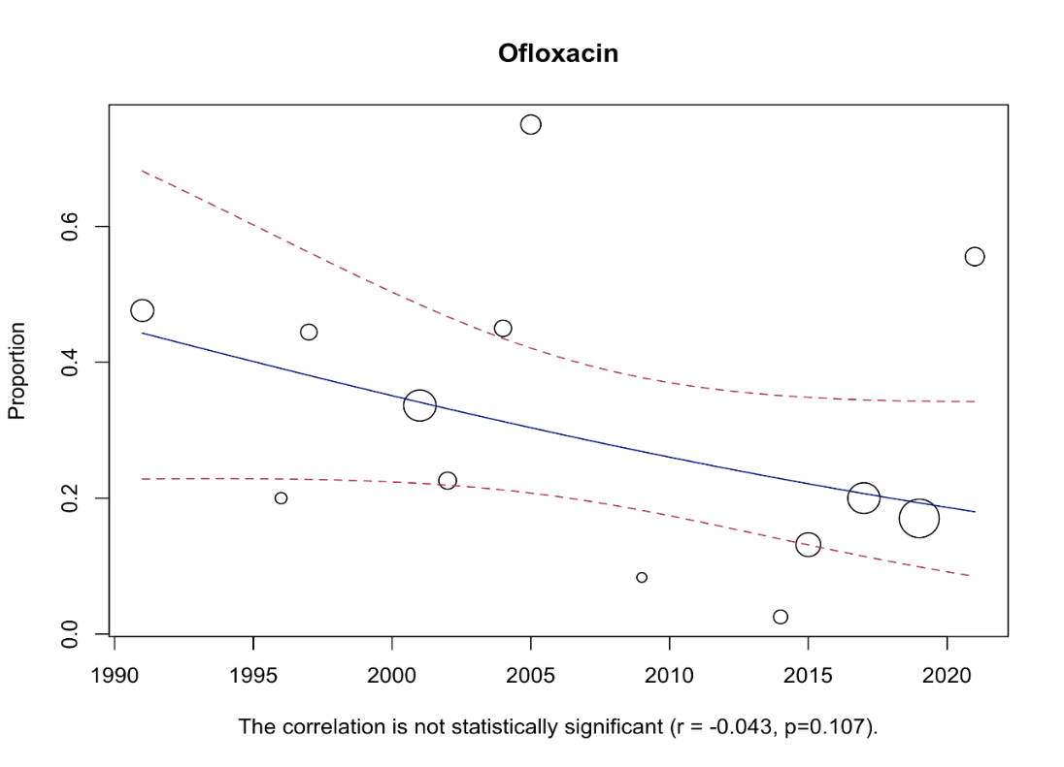

Figure 69. Bubble plot with fitted meta-regression for the year of publication
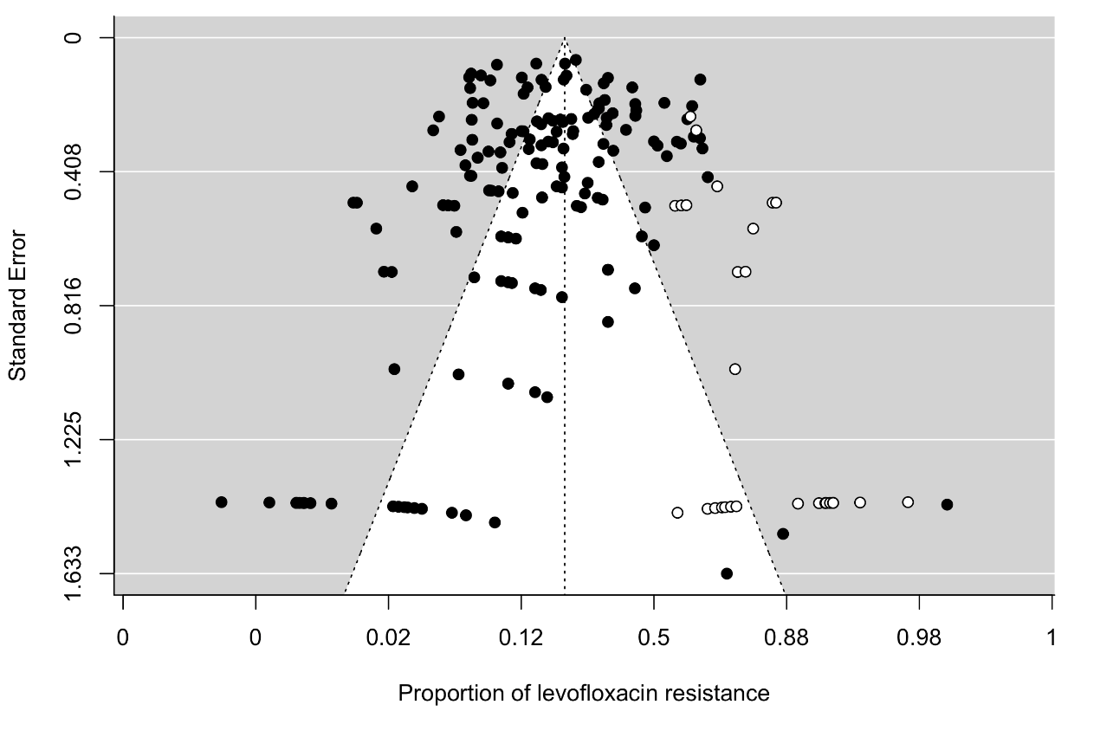

Figure 70. The funnel plot of meta-analysis of publication studies. Each black dot represents a study. The white dots represent missing studies. The black line in the middle represents the average effect size.
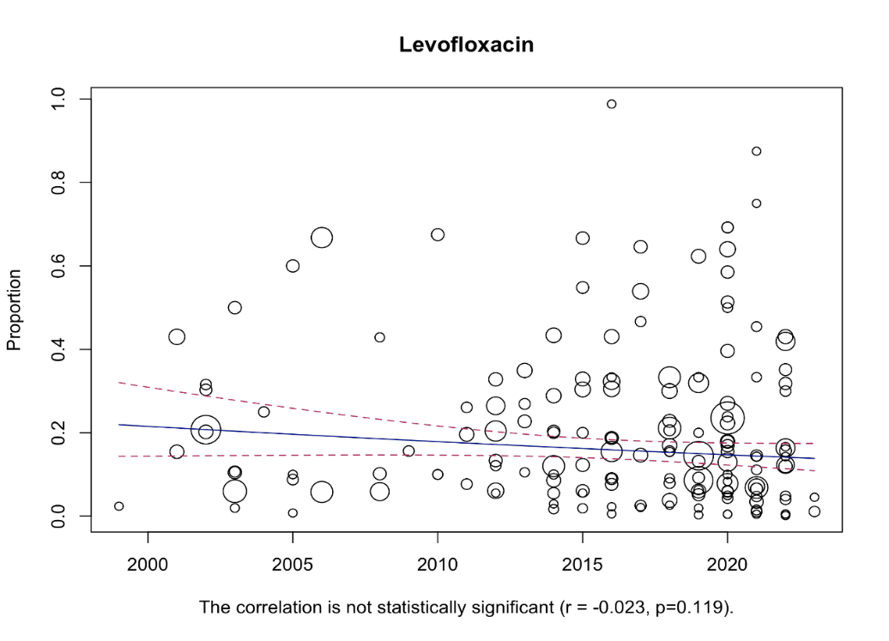

Figure 71. Bubble plot with fitted meta-regression for the year of publication

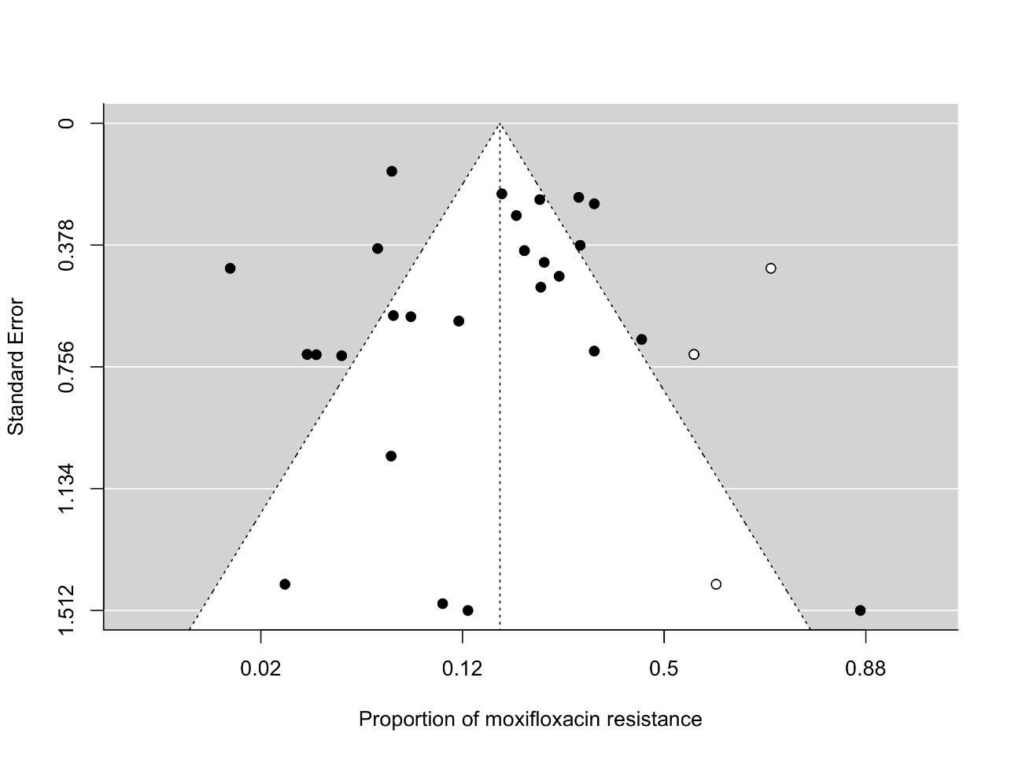

Figure 72. The funnel plot of meta-analysis of publication studies. Each black dot represents a study. The white dots represent missing studies. The black line in the middle represents the average effect size.
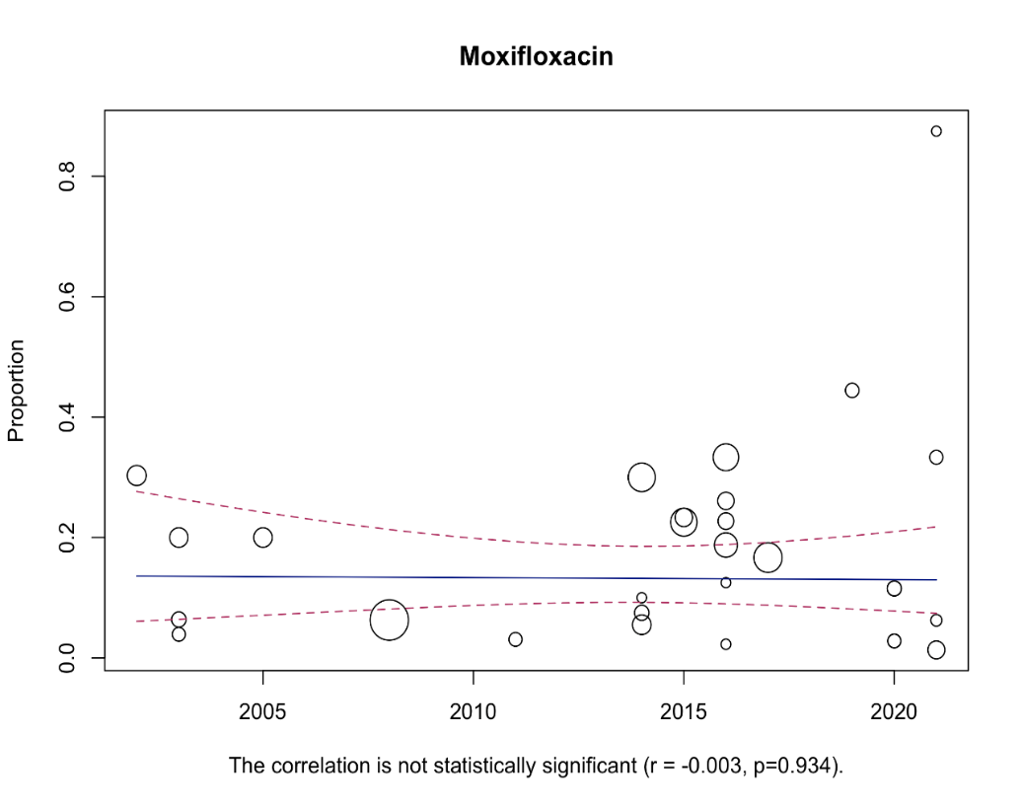

Figure 73. Bubble plot with fitted meta-regression for the year of publication
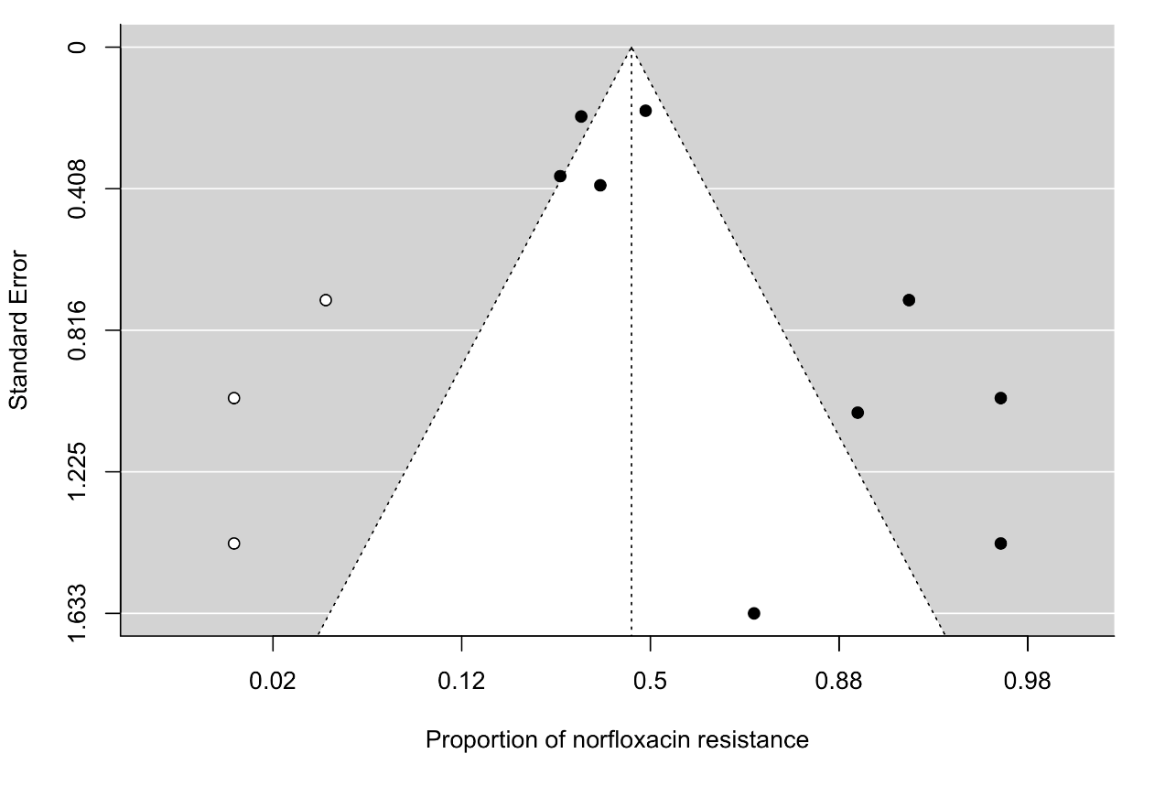
Figure 74. The funnel plot of meta-analysis of publication studies. Each black dot represents a study. The white dots represent missing studies. The black line in the middle represents the average effect size.
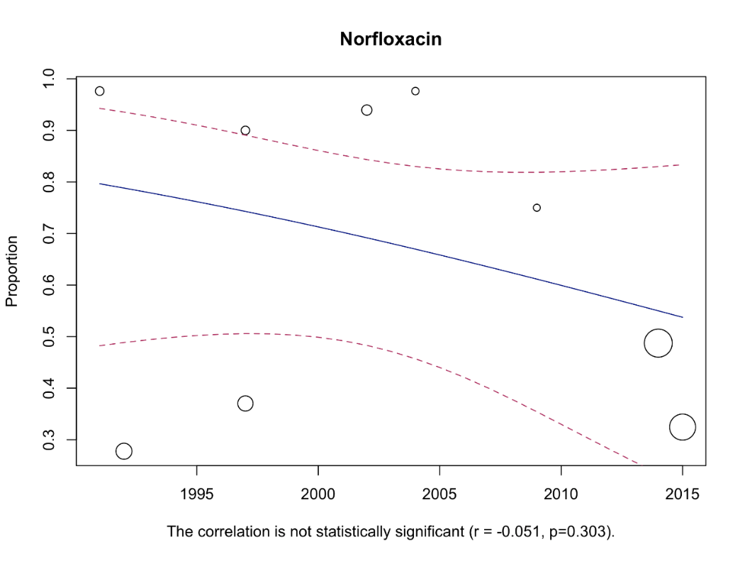

Figure 75. Bubble plot with fitted meta-regression for the year of publication
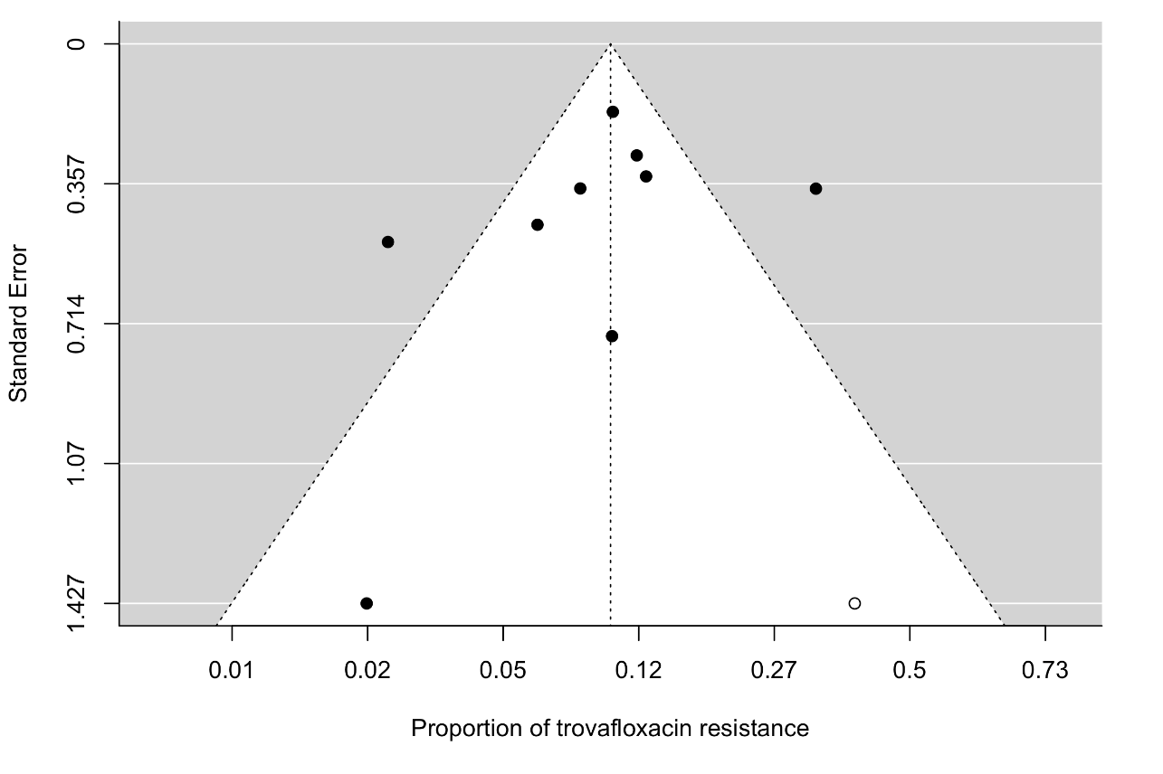
Figure 76. The funnel plot of meta-analysis of publication studies. Each black dot represents a study. The white dots represent missing studies. The black line in the middle represents the average effect size.
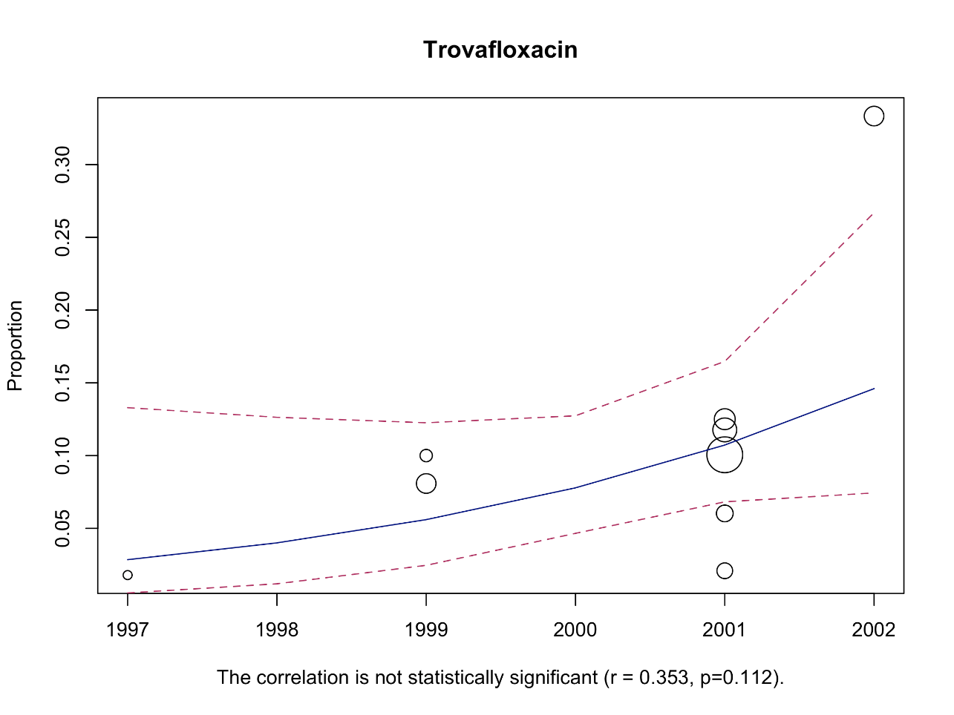

Figure 77. Bubble plot with fitted meta-regression for the year of publication

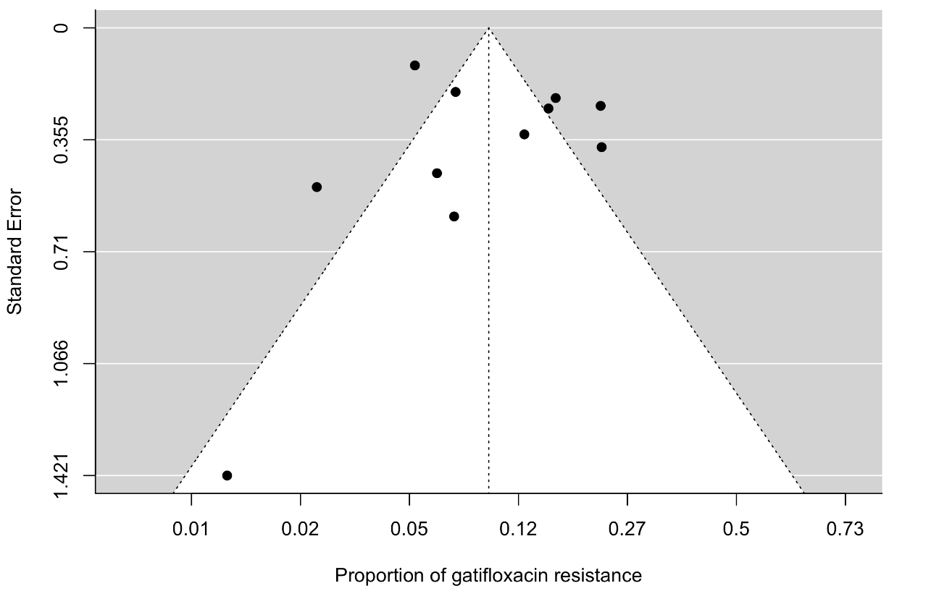
Figure 78. The funnel plot of meta-analysis of publication studies. Each black dot represents a study. The white dots represent missing studies. The black line in the middle represents the average effect size.
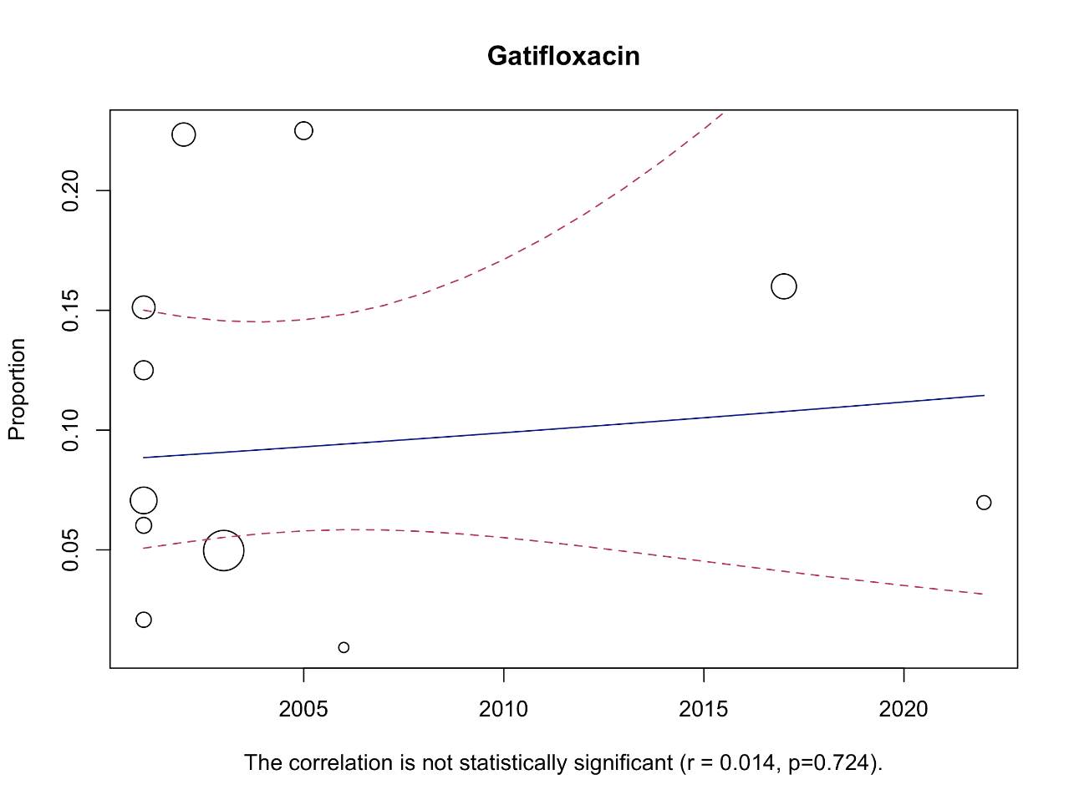

Figure 79. Bubble plot with fitted meta-regression for the year of publication

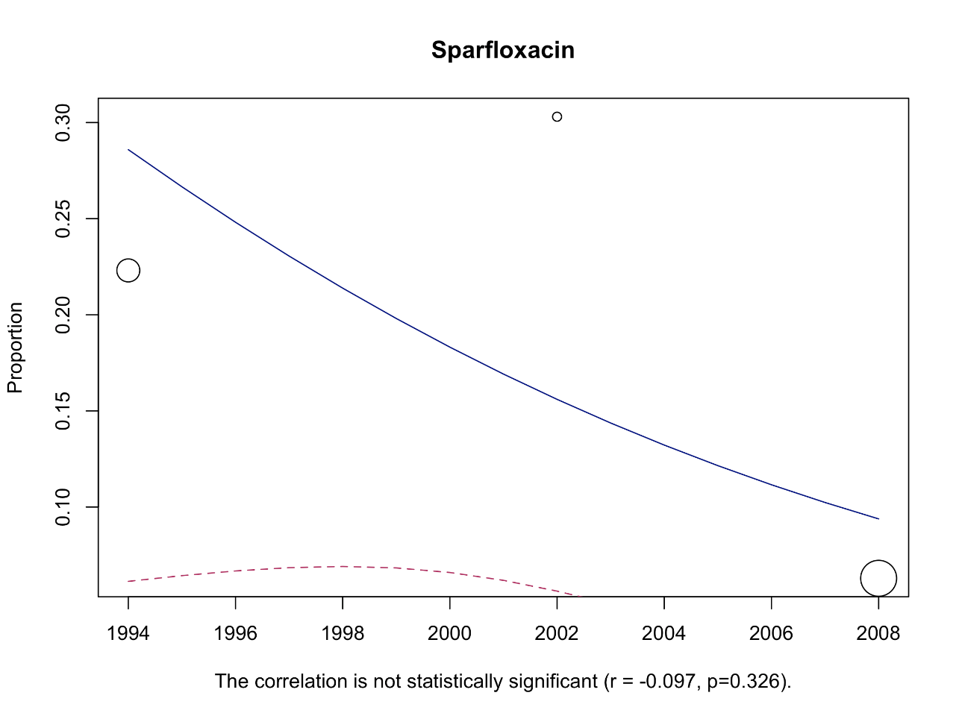
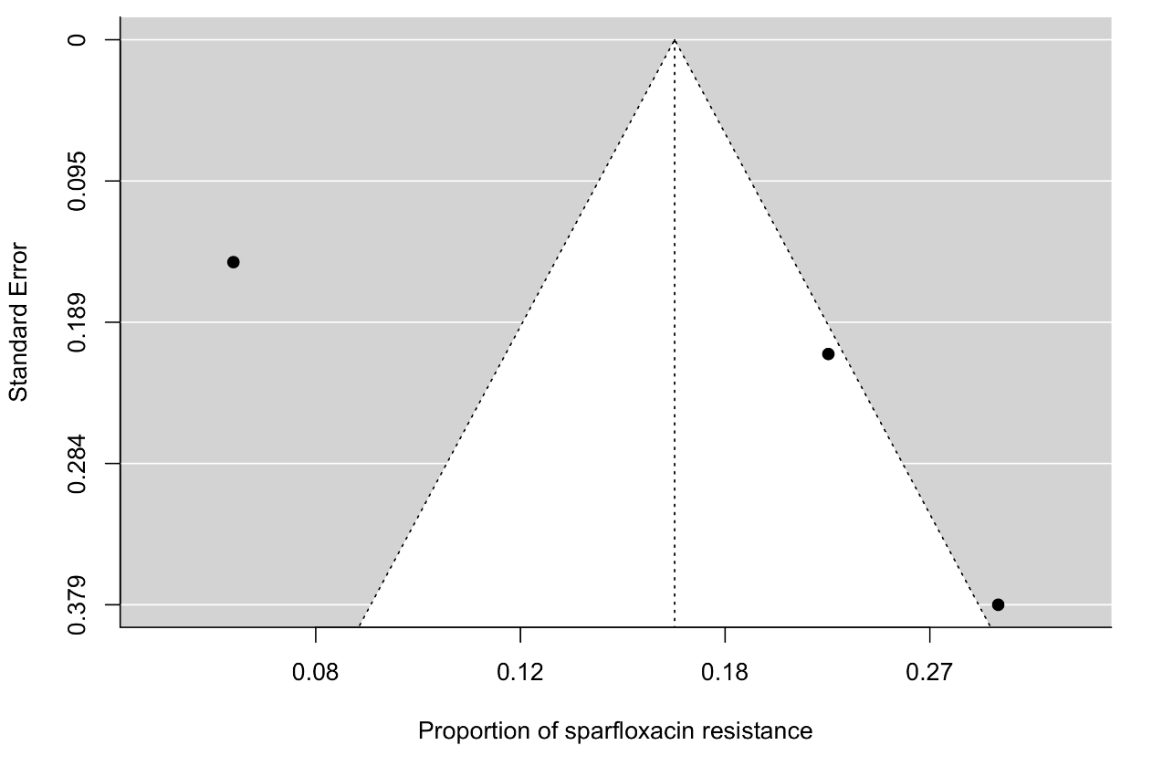
Figure 80. The funnel plot of meta-analysis of publication studies. Each black dot represents a study. The white dots represent missing studies. The black line in the middle represents the average effect size.

Figure 81. Bubble plot with fitted meta-regression for the year of publication

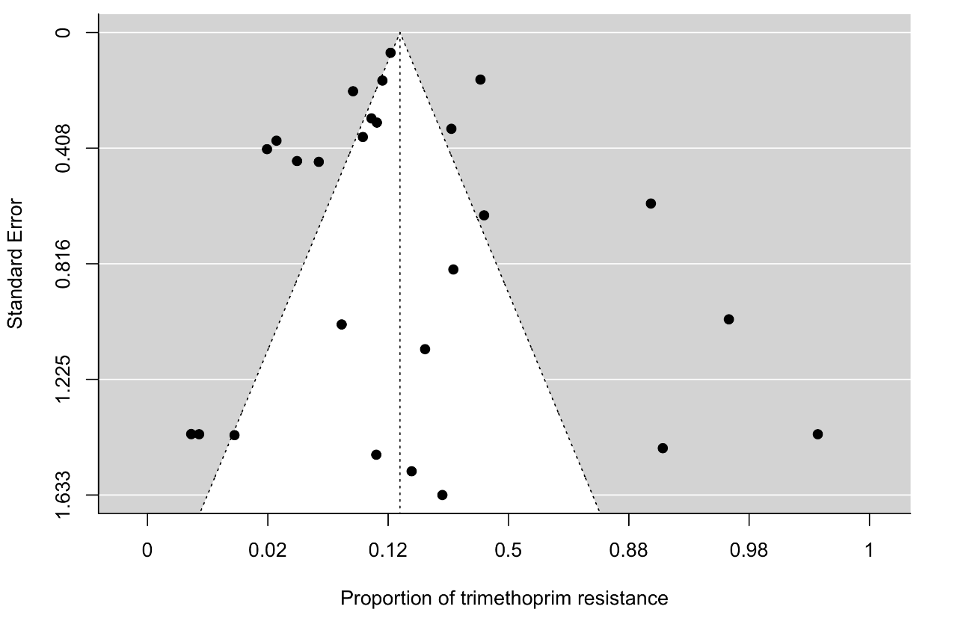
Sulfonamides
Figure 82. The funnel plot of meta-analysis of publication studies. Each black dot represents a study. The white dots represent missing studies. The black line in the middle represents the average effect size
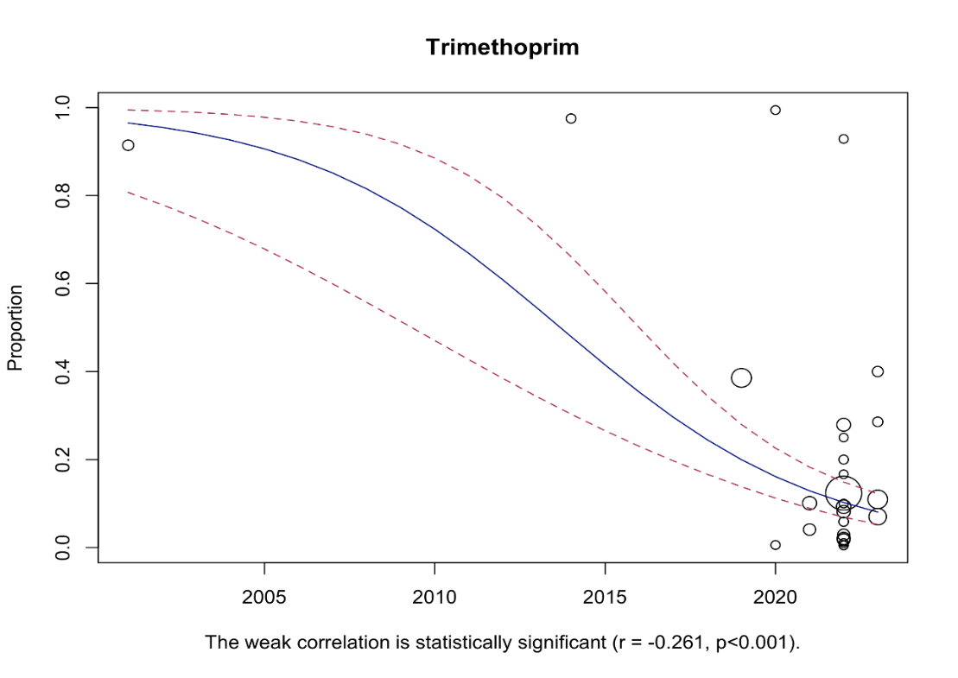

Figure 83. Bubble plot with fitted meta-regression for the year of publication

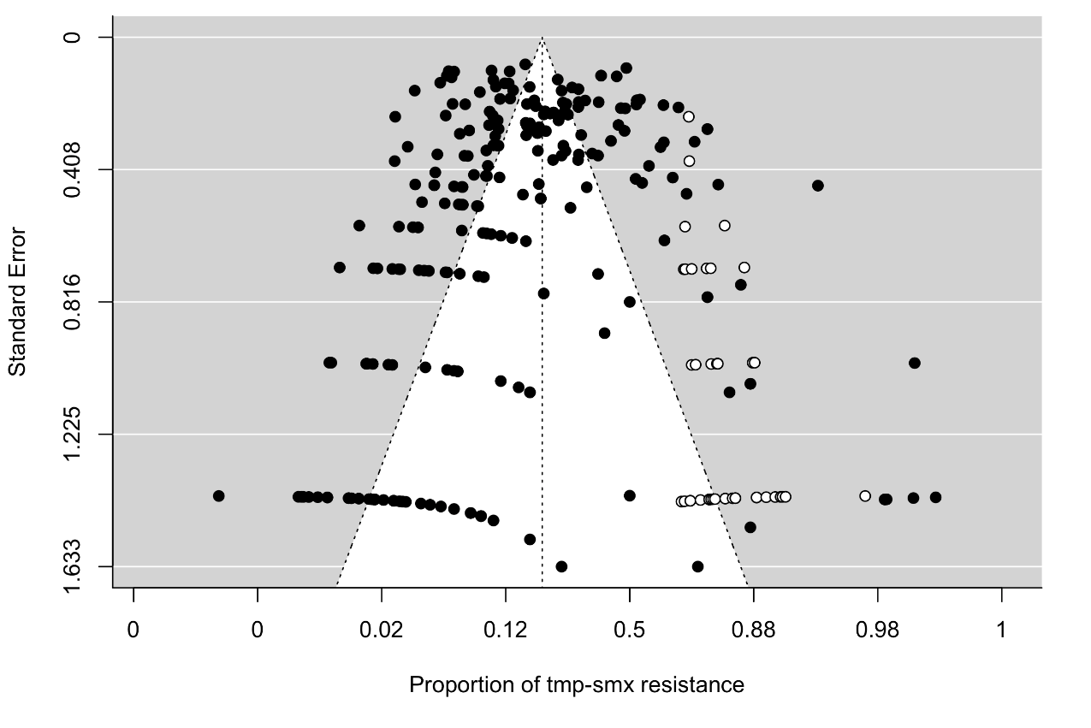
Figure 84. The funnel plot of meta-analysis of publication studies. Each black dot represents a study. The white dots represent missing studies. The black line in the middle represents the average effect size
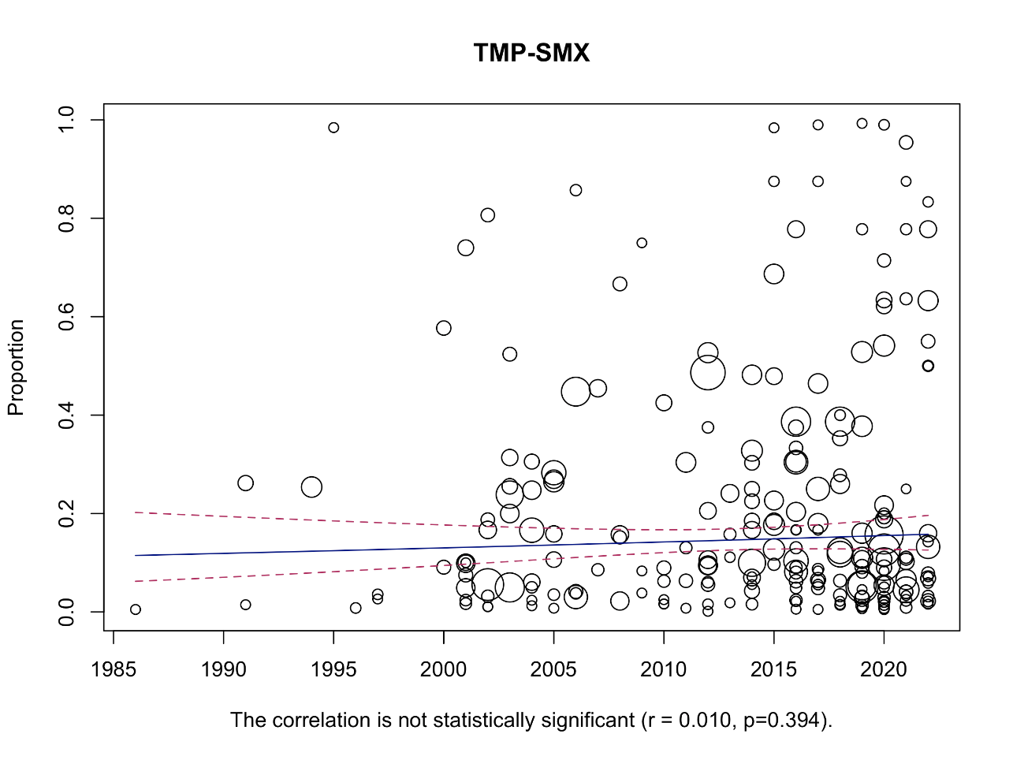

Figure 85. Bubble plot with fitted meta-regression for the year of publication
Chloramphenicol
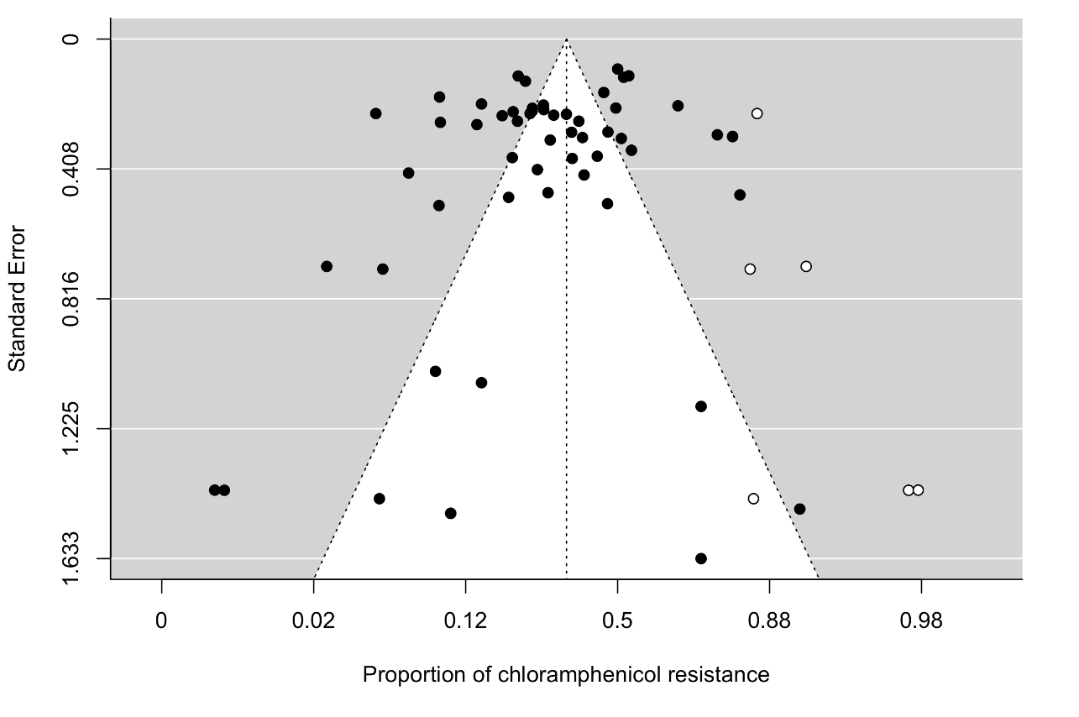
Figure 86. The funnel plot of meta-analysis of publication studies. Each black dot represents a study. The white dots represent missing studies. The black line in the middle represents the average effect size
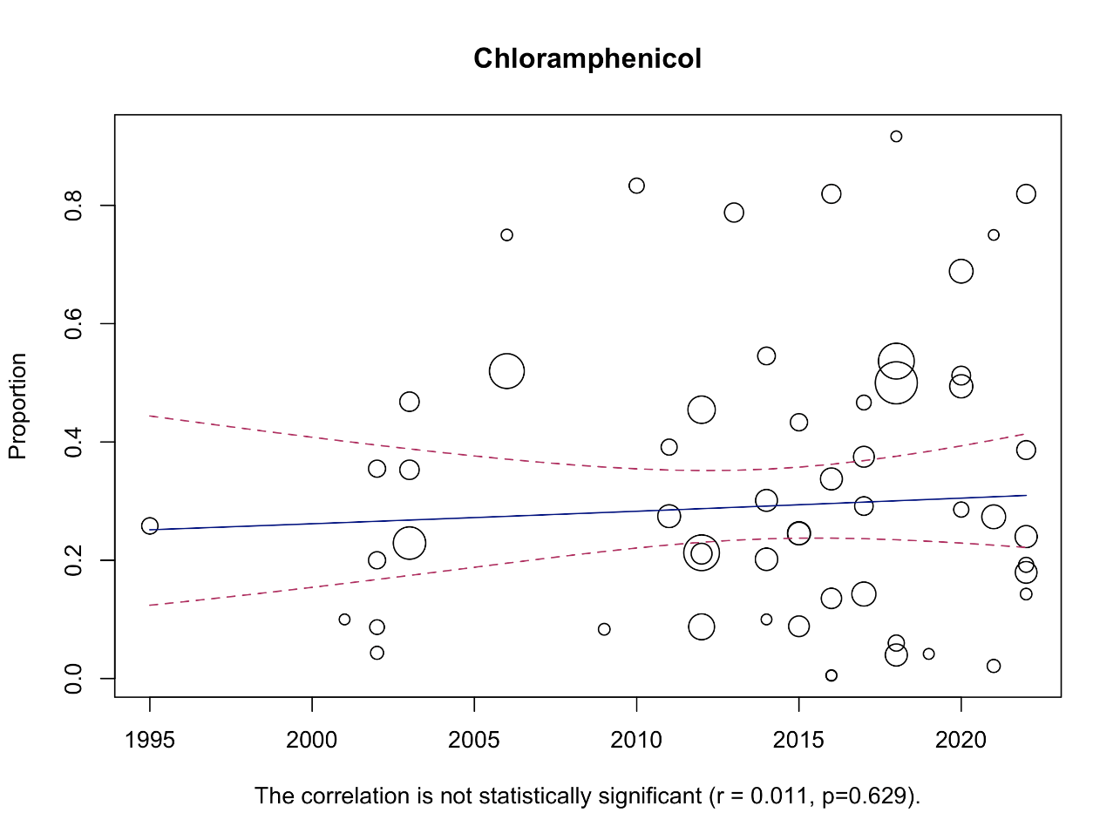

Figure 87. Bubble plot with fitted meta-regression for the year of publication
Colistin
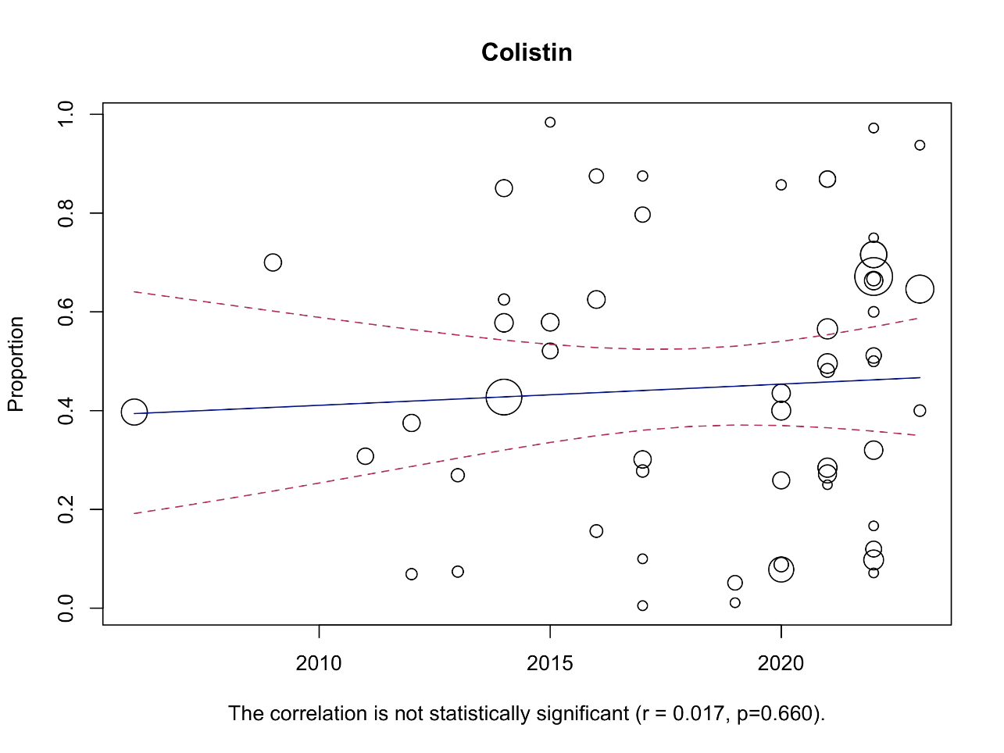
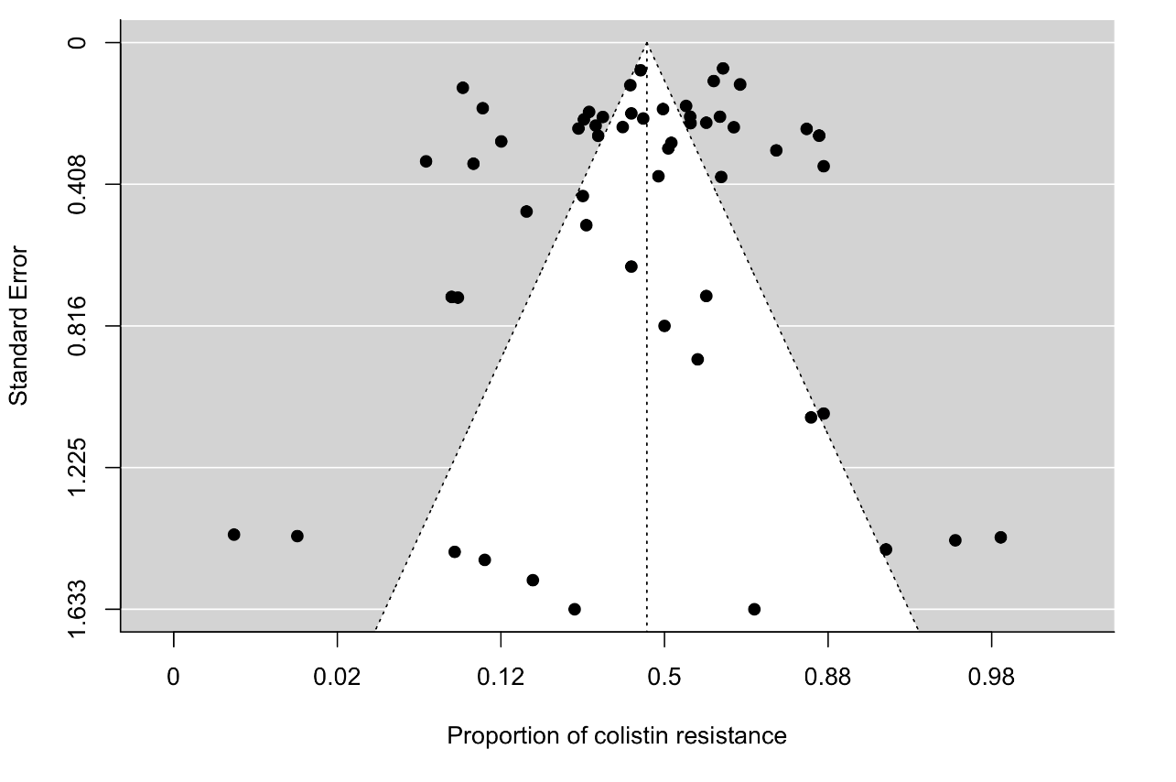
Figure 88. The funnel plot of meta-analysis of publication studies. Each black dot represents a study. The white dots represent missing studies. The black line in the middle represents the average effect size

Figure 89. Bubble plot with fitted meta-regression for the year of publication
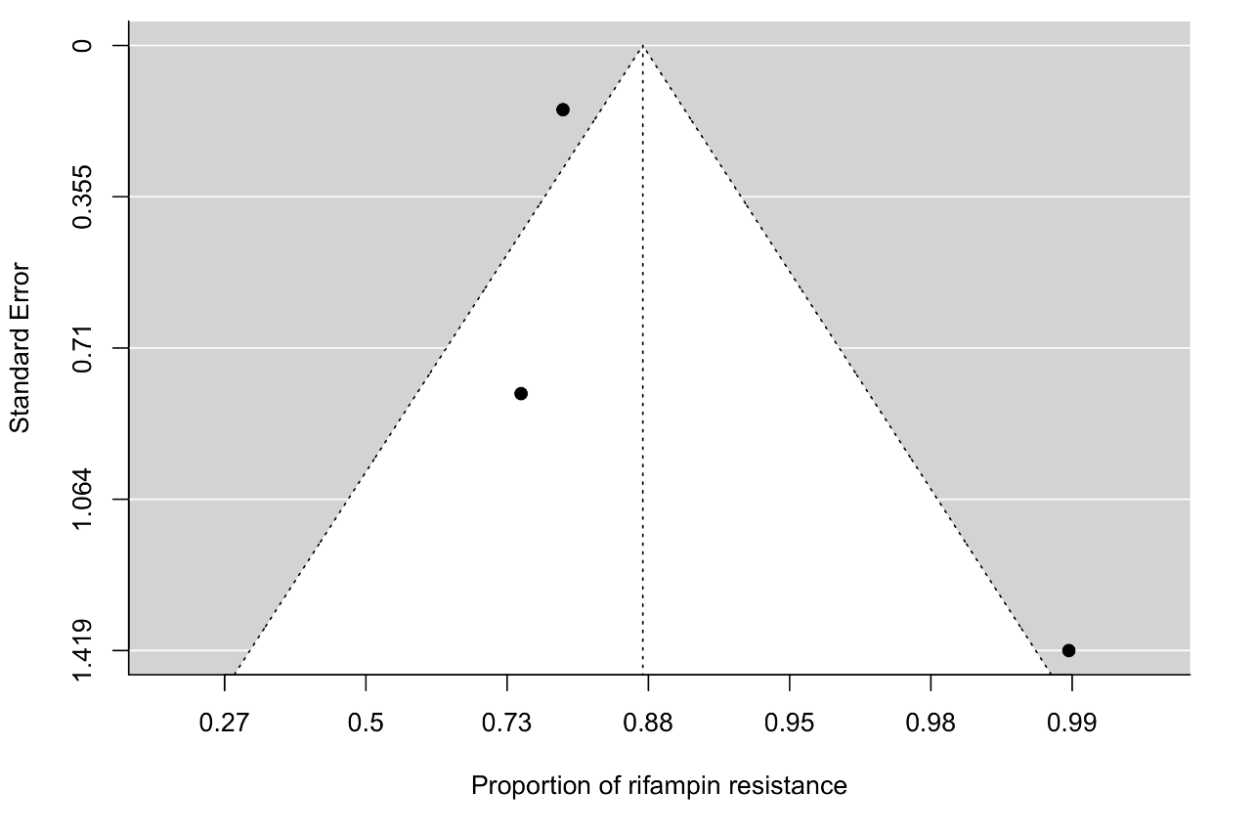
Rifampin

Figure 90. The funnel plot of meta-analysis of publication studies. Each black dot represents a study. The black line in the middle represents the average effect size
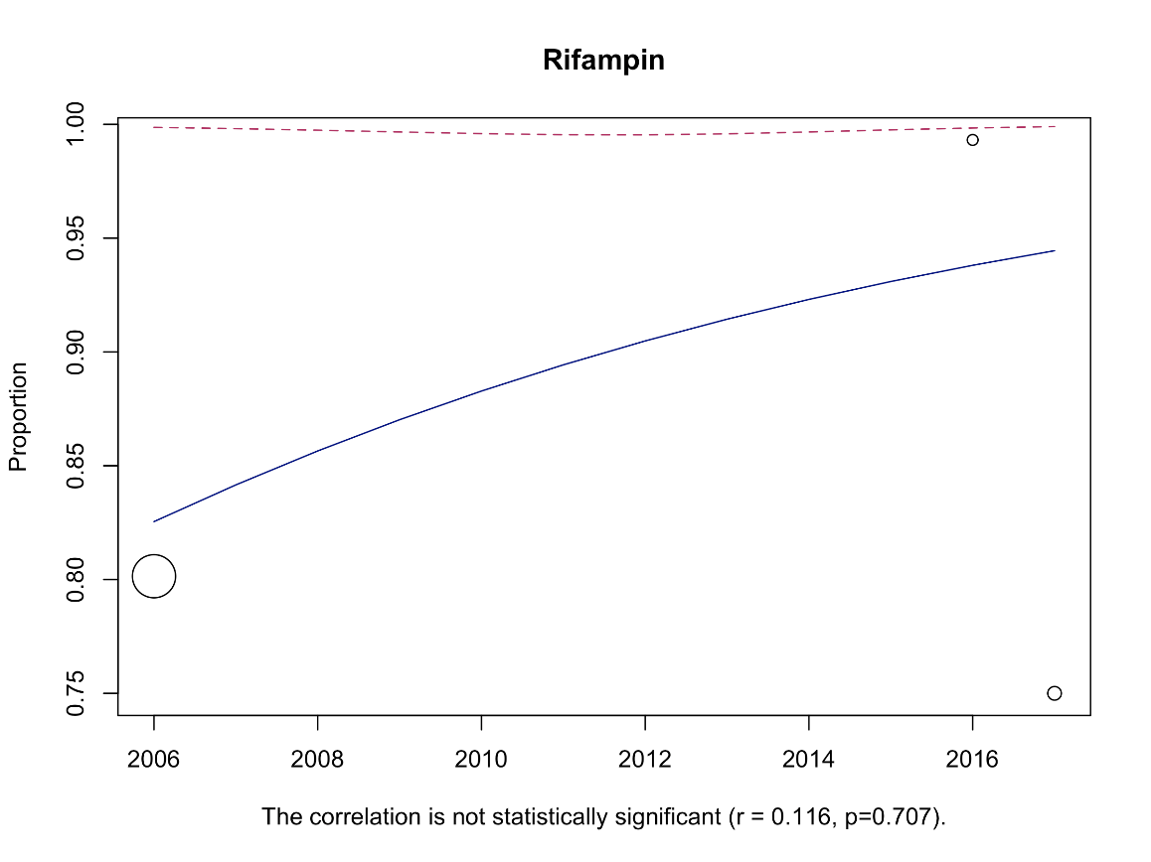

Figure 91. Bubble plot with fitted meta-regression for the year of publication.

