Supplementary file

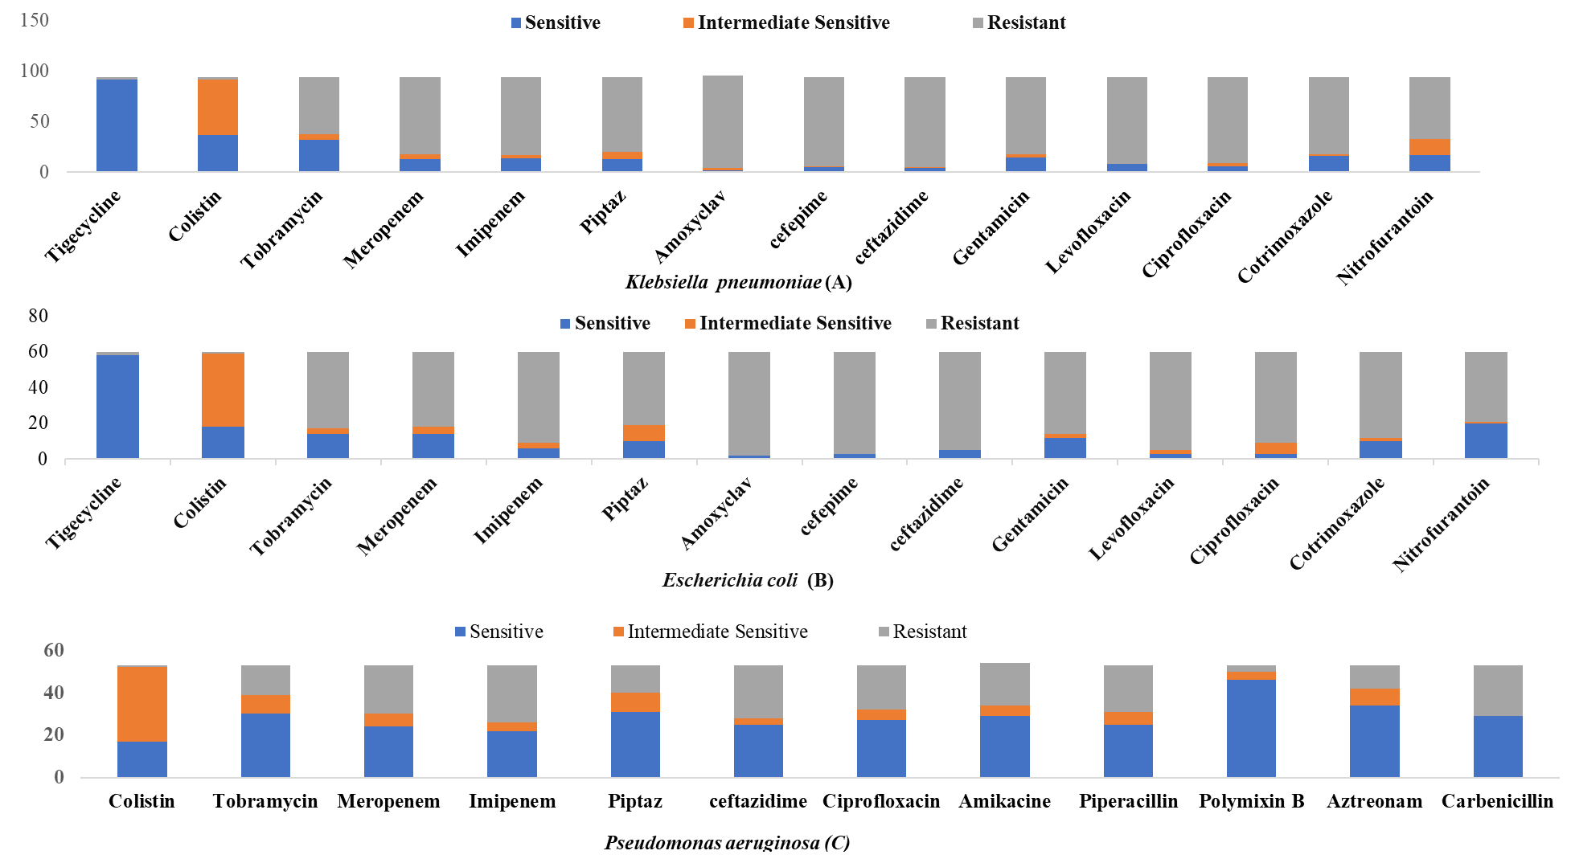
Supplementary Figure 1(A-C). Antibiotic susceptibility pattern of Gram-negative bacteria
Illustrates the antimicrobial susceptibility pattern of the predominant Gram-negative bacteria. The X-axis indicates the names of antibiotics that were tested against the specified bacteria. The blue coloration within each bar signifies the number of isolates that exhibit sensitivity to the particular antibiotics. However, the orange coloration reflects intermediate sensitivity, while the gray coloration indicates resistance to the antibiotics for each of the isolates. The Y-axis represents the total number of bacterial isolates

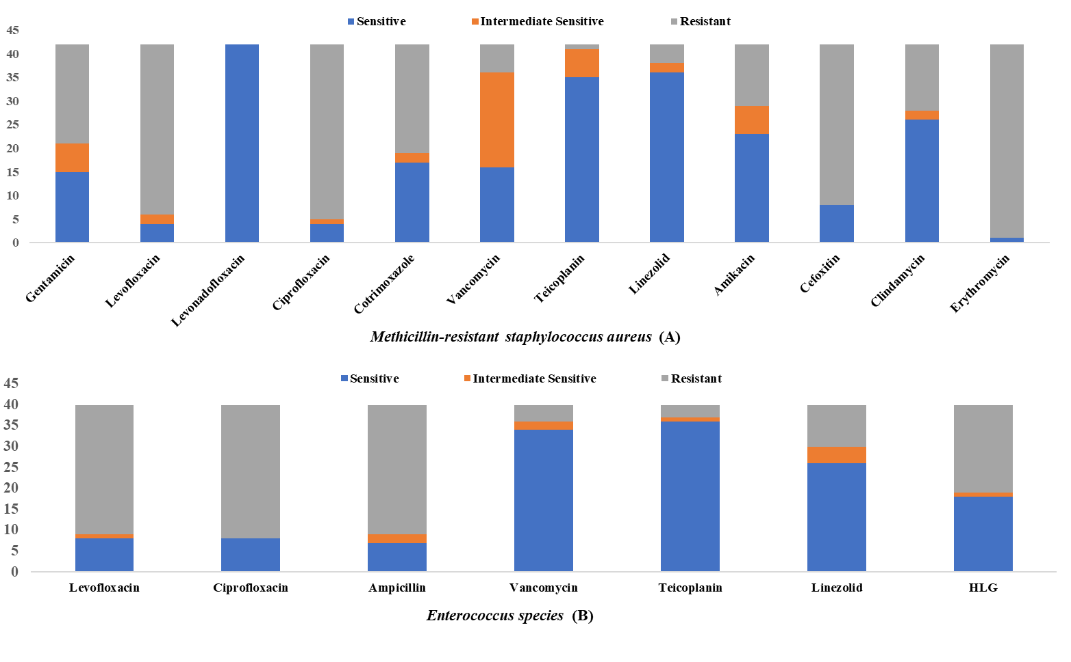Supplementary Figure 2. Antibiotic susceptibility pattern of Gram-positive isolates
Illustrates the antimicrobial susceptibility pattern of the predominant Gram-positive bacteria. The X-axis indicates the names of antibiotics that were tested against the specified bacteria. The blue coloration within each bar signifies the number of isolates that exhibit sensitivity to the particular antibiotics. However, the orange coloration reflects intermediate sensitivity, while the gray coloration indicates resistance to the antibiotics for each of the isolates. The Y-axis represents the total number of bacterial isolates.

Supplementary Figure 3: Susceptibility pattern of fungal isolates

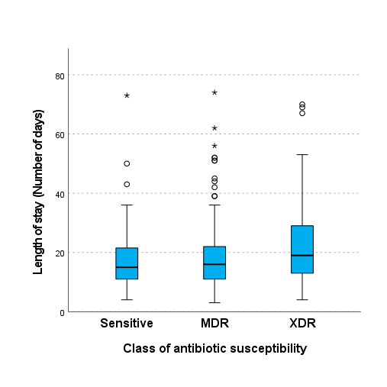
Figure 4. Antibiotic susceptibility class and length of hospital stay

Supplementary Table 1 - Prevalence of Bacterial Isolates on the basis of Antibiotic susceptibility class and associated 30-day mortality in each cancer type.
Diagnosis | Class of antibiotic susceptibility | 30-day mortality | Counts | % of Total | Cumulative %
Acute leukaemia | Sensitive | Dead | 1 | 0.2 % | 0.2 %
Acute leukaemia | Sensitive | Alive | 9 | 2.1 % | 2.4 %
Acute leukaemia | MDR | Dead | 8 | 1.9 % | 4.2 %
Acute leukaemia | MDR | Alive | 11 | 2.6 % | 6.8 %
Acute leukaemia | XDR | Dead | 11 | 2.6 % | 9.4 %
Acute leukaemia | XDR | Alive | 1 | 0.2 % | 9.6 %
Astrocytoma | Sensitive | Dead | 0 | 0.0 % | 9.6 %
Astrocytoma | Sensitive | Alive | 1 | 0.2 % | 9.9 %
Astrocytoma | MDR | Dead | 0 | 0.0 % | 9.9 %
Astrocytoma | MDR | Alive | 0 | 0.0 % | 9.9 %
Astrocytoma | XDR | Dead | 0 | 0.0 % | 9.9 %
Astrocytoma | XDR | Alive | 0 | 0.0 % | 9.9 %
Breast | Sensitive | Dead | 0 | 0.0 % | 9.9 %
Breast | Sensitive | Alive | 15 | 3.5 % | 13.4 %
Breast | MDR | Dead | 1 | 0.2 % | 13.6 %
Breast | MDR | Alive | 13 | 3.1 % | 16.7 %
Breast | XDR | Dead | 8 | 1.9 % | 18.6 %
Breast | XDR | Alive | 3 | 0.7 % | 19.3 %
Burkitts lymphoma | Sensitive | Dead | 0 | 0.0 % | 19.3 %
Burkitts lymphoma | Sensitive | Alive | 1 | 0.2 % | 19.5 %
Burkitts lymphoma | MDR | Dead | 0 | 0.0 % | 19.5 %
Burkitts lymphoma | MDR | Alive | 1 | 0.2 % | 19.8 %
Burkitts lymphoma | XDR | Dead | 0 | 0.0 % | 19.8 %
Burkitts lymphoma | XDR | Alive | 0 | 0.0 % | 19.8 %
Cervix | Sensitive | Dead | 1 | 0.2 % | 20.0 %
Cervix | Sensitive | Alive | 9 | 2.1 % | 22.1 %
Cervix | MDR | Dead | 4 | 0.9 % | 23.1 %
Cervix | MDR | Alive | 25 | 5.9 % | 28.9 %
Cervix | XDR | Dead | 11 | 2.6 % | 31.5 %
Cervix | XDR | Alive | 4 | 0.9 % | 32.5 %
Chronic leukemia | Sensitive | Dead | 1 | 0.2 % | 32.7 %
Chronic leukemia | Sensitive | Alive | 1 | 0.2 % | 32.9 %
Chronic leukemia | MDR | Dead | 3 | 0.7 % | 33.6 %
Chronic leukemia | MDR | Alive | 3 | 0.7 % | 34.4 %
Chronic leukemia | XDR | Dead | 1 | 0.2 % | 34.6 %
Chronic leukemia | XDR | Alive | 2 | 0.5 % | 35.1 %
Colorectal cancer | Sensitive | Dead | 2 | 0.5 % | 35.5 %
Colorectal cancer | Sensitive | Alive | 4 | 0.9 % | 36.5 %
Colorectal cancer | MDR | Dead | 2 | 0.5 % | 36.9 %
Colorectal cancer | MDR | Alive | 10 | 2.4 % | 39.3 %
Colorectal cancer | XDR | Dead | 2 | 0.5 % | 39.8 %
Colorectal cancer | XDR | Alive | 13 | 3.1 % | 42.8 %
Common bile duct | Sensitive | Dead | 0 | 0.0 % | 42.8 %
Common bile duct | Sensitive | Alive | 0 | 0.0 % | 42.8 %
Common bile duct | MDR | Dead | 0 | 0.0 % | 42.8 %
Common bile duct | MDR | Alive | 1 | 0.2 % | 43.1 %
Common bile duct | XDR | Dead | 0 | 0.0 % | 43.1 %
Common bile duct | XDR | Alive | 1 | 0.2 % | 43.3 %
Ear | Sensitive | Dead | 0 | 0.0 % | 43.3 %
Ear | Sensitive | Alive | 1 | 0.2 % | 43.5 %
Ear | MDR | Dead | 0 | 0.0 % | 43.5 %
Ear | MDR | Alive | 0 | 0.0 % | 43.5 %
Ear | XDR | Dead | 0 | 0.0 % | 43.5 %
Ear | XDR | Alive | 0 | 0.0 % | 43.5 %
Ewings sarcoma | Sensitive | Dead | 0 | 0.0 % | 43.5 %
Ewings sarcoma | Sensitive | Alive | 1 | 0.2 % | 43.8 %
Ewings sarcoma | MDR | Dead | 3 | 0.7 % | 44.5 %
Ewings sarcoma | MDR | Alive | 2 | 0.5 % | 44.9 %
Ewings sarcoma | XDR | Dead | 0 | 0.0 % | 44.9 %
Ewings sarcoma | XDR | Alive | 2 | 0.5 % | 45.4 %
Giant cell Tumor | Sensitive | Dead | 0 | 0.0 % | 45.4 %
Giant cell Tumor | Sensitive | Alive | 0 | 0.0 % | 45.4 %
Giant cell Tumor | MDR | Dead | 0 | 0.0 % | 45.4 %
Giant cell Tumor | MDR | Alive | 0 | 0.0 % | 45.4 %
Giant cell Tumor | XDR | Dead | 1 | 0.2 % | 45.6 %
Giant cell Tumor | XDR | Alive | 1 | 0.2 % | 45.9 %
Gall bladder | Sensitive | Dead | 1 | 0.2 % | 46.1 %
Gall bladder | Sensitive | Alive | 6 | 1.4 % | 47.5 %
Gall bladder | MDR | Dead | 6 | 1.4 % | 48.9 %
Gall bladder | MDR | Alive | 11 | 2.6 % | 51.5 %
Gall bladder | XDR | Dead | 10 | 2.4 % | 53.9 %
Gall bladder | XDR | Alive | 5 | 1.2 % | 55.1 %
Glioblastoma | Sensitive | Dead | 1 | 0.2 % | 55.3 %
Glioblastoma | Sensitive | Alive | 0 | 0.0 % | 55.3 %
Glioblastoma | MDR | Dead | 1 | 0.2 % | 55.5 %
Glioblastoma | MDR | Alive | 0 | 0.0 % | 55.5 %
Glioblastoma | XDR | Dead | 1 | 0.2 % | 55.8 %
Glioblastoma | XDR | Alive | 0 | 0.0 % | 55.8 %
Head and neck cancer | Sensitive | Dead | 2 | 0.5 % | 56.2 %
Head and neck cancer | Sensitive | Alive | 14 | 3.3 % | 59.5 %
Head and neck cancer | MDR | Dead | 8 | 1.9 % | 61.4 %
Head and neck cancer | MDR | Alive | 18 | 4.2 % | 65.6 %
Head and neck cancer | XDR | Dead | 7 | 1.6 % | 67.3 %
Head and neck cancer | XDR | Alive | 6 | 1.4 % | 68.7 %
Hodgkings | Sensitive | Dead | 0 | 0.0 % | 68.7 %
Hodgkings | Sensitive | Alive | 0 | 0.0 % | 68.7 %
Hodgkings | MDR | Dead | 0 | 0.0 % | 68.7 %
Hodgkings | MDR | Alive | 0 | 0.0 % | 68.7 %
Hodgkings | XDR | Dead | 1 | 0.2 % | 68.9 %
Hodgkings | XDR | Alive | 0 | 0.0 % | 68.9 %
Kidney | Sensitive | Dead | 0 | 0.0 % | 68.9 %
Kidney | Sensitive | Alive | 0 | 0.0 % | 68.9 %
Kidney | MDR | Dead | 2 | 0.5 % | 69.4 %
Kidney | MDR | Alive | 0 | 0.0 % | 69.4 %
Kidney | XDR | Dead | 0 | 0.0 % | 69.4 %
Kidney | XDR | Alive | 0 | 0.0 % | 69.4 %
Liver | Sensitive | Dead | 0 | 0.0 % | 69.4 %
Liver | Sensitive | Alive | 0 | 0.0 % | 69.4 %
Liver | MDR | Dead | 1 | 0.2 % | 69.6 %
Liver | MDR | Alive | 5 | 1.2 % | 70.8 %
Liver | XDR | Dead | 0 | 0.0 % | 70.8 %
Liver | XDR | Alive | 0 | 0.0 % | 70.8 %
Lower limb | Sensitive | Dead | 0 | 0.0 % | 70.8 %
Lower limb | Sensitive | Alive | 4 | 0.9 % | 71.8 %
Lower limb | MDR | Dead | 1 | 0.2 % | 72.0 %
Lower limb | MDR | Alive | 2 | 0.5 % | 72.5 %
Lower limb | XDR | Dead | 3 | 0.7 % | 73.2 %
Lower limb | XDR | Alive | 3 | 0.7 % | 73.9 %
Lung | Sensitive | Dead | 1 | 0.2 % | 74.1 %
Lung | Sensitive | Alive | 3 | 0.7 % | 74.8 %
Lung | MDR | Dead | 4 | 0.9 % | 75.8 %
Lung | MDR | Alive | 6 | 1.4 % | 77.2 %
Lung | XDR | Dead | 2 | 0.5 % | 77.6 %
Lung | XDR | Alive | 2 | 0.5 % | 78.1 %
Meningioma | Sensitive | Dead | 0 | 0.0 % | 78.1 %
Meningioma | Sensitive | Alive | 0 | 0.0 % | 78.1 %
Meningioma | MDR | Dead | 0 | 0.0 % | 78.1 %
Meningioma | MDR | Alive | 1 | 0.2 % | 78.4 %
Meningioma | XDR | Dead | 0 | 0.0 % | 78.4 %
Meningioma | XDR | Alive | 0 | 0.0 % | 78.4 %
Multiple myeloma | Sensitive | Dead | 0 | 0.0 % | 78.4 %
Multiple myeloma | Sensitive | Alive | 1 | 0.2 % | 78.6 %
Multiple myeloma | MDR | Dead | 1 | 0.2 % | 78.8 %
Multiple myeloma | MDR | Alive | 5 | 1.2 % | 80.0 %
Multiple myeloma | XDR | Dead | 1 | 0.2 % | 80.2 %
Multiple myeloma | XDR | Alive | 1 | 0.2 % | 80.5 %
Non-hodgkin’s lymphoma | Sensitive | Dead | 1 | 0.2 % | 80.7 %
Non-hodgkin’s lymphoma | Sensitive | Alive | 0 | 0.0 % | 80.7 %
Non-hodgkin’s lymphoma | MDR | Dead | 2 | 0.5 % | 81.2 %
Non-hodgkin’s lymphoma | MDR | Alive | 4 | 0.9 % | 82.1 %
Non-hodgkin’s lymphoma | XDR | Dead | 1 | 0.2 % | 82.4 %
Non-hodgkin’s lymphoma | XDR | Alive | 1 | 0.2 % | 82.6 %
Nose | Sensitive | Dead | 0 | 0.0 % | 82.6 %
Nose | Sensitive | Alive | 0 | 0.0 % | 82.6 %
Nose | MDR | Dead | 0 | 0.0 % | 82.6 %
Nose | MDR | Alive | 1 | 0.2 % | 82.8 %
Nose | XDR | Dead | 0 | 0.0 % | 82.8 %
Nose | XDR | Alive | 0 | 0.0 % | 82.8 %
Ovary | Sensitive | Dead | 0 | 0.0 % | 82.8 %
Ovary | Sensitive | Alive | 1 | 0.2 % | 83.1 %
Ovary | MDR | Dead | 0 | 0.0 % | 83.1 %
Ovary | MDR | Alive | 6 | 1.4 % | 84.5 %
Ovary | XDR | Dead | 1 | 0.2 % | 84.7 %
Ovary | XDR | Alive | 3 | 0.7 % | 85.4 %
Pancreas | Sensitive | Dead | 0 | 0.0 % | 85.4 %
Pancreas | Sensitive | Alive | 0 | 0.0 % | 85.4 %
Pancreas | MDR | Dead | 0 | 0.0 % | 85.4 %
Pancreas | MDR | Alive | 3 | 0.7 % | 86.1 %
Pancreas | XDR | Dead | 0 | 0.0 % | 86.1 %
Pancreas | XDR | Alive | 2 | 0.5 % | 86.6 %
Penis | Sensitive | Dead | 0 | 0.0 % | 86.6 %
Penis | Sensitive | Alive | 2 | 0.5 % | 87.1 %
Penis | MDR | Dead | 0 | 0.0 % | 87.1 %
Penis | MDR | Alive | 1 | 0.2 % | 87.3 %
Penis | XDR | Dead | 2 | 0.5 % | 87.8 %
Penis | XDR | Alive | 2 | 0.5 % | 88.2 %
Periampullary | Sensitive | Dead | 0 | 0.0 % | 88.2 %
Periampullary | Sensitive | Alive | 0 | 0.0 % | 88.2 %
Periampullary | MDR | Dead | 0 | 0.0 % | 88.2 %
Periampullary | MDR | Alive | 1 | 0.2 % | 88.5 %
Periampullary | XDR | Dead | 0 | 0.0 % | 88.5 %
Periampullary | XDR | Alive | 1 | 0.2 % | 88.7 %
Pleomorphic rhabdomyosarcoma | Sensitive | Dead | 1 | 0.2 % | 88.9 %
Pleomorphic rhabdomyosarcoma | Sensitive | Alive | 0 | 0.0 % | 88.9 %
Pleomorphic rhabdomyosarcoma | MDR | Dead | 0 | 0.0 % | 88.9 %
Pleomorphic rhabdomyosarcoma | MDR | Alive | 0 | 0.0 % | 88.9 %
Pleomorphic rhabdomyosarcoma | XDR | Dead | 0 | 0.0 % | 88.9 %
Pleomorphic rhabdomyosarcoma | XDR | Alive | 0 | 0.0 % | 88.9 %
Prostate | Sensitive | Dead | 0 | 0.0 % | 88.9 %
Prostate | Sensitive | Alive | 0 | 0.0 % | 88.9 %
Prostate | MDR | Dead | 1 | 0.2 % | 89.2 %
Prostate | MDR | Alive | 4 | 0.9 % | 90.1 %
Prostate | XDR | Dead | 2 | 0.5 % | 90.6 %
Prostate | XDR | Alive | 0 | 0.0 % | 90.6 %
Stomach | Sensitive | Dead | 1 | 0.2 % | 90.8 %
Stomach | Sensitive | Alive | 3 | 0.7 % | 91.5 %
Stomach | MDR | Dead | 1 | 0.2 % | 91.8 %
Stomach | MDR | Alive | 1 | 0.2 % | 92.0 %
Stomach | XDR | Dead | 0 | 0.0 % | 92.0 %
Stomach | XDR | Alive | 1 | 0.2 % | 92.2 %
Testies | Sensitive | Dead | 0 | 0.0 % | 92.2 %
Testies | Sensitive | Alive | 0 | 0.0 % | 92.2 %
Testies | MDR | Dead | 1 | 0.2 % | 92.5 %
Testies | MDR | Alive | 1 | 0.2 % | 92.7 %
Testies | XDR | Dead | 0 | 0.0 % | 92.7 %
Testies | XDR | Alive | 0 | 0.0 % | 92.7 %
Thyroid | Sensitive | Dead | 0 | 0.0 % | 92.7 %
Thyroid |  | Alive | 0 | 0.0 % | 92.7 %
Thyroid | MDR | Dead | 1 | 0.2 % | 92.9 %
Thyroid |  | Alive | 2 | 0.5 % | 93.4 %
Thyroid | XDR | Dead | 1 | 0.2 % | 93.6 %
Thyroid |  | Alive | 0 | 0.0 % | 93.6 %
Upper limb | Sensitive | Dead | 0 | 0.0 % | 93.6 %
Upper limb | Sensitive | Alive | 2 | 0.5 % | 94.1 %
Upper limb | MDR | Dead | 0 | 0.0 % | 94.1 %
Upper limb | MDR | Alive | 2 | 0.5 % | 94.6 %
Upper limb | XDR | Dead | 0 | 0.0 % | 94.6 %
Upper limb | XDR | Alive | 0 | 0.0 % | 94.6 %
Urinary bladder | Sensitive | Dead | 0 | 0.0 % | 94.6 %
Urinary bladder | Sensitive | Alive | 4 | 0.9 % | 95.5 %
Urinary bladder | MDR | Dead | 2 | 0.5 % | 96.0 %
Urinary bladder | MDR | Alive | 4 | 0.9 % | 96.9 %
Urinary bladder | XDR | Dead | 1 | 0.2 % | 97.2 %
Urinary bladder | XDR | Alive | 1 | 0.2 % | 97.4 %
Uterus | Sensitive | Dead | 0 | 0.0 % | 97.4 %
Uterus | Sensitive | Alive | 3 | 0.7 % | 98.1 %
Uterus | MDR | Dead | 0 | 0.0 % | 98.1 %
Uterus | MDR | Alive | 3 | 0.7 % | 98.8 %
Uterus | XDR | Dead | 1 | 0.2 % | 99.1 %
Uterus | XDR | Alive | 1 | 0.2 % | 99.3 %
Vagina | Sensitive | Dead | 0 | 0.0 % | 99.3 %
Vagina | Sensitive | Alive | 1 | 0.2 % | 99.5 %
Vagina | MDR | Dead | 0 | 0.0 % | 99.5 %
Vagina | MDR | Alive | 0 | 0.0 % | 99.5 %
Vagina | XDR | Dead | 0 | 0.0 % | 99.5 %
Vagina | XDR | Alive | 0 | 0.0 % | 99.5 %
Vulva | Sensitive | Dead | 0 | 0.0 % | 99.5 %
Vulva | Sensitive | Alive | 1 | 0.2 % | 99.8 %
Vulva | MDR | Dead | 0 | 0.0 % | 99.8 %
Vulva | MDR | Alive | 1 | 0.2 % | 100.0 %
Vulva | XDR | Dead | 0 | 0.0 % | 100.0 %
Vulva | XDR | Alive | 0 | 0.0 % | 100.0 %

Supplementary Table 2 Multinomial logistic regression analysis for prediction of antimicrobial resistance in cancer patients
Parameter Estimates
Class of Resistanceª |  | B | Std. Error | Wald | df | Sig. | Exp(B) | 95% Confidence Interval for Exp(B)
 |  |  |  |  |  |  |  | Lower Bound | Upper Bound
MDR | Intercept | 51.544 | 189.323 | .001 | 1 | .974
MDR | Diagnosis Type | .005 | .323 | .000 | 1 | .988 | 1.005 | .534 | 1.891
MDR | Type of Cancer | -7.518 | 349.129 | .000 | 1 | .983 | .001 | 3.595 | 8.201
MDR | Stage | .123 | .346 | .126 | 1 | .723 | 1.131 | .574 | 2.229
MDR | Histological Classification | .866 | .784 | 1.219 | 1 | .270 | 2.377 | .511 | 11.050
MDR | Cardiovascular Comorbidity | .575 | .517 | 1.237 | 1 | .266 | 1.777 | .645 | 4.898
MDR | Pneumonia | -11.129 | 72.311 | .024 | 1 | .878 | 1.468 | 4.127 | 5.256
MDR | Metastasis | -.089 | .841 | .011 | 1 | .916 | .915 | .176 | 4.755
MDR | Jaundice | -1.963 | 1.348 | 2.119 | 1 | .145 | .140 | .010 | 1.974
MDR | Sepsis | -1.077 | 1.289 | .698 | 1 | .403 | .340 | .027 | 4.262
MDR | Anemia | -.041 | .804 | .003 | 1 | .959 | .960 | .199 | 4.637
MDR | Hypothyroidisam | -.844 | .614 | 1.891 | 1 | .169 | .430 | .129 | 1.432
MDR | Prior H/O surgery | 1.005 | .365 | 7.578 | 1 | .006 | 2.731 | 1.336 | 5.586
MDR | H/O Radiation | -1.140 | .542 | 4.425 | 1 | .035 | .320 | .111 | .925
MDR | H/O Chemo | 1.600 | .425 | 14.138 | 1 | .000 | 4.952 | 2.151 | 11.400
MDR | Treatment Given | -.048 | .146 | .108 | 1 | .743 | .953 | .717 | 1.268
MDR | Tracheostomy | .723 | 1.095 | .436 | 1 | .509 | 2.060 | .241 | 17.605
MDR | IV Canulla | 0^{b} | . | . | 0 | . | . | . | .
MDR | Foleys catheter | -.040 | .385 | .011 | 1 | .918 | .961 | .452 | 2.044
MDR | RT | -.228 | .419 | .297 | 1 | .586 | .796 | .351 | 1.808
MDR | CVC | -.369 | .839 | .194 | 1 | .660 | .691 | .134 | 3.575
MDR | NCI Category | .540 | .536 | 1.018 | 1 | .313 | 1.717 | .601 | 4.904
MDR | MASCC | -.161 | .396 | .165 | 1 | .684 | .851 | .391 | 1.851
MDR | Type of Sample | -.055 | .864 | .004 | 1 | .950 | .947 | .174 | 5.152
MDR | Pathogen identified | -.335 | .075 | 20.007 | 1 | .000 | .716 | .618 | .829
MDR | Polymicrobial/Monomicrobial | -.969 | .465 | 4.343 | 1 | .037 | .379 | .152 | .944
MDR | Type of Bacteria | 3.155 | .933 | 11.443 | 1 | .001 | 23.446 | 3.769 | 145.845
MDR | Type of infection | -.659 | .386 | 2.910 | 1 | .088 | .517 | .243 | 1.103
MDR | Use of Antibiotics | -.497 | .432 | 1.324 | 1 | .001 | 2.460 | 1.741 | 6.481
MDR | History of Hospitalisation | 1.075 | .507 | 4.489 | 1 | .034 | 2.930 | 1.084 | 7.922
MDR | Recent | .681 | .684 | .991 | 1 | .319 | 1.975 | .517 | 7.544
MDR | Progression | 0^{b} | . | . | 0 | . | . | . | .
MDR | Solid Tumor | 0^{b} | . | . | 0 | . | . | . | .
MDR | Heamatological | 0^{b} | . | . | 0 | . | . | . | .
MDR | Stage-II | .084 | .513 | .027 | 1 | .870 | 1.088 | .398 | 2.973
MDR | Stage-III | .232 | .639 | .131 | 1 | .717 | 1.261 | .361 | 4.407
MDR | Stage-IV | .204 | .966 | .045 | 1 | .833 | 1.227 | .185 | 8.154
MDR | Carcinoma | -4.480 | 574.684 | .000 | 1 | .994 | .011 | .000 | .^{c}
MDR | Leukemia | -11.206 | 527.511 | .000 | 1 | .983 | 1.36 | .000 | .^{c}
MDR | HTN | -2.248 | 1.542 | 2.125 | 1 | .145 | .106 | .005 | 2.170
MDR | HTN+DM | -2.033 | 1.136 | 3.201 | 1 | .074 | .131 | .014 | 1.214
MDR | DM | 0^{b} | . | . | 0 | . | . | . | .
MDR | NCI-III | -.077 | 1.933 | .002 | 1 | .968 | .926 | .021 | 40.872
MDR | NCI-IV | .862 | 2.056 | .176 | 1 | .009 | 1.247 | 1.042 | 1.426
MDR | Neutrophillia | 1.717 | 2.616 | .431 | 1 | .512 | 5.567 | .033 | 937.926
MDR | Pus | 1.075 | 4.353 | .061 | 1 | .805 | 2.930 | .001 | 14856.720
MDR | Urine | .657 | 3.526 | .035 | 1 | .852 | 1.929 | .002 | 1933.925
MDR | Blood | 1.979 | 2.736 | .523 | 1 | .469 | 7.239 | .034 | 1544.927
MDR | Sputum | .990 | 2.019 | .241 | 1 | .624 | 2.692 | .051 | 140.711
MDR | Chemotherapy | -.415 | .884 | .221 | 1 | .638 | .660 | .117 | 3.730
MDR | Surgery | .852 | .776 | 1.205 | 1 | .272 | 2.344 | .512 | 10.721
MDR | Female | -.270 | .354 | .581 | 1 | .446 | .763 | .381 | 1.528
MDR | Male | 0^{b} | . | . | 0 | . | . | . | .
XDR | Intercept | -3.306 | 148.141 | .000 | 1 | .982
XDR | Diagnosis Type | -.069 | .439 | .025 | 1 | .875 | .933 | .394 | 2.208
XDR | Type of Cancer | 2.930 | 397.148 | .000 | 1 | .994 | 18.722 | .000 | .^{c}
XDR | Stage | .864 | .428 | 4.085 | 1 | .043 | 2.374 | 1.027 | 5.488
XDR | Histological Classification | 1.633 | .859 | 3.617 | 1 | .057 | 5.119 | .951 | 27.545
XDR | Cardiovascular morbidity | 1.381 | .676 | 4.173 | 1 | .041 | 3.978 | 1.057 | 14.961
XDR | Pneumonia | -11.202 | 72.316 | .024 | 1 | .877 | 1.365 | 3.802 | 4.900
XDR | Metastasis | -1.583 | .909 | 3.033 | 1 | .082 | .205 | .035 | 1.220
XDR | Jaundice | -2.438 | 1.457 | 2.798 | 1 | .094 | .087 | .005 | 1.520
XDR | Sepsis | -2.121 | 1.349 | 2.472 | 1 | .116 | .120 | .009 | 1.687
XDR | Anemia | .330 | 1.150 | .083 | 1 | .774 | 1.391 | .146 | 13.256
XDR | Hypothyroidisam | -.431 | .684 | .398 | 1 | .528 | .650 | .170 | 2.481
XDR | Prior H/O surgery | .652 | .439 | 2.209 | 1 | .040 | 1.920 | 1.562 | 4.535
XDR | H/O Radiotherapy | -.712 | .648 | 1.205 | 1 | .272 | .491 | .138 | 1.749
XDR | H/O Chemotherapy | 1.346 | .487 | 7.650 | 1 | .006 | 3.841 | 1.480 | 9.968
XDR | Treatment Given | .080 | .174 | .210 | 1 | .647 | 1.083 | .770 | 1.523
XDR | Tracheostomy | 1.494 | 1.330 | 1.262 | 1 | .261 | 4.455 | .329 | 60.387
XDR | IV Canulla | 0^{b} | . | . | 0 | . | . | . | .
XDR | Foleys catheter | -.440 | .476 | .857 | 1 | .355 | .644 | .253 | 1.636
XDR | RT | -.574 | .488 | 1.381 | 1 | .240 | .563 | .216 | 1.467
XDR | CVC | -.748 | .896 | .697 | 1 | .404 | .473 | .082 | 2.742
XDR | NCI Category | .612 | .788 | .603 | 1 | .437 | 1.844 | .394 | 8.640
XDR | MASCC | -1.071 | .472 | 5.157 | 1 | .023 | .343 | .136 | .864
XDR | Type of Sample | -.380 | 1.097 | .120 | 1 | .729 | .684 | .080 | 5.869
XDR | Pathogen identified | -.402 | .088 | 20.887 | 1 | .000 | .669 | .563 | .795
XDR | Polymicrobial/Monomicrobial | .143 | .512 | .078 | 1 | .780 | 1.154 | .423 | 3.148
XDR | Type of Bacteria | -.326 | 1.503 | .047 | 1 | .828 | .722 | .038 | 13.732
XDR | Type of infection | -.994 | .465 | 4.564 | 1 | .033 | .370 | .149 | .921
XDR | Use of Antibiotics | -.303 | .496 | .372 | 1 | .021 | 3.432 | 1.650 | 10.842
XDR | History of Hospitalisation | 1.355 | .577 | 5.520 | 1 | .019 | 3.877 | 1.252 | 12.004
XDR | Recent | .596 | .872 | .467 | 1 | .494 | 1.815 | .328 | 10.034
XDR | Progression | 0^{b} | . | . | 0 | . | . | . | .
XDR | Solid Tumor | 0^{b} | . | . | 0 | . | . | . | .
XDR | Hematological | 0^{b} | . | . | 0 | . | . | . | .
XDR | Stage-II | -.022 | .705 | .001 | 1 | .975 | .978 | .246 | 3.897
XDR | Stage-III | -.240 | .739 | .105 | 1 | .746 | .787 | .185 | 3.351
XDR | Stage-IV | .500 | 1.107 | .204 | 1 | .651 | 1.649 | .188 | 14.450
XDR | Carcinoma | 6.563 | 397.149 | .000 | 1 | .987 | 708.187 | .000 | .^{c}
XDR | Leukemia | 13.406 | .000 | . | 1 | .091 | 2.351 | 1.238 | 3.785
XDR | HTN | -4.012 | 2.012 | 3.976 | 1 | .046 | .018 | .000 | .934
XDR | HTN+DM | -3.564 | 1.479 | 5.809 | 1 | .016 | .028 | .002 | .514
XDR | DM | 0^{b} | . | . | 0 | . | . | . | .
XDR | NCI-III | -.559 | 2.735 | .042 | 1 | .838 | .572 | .003 | 121.596
XDR | NCI-IV | .661 | 3.054 | .047 | 1 | .001 | 1.346 | 1.121 | 1.616
XDR | Neutrophillia | 1.598 | 3.843 | .173 | 1 | .678 | 4.941 | .003 | 9217.130
XDR | Pus | 1.053 | 5.394 | .038 | 1 | .845 | 2.866 | 7.347 | 15.683
XDR | Urine | 1.001 | 4.340 | .053 | 1 | .818 | 2.720 | .001 | 13441.982
XDR | Blood | 1.081 | 3.326 | .106 | 1 | .745 | 2.948 | .004 | 1996.977
XDR | Sputum | .441 | 2.413 | .033 | 1 | .855 | 1.554 | .014 | 176.065
XDR | Chemotherapy | -.969 | 1.059 | .837 | 1 | .360 | .379 | .048 | 3.025
XDR | Surgery | .330 | .934 | .125 | 1 | .724 | 1.391 | .223 | 8.675
XDR | Female | -.636 | .438 | 2.111 | 1 | .146 | .529 | .224 | 1.249
XDR | Male | 0^{b} | . | . | 0 | . | . | . | .
a. The reference category is: Sensitive.
b. This parameter is set to zero because it is redundant.
c. Floating point overflow occurred while computing this statistic. Its value is therefore set to system missing.

Supplementary Table 3 Bivariate logistic regression analysis for prediction of risk factors for 30-day Mortality
Factor | 30-Day survival (n=300) | 30- Day mortality(n=140) | OR  (CI-95%) | p-value*
Recurrence  Remission | 41(13.7)  34(11.3) | 25(17.9)  1(0.7) | 27.65(2.00-38.75)  0.29(.06-14.61) | 0.013  0.534
Solid Tumour | 264(88.0) | 111(79.3) | 0.519(0.31-0.87) | 0.013
Stage-I  Stages-II  Stages-III  Stages-IV | 26(8.7)  114(38.0)  100(33.3)  22(7.3) | 1(0.7)  43(30.7)  46(32.9)  20(14.3) | 0.11(0.01-1.22)  0.05(0.01-0.63)  0.03(0.02-0.48)  0.84(.02-108.37) | 0.071  0.020  0.013  0.001
HTN  DM  HTN+DM  Jaundice  Sepsis  Anaemia  Hypothyroidism  Metastasis | 40(13.3)  27(9.0)  26(8.7)  8(2.66)  4(1.33)  11(3.66)  34(11.33)  31(7.04) | 17(25.0)  10(7.1)  18(12.85)  1(0.71)  16(11.42)  3(2.14)  12(8.57)  19(13.57) | 0.504(0.095-2.676)  0.125(0.029-.549)  0.436(0.143-1.34)  0.034(0.002-0.598)  6.790(1.23-37.68)  0.499(0.070-3.559)  0.556(0.163-1.894)  4.668(1.341-16.25) | 0.421  0.145  0.006  0.021  0.028  0.488  0.348  0.150
History of Surgery  History of Radiation  History of Chemotherapy | 88(29.3)  49(16.0)  109(36.00) | 41(29.28)  26(18.57)  55(39.28) | 1.275(0.581-2.792)  2.038(0.710-5.855)  1.439(0.604-3.425) | 0.54  0.18  0.41
Chemotherapy  Radiotherapy  Surgery | 98(32.7)  16(5.3)  93(31.0) | 50(35.7)  8(5.7)  23(16.4) | 3.546(1.06-11.805)  2.400(.425-13.540)  1.449(.253-8.304) | 0.039  0.321  0.67
Foley Catheter  RT  CVC  Tracheostomy  ET Tube | 162(36.81)  69(15.68)  10 (2.72)  12(2.72)  07(1.59) | 112(25.45)  74(16.81)  23(5.22)  08(2.00)  06(1.40) | 4.13(1.720-9.925)  2.74(1.188-6.335)  12.51(2.85-54.96)  17.23(0.28-104.84)  2.02(.057-72.178) | 0.002  0.018  <0.001  0.173  0.699
NCI Category-III  NCI Category-IV  Neutrophilia | 8(2.7)  21(7.0)  141(47.0) | 3(2.1)  20(14.3)  88(62.85) | 1.096(.084-14.231)  1.395(.082-1.890)  1.265(0.111-0.631) | 0.045  0.002  0.003
High Risk (<21) | 32(31.3) | 142(68.7) | 2.493(1.083-5.738) | 0.032*
Klebsiella Pneumoniae | 57(17.3) | 37(27.61) | 1.40(0.46-.20) | 0.553
E.Coli | 41(12.0) | 19(14.17) | 1.106(0.314-3.896) | 0.875
Klebsiella oxytoca | 37(11.0) | 21(15.67) | 0.430(0.094-1.969) | 0.277
Pseudomona aeruginosa | 14(4.7) | 19(14.17) | 1.532(0.315-7.447) | 0.597
Klebsiella Spp. | 24(8.0) | 14(10.44) | 0.883(0.137-5.701) | 0.896
Acinetobacter baumannii | 12(4.0 | 12(8.9) | 1.25(.155-10.082) | 0.835
Pseudomonas spp. | 14(4.7) | 10(7.44) | 1.55(.09-26.74) | 0.765
Citobacter spp. | 5(1.7) | 6(4.44) | 1.62(.067-39.38) | 0.767
MRSA | 28(8.7) | 14(10.44) | 0.113(0.01-1.081) | 0.058
Enterococcus Spp. | 31(9.0) | 09(6.71) | 0.316(.032-3.126) | 0.324
SSI | 150(43.3) | 39(7.73) | 0.424(.253-.709) | 0.001
UTI | 111(32.0) | 75(14.88) | 0.20(0.11-0.38) | <0.001
BSI | 41(10.7) | 43(8.5) | 0.53(0.25-1.14) | 0.15
Pneumonia | 39(0.3) | 16(3.17) | 0.062(0.006-0.618) | 0.018
VAP | 2(9.7) | 09(1.7) | 2.350(0.757-3.25) | 0.032
Polymicrobial | 52(17.3) | 37(43.4) | 1.58(0.36-2.35) | 0.027
Community-acquired  Nosocomial | 64(21.3)  227(75.7) | 46(25.3)  136(74.7) | 1.53(0.49-4.7)  1.39(0.50-4.04 | 0.012  0.031
GNB  GPB | 257(66.23)  80(68.96) | 131(33.77)  36(31.04) | 1.53(0.49-4.7)  1.39(0.50-4.04 | 0.54  0.39
MDR  XDR | 177(35.11)  66(13.09) | 65(12.89)  84(16.66) | 3.40(2.12-5.44)  8.12(4.11-16.06) | <0.001*  <0.001*

