SUPPLEMENTARY TABLE S3: PRODUCT INFORMATION FROM PRODUCTS USED IN DIAGNOSTIC ACCURACY STUDIES.

Product name | Brand | Storage | Availabilityª | Incubation time as indicated by the supplier | Product picture
Enrichment broth
Tryptic soy broth | Sigma-Aldrich, Buchs, Switzerland | Available as dehydrated powder, store at 2-25˚C in a dry place. | High | Not applicable | 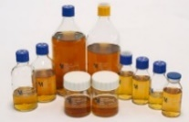
Selective media
Cetrimide agar | Oxoid, Basingstoke, UK | Available as dehydrated medium, store at 10-30˚C. | Not widely available^{b} | Up to 48 hours | 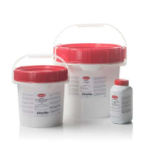
Cetrimide agar | bioMérieux, Marcy L'Étoile, France | Available as poured plates. | Not widely available | Information not available | 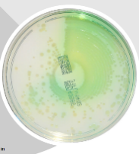
CHROMagar Pseudomonas | CHROMagarᵀᴹ | Available as dehydrated powder, store at 15-30˚C in a dry place away from light. | Available | 24/26 hours, extension to 48 hours for fragile Pseudomonas species (small colonies, etc.) | 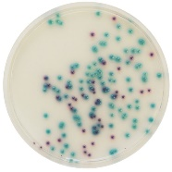
Pseudomonas C-N selective agar | Oxoid, Basingstoke, UK | Available as poured plates, store at 2-12˚C. | Not widely available^{b} | Information not available | 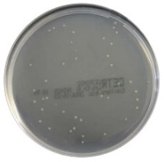
Pseudomonas  chromogenic medium | bioMérieux, La Balme-les-Grottes, France | Available as poured plates. | Not widely available | 24 hours | 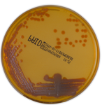
HardyCHROM CRE agar | Hardy Diagnostics | Available as poured plates. | Not widely available | 18-24 hours | 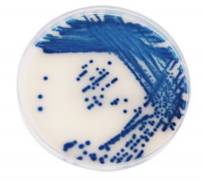
chromID CARBA agar | bioMérieux | Available as poured plates. | Not widely available | 18 hours | 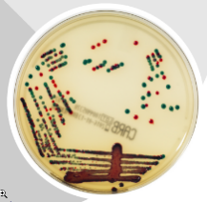
Supplement
Meropenem | Sigma-Aldrich, Buchs, Switzerland | Available as powder | Available | Not applicable | Not available
ª Availability determined from the manufacturers’ websites. Subsequently, it was cross-checked if it could be ordered in the Netherlands and Indonesia as proof of worldwide availability (last checked in 2023).
^{b} Not available in Indonesia

