Supplementary Figure 1. Schematic of the OMP extraction protocol for analysis by A) SDS-PAGE and B) MALDI-TOF/MS.
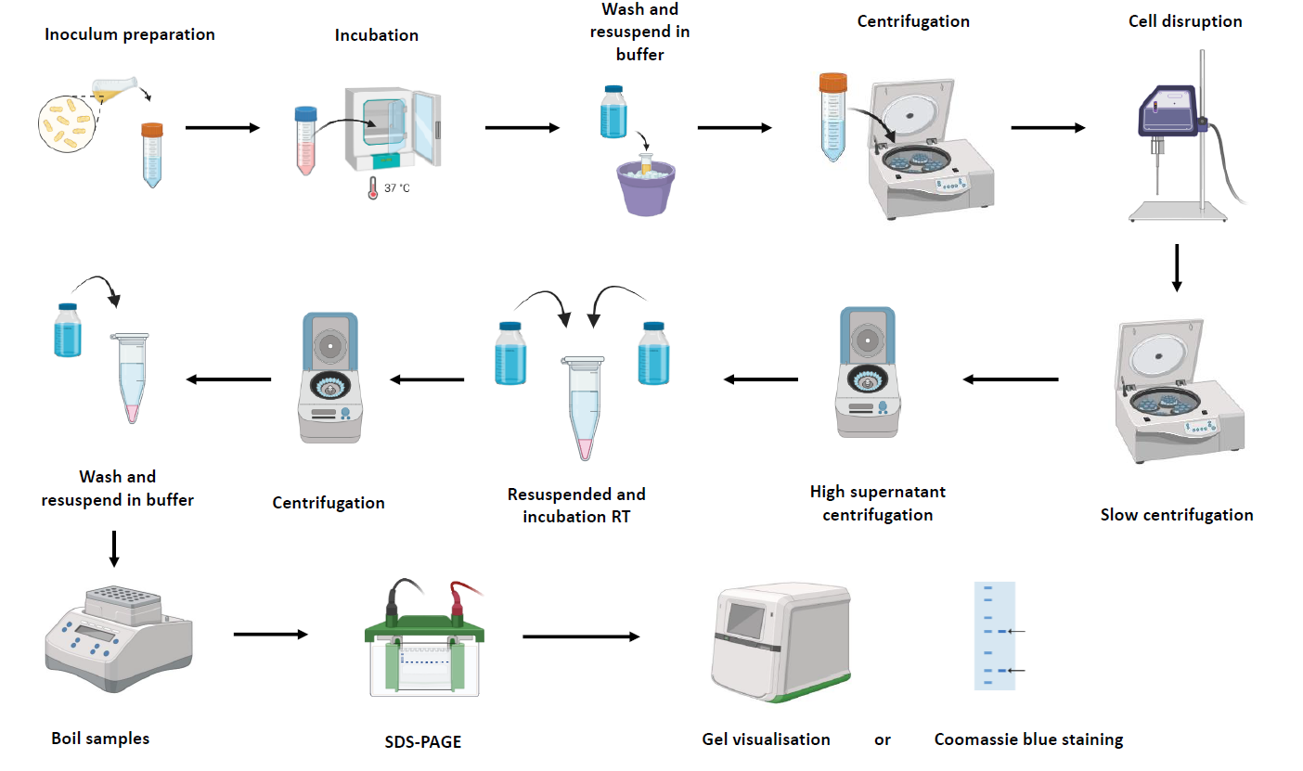
- OMP extraction protocol by SDS-PAGE. (RT) room temperature.
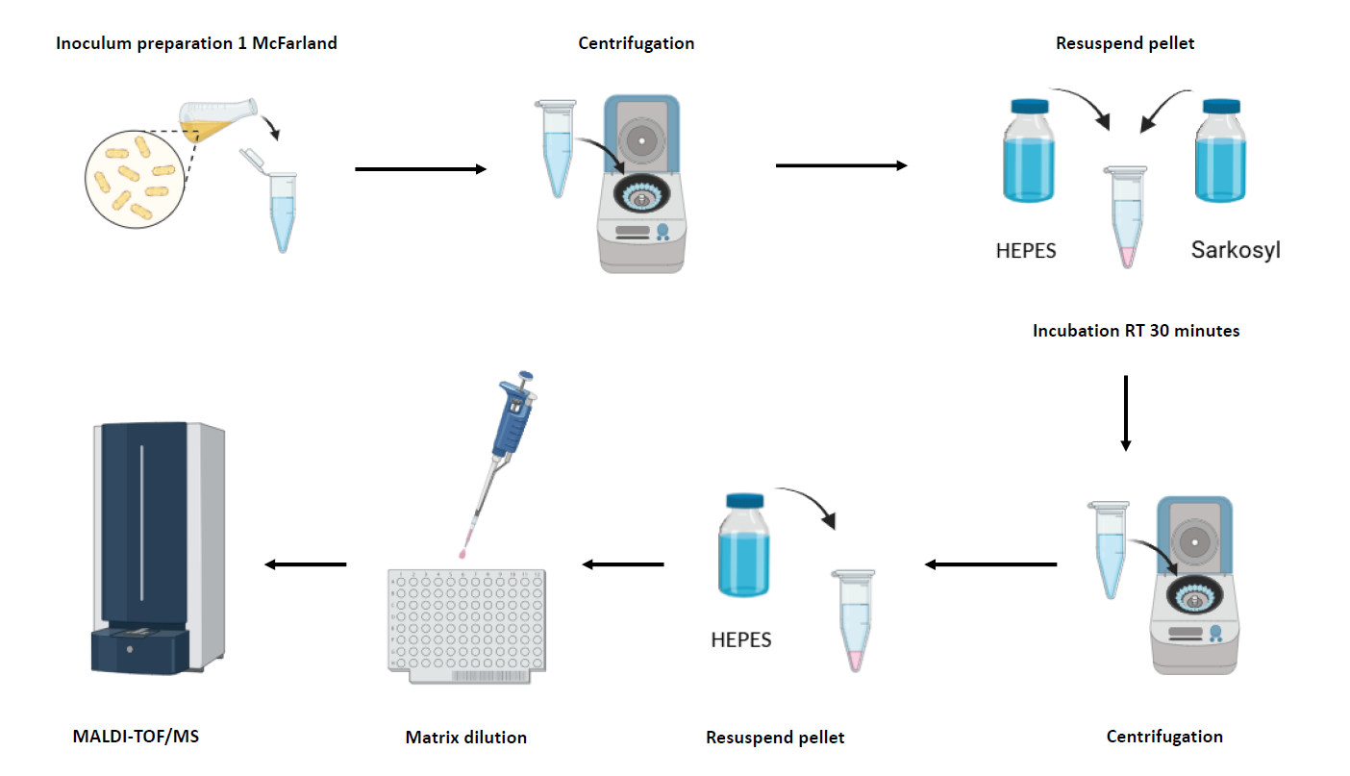
- OMP extraction protocol by MALDI-TOF/MS. (Sarkosyl) sodium lauroyl sarcosinate, (RT) room temperature.
Supplementary table 1. Mutations in the genes studied.
ID_Isolate | Phenotype | ST | OmpA | OmpK26 | OmpK35 | OmpK36 | OmpK37 | LamB | PhoE
CHURS-5-1534 | Kp-WT | 268 | NM | NM | NM | NM | IS-5-(N), N208G, M211Q, IS-212-215-(HYTH), Q217E, T218R, N219Y, R221K, E226D, N252S, D253T, IS-254-259 (SSTNGG), V261I | NM | NM
CHURS-9-1075 | Kp-WT | 17 | NM | L74F | NM | DEL-162-163-(TS), P164A, A171W, L172Q, Y188W, N203T, G204D, D205E, R208S, L209V, D210P, K211A, IS-212-(L), T235S, DEL-246-251-(FSGNGE), S252A, D253G, I255L, DEL-256-(S), I291L, IS-293-(R), L299I, R334K | IS-5-(N), T239A | NM | NM
CHURS-170652 | Kp-WT | 34 | NM | NM | NM | V157P, T162A, IS-163-(L), G187T, F179Y, H199N, N203L, IS-208-(S), R209K, D211A, K212L, T235G, DEL-246-251-(FSGNGE), S252A, D253G, I255L, DEL-256-(S), I291L, IS-293-(R), L299I, E328D, D330S, R334N | IS-5-(N), N208G, M211Q, IS-212-215-(HYTH), Q217E, T218R, N219Y, R221K, E226D, N252S, D253T, IS-254-259 (SSTNGG), V261I, R293H | NM | NM
CHURS-170744 | Kp-WT | 1628 | NM | NM | NM | V157P, T162A, IS-163-(L), G187T, F179Y, H199N, N203L, IS-208-(S), R209K, D211A, K212L, T235G, DEL-246-251 (FSGNGE), S252A, D253G, I255L, DEL-256-(S), I291L, L299I, E328D, D330S, R333H, R334N | IS-5-(N), N208G, M211Q, IS-212-215-(HYTH), Q217E, T218R, N219Y, R221K, E226D, N252S, D253T, IS-254-259 (SSTNGG), V261I | NM | NM
CHURS-170943 | Kp-WT | 34 | NM | NM | NM | V157P, T162A, IS-163-(L), G187T, F179Y, H199N, N203L, IS-208 (S), R209K, D211A, K212L, T235G, DEL-246-251 (FSGNGE), S252A, D253G, I255L, DEL-256-(S), I291L, IS-293-(R), L299I, E328D, D330S, R334N | IS-5-(N), N208G, M211Q, IS-212-215-(HYTH), Q217E, T218R, N219Y, R221K, E226D, N252S, D253T, IS-254-259 (SSTNGG), V261I, R293H | NM | NM
CHURS-171503 | Kp-WT | 6428 | NM | NM | NM | T65V, S67G, S68T, S69D, D70Q, A72S, DEL-162-163-(GT), S163D, P164M, L172Q, L183V, Y188W, N203T, G204D, R208N, D210V, K211L, N216D, T235S, DEL-246-251-(FSGNGE), S252A, D253G, I255L, DEL-256-(S), I291L, IS-292-(R), L299I, E328D, D330S, R334N | IS-5-(N) | NM | NM
CHURS-171703 | Kp-WT | 1628 | NM | NM | NM | V157P, T162A, IS-163-(L), G187T, F179Y, H199N, N203L, IS-208-(S), R209K, D211A, K212L, DEL-246-251-(FSGNGE), S252A, D253G, I255L, DEL-256-(S), I291L, L299I, E328D, D330S, R333H, R334N | IS-5-(N), N208G, M211Q, IS-212-215-(HYTH), Q217E, T218R, N219Y, R221K, E226D, N252S, D253T, IS-254-259-(SSTNGG), V261I | NM | NM
CHURS-174873 | Kp-WT | 6429 | NM | NM | NM | DEL-162-163-(TS), P164A, L172S, N203T, G204D, D205E, R208N, L209V, D210P, K211A, IS-212-(L), T235S, DEL-246-251-(FSGNGE), S252A, D253G, I255L, DEL-256-(S), I291L, IS-292-(R), L299I, E328D, D330S, R334N | IS-5-(N) | NM | NM
CHURS-175802 | Kp-WT | 1825 | NM | NM | NM | NM | IS-5-(N), N208G, M211Q, IS-212-215-(HYTH), Q217E, T218R, N219Y, R221K, E226D, N252S, D253T, IS254-259-(SSTNGG), V261I | NM | NM
ATCC 700603 | Kp-ESBL | 489 | L247M, Y249F, E291K | A97V, N121D, V139A, S159N, | I52T, T71P, A160S, R162H, S189G, IS 235 (N), E236Q, D237G, H239Y, S275A, A277G, I290V, D317A, K320R, A321E | D70N, T162A, DEL 163 (S), DEL 164 (P), L173Q, L184V, Y189F, N204T, G205D, R209N, D212V, K213L, R215N, F248A, S249G, G250S, N251L, IS 253-259 (ESDSISG), I293L, L294I, E330D, D332S, R336N, I339V | IS 5 (N), L13V, L66V, T67S, S68A, S69G, E142D, V163I, D190N, D254N, N291T, R293S, G328D, K331S, E334K | NM | D44E
RHURS-0113 | Kp-ESBL | 38 | NM | NM | NM | V156P, T161A, IS-162-(L), G170T, F179Y, H199N, N203L, IS-208-(S), R209K, D211A, K212L, IS-246-251-(ESDSISG), S252A, D253G, I254L, DEL-255-(S), I291L, L299I, E328D, D330S, R334N | IS-5-(N), N208G, M211Q, IS-212-215-(HYTH), Q217E, T218R, N219Y, R221K, E226D, N252S, D253T, IS-254-259-(SSTNGG), V261I | NM | NM
RHURS-0114 | Kp-ESBL | 38 | NM | NM | NM | V156P, T161A, IS-162-(L), G170T, F179Y, H199N, N203L, IS-208-(S), R209K, D211A, K212L, IS-246-251-(ESDSISG), S252A, D253G, I254L, DEL-255-(S), I291L, L299I, E328D, D330S, R334N | IS-5-(N), N208G, M211Q, IS-212-215-(HYTH), Q217E, T218R, N219Y, R221K, E226D, N252S, D253T, IS-254-259-(SSTNGG), V261I | NM | NM
RHURS-0115 | Kp-ESBL | 38 | NM | NM | E2K* | V156P, T161A, IS-162-(L), G170T, F179Y, H199N, N203L, IS-208-(S), R209K, D211A, K212L, IS-246-251-(ESDSISG), S252A, D253G, I254L, DEL-255-(S), I291L, L299I, E328D, D330S, R334N | IS-5-(N), N208G, M211Q, IS-212-215-(HYTH), Q217E, T218R, N219Y, R221K, E226D, N252S, D253T, IS-254-259-(SSTNGG), V261I | NM | NM
RHURS-0039 | Kp-KPC | 258 | IS-185-191-(AP) | L74F | Stop-codon-67 | T161A, IS-162-(L), G170T, F2179Y, H199N, N203L, IS-207-(S) R208K, D210A, K211L, DEL-246-251-(FSGNGE), S252A, D253G, I255L, DEL-256-(S), I291L, L299I, E328D, D330S, R333H, R334N | IS-5-(N), N208G, M211Q, IS-212-214-(HYTH), Q216E, T217R, N218Y, R220K, E224D, N252S, D253T, IS-254-259-(SSTNGG), V261I | NM | NM
RHURS-0308 | Kp-KPC | 512 | NM | L74F | Stop-codon-67 | IS-111-112-(GD), T161A, IS-162-(L), G170T, F179Y, H199N, N203L, IS-208-(S) R209K, D211A, K212L, DEL-246-251-(FSGNGE), S252A, D253G, I255L, DEL-256-(S), I291L, L299I, E328D, D330S, R333H, R334N | IS-5-(N), N208G, M211Q, IS-212-214-(HYTH), Q216E, T217R, N218Y, R220K, E224D, N252S, D253T, IS-254-259-(SSTNGG), V261I | NM | NM
CHURS-000952 | Kp-KPC | 512 | NM | L74F | Stop-codon-67 | T161A, IS-162-(L), G170T, F2179Y, H199N, N203L, IS-207-(S) R208K, D210A, K211L, DEL-246-251-(FSGNGE), S252A, D253G, I255L, DEL- 256-(S), I291L, L299I, E328D, D330S, R333H, R334N | IS-5-(N), N208G, M211Q, IS-212-214-(HYTH), Q216E, T217R, N218Y, R220K, E224D, N252S, D253T, IS-254-259-(SSTNGG), V261I | NM | NM
CHURS-170942 | Kp-KPC | 512 | NM | L74F | Stop-codon-67 | IS-111-112-(GD), T161A, IS-162-(L), G170T, F179Y, H199N, N203L, IS-208-(S) R209K, D211A, K212L, DEL-246-251 (FSGNGE), S252A, D253G, I255L, DEL-256-(S), I291L, L299I, E328D, D330S, R333H, R334N | IS-5-(N), N208G, M211Q, IS-212-214-(HYTH), Q216E, T217R, N218Y, R220K, E224D, N252S, D253T, IS-254-259-(SSTNGG), V261I | NM | NM
CHURS-175691 | Kp-KPC | 512 | NM | L74F | Stop-codon-67 | IS-111-112-(GD), T161A, IS-162-(L), G170T, F179Y, H199N, N203L, IS-208-(S) R209K, D211A, K212L, A243T, T244Q, R245T, F246Y, DEL-247-248-(SG), G250A, E251T, S252R, D253A, S254G, I255S, S256L, I291L, L299I, E328D, D330S, R333H, R334N | IS-5-(N), N208G, M211Q, IS-212-214-(HYTH), Q216E, T217R, N218Y, R220K, E224D, N252S, D253T, IS-254-259 (SSTNGG), V261I | NM | NM
CHURS-180130 | Kp-KPC | 512 | NM | L74F | Stop-codon-67 | IS-111-112-(GD), T161A, IS-162-(L), G170T, F179Y, H199N, N203L, IS-208-(S) R209K, D211A, K212L, DEL-246-251-(FSGNGE), S252A, D253G, I255L, DEL-256-(S), I291L, L299I, E328D, D330S, R333H, R334N | IS-5-(N), N208G, M211Q, IS-212-214-(HYTH), Q216E, T217R, N218Y, R220K, E224D, N252S, D253T, IS-254-259-(SSTNGG), V261I | NM | NM
CHURS-184677 | Kp-KPC | 512 | NM | L74F | Stop-codon-67 | T161A, IS-162-(L), G170T, F179Y, H199N, N203L, IS-208-(S) R209K, D211A, K212L, DEL-246-251-(FSGNGE), S252A, D253G, I255L, DEL-256-(S), I291L, L299I, E328D, D330S, R333H, R334N | IS- 5-(N), N208G, M211Q, IS-212-214-(HYTH), Q216E, T217R, N218Y, R220K, E224D, N252S, D253T, IS-254-259-(SSTNGG), V261I | NM | NM
RHURS-0132 | Kp-OXA-48 | 15 | NM | NM | Stop-codon-15* | Stop-codon-65 | IS-5-(N) | NM | NM
CHURS-009-IS | Kp-OXA-48 | 11 | NM | L74F | T119S | T161A, IS-162-(L), G170T, F179Y, H199N, N203L, IS-208-(S), R209K, D211A, K212L | IS- 5-(N), N208G, M211Q, IS-212-215-(HYTH), Q217E, T218R, N219Y, R221K, E226D, N252S, D253T, IS-254-259-(SSTNGG), V261I | NM | NM
CHURS-000694 | Kp-OXA-48 | 15 | NM | NM | Stop-codon-15* | Stop-codon-171 | IS-5-(N) | NM | NM
CHURS-000958 | Kp-OXA-48 | 15 | NM | NM | Stop-codon-15* | T161A, IS-162-(L), G170T, F179Y, H199N, N203L, IS-208-(S) R209K, D211A, K212L, DEL-246-251-(FSGNGE), S252A, D253G, I255L, DEL-256-(S), I291L, L299I, E328D, D330S, R333H, R334N | IS-5-(N) | NM | NM
CHURS-001262 | Kp-OXA-48 | 15 | NM | NM | Stop-codon-15* | T161A, IS-162-(L), G170T, F179Y, H199N, N203L, IS-208-(S) R209K, D211A, K212L, DEL-246-251-(FSGNGE), S252A, D253G, I255L, DEL-256-(S), I291L, L299I, E328D, D330S, R333H, R334N | IS-5-(N) | NM | NM
CHURS-181073 | Kp-OXA-48 | 15 | NM | NM | Stop-codon-15* | T161A, IS-162-(L), G170T, F179Y, H199N, N203L, IS-208-(S) R209K, D211A, K212L, DEL-246-251-(FSGNGE), S252A, D253G, I255L, DEL-256-(S), I291L, L299I, E328D, D330S, R333H, R334N | IS-5-(N) | NM | NM
CHURS-183019 | Kp-OXA-48 | 15 | NM | NM | Stop-codon-15* | T161A, IS-162-(L), G170T, F179Y, H199N, N203L, IS-208-(S) R209K, D211A, K212L, DEL-246-251-(FSGNGE), S252A, D253G, I255L, DEL-256-(S), I291L, L299I, E328D, D330S, R333H, R334N | IS-5-(N) | NM | NM

NM (no mutation compared to wild-type). Stop-codon-x (position of the protein with a stop codon). IS (insertion sequence). DEL (deletion). (*) mutation in the signal peptide.

