Supplementary materials

Activity of imipenem/relebactam against KPC-producing Klebsiella pneumoniae and the role of Ompk36 mutation in determining resistance: an Italian retrospective analysis

Contents

Figure S1 2
Table S1 3
Table S2 4
Table S3 5
Table S4 6
Table S5 7

Figure S1
Minimum spanning tree computed using Grapetree (v2.2). Cluster alert distance: 21SNPs
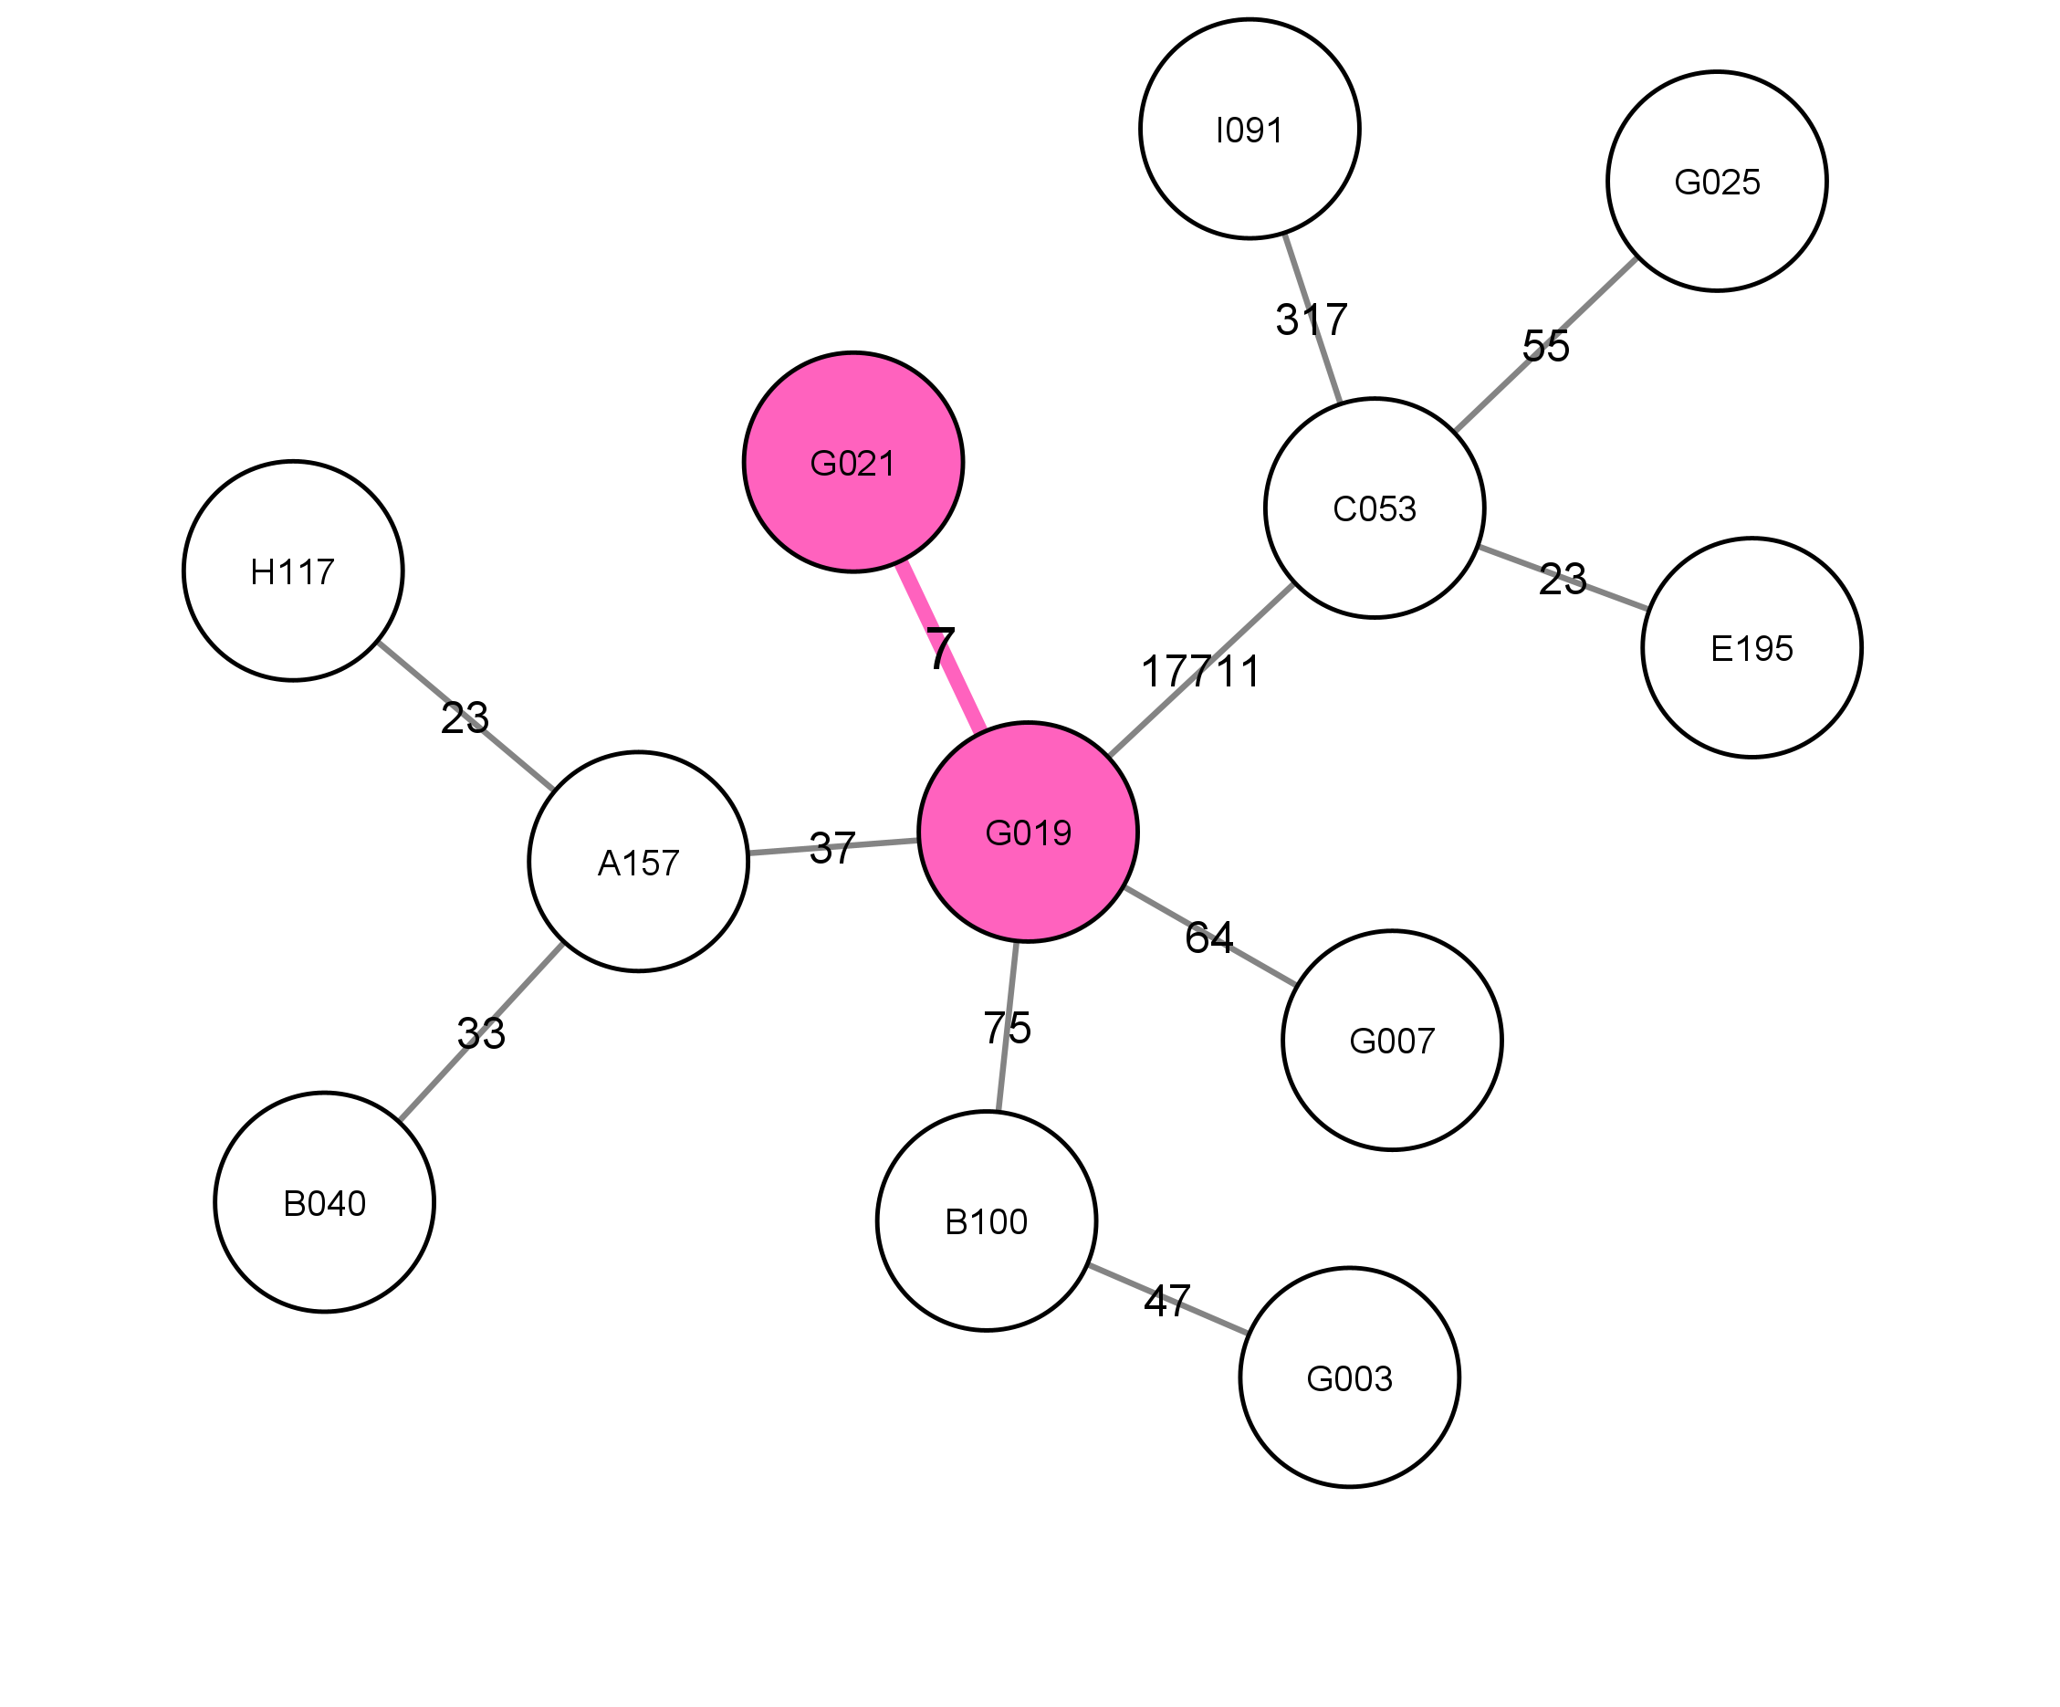

Table S1
Bioproject accession codes

ID | BioProject | Accession | SRA
B100 | PRJNA1162767 | SAMN43826029 | SRR30721139
B040 | PRJNA1162767 | SAMN43825953 | SRR30721467
C053 | PRJNA1162767 | SAMN43825950 | SRR30721471
G025 | PRJNA1162767 | SAMN43825691 | SRR30721226
G021 | PRJNA1162767 | SAMN43825689 | SRR30721508
G019 | PRJNA1162767 | SAMN43825688 | SRR30721509
A157/2 | PRJNA1162767 | SAMN43825641 | SRR30721102
H117 | PRJNA1162767 | SAMN43825605 | SRR30721249
E195 | PRJNA1162767 | SAMN43825586 | SRR30721270
G003 | PRJNA1162767 | SAMN43825548 | SRR30721423
G007 | PRJNA1162767 | SAMN43825542 | SRR30721429
I091 | PRJNA1162767 | SAMN43825492 | SRR30721400

Table S2
Susceptibility to imipenem/relebactam of Klebsiella pneumoniae strains susceptible and resistant to the other study drugs.

 | IMI/REL S | IMI/REL R | TOT
COL S | 497 | 10 | 603
COL R | 94 | 2 | 603
MVB S | 590 | 12 | 603
MVB R | 1 | 0 | 603
CZA S | 586 | 11 | 603
CZA R | 5 | 1 | 603

S: susceptible; R: resistant; COL: colistin, MVB: meropenem/vaborbactam, CZA: ceftazidime/avibactam; IMI/REL: imipenem/relebactam.

Table S3
Plasmids identified in each selected isolate

ID | Col(MG828)_1 | Col440I_1 | Col440II_1 | ColRNAI_1 | IncFIB(K)_1 | IncFIB(pKPHS1)_1 | IncFIB(pNDM-Mar)_1 | IncFIB(pQil)_1 | IncFII(pKP91)_1 | IncFII(Yp)_1 | IncHI1B(pNDM-MAR)_1 | IncR_1 | IncX3_1
A157/2 |  |  |  |  | 1 |  | 1 | 1 | 1 |  | 1
B040 |  |  |  | 1 | 1 |  |  | 1 | 1
B100 |  |  |  |  | 1 |  |  | 1 | 1
C053 |  |  |  | 1 | 1 |  |  |  | 1 |  |  |  | 1
E195 |  |  |  | 1 |  |  |  |  | 1 |  |  |  | 1
G003 |  |  |  |  |  |  | 1 | 1 | 1
G007 |  |  |  |  | 1 |  |  | 1 | 1
G019 |  |  |  |  | 1 |  |  | 1 | 1
G021 |  |  |  |  | 1 |  |  | 1 | 1
G025 | 1 |  |  | 1 | 1 |  |  |  |  | 1 |  |  | 1
H117 |  |  |  |  | 1 |  |  |  | 1
I091 |  |  |  | 1 | 1 |  |  |  | 1 |  |  |  | 1

Table S4
Determinants of resistance identified in each selected isolate (analysis performed with NCBI AMRFinder)

ID | aac(3)-IIe | aac(6')-Ib | aac(6')-Ib-cr5 | aadA1 | aadA2 | aph(3'')-Ib | aph(3')-Ia | aph(6)-Id | blaCTX-M-15 | blaKPC-2 | blaKPC-3 | blaOXA | blaOXA-1 | blaSHV-11 | blaSHV-12 | blaSHV-168 | blaSHV-28 | blaTEM | blaTEM-1 | catB3 | dfrA12 | dfrA14 | fosA | mph(A) | oqxA | oqxB | oqxB19 | qacEdelta1 | qnrB1 | qnrS1 | sul1 | sul2 | tet(A)
A157/2 |  |  | 1 |  |  |  |  |  |  | 1 |  |  | 1 |  |  |  | 1 |  |  | 1 |  |  | 1 |  | 1 |  | 1 |  | 1
B040 |  |  | 1 |  |  |  |  |  | 1 | 1 |  | 1 | 1 |  |  |  | 1 |  | 1 | 1 |  | 1 | 1 |  | 1 |  | 1 |  | 1
B100 | 1 |  |  |  |  | 1 |  | 1 | 1 |  | 1 | 1 |  |  |  |  | 1 |  | 1 |  |  | 1 | 1 |  | 1 |  | 1 |  | 1 |  |  | 1 | 1
C053 |  | 1 |  |  |  |  | 1 |  |  | 1 |  |  |  |  | 1 |  |  |  |  |  |  |  | 1 |  | 1 | 1
E195 |  | 1 |  |  |  |  | 1 |  |  | 1 |  |  |  |  | 1 |  |  |  |  |  |  |  | 1 |  | 1 | 1
G003 | 1 |  | 1 | 1 | 1 | 1 | 1 | 1 | 1 |  | 1 | 1 | 1 |  |  |  |  | 1 |  | 1 | 1 |  | 1 | 1 | 1 |  | 1 | 1 | 1 | 1 | 1 | 1 | 1
G007 | 1 |  |  |  |  | 1 |  | 1 | 1 |  | 1 |  | 1 |  |  |  | 1 |  | 1 | 1 |  | 1 | 1 |  | 1 |  | 1 |  | 1 |  |  | 1
G019 | 1 |  | 1 |  |  |  |  |  | 1 |  | 1 | 1 | 1 |  |  |  | 1 |  | 1 | 1 |  | 1 | 1 |  | 1 |  | 1 |  | 1
G021 | 1 |  | 1 |  |  |  |  |  | 1 |  | 1 | 1 | 1 |  |  |  | 1 |  | 1 | 1 |  | 1 | 1 |  | 1 |  | 1 |  | 1
G025 |  | 1 |  |  |  |  |  |  |  | 1 |  |  |  |  | 1 |  |  |  |  |  |  |  | 1 |  | 1 | 1
H117 |  |  | 1 |  |  |  |  |  |  | 1 |  |  | 1 |  |  |  | 1 |  |  | 1 |  | 1 | 1 |  | 1 |  | 1 |  | 1
I091 |  | 1 |  |  |  |  |  |  |  |  | 1 | 1 |  | 1 |  |  |  |  | 1 |  |  |  | 1 |  | 1 | 1

Table S5
Virulence analysis performed on the selected isolates

ID | entA | entB | fepC | fyuA | irp1 | irp2 | ompA | yagV/ecpE | yagW/ecpD | yagX/ecpC | yagY/ecpB | yagZ/ecpA | ybtA | ybtE | ybtP | ybtQ | ybtS | ybtT | ybtU | ybtX | ykgK/ecpR
A157/2 | 1 | 1 | 1 | 1 | 1 | 1 | 1 | 1 | 1 | 1 | 1 | 1 | 1 | 1 | 1 | 1 | 1 | 1 | 1 | 1 | 1
B040 | 1 | 1 | 1 | 1 | 1 | 1 | 1 | 1 | 1 | 1 | 1 | 1 | 1 | 1 | 1 | 1 | 1 | 1 | 1 | 1 | 1
B100 | 1 | 1 | 1 |  |  |  | 1 | 1 | 1 | 1 | 1 | 1 |  |  |  |  |  |  |  |  | 1
C053 | 1 | 1 | 1 | 1 | 1 | 1 | 1 | 1 | 1 | 1 | 1 | 1 | 1 | 1 | 1 | 1 | 1 | 1 | 1 | 1 | 1
E195 | 1 | 1 | 1 | 1 | 1 | 1 | 1 | 1 | 1 | 1 | 1 | 1 | 1 | 1 | 1 | 1 | 1 | 1 | 1 | 1 | 1
G003 | 1 | 1 | 1 |  |  |  | 1 | 1 | 1 | 1 | 1 | 1 |  |  |  |  |  |  |  |  | 1
G007 | 1 | 1 | 1 |  |  |  | 1 | 1 | 1 | 1 | 1 | 1 |  |  |  |  |  |  |  |  | 1
G019 | 1 | 1 | 1 | 1 | 1 | 1 | 1 | 1 | 1 | 1 | 1 | 1 | 1 | 1 | 1 | 1 | 1 | 1 | 1 | 1 | 1
G021 | 1 | 1 | 1 | 1 | 1 | 1 | 1 | 1 | 1 | 1 | 1 | 1 | 1 | 1 | 1 | 1 | 1 | 1 | 1 | 1 | 1
G025 | 1 | 1 | 1 | 1 | 1 | 1 | 1 | 1 | 1 | 1 | 1 | 1 | 1 | 1 | 1 | 1 | 1 | 1 | 1 | 1 | 1
H117 | 1 | 1 | 1 | 1 | 1 | 1 | 1 | 1 | 1 | 1 | 1 | 1 | 1 | 1 | 1 | 1 | 1 | 1 | 1 | 1 | 1
I091 | 1 | 1 | 1 |  |  |  | 1 | 1 | 1 | 1 | 1 | 1 |  |  |  |  |  |  |  |  | 1

